|  |
| --- |
| **[ Internet of things ]** |
|  |

Practical-2

**-:AIM:-**

**To study Sensors and Actuators.**

Submitted By: Dharmay Sureja

Enrollment No:17012011056



**GANPAT UNIVERSITY**

**U. V. Patel College of Engineering**

**Computer Engineering Department**

**AIM:- To study Sensors and Actuators.**

**Theory:**

A **Sensor** is a converter that measures a physical quantity and converts it into a signal which can be read by an observer or by an (today mostly electronic) instrument.

An **Actuator** is a type of motor for moving or controlling a mechanism or system. It is operated by a source of energy, typically electric current, hydraulic fluid pressure, or pneumatic pressure, and converts that energy into motion. An actuator is the mechanism by which a control system acts upon an environment.

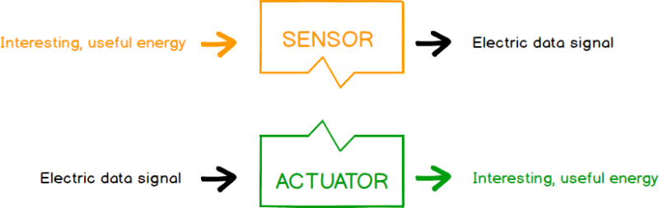

**SENSORS:**

We frequently use different types of sensors in several electrical and electronic applications, which are classified as chemical, pressure, temperature, position, force, proximity, thermal, presence, flow, optical, automotive, sound, speed, magnetic, electric, heat, [fiber-optic sensors](https://www.elprocus.com/diffrent-types-of-fiber-optic-sensors/), analog and digital sensors. A sensor can be defined as an appliance that detects changes in physical or electrical or other quantities and by this means, generally, produces an electrical or optical signal output as an acknowledgement of the change in that specific quantity.

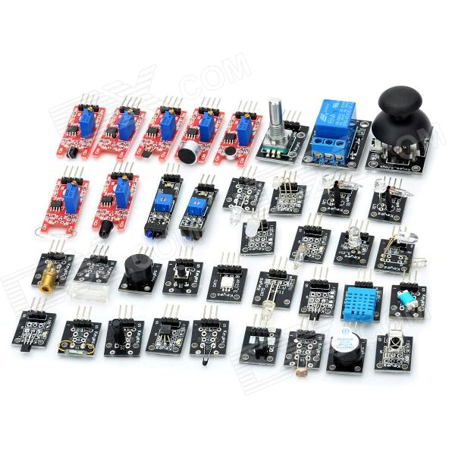

**Characteristics of Sensors:**

A good sensor should have the following characteristics

* High Sensitivity: Sensitivity indicates how much the output of the device changes with unit change in input (quantity to be measured). For example the voltage of a temperature sensor changes by 1mV for every 1oC change in temperature than the sensitivity of the sensor is said to be 1mV/oC.
* Linearity: The output should change linearly with the input.
* High Resolution: Resolution is the smallest change in the input that the device can detect.
* Less Noise and Disturbance.
* Less power consumption.

**TYPES of Sensors**

All sensors used for implementations of IOT application classify in two major category; analog and digital sensors.

**ANALOG SENSORS:**

There are different types of sensors that produce continuous analog output signal and these sensors are considered as analog sensors. This continuous output signal produced by the analog sensors is proportional to the measured. There are various types of analog sensors such as accelerometers, pressure sensors, light sensors, sound sensors, temperature sensors, and so on.

#### Accelerometers

Analog sensors that detect changes in position, velocity, orientation, shock, vibration, and tilt by sensing motion are called as accelerometers. These analog accelerometers are again classified into different types based on the variety of configurations and sensitivities.

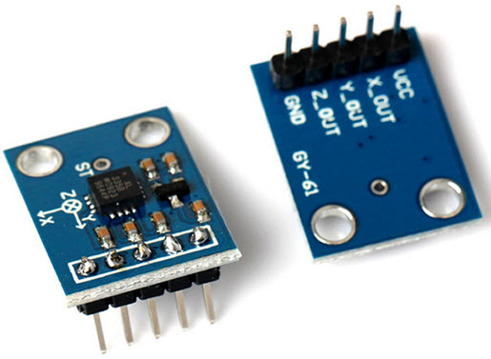

These accelerometers are available as analog and digital sensors, based on the output signal. Analog accelerometer produces a constant variable voltage based on the amount of acceleration applied to the accelerometer.

* Small board size - Just 28mm X 23mm
* Simple 5 pin interface (VCC, GND, Xout, Yout, Zout, Self Test)
* Needs no external components
* Easy to mount on General purpose PCB, Breadboards and special PCBs
* Low Current Consumption: 500 μA
* Low Voltage Operation: 5V
* High Sensitivity for small movements
* Fast Turn On Time
* Integral Signal Conditioning with Low Pass Filter
* Robust Design, High Shocks Survivability

#### Light Sensors

Analog sensors that are used for detecting the amount of light striking the sensors are called as light sensors. These analog light sensors are again classified into various types such as photo-resistor, Cadmium Sulfide (CdS), and, photocell.

[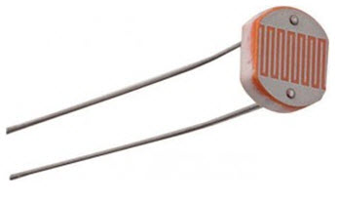Light dependent resistor](https://www.elprocus.com/phototransistor-basics-and-advantages/) (LDR) can be used as analog light sensor which can be used to switch on and off loads automatically based on the day light incident on the LDR. The resistance of the LDR increases with decrease in light and decreases with increase in light.

#### Sound Sensors

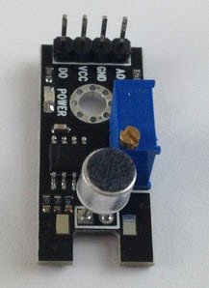Analog sensors that are used to sense sound level are called as sound sensors. These analog sound sensors translate the amplitude of the acoustic volume of the sound into an electrical voltage for sensing sound level. This process requires some circuitry, and utilizes microcontroller along with a microphone for creating an analog output signal.

#### analog-pressure-sensorPressure Sensor

The analog sensors that are used to measure the amount of pressure applied to a sensor are called as analog pressure sensors. Pressure sensor will produce an analog output signal that is proportional to the amount of applied pressure. These pressure sensors are used for different types of applications such as piezoelectric plates or [piezoelectric sensors](https://www.elprocus.com/piezoelectric-ultrasonic-motor-technology/) that are used for the generation of electric charge. These piezoelectric sensors are one type of pressure sensors that can produce an analog output voltage signal proportional to the pressure applied to the piezoelectric sensor.

#### Analog Temperature sensor

Temperature sensors are widely available as both digital and analog sensors. Typically used analog temperature sensors are thermistors. There are [different types of thermistors](https://www.elprocus.com/introduction-to-thermistor-types-with-its-workings-and-applications/) that are used for different applications. Thermistor is a thermally sensitive resistor that is used for Temperature sensors are widely available as both digital and analog sensors. Typically used analog temperature sensors are thermistors. There are [different types of thermistors](https://www.elprocus.com/introduction-to-thermistor-types-with-its-workings-and-applications/) that are used for different applications. Thermistor is a thermally sensitive resistor that is used for 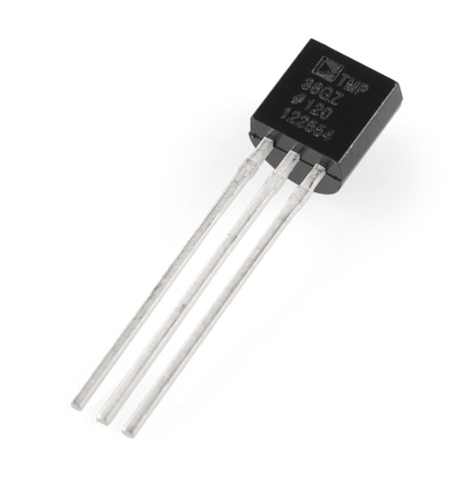detecting changes in temperature. If the temperature increases, then the electrical resistance of thermistor increases. Similarly, if temperature decreases, then the resistance decreases.

It is used in various temperature sensor applications.

* Voltage Input: 2.7 V to 5.5 VDC
* 10 mV/°C scale factor
* ±2°C accuracy over temperature
* ±0.5°C linearity
* Operating Range: −40°C to +125°C

#### Water Level Sensor

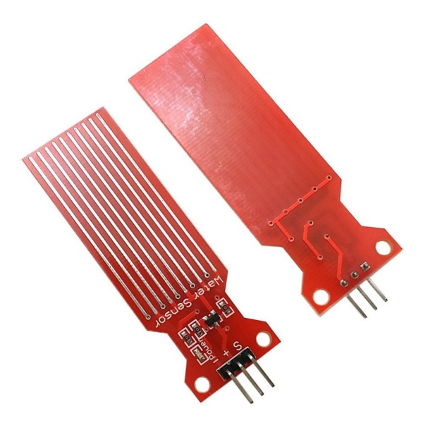Water Sensor water level sensor is an easy-to-use, cost-effective high level/drop recognition sensor, which is obtained by having a series of parallel wires exposed traces measured droplets/water volume in order to determine the water level. Easy to complete water to analog signal conversion and output analog values can be directly read Arduino development board to achieve the level alarm effect.

* Operating voltage: DC3-5V
* Operating current: less than 20mA
* Sensor Type: Analog
* Detection Area: 40mmx16mm
* Humidity: 10% -90% non-condensing
* Product Dimensions: 62mmx20mmx8mm

**DIGITAL SENSORS:**

Electronic sensors or electrochemical sensors in which data conversion and data transmission takes place digitally are called as digital sensors. These digital sensors are replacing analog sensors as they are capable of overcoming the drawbacks of analog sensors. The digital sensor consists of majorly three components: senor, cable, and transmitter.

In digital sensors, the signal measured is directly converted into digital signal output inside the digital sensor itself. And this digital signal is transmitted through cable digitally. There are different types of digital sensors that overcome disadvantages of analog sensors.

#### Digital Temperature and Humidity Sensor

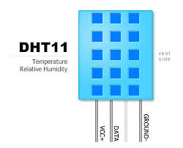DHT11 and DHT22 digital temperature sensor available for measurement of temperature and humidity

The DHT11 sensor includes a resistive-type humidity measurement component, an NTC temperature measurement component and a high-performance 8-bit microcontroller inside, and provides calibrated digital signal output.

* Power Supply： 3.3~5.5V DC
* Output： 4 pin single row
* Measurement Range： Humidity 20-90%RH， Temperature 0~50℃
* Accuracy： Humidity +-5%RH， Temperature +-2℃
* Resolution： Humidity 1%RH， Temperature 1℃
* Interchangeability： Fully Interchangeable
* Long-Term Stability： <±1%RH/year

It has high reliability and excellent long-term stability

**DHT22**

DHT22 includes a capacitive sensor wet components and a high-precision temperature measurement devices, and connected with a high-performance 8-bit microcontroller. The sensor has excellent quality, fast response, strong anti-jamming capability, and high cost.  
Standard single-bus interface, system integration quick and easy. Small size, low power consumption, signal transmission distance up to 20 meters, making it the best choice of all kinds of applications and even the most demanding applications.

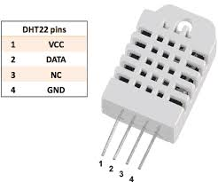DHT22 has higher precision and can replace the expensive imported SHT10 temperature and humidity sensor.  
It can measure the environment temperature and humidity to meet the high demand. The product has high reliability and good stability. If it's used and combined with special sensor Arduino expansion board, it will be easily implemented the interactive effect which related to the temperature and humidity perception.

* Supply voltage: 5V
* Temperature range:-40-80℃ resolution0.1℃ error <±0.5℃
* Humidity range:0-100%RH resolution0.1%RH error±2%RH
* Sequence of the line:VCC,GND,S
* Size: 38 x 20mm

#### Ultrasonic Sensor

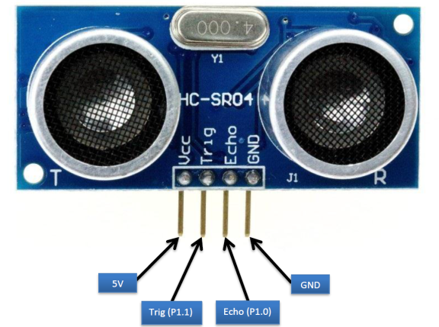Ultrasonic sensor distance measuring module is stable, measure the distance accurately. The sensor with High precision, blind spots (3cm) super close. Its provides a full set of ranging process.

* Working voltage : 5V(DC)
* Static current: Less than 2mA.
* Output signal: Electric frequency signal, high level 5V, low level 0V.
* Sensor angle: Not more than 15 degrees.
* Detection distance: 2cm~450cm.
* High precision: Up to 3mm
* Mode of connection: VCC / trig(T) / echo(R) / GND

#### IROIR Sensor (Obstacle sensor)

IR Obstacle Sensor consists of a TSOP as a receiver and IR LED as a transmitter. TSOP as a receiver provides flexibility of sensing light. The sensor is perfectly suited for Detecting obstacle within line of sight. The Control Circuit Applied for the sensor is based on LM555 Timer IC working. The Analog signal generated from the TSOP is processed by an Inverting Amplifier and then fed to the Timer IC and we get a Digital Output at the output Pin. The Digital output makes it a good device to interface with any device compatible with Digital Signal.

* Obstacle Avoider or Obstacle sensor for robots and electronics with range between 3cms to 7cms
* 0.1th inch (2.54 mm) with Breadboard compatiblity
* Obstacle sensing LED and Power LED
* Arduino, AVR, PIC and other microcontroller Compatible
* A compact form on a tiny board

#### Flame-SensorFlame Sensor

Flame Detection Sensor Module is sensitive to the flame, but also can detect ordinary light. Usually used as a flame alarm.

Detects a flame or a light source of a wavelength in the range of 760nm-1100 nm. Detection point of about 60 degrees, particularly sensitive to the flame spectrum. Sensitivity is adjustable, stable performance.

* Detection angle about 60 degrees, it is sensitive to the flame spectrum. Accuracy adjustable
* Operating voltage 3.3V-5V
* Output (a). analog voltage output (b). digital switch outputs (0 and 1)
* With a mounting screw hole PCB size: 3cm \* 1.6cm
* Power indicator (red) and digital switch output indicator (green)
* Comparator chip LM393 ,it is stable.
* Flame detection distance, lighter flame test can be triggered within 0.8m, if the intensity of flame is high , the detection distance will be increased

#### mq-135-gas-sensor-3_5Gas Sensor

It is a hazardous gas detection apparatus for the family, the environment, suitable for ammonia, aromatic compounds, Sulphur, benzene vapors, smoke and other gases harmful gas detection, gas-sensitive element test.

Air quality sensor is for detecting a wide range of gases, including NH3, NOx, alcohol, benzene, smoke and CO2. Ideal for use in office or factory with simple drive and monitoring circuit.

* 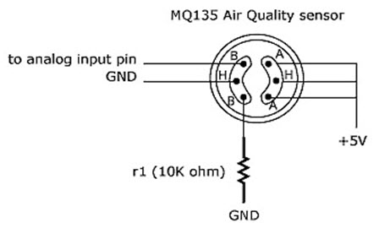Dual signal output (analog output, and TTL level output)
* TTL output valid signal is low
* Analog output with increasing concentration, the higher the concentration, the higher the voltage
* Sulphide, benzene, smoke and other harmful gases with high sensitivity
* Has a long life and reliable stability
* Rapid response recovery characteristics

#### Human/Metal Touch Sensor

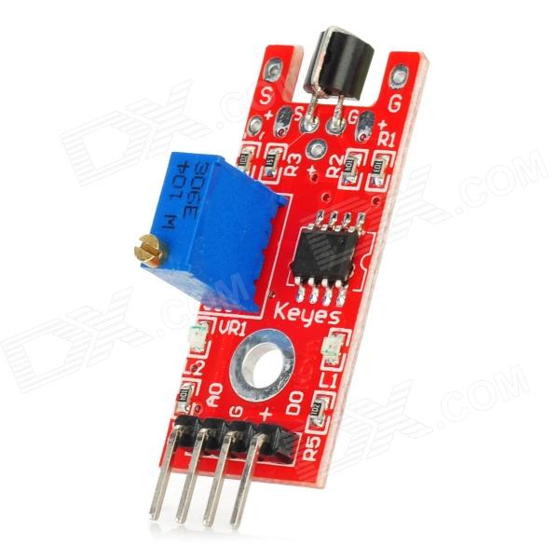The module is based on a touch-sensing IC (TTP223B) capacitive touch switch module. In the normal state, the modules output is low, lower power consumption; When a finger touches the corresponding position, the modules output is high, if not touched for 12 seconds, it switches to low-power mode. Jog type : the initial state is lower , higher touch , do not touch is lower ( similar touch of a button feature )

This Module can be installed in such as surface plastic, glass of non-metallic materials. In addition to the thin paper ( non-metallic ) covering the surface of the module , as long as the correct location of the touch , you can make hidden in the walls, desktops and other parts of buttons.

* Low power consumption
* Power supply for 2 ~ 5.5V DC
* Can replace the traditional touch of a button
* Four M2 screws positioning holes for easy installation

#### LineLine Tracker Sensor

Line Tracker sensor consists of 3 IR transmitter and IR receiver pairs. This tracker sensor is typically used for robots in line following task. It can be used for either dark or bright line following. The tracker sensor have 3 digital outputs to user indicating the existence of the line. Every sensor is provided with its own LEDs as indication of line detection

#### PIR Motion sensor

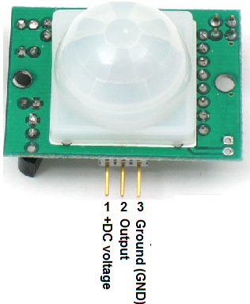

The Passive Infrared Sensor (PIR) sensor module is used for motion detection. It can be used as motion detector for security systems or robotics. It works on 5V DC and gives TTL output which can be directly given to microcontroller or to relay through a transistor. It consists of pyroelectric sensor and Fresnel lens that detects motion by measuring change in the infrared levels emitted by the objects. It can detect motion up to 20ft. This module is very sensitive to change in infrared levels subjected by human movement.

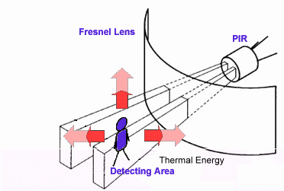

* Supply:  5V DC
* Detection range: 6meters
* Output: 3.3V
* Adjustable sensitivity levels (High or Low)
* Settling time: 60 seconds
* Size: Length 32mm, Width 24mm, Height 26mm

**Actuators**

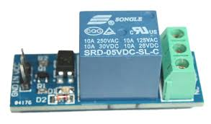

#### Relay

Relay provides an electrical connection between two or more points in response to the application of a control signal. Relays are basically electrically operated switches that come in many shapes, sizes and power ratings suitable for all types of applications. Relays can also have single or multiple contacts within a single package

#### DC Motor

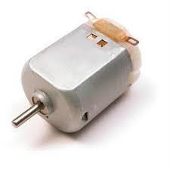A DC motor (Direct Current motor) is the most common type of motor. DC motors normally have just two leads, one positive and one negative. If you connect these two leads directly to a battery, the motor will rotate. If you switch the leads, the motor will rotate in the opposite direction.

#### Servo Motor

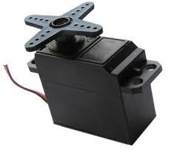A Servo Motor is a small device that has an output shaft. This shaft can be positioned to specific angular positions by sending the servo a coded signal. As long as the coded signal exists on the input line, the servo will maintain the angular position of the shaft. If the coded signal changes, the angular position of the shaft changes. In practice, servos are used in radio-controlled airplanes to position control surfaces like the elevators and rudders. They are also used in radio-controlled cars, puppets, and of course, robots.

Servos are extremely useful in robotics. The motors are small, have built-in control circuitry, and are extremely powerful for their size. A standard servo such as the Futaba S-148 has 42 oz/inches of torque, which is strong for its size. It also draws power proportional to the mechanical load. A lightly loaded servo, therefore, does not consume much energy.

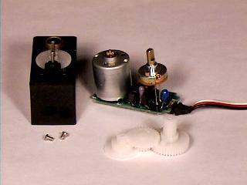

The guts of a servo motor is shown in the following picture. You can see the control circuitry, the motor, a set of gears, and the case. You can also see the 3 wires that connect to the outside world. One is for power (+5volts), ground, and the white wire is the control wire.

#### Stepper Motor

A Stepper Motor or a step motor is a brushless, synchronous motor, which divides a full rotation into a number of steps. Unlike a brushless DC motor, which rotates continuously when a fixed DC voltage is applied to it, a step motor rotates in discrete step angles.

The Stepper Motors therefore are manufactured with steps per revolution of 12, 24, 72, 144, 180, and 200, resulting in stepping angles of 30, 15, 5, 2.5, 2, and 1.8 degrees per step. The stepper motor can be controlled with or without feedback.

Imagine a motor on an RC airplane. The motor spins very fast in one direction or another. You can vary the speed with the amount of power given to the motor, but you cannot tell the propeller to stop at a specific position.

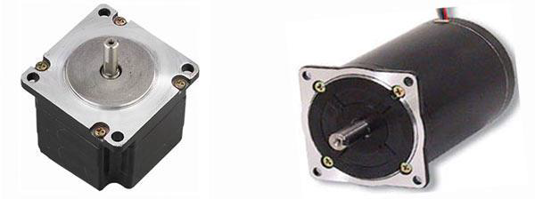Now imagine a printer. There are lots of moving parts inside a printer, including motors. One such motor acts as the paper feed, spinning rollers that move the piece of paper as ink is being printed on it. This motor needs to be able to move the paper an exact distance to be able to print the next line of text or the next line of an image.

There is another motor attached to a threaded rod that moves the print head back and forth. Again, that threaded rod needs to be moved an exact amount to print one letter after another. This is where the stepper motors come in handy.

#### 7-segment-LED-display-pinout-imageSeven Segment Display

The seven segments display a very simple device. It is a combination of 8 LEDs (the decimal point -DP- is the 8th), which can be arranged so that different combinations can be used to make numerical digits.

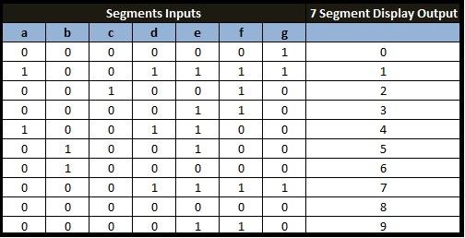

#### LCD-Display-TutorialLCD Display

An LCD is an electronic display module which uses liquid crystal to produce a visible image. The 16×2 LCD display is a very basic module commonly used in DIYs and circuits. The 16×2 translates display 16 characters per line in 2 such lines. In this LCD each character is displayed in a 5×7 pixel matrix.

**Common Sensors and Transducers**

|  |  |  |
| --- | --- | --- |
| **Quantity being measured** | **Input Device (Sensor)** | **Output Device** |
| **Light Level** | Light Dependent Resistor (LDR) Photodiode Photo-transistor Solar Cell | Lights & Lamps LED’s & Displays Fiber Optics |
| **Temperature** | Thermocouple Thermistor Thermostat Resistive Temperature Detectors | Heater Fan |
| **Force/Pressure** | Strain Gauge Pressure Switch Load Cells | Lifts & Jacks Electromagnet Vibration |
| **Position** | Potentiometer Encoders Reflective/Slotted Opto-switch LVDT | Motor Solenoid Panel Meters |
| **Speed** | Tacho-generator Reflective/Slotted Opto-coupler Doppler Effect Sensors | AC and DC Motors Stepper Motor Brake |
| **Sound** | Carbon Microphone Piezo-electric Crystal |  |

There are many sensors are in used in phone I listed out some sensors.

1. **ACCELEROMETER SENSOR**

Many smartphones and even some feature phones have an accelerometer, which detects the orientation the device being held and aligns the screen to suit the new orientation. When you rotate the phone sideways, the screen automatically switches to widescreen mode for tasks such as writing text messages, viewing photos, browsing the web, or playing games.

1. **GYROSCOPE  SENSOR**

An accelerometer measures linear acceleration of movement whereas a gyroscope measures angular velocity. Apple was the first to introduce a 3-axis gyroscope in a smartphone. The 3-axis gyroscope allows high-precision tracking of rotation/pitch on the X axis, roll on the Y axis, and yaw on the Z axis. A gyroscope is more powerful than an accelerometer. A built-in gyroscope enhances user experience, especially in gaming. With a gyroscope-enhanced shooting game, for example, you can point the phone to aim the gun.

1. **PROXIMITY SENSOR**

A proximity sensor detects nearby objects without any physical contact. It can sense how close the phone is to the user’s cheek. It’s very useful in touchscreen mobile phones. When you raise the phone to your ear during a call, the proximity sensor detects this and turns off the screen to save battery and prevent unintentional operation. When you take the phone away from your ear, the screen turns back on.

1. **AMBIENT LIGHT SENSOR**

An ambient light sensor is mounted in mobile phones to automatically measure the amount of light in the environment and adjust screen brightness accordingly. In dim environments, the screen dims; in bright environments, the screen brightens. An ambient light sensor extends a phone’s battery life and makes viewing more comfortable.

1. **BAROMETER**

Barometer has the role to measure air pressure. This reading is important because it helps your iPhone determine altitude, as well as relative elevation changes. This way your iOS device can track your vertical movement, without the need of GPS assistance. More, it transforms your iPhone in an actual barometer, because air pressure reading is used for weather forecasting

1. **TouchID Fingureprint Sensor**

The technology within Touch ID is some of the most advanced hardware and software that we've put into any device. The button is made from sapphire crystal—one of the clearest, hardest materials available. This protects the sensor and acts as a lens to precisely focus it on your finger. On iPhone and iPad, a steel ring surrounding the button detects your finger and tells Touch ID to start reading your fingerprint.

Touch ID can read multiple fingerprints, and it can read fingerprints in 360-degrees of orientation. It then creates a mathematical representation of your fingerprint and compares this to your enrolled fingerprint data to identify a match and unlock your device. It’s only this mathematical representation of your fingerprint that is stored—never images of your finger itself. Touch ID will incrementally update the mathematical representation of enrolled fingerprints over time to improve matching accuracy.