|  |
| --- |
| **[ INTERNET OF THINGS ]** |
|  |

Practical-5



Submitted By: Dharmay Sureja

Enrollment No:17012011056





**AIM:- Arduino programming with IR and Ultrasonic Sensor.**

**Experiment**

1. **Control the RGB LED using IR Sensor and IR Remote Control.**

Components used : Arduino Uno R3, RGB LED, IR Sensor, IR Remote

Circuit:

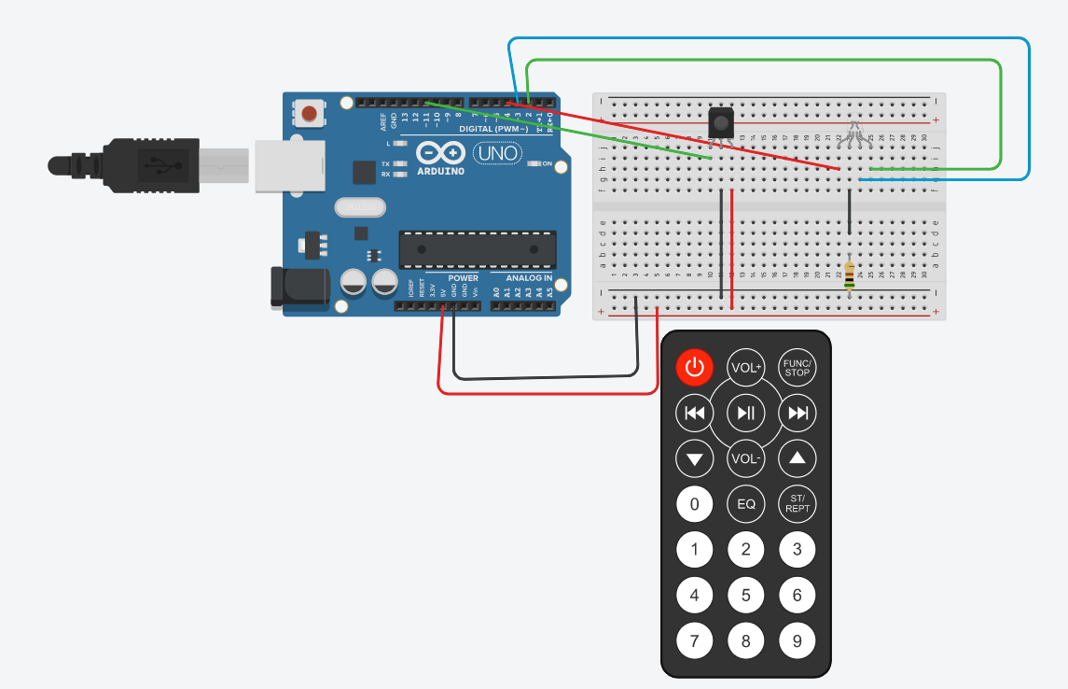

Code:

#include <IRremote.h>

int RECV_PIN=11;

int red = 4;

int green = 2;

int blue = 3;

IRrecv irrecv(RECV_PIN);

decode_results results;

void setup()

{

Serial.begin(9600);

irrecv.enableIRIn();

pinMode(red,OUTPUT);

pinMode(green,OUTPUT);

pinMode(blue,OUTPUT);

}

void loop()

{

if (irrecv.decode(&results))

{

Serial.println(results.value, HEX);

irrecv.resume();

if(results.value==0xFD08F7)

{

digitalWrite(red,HIGH);

digitalWrite(green,LOW);

digitalWrite(blue,LOW);

}

if(results.value==0xFD48B7)

{

digitalWrite(red,LOW);

digitalWrite(green,LOW);

digitalWrite(blue,HIGH);

}

if(results.value==0xFD8877)

{

digitalWrite(red,LOW);

digitalWrite(green,HIGH);

digitalWrite(blue,LOW);

}

if(results.value==0xFD00FF)

{

digitalWrite(red,LOW);

digitalWrite(green,LOW);

digitalWrite(blue,LOW);

}

}

delay(100);

}

Output :

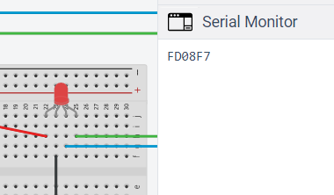

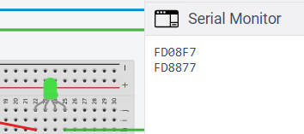

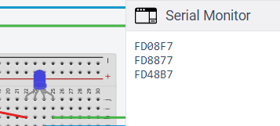

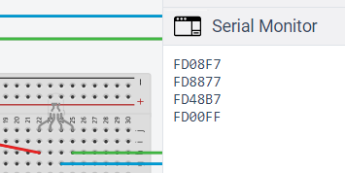

1. **Measure the distance of obstacle using ultrasonic sensor and display it on serial monitor.**

Components used : Arduino Uno R3, Ultrasonic Distance Sensor

Circuit:

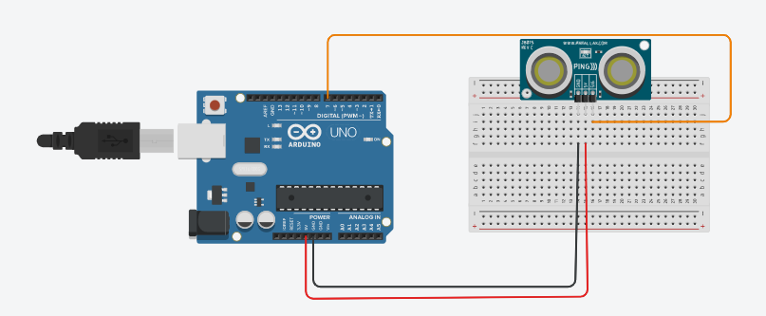

Code:

int cm = 0;

long readUltrasonicDistance(int triggerPin, int echoPin)

{

pinMode(triggerPin, OUTPUT);

digitalWrite(triggerPin, LOW);

delayMicroseconds(2);

digitalWrite(triggerPin, HIGH);

delayMicroseconds(10);

digitalWrite(triggerPin, LOW);

pinMode(echoPin, INPUT);

return pulseIn(echoPin, HIGH);

}

void setup()

{

Serial.begin(9600);

}

void loop()

{

cm = 0.01723 * readUltrasonicDistance(7, 7);

Serial.print(cm);

Serial.println("cm");

}

Output :

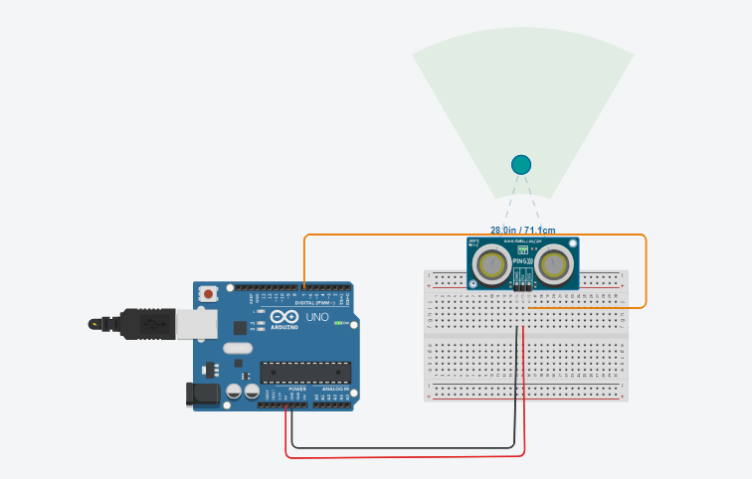

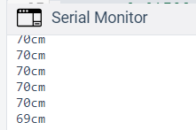

1. **Measure the distance of obstacle using ultrasonic sensor and if distance is less than 100 cm then on the LED.**

Components used : Arduino Uno R3, LED, Ultrasonic Distance Sensor, Resistor

Circuit:

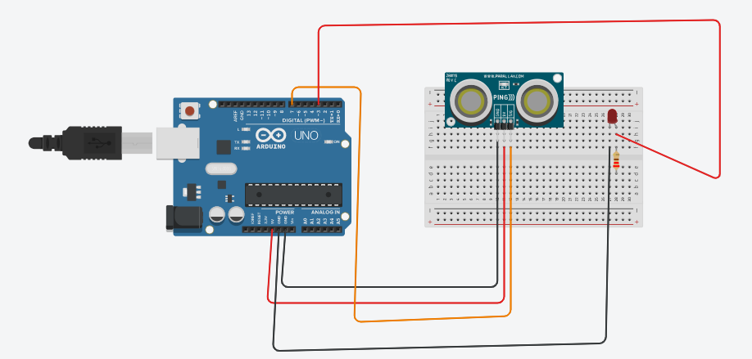

Code:

int cm = 0;

long readUltrasonicDistance(int triggerPin, int echoPin)

{

pinMode(triggerPin, OUTPUT);

digitalWrite(triggerPin, LOW);

delayMicroseconds(2);

digitalWrite(triggerPin, HIGH);

delayMicroseconds(10);

digitalWrite(triggerPin, LOW);

pinMode(echoPin, INPUT);

return pulseIn(echoPin, HIGH);

}

void setup()

{

Serial.begin(9600);

pinMode(3, OUTPUT);

}

void loop()

{

cm = 0.01723 * readUltrasonicDistance(7, 7);

Serial.print(cm);

Serial.println("cm");

delay(100);

if (cm<100)

{

analogWrite(3 , 255);

}

else

{

analogWrite(3 , 0);

}

}

Output :

