|  |
| --- |
| **[ Internet of things ]** |
|  |

Practical-6

**-:AIM:-**

**Arduino Programming With Actuator.**

Submitted By: Dharmay Sureja

Enrollment No:17012011056



**GANPAT UNIVERSITY**

**U. V. Patel College of Engineering**

**Computer Engineering Department**

**AIM:- Arduino programming with Actuator.**

**Experiments**

1. **Display current temperature of room in 26X2 LCD Display.**

**Components used :** Arduino Uno R3, LCD 16 x 2, Temperature Sensor .

**Circuit**:

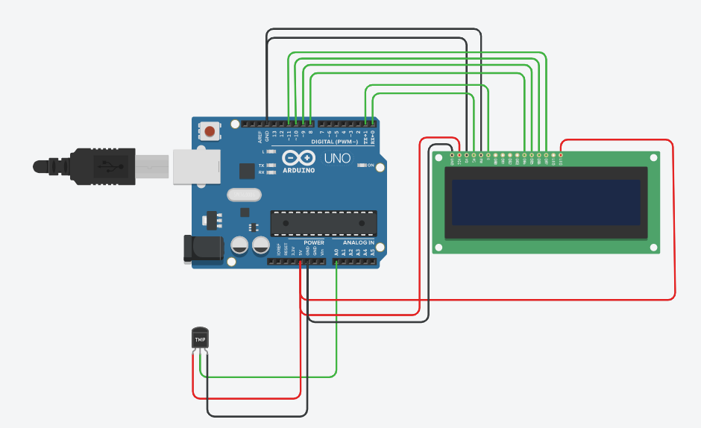

Code:

#include <LiquidCrystal.h>

int sensorPin = 0;

LiquidCrystal lcd(0, 1, 8, 9, 10, 11);

void setup(){

lcd.begin(16,2);

}

void loop()

{

int reading = analogRead(sensorPin);

float voltage = reading * 5.0;

voltage /= 1024.0;

float temperatureC = (voltage - 0.5) * 100 ;

lcd.print(temperatureC);

lcd.setCursor(0, 0);

delay(1000);

lcd.clear();

}

**Output :**

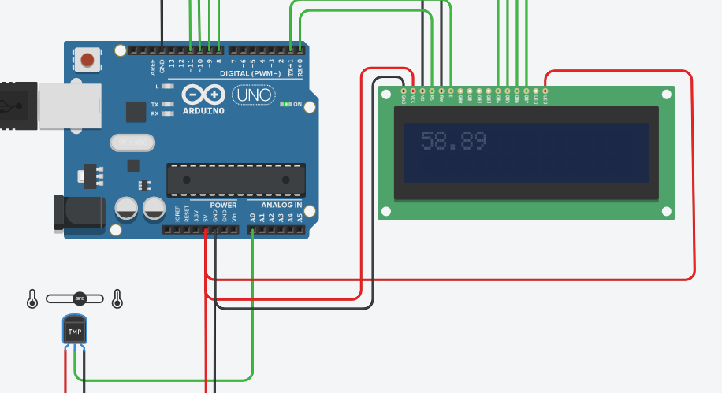

1. **Rotate the servo motor based on the value of potentiometer .**

**Components used:** Arduino Uno R3, 250 kOhm Potentiometer , micro Servo .

**Circuit:**

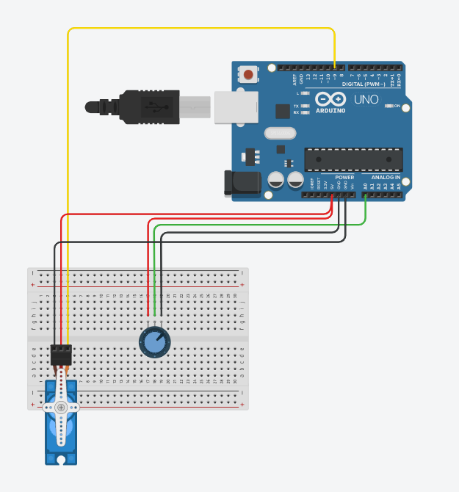

Code:

#include <Servo.h>

Servo myServo;

void setup() {

Serial.begin(9600);

myServo.attach(9);

}

void loop() {

int analogValue = analogRead(A0);

int angle = map(analogValue, 0, 1023, 0, 180);

myServo.write(angle);

Serial.print("Analog: ");

Serial.print(analogValue);

Serial.print(", Angle: ");

Serial.println(angle);

delay(100);

}

**Output :**

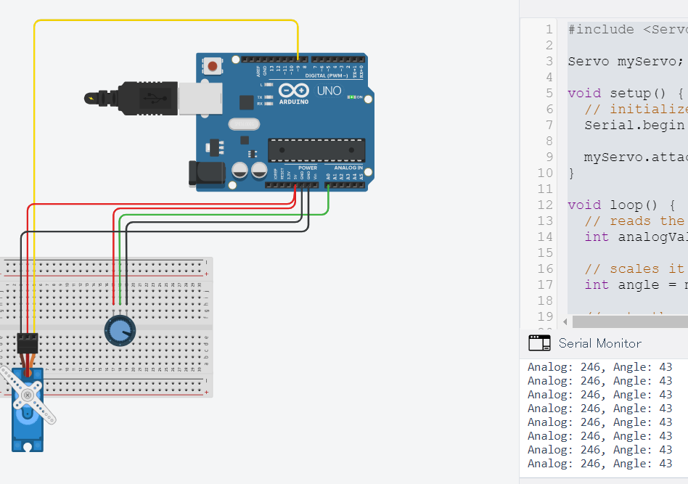

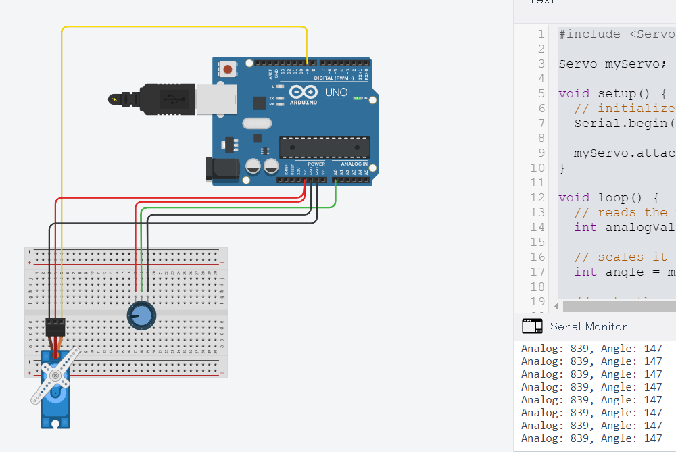

1. **Rotate the Servo motor based on the value on the value of current room temperature.**

**Components used :** Arduino Uno R3, RGB LED, Temperature Sensor, Resistor (1-Ohm) , Micro servo.

**Circuit:**

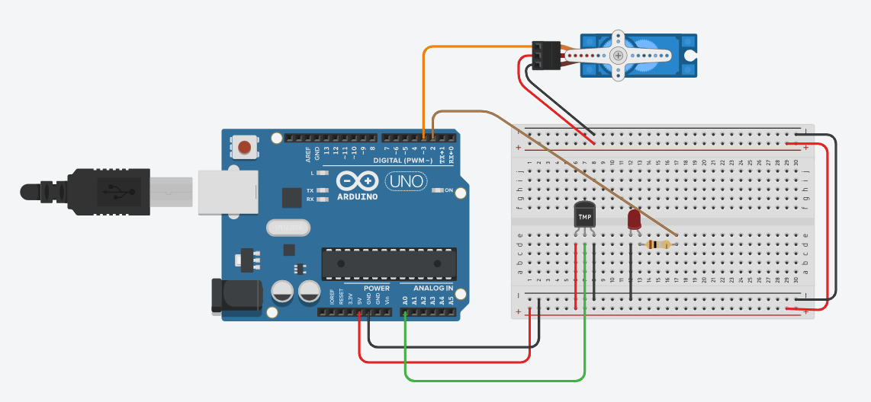

Code:

#include <Servo.h>

#define temperature A0

#define ledIndicator 2

Servo mainServo;

int position = 0;

int previousPosition;

void setup() {

pinMode(temperature, INPUT);

pinMode(ledIndicator, OUTPUT);

mainServo.attach(3);

Serial.begin(9600);

}

void loop() {

int tempReading = analogRead(temperature);

float voltage = tempReading * 5.0;

voltage /= 1024.0;

float tempC = (voltage - 0.5) * 100;

int position = map(tempC, 0, 50, 0, 180);

Serial.println(position);

if(previousPosition != position){

mainServo.write(position);

digitalWrite(ledIndicator, HIGH);

delay(1000);

}

digitalWrite(ledIndicator, LOW);

previousPosition = position;

}

**Output :**

