|  |
| --- |
| **[ Internet of things ]** |
|  |

Practical-7

**-:AIM:-**

**Raspbian Operating Installation**

Submitted By: Dharmay Sureja

Enrollment No:17012011056



**GANPAT UNIVERSITY**

**U. V. Patel College of Engineering**

**Computer Engineering Department**

**AIM:- Raspbian Operating Installation**

**Prepare Manual for Following.**

1. **Raspberry pi Architecture.**

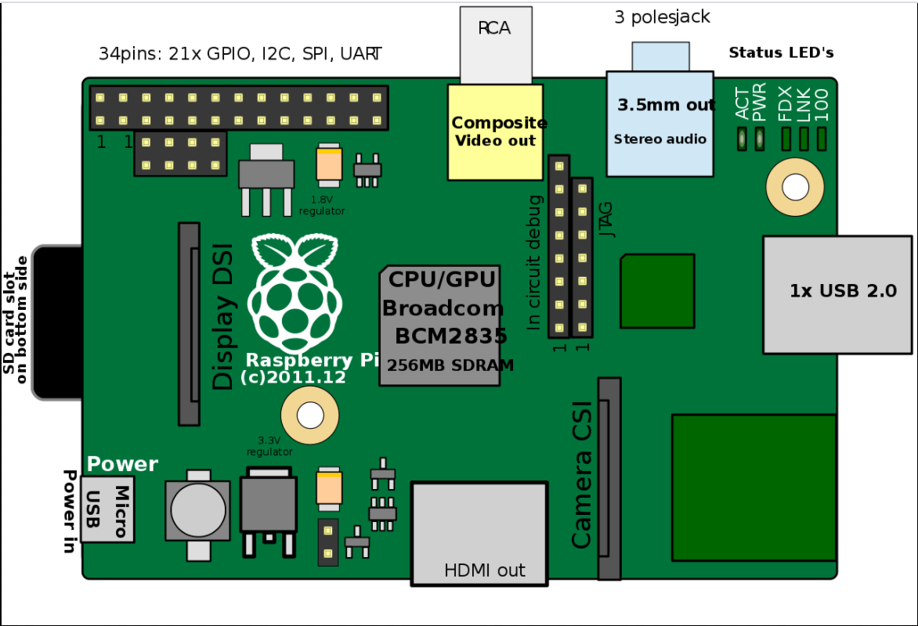

The Raspberry pi is a single computer board with credit card size, that can be used for many tasks that your computer does, like games, word processing, spreadsheets and also to play HD video.

The raspberry pi comes in two models, they are model A and model B. The main difference between model A and model B is USB port. Model A board will consume less power and that does not include an Ethernet port. But, the model B board includes an Ethernet port and designed in china.

The raspberry pi board comprises a program memory (RAM), processor and graphics chip, CPU, GPU, Ethernet port, GPIO pins, Xbee socket, UART, power source connector. And various interfaces for other external devices. It also requires mass storage, for that we use an SD flash memory card. So that raspberry pi board  will boot from this SD card similarly as a PC boots up into windows from its hard disk.

Essential hardware specifications of raspberry pi board mainly include SD card containing Linux OS, US keyboard, monitor, power supply and video cable. Optional hardware specifications  include USB mouse, powered USB hub, case, internet connection, the Model A or B: USB WiFi adaptor is used and internet connection to  Model B is LAN cable.

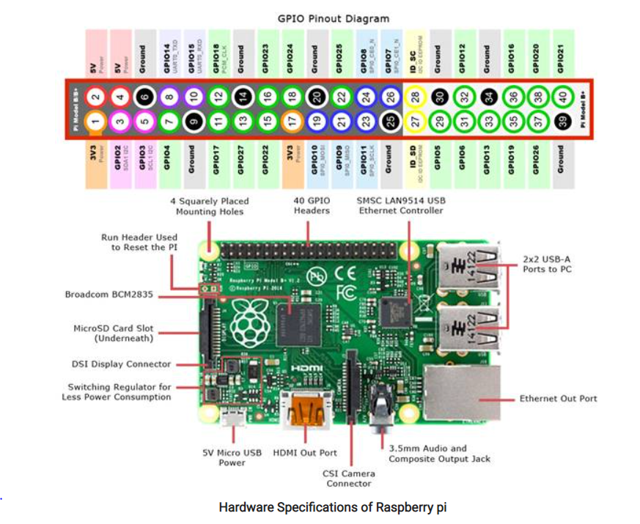

* **Memory**

The raspberry pi model Aboard is designed with 256MB of SDRAM and model B is designed with 51MB.Raspberry pi is a small size PC compare with other PCs. The normal PCs RAM memory is available in gigabytes. But in raspberry pi board, the RAM memory is available more than 256MB or 512MB.

* **CPU (Central Processing Unit)**

The Central processing unit is the brain of the raspberry pi board and that is responsible for carrying out the instructions of the computer through logical and mathematical operations. The raspberry pi uses ARM11 series processor, which has joined the ranks of the Samsung galaxy phone.

* **GPU (Graphics Processing Unit)**

The GPU is a specialized chip in the raspberry pi board and that is designed to speed up the operation of image calculations. This board designed with a Broadcom video core IV and it supports OpenGL

* **Ethernet Port**

The Ethernet port of the raspberry pi is the main gateway for communicating with additional devices. The raspberry pi Ethernet port is used  to plug your home router to access the internet.

* **GPIO Pins**

The general purpose input & output pins are used in the raspberry pi to associate with the other electronic boards. These pins can accept input & output commands based on programming raspberry pi. The raspberry pi affords digital GPIO pins. These pins are used to connect other electronic components. For example, you can connect it to the temperature sensor to transmit digital data.

* **XBee Socket**

The XBee socket is used in raspberry pi board for the wireless communication purpose.

* **Power Source Connector**

The power source cable is a small switch, which  is placed on side of the shield. The main purpose of the power source connector is to enable an external power source.

* **UART**

The Universal Asynchronous Receiver/ Transmitter is a serial input & output port. That can be used to transfer the serial data in the form of text and it is useful for converting the debugging code.

* **Display**

The connection options of the raspberry pi board are two types such as HDMI and Composite.Many LCD and HD TV monitors can be attached using an HDMI male cable and with a low-cost adaptor. The versions of HDMI are 1.3 and 1.4 are supported and 1.4 version cable is recommended. The O/Ps of the Raspberry Pi audio and video through HMDI, but does not support HDMI I/p. Older TVs can be connected using composite video. When using a composite video connection, audio is available from the 3.5mm jack socket and can be sent to your TV. To send audio to your TV, you need a cable which adjusts from 3.5mm to double RCA connectors.

Model A Raspberry Pi Board

The Raspberry Pi board  is a Broadcom(BCM2835) SOC(system on chip) board. It comes equipped with an ARM1176JZF-S core CPU, 256 MB of SDRAM and 700 MHz,. The raspberry pi USB 2.0 ports use only external data connectivity options. The board draws its power from a micro USB adapter, with min range of 2. Watts (500 MA). The graphics, specialized chip is designed to speed up the operation of image calculations. This is in built with Broadcom video core IV cable, that is useful if you want to run a game and video through your raspberry pi.

#### Features of Raspberry PI Model A

* The Model A raspberry pi features mainly includes
* 256 MB SDRAM memory
* Single 2.0 USB connector
* Dual Core Video Core IV Multimedia coprocessor
* HDMI (rev 1.3 & 1.4) Composite RCA (PAL and NTSC) Video Out
* 3.5 MM Jack, HDMI, Audio Out
* SD, MMC, SDIO Card slot on board storage
* Linux Operating system
* Broadcom BCM2835 SoC full HD multimedia processor
* 8.6cm*5.4cm*1.5cm dimensions

### Model B Raspberry pi Board

The Raspberry Pi is a Broadcom BCM2835 SOC (system on chip board). It comes equipped with a 700 MHz, 512 MB of SDRAM  and ARM1176JZF-S core CPU. The USB 2.0 port of the raspberry pi boars uses only external data connectivity options. The Ethernet in the raspberry pi is the main gateway to interconnect with other devices and the internet in model B. This draws its power from a micro USB adapter, with a minimum range of 2.5 watts(500 MA). The graphics, specialized chip is designed to speed up the manipulation of image calculations. This is in built with Broadcom video core IV cable, that is useful if you want to run a game and video through your raspberry pi.

#### Features of Raspberry PI Model B

* 512 MB SDRAM memory
* Broadcom BCM2835 SoC full high definition  multimedia processor
* Dual Core Video Core IV Multimedia coprocessor
* Single 2.0 USB connector
* HDMI (rev 1.3 and 1.4) Composite RCA (PAL & NTSC) Video Out
* 3.5 MM Jack, HDMI Audio Out
* MMC, SD, SDIO Card slot on board storage
* Linux Operating system
* Dimensions are 8.6cm*5.4cm*1.7cm
* On board 10/100 Ethernet RJ45 jack

1. **Installation of Raspbian and NOOBS Operating Systems.**

* **Install Raspbian OS**
* **Step 1: Download Raspbian**

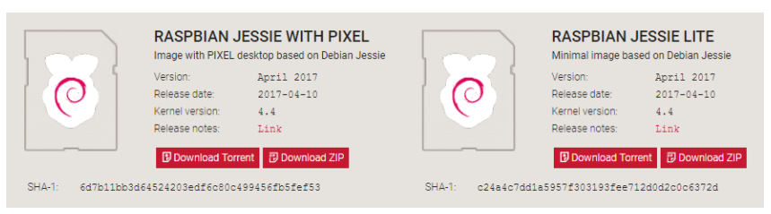

I promised to show you how to install Raspbian on the Raspberry Pi, so it’s about time that we got started! First things first: hop onto your computer (Mac and PC are both fine) and download the Raspbian disc image.

You can find the latest version of Raspbian on the Raspberry Pi Foundation’s website here.

**Link for Raspbian OS** : <https://www.raspberrypi.org/downloads/raspberry-pi-os/>

Give yourself some time for this, especially if you plan to use the traditional download option rather than the torrent. It can easily take a half hour or more to download.

* **Step 2: Unzip the file**

The Raspbian disc image is compressed, so you’ll need to unzip it. The file uses the ZIP64 format, so depending on how current your built-in utilities are, you need to use certain programs to unzip it.

* **Step 3: Write the disc image to your microSD card**

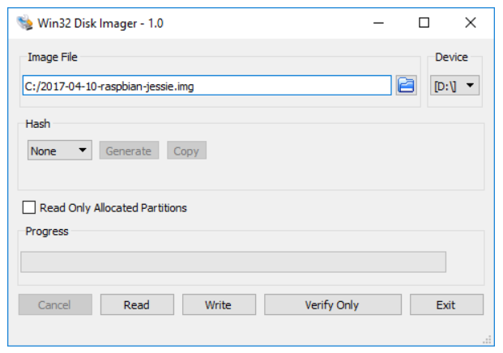

Next, pop your microSD card into your computer and write the disc image to it. You’ll need a specific program to do this:

* + Windows users, your answer is Win32 Disk Imager.
  + Mac users, you can use the disk utility that’s already on your machine.
  + Linux people, Etcher – which also works on Mac and Windows – is what the Raspberry Pi Foundation recommends.

The process of actually writing the image will be slightly different across these programs, but it’s pretty self-explanatory no matter what you’re using. Each of these programs will have you select the destination (make sure you’ve picked your microSD card!) and the disc image (the unzipped Raspbian file). Choose, double-check, and then hit the button to write.

* **Step 4: Put the microSD card in your Pi and boot up**

Once the disc image has been written to the microSD card, you’re ready to go! Put that sucker into your Rasberry Pi, plug in the peripherals and power source, and enjoy. The current edition to Raspbian will boot directly to the desktop. Your default credentials are username pi and password raspberry.

* **Install NOOBS OS**
* **Step 1: Download NOOBS and extract it**

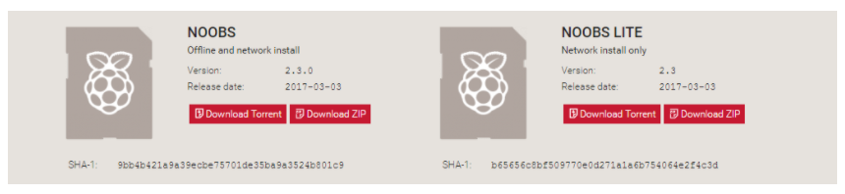

You’re going to use your computer to put NOOBS on an SD card – so step one is to get NOOBS onto your computer!

**Link for NOOBS OS :-** <https://www.raspberrypi.org/downloads/noobs/>

The NOOBS download page will let you choose between NOOBS and “NOOBS Lite.” NOOBS includes a full version of Raspbian, so you can install that particular operating system without using the internet at all. With NOOBS Lite, on the other hand, you’ll need a network connection to install any of the operating systems NOOBS makes available – even Raspbian.

Go ahead and choose whichever version you would like. NOOBS will download as a .zip file, so before you do anything else, go ahead and extract it.

* **Step 2: Format an SD card**

Now you’re going to want to go ahead and stick your SD card into the corresponding slot on your computer. You’re going to want to format it as FAT. There are a few ways to do this:

On Mac or Windows, use the [SD Association’s Formatting Tool](https://www.sdcard.org/downloads/formatter/eula_windows/) (Mac users can also just use the disk utility). Make sure the “Format size adjustment” option is set to “on.” Then erase it in FAT (or MS-DOS) format.

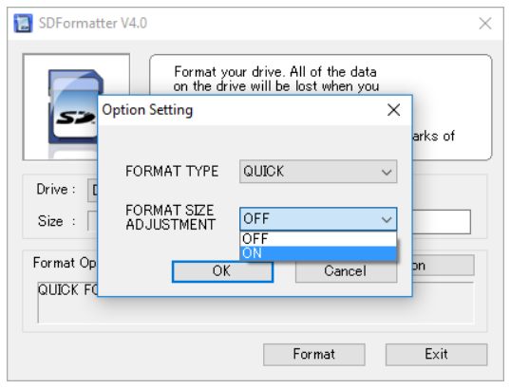

* **Step 3: Put the NOOBS files on the SD card**

Now, just drag and drop the NOOBS files into your newly formatted SD card. You want the files only, so if your .zip extracted to a folder, open that folder up and select only the stuff inside of it.

* **Step 4: Put your SD card into your Raspberry Pi and boot it up**

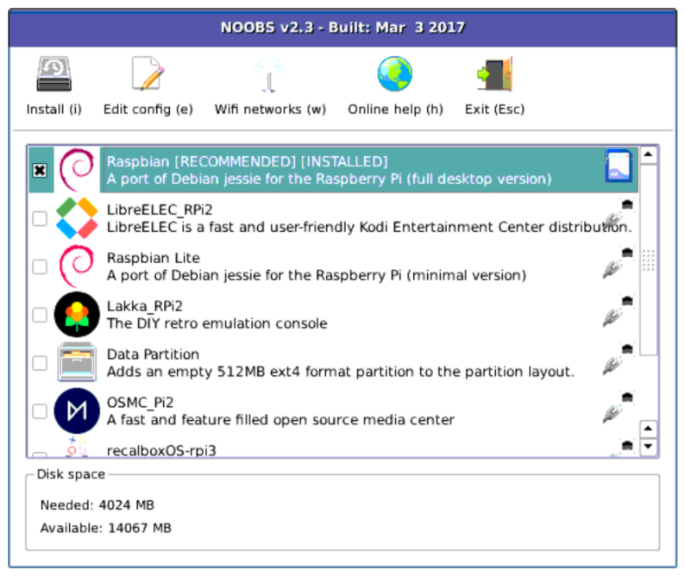

Once you have NOOBS on your SD card, using it is incredibly easy. Just put the SD card into your Raspberry Pi and start that sucker up. As we said before, while this guide is called “How to install NOOBS on the Raspberry Pi,” the endgame here is actually to install an operating system like Raspbian, LibreELEC, OSMC, or any of the others NOOBS gives you access to.

This is the step in which that happens. After booting to NOOBS, you’ll be greeted with a menu that will let you choose which operating system you’d like to install on your Pi. Your menu may look a little bit different than the one in the screenshot above, because NOOBS ingeniously adapts to your generation and model of Raspberry Pi.

1. **List of Components ( other devices and connector )**

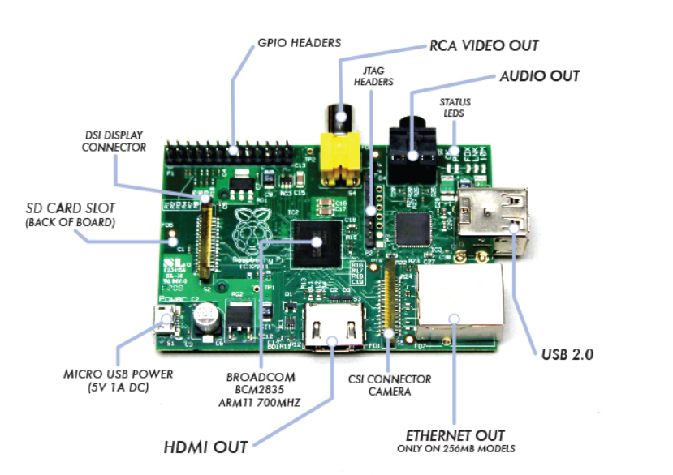

List of Components are as Below :

1. Micro-USB Power Supply
2. SD Card Slot
3. USB Ports & Ethernet Port
4. HDMI ( High Definition Multimedia Interface )
5. Video Out ( RCA Cable )
6. Status Led’s
7. GPIO ( General Purpose Input Output )
8. CSI Camera Connector
9. System On Chip ( SoC )
10. **Difference between BCM and BOARD mode.**

|  |  |
| --- | --- |
| **BOARD mode** | **BCM Mode** |
| This type of pin numbering refers to the number of the pin in the plug, i.e, the numbers printed on the board, for example, P1. | The BCM option refers to the pin by “Broadcom SOC Channel. They signify the Broadcom SOC channel designation. The BCM channel changes as the version number changes. |
| The advantage of this type of numbering is, it will not change even though the version of board changes. | The BCM channel changes as the version number changes. |
| may be safer to use the BOARD numbers if you are going to use more than one Raspberry Pi in a project. | **BCM** numbers changed between versions of the Pi1 Model B. |
| Use BCM mode in Programmatically  import RPi.GPIO as GPIO  GPIO.setmode(GPIO.BOARD) | Use BOARD mode in Programmatically  import RPi.GPIO as GPIO  GPIO.setmode(GPIO.BCM) |