|  |
| --- |
| **[ Internet of things ]** |
|  |

Practical-9

**-:AIM:-**

**Raspberry pi basic Programming with Sensors.**

Submitted By: Dharmay Sureja

Enrollment No:17012011056



**GANPAT UNIVERSITY**

**U. V. Patel College of Engineering**

**Computer Engineering Department**

**AIM:- Raspbian pi basic programming with Sensors.**

**Experiments**

1. **Display room Temperature**

**Components used :** Breadboard , LED , 4.7K Ohm Resistor , Raspberry pi , USB Cable

SD Card & Adapter , Jumper Wire , Temperature Sensor

**Circuit**:

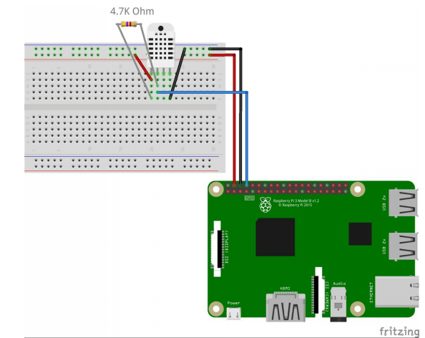

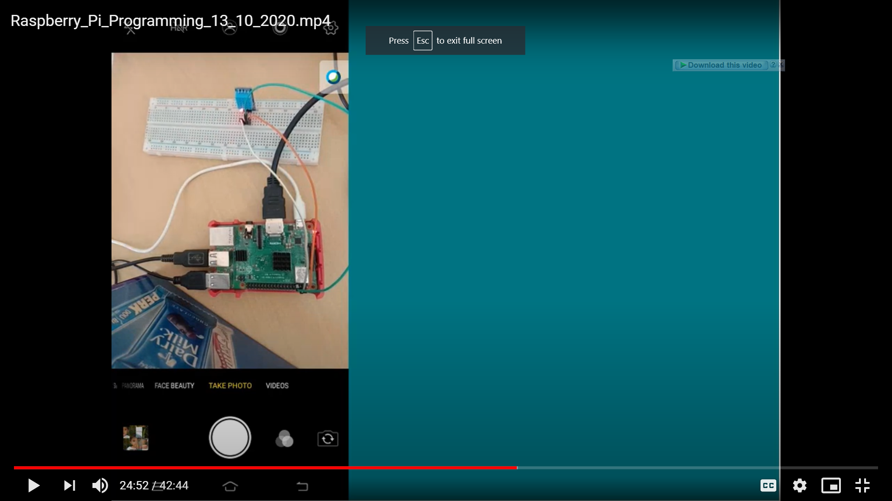

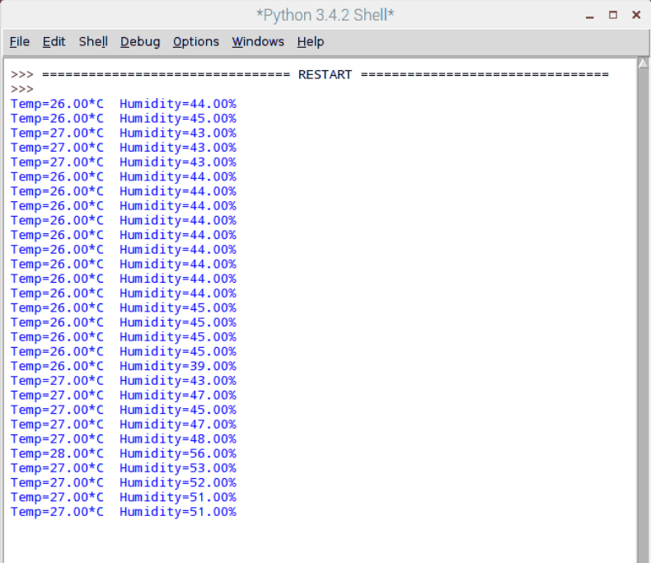

**Code** : Adafruit_DHT.py

import sys

import Adafruit_DHT

sensor_args = { '11' : Adafruit_DHT.DHT11,

'22' : Adafruit_DHT.DHT22,

'2302' : Adafruit_DHT.DHT2302

}

if lng(sys.argv) == 3 and sys.args[1] in sensor_args:

sensor = sensor_args[sys.argv[1]]

pin = sys.argv[2]

else:

print("Usage : sudo ./Adafruit_DHT.py [11|22|2302] <GPIO pin number> ")

print("Example : sudo ./Adafruit_DHT.py 2302 4 - Read From AM2302 Connected to GPIO pin #4")

sys.exit()

humidity,temperature = Adafruit_DHT.read_retry(sensor,pin)

if humidity is not None temperature is not None:

print('Temp: {0:0.1f} C Humidity: {1:0.1f} %'.format(temperature,humidity))

else:

print('Failed to get Reading. Try Again !')

sys.exit()

1. **Upload room Temperature on Cloud ( Thinspeak )**

**Code :** Adafruit_DHT.py

**import sys**

**import Adafruit_DHT**

**import RPi.GPIO as GPIO**

**import urllib2**

**myAPI = 'JR0EK9X8Z7VN2LP6'**

**baseURL = 'https://api.thingspeak.com/update?api_key=%s' % myAPI**

**GPIo.setmode(GPIO.BCM)**

**sensor_args = { '11' : Adafruit_DHT.DHT11,**

**'22' : Adafruit_DHT.DHT22,**

**'2302' : Adafruit_DHT.DHT2302**

**}**

**if lng(sys.argv) == 3 and sys.args[1] in sensor_args:**

**sensor = sensor_args[sys.argv[1]]**

**pin = sys.argv[2]**

**else:**

**print("Usage : sudo ./Adafruit_DHT.py [11|22|2302] <GPIO pin number> ")**

**print("Example : sudo ./Adafruit_DHT.py 2302 4 - Read From AM2302 Connected to GPIO pin #4")**

**sys.exit()**

**print("Starting Uplpoading Data . . .")**

**humidity,temperature = Adafruit_DHT.read_retry(sensor,pin)**

**while True:**

**try:**

**print("Uploading Tem[erature %.1f"%temperature)**

**print(baseURL + &field1=%s&field2=%s"%(temperature,humidity))**

**f = urllib2.urlopen(baseURL + &field1=%s&field2=%s"%(temperature,humidity))**

**f.close()**

**except:**

**print("Exiting .")**

**break**

1. Sign Up on www.thingspeak.com using your email id

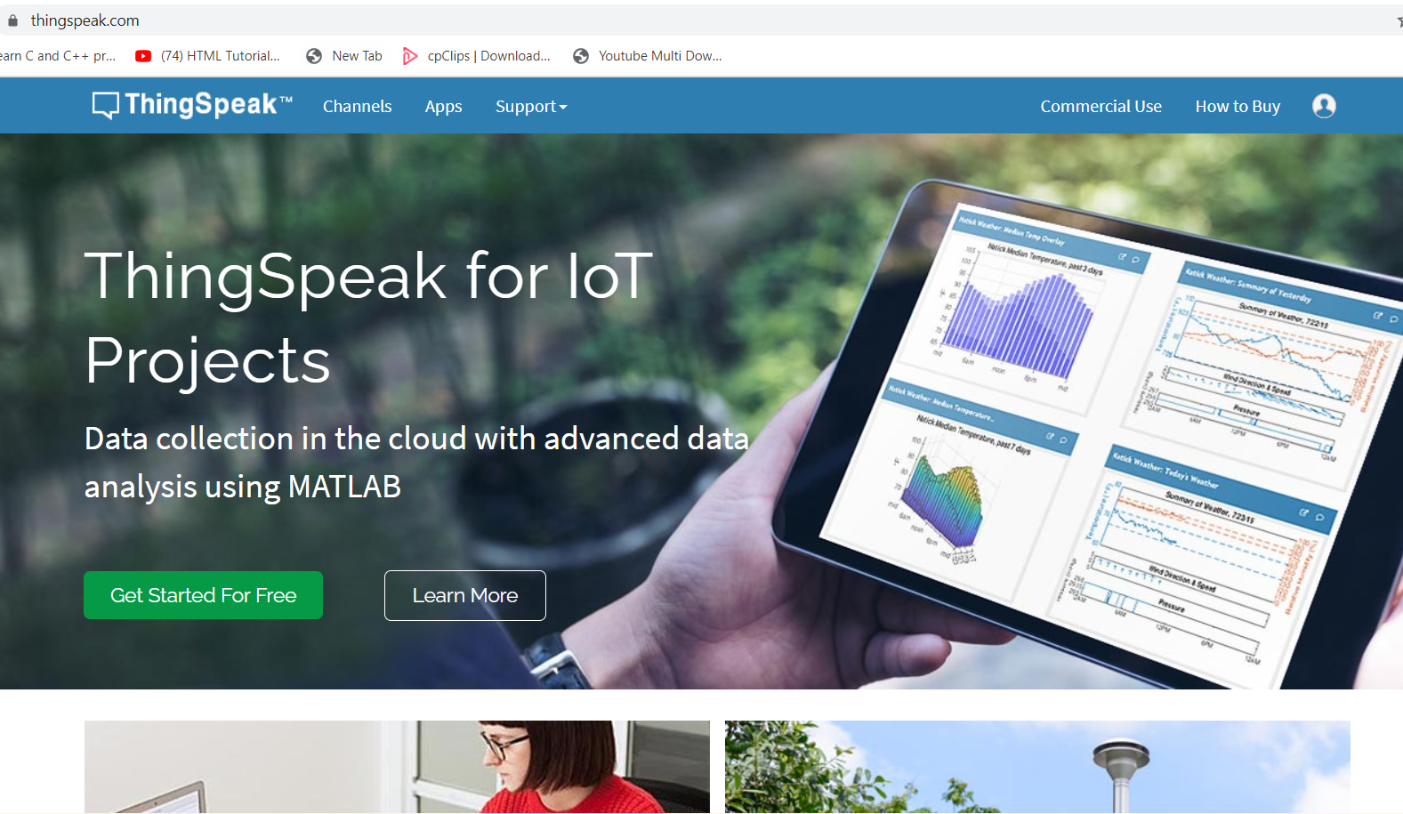

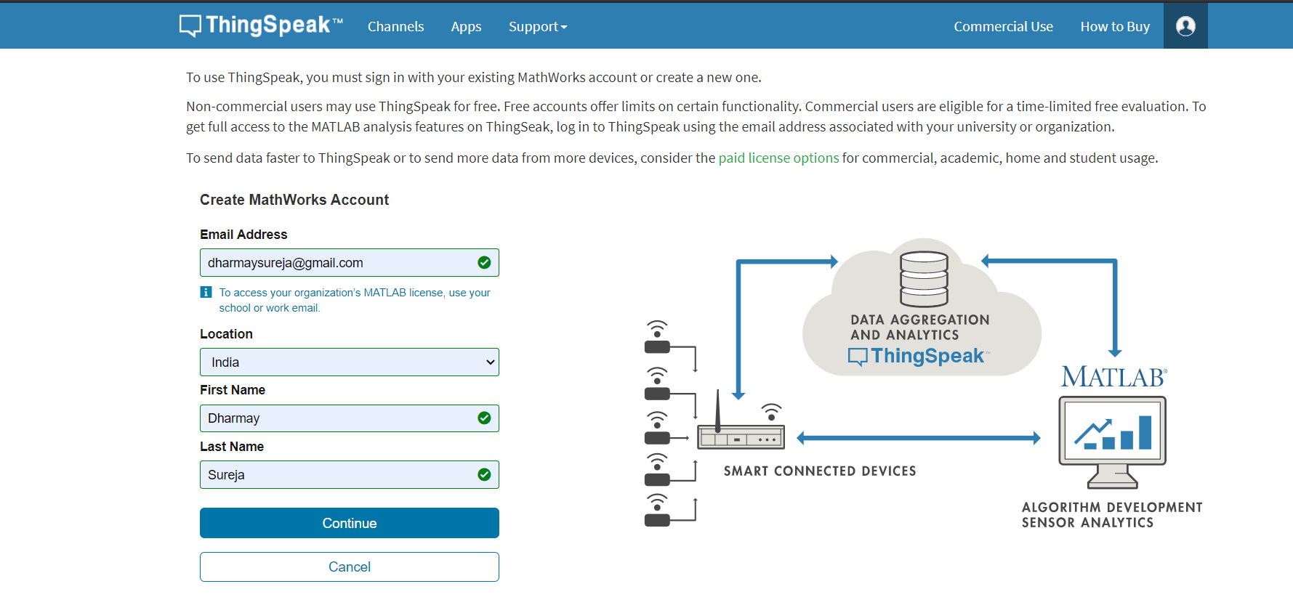

1. Make sure to click the checkbox saying "By signing up, you agree to the Terms of Use and Privacy Policy".

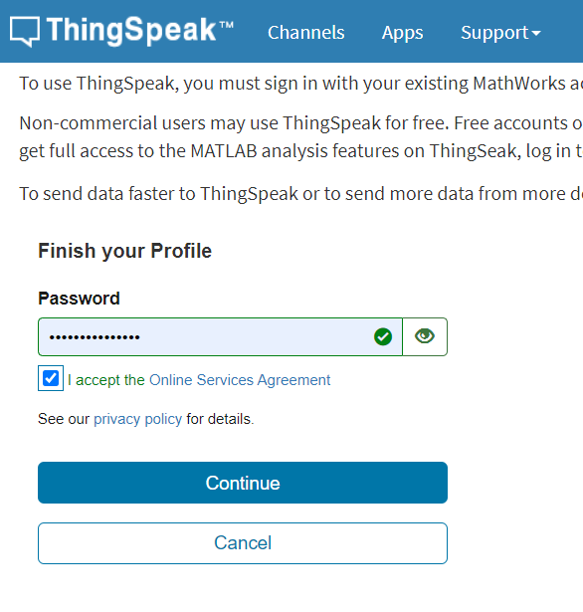

1. Goto Channels and Create a New Channel
2. Fill the following Details
3. Any Name for Your Channel
4. Description : if you have any description like “Temperature Channel”
5. Field 1 Label as “Temperature ” Since we are going to upload .
6. Save Channel

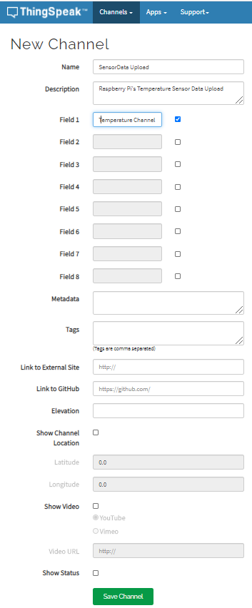

1. Saving Process might Take a While
2. Please Select Your Channel.
3. You would see tabs like
4. Private View
5. Public View
6. Channel Settings
7. API Keys
8. Data Import/Export

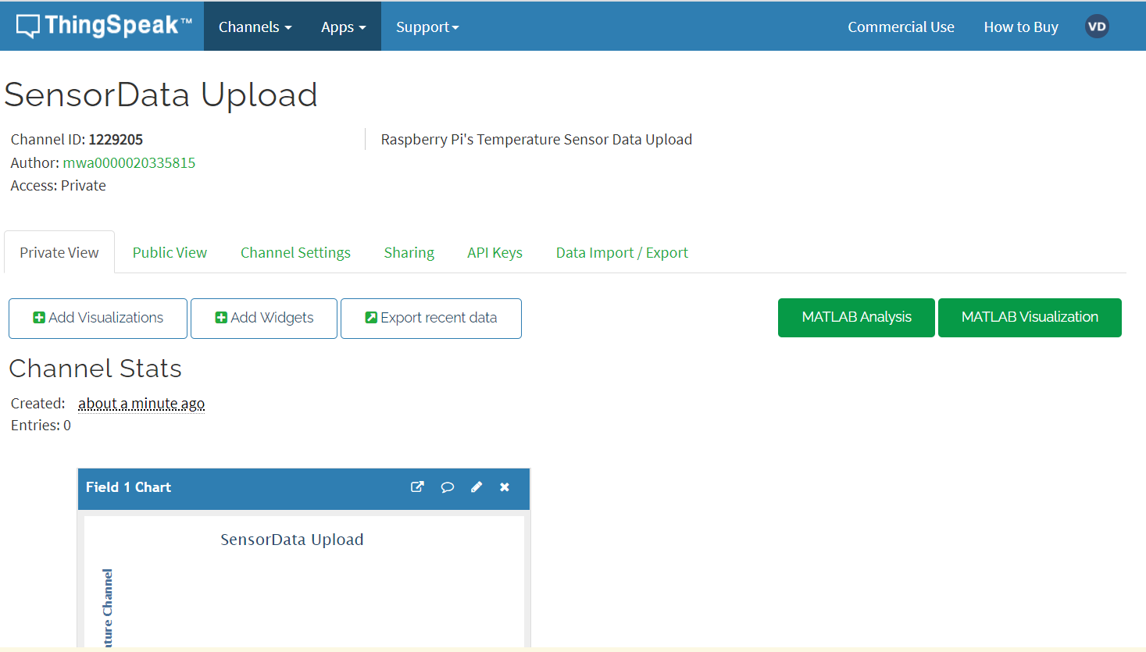

1. Click API Keys Tab
2. You will Find API Key similar to this **: “**7BMH83M0KARON75Z**”**

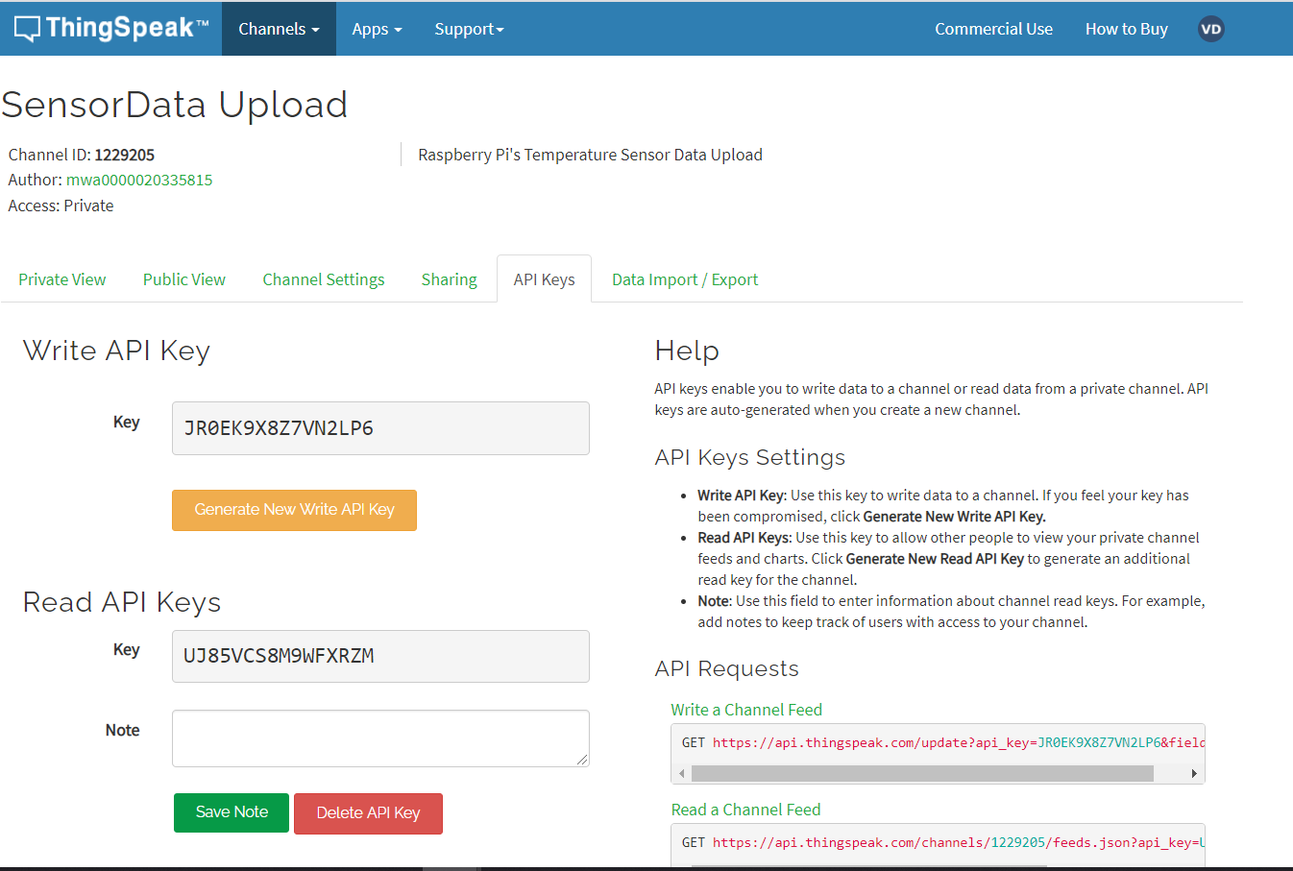

1. Please run the following commands in Your SSH Connection .

sudo python ~/Projects/temp_upload.py YOURWRITEAPIKEY

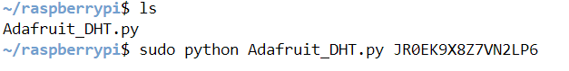

1. Once the script starts running it will upload the temperature values of the room.

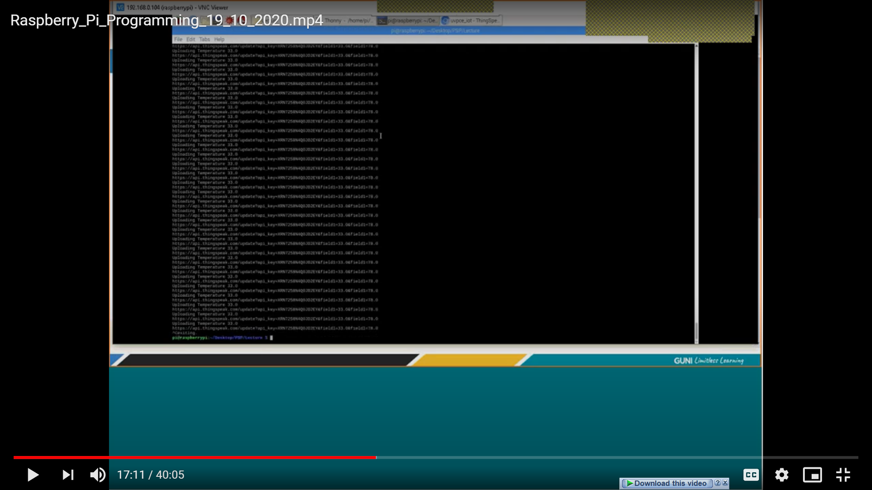

1. Click Private View Tab to see the graph with temperature vs Time

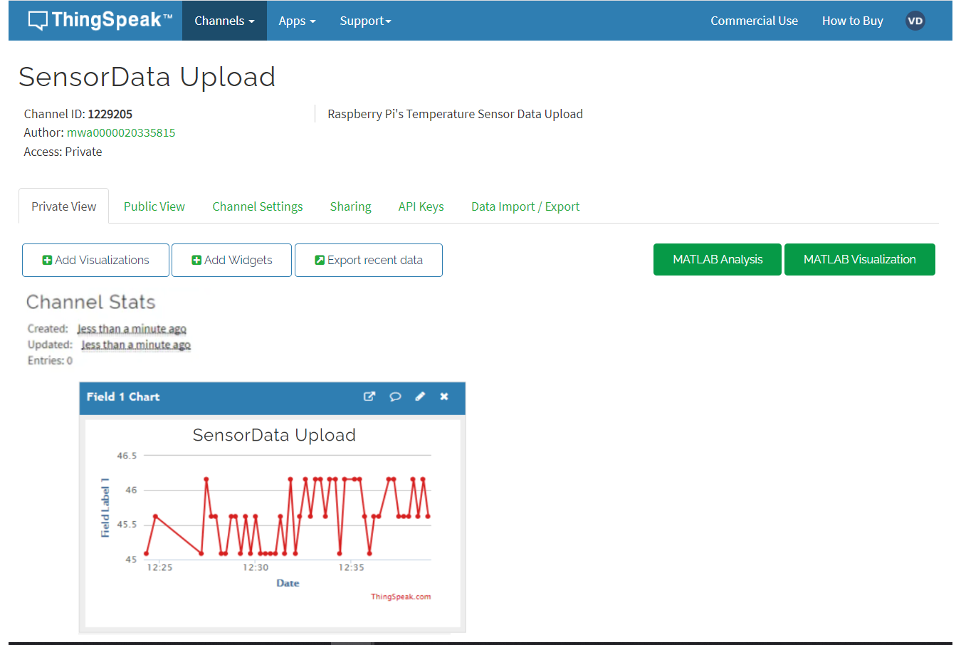

1. You can change the values by changing room temperature.