|  |
| --- |
| **[ Internet of things ]** |
|  |

Prerequisites

**-:AIM:-**

**Implementation of Program in python**

Submitted By: Dharmay Sureja

Enrollment No:17012011056



**GANPAT UNIVERSITY**

**U. V. Patel College of Engineering**

**Computer Engineering Department**

**AIM:- Implementation of Program in python**

**1 .Write a program to print following**

**“===========================”**

**Your Name**

**Your Enrollment No.**

**Branch: CE/IT**

**Age:XX**

**Email:your mail ID**

**Mobile No: your No.**

**“===========================”**

**CODE:-**

print(""" “===========================”

Dharmay Sureja

17012011056

Branch: CE

Age:20

Email:surejadharmay@gmail.com

Mobile No:9409434188.

“===========================” """)

**Output:-**

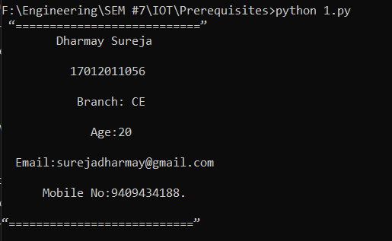

**2. Write a program to find the sum of digits of given number.**

**Code:**

a=input("enter number ")

b=list(a)

c=len(a)

c=c-1

num=0

while (c>=0):

num=num+int(b[c])

c=c-1

print("sum=",num)

Output:-

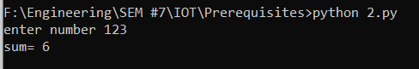

**3. Write a program to check if number is prime or not.**

**Code:-**

no=int(input("enter number= "))

i=2

flag=0

while(i<no):

if(no%i==0):

flag=1

break

i=i+1

if(flag==1):

print(no,"is not prime")

else:

print(no,"is prime")

**Output:-**

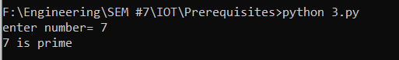

**4. Write a program that reads a number from 1 to 7 and accordingly it should display Monday to Sunday.(using if..elif)**

**CODE:-**

no=int(input("enter number= "))

if(no==1):

print("sunday")

elif(no==2):

print("monday")

elif(no==3):

print("tuesday")

elif(no==4):

print("wednesday")

elif(no==5):

print("thursday")

elif(no==6):

print("friday")

elif(no==7):

print("saturday")

else:

print("number is unacceptable")

**Output:-**

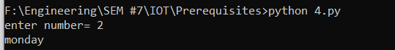

**5. Write a python code to replace a substring of given length with new substring**

**CODE:**

l1=list(input("enter String= "))

a=int(input("enter starting range of substring "))

b=int(input("enter ending range of substring "))

l2=list(input("Enter replacing substring "))

i=a

j=0

while(i<b):

l1[i]=l2[j]

j+=1

i+=1

j=0

while(j<len(l1)):

print(l1[j],end="")

j+=1

**Output:-**

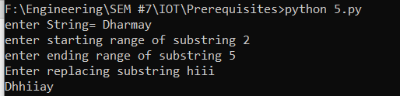

**6. WAP which takes five subject marks from user store in list , find average & display it on screen with appropriate message.**

**CODE:-**

i=0

l=[]

sum=0

while(i<5):

print("enter marks for subject ",i)

a=int(input())

l.append(a)

sum=sum+a

i=i+1

avg=sum/5

print("average is= ",avg)

if (avg >= 90):

print("Excellent Marks")

elif (avg >= 80):

print("very Good")

elif (avg >= 60):

print("Average")

elif (avg >= 45):

print("Not Bad")

elif (avg >= 30):

print("Try Hard next time")

else:

print("FAIL")

**Output:-**

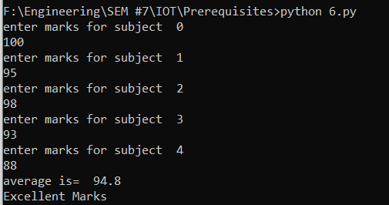

**7.**  **WAP which take one string as input convert it in list , reverse it & check for palindrome using list functions.**

**CODE:-**

l1=list(input("enter String values "))

l2=[]

for data in l1:

l2.append(data)

l1.reverse()

if(l1==l2):

print("list is palindrome")

else:

print("Not palindrome")

**Output:-**

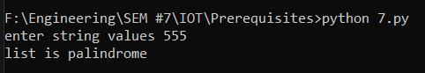

**8. WAP which takes comma separated string from user & store each string which separated by comma in list & display list.**

**CODE:-**

s1=input("Enter the strings separated by comma : ")

l1=list(s1.split(','))

print("The entered strings are : ")

for k in l1:

print(k)

**Output:-**

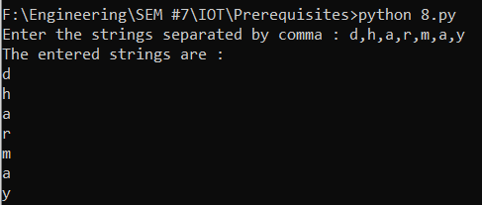

**9. Write a user defined function to find Armstrong numbers within given range.**

**CODE:-**

def arm(n1,n2):

#print("In function")

a=[]

i=n1

while(i<=n2):

sum1=0

j=i

while(j>0):

sum1+=(j%10)**3

j=j//10

if(sum1==i):

a.append(i)

i+=1

print("Armstrong numbers in the range from ",n1," to ",n2," is:")

for k in a:

print(k)

n1=int(input("Enter the starting of the range :"))

n2=int(input("Enter the ending of the range :"))

arm(n1,n2)

**OUTPUT:-**

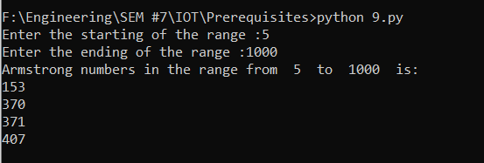

**10.** **WAP which takes 4 arguments, representing name & scores of player from 3 judges. The function should determine and display the name, bottom, top, and average score.**

**CODE:-**

def score_summary(name,m1,m2,m3):

sc=[m1,m2,m3]

mini=min(sc)

maxi=max(sc)

avg=(m1+m2+m3)/3

return (name,maxi,mini,avg)

name=input("Enter name :")

m1=float(input("Enter score from 1st judge :"))

m2=float(input("Enter score from 2nd judge :"))

m3=float(input("Enter score from 3rd judge :"))

name,maxi,mini,avg=score_summary(name,m1,m2,m3)

print(name," : Max ",maxi," , Min ",mini," ,Average ",avg)

**OUTPUT:-**

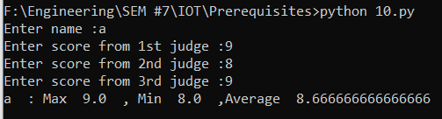

**11.** **WAP which takes user input to prepare hindi-english dictionary & print Content of dictionary in last.**

**CODE:-**

dict1={}

no=int(input("Enter how many values you want to enter in dictionary :"))

i=0

while(i<no):

hn=input("Enter hindi word : ")

en=input("Enter english meaning : ")

dict1[hn]=en

i+=1

formatting='{:7s} {:7s}'

for (hindi,eng) in dict1.items():

print("The word :{:7s}'s meaning is :{:7s}".format(hindi,eng))

input()

**OUTPUT:-**

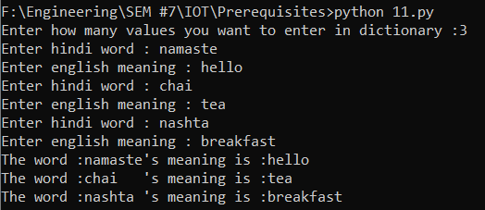

**12.** **Write a program which stores user inputted 5 students data (like enrollment No.,Name, Age,email) in text file & display it from file**

**CODE:-**

i=0

ob=open("pr6tx.txt",'w+')

ob.write("Information of Student : \n")

frm='{:<9s} {:<16s} {:<5s} {:<21s}'+"\n"

ob.write(frm.format("Enr no.","Name","Age","Email id"))

while(i<5):

enr=input("Enter Enrollment no. : ")

nm=input("Enter name : ")

age=input("Enter age : ")

em=input("Enter email : ")

ob.write(frm.format(enr,nm,age,em))

i+=1

ob.close()

ob=open("pr6tx.txt",'r')

for line in ob:

print(line)

ob.close()

**OUTPUT:-**

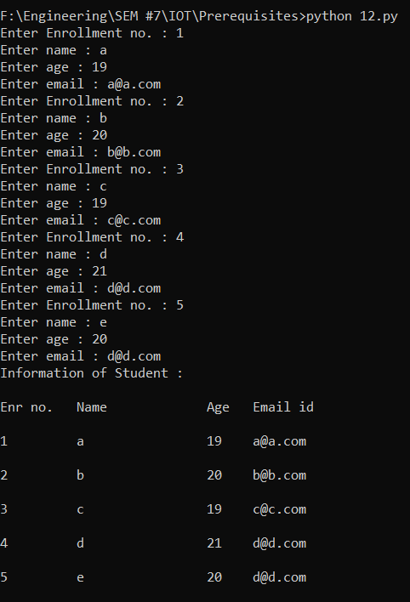

**13.** **Write a program which stores user inputted 5 students’ data (like enrollment No., Name, Age, email etc…) in sqlite database & display it by retrieving from database.**

**CODE:-**

import sqlite3

def adddata() :

e_no = int(input("Enter student Enrollment no: "))

name = input("Enter student Name: ")

pwd = input("Enter student Password: ")

age = int(input("Enter student Age: "))

email = input("Enter student Email: ")

add = input("Enter student Address: ")

try :

qry = "INSERT INTO STUINFO(EN_NO,NAME,PASSWORD,AGE,EMAIL,ADDRESS) VALUES (%d,'%s','%s',%d,'%s','%s')"%(e_no,name,pwd,age,email,add)

conn.execute(qry)

conn.commit()

print("Data inserted Successfully!!")

except :

print("Data already exists!!")

def deldata(conn) :

e_no = int(input("Enter student Enrollment no which you want to delete: "))

try :

conn.execute("DELETE from STUINFO where EN_NO=%d;"%(e_no))

conn.commit()

print("Data deleted Successfully!!")

except :

print("Data not exists!!")

def updatedata(conn) :

e_no = int(input("Enter student Enrollment no: "))

name = input("Enter student New Name: ")

pwd = input("Enter student New Password: ")

age = int(input("Enter student New Age: "))

email = input("Enter student New Email: ")

add = input("Enter student New Address: ")

try :

conn.execute("UPDATE STUINFO set NAME = '%s',PASSWORD = '%s',AGE = %d,EMAIL = '%s',ADDRESS = '%s' where EN_NO = %d"%(name,pwd,age,email,add,e_no))

conn.commit()

print("Data updated Successfully!!")

except :

print("Data not exists!!")

def searchdata(conn) :

e_no = int(input("Enter student Enrollment no: "))

formatting = " {:3} {:10} {:10} {:3} {:30} {:50} "

try :

cur = conn.cursor()

cur.execute("SELECT * from STUINFO where EN_NO = %d"%(e_no))

i = cur.fetchone()

print(formatting.format("ENO","NAME","PASSWORD","AGE","EMAIL","ADDRESS"))

#print("\n")

print(formatting.format(i[0],i[1],i[2],i[3],i[4],i[5]))

except :

print("Data not exists!!")

def disdata(conn) :

formatting = " {:3} {:10} {:10} {:3} {:30} {:50} "

try :

cursor = conn.execute("SELECT * from STUINFO")

print(formatting.format("ENO","NAME","PASSWORD","AGE","EMAIL","ADDRESS"))

#print("\n")

for i in cursor :

print(formatting.format(i[0],i[1],i[2],i[3],i[4],i[5]))

except :

print("Data not exists!!")

conn = sqlite3.connect("studentinfo.db")

print("Opened database successfully")

try :

conn.execute('''CREATE TABLE STUINFO

(EN_NO INT PRIMARY KEY NOT NULL,

NAME TEXT NOT NULL,

PASSWORD CHAR(10) NOT NULL,

AGE INT NOT NULL,

EMAIL CHAR(30),

ADDRESS CHAR(50))''')

print("Table Created successfully!!")

except :

print("Table aleady Created!!")

y=1

while y == 1 :

choice = int(input("\n1.Add Data 2.Delete Data 3.Update Data 4.Search Data 5.Display Data : "))

if choice == 1 :

adddata()

elif choice == 2 :

deldata(conn)

elif choice == 3 :

updatedata(conn)

elif choice == 4 :

searchdata(conn)

elif choice == 5 :

disdata(conn)

else :

print("choose appropiate choice!!")

y = int(input("\n1.continue 2.Exit : "))

conn.close()

**OUTPUT:-**

