**Ex:1**

**a)**

This is divided into three stages:

The initial stage is to fully characterize the data needs of the database users. You need to ask the client as often as possible about what needs may arise, and you need to consider everything yourself.

The second step is to choose a data model. Applying the concept of the chosen data model, translate the requirements from the initial step into a conceptual database schema. You need to draw it all on paper and on special online sites to visualize how everything will turn out. And you need to describe the types of operations that will be performed on the data.

The final step is to move from the abstract data model to the database implementation. We need to decide which database schema we are going to use. We have to choose a proper and good design. And make the database schema such that if you need to change / add / delete something, it would be convenient.

**b)** An entity relationship model (or ER model) describes the interrelated entities of interest in a particular domain of knowledge. The basic ER model consists of entity types (which classify objects of interest) and defines the relationships that can exist between entities (instances of these entity types).

**Ex:2**

**a)**

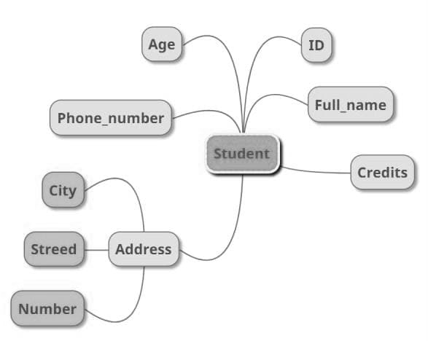

**b)**

|  |
| --- |
| **Student** |
| name |
| university_name |
| faculty |
| id |
| course_id |

|  |
| --- |
| **University** |
| name |
| address |
| Rating |

|  |
| --- |
| **Office_registrator** |
| Address |
| Room_number |
| Employee_number |

|  |
| --- |
| **Course** |
| faculty |
| title |
| course_id |

|  |
| --- |
| **Teacher** |
| Name |
| Salary |
| ID |

|  |
| --- |
| **Dormitory** |
| Address |
| Repaired_or_not |
| cost |

|  |
| --- |
| **Advisor** |
| Student_id |
| Teacher_id |

**Ex:3**

a) One – to – one relationship

ID

has

student

b) One – to – many relationship

assigned

order

customer

c) Many – to – one relationship

college

student

study

b) Many – to – many relationship

assigned

project

student

**Ex:4**

a)

|  |  |
| --- | --- |
| **Table** | |
| PK | S_id |
| FK | First_name  Last_name  Birth_of_date  Phone_number_id |

|  |  |
| --- | --- |
| **Phone_numbers** | |
| PK | Phone_number_id |
|  | number |

b)

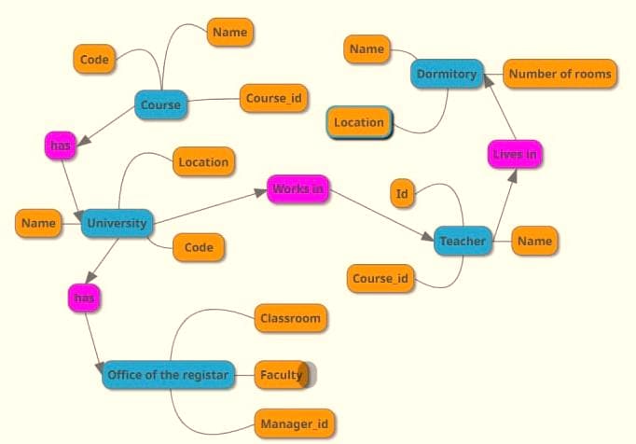

**Ex:5**

|  |  |
| --- | --- |
| **CompanyINFO** | |
| PK | Company_id |
| FK | Name  Location_id |

|  |  |
| --- | --- |
| **Location** | |
| PK | Location_id |
|  | name |

|  |  |
| --- | --- |
| **Employee** | |
| PK | Employee_id |
| FK  FK | Gender  Birth_of_date  Phone_number_id  First_name  Last_name  Company_id  Phone_number_id |

|  |  |
| --- | --- |
| **Works on** | |
| PK, FK | Employee_id |
| PK, FK | Project_id |

|  |  |
| --- | --- |
| **Phone numbers** | |
| PK | Phone_number_id |
|  | Phone_number |

|  |  |
| --- | --- |
| **Project** | |
| PK | Project_id |
| FK | Name  Company_id |