



Programing with Java

## Arrays snacks - Check Out App

(c) Property of Semicolon Village Limited. All rights reserved by the company.





* Y o u h a v e b e e n h i r e d t o d e v e l o p a n ecommerce checkout system for Semicolon Store. The store sells a variety of products, and each product has a name and a price.
* Implement a checkout system for the store that allows the cashier do the following:

1. Enter each product details in the user’s cart - Product and quantity purchased.
2. Displays customers invoice.
3. Computes total, discount and VAT of 7.5% of total price.

(c) Property of Sem2icolon Village Limited. All rights reserved by the company.

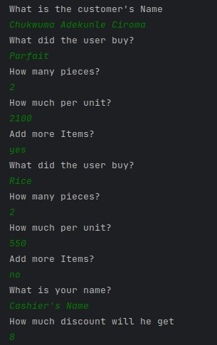



# Sample Input

(c) Property of Sem3icolon Village Limited. All rights reserved by the company.

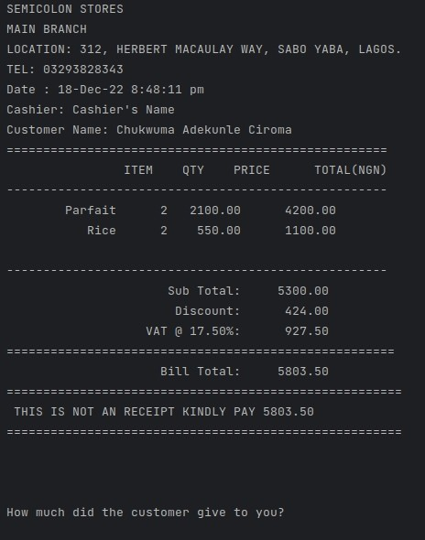



# Sample Output

(c) Property of Sem4icolon Village Limited. All rights reserved by the company.





# Sample Input

(c) Property of Sem5icolon Village Limited. All rights reserved by the company.

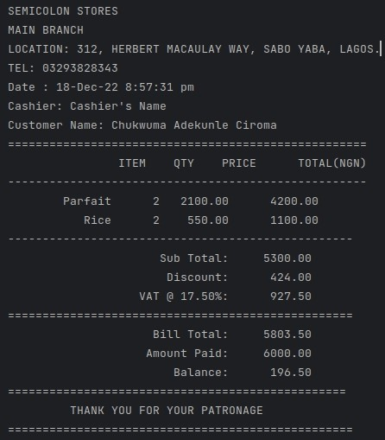



# Sample Output

(c) Property of Sem6icolon Village Limited. All rights reserved by the company.





## Submission instruction:

Add to your existing git repository and send link.

(c) Property of Sem7icolon Village Limited. All rights reserved by the company.





Season greetings!

(c) Property of Sem8icolon Village Limited. All rights reserved by the company.