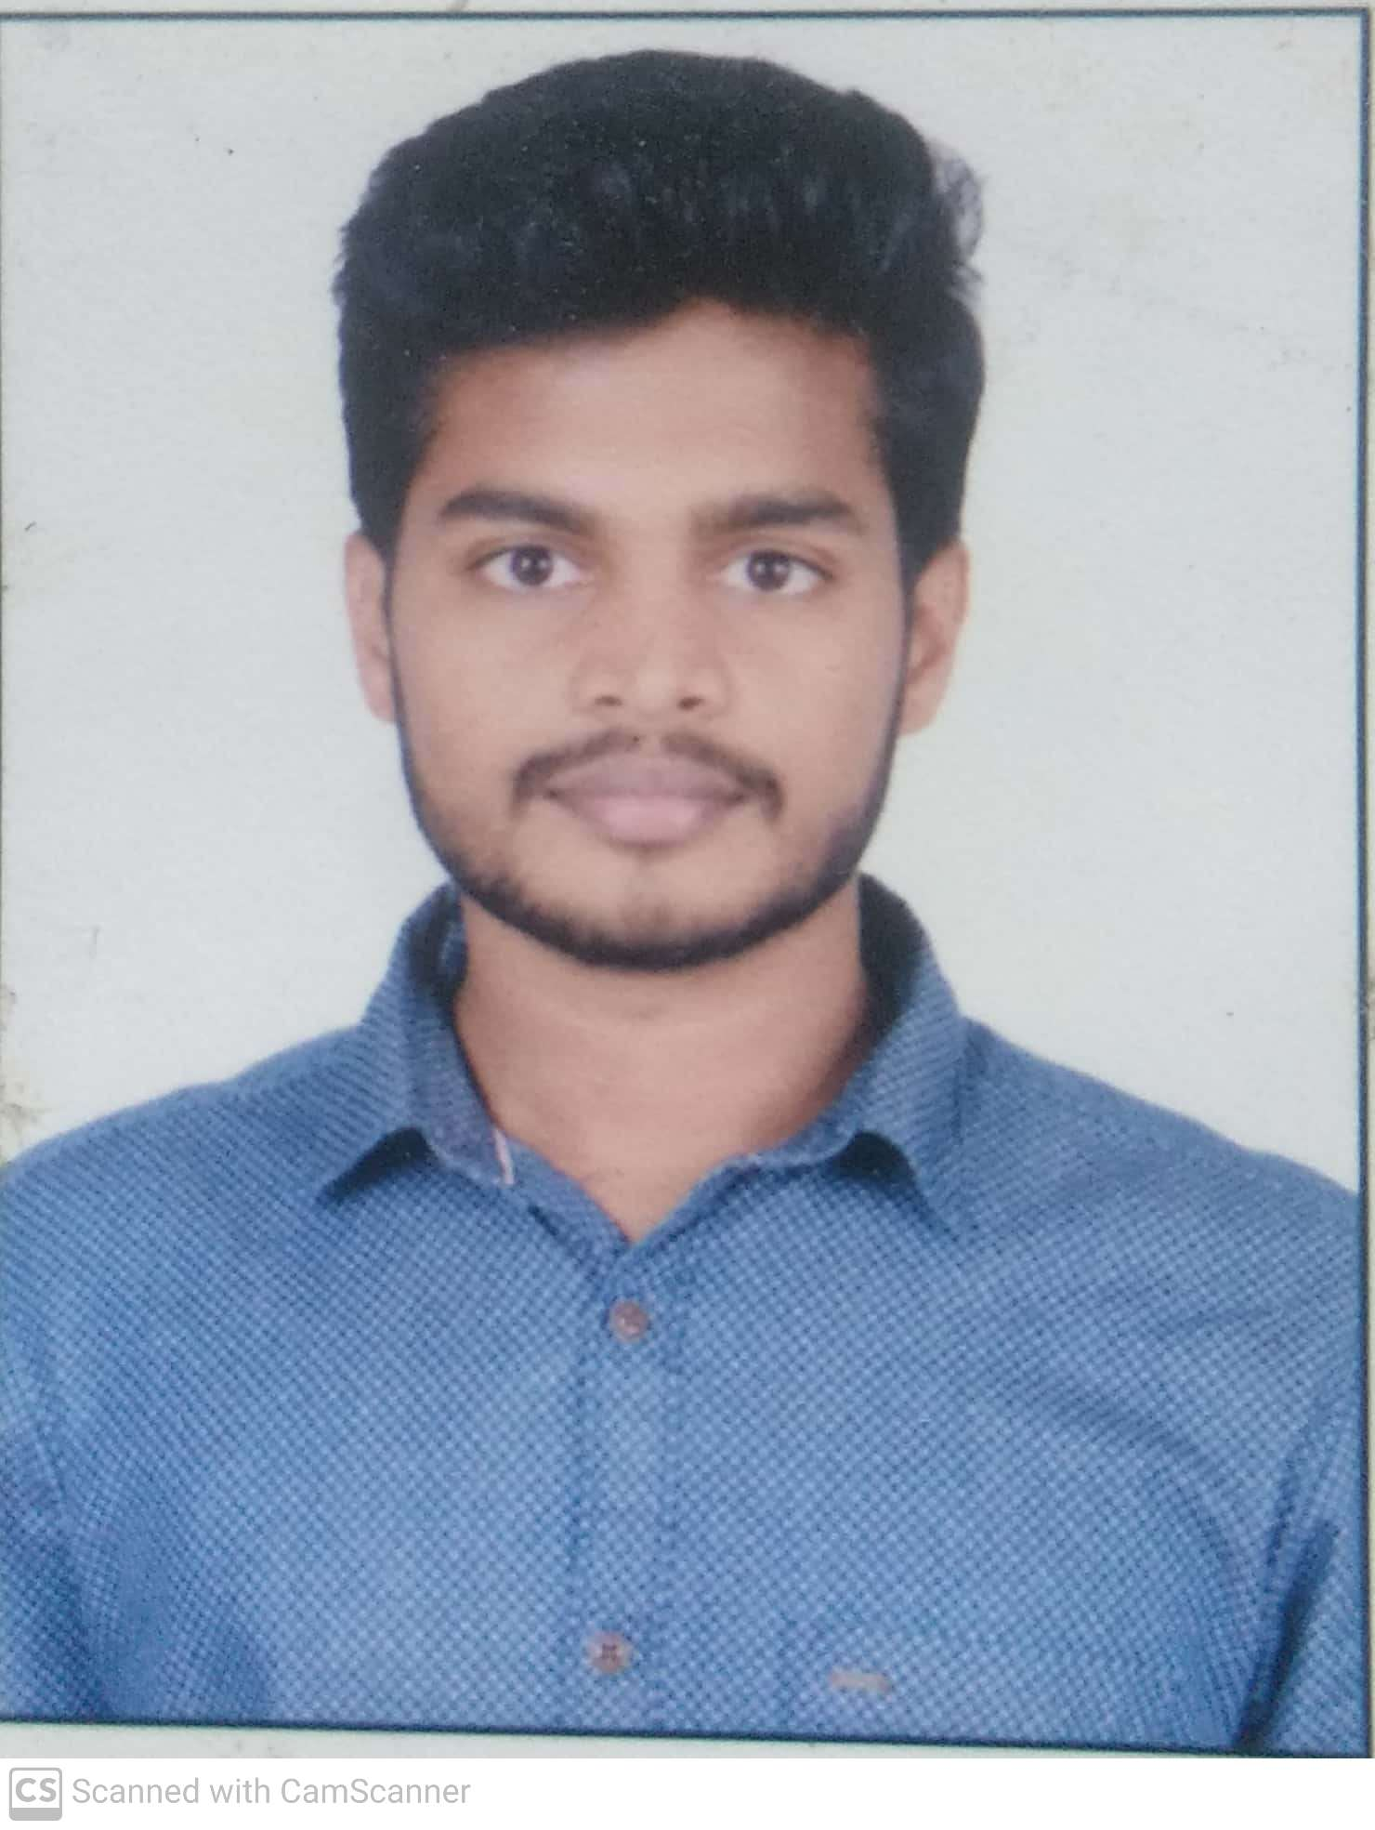

adesh | 8623725804 | adeshpadwal21@gmail.com

# About Me

bjbfdkjdsabd

# Work Experience

**ugam solutions** *jan-mar*khkjwhxhfdjvegcbfjhdgfsdhjcfsdjhfgewjf

# Skills

* c cpp java python javascript angular github git boostraphtml5 css3