**CHAPTER FOUR**

**PRESENTATION AND ANALYSIS OF RESULTS**

**4.0 INTRODUCTION**

In this section, we present the results of the time series analysis of the data used in this study. Here, we make use of three time series models which are: Autoregressive Integrated Moving Average(ARIMA), Artificial Neural Network (ANN) and the combined of ARIMA-ANN model. The data modelled are the Naira-Dollar exchange rate, Naira-Euro exchange rate and the Naira pounds exchange rate and they span from January 2001 to March 2023. The data was obtained from the publication of Central Bank of Nigeria. The analysis is sectioned into explanatory data analysis, Unit root test, ARIMA modelling, ANN modelling, ARIMA-ANN modelling, model performance comparison and lastly the conclusion.

**4.1 EXPLORATORY DATA ANALYSIS**

In this section, we show the descriptive statistics of Naira-Dollar, Naira-Euro and Naira -Pounds exchange rate data and also perform the time plot of the data.

4.1.1 DESCRIPTIVE STATISTICS

Tables 4.1 below shows the mean and standard deviation of the variables (Naira-Dollar, Naira-Euro and Naira -Pounds) that was examined in this research. Table 4.1 shows the mean, standard deviation, minimum, maximum and coefficient of variation of the data.

**Table 4.1: Descriptive Analysis for the Exchange rate**

|  |  |  |  |
| --- | --- | --- | --- |
| **Descriptive** | **Naira-Dollar** | **Naira-Euro** | **Naira-Pounds** |
| Mean | 210.29 | 250.53 | 307.58 |
| CI. Mean 0.95 | 2.78 | 2.92 | 2.98 |
| Median | 155.74 | 207.69 | 250.33 |
| Standard Deviation | 102.59 | 107.50 | 109.74 |
| Var | 10524.60 | 11557.19 | 12043.87 |
| Coef of var | 0.49 | 0.43 | 0.36 |
| SE.mean | 1.42 | 1.49 | 1.52 |
| Range | 348.65 | 494.01 | 422.80 |
| Minimum | 112.85 | 150.73 | 160.58 |
| Maximum | 461.50 | 509.74 | 583.37 |
| Sum | 1098769.16 | 137017.55 | 1605591.28 |
| Count | 5225 | 5217 | 5220 |

From table 4.1 above, Naira-Dollar, Naira-Euro and Naira -Pounds has mean of 210.29, 250.53 and 307.58 respectively. The table also shows that the minimum and maximum values of the three aforementioned variables in this study are 112.85 and 461.50, 150.73 and 509.74, 160.58 and 583.37 respectively.

4.1.2 TIME PLOT

Time plot shows the movement over time of a particular variable. Below is the time plot of the exchange rate variables which span from 2001 to 2023. From the time plot, we observed fluctuations and inconsistent movement from 2001 to 2023.

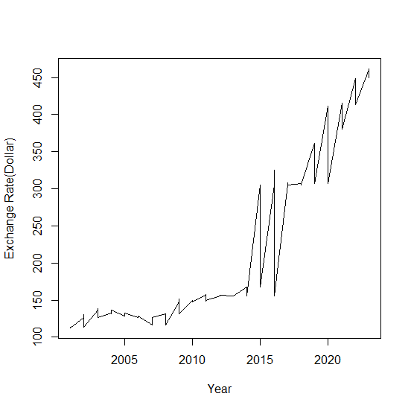

*Fig 4.1: Time plot for Naira - Dollar Exchange rate*

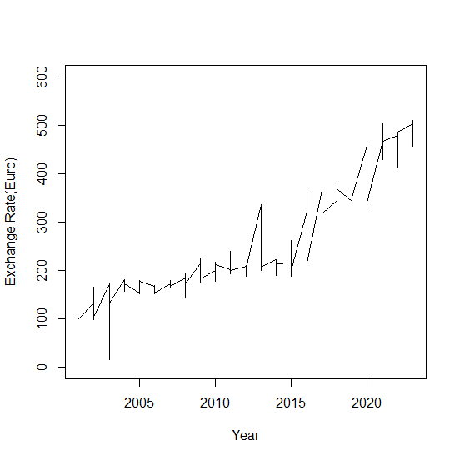

*Fig 4.1: Time plot for Naira - Euro Exchange rate*

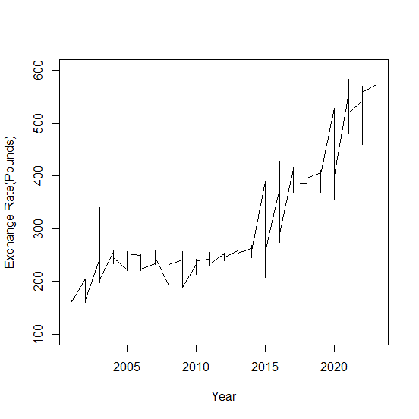

*Fig 4.3: Time plot for Naira - Pound Exchange rate*

Figures 4.1, 4.2 and 4.3 above shows the time plot of Naira-Dollar, Naira-Euro and Naira-Pounds respectively. The plot shows irregular movements from 2001 to 2023. It also shows a hike of drastic increase from 2015.

**4.2 UNIT ROOT TEST**

Unit root test is a test to show the stationarity status of our data. Augumented Dickey-Fuller test statistic and Philip-Perron are the unit root test approaches used to test for the stationarity of our variables. The result below shows that Naira-Euro is stationary after showing a significant p-value of 0.02192 and 0.01 at 5% level of significance for Augumented Dickey-Fuller test statistic and Philip-Perron unit root test. Philip-Perron unit root test also shows stationarity for Naira-Pounds with p-value of 0.02345 at 5% level of significance.

**Table 4.2: Adf anf PP tests for Naira-Dollar**

|  |  |  |  |
| --- | --- | --- | --- |
|  | statistic | Lag | P-value |
| ADF | -2.8056 | 17 | 0.2372 |
| PP | -17.057 | 10 | 0.1587 |

Table 4.3: Adf anf PP tests for Naira-Euro

|  |  |  |  |
| --- | --- | --- | --- |
|  | statistic | Lag | P-value |
| ADF | -3.7407 | 17 | 0.02192 |
| PP | -29.605 | 10 | 0.01 |

Table 4.4: Adf anf PP tests for Naira-Pounds

|  |  |  |  |
| --- | --- | --- | --- |
|  | statistic | Lag | P-value |
| ADF | -3.3158 | 17 | 0.06789 |
| PP | -25.238 | 10 | 0.02345 |

The results of the two unit-root tests are reported above. At the 1 per cent significance level, the results of the ADF unit root test suggest that Naira-Euro and Naira Pounds variables are integrated of order one, *I* (1) process. The absolute value of the ADF test is greater than the absolute critical value at 1%. Hence, they are stationary. However, the PP and ADF unit root tests exhibit that all variables are stationary at the first difference at 1% and 5% significant level except for Naira-Dollar variable. As noted in the earlier section, the ADF test often has weak power when the sample size of a study is small, so the use of the results provided by PP unit root tests is preferred, for this reason, we surmised that the variables could be well characterized as *I* (1) process.

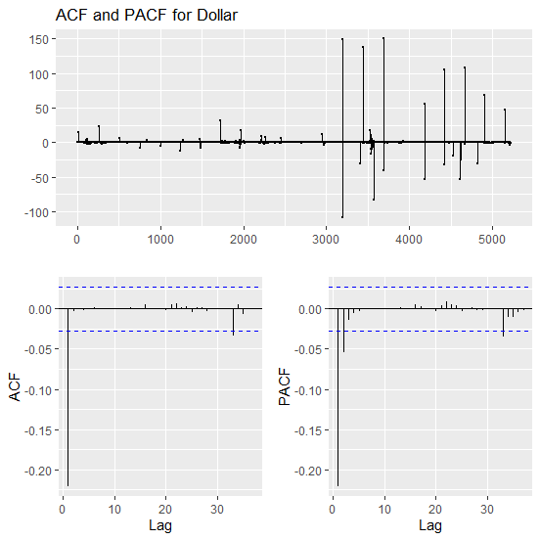

*Fig 4.4: ACF and PACF for Naira - Pound Exchange rate*

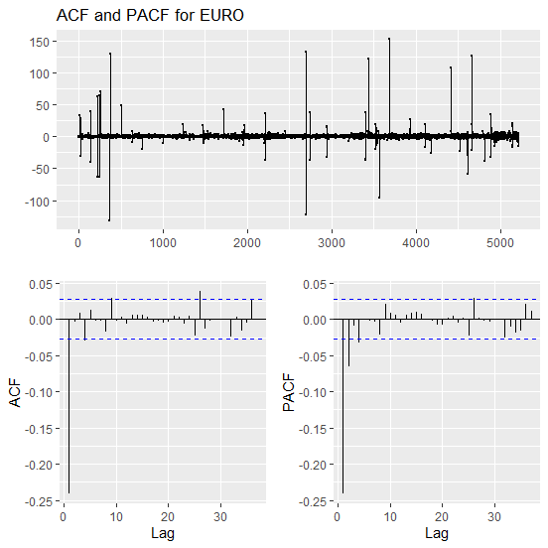

*Fig 4.5: ACF and PACF for Naira - Euro Exchange rate*

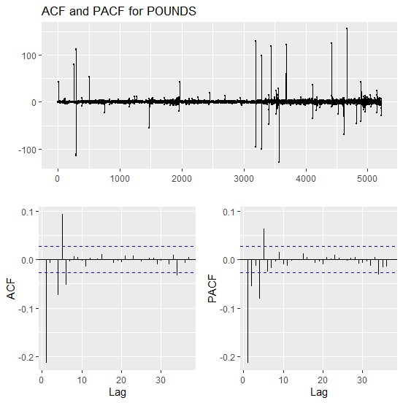

*Fig 4.6: ACF and PACF for Naira - Pounds Exchange rate*

**4.3 ARIMA RESULT**

In this section, we present the result of the Autoregressive Integrated Moving Average(ARIMA) of the Naira-Dollar, Naira-Euro and Naira-Pounds exchange rate for Nigeria.

**4.3.1 ARIMA results for Naira - Dollar exchange rate**

The suggested ARIMA results for Naira - Dollar exchange rate is presented in Table 4.5 below with their respective AIC values. The order with the lowest AIC shall be considered the best for the exchange rate variable.

Table 4.5: Different ARIMA parameters for Dollar

|  |  |
| --- | --- |
| ARIMA | AIC |
| ARIMA(2,1,2)(1,0,1)[12] with drift | 30144.1 |
| ARIMA(0,1,0) with drift | 30401.8 |
| ARIMA(1,1,0)(1,0,0)[12] with drift | 30152.47 |
| ARIMA(0,1,1)(0,0,1)[12] with drift | 30130.67 |
| ARIMA(0,1,0) | 30400.54 |
| ARIMA(0,1,1) with drift | 30128.67 |
| ARIMA(0,1,1)(1,0,0)[12] with drift | 30142.7 |
| ARIMA(0,1,1)(1,0,1)[12] with drift | 30144.7 |
| ARIMA(1,1,1) with drift | 30131.6 |
| ARIMA(0,1,2) with drift | 30130.6 |
| ARIMA(1,1,0) with drift | 30146.5 |
| ARIMA(1,1,2) with drift | 30133.62 |
| **ARIMA(0,1,1)** | **30128.01** |
| ARIMA(0,1,1)(1,0,0)[12] | 30142.02 |
| ARIMA(0,1,1)(0,0,1)[12] | 30130.01 |
| ARIMA(0,1,1)(1,0,1)[12] | 30144.03 |
| ARIMA(1,1,1) | 30130.96 |
| ARIMA(0,1,2) | 30129.96 |
| ARIMA(1,1,0) | 30145.66 |
| ARIMA(1,1,2) | 30132.97 |

From Table 4.5 above, it could be deduce that the Naira-Dollar exchange rate is best modelled with ARIMA(0,1,1) with the smallest AIC value of 30131.31. This shall be the ARIMA model which shall be used for the prediction of Naira-Dollar exchange rate

**Table 4.6: ARIMA estimate for the Naira-Dollar exchange rate**

|  |  |  |
| --- | --- | --- |
|  | Coefficients | s.e. |
| ma1 | 0.2384 | 0.0138 |

|  |
| --- |
| sigma^2 estimated as 135.6: log likelihood=-809.18 |
| AIC=30131.31 AICc=30131.31 BIC=30144.35 |

Training set error measures:

|  |  |  |  |  |  |  |  |
| --- | --- | --- | --- | --- | --- | --- | --- |
|  | ME | RMSE | MAE | MPE | MAPE | MASE | ACF1 |
| Training set | 0.80779 | 4.9248 | 0.4151 | 0.01162 | 0.1772 | 0.1494 | 0.000488 |

Table 4.6 above shows the estimate value of the Naira-Dollar exchange rate. It produces MA1 with coefficient value of 0.2384 and standard deviation 0f 0.0138. It also shows its RMSE, MAE and MAPE values to be 4.9248, 0.4151 and 0.1772 respectively. Figure 4.7 below shows the residual plot of the model with the ACF and PACF plots.

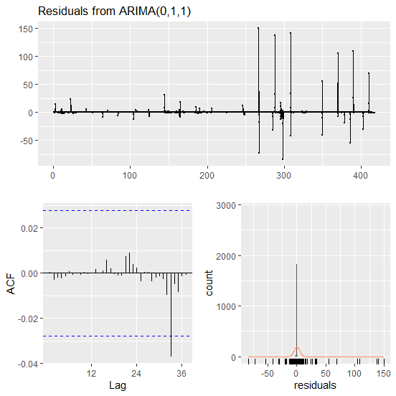

*Fig 4.7: Residual plot for ARIMA(0,1,1) of Naira - Dollar Exchange rate*

**4.3.2 Forecast of ARIMA(0,1,1) for Naira-Dollar exchange rate**

Table 4.7 below shows the forecast table for the Naira-Dollar exchange rate. It shows the actual, predicted, error values and the error percent. Figure 4.8 shows the forecast plot of the Naira-Dollar exchange rate using ARIMA(0,1,1) as the model for prediction.

**Table 4.7: Forecast of ARIMA(0,1,1) for Naira-Dollar exchange rate**

|  |  |  |  |
| --- | --- | --- | --- |
| Actual | Predicted | Error | Error_Percent |
| 420.83 | 421 | 0.17 | 0.00 |
| 420.46 | 421 | 0.54 | 0.00 |
| 419.89 | 421 | 1.11 | 0.00 |
| 419.72 | 421 | 1.28 | 0.00 |
| 419.37 | 421 | 1.63 | 0.00 |
| 419.19 | 421 | 1.81 | 0.00 |
| 418.47 | 421 | 2.53 | 0.01 |
| 418.07 | 421 | 2.93 | 0.01 |
| 417.48 | 421 | 3.52 | 0.01 |
| 417.19 | 421 | 3.81 | 0.01 |
| 418.90 | 421 | 4.10 | 0.01 |

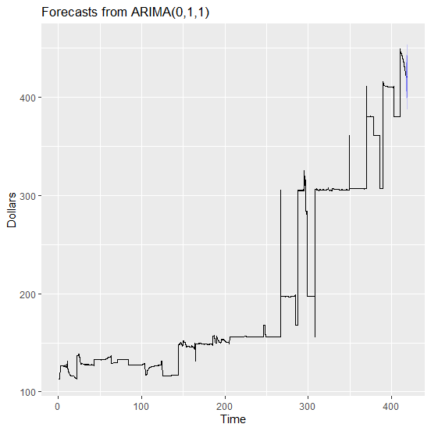

*Fig 4.8: Forecast plot for ARIMA(0,1,1) of Naira - Dollar Exchange rate*

**4.3.3 ARIMA results for Naira - Euro exchange rate**

The suggested ARIMA results for Naira - Euro exchange rate is presented in Table 4.8 below with their respective AIC values. The order with the lowest AIC shall be considered the best for the exchange rate variable.

Table 4.8: Different ARIMA parameters for Naira-Euro

|  |  |
| --- | --- |
| ARIMA | AIC |
| ARIMA(2,1,2)(1,0,1)[12] with drift | 32471.9 |
| ARIMA(0,1,0) with drift | 32817.19 |
| ARIMA(1,1,0)(1,0,0)[12] with drift | 32499.78 |
| ARIMA(0,1,1)(0,0,1)[12] with drift | 32491.28 |
| ARIMA(0,1,0) | 32815.7 |
| ARIMA(2,1,2)(0,0,1)[12] with drift | 32499.17 |
| ARIMA(2,1,2)(1,0,0)[12] with drift | 32482.15 |
| ARIMA(2,1,2)(2,0,1)[12] with drift | 32461.93 |
| ARIMA(2,1,2)(2,0,0)[12] with drift | 32459.92 |
| ARIMA(1,1,2)(2,0,0)[12] with drift | 32456.98 |
| ARIMA(1,1,2)(1,0,0)[12] with drift | 32479.17 |
| ARIMA(1,1,2)(2,0,1)[12] with drift | 32458.98 |
| ARIMA(1,1,2)(1,0,1)[12] with drift | 32468.91 |
| ARIMA(0,1,2)(2,0,0)[12] with drift | 32479.94 |
| ARIMA(1,1,1)(2,0,0)[12] with drift | 32454.98 |
| ARIMA(1,1,1)(1,0,0)[12] with drift | 32477.22 |
| ARIMA(1,1,1)(2,0,1)[12] with drift | 32456.99 |
| ARIMA(1,1,1)(1,0,1)[12] with drift | 32466.9 |
| ARIMA(0,1,1)(2,0,0)[12] with drift | 32477.99 |
| ARIMA(1,1,0)(2,0,0)[12] with drift | 32476.67 |
| ARIMA(2,1,1)(2,0,0)[12] with drift | 32457.36 |
| ARIMA(0,1,0)(2,0,0)[12] with drift | 32798.8 |
| ARIMA(2,1,0)(2,0,0)[12] with drift | 32457.65 |
| **ARIMA(1,1,1)(2,0,0)[12]** | **32453.83** |
| ARIMA(1,1,1)(1,0,0)[12] | 32476.04 |
| ARIMA(1,1,1)(2,0,1)[12] | 32455.84 |
| ARIMA(1,1,1)(1,0,1)[12] | 32465.82 |
| ARIMA(0,1,1)(2,0,0)[12] | 32476.7 |
| ARIMA(1,1,0)(2,0,0)[12] | 32475.35 |
| ARIMA(2,1,1)(2,0,0)[12] | 32456.25 |
| ARIMA(1,1,2)(2,0,0)[12] | 32455.82 |
| ARIMA(0,1,0)(2,0,0)[12] | 32797.14 |
| ARIMA(0,1,2)(2,0,0)[12] | 32478.66 |
| ARIMA(2,1,0)(2,0,0)[12] | 32456.45 |
| ARIMA(2,1,2)(2,0,0)[12] | 32458.78 |

From Table 4.8 above, it could be deduce that the Naira-Euro exchange rate is best modelled with ARIMA(0,1,1)ARIMA(1,1,1)(2,0,0)[12] with the smallest AIC value of 32497.99. This shall be the model which shall be used for the prediction of Naira-Euro exchange rate

**Table 4.9: ARIMA estimate for the Naira-Euro exchange rate**

|  |  |  |  |  |
| --- | --- | --- | --- | --- |
|  | ar1 | ma1 | sar1 | sar2 |
| estimate | 0.0123 | -0.2732 | -0.0034 | 0.0009 |
| s.e. | NaN | NaN | NaN | 0.0164 |

|  |
| --- |
| sigma^2 estimated as 38.93: log likelihood=-16244  AIC=32497.99 AICc=32498 BIC=32530.58 |

|  |  |  |  |  |  |  |  |
| --- | --- | --- | --- | --- | --- | --- | --- |
|  | ME | RMSE | MAE | MPE | MAPE | MASE | ACF1 |
| Training set | 0.08862 | 6.2364 | 1.6205 | -0.1493 | 0.8718 | 0.2528 | -0.00027 |

Table 4.9 above shows the estimate value of the Naira-Euro exchange rate. It produces ARIMA(1,1,1)(2,0,0)[12] model with coefficients value of 0.0123, -0.2732, -0.0034 and 0.0009 for ar1, ma1, sar1 and sar2 respectively. It also shows its RMSE, MAE and MAPE values to be 6.2364, 1.6205 and 0.8718 respectively. Figure 4.9 below shows the residual plot of the model with the ACF and PACF plots.

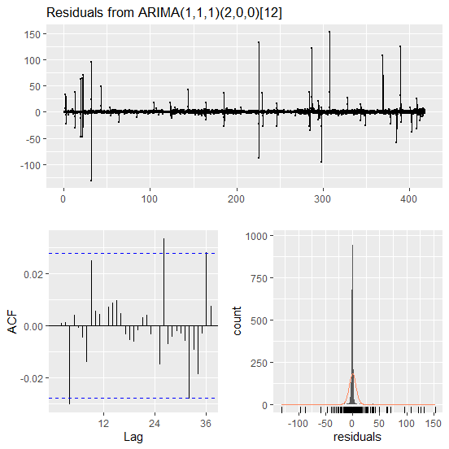

*Fig 4.9: Residual plot for ARIMA(1,1,1)(2,0,0)[12]*  *of Naira - Euro Exchange rate*

**4.3.4 Forecast of ARIMA(1,1,1)(2,0,0)[12] for Naira-Euro exchange rate**

Table 4.7 below shows the forecast table for the Naira-Euro exchange rate. It shows the actual, predicted, error values and the error percent. Figure 4.10 shows the forecast plot of the Naira-Euro exchange rate using ARIMA(1,1,1)(2,0,0)[12] as the model for prediction.

**Table 4.10: Forecast of ARIMA(1,1,1)(2,0,0)[12] for Naira-Euro exchange rate**

|  |  |  |  |
| --- | --- | --- | --- |
| Actual | Predicted | Error | Error_Percent |
| 426.6185 | 426 | -0.6185 | 0.00 |
| 426.4887 | 426 | -0.4887 | 0.00 |
| 424.3469 | 426 | 1.6531 | 0.00 |
| 421.3248 | 426 | 4.6752 | 0.01 |
| 422.1994 | 426 | 3.8006 | 0.01 |
| 421.6330 | 426 | 4.3670 | 0.01 |
| 425.3947 | 426 | 2.6002 | 0.00 |
| 423.3998 | 426 | 2.6002 | 0.01 |
| 423.9513 | 426 | 2.0487 | 0.00 |
| 423.7740 | 426 | 2.2260 | 0.01 |
| 426.4126 | 426 | -0.4126 | 0.00 |
| 421.9579 | 426 | 4.0421 | 0.01 |

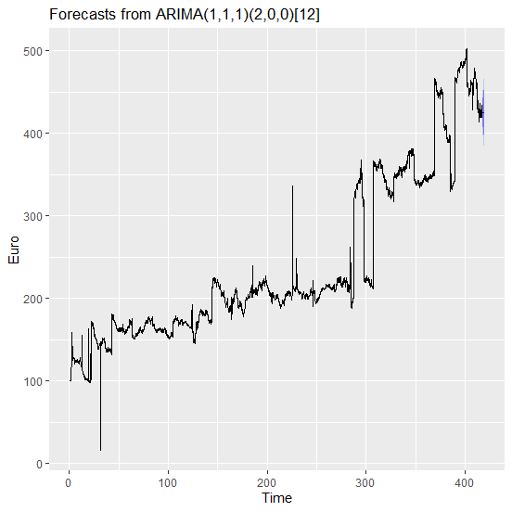

*Fig 4.10: Forecast plot for ARIMA(1,1,1)(2,0,0)[12] of Naira - Euro Exchange rate*

**4.3.5 ARIMA results for Naira - Pounds exchange rate**

The suggested ARIMA results for Naira - Pounds exchange rate is presented in Table 4.11 below with their respective AIC values. The order with the lowest AIC shall be considered the best for the exchange rate variable.

Table 4.11: Different ARIMA parameters for Naira-Pounds

|  |  |
| --- | --- |
| ARIMA | AIC |
| ARIMA(2,1,2)(1,0,1)[12] with drift | 33276.6 |
| ARIMA(0,1,0) with drift | 33552.57 |
| ARIMA(1,1,0)(1,0,0)[12] with drift | 33291.34 |
| ARIMA(0,1,1)(0,0,1)[12] with drift | 33301.67 |
| ARIMA(0,1,0) | 33551.06 |
| ARIMA(2,1,2)(0,0,1)[12] with drift | 33304.54 |
| ARIMA(2,1,2)(1,0,0)[12] with drift | 33274.6 |
| ARIMA(2,1,2) with drift | 33302.6 |
| ARIMA(2,1,2)(2,0,0)[12] with drift | 33288.12 |
| ARIMA(2,1,2)(2,0,1)[12] with drift | 33290.16 |
| ARIMA(1,1,2)(1,0,0)[12] with drift | 33275.43 |
| ARIMA(2,1,1)(1,0,0)[12] with drift | 33272.77 |
| ARIMA(2,1,1) with drift | 33300.59 |
| ARIMA(2,1,1)(2,0,0)[12] with drift | 33286.15 |
| ARIMA(2,1,1)(1,0,1)[12] with drift | 33274.74 |
| ARIMA(2,1,1)(0,0,1)[12] with drift | 33302.6 |
| ARIMA(2,1,1)(2,0,1)[12] with drift | 33288.16 |
| ARIMA(1,1,1)(1,0,0)[12] with drift | 33273.54 |
| ARIMA(2,1,0)(1,0,0)[12] with drift | 33277.92 |
| ARIMA(3,1,1)(1,0,0)[12] with drift | 33275.2 |
| ARIMA(3,1,0)(1,0,0)[12] with drift | 33280.15 |
| ARIMA(3,1,2)(1,0,0)[12] with drift | 33254.1 |
| ARIMA(3,1,2) with drift | 33281.64 |
| ARIMA(3,1,2)(2,0,0)[12] with drift | Inf |
| ARIMA(3,1,2)(1,0,1)[12] with drift | 33256.09 |
| ARIMA(3,1,2)(0,0,1)[12] with drift | 33283.51 |
| ARIMA(3,1,2)(2,0,1)[12] with drift | Inf |
| ARIMA(4,1,2)(1,0,0)[12] with drift | 33230.01 |
| ARIMA(4,1,2) with drift | 33258.42 |
| ARIMA(4,1,2)(2,0,0)[12] with drift | 33243.46 |
| ARIMA(4,1,2)(1,0,1)[12] with drift | 33231.99 |
| ARIMA(4,1,2)(0,0,1)[12] with drift | 33260.43 |
| ARIMA(4,1,2)(2,0,1)[12] with drift | 33245.44 |
| ARIMA(4,1,1)(1,0,0)[12] with drift | 33230.53 |
| ARIMA(5,1,2)(1,0,0)[12] with drift | 33232.09 |
| ARIMA(4,1,3)(1,0,0)[12] with drift | 33230.61 |
| ARIMA(3,1,3)(1,0,0)[12] with drift | 33242.97 |
| ARIMA(5,1,1)(1,0,0)[12] with drift | 33230.7 |
| ARIMA(5,1,3)(1,0,0)[12] with drift | 33234.7 |
| **ARIMA(4,1,2)(1,0,0)[12]** | **33228.78** |
| ARIMA(4,1,2) | 33257.37 |
| ARIMA(4,1,2)(2,0,0)[12] | 33242.21 |
| ARIMA(4,1,2)(1,0,1)[12] | 33230.76 |
| ARIMA(4,1,2)(0,0,1)[12] | 33259.37 |
| ARIMA(4,1,2)(2,0,1)[12] | 33244.19 |
| ARIMA(3,1,2)(1,0,0)[12] | 33252.88 |
| ARIMA(4,1,1)(1,0,0)[12] | 33229.33 |
| ARIMA(5,1,2)(1,0,0)[12] | 33230.81 |
| ARIMA(4,1,3)(1,0,0)[12] | 33229.28 |
| ARIMA(3,1,1)(1,0,0)[12] | 33274 |
| ARIMA(3,1,3)(1,0,0)[12] | 33241.71 |
| ARIMA(5,1,1)(1,0,0)[12] | 33229.43 |
| ARIMA(5,1,3)(1,0,0)[12] | 33233.45 |

From Table 4.11 above, it could be deduce that the Naira-Pounds exchange rate is best modelled with ARIMA(4,1,2)(1,0,0)[12] with the smallest AIC value of 33259.38. This shall be the model which shall be used for the prediction of Naira-Pounds exchange rate.

**Table 4.12: ARIMA estimate for the Naira-Pounds exchange rate**

|  |  |  |  |  |  |  |  |
| --- | --- | --- | --- | --- | --- | --- | --- |
|  | ar1 | ar2 | ar3 | ar4 | ma1 | ma2 | sar1 |
| estimate | -0.8654 | -0.4270 | -0.1188 | -0.1067 | 0.6429 | 0.2226 | 0.0004 |
| s.e. | 0.1217 | 0.1469 | 0.0372 | 0.0158 | 0.1221 | 0.1313 | 0.0144 |

|  |
| --- |
| sigma^2 estimated as 45.31: log likelihood=-16621.69  AIC=33259.38 AICc=33259.4 BIC=33311.51 |

Training set error measures:

|  |  |  |  |  |  |  |  |
| --- | --- | --- | --- | --- | --- | --- | --- |
|  | ME | RMSE | MAE | MPE | MAPE | MASE | ACF1 |
| Training set | 0.09277 | 6.7258 | 1.9615 | 0.0014 | 0.6545 | 0.25409 | 0.00016 |

Table 4.12 above shows the estimate value of the Naira-Pounds exchange rate. It produces ARIMA(4,1,2)(1,0,0)[12] model with coefficients value of -0.8654, -0.4270, -0.1188, -0.1067, 0.6429, 0.2226 and 0.0004 for ar1, ar2, ar3, ar4, ma1, ma2 and sar1 respectively. It also shows its RMSE, MAE and MAPE values to be 6.7258, 1.9615 and 0.6545 respectively. Figure 4.11 below shows the residual plot of the model with the ACF and PACF plots.

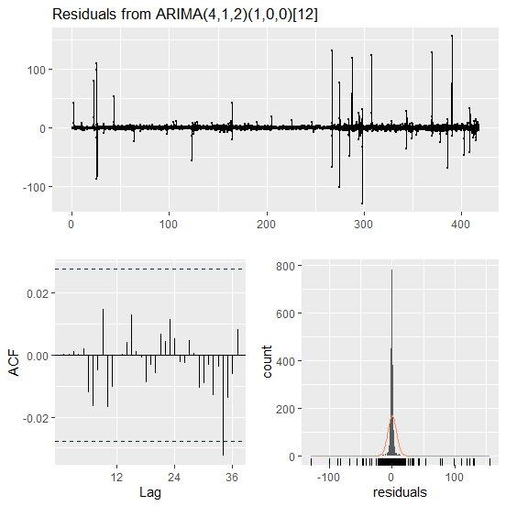

Fig 4.11: Residual plot for ARIMA(4,1,2)(1,0,0)[12] of Naira - Pounds Exchange rate

**4.3.6 Forecast of ARIMA(0,1,1) for Naira- Pounds exchange rate**

Table 4.13 below shows the forecast table for the Naira-Pounds exchange rate. It shows the actual, predicted, error values and the error percent. Figure 4.12 shows the forecast plot of the Naira-Pounds exchange rate using ARIMA(4,1,2)(1,0,0)[12] as the model for prediction.

**Table 4.13: Forecast of ARIMA(4,1,2)(1,0,0)[12]] for Naira-Pounds exchange rate**

|  |  |  |  |
| --- | --- | --- | --- |
| Actual | Predicted | Error | Error_Percent |
| 505.1122 | 508 | 2.8878 | 0.01 |
| 508.4906 | 508 | -0.4906 | 0.00 |
| 509.6810 | 508 | -1.6810 | 0.00 |
| 509.5769 | 508 | -1.5769 | 0.00 |
| 505.1412 | 508 | 2.8588 | 0.01 |
| 504.2141 | 508 | 3.7859 | 0.01 |
| 501.7310 | 508 | 6.2690 | 0.01 |
| 498.6606 | 508 | 9.3394 | 0.02 |
| 501.5259 | 508 | 6.4741 | 0.01 |
| 497.4449 | 508 | 10.5551 | 0.02 |
| 495.9955 | 508 | 12.0045 | 0.02 |
| 497.5696 | 508 | 10.4304 | 0.02 |
| 500.0180 | 508 | 7.9820 | 0.02 |

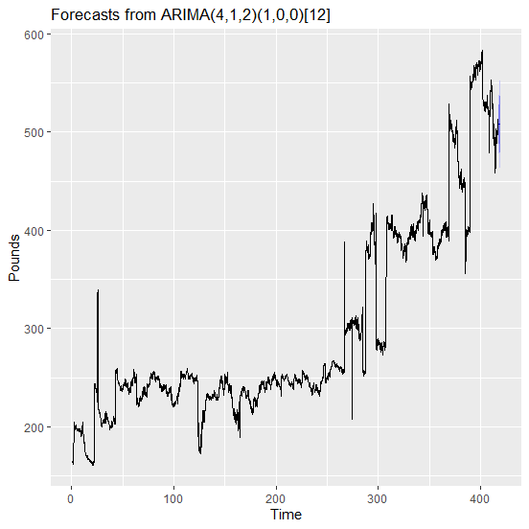

Fig 4.12: Forecast plot for ARIMA(4,1,2)(1,0,0)[12] of Naira - Pounds Exchange rate

**4.4 NEURAL NETWORK RESULT**

This section discusses the result obtained using Artificial Neural Network(ANN) model for the Naira-Dollar, Naira -Euro and Naira - Pounds exchange rates. Tables 4.14, 4.15 and 4.16 show the ANN output for the three time series data.

**Table 4.14: ANN model for Naira - Dollar exchange rate**

|  |
| --- |
| Model: NNAR(25,1,13)[12]  Average of 20 networks, each of which is  a 25-13-1 network with 352 weights  options were - linear output units |

|  |  |  |  |  |  |
| --- | --- | --- | --- | --- | --- |
| ME | RMSE | MAE | MPE | MAPE | MASE |
| 0.0181 | 4.52 | 0.566 | -0.03 | 0.262 | 0.204 |

Table 4.14 above shows that ANN model Naira-Dollar data as Neural Network Autoregressive model, NNAR(25,1,13)[12] with average of 20 networks each of which is 25 inputs, 1 hidden neuron and 13 outputs. The table also shows that the model produced RMSE, MAE and MAPE of 4.52, 0.566 and 0.262 respectiely.

**Table 4.15: ANN model for Naira - Euro exchange rate**

|  |
| --- |
| Model: NNAR(36,1,18)[12]  Average of 20 networks, each of which is  a 36-18-1 network with 685 weights  options were - linear output units |

|  |  |  |  |  |  |
| --- | --- | --- | --- | --- | --- |
| ME | RMSE | MAE | MPE | MAPE | MASE |
| 0.0396 | 5.56 | 1.59 | -0.177 | 0.849 | 0.248 |

Table 4.15 above shows that ANN model Naira-Euro data as Neural Network Autoregressive model, NNAR(36,1,18)[12] with average of 20 networks each of which is 36 inputs, 1 hidden neuron and 18 outputs. The table also shows that the model produced RMSE, MAE and MAPE of 5.56, 1.59 and 0.849 respectiely.

**Table 4.16: ANN model for Naira - Pounds exchange rate**

|  |
| --- |
| Model: NNAR(25,1,13)[12]  Average of 20 networks, each of which is  a 25-13-1 network with 352 weights  options were - linear output units |

|  |  |  |  |  |  |
| --- | --- | --- | --- | --- | --- |
| ME | RMSE | MAE | MPE | MAPE | MASE |
| 0.0457 | 6.05 | 1.83 | -0.0220 | 0.607 | 0.237 |

Table 4.16 above shows that ANN model Naira-Pounds data as Neural Network Autoregressive model, NNAR(25,1,13)[12] with average of 20 networks each of which is 25 inputs, 1 hidden neuron and 13 outputs. The table also shows that the model produced RMSE, MAE and MAPE of 6.05, 1.83 and 0.607 respectiely.

**4.4.1 ANN Forecast for Naira - Dollar exchange rate**

Table 4.17 below shows the forecast table for the Naira-Dollar exchange rate. It shows the actual, predicted, error values and the error percent. Figure 4.13 shows the forecast plot of the Naira-Dollar exchange rate using NNAR(25,1,13)[12] as the model for prediction.

**Table 4.17: Forecast of NNAR(25,1,13)[12] for Naira-Dollar exchange rate**

|  |  |  |  |
| --- | --- | --- | --- |
| Actual | Predicted | Error | Error_Percent |
| 420.83 | 417.5477 | 3.28 | 0.78 |
| 420.46 | 416.9205 | 3.54 | 0.84 |
| 419.89 | 416.3156 | 3.57 | 0.85 |
| 419.72 | 415.7226 | 4 | 0.95 |
| 419.37 | 415.1442 | 4.23 | 1.01 |
| 419.19 | 414.5912 | 4.6 | 1.1 |
| 418.47 | 414.0531 | 4.42 | 1.06 |
| 418.47 | 413.5488 | 4.92 | 1.18 |
| 418.07 | 420.1643 | -2.09 | -0.5 |
| 417.48 | 419.5007 | -2.02 | -0.48 |
| 417.49 | 418.8376 | -1.35 | -0.32 |
| 416.90 | 418.1892 | -1.29 | -0.31 |

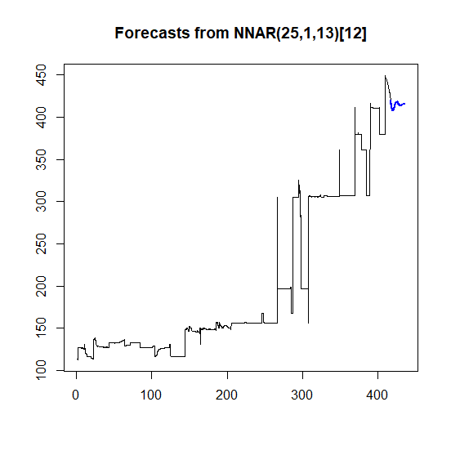 Fig 4.13: Forecast plot for NNAR(25,1,13)[12] of Naira - Dollar Exchange rate

**4.4.2 ANN Forecast for Naira - Euro exchange rate**

Table 4.18 below shows the forecast table for the Naira-Euro exchange rate. It shows the actual, predicted, error values and the error percent. Figure 4.14 shows the forecast plot of the Naira-Euro exchange rate using NNAR(36,1,18)[[12] as the model for prediction.

**Table 4.18: Forecast of NNAR(25,1,13)[12] for Naira-Euro exchange rate**

|  |  |  |  |
| --- | --- | --- | --- |
| Actual | Predicted | Error | Error_Percent |
| 426.6185 | 430.3621 | -3.74 | 0.88 |
| 426.4887 | 432.0818 | -5.59 | 1.31 |
| 424.3469 | 432.7086 | -8.36 | 1.97 |
| 421.3248 | 432.8080 | -11.48 | 2.73 |
| 422.1994 | 433.0906 | -10.89 | 2.58 |
| 421.6330 | 432.9157 | -11.28 | 2.68 |
| 425.3947 | 433.3009 | -7.91 | 1.86 |
| 423.3998 | 433.5835 | -10.18 | 2.41 |
| 423.9513 | 425.7068 | -1.76 | 0.41 |
| 423.7740 | 426.6807 | -2.91 | 0.69 |
| 426.4126 | 428.0579 | -1.65 | 0.39 |
| 421.9579 | 429.1539 | -7.2 | 1.71 |

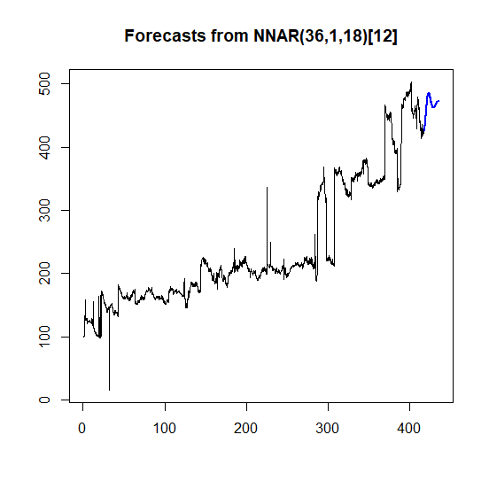

*Fig 4.14: Forecast plot for NNAR(36,1,18)[[12] of Naira - Euro Exchange rate*

**4.4.3 ANN Forecast for Naira - Pounds exchange rate**

Table 4.17 below shows the forecast table for the Naira-Pounds exchange rate. It shows the actual, predicted, error values and the error percent. Figure 4.15 shows the forecast plot of the Naira-Pounds exchange rate using NNAR(25,1,13)[12] as the model for prediction.

**Table 4.17: Forecast of NNAR(25,1,13)[12] for Naira-Pounds exchange rate**

|  |  |  |  |
| --- | --- | --- | --- |
| Actual | Predicted | Error | Error_Percent |
| 505.1122 | 511.7551 | -6.64 | 1.32 |
| 508.4906 | 512.7595 | -4.27 | 0.84 |
| 509.6810 | 514.2150 | -4.53 | 0.89 |
| 509.5769 | 515.7916 | -6.21 | 1.22 |
| 505.1412 | 516.4867 | -11.35 | 2.25 |
| 504.2141 | 517.3859 | -13.17 | 2.61 |
| 501.7310 | 518.1525 | -16.42 | 3.27 |
| 498.6606 | 518.4091 | -19.75 | 3.96 |
| 501.5259 | 508.9469 | -7.42 | 1.48 |
| 497.4449 | 509.7443 | -12.3 | 2.47 |
| 495.9955 | 509.4386 | -13.44 | 2.71 |
| 497.5696 | 510.3045 | -12.73 | 2.56 |

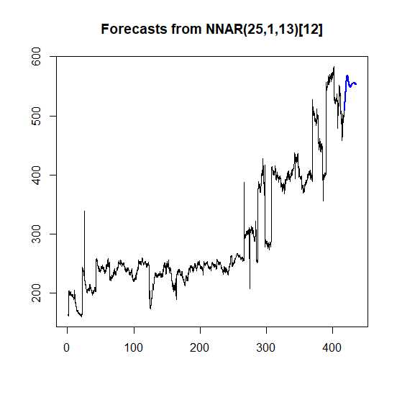

*Fig 4.15: Forecast plot for NNAR(25,1,13)[[12] of Naira - Pounds Exchange rate*

**4.5 ARIMA-NEURAL NETWORK RESULT**

This section discusses the result obtained using ARIMA-Artificial Neural Network(ANN) model for the Naira-Dollar, Naira -Euro and Naira - Pounds exchange rates. Tables 4.18, 4.20 and 4.22 show the ARIMA-ANN output for the three time series data.

**4.5.1** **ARIMA-ANN results for Naira - Dollar exchange rate**

**Table 4.18: ARIMA-ANN results for Naira - Dollar exchange rate**

|  |  |
| --- | --- |
| ARIMA coefficients | Value |
| ma1 | -0.2337267 |

|  |
| --- |
| ANN Summary |
| Average of 20 networks, each of which is  a 1-1-1 network with 4 weights  options were - linear output units |

|  |  |  |
| --- | --- | --- |
| RMSE | MAE | MAPE |
| 4.365134 | 0.4147789 | 0.1731256 |

Table 4.18 above shows that ARIMA-ANN model Naira-Dollar data as ARIMA-Neural Network Autoregressive model, ARIMA(0,0,1)NNAR(1,1,1) with average of 20 networks each of which is 1 inputs, 1 hidden neuron and 11 outputs. The table also shows that the model produced RMSE, MAE and MAPE of 4.365134, 0.4147789 and 0.1731256 respectiely.

**4.5.2 Forecast results for Naira - Dollar exchange rate using ARIMA-ANN**

Table 4.17 below shows the forecast table for the Naira-Dollar exchange rate using ARIMA(0,0,1)NNAR(1,1,1) model. It shows the actual, predicted, error values and the error percent.

**Table 4.19: Forecast results for Naira - Dollar exchange rate**

|  |  |  |  |
| --- | --- | --- | --- |
| Actual | Predicted | Error | Error Percent |
| 429.38 | 449.760 | -20.38 | 4.75 |
| 429.11 | 449.7616 | -20.65 | 4.81 |
| 428.81 | 449.7616 | -20.95 | 4.89 |
| 428.51 | 449.7616 | -21.25 | 4.96 |
| 428.10 | 449.7616 | -21.66 | 5.06 |
| 427.76 | 449.7616 | -22 | 5.14 |
| 427.43 | 449.7616 | -22.33 | 5.22 |
| 426.61 | 449.7616 | -23.15 | 5.43 |
| 490.26 | 449.7616 | 40.5 | 8.26 |
| 450.55 | 449.7616 | 0.79 | 0.17 |
| 450.03 | 449.7616 | 0.27 | 0.06 |
| 449.51 | 449.7616 | -0.25 | 0.06 |

**4.5.3** **ARIMA-ANN results for Naira - Euro exchange rate**

**Table 4.20: ARIMA-ANN results for Naira -Euro exchange rate**

|  |  |
| --- | --- |
| ARIMA coefficients | Value |
| ma1 | -0.2589309 |

|  |
| --- |
| ANN Summary |
| Average of 20 networks, each of which is  a 1-1-1 network with 4 weights  options were - linear output units |

|  |  |  |
| --- | --- | --- |
| RMSE | MAE | MAPE |
| 5.094977 | 1.562855 | 0.8418087 |

Table 4.20 above shows that ARIMA-ANN model Naira-Euro data as ARIMA-Neural Network Autoregressive model, ARIMA(0,0,1)NNAR(1,1,1) with average of 20 networks each of which is 1 inputs, 1 hidden neuron and 11 outputs. The table also shows that the model produced RMSE, MAE and MAPE of 5.094977, 1.562855 and 0.8418087 respectiely.

**4.5.4 Forecast results for Naira - Euro exchange rate using ARIMA-ANN**

Table 4.21 below shows the forecast table for the Naira-Euro exchange rate using ARIMA(0,0,1)NNAR(1,1,1) model. It shows the actual, predicted, error values and the error percent.

**Table 4.21:** ARIMA-ANN Forecast results for Naira - Euro exchange rate

|  |  |  |  |
| --- | --- | --- | --- |
| Actual | Predicted | Error | Error Percent |
| 426.6185 | 461.0184 | -34.4 | 8.06 |
| 426.4887 | 461.7440 | -35.26 | 8.27 |
| 424.3469 | 461.9936 | -37.65 | 8.87 |
| 421.3248 | 462.0811 | -40.76 | 9.67 |
| 422.1994 | 462.1115 | -39.91 | 9.45 |
| 421.6330 | 462.1220 | -40.49 | 9.6 |
| 425.3947 | 462.1256 | -36.73 | 8.63 |
| 423.3998 | 462.1268 | -38.73 | 9.15 |
| 423.9513 | 462.1273 | -38.18 | 9.00 |
| 423.7740 | 462.1274 | -38.35 | 9.05 |
| 426.4126 | 462.1275 | -35.71 | 8.38 |
| 421.9579 | 462.1275 | -40.17 | 9.52 |

**4.5.5** **ARIMA-ANN results for Naira - Pounds exchange rate**

**Table 4.22: ARIMA-ANN results for Naira -Pounds exchange rate**

|  |  |
| --- | --- |
| ARIMA coefficients | Value |
| ma1 | 0.2303085 |

|  |
| --- |
| ANN Summary |
| Average of 20 networks, each of which is  a 6-4-1 network with 33 weights  options were - linear output units |

|  |  |  |
| --- | --- | --- |
| RMSE | MAE | MAPE |
| 5.964977 | 1.066428 | 0.6078308 |

Table 4.22 above shows that ARIMA-ANN model Naira-Pounds data as ARIMA-Neural Network Autoregressive model, ARIMA(0,0,1)NNAR(6,4,1) with average of 20 networks each of which is 6 inputs, 4 hidden neuron and 11 outputs. The table also shows that the model produced RMSE, MAE and MAPE of 5.964977, 1.066428 and 0.6078308 respectiely.

**4.5.6 ARIMA-ANN Forecast results for Naira - Pounds exchange rate**

Table 4.23 below shows the forecast table for the Naira-Pounds exchange rate using ARIMA(0,0,1)NNAR(6,4,1) model. It shows the actual, predicted, error values and the error percent.

**Table 4.23:** ARIMA-ANN Forecast results for Naira - Pounds exchange rate

|  |  |  |  |
| --- | --- | --- | --- |
| Actual | Predicted | Error | Error Percent |
| 505.1122 | 515.6692 | -10.56 | 2.09 |
| 508.4906 | 515.2857 | -6.8 | 1.34 |
| 509.6810 | 514.0773 | -4.4 | 0.86 |
| 509.5769 | 514.0331 | -4.46 | 0.87 |
| 505.1412 | 513.3008 | -8.16 | 1.62 |
| 504.2141 | 515.6597 | -11.45 | 2.27 |
| 501.7310 | 514.5619 | -12.83 | 2.56 |
| 498.6606 | 514.4281 | -15.77 | 3.16 |
| 501.5259 | 514.4282 | -12.9 | 2.57 |
| 497.4449 | 514.3880 | -16.94 | 3.41 |
| 495.9955 | 514.4618 | -18.47 | 3.72 |
| 497.5696 | 514.4651 | -16.9 | 3.4 |

**4.6 Model comparison using Naira - Dollar exchange rate**

In this section, we examined the performance comparison the three models used to model Naira - Dollar, Naira - Euro and Naira - Pounds exchange rates. Tables 4.24, 4.25 and 4.26 show the model comparison for Naira - Dollar, Naira - Euro and Naira - Pounds respectively.

**Table 4.24: Model comparison using Naira - Dollar exchange rate**

|  |  |  |  |
| --- | --- | --- | --- |
| Approach | MAE | RMSE | MAPE |
| ANN | 0.57 | 4.52 | 0.26 |
| ARIMA | 0.42 | 4.92 | 0.18 |
| ARIMA-ANN | 0.41 | 4.34 | 0.17 |

**Table 4.25: Model comparison using Naira - Euro exchange rate**

|  |  |  |  |
| --- | --- | --- | --- |
| Approach | MAE | RMSE | MAPE |
| ANN | 1.59 | 5.56 | 0.85 |
| ARIMA | 1.62 | 6.24 | 0.87 |
| ARIMA-ANN | 1.56 | 5.09 | 0.84 |

**Table 4.26: Model comparison using Naira - Pounds exchange rate**

|  |  |  |  |
| --- | --- | --- | --- |
| Approach | MAE | RMSE | MAPE |
| ANN | 1.83 | 6.05 | 0.61 |
| ARIMA | 1.96 | 6.73 | 0.65 |
| ARIMA-ANN | 1.07 | 5.96 | 0.61 |

**4.7 Conclusion**

In this study, we study the modelling of Naira-Dollar, Naira-Euro and Naira-Pounds Nigeria exchange rates using ARIMA, ANN and the combine ARIMA-ANN model. We obtained the exploratory data analysis of these exchange rates and observed that Naira-Dollar has the least exchange rate and Naira-Pounds has the highest. It was also observed that both Naira-Euro and Naira-Pounds are stationary at Order(I). Out of the three time series models considered for these exchange rate, the combined model of ARIMA-ANN outperformed the other two i.e ARIMA and ANN as it produced lowest Mean Absolute Erorr(MAE), Root Mean Square Error(RMSE) and Mean Absolute Percentage Error( MAPE) values.