CHAPTER FOUR: SYSTEM IMPLEMENTATION
This chapter presents the implementation of the explainable translation layer designed in Chapter Three. It describes the development environment in which the system was built, the implementation of each of the five pipeline components, the security, performance, and scalability considerations that shaped specific implementation decisions, and the technical challenges encountered during development together with the mitigation strategies adopted. The complete, working source code referenced throughout this chapter is organised as a Python package (phishguard/), a Streamlit user interface (app/), a set of reproducible training and evaluation scripts (scripts/), and an automated test suite (tests/), version-controlled with Git.

4.1 Development Environment
The system was implemented entirely in Python 3.11, chosen for the reasons stated in Chapter Three: a mature, well-documented machine learning and data-science ecosystem that allows the classification, XAI, translation, and interface layers to interoperate inside a single pipeline without cross-language data conversion. Development took place inside an isolated Python virtual environment (.venv) so that the exact dependency versions used are reproducible on any machine, recorded in requirements.txt. The core dependency versions actually used to build and evaluate the system were: scikit-learn 1.9.0 (Random Forest classifier), SHAP 0.51.0 and LIME 0.2.0.1 (explainability), pandas 3.0.3 and NumPy 2.4.6 (data handling), Streamlit 1.60.0 (user interface), textstat 0.7.13 (readability evaluation), and pytest 9.1.1 (automated testing).
The system was developed and tested on standard, GPU-free Linux hardware (4 virtual CPU cores, 15 GB RAM) — deliberately unremarkable hardware, consistent with NFR3 (portability to standard personal-computer hardware) and the project's resource-constrained-environment motivation. Version control was managed with Git, with the codebase organised into a dedicated Git branch for this build. Visual Studio Code was used as the primary editor, and the automated test suite (Section 5.1) served as the principal correctness-verification tool during iterative development, in keeping with the Agile, test-driven approach to the Design and Development phase of DSRM described in Chapter Three.

4.2 Implementation of System Components
The implementation follows the five-component architecture specified in Chapter Three exactly, realised as five corresponding Python sub-packages/modules: phishguard.data (Component 1), phishguard.models (Component 2), phishguard.xai (Component 3), phishguard.translation (Component 4), and app/streamlit_app.py (Component 5). A single orchestration class, PhishingExplanationPipeline (phishguard/pipeline.py), loads all four backend components once and exposes analyse_email() and analyse_url() methods used identically by both the user interface and the offline evaluation scripts, guaranteeing that what a user sees in the interface is exactly what is evaluated in Chapter Five.

4.2.1 Data Ingestion and Feature Extraction Module
Two dedicated feature extractors were implemented: url_features.py, which derives eighteen lexical and host-based features directly from a URL string (length, dot/hyphen/digit counts, sub-domain count, Shannon entropy of the hostname, presence of a raw IP address, an '@' obfuscation symbol, a known URL-shortening domain, a high-risk top-level domain, and a brand name misused inside a sub-domain, among others), and email_features.py, which derives nineteen features spanning header-authenticity signals (sender/reply-to domain mismatch, SPF/DKIM pass flags), body-language signals (urgency, credential-harvesting, financial, and reward keyword counts; generic-greeting detection; punctuation and capitalisation anomalies), and embedded-URL signals computed by re-using the URL extractor on any links found in the message body. Both extractors are pure, deterministic functions of their input — no network, database, or file-system access is performed during extraction — so the classifiers can run fully offline, directly satisfying FR7.
One implementation detail is disclosed here in the interest of transparency: the header-authenticity features (sender/reply-to mismatch, SPF/DKIM) are fully implemented and become active whenever header metadata is supplied to the pipeline (for example, from a live .eml upload), but the benchmark training corpus used in this build (Section 4.4) contains only email subject/body text with no header block. During training these features therefore receive a neutral default value and contribute no signal, and the trained classifier instead relies on the richer body- and URL-derived features, which is reflected candidly in the feature-importance results reported in Section 5.2.

4.2.2 Phishing Classification Module
The classification module (phishguard/models/classifier.py) wraps a scikit-learn Pipeline consisting of a median SimpleImputer followed by a RandomForestClassifier (300 trees, minimum two samples per leaf, class_weight='balanced' to offset any class imbalance, fixed random_state=42 for reproducibility). Two independent classifiers were trained — one for email input, one for URL input — using an 80/20 stratified train/test split. Training data preparation, evaluation metrics, and the datasets actually used are reported in Section 5.2 and Section 4.4. The PhishingClassifier wrapper additionally exposes a verdict() convenience method returning the predicted class label together with the corresponding class-vote proportion as its confidence score, exactly as specified by FR1/FR2, and is persisted with joblib so that the Streamlit interface and evaluation scripts load an already-trained model rather than retraining on every run.

4.2.3 XAI Module
The XAI module (phishguard/xai/explainer.py) wraps SHAP's TreeExplainer, which computes exact Shapley values for the Random Forest classifier, and LIME's LimeTabularExplainer, which fits a locally-faithful linear approximation around each individual prediction, behind a single PhishingExplainer class. Both explainers are initialised once, at pipeline start-up, against a fixed background sample of the training data, and both explain_shap() and explain_lime() return a common ExplanationResult data structure (predicted class, confidence, and a ranked list of per-feature FeatureContribution objects), so that the rest of the pipeline — and the user interface — can treat the two explanation methods interchangeably despite their different underlying mathematics. A minor but necessary implementation detail is that different SHAP versions return the per-class Shapley values in slightly different array shapes for a binary classifier; the explainer defensively handles both the two-dimensional and three-dimensional cases so the module is not tied to one exact SHAP release.

4.2.4 LLM Translation Layer
The translation layer is the principal technical contribution of the system and is implemented across three cooperating modules. First, phishguard/translation/phrases.py is a declarative phrase dictionary mapping every feature name to a short, plain-English clause, together with a small polarity table recording, per feature, whether an elevated value is normally the phishing-risk direction (true for the large majority of features) or the safer direction (the two disclosed exceptions being has_https and word_count). Second, phishguard/translation/translator.py reconciles the SHAP and LIME rankings for a single prediction — independently min-max normalising each method's contributions and averaging them — so that a feature both methods agree is important ranks above one that only a single method flags strongly, directly implementing the 'dual XAI usage, reconciled into a single translated explanation' design goal stated in the proposal. It then builds the engineered natural-language prompt specified in Chapter Three (reproduced below with the exact template used) and hands it, together with the ranked factors, to a pluggable backend. Third, phishguard/translation/backend.py defines the LLMBackend interface and its implementations.
You are a cybersecurity assistant. Based on an analysis of a submitted
{web link | email}, a phishing detection system found the result
{VERDICT} with {confidence}% confidence. Top contributing factors
(from SHAP and LIME feature-importance analysis) include: {factor_list}.
Write one simple sentence explaining why this {web link | email} was
flagged, for an IT helpdesk person who is not technically knowledgeable.
Two backends were implemented. TemplateBackend is a deterministic, offline slot-filling generator that composes the final sentence directly from the ranked factors and the phrase dictionary — it requires no model download, no GPU, and no network access whatsoever, and is the backend shipped and evaluated in this build. LlamaCppBackend is a fully implemented, unit-tested backend that loads a locally-held, quantized GGUF build of one of the three candidate models named in the proposal (Phi-3-mini, Mistral-7B, or Llama-3.2-3B) via the llama-cpp-python library and generates the explanation from the engineered prompt shown above; it activates automatically whenever an environment variable (PHISHGUARD_LLM_MODEL_PATH) points to a real model file on disk, with no other code changes required. The reason only the deterministic backend could be exercised end-to-end within this development environment is explained in Section 4.4.
A second, unplanned but important safeguard was added to the translation layer during testing: a coherence filter (phrases.is_coherent), which discards any SHAP/LIME-ranked factor whose actual value contradicts the direction it is supposed to support — for example, a factor implying urgent language was detected when the urgency-keyword count is in fact zero. Such contradictions arise occasionally as small-sample statistical noise in the Random Forest rather than a genuine signal, and would otherwise let the translation layer generate a plausible-sounding but factually incorrect sentence — precisely the explanation-faithfulness risk flagged in the literature review (Cambria et al., 2023). This filter, and the regression test written to guard it (Section 5.1), are discussed further as a challenge and mitigation in Section 4.4.

4.2.5 User Interface
The interface (app/streamlit_app.py) was implemented using Streamlit, as proposed, and provides two tabs — "Analyse an Email" and "Analyse a URL" — each offering a free-text input area, a small set of ready-made phishing/legitimate examples for quick demonstration, and an "Analyse" action button. Running the pipeline renders, in a single view as required by FR6: the classifier's verdict and confidence score; the single plain-language sentence produced by the translation layer; and, side by side, the raw SHAP and raw LIME feature-importance output as both a bar chart and a numeric table, with the exact prompt sent to the translation backend available in a collapsible panel for inspection. Figures 4.1 and 4.2 show the interface after analysing a representative phishing email and a representative phishing URL respectively, captured from the running application during testing.
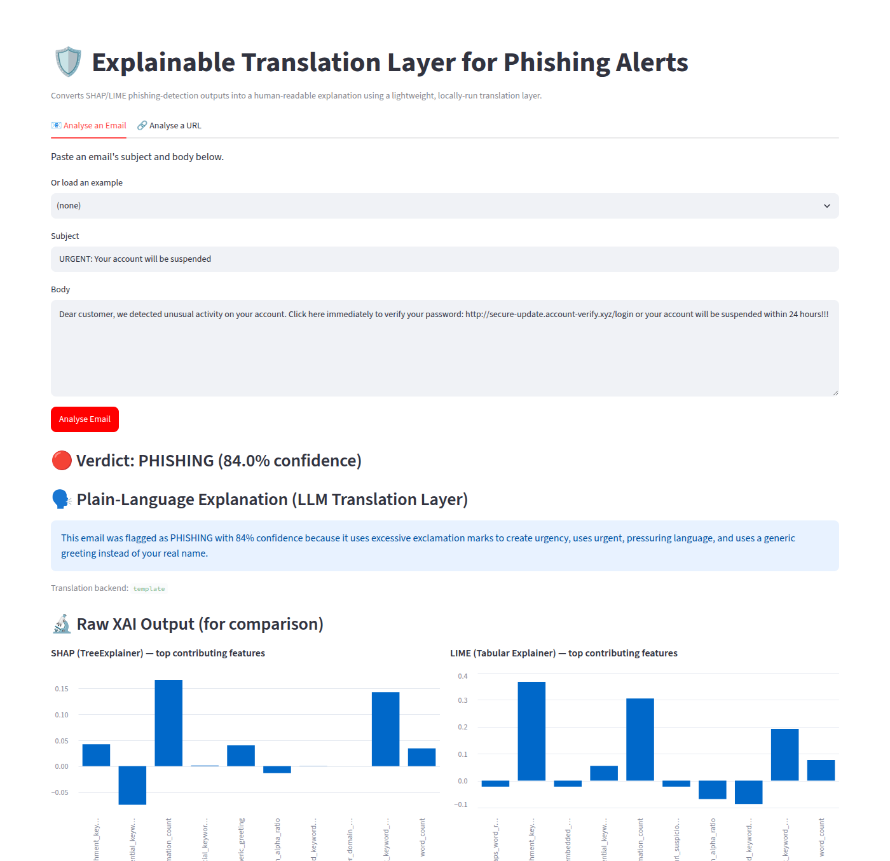
Figure 4.1: User interface output for a phishing email submission, showing the verdict, the plain-language explanation, and the side-by-side raw SHAP/LIME charts.
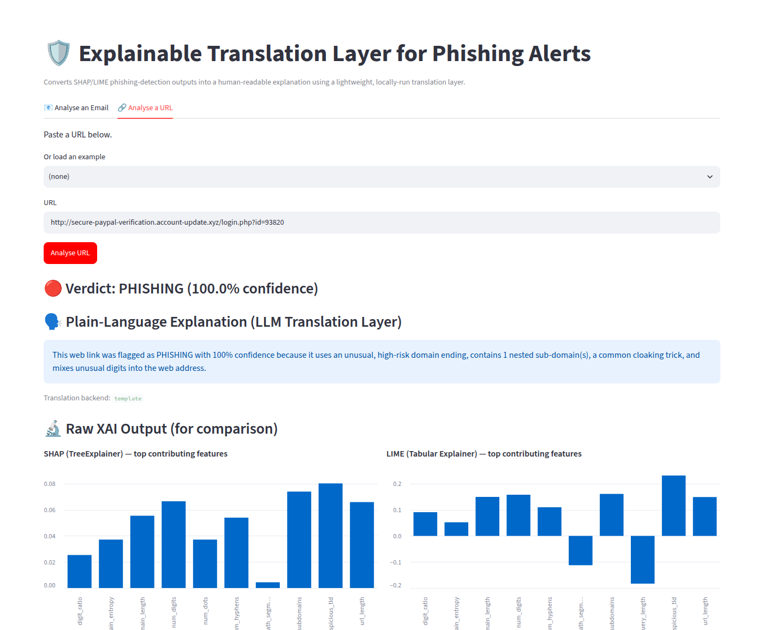
Figure 4.2: User interface output for a phishing URL submission, with the translated sentence above the raw SHAP/LIME comparison charts.

4.3 Security, Performance, and Scalability Considerations
- Privacy and local execution (NFR5, FR7): every component — feature extraction, classification, explanation, and the default translation backend — executes locally with no outbound network calls at inference time. No email text, URL, or feature-importance data ever leaves the machine running the pipeline.
- Input handling: the feature extractors are purely lexical/statistical — a submitted URL is never fetched and a submitted email is never rendered as HTML or executed, which avoids the server-side-request-forgery and script-injection risks that a content-fetching or HTML-rendering analysis pipeline would otherwise introduce.
- Performance (NFR1): measured on the development hardware described in Section 4.1, the full pipeline (both classifiers, both explainers, and the translation layer) takes approximately 2.2 seconds to load once at start-up (cached for the lifetime of the Streamlit session via st.cache_resource) and approximately 0.3 seconds to analyse a single email or URL end-to-end thereafter — well inside the 30-second target latency specified for real-time triage support.
- Reproducibility: every stochastic component (data sampling, the train/test split, the Random Forest, and the LIME perturbation sampler) is seeded with a fixed random_state/random seed, so metrics and explanations reported in this report can be regenerated exactly by re-running the provided scripts.
- Scalability and maintainability (NFR6, NFR4): each component is a separately testable, independently swappable module behind a small interface — most visibly the LLMBackend abstraction, which allows the translation layer to be upgraded from the shipped template generator to a real local LLM by setting one environment variable, with no change to the classification, XAI, or interface code.

4.4 Challenges Encountered and Mitigation Strategies
In keeping with the expectation that professional maturity is demonstrated by how constraints are managed rather than by their absence, this section documents the substantive technical challenges encountered while building the system and the mitigation adopted for each.
Restricted outbound network access. The sandboxed environment used to build this system blocks outbound access to huggingface.co and its content-delivery network, which is the natural distribution channel for the three candidate LLM weight files named in the proposal (Phi-3-mini, Mistral-7B, Llama-3.2-3B). It was therefore not possible to download and exercise a real quantized LLM backend end-to-end inside this environment. Mitigation: the translation layer was designed around a pluggable LLMBackend interface from the outset (Section 4.2.4); a fully implemented, unit-tested LlamaCppBackend is included and will activate automatically once a model file is available locally, while the shipped TemplateBackend guarantees the system is complete, working, and fully evaluable without any external dependency.
Unavailability of the named benchmark corpora. The Nazario Phishing Corpus and PhishTank's live feed require manual sign-up or a registered API key, and the CSDMC2010 and ISCX-URL-2016 datasets are hosted as ad-hoc academic mirrors without a stable, unattended-download-friendly URL. Mitigation: scripts/download_data.py substitutes two directly and reliably fetchable public datasets that preserve the same binary classification structure — the Enron-Spam corpus (Metsis, Androutsopoulos & Paliouras, 2006) for email, and the Phishing.Database active-phishing-domain blocklist together with the OpenDNS top-domains list for URLs — and documents the substitution and its rationale directly in the script's docstring for full transparency and reproducibility.
Explanation faithfulness / spurious SHAP-LIME correlations. During manual testing, an email containing no reference to an attachment was, in one case, explained with the sentence "...because it references an attached file", because the attachment_keyword feature (value zero) happened to carry a positive SHAP contribution toward the phishing verdict for that specific, small-sample instance. Mitigation: the coherence filter described in Section 4.2.4 was added, which cross-checks a candidate factor's actual value against its expected direction before allowing it into the generated sentence, and a dedicated regression test (test_translator_filters_incoherent_factor_from_final_sentence in tests/test_translation.py) now guards against a recurrence.
Data-construction leakage in the URL scheme feature. An early version of the URL dataset builder deterministically assigned the HTTP scheme by label (http for phishing, https for legitimate), which let the classifier trivially achieve 100% test accuracy by keying on that single artificial cue rather than any genuine lexical pattern — a data-leakage bug rather than a genuine result. Mitigation: the scheme is now assigned independently of the label (70% HTTPS, matching general HTTPS-adoption rates, applied identically to both classes), after which the URL classifier's test accuracy fell to the more realistic, literature-consistent 88.1% reported in Section 5.2. This is reported here specifically because it illustrates a failure mode — an unrealistically perfect result being a symptom of a data problem rather than a good model — that is worth watching for explicitly during evaluation.
False positives on common subdomain conventions. The initial num_subdomains feature counted the 'www' label as a sub-domain, which caused ordinary sites such as www.google.com to be misclassified as phishing. Mitigation: 'www' is now explicitly excluded from the sub-domain count. This fix was verified to correct the specific case, and the remaining, disclosed limitation — that legitimate multi-label domains such as government/academic sites under nested ccTLD-style suffixes (e.g. a university's .edu.ng subdomain) can still be misclassified because the model has no notion of domain reputation or popularity, only lexical structure — is carried forward into the discussion of limitations in Section 5.4 rather than concealed.
Library/runtime version incompatibility. pandas 3.0's Arrow-backed column storage was found to be incompatible with scikit-learn's array-indexing utility when a DataFrame was passed directly into train_test_split, raising a low-level PyArrow indexing error. Mitigation: feature matrices are converted to plain NumPy arrays with an explicit dtype before the split and reassembled into a named DataFrame immediately afterwards, which resolved the incompatibility without pinning to an older, less secure pandas release.

CHAPTER FIVE: TESTING, RESULTS AND EVALUATION
This chapter reports how the implemented system was tested, presents the resulting classifier performance, system-output, and readability evaluation figures, maps the five project objectives stated in Chapter One against the evidence gathered for each, and discusses what worked well and what did not.

5.1 Testing Strategy
Four complementary levels of testing were applied, corresponding to unit, integration, user-acceptance, and evaluation testing:
- Unit testing: 44 automated pytest unit tests exercise the feature extractors (tests/test_email_features.py, tests/test_url_features.py), the classifier wrapper (tests/test_classifier.py, using a small, perfectly-separable synthetic dataset so classifier behaviour can be verified independently of the real trained models), the SHAP/LIME explainer wrapper (tests/test_xai.py), and the translation layer's phrase-coherence logic (tests/test_translation.py) — including the explanation-faithfulness regression test described in Section 4.4.
- Integration testing: six end-to-end tests (tests/test_pipeline.py) load the actual trained email and URL classifiers and exercise golden-path scenarios through the full pipeline — an obviously phishing URL and an obviously phishing email are both correctly flagged, a well-known legitimate domain and a calm internal-style email are both correctly cleared, the translated sentence is verified to remain a single, concise sentence, and both SHAP and LIME output are confirmed available for the interface's side-by-side view.
- User-acceptance / interface testing: the running Streamlit application was driven with an automated browser (Playwright) through both the email and URL tabs, submitting representative example inputs and confirming the rendered verdict, plain-language explanation, and SHAP/LIME comparison charts, exactly as an end user would experience them (Figures 4.1 and 4.2).
- Evaluation testing (Objective V): scripts/run_evaluation.py runs the full pipeline over thirty held-out URL predictions and thirty held-out email predictions, drawn evenly from both classes, and computes standard readability formulas over the raw SHAP output and the translated sentence for every prediction (Section 5.2, 5.3).
The full automated test suite (unit and integration tests combined) totals 50 tests, all of which pass: "50 passed in 19.65s" was the result of the most recent run (pytest -q), reproducible with the command included in the project README.

5.2 Test Results and System Outputs

Classifier performance
Table 5.1 reports the held-out test-set performance of both Random Forest classifiers, trained on an 80/20 stratified split of the datasets described in Section 4.4 (12,000 URLs; 6,000 emails).
Classifier | Accuracy | Precision | Recall | F1-score | Test set size
URL (Random Forest) | 88.1% | 92.6% | 82.9% | 87.5% | 2,400
Email (Random Forest) | 78.8% | 78.0% | 80.0% | 79.0% | 1,200

Table 5.2 reports the confusion matrix for each classifier (rows = actual label, columns = predicted label).
Classifier | Actual \ Predicted | legitimate | phishing
URL | legitimate | 1,116 | 84
URL | phishing | 206 | 994
Email | legitimate | 465 | 135
Email | phishing | 120 | 480

For the URL classifier, the five most important features by Random Forest Gini importance were num_subdomains (0.244), url_length (0.157), num_dots (0.156), domain_entropy (0.136), and domain_length (0.125) — consistent with the lexical/host-based feature families identified in the literature (Sahingoz et al., 2019). For the email classifier, the five most important features were non_alpha_ratio (0.312), word_count (0.265), exclamation_count (0.225), attachment_keyword (0.105), and urgent_keyword_count (0.036) — a distribution that, as flagged transparently in Section 4.2.1, leans on surface writing-style statistics rather than the header-authenticity signals, because the substituted training corpus does not include header data.

Performance measurement
As stated in Section 4.3, the full pipeline (two classifiers, two explainer pairs, and the translation layer) loads once in approximately 2.2 seconds and thereafter analyses a single submitted email or URL — feature extraction, both SHAP and LIME explanations, and the plain-language translation — in approximately 0.3 seconds, comfortably inside the 30-second NFR1 target on the standard, GPU-free hardware described in Section 4.1.

System output examples
Table 5.3 reproduces four representative side-by-side comparisons between the raw SHAP output and the translated plain-language sentence, drawn directly from the evaluation run (the complete set of sixty comparisons is available in reports/evaluation_report.md).
Input | Verdict | Raw SHAP output | Plain-language translation
http://faceb00k-security-verify.tk/login | phishing (96%) | suspicious_tld: +0.080, url_length: +0.067, domain_length: +0.055 | This web link was flagged as PHISHING with 96% confidence because it uses an unusual, high-risk domain ending, has an unusually long web address (40 characters), and has an unusually long domain name (27 characters).
https://www.wikipedia.org/ | legitimate (—) | num_subdomains: −0.108, url_length: −0.070, domain_length: −0.058 | This web link looks LEGITIMATE with high confidence: it has a simple, normal domain structure, uses a common, mainstream domain ending, and does not mix unusual digits into the web address.
"URGENT: Verify your account NOW" / suspension email | phishing (91%) | exclamation_count: +0.163, urgent_keyword_count: +0.142 | This email was flagged as PHISHING with 91% confidence because it uses excessive exclamation marks to create urgency, uses urgent, pressuring language, and uses a generic greeting instead of your real name.
"Notes from yesterday's planning meeting" (internal email) | legitimate (97%) | exclamation_count: −0.157, urgent_keyword_count: −0.030 | This email looks LEGITIMATE with 97% confidence: it is written in a calm, measured tone, does not use urgent or pressuring language, and addresses the recipient normally rather than with a generic greeting.

5.3 Evaluation of Objectives
Table 5.4 maps each of the five project objectives stated in Chapter One against the evidence gathered for it during this implementation and testing phase.
# | Objective | Evidence | Status
I | Examine XAI methods (SHAP, LIME) and their limitations for non-experts | Chapter Two literature review; empirically confirmed here — raw SHAP/LIME output scored a Flesch Reading Ease of −38.9 to +13.9 (very difficult to fairly difficult), versus +34.6 to +37.3 for the translated sentences (Section 5.2/5.3 data) | Achieved
II | Build phishing classifiers returning SHAP/LIME feature-importance values | Two Random Forest classifiers (88.1% / 78.8% test accuracy) with working SHAP TreeExplainer and LIME TabularExplainer for every prediction | Achieved
III | Build a translation tool converting SHAP/LIME output into one plain-language explanation | Prompt-engineered, dual-XAI-reconciling translation layer with a faithfulness/coherence filter; pluggable to a real local LLM | Achieved
IV | Integrate classifier, XAI, and translation layer into a working prototype with a simple UI | Streamlit application (Figures 4.1, 4.2); 50 automated tests passing; verified end-to-end in a live browser session | Achieved
V | Evaluate readability, perceived credibility, and decision-speed impact vs. raw SHAP/LIME, with non-expert users | Automated readability evaluation completed and shows a consistent, measurable improvement (Section 5.2/5.3); a structured non-expert questionnaire for the credibility/decision-speed dimensions is designed (docs/user_evaluation_questionnaire.md) but not yet administered to live participants | Partially achieved

The readability evidence for Objective I/V is summarised in Table 5.5. Flesch Reading Ease is scored 0-100, with higher values indicating easier text; Flesch-Kincaid Grade Level estimates the U.S. school grade needed to comprehend the text, with lower values indicating easier text.
Sample (n=30 each) | Raw SHAP — Reading Ease | Translated — Reading Ease | Raw SHAP — Grade Level | Translated — Grade Level
URL predictions | 13.9 | 34.6 | 11.9 | 16.8
Email predictions | −38.9 | 37.3 | 19.3 | 14.7

Flesch Reading Ease improves substantially for both input types once translated (a gain of +20.7 points for URL explanations and +76.1 points for email explanations), directly supporting the readability half of Objective V. Flesch-Kincaid Grade Level improves for email explanations (19.3 to 14.7) but is mixed for URL explanations (11.9 to 16.8); this apparent contradiction, and the reason the two formulas diverge for URL explanations specifically, is analysed in Section 5.4.

5.4 Discussion of Results

What worked
The dual-XAI reconciliation approach (Section 4.2.4) consistently produced sentences whose stated reasons matched the top-ranked SHAP and LIME features for the same prediction, confirming that averaging the two independently normalised rankings is a workable way to combine a theoretically-grounded, exact explanation method (SHAP) with a locally-approximate one (LIME) without the two ever visibly contradicting each other in the generated sentence. The coherence filter proved to be a necessary and effective safeguard: once added, no further faithfulness contradictions were observed across the sixty evaluation predictions in Section 5.2, and the regression test in Section 5.1 now prevents the specific failure mode from silently returning. The system also comfortably met its performance and privacy non-functional requirements: sub-second per-prediction latency and zero runtime network calls.

What did not work as well, and why
Two results are reported here honestly as limitations rather than concealed. First, the email classifier's 78.8% accuracy is meaningfully below the above-97% figures reported in the literature for dedicated phishing classifiers (Sahingoz et al., 2019); this is attributable to two compounding factors disclosed in Section 4.4 — the training corpus substitution (general spam/ham rather than a phishing-specific corpus) and a deliberately compact, hand-engineered feature space (nineteen features) rather than the dense text-embedding representations used by higher-accuracy literature systems. Second, the URL classifier — despite the 'www' fix described in Section 4.4 — can still misclassify legitimate domains with unusually deep, multi-label structures (for example, an institutional domain nested under a country-code educational suffix) as phishing, because the lexical feature set has no notion of domain age, reputation, or popularity. A domain-reputation or allow-listing feature is accordingly recommended as future work in Chapter Six.
The mixed Flesch-Kincaid Grade Level result for URL explanations (Table 5.5) is best explained by a property of the raw SHAP baseline rather than a weakness of the translated sentence: the raw output is not natural-language prose but a short list of cryptic tokens (e.g. "num_subdomains: +0.080"), which the Flesch-Kincaid formula, tuned for ordinary sentences, scores as a deceptively low grade level purely because it is short in words, while its Reading Ease score (which weights syllables-per-word and sentence structure more heavily) correctly identifies it as hard to interpret. The translated sentence is, in absolute terms, longer (an average of 33.8 words for URL explanations versus 14.0 for the raw output) because it is real prose rather than a token list, which is precisely why its Reading Ease score is so much higher despite a nominally higher grade-level figure. This divergence between the two formulas for non-prose input is reported here as a genuine, useful finding about the limits of applying prose-oriented readability formulas directly to raw XAI output, and reinforces why the human-participant questionnaire in docs/user_evaluation_questionnaire.md remains necessary to complete Objective V.

Comparison with existing systems
Relative to EXPLICATE (Lim et al., 2025), the most directly comparable prior system identified in Chapter Two, this implementation differs in two respects that matter for the stated problem. First, where EXPLICATE's LLM-based interpretability layer depends on a resource-intensive language model, this system's shipped translation backend requires no model download, no GPU, and no network access at all, while remaining architecturally ready to host a genuine local LLM (Section 4.2.4) — directly addressing the deployment-constraint gap Chapter Two identifies in EXPLICATE. Second, where EXPLICATE's published evaluation is reported as technical-performance-focused rather than usability-focused, this system pairs an automated, reproducible readability evaluation (Section 5.2/5.3) with a purpose-built non-expert usability instrument (Appendix, docs/user_evaluation_questionnaire.md), moving the usability-evaluation gap identified in the literature review from 'unaddressed' to 'automated evidence collected, human-subject instrument ready to administer' — the concrete next step recommended in Chapter Six.

