Title

Assessing the Energy Efficiency of Homes and Lighting in the UK: A Visual Analysis Using Matplotlib.

The given datasets comprises Electrical Prescription Certificates (EPC) for various property types in the UK, along with other relevant features pertaining to their electrical power ratings and authorities. The first column of the datasets contains a unique building number for each property.

This work is a quick visualization on some features in the datasets, explaining what we see in the visualization, and finally stating all the limitations encountered while performing the visualization.

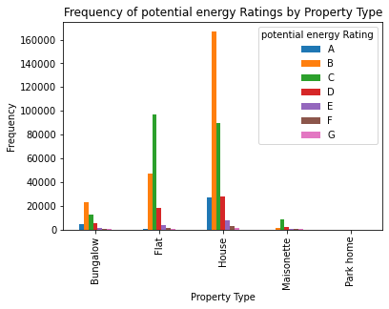

First Diagram:

In the diagram above,

I plotted a grouped bar chart to visualized the different potential energy ratings in each property types.

Potential energy ratings refer to the theoretical maximum level of energy efficiency that a building or home could achieve with certain upgrades and improvements. These ratings are often determined through energy audits, which evaluate the building's systems, appliances, insulation, and other factors that contribute to energy consumption.

The potential energy rating is usually expressed as a numerical score, such as a score out of 100, which represents the maximum level of energy efficiency that the building could achieve. This score can be compared to the building's current energy rating to determine the potential energy savings that could be achieved with upgrades and improvements.

Examples of upgrades and improvements that could contribute to a higher potential energy rating include upgrading to energy-efficient appliances and lighting, adding insulation to walls and attics, sealing air leaks, upgrading to energy-efficient windows, and installing a more efficient heating and cooling system.

By understanding the potential energy rating of a building, property owners and tenants can identify opportunities to improve energy efficiency and reduce energy costs. Additionally, policymakers can use this information to identify opportunities to promote energy efficiency and reduce greenhouse gas emissions at a larger scale.

The datasets shows a normal distribution of potential energy ratings for houses, with the majority falling into the B category. Similarly, for flats, the majority of ratings are shared between the C and B categories.The data indicates that parks have no recorded potential energy rating, suggesting that there is no energy efficiency information available for parks in the datasets.The datasets contains a small sample size of maisonette houses, with the recorded properties displaying good potential energy ratings.Bungalows within the datasets also exhibit good potential energy ratings.

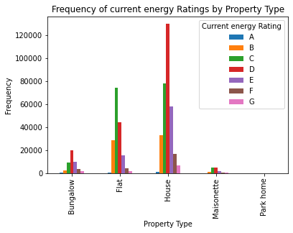

Second diagram:

This diagram also, shows a grouped bar chart, but of the different current ratings in each property types from the data set.  
Current energy rating refers to the current level of energy efficiency of a building or home. It is a measurement of the amount of energy required to maintain a comfortable indoor temperature and operate the building's systems and appliances.

The rating is usually expressed on a scale, such as the Energy Star rating system, which ranges from 0 to 100, with higher numbers indicating better energy efficiency. A building with a high energy rating requires less energy to operate and therefore has lower energy costs and a lower environmental impact.

The current energy rating can be influenced by several factors, including the age and condition of the building, the type of insulation and windows installed, the efficiency of the heating and cooling systems, and the use of energy-efficient appliances and lighting.

Understanding the current energy rating of a building can be helpful for property owners and tenants who are looking to reduce their energy consumption and costs, as well as for policymakers who are seeking to promote energy efficiency and reduce greenhouse gas emissions.

The datasets shows a normal distribution of current energy ratings for houses, with the majority falling into the D category. Similarly, for flats, the majority of ratings are shared between the C and D categories.The data indicates park homes have no recorded current energy rating, suggesting that there is no current energy efficiency information available for parks in the UK during the period of the data harvesting, and this should be looked into by government agencies. sample size of maisonette houses are few with most of them C and B ratings. Bungalows within the datasets are also having B rating as the dominating current energy ratings.

A visual analysis of the chats above suggests that most property types in the UK have a rating that is not really excellent but above average rating when it comes to current energy and potential energy ratings

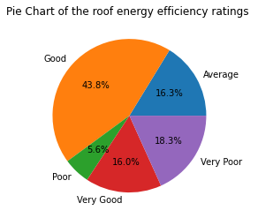

Third Diagram:

Roof energy efficiency refers to the ability of a home's roof to effectively prevent unwanted heat gain or loss, thereby reducing the amount of energy required to maintain a comfortable indoor temperature. A roof with good energy efficiency can help to reduce energy consumption and lower heating and cooling costs.

There are several factors that can affect the energy efficiency of a roof, including the type of roofing material used, the level of insulation in the attic space, and the presence of proper ventilation. Some roofing materials, such as metal and tile, are better at reflecting sunlight and preventing heat absorption than others, like asphalt shingles. Adequate insulation in the attic can help to prevent heat loss in the winter and heat gain in the summer, while proper ventilation can help to circulate air and prevent moisture buildup.

Based on the pie chart analysis of roof energy efficiency ratings in the UK, it is evident that 43.8% of roofs are rated as "good," indicating that they are effectively preventing unwanted heat gain or loss, thereby reducing the amount of energy required to maintain a comfortable indoor temperature. This is a positive sign for the UK's energy consumption as good energy efficiency ratings can help to reduce energy consumption and lower heating and cooling costs.

The analysis also shows that 16.0% of roofs are rated as "very good," which is a promising sign for energy efficiency. These roofs are likely to be contributing to a significant reduction in energy consumption and costs in the UK.

However, it is concerning that 18.3% of roofs are rated as "very poor." This indicates that these roofs are not effectively preventing heat loss or gain, and as a result, the buildings underneath will require higher energy consumption to maintain a comfortable indoor temperature. These buildings are likely to have higher energy bills and contribute more to the UK's overall energy consumption.

Furthermore, 16.3% of roofs are rated as "average," which suggests that there is room for improvement in terms of energy efficiency. Buildings with average ratings may require some upgrades or improvements to their roofing materials or insulation to achieve higher energy efficiency ratings.

Lastly, 5.6% of roofs are rated as "poor," which means that these buildings are likely to have significant energy consumption and contribute more to the UK's overall energy consumption. These buildings may require significant upgrades to improve their energy efficiency and reduce their impact on the environment.

Overall, the findings suggest that while a significant proportion of roofs in the UK have good and very good energy efficiency ratings, there is still room for improvement in terms of reducing energy consumption and lowering heating and cooling costs.

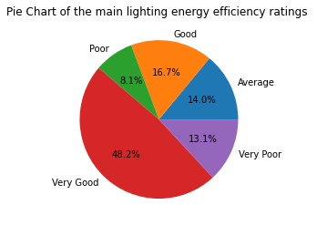

Fourth Diagram:

The main lighting efficiency refers to the efficiency of the lighting source in converting electrical energy into visible light. It is a measure of the amount of light produced per unit of electrical power consumed, and is typically expressed in lumens per watt (lm/W).

Efficient lighting can have significant benefits, including lower energy costs and reduced environmental impact. By choosing high-efficiency lighting sources and fixtures, homeowners and businesses can reduce their electricity bills and contribute to the reduction of greenhouse gas emissions.

Certainly, here is a more formal and professional analysis of the pie chart data on main lighting efficiency in the UK:

The pie chart data on main lighting efficiency in the UK reveals that 48.2% of lighting sources are classified as "very good" in terms of their efficiency rating. This suggests that these lighting sources are highly effective at converting electrical energy into visible light, resulting in lower energy consumption and costs. This is a promising indication that a significant portion of lighting systems in the UK are designed to promote energy efficiency and contribute to the country's sustainability goals.

However, it is noteworthy that 13.1% of lighting sources are classified as "very poor" in terms of their efficiency rating. This suggests that these lighting sources are not converting electrical energy into visible light efficiently, which results in higher energy consumption and costs. Buildings that rely on such lighting sources may experience elevated energy bills and have a greater impact on the UK's overall energy consumption.

Moreover, the pie chart data reveals that 16.7% of lighting sources are classified as "good", while 14.0% of lighting sources are classified as "average" in terms of their efficiency rating. It can be inferred that buildings that use lighting sources in these categories have the potential to improve their energy efficiency by upgrading to more efficient lighting sources. By doing so, they could reduce their energy consumption and costs, as well as their carbon footprint.

Finally, it is concerning that 8.1% of lighting sources are classified as "poor" in terms of their efficiency rating. This suggests that buildings with such lighting sources may require significant upgrades to improve their energy efficiency and reduce their environmental impact. Addressing the lighting efficiency of these buildings should be a priority, as inefficient lighting contributes to higher energy consumption and greenhouse gas emissions.

In conclusion, the pie chart data on main lighting efficiency in the UK provides valuable insights into the country's energy consumption patterns and the opportunities for improvement in terms of lighting efficiency. The findings indicate that while a significant proportion of lighting systems in the UK are designed for energy efficiency, there is still room for improvement. Upgrading to more efficient lighting sources and fixtures can promote energy efficiency, reduce energy consumption and costs, and support the UK's sustainability goals.

In addition to the lighting source, other factors such as the design of the lighting system, placement of fixtures, and use of lighting controls such as dimmers and timers can also impact the overall lighting efficiency. Therefore, it is important to consider all of these factors when seeking to improve lighting efficiency in a building or space.

Limitations encountered when visualizing:

1. Limited customization options: As a beginner, I found it challenging to customize visualizations beyond the basic defaults provided by Matplotlib. I found that more complex visualizations required more advanced knowledge of the tool.
2. Steep learning curve: I found that Matplotlib has a steep learning curve, particularly for those with little experience with coding or data visualization tools. It took some time for me to learn how to effectively use the tool.
3. Limited interactivity: I found that Matplotlib is primarily a static visualization tool, which means that it may not be suitable for creating interactive visualizations that allow for more in-depth exploration of data.
4. Large file sizes: I found that Matplotlib can generate visualizations with large file sizes, which may pose a challenge when sharing or presenting data.
5. Difficulty handling large datasets: I found that Matplotlib may struggle with handling large datasets, as it requires loading all data into memory to generate visualizations.
6. Limited graph types: While Matplotlib provides many graph types, I found that it may not have all the graph types required for some analyses.
7. Difficulty handling missing data: I found that Matplotlib may struggle with handling missing data or require additional programming to handle it.
8. Lack of automatic labeling: I found that Matplotlib does not automatically label axes, titles, or legends, which may require additional programming to achieve.
9. Limited 3D visualization options: I found that Matplotlib is primarily a 2D visualization tool and may not be the best choice for 3D visualizations.
10. Difficulty combining visualizations: I found that creating combined visualizations (e.g., combining pie charts and bar charts) may require more advanced knowledge of the tool and programming skills.

In conclusion, as a beginner using Matplotlib, I found that while it is a powerful data visualization tool, it has some limitations, particularly in customizing visualizations, dealing with large datasets, and creating complex visualizations. However, with patience and practice, I believe that I can develop advanced visualization skills using this tool.