BOSCH REXROTH AG

Predictive Maintenance for Hydraulic Systems

EXPLORATORY DATA ANALYSIS REPORT

Project | Predictive Maintenance for Hydraulic Systems
Client | Bosch Rexroth AG
Report Type | Exploratory Data Analysis (EDA)
Date | May 2026
Prepared By | Data Analytics Team
Framework | Agile / Scrum — 3 Week Accelerated Project

1. EXECUTIVE SUMMARY

This Exploratory Data Analysis (EDA) report presents a comprehensive examination of the multi-sensor telemetry data collected from 10 hydraulic power units (HPU_01 to HPU_10) operated by Bosch Rexroth AG. The primary objective of this analysis is to transition the organisation from a reactive maintenance culture to a data-driven predictive maintenance strategy.

The dataset comprises 864,000 sensor readings collected across four interconnected data sources: Equipment Master, Sensor Telemetry, Failure Labels and Maintenance Log. After thorough data cleaning and validation, the final cleaned dataset contains 861,410 rows ready for analysis and machine learning model development.

Key Findings at a Glance

Metric | Value
Total Machines | 10 Hydraulic Power Units
Total Sensor Readings | 861,410 (after cleaning)
Total Failure Events | 9 confirmed failure events
Total Downtime Hours | 106.70 hours
Total Repair Cost | $183,296
Total Maintenance Cost | $97,002
Total Combined Cost | $280,298
Most Common Failure | Pump Wear (6.67%)
Most At Risk Machine | HPU_09 (Avg RUL: 171.84 hrs)
Healthiest Machine | HPU_10 (Zero anomalies, RUL: 500 hrs)

2. DATASET OVERVIEW

The analysis is based on four interconnected datasets that together provide a complete picture of the hydraulic system operations at Bosch Rexroth AG.

2.1 Equipment Master
The Equipment Master table serves as the parent table containing reference information about each of the 10 hydraulic machines. It includes machine identification, installation dates, total operating hours, fluid type and maintenance priority. All other tables reference this table through the machine_id foreign key.

2.2 Sensor Telemetry
The Sensor Telemetry table is the largest and most granular dataset containing 861,410 rows of time series sensor readings collected from 12 sensor channels. Each row represents a single sensor reading captured at a specific timestamp for a specific machine. The key sensor channels include pressure in bar, temperature in Celsius, flow rate in litres per minute, vibration in both X and Y axes in g-force and pump RPM.

2.3 Failure Labels
The Failure Labels table contains records of confirmed failure events across the fleet. It includes the failure mode, timestamps of when degradation began and when failure occurred, repair costs in USD and downtime hours. A total of 9 confirmed failure events are recorded across 4 distinct failure modes.

2.4 Maintenance Log
The Maintenance Log table contains 51 records of all maintenance activities performed across the fleet. Each record includes the action type, component replaced, technician information, timestamp and cost. Three types of maintenance actions are recorded: Preventive, Reactive and Inspection.

Table | Total Rows | Primary Key
equipment_master | 10 | machine_id
sensor_telemetry | 861,410 | timestamp + machine_id
failure_labels | 9 | failure_event_id
maintenance_log | 51 | maintenance_id

3. DATA CLEANING SUMMARY

Prior to conducting the exploratory data analysis a thorough data cleaning process was performed on the sensor telemetry dataset to ensure data quality and reliability. The following section documents the issues identified and the corrective actions taken.

3.1 Missing Value Profile
A comprehensive null value audit was conducted across all 13 columns of the sensor telemetry table. The results revealed two distinct categories of missing values.

Column | Null Count | % of Total | Action Taken
pressure_bar | 2,590 | 0.30% | Rows Deleted
temp_celsius | 2,590 | 0.30% | Rows Deleted
flow_lpm | 2,590 | 0.30% | Rows Deleted
vibration_x_g | 2,590 | 0.30% | Rows Deleted
vibration_y_g | 2,590 | 0.30% | Rows Deleted
pump_rpm | 2,590 | 0.30% | Rows Deleted
failure_mode | 737,280 | 85.34% | Filled with Normal
All other columns | 0 | 0.00% | No action needed

3.2 Sensor Dropout Investigation
The 2,590 null rows across all 6 sensor columns were investigated and confirmed to be caused entirely by sensor dropout events where the machine lost connection and all sensors stopped recording simultaneously. This was verified by cross referencing with the is_sensor_dropout column which showed a perfect 100% alignment between sensor nulls and dropout flags.

Since the dataset is used for analysis and reporting purposes and the affected rows represented only 0.30% of the total dataset these rows were deleted without any meaningful impact on the analysis results.

3.3 Failure Mode Nulls
The 737,280 null values in the failure_mode column were identified as representing normal machine operating periods with no failure occurring. These were filled with the value Normal to clearly represent the healthy operating state rather than treating them as missing data.

Business Insight: After cleaning the dataset was reduced from 864,000 to 861,410 rows with 100% data completeness across all sensor columns. This represents a data quality improvement from 99.70% to 100%.

4. EXPLORATORY DATA ANALYSIS FINDINGS

4.1 Failure Mode Distribution
The analysis of failure mode distribution across all 861,410 sensor readings reveals the frequency and prevalence of each failure type in the hydraulic fleet.

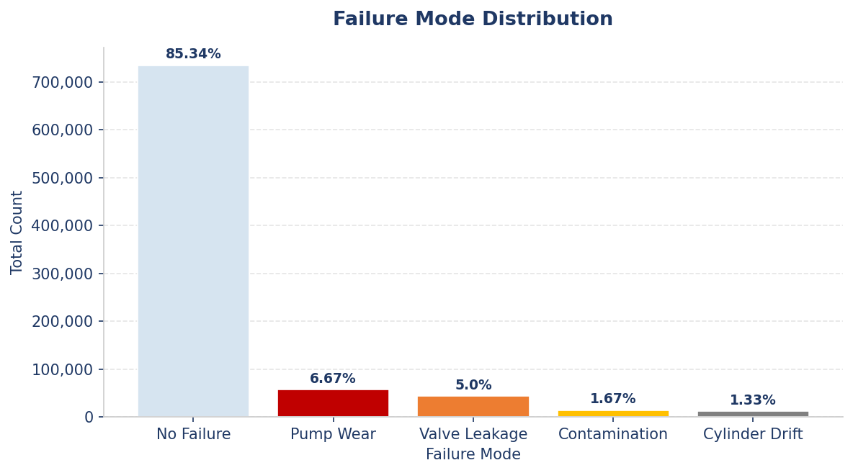

Failure Mode | Total Count | Percentage | Risk Level
No Failure | 735,088 | 85.34% | Normal
Pump Wear | 57,451 | 6.67% | High
Valve Leakage | 43,049 | 5.00% | High
Contamination | 14,362 | 1.67% | Medium
Cylinder Drift | 11,460 | 1.33% | Medium

Business Insight: Pump Wear and Valve Leakage together account for 11.67% of all sensor readings. Prioritizing maintenance on pumps and valves would have the biggest impact on reducing downtime and repair costs for Bosch Rexroth.

4.2 Sensor Reading Statistics
The following analysis presents the minimum, average and maximum values for all six key sensor channels across the entire dataset to establish normal operating ranges and identify potential outliers.

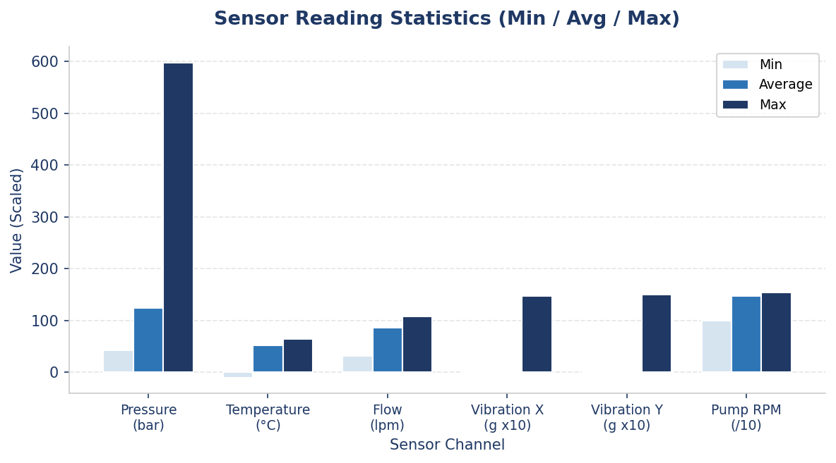

Sensor | Average | Minimum | Maximum
Pressure (bar) | 123.75 | 42.96 | 598.47
Temperature (C) | 52.22 | -9.94 | 64.86
Flow (lpm) | 86.15 | 31.25 | 108.13
Vibration X (g) | 0.14 | 0.05 | 14.74
Vibration Y (g) | 0.14 | 0.05 | 14.97
Pump RPM | 1,479.73 | 1,000.00 | 1,540.00

Business Insight: The extreme spikes in pressure (max 598.47 bar) and vibration (max 14.74g) are the most concerning findings. These outliers are very likely occurring during failure events such as pump wear and valve leakage and represent critical early warning signals.

4.3 Anomaly Rate Per Machine
The anomaly rate analysis examines the percentage of sensor readings flagged as abnormal for each of the 10 machines in the fleet providing a direct measure of machine health.

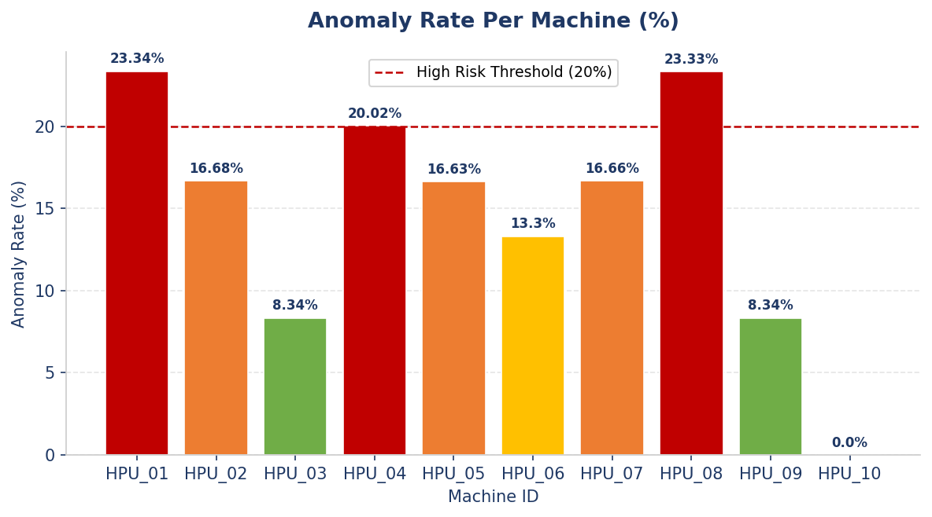

Business Insight: HPU_01 and HPU_08 have the highest anomaly rates at 23.34% and 23.33% respectively meaning almost 1 in every 4 sensor readings is flagged as abnormal. HPU_10 has zero anomalies confirming it as the healthiest machine in the fleet.

4.4 Remaining Useful Life (RUL) Distribution
The RUL analysis examines the average, minimum and maximum remaining useful life hours for each machine providing a direct measure of how close each machine is to requiring maintenance intervention.

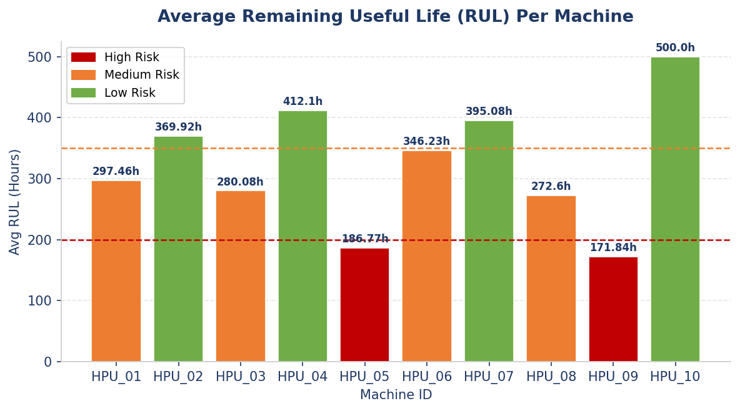

Business Insight: HPU_09 and HPU_05 are the most critical machines with average RUL of 171.84 and 186.77 hours respectively. Immediate maintenance should be scheduled for these two machines before their RUL reaches zero.

4.5 Maintenance Cost Per Machine
The maintenance cost analysis examines the total and average cost of maintenance activities per machine helping identify which machines are consuming the most maintenance resources.

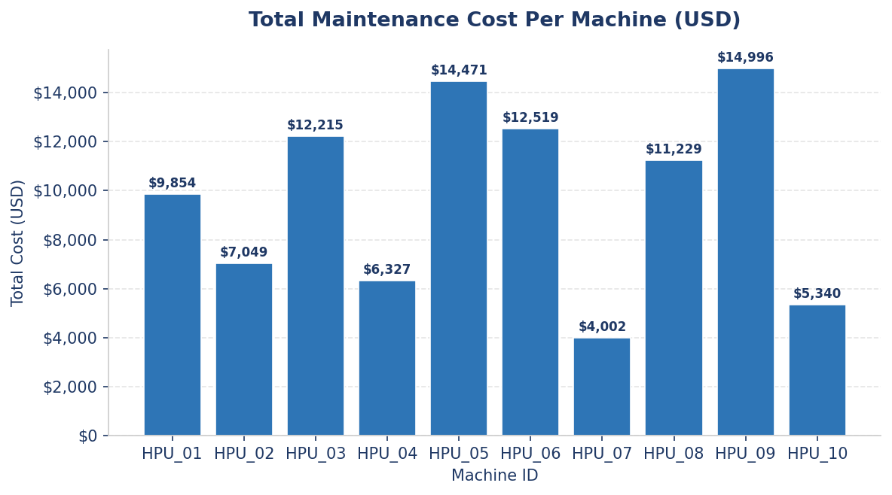

Business Insight: The top 5 most expensive machines to maintain are HPU_09, HPU_05, HPU_06, HPU_03 and HPU_08 with a combined maintenance cost of $65,430. Implementing predictive maintenance on these 5 machines alone would generate the most significant cost savings.

4.6 Repair Cost and Downtime by Failure Mode
This analysis examines the financial and operational impact of each failure mode by calculating total repair costs and total downtime hours to identify which failures have the greatest business impact.

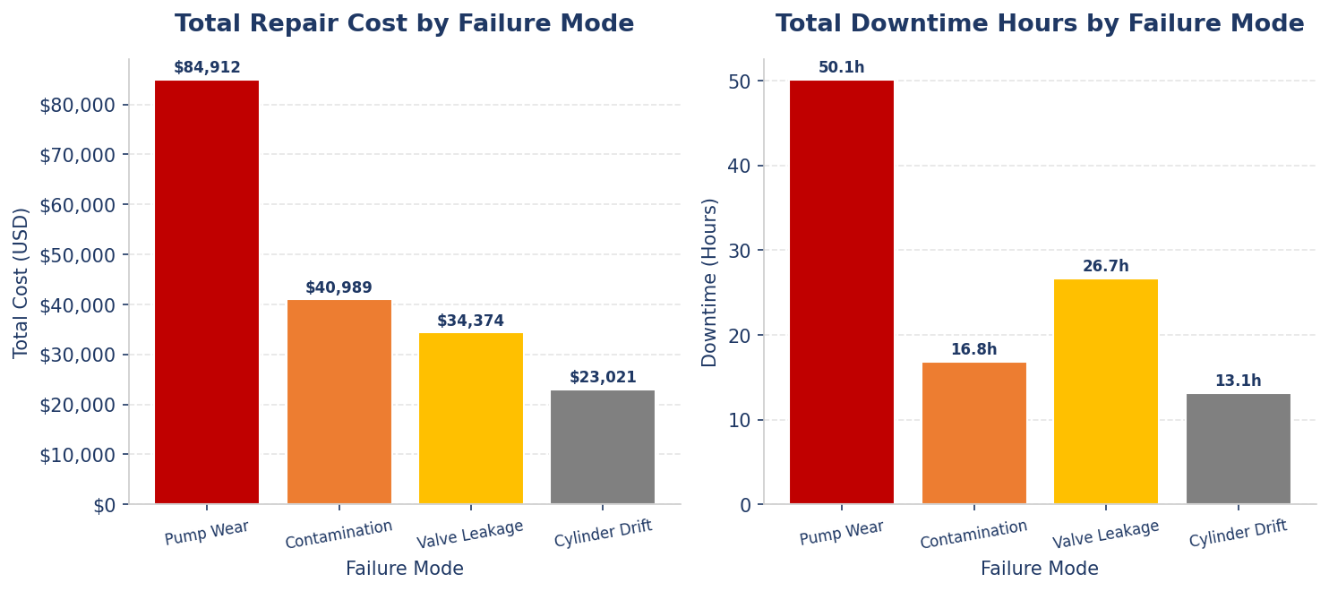

Failure Mode | Failures | Total Cost ($) | Total Downtime | Avg Cost ($)
Pump Wear | 3 | 84,912 | 50.10 hrs | 28,304
Contamination | 2 | 40,989 | 16.80 hrs | 20,495
Valve Leakage | 3 | 34,374 | 26.70 hrs | 11,458
Cylinder Drift | 1 | 23,021 | 13.10 hrs | 23,021
TOTAL | 9 | 183,296 | 106.70 hrs | -

Business Insight: Pump wear alone accounts for 46.3% of all repair costs and 47% of all downtime hours. Preventing even one pump wear failure through predictive maintenance would save Bosch Rexroth an average of $28,304 and 16.70 hours of production downtime per event.

4.7 Reactive vs Proactive Maintenance Ratio
The maintenance ratio analysis examines the balance between proactive and reactive maintenance activities to assess the current state of maintenance practices against the target KPI of 80% proactive and 20% reactive.

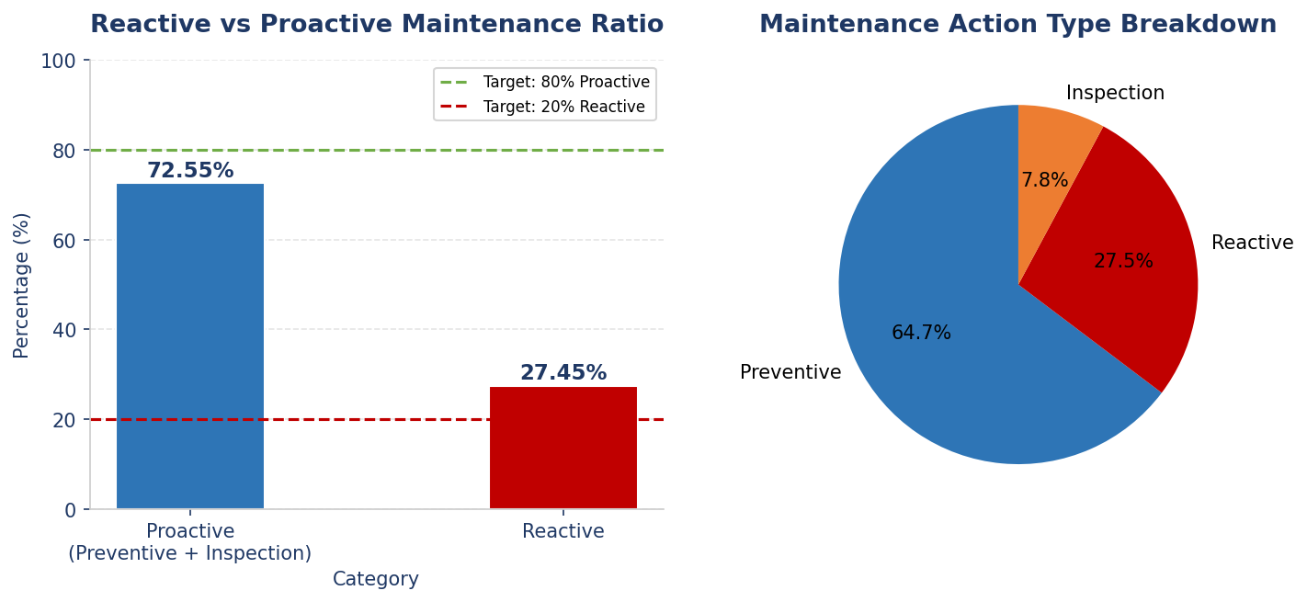

Business Insight: The current proactive ratio stands at 72.55% against the target of 80%. This means Bosch Rexroth needs to convert at least 4 more reactive maintenance activities into planned preventive activities to meet the KPI target.

4.8 Fluid Type Correlation with RUL
This analysis investigates whether the type of hydraulic fluid used in each machine has a statistically meaningful impact on the remaining useful life and anomaly rate of the machines.

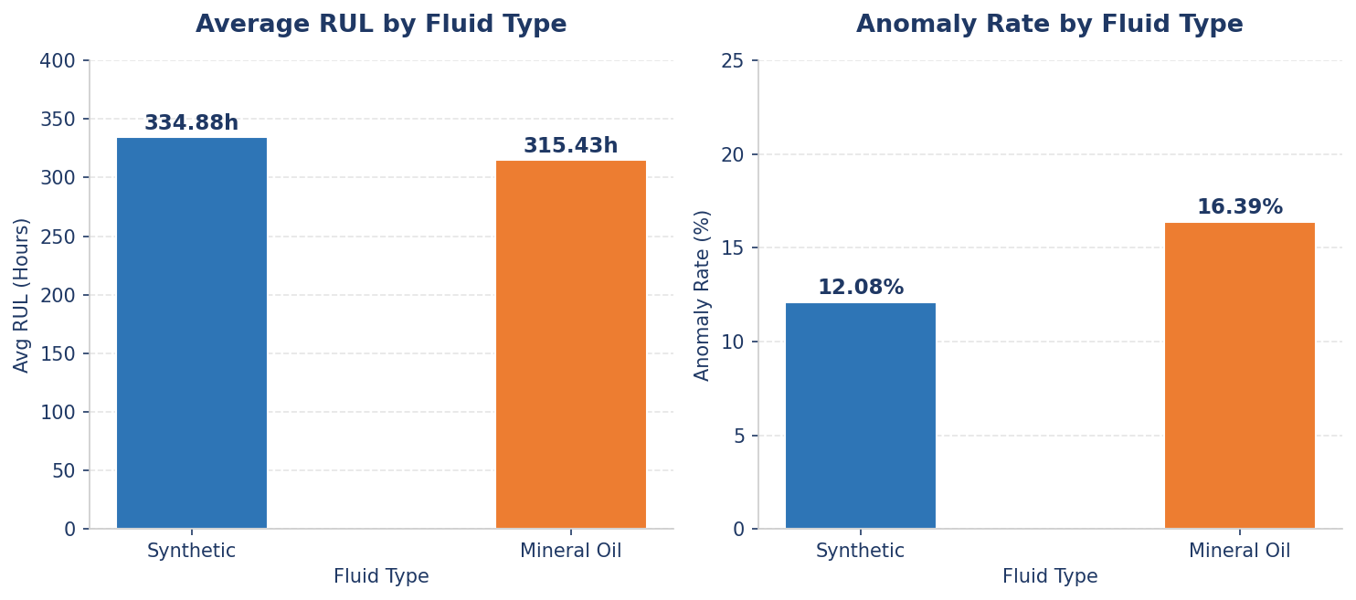

Fluid Type | Machines | Avg RUL (hrs) | Anomaly Rate | Avg Pressure
Synthetic | 4 | 334.88 | 12.08% | 124.08
Mineral Oil | 6 | 315.43 | 16.39% | 123.53

Business Insight: Synthetic fluid machines show a 6.2% higher average RUL and 26.3% lower anomaly rate compared to mineral oil machines. Transitioning more machines from mineral oil to synthetic fluid could extend component life and reduce maintenance frequency.

4.9 Machine Risk Classification
Based on the average RUL analysis all 10 machines were classified into three risk categories to provide maintenance engineers with a clear prioritisation framework for maintenance scheduling.

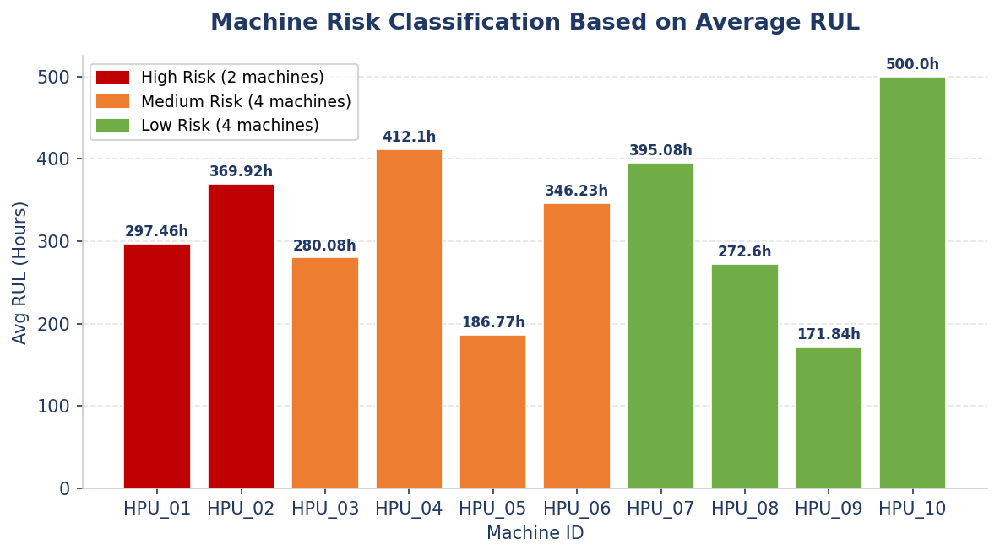

Risk Level | Machines | Avg RUL (hrs) | Anomaly Rate | Count
High Risk | HPU_09, HPU_05 | Below 200 hrs | 8-17% | 2
Medium Risk | HPU_08, HPU_03, HPU_01, HPU_06 | 200-350 hrs | 8-23% | 4
Low Risk | HPU_02, HPU_07, HPU_04, HPU_10 | Above 350 hrs | 0-20% | 4

5. KEY INSIGHTS & RECOMMENDATIONS

5.1 Immediate Action Required
Based on the EDA findings the following machines require immediate maintenance intervention:

- HPU_09 — Average RUL of 171.84 hours with 6 maintenance activities already performed at a total cost of $16,482. Schedule immediate maintenance before RUL reaches zero.
- HPU_05 — Average RUL of 186.77 hours with the highest average maintenance cost per activity at $3,617.75. Immediate inspection recommended.

5.2 Sensor Threshold Recommendations
Based on the sensor threshold analysis by failure mode the following alert thresholds are recommended for the predictive maintenance system:

Sensor | Normal Range | Warning Threshold | Failure Mode
Pressure (bar) | Above 110 | Below 110 | Pump Wear
Temperature (C) | Below 57 | Above 57 | Pump Wear / Valve Leakage
Vibration X (g) | Below 0.20 | Above 0.20 | Pump Wear
Vibration X (g) | Below 1.0 | Above 1.0 | Contamination
Flow (lpm) | Above 80 | Below 80 | Valve Leakage

5.3 Strategic Recommendations

- Transition HPU_01, HPU_05 and HPU_09 from Low and Medium maintenance priority to High priority based on their actual risk profiles revealed by the sensor data.
- Consider transitioning more machines from mineral oil to synthetic fluid to achieve a 6.2% improvement in average RUL and 26.3% reduction in anomaly rate.
- Increase the frequency of preventive inspections from the current 4 activities to at least 8 activities to push the proactive maintenance ratio from 72.55% to the target of 80%.
- Implement automated sensor threshold alerts for pressure, temperature, vibration and flow to provide 5 to 14 day advance warning of developing failures.
- Consider asset replacement evaluation for HPU_08 which has 24,309 operating hours the highest in the fleet and a repair cost of $30,336 per failure event.

5.4 KPI Gap Analysis

KPI | Target | Current | Status
Proactive Maintenance Ratio | 80% | 72.55% | Below Target
Reactive Maintenance Ratio | 20% | 27.45% | Above Target
Unplanned Downtime Reduction | 30-50% | Baseline: 106.70 hrs | To be measured
Maintenance Cost Variance | 20-30% savings | Baseline: $280,298 | To be measured

Business Insight: This EDA report establishes the baseline metrics required to measure the success of the predictive maintenance implementation. The machine learning models being developed by the Data Science team will target an F1-Score of 85% for failure classification and MAE of 10 hours or less for RUL prediction to deliver actionable maintenance interventions.

End of Report
Bosch Rexroth AG | Predictive Maintenance EDA Report | May 2026

