1.

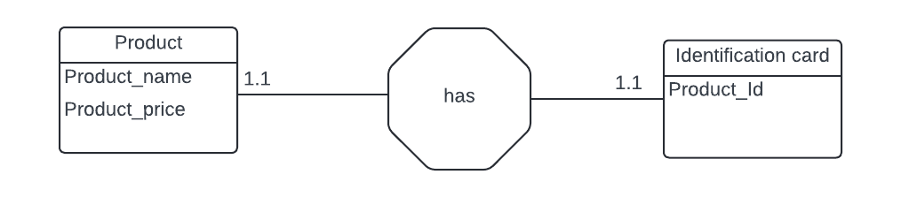

Note:

It is a one-to-one relationship each product ID corresponds to one product name and one product price.

2.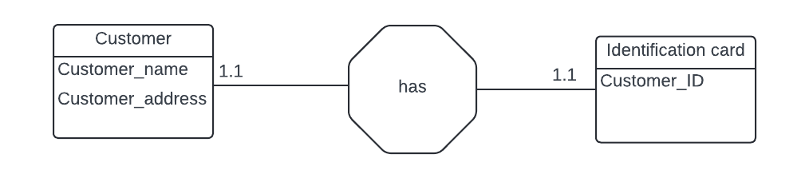

Note: Each customer ID corresponds to one unique customer name and one specific address.

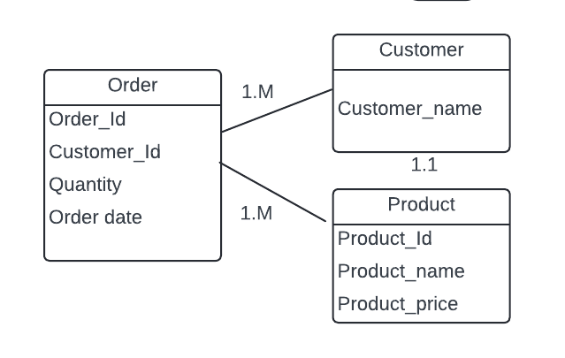

Notes:

* The visual representation above represents how the entities are related and the cardinality of the relationships.
* The order that is connected to the customer indicates one-to-many relationship while the order connected to the product entity also indicates a one-to-many relationship.
* This visual representation also indicates that one order contains many products, each with its own quantity and order date, but it is placed by **one customer.**