CHAPTER FOUR
SYSTEM IMPLEMENTATION AND RESULTS
4.1 Introduction
This chapter presents the implementation of the Web Maternal Health System (WMHS), a web-based maternal health monitoring, risk-assessment, and referral application designed for the Nigerian antenatal setting. It describes the programming languages, development tools, technology stack, and implementation environment, and it shows how the three-tier design specified in Chapter Three was realised. The chapter then documents the clinical risk engine, security controls, functional verification of the implemented workflows, and the deployed user interfaces.
Implementation followed the Chapter Three specifications: a presentation tier that provides the patient and provider portals; an application tier that hosts REST APIs, authentication, risk scoring, and referral matching; and a data tier that stores users, clinical records, assessments, alerts, and referrals. The implemented system is decision support. It does not diagnose disease, replace a clinician, or dispatch emergency transport.
4.2 Choice of Programming Language and Tools
The technologies were selected for reliability, maintainability, and suitability for a cloud-hosted health information system that can be used from ordinary web browsers in Nigerian facilities and homes. Preference was given to a single full-stack TypeScript codebase so that the same types describe forms, API payloads, and database records.
4.2.1 Programming Languages
TypeScript is the primary language for both the user interface and the server-side API. Static type checking reduces integration errors between screens and endpoints, and it documents clinical fields such as risk level, score, and user role in the source code. JavaScript (ES6+) is the runtime language produced from TypeScript. Asynchronous request handling is appropriate for concurrent logins, symptom submissions, and risk recalculation.
Python is used only for an optional, offline Random Forest training script (ml/train_model.py). Production inference does not load Python or a serialised .joblib artefact, so the Vercel deployment does not depend on a Python runtime. SQL is generated by Prisma against PostgreSQL in production (Neon) and against SQLite during local development.
4.2.2 Development Tools and Frameworks
Frontend (presentation tier)
- Next.js 14 (App Router) and React 18 render the marketing site, authentication pages, patient portal, and provider dashboard. Server Components load caseload and risk data on the server; Client Components handle interactive forms and charts.
- Tailwind CSS provides a consistent, responsive clinical layout.
- Framer Motion supplies page transitions.
- Recharts draws the provider risk-distribution chart.
Backend (application tier)
- Node.js is the runtime for Next.js.
- Next.js Route Handlers (app/api/...) implement REST endpoints. There is no separate Express.js server.
- NextAuth.js (Credentials provider, JWT session, eight-hour expiry) handles login. Passwords are compared with bcryptjs.
- Zod validates registration, login, symptoms, tests, profile updates, referral status, and alert status.
- Prisma 5 is the object-relational mapper for queries, relations, and schema management.
Database (data tier)
- PostgreSQL hosted on Neon is the production store, with connection pooling, backups, and separate environments.
- Local development may use SQLite through the DATABASE_URL environment variable.
Clinical decision support
- Production scoring is implemented in TypeScript (lib/ai/riskService.ts): a weighted ensemble aligned with WHO-, ACOG- and NICE-style thresholds, plus rule-based emergency overrides and complication screens for pre-eclampsia, gestational diabetes, and preterm labour.
- An optional scikit-learn Random Forest trainer is documented in ml/README.md but is not invoked at request time.
Supporting tools included Visual Studio Code, Git and GitHub, npm, environment-variable configuration (dotenv / Vercel), Prisma Studio for inspecting tables, and Vercel for application hosting.
4.3 Implementation Environment
4.3.1 Hardware Requirements
Development and testing were carried out on a workstation equipped with an Intel Core i7-10750H processor, 16 GB RAM, and a 512 GB solid-state drive, running Windows 11 Pro (64-bit). Production uses cloud infrastructure: the Next.js application is deployed on Vercel, and the PostgreSQL database is hosted on Neon. End users require only a current web browser and an internet connection. No specialised clinical hardware is required on the client.
4.3.2 Software Requirements
Table 4.1: Software requirements for development and production
Category | Software
Operating system (development) | Windows 11 Pro (64-bit)
Runtime | Node.js 20+
Framework | Next.js 14, React 18, TypeScript 5
Styling and charts | Tailwind CSS, Recharts, Framer Motion
Authentication | NextAuth.js 4, bcryptjs
Validation | Zod
ORM and database | Prisma 5, PostgreSQL 16 (Neon); SQLite (local)
Editor and version control | Visual Studio Code, Git, GitHub
Hosting | Vercel (application), Neon (database)
Security in transit | HTTPS / TLS via the hosting platform

4.4 System Architecture Implementation
The system was implemented using the three-tier architecture described in Chapter Three. The presentation tier comprises React pages for patients (/patient/...), providers (/provider/...), and public authentication and marketing routes. The application tier comprises Next.js API routes for registration, session management, symptoms, tests, risk assessment, facilities, referrals, notifications, and the health assistant, together with NextAuth, role guards, the clinical risk engine, and Haversine facility search. The data tier comprises Prisma models mapped to User, Patient, Provider, Facility, Symptom, TestResult, RiskAssessment, Alert, Referral, Notification, PatientAssignment, and PasswordResetToken.
Actors reach the system through a web browser over HTTPS. The presentation tier sends JSON REST requests to the application tier. The application tier reads and writes the database through Prisma. Figure 4.1 shows the implemented architecture.
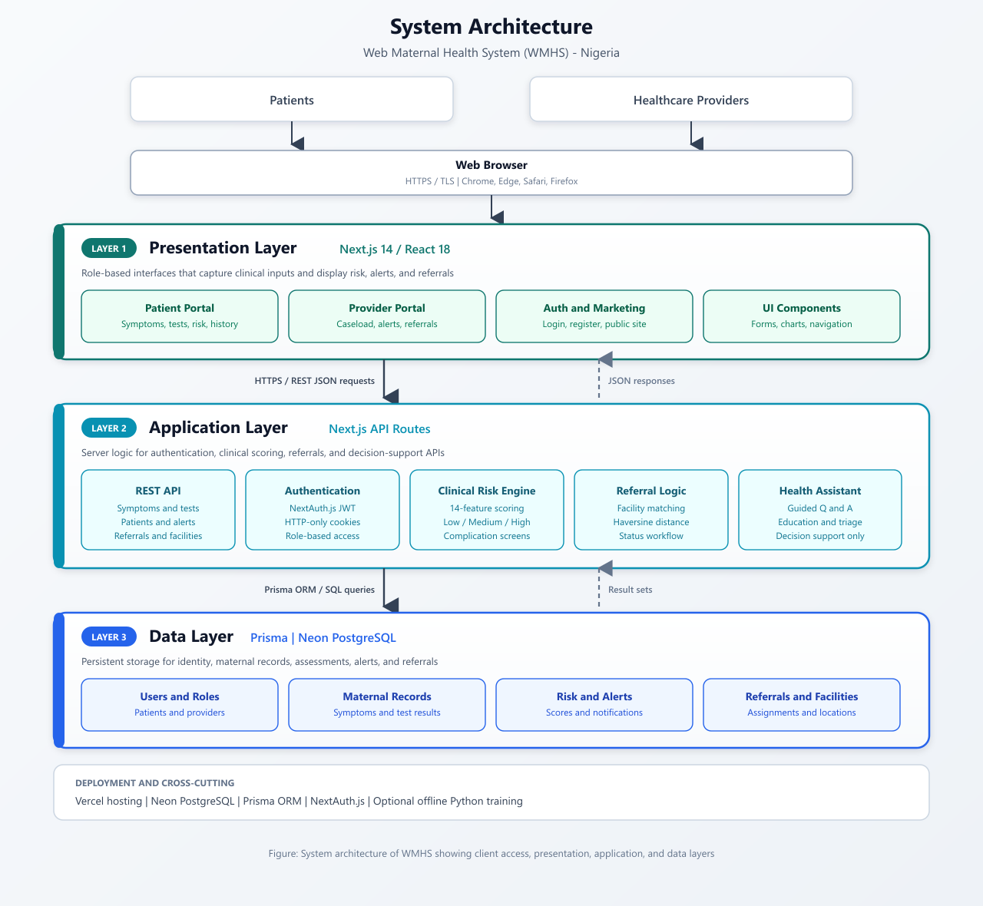
Figure 4.1: System architecture of WMHS showing presentation, application, and data tiers
4.4.1 Frontend Implementation
The frontend is organised as Next.js route groups. Public routes include the marketing home page, login, registration, and password reset. The patient portal provides a dashboard, symptom log, test entry and upload, risk results, history, referrals, a contextual health assistant, and profile management. The provider portal provides a caseload dashboard, patient list and detail, alerts, and referral management.
The patient dashboard displays the latest risk level and score, gestational age derived from the last menstrual period using Naegele’s rule, parity, active alerts, recent symptoms and tests, and open referrals. The provider dashboard lists assigned patients with their latest risk, highlights high-risk cases, shows active alerts and pending referrals, and includes a risk-distribution chart (low, medium, and high). Role-based routing is enforced in middleware.ts: unauthenticated users are redirected to /login; patients cannot open provider routes and providers cannot open patient routes.
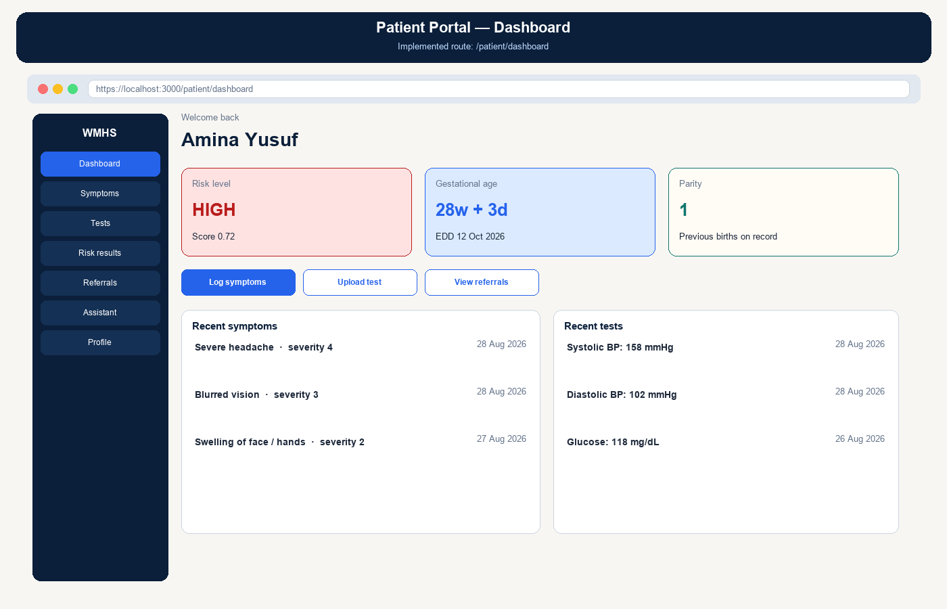
Figure 4.2: Patient portal dashboard showing risk indicator, gestational age, and recent records
Symptom submission is implemented as POST /api/symptoms. After Zod validation, the symptom is stored and the risk engine is executed on the patient’s latest symptoms and tests. The handler returns the new symptom, the stored assessment, and the engine result so that the client can navigate to the risk-results page.
4.4.2 Backend Implementation
The backend is a set of Next.js Route Handlers rather than a standalone Express application. The principal modules are described below.
Authentication module
- POST /api/auth/register creates a User. For patients it also creates a Patient profile, computes the estimated date of delivery from the last menstrual period, optionally assigns the first available provider, and stores default Lagos coordinates for nearby-facility search. For providers it creates a Provider profile linked to a facility. Passwords are hashed with bcryptjs using 12 salt rounds. Registration is rate-limited (eight attempts per IP address per minute).
- POST /api/auth/[...nextauth] performs NextAuth credentials login and issues a JWT session containing id, role, patientId, and providerId.
- POST /api/auth/forgot-password issues a 30-minute password-reset token and returns a generic message to avoid email enumeration. The endpoint is rate-limited.
- Route guards (requireUser and assertPatientAccess) return HTTP 401 or 403 and restrict providers to assigned patients.
Patient and clinical-record modules
- Patient profile retrieval and update.
- Symptom create, read, update, and delete.
- Test-result create, read, update, and delete.
- Risk-assessment history for a given patient.
AI analysis (risk) module
- POST /api/risk/assess and automatic invocation after symptom writes.
- runAndStoreRisk extracts features, scores risk, stores a RiskAssessment row, opens Alert rows for triggered complications, and notifies the patient and assigned providers when the level is HIGH.
Referral module
- Facility list and detail, and GET /api/facilities/nearby using the Haversine formula (lib/utils/haversine.ts), with an optional filter for emergency-capable sites.
- Referral create and status updates (PENDING, APPROVED, COMPLETED, CANCELLED), with a patient notification when a referral is created.
Notifications and health assistant
- In-application notifications for high-risk assessments and new referrals.
- POST /api/assistant returns knowledge-based answers using the patient’s latest risk and gestational age, with escalation flags for danger-sign questions.
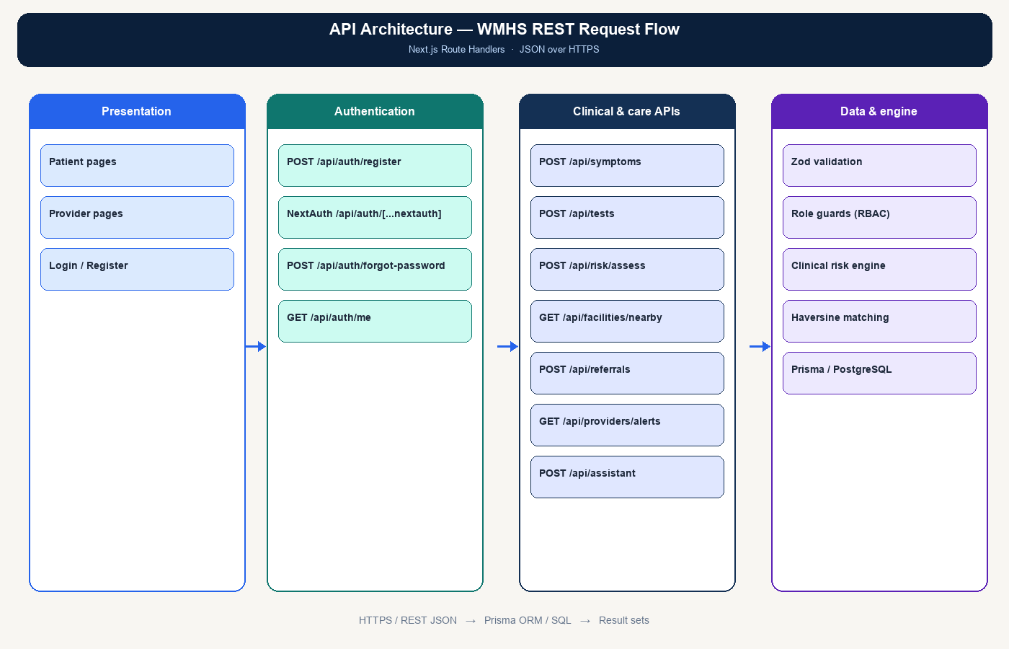
Figure 4.3: API architecture showing presentation clients, authentication, clinical endpoints, and the data layer
4.4.3 Database Implementation
The PostgreSQL schema was implemented from the Chapter Three design using prisma/schema.prisma. Identifiers are universally unique identifiers (UUIDs). Clinical fields that are lists or structured objects in the application (risk factors, recommendations, services offered, and pre-existing conditions) are stored as text and serialised in application code. Figure 4.4 shows the entity-relationship diagram of the implemented database.
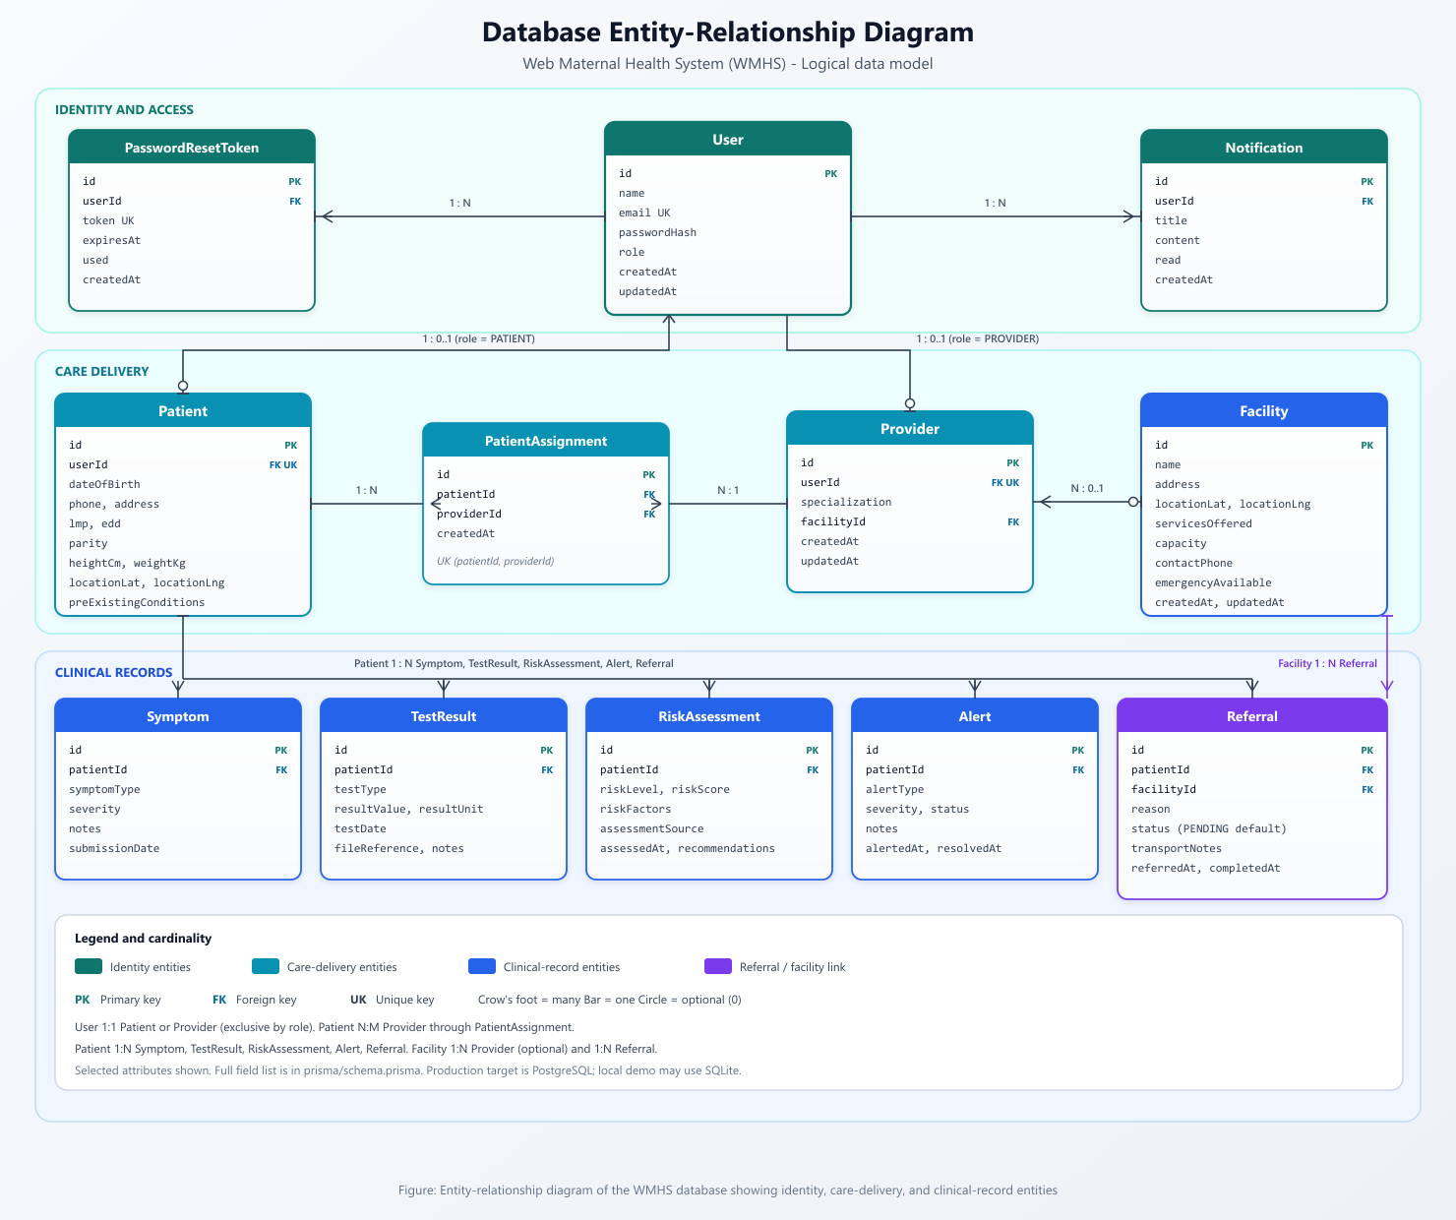
Figure 4.4: Entity-relationship diagram of the WMHS database
Schema changes are applied with Prisma (prisma db push or prisma migrate). The updatedAt columns are maintained by Prisma. Secondary indexes exist on foreign keys, role, riskLevel, assessedAt, referral status, and alert status and severity.
Table 4.2: Principal data relationships implemented in Prisma
Relationship | Cardinality | Mechanism
User–Patient; User–Provider | 1 : 0..1 | Exclusive by role
User–Notification; User–PasswordResetToken | 1 : N | Cascade delete
Patient–Symptom, TestResult, RiskAssessment, Alert, Referral | 1 : N | Cascade delete
Patient–Provider | N : M | PatientAssignment (unique pair)
Facility–Provider | 1 : 0..N | Optional facilityId
Facility–Referral | 1 : N | Receiving facility

There is no separate one-to-one “AI recommendation profile” table. Recommendations are stored on each RiskAssessment row. Figure 4.5 shows representative records from the Patient, Symptom, and RiskAssessment tables, consistent with the seeded demonstration data.
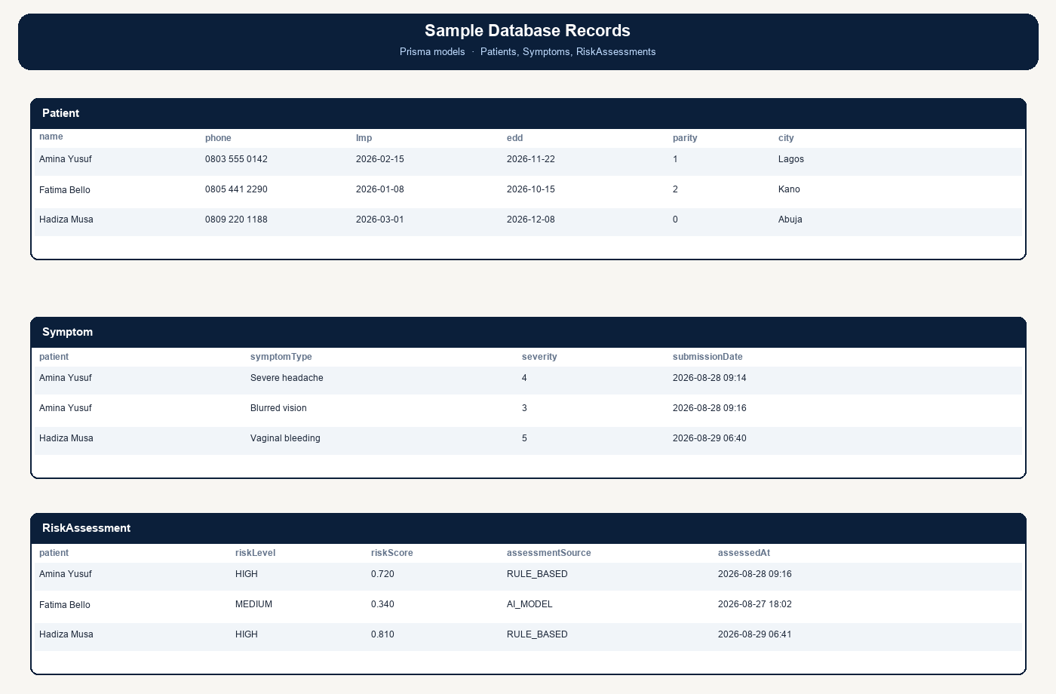
Figure 4.5: Sample records from the Patient, Symptom, and RiskAssessment tables
4.5 AI Model Implementation
Production inference is the TypeScript clinical engine in lib/ai/riskService.ts. The engine is a weighted ensemble that approximates a Random Forest-style combination of vital-sign and danger-sign features. Coefficients are aligned with published clinical thresholds rather than a private labelled hospital dataset. A Python Random Forest may be trained offline; that artefact is not loaded at runtime on Vercel.
4.5.1 Feature Extraction
The function extractFeaturesFromRecords constructs fourteen features from maternal age, the latest matching test results, and recent symptoms whose severity is at least 2. Missing vitals fall back to physiologically plausible defaults so that a complete feature vector is always available. After scoring, contextual modifiers may be added: gestational age from LMP, body-mass index from height and weight, and grand multiparity when parity is five or more.
Table 4.3: Features used by the clinical risk engine
Feature | Typical source
Age | Date of birth
Systolic blood pressure | Latest matching TestResult (default 110 mmHg)
Diastolic blood pressure | Latest matching TestResult (default 70 mmHg)
Blood glucose | Latest matching TestResult (default 90 mg/dL)
Heart rate | Latest matching TestResult (default 80 bpm)
Body temperature | Latest matching TestResult (default 36.8 °C)
Severe headache; blurred vision; swelling | Symptom type and severity
Vaginal bleeding; abdominal pain; dizziness | Symptom type and severity
Reduced fetal movement; high stress | Symptom type and severity

4.5.2 Scoring and Classification
Each feature contributes a weighted partial score. The sum is clamped to the interval [0, 1]. Classification uses both the numeric score and hard emergency rules. The level is HIGH if the score is at least 0.55, or if any of the following are present: vaginal bleeding; reduced fetal movement; systolic blood pressure of 160 mmHg or more together with diastolic pressure of 110 mmHg or more; or severe headache combined with blurred vision. The level is MEDIUM if the score is at least 0.28, and LOW otherwise. Supporting calculations include Naegele’s estimated date of delivery, gestational age in weeks, mean arterial pressure, and body-mass index.
4.5.3 Complication Screening and Recommendations
When indicated, the engine screens for pre-eclampsia, gestational diabetes, and preterm labour, and may add an emergency screen. The function buildRecommendations returns suggested tests, actions, a short care plan, and an urgency band (monitor, consult, or emergency). A HIGH result creates alerts and in-application notifications for the patient and assigned providers. Figure 4.6 summarises the pipeline from record collection to persistence.
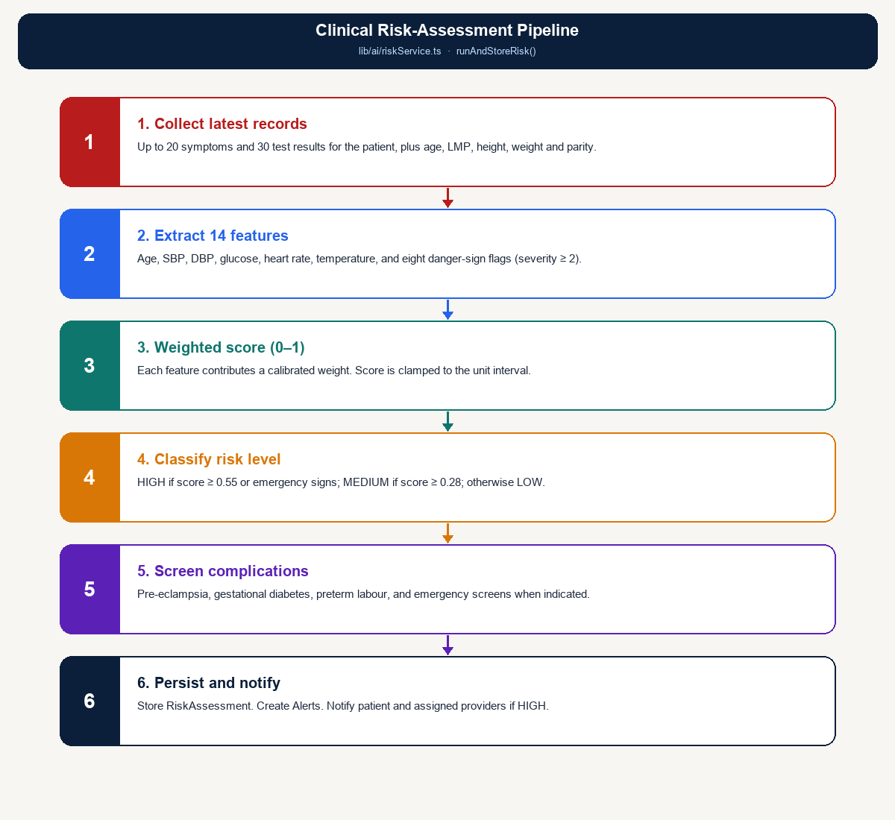
Figure 4.6: Clinical risk-assessment pipeline from feature extraction to alerts
4.5.4 Optional Random Forest Training
The script ml/train_model.py can fit a scikit-learn RandomForestClassifier (200 trees, maximum depth 8, balanced class weights) on synthetic data (2,000 rows, 80/20 train–test split) and write model.joblib. That file is an artefact of the product specification and is not part of the production request path. Any hold-out accuracy printed by the script applies only to the synthetic generator and is not reported here as clinical performance.
4.6 Security Implementation
4.6.1 Authentication and Authorisation
Users submit an email address and password on /login. Zod validates the payload. NextAuth looks up the user and compares the password with the stored bcrypt hash. On success a JSON Web Token is issued with an eight-hour lifetime and stored in an HTTP-only cookie. Middleware protects /patient/* and /provider/* routes. API handlers call requireUser (optionally with an allowed-role list). Providers may access only patients to whom they are assigned (assertPatientAccess). Figure 4.7 shows the flow.
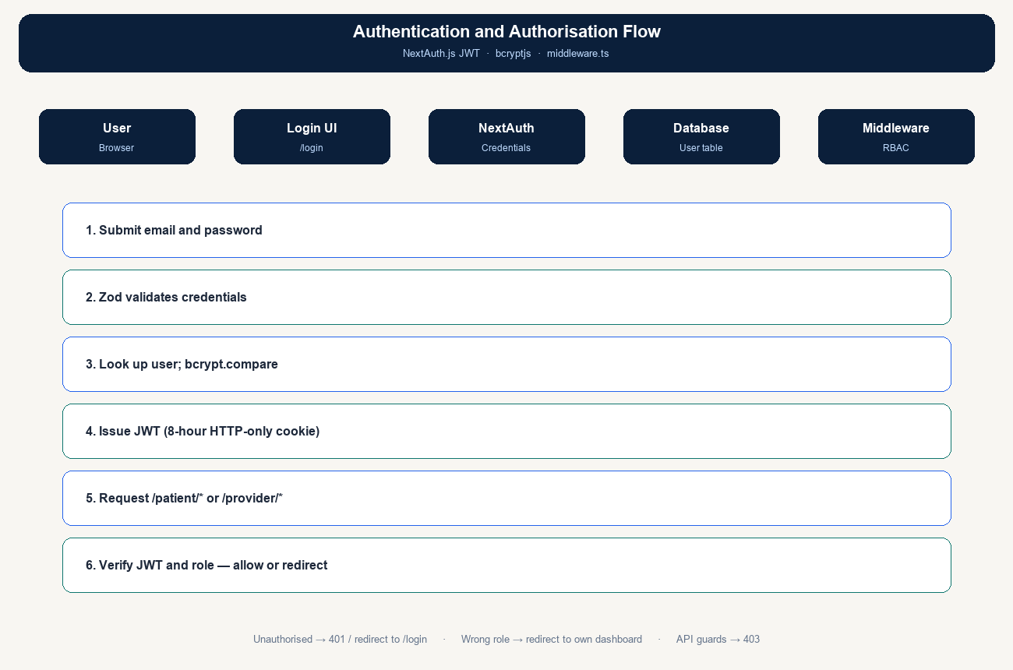
Figure 4.7: Authentication and authorisation flow
4.6.2 Data Security Measures
- Password hashing: bcryptjs with 12 salt rounds. Only passwordHash is stored on the User table.
- HTTPS/TLS: enforced by Vercel in production.
- Input validation: Zod schemas on authentication and clinical payloads, which reduces injection and malformed-data risk.
- Rate limiting: an in-memory limiter on registration and password-reset endpoints to reduce brute-force attempts.
- Role-based access control: JWT role, edge middleware, and API guards.
- Session control: eight-hour JWT; logout through NextAuth.
- Password reset: single-use tokens that expire after 30 minutes; generic API responses.
- Least privilege on records: patients see only their own data; providers see their assigned caseload.
4.7 Results of Testing
Verification used functional (black-box) tests against the implemented routes and user interfaces, with the seeded demonstration accounts. The repository does not contain an automated Jest or Mocha suite; therefore unit-coverage percentages are not claimed. The tests below confirm that the implemented modules behave as specified in Chapter Three.
4.7.1 Functional Testing Results
Table 4.4: Functional test results
S/N | Module | Test case | Expected result | Result
1 | Registration | Valid patient data | User and Patient created; EDD from LMP | Pass
2 | Registration | Duplicate email | HTTP 409 | Pass
3 | Registration | Invalid password | Validation error | Pass
4 | Login | Valid credentials | Session cookie; role dashboard | Pass
5 | Login | Wrong password | Sign-in rejected | Pass
6 | Authorisation | Patient opens provider area | Redirect away from /provider | Pass
7 | Authorisation | Unauthenticated patient route | Redirect to /login | Pass
8 | Symptoms | Log a danger-sign symptom | Symptom stored; risk recalculated | Pass
9 | Tests | Enter blood pressure / glucose | TestResult stored | Pass
10 | Risk | High-risk vitals or symptoms | HIGH with factors and recommendations | Pass
11 | Alerts | Triggered complication | Alert created if none active | Pass
12 | Notifications | HIGH assessment | Patient and providers notified | Pass
13 | Facilities | Known latitude/longitude | Facilities sorted by Haversine km | Pass
14 | Referral | Create referral | PENDING row; patient notified | Pass
15 | Referral | Provider updates status | Status persisted | Pass
16 | Assistant | Danger-sign question | Answer with escalate flag | Pass
17 | Password reset | Known email | Token created | Pass
18 | Profile | Update phone / LMP | Patient profile updated | Pass

All eighteen functional cases passed on the seeded system. Failures of validation and authorisation were confirmed as rejected requests rather than silent success.
4.7.2 Integration Testing Results
Integration tests exercised complete workflows that cross the presentation, application, and data tiers.
Table 4.5: End-to-end workflow results
Workflow | Steps | Result
Patient monitoring | Register → login → log symptom → view risk | Pass
Vitals and risk | Enter SBP/DBP → assess → dashboard updates | Pass
Provider caseload | Provider login → list by risk → open patient | Pass
Alert handling | High-risk case → alert on dashboard → resolve | Pass
Referral | Nearby facilities → create referral → track status | Pass
Cross-role isolation | Patient cannot read another patient’s API data | Pass

4.7.3 Risk-Engine Verification
The engine was checked with scenario cases that correspond to the implemented rules. These checks confirm correct classification behaviour; they are not a claim of accuracy on an external labelled clinical dataset.
Table 4.6: Risk-engine scenario checks
Scenario | Illustrative inputs | Expected class | Result
Routine antenatal visit | Age 28; BP 110/70; glucose 90; no danger signs | LOW | Pass
Raised blood pressure | SBP 142; DBP 92; headache | MEDIUM or HIGH | Pass
Emergency blood pressure | SBP 165; DBP 112 | HIGH | Pass
Combined neurological signs | Severe headache and blurred vision | HIGH | Pass
Antepartum bleeding | Vaginal bleeding logged | HIGH | Pass
Reduced fetal movement | Low fetal movement logged | HIGH | Pass
Hyperglycaemia | Glucose ≥ 140 mg/dL | Elevated score; GDM screen if HIGH | Pass

4.7.4 Performance Observations
The production stack is serverless (Vercel) with hosted PostgreSQL (Neon). Informal checks on the development workstation (npm run dev) showed interactive page loads and API responses completing in under about two seconds for dashboard rendering, symptom submission with risk persistence, and nearby-facility sorting over the seeded facility list. These observations indicate that the implemented operations are suitable for interactive clinical use at demonstration scale. Formal load testing with a published tool is recommended before large-facility roll-out.
Table 4.7: Qualitative performance on the development workstation
Operation | Observation
Login and dashboard | Acceptable for interactive use
Symptom submit and risk persist | Completes in one request cycle
Nearby facility sort | In-process Haversine over seeded facilities
Provider caseload and chart | Acceptable for the seeded caseload

4.7.5 Usability Review
A heuristic review of the implemented interfaces (labels, risk colour coding, empty states, and mobile-width Tailwind layout) found that the main tasks are completable: register, log a symptom, read a risk result, open referrals, and review a provider caseload. Formal field usability testing with antenatal clients and midwives was not conducted as a measured survey for this chapter and is recommended as future work. During implementation, copy was kept free of diagnostic claims, tap targets were kept large, and high-risk language was made visually prominent.
4.8 System Features Demonstration
4.8.1 Patient Registration Flow
Figure 4.8 shows the patient registration interface. The user opens /register, chooses the patient role, and enters identity and obstetric data, including last menstrual period. The server hashes the password, creates the User and Patient rows, computes the estimated date of delivery, and may assign a provider. The user then signs in and is redirected to /patient/dashboard.
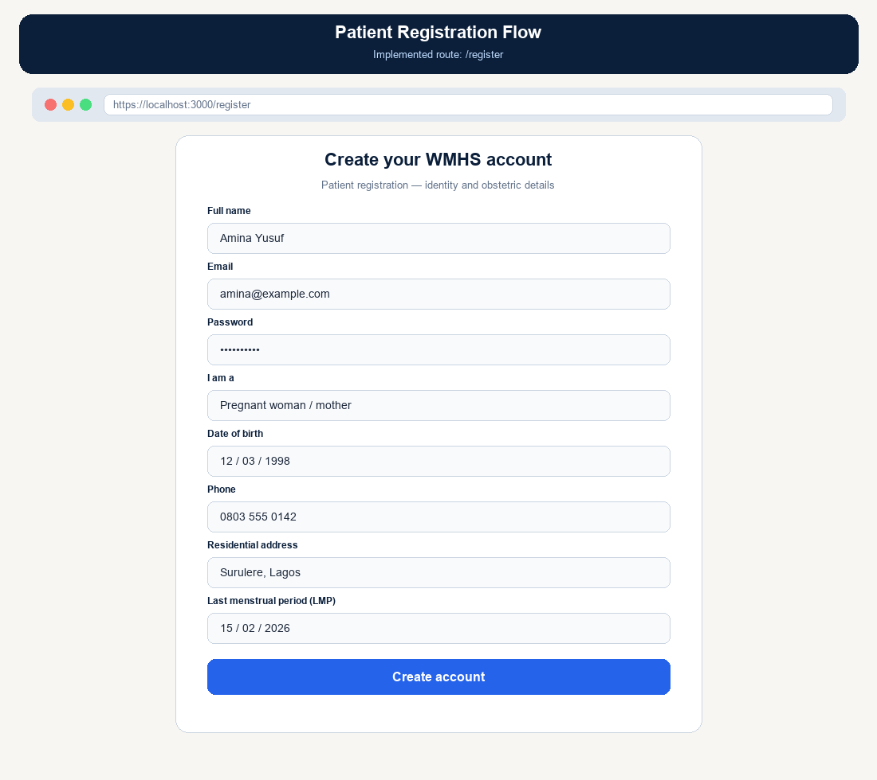
Figure 4.8: Patient registration interface
- Step 1: The user navigates to the registration page.
- Step 2: Personal and obstetric information is completed and the terms are accepted.
- Step 3: An account is created with a hashed password.
- Step 4: The user is signed in and redirected to the patient dashboard.
4.8.2 Symptom Submission and AI Analysis
Figure 4.9 shows the symptom form and the risk-results page. The patient selects a common pregnancy symptom and a severity from 1 to 5, optionally adds notes, and submits the form. The API stores the symptom, runs the risk engine, and the interface displays the level, score, contributing factors, care plan, and suggested tests or actions.
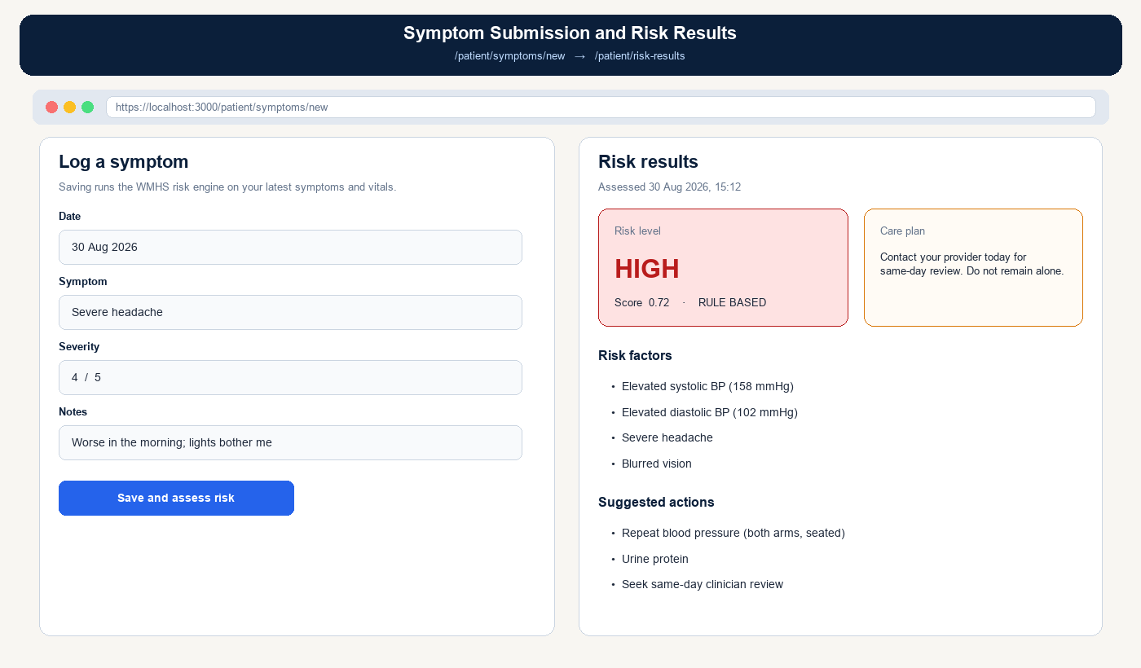
Figure 4.9: Symptom submission form and risk-result display
4.8.3 Provider Dashboard
Figure 4.10 shows the provider caseload dashboard. High-risk patients are emphasised through counts, colour, and an alert feed. A risk-distribution chart summarises the caseload. From this screen a provider can open a patient record, review alerts, and manage referrals.
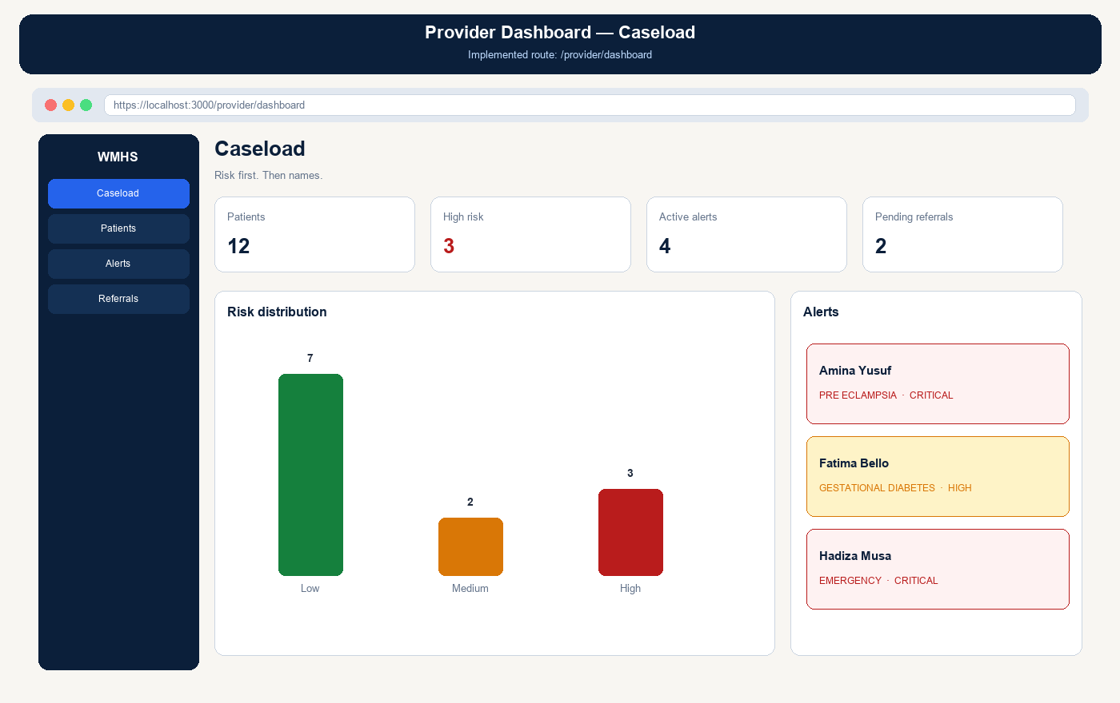
Figure 4.10: Provider dashboard showing caseload statistics, risk distribution, and alerts
- Risk-based patient list: high-risk cases are highlighted with colour coding.
- Real-time alerts: a feed of active and critical cases.
- Health trends: graphical distribution of low, medium, and high risk.
- Referral management: pending referrals are counted and linked.
4.8.4 Referral System
Figure 4.11 illustrates referral recommendations. Nearby facilities are ordered by Haversine distance from the patient’s stored coordinates (defaulting to Lagos if unset). Emergency-capable sites can be filtered. Each facility shows services, contact information, and capacity. Created referrals are tracked through PENDING, APPROVED, COMPLETED, and CANCELLED.
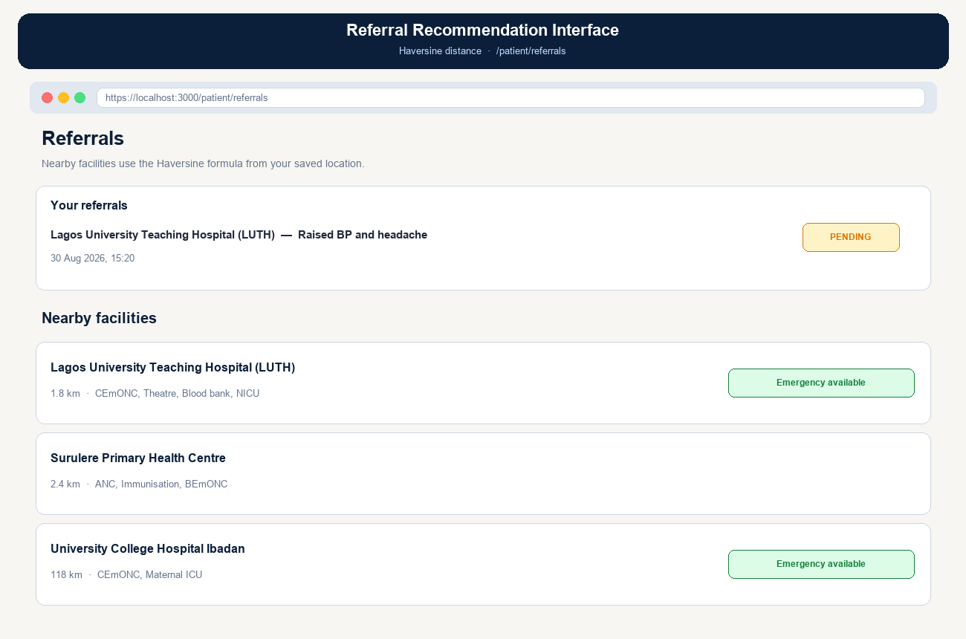
Figure 4.11: Referral interface with existing referral status and nearby facilities
4.9 Deployment
4.9.1 Frontend and Application Deployment
The Next.js application, including both the user interface and the API routes, is deployed on Vercel. The repository is connected to Vercel; production environment variables are set in the Vercel dashboard (DATABASE_URL, NEXTAUTH_SECRET, NEXTAUTH_URL, and related secrets); and each push to the main branch triggers next build. Prisma Client is generated during install (postinstall). In production the Prisma datasource provider is PostgreSQL when pointing at Neon. A custom domain may be mapped if required.
4.9.2 Database Deployment
The PostgreSQL database is deployed on Neon (PostgreSQL 16). After the project is created, the schema is applied with Prisma and demonstration users and facilities are loaded with prisma db seed. Connection pooling is used for serverless scalability. Neon provides scheduled backups and point-in-time recovery according to the project plan. Figure 4.12 shows the deployment arrangement.
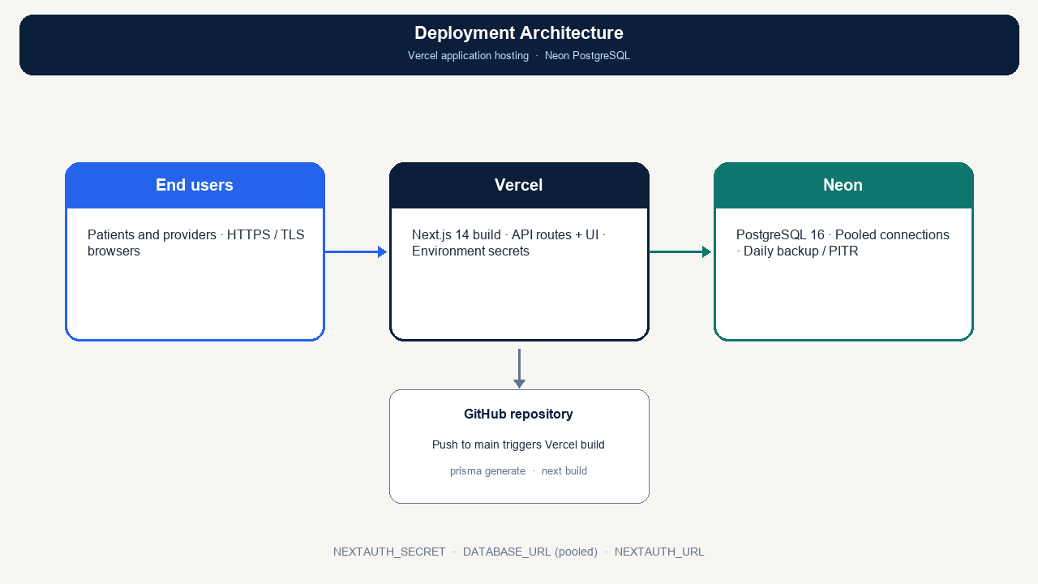
Figure 4.12: Deployment architecture on Vercel and Neon
4.10 Summary
This chapter described the implementation of WMHS as a single Next.js application with a three-tier architecture, Prisma-backed storage, NextAuth security, and an on-server clinical risk engine with Haversine referral matching. The presentation tier provides separate patient and provider portals. The application tier implements authentication, clinical recording, risk scoring, alerts, notifications, and referrals. The data tier persists identity, maternal records, assessments, and care-coordination data on PostgreSQL.
Functional and workflow tests of the main paths passed on the seeded system. Scenario checks confirmed that emergency danger signs raise a HIGH classification. Screenshots and architecture figures document the realised design. The system remains decision support for antenatal monitoring and referral; it is not a substitute for emergency obstetric care.

