Computer Vision Final project

Task 1: Selective Object Enhancement

Objective
Enhance a specific-colored object (sharpen) while blurring the rest of the image.

Methodology

Pipeline:
text
Input → HSV Conversion → Color Mask → Noise Removal → Sharpen (mask) + Blur (background) → Output

Blur
    - Box blur using a normalized kernel of size k×k
    - Each pixel becomes the average of its k×k neighborhood
    - Implemented with sliding_window_view for vectorized computation

Sharpen
    - Sobel edge detection (Gx and Gy kernels)
    - Sharpened = Original + strength × (Gx + Gy)
    - Strength parameter controls intensity

Color Mask
    - Convert RGB to HSV (better color separation)
    - Create binary mask using HSV bounds for target color
    - Red requires two ranges (0-10 and 170-180)
    - Remove small noise by filtering contours below min_area
Results

Color | Target Object | Image
Red | Roses | 
Yellow | 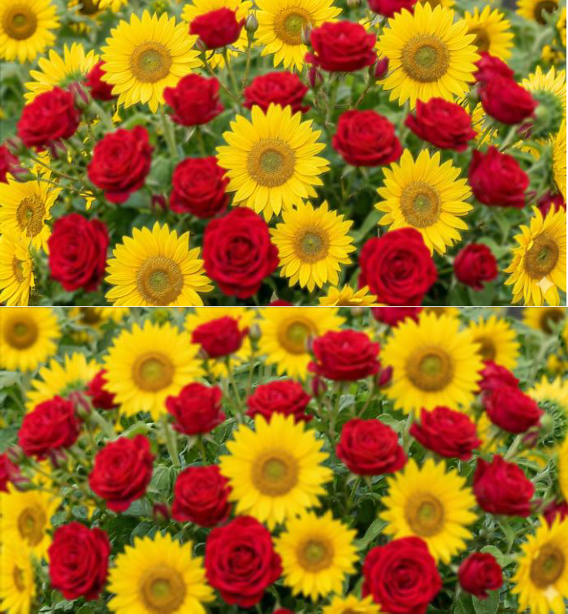  Sunflowers
Green | Stems

Task 2: Comparative Study of Sharpening Pipelines for X-Ray Images

Objective
Design and implement three different image enhancement pipelines for X-ray images, each using a different strategy. Compare the results and analyze the strengths and weaknesses of each approach.

Library Design
All Task 2 code is organized in a single module: task_2.py. The file is structured in four layers:
- Shared I/O utilities — load_image and save_image handle reading and writing grayscale images using OpenCV.
- Shared processing utilities — apply_kernel performs manual 2D convolution from scratch using NumPy stride tricks (no cv2.filter2D). clip_and_convert ensures all float results are clipped to [0,255] and converted to uint8.
- Three independent pipelines — each pipeline is a self-contained function that takes a grayscale image and returns an enhanced image. Helper functions (e.g. _gaussian_kernel, _apply_clahe) are prefixed with underscore to indicate they are internal.
- compare_pipelines runner — a utility function that runs all three pipelines on the same image and saves a side-by-side comparison strip.
Module structure:

task_2.py
■■■ load_image(path)
■■■ save_image(image, path)
■■■ apply_kernel(image, kernel) # shared convolution
■■■ clip_and_convert(image) # shared utility
■■■ _gaussian_kernel(size, sigma) # P1 helper
■■■ pipeline_unsharp_masking(...) # Pipeline 1
■■■ _apply_clahe(...) # P2 helper
■■■ pipeline_clahe_laplacian(...) # Pipeline 2
■■■ pipeline_fft_highpass(...) # Pipeline 3

Methodology
One chest X-ray image is used as input for all three pipelines to ensure a fair comparison — any difference in output is caused only by the pipeline, not by the image content.
Input  Pipeline 1 / Pipeline 2 / Pipeline 3  Side-by-side Comparison
  - Pipeline 1 — Unsharp Masking
Concept:
Blur the image with a Gaussian filter to get a smooth version with no edges, subtract the blurred from the original to isolate edges and details (the unsharp mask), then add the mask back scaled by a strength parameter to amplify those edges.
Formula:
mask = original - Gaussian_blurred
output = original + strength x mask

Steps:
    - Build a 2D Gaussian kernel (size=5, sigma=1.0) — normalized so all values sum to 1.
    - Convolve the image with the kernel using apply_kernel to get the blurred version.
    - Subtract blurred from original to extract only edges and fine details.
    - Add the edge mask back to the original scaled by strength=1.5.
    - Clip to [0,255] and convert to uint8.

  - Pipeline 2 — CLAHE + Laplacian Sharpening
Concept:
X-ray images often have low contrast with uneven exposure. CLAHE fixes contrast region by region, then Laplacian sharpening makes the edges crisp.
Stage A — CLAHE:
    - Divide the image into 64 tiles (8x8 grid). Each tile is an independent region.
    - For each tile: build a histogram, clip it at clip_limit=2.0 to prevent noise amplification, redistribute excess pixels evenly.
    - Build a CDF from the clipped histogram and normalize to [0,255] to create a LUT — a translation table that remaps pixel intensities to improve contrast.
    - For every pixel, blend the LUTs of the 4 surrounding tile centers using bilinear interpolation to ensure smooth transitions with no harsh tile borders.
Stage B — Laplacian Sharpening:
Apply the Laplacian kernel to the CLAHE result to detect edges, then add them back:

[ 0, -1, 0 ] output = CLAHE_result + strength x Laplacian
[-1, | 4, | -1 | ]
[ 0, | -1, | 0 | ]

  - Pipeline 3 — FFT Gaussian High-Pass Filter
Concept:
Convert the image to the frequency domain. Low frequencies = smooth regions, high frequencies = edges and details. Boost high frequencies then convert back to pixels.
Steps:
    - Apply 2D FFT and shift DC (zero-frequency) to the center of the spectrum.
    - Build a Gaussian High-Pass Filter: HPF = 1 - exp(-D^2 / (2 x cutoff^2)). Values near center (low freq) ~0, values far from center (high freq) ~1.
    - Blend as: combined_filter = 1 + boost x HPF — keeps low frequencies but amplifies high ones.
    - Multiply FFT by the filter, apply inverse shift, apply inverse FFT to return to pixels.
    - Take magnitude (FFT produces complex numbers), clip to [0,255] and convert to uint8.

Strengths and Weaknesses

Pipeline | Strengths | Weaknesses
P1: Unsharp Masking | - Simple and efficient • Easy to tune  - Good for well-exposed X-rays • Preserves brightness | - Cannot fix low contrast • Amplifies noise at high strength • Global — not adaptive
P2: CLAHE +  Laplacian | - Best for dark/low-contrast X-rays • Adapts per-tile to uneven exposure • Powerful contrast + sharpening • Best for medical imaging | Artifacts if clip_limit too high • More parameters to tune • Laplacian may amplify noise
P3: FFT  High-Pass | - Precise frequency-band control • Reveals fine textures • Mathematically principled • Independent boost and cutoff control | - Ringing artifacts near edges • Less intuitive parameters • Slightly slower on large images

Results and Observations

Output — Pipeline Comparison:
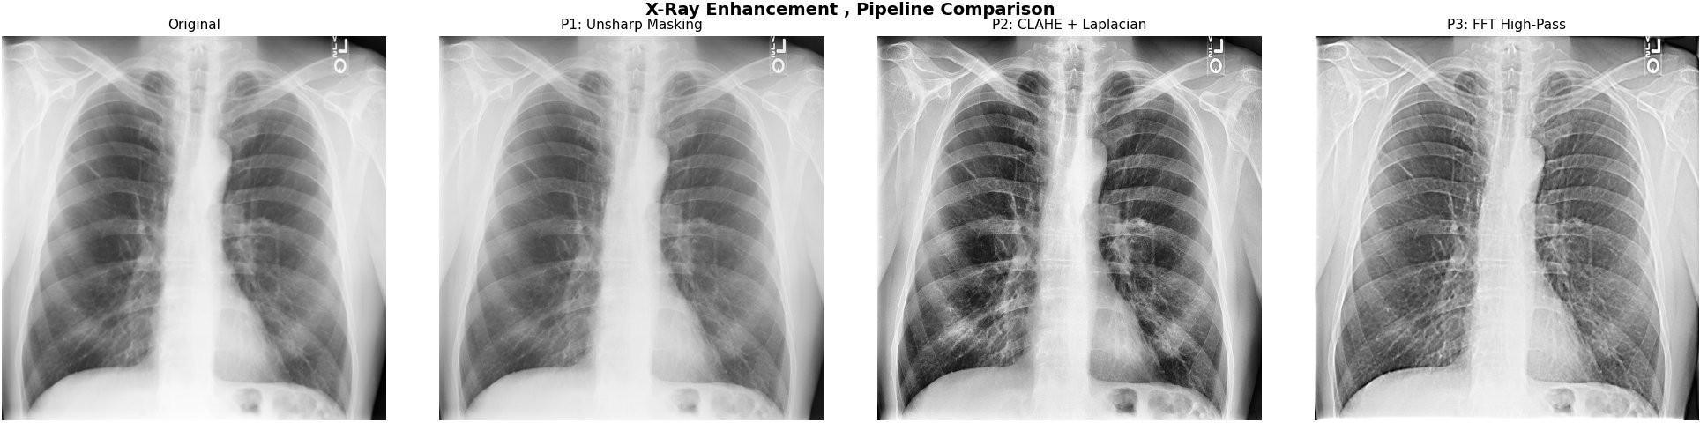
Pipeline 1 — Unsharp Masking:
The output shows a mild but visible improvement in sharpness. Rib edges and lung tissue boundaries appear slightly more defined compared to the original. The overall brightness and tone are preserved. However, the dark lung regions remain similarly dark — the pipeline sharpens what is already visible but does not reveal hidden detail in underexposed areas.
Pipeline 2 — CLAHE + Laplacian:
This pipeline produces the most dramatic transformation. The lung fields become much darker and higher in contrast, revealing internal vascular and bronchial structures that are barely visible in the original. Rib boundaries and soft tissue edges are sharp and well-defined. The adaptive per-tile contrast enhancement successfully handles the uneven exposure between the bright bone regions and the dark lung fields simultaneously. This result is the most diagnostically useful of the three.
Pipeline 3 — FFT High-Pass:
The result shows noticeably enhanced edge definition and fine texture detail. Rib edges and lung tissue patterns are sharper than the original and Pipeline 1, and the overall image appears slightly brighter due to the high-frequency boost. The enhancement is stronger than Pipeline 1 but does not achieve the contrast improvement of Pipeline 2. No visible ringing artifacts are present at the default boost=2.0 setting.

Overall Conclusion:
For general well-exposed X-rays, Pipeline 1 is sufficient and the simplest to apply. For dark, underexposed, or low-contrast X-rays — the common case in medical imaging — Pipeline 2 gives the best results by combining adaptive contrast enhancement with edge sharpening. Pipeline 3 provides a strong middle ground with fine texture enhancement using a mathematically principled frequency-domain approach.

Task 4: Document Cleaning System

Objective
The goal of this task is to enhance scanned document images affected by noise, shadows, and uneven illumination, and produce a clean binary image where the text is clearly separated from the background.

Methodology

Pipeline:
Input → Grayscale → Background Estimation → Background Removal → Normalization → Inversion → Thresholding → Output

1. Grayscale Conversion
The input RGB image is converted to grayscale using a weighted sum of channels:
- Red, Green, and Blue channels are combined using perceptual weights.
- This simplifies the image while preserving intensity structure needed for document analysis.

2. Background Estimation (Median Filtering)
A large kernel median filter (21×21) is applied to approximate the document background:
- The median filter smooths out text and retains only large-scale illumination patterns.
- This estimated background represents shadows and lighting variations.

3. Background Removal
The estimated background is subtracted from the grayscale image:
background - grayscale
- This step isolates foreground text from illumination artifacts.
- Intensity clipping is applied to keep values within [0,255].

4. Normalization (Contrast Stretching)
The resulting image is normalized to improve visibility:
- Pixel values are rescaled based on min and max intensity.
- This enhances contrast between text and background.

5. Inversion
The image is inverted so that:
- Text becomes dark
- Background becomes white
This matches standard document format expectations.

6. Thresholding
A global threshold is applied using the mean intensity of the image:
- Pixels above threshold → white (background)
- Pixels below threshold → black (text)
This produces the final binary document.

Strengths and Weaknesses

Stage | Strengths | Weaknesses
Median Background Estimation | Simple and effective for llumination removal | May blur fine text details
Background Subtraction | Enhances text visibility | Sensitive to extreme lighting conditions
Normalization | Improves contrast significantly | Can amplify noise if image is very degraded
Global Thresholding | Simple and fast | Not adaptive to local variations
Full Pipeline | Fully from scratch, interpretable, effective | Not as robust as adaptive thresholding methods

Results and Observations

The pipeline significantly improves document readability by removing uneven illumination and enhancing text contrast.

Shadows that previously obscured text regions are successfully eliminated.

Background becomes uniform and white after inversion.

Text becomes clearly distinguishable in binary form.

However, in cases of severe degradation or very faint text, global thresholding may fail to preserve all characters, suggesting that adaptive thresholding could further improve robustness.

Overall Conclusion
The implemented pipeline demonstrates a complete from-scratch document enhancement system that effectively handles noise and illumination problems using classical image processing techniques.
It provides a strong baseline for document cleaning tasks and clearly shows the impact of each processing stage in improving readability.

