Fiverr gig : <https://www.fiverr.com/share/BbN92z>

Guru gig : <http://tinyurl.com/yas7d9o5>

freelancer proposal :

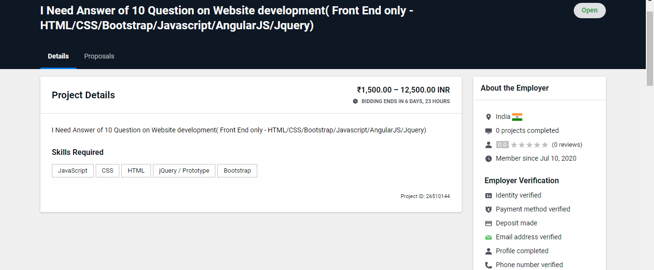

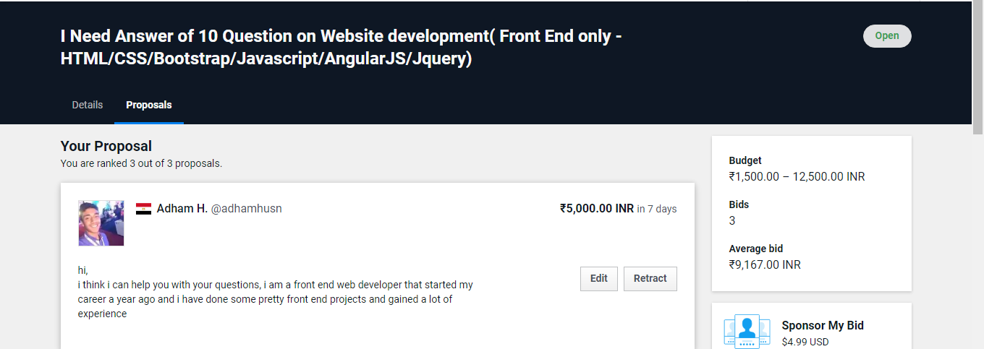

Upwork proposal :

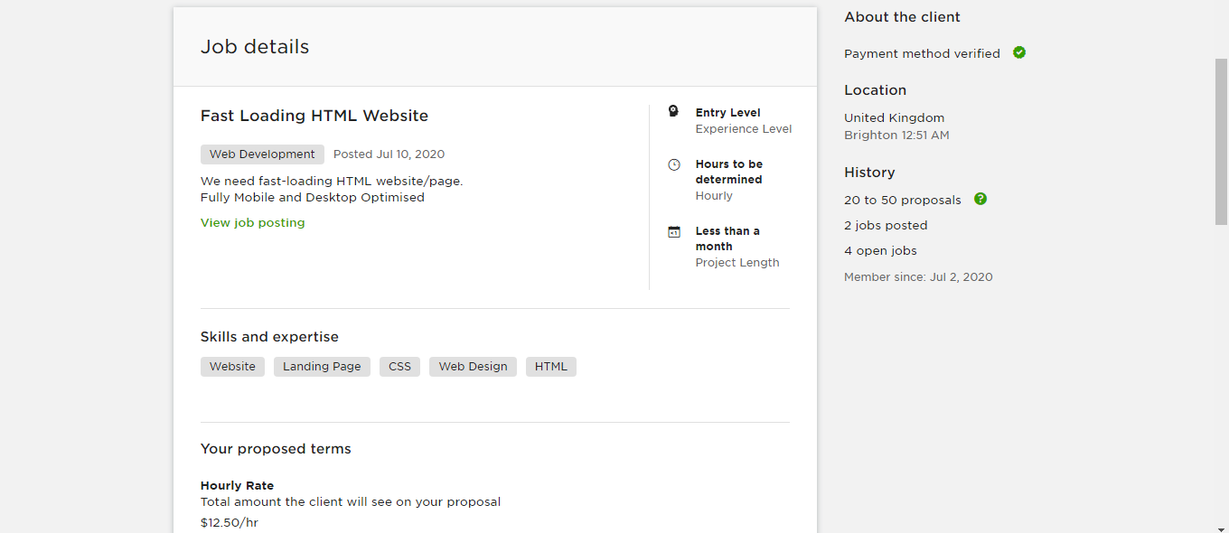

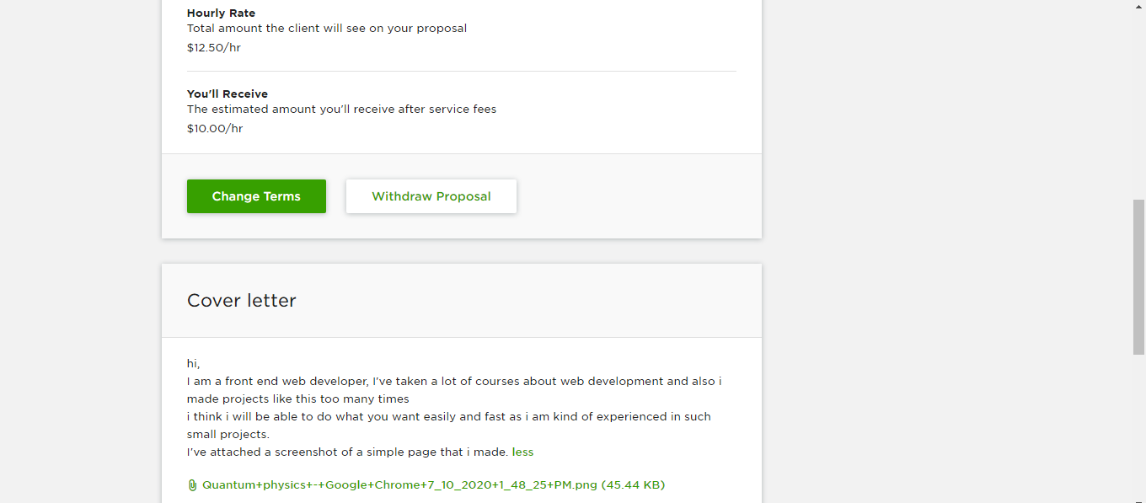

**All proposal details are included in screenshots**