
Estately Real-Estate Platform
Department of Computer Science
Faculty of Science – Alexandria University

Prepared By:
Belal Mohamed El-Sayed
ID: 20231538320
Yussif Mohamed Hassan
ID: 20231538330
Mahmoud Alaa El-Dien Mahmoud
ID: 20231545006
Zyad Alaa El-Sayed
ID: 20236554855
Adham Hesham Mohamed
ID: 20231555158

Supervised By:
Dr. Shimaa Al-Morsy
2026

1. Introduction
a. Motivation
The real estate market has become increasingly dependent on digital platforms for property searching, management, and communication between buyers, sellers, and agents. However, many existing systems suffer from limited functionality, outdated interfaces, poor scalability, or lack of integration between core services.
The motivation behind developing the Estately system is to provide a modern, organized, and scalable real estate platform that simplifies property management and enhances the overall user experience for both customers and administrators.
The project also aims to apply modern software engineering principles such as layered architecture, separation of concerns, and maintainable code structure using ASP.NET technologies.

b. Problem Statement
Many currently available real estate applications face several issues, including:
- Complex and non-user-friendly interfaces.
- Limited filtering and property searching capabilities.
- Weak scalability and maintainability in system architecture.
- Lack of proper separation between business logic, data access, and presentation layers.
- Difficulty in managing property listings efficiently.
These problems reduce user satisfaction and make system maintenance and future expansion more difficult.
The proposed solution, Estately, addresses these issues by providing a structured multi-layered architecture with improved usability, maintainability, and performance.

c. Goals of the Project
The main goals of the project are:
- Develop a modern real estate management platform.
- Provide users with an easy and efficient property browsing experience.
- Allow administrators to manage properties and users effectively.
- Apply clean architecture principles and layered software design.
- Improve maintainability, scalability, and code reusability.
- Implement secure and organized backend services.
- Create a responsive and user-friendly web application.
- The system aims to act as a smart real estate assistant that understands natural language and explains real data without inventing facts.

d. Currently Available Solutions (Applications)
Several real estate platforms currently exist in the market, including:
- Nawy
- Property Finder
- Bayut Egypt
- Egyptian Official Real Estate Platform
These platforms provide property listing and searching services, but many of them either focus mainly on advertisements or lack flexibility in customization and maintainability from a software engineering perspective.

e. Features Matrix
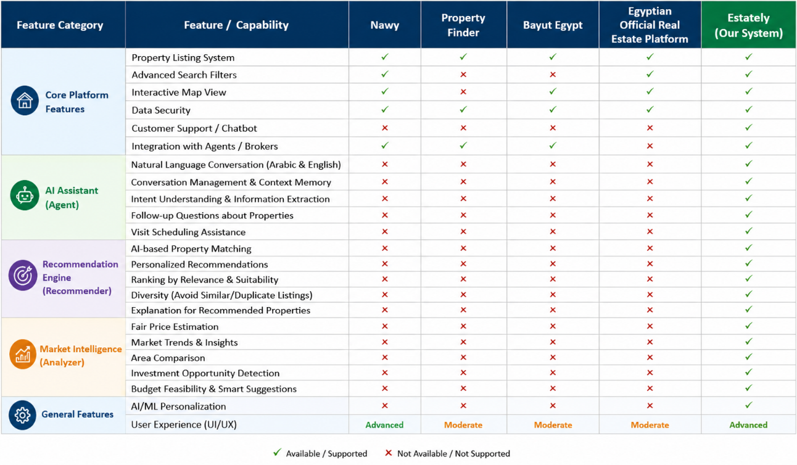

f. Software Development Methodology Used
The project adopted the Agile Software Development Methodology, specifically an Iterative & Incremental approach.
Reasons for Choosing Agile:
- Flexibility:
Agile allows continuous modification and improvement of requirements during development.
- Incremental Development:
The system can be developed module by module, making testing and debugging easier.
- Continuous Feedback:
Regular testing and evaluation help improve system quality throughout development.
- Better Risk Management:
Problems can be detected early during iterations instead of after completing the entire project.
- Suitable for Web Applications:
Since the project is a layered ASP.NET web application, Agile supports continuous enhancement of features and user experience.
The development process was divided into multiple iterations, where each iteration focused on implementing and testing a specific set of features such as property management, and service integration, authentication.

2. Requirements Analysis:
a&b. Surveys, Questionnaires and Results
A survey was conducted to collect feedback from potential users regarding real estate applications and to better understand user requirements and expectations from the proposed system.
The survey focused on several aspects, including:
- Ease of using current real estate applications.
- User satisfaction with existing property search features.
- Common problems users face while browsing properties.
- Important features users expect in a modern real estate platform.
- User opinions about interface design, filtering options, and system performance.
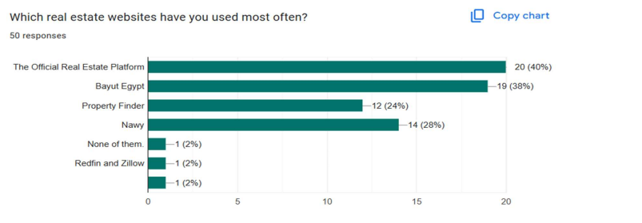
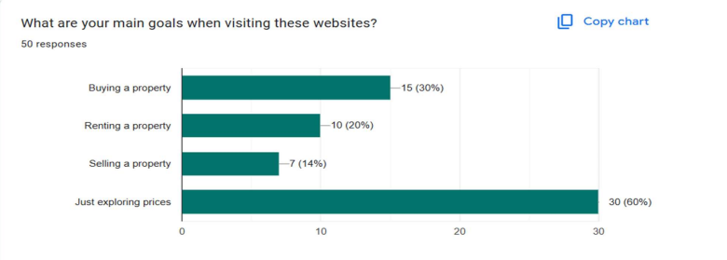
The survey results showed that:
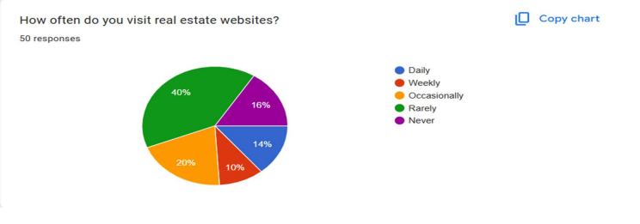
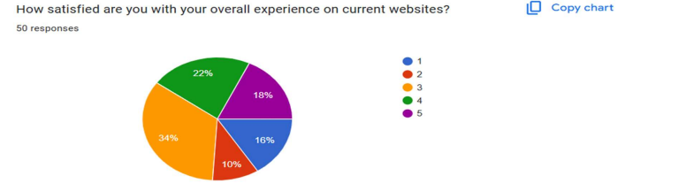
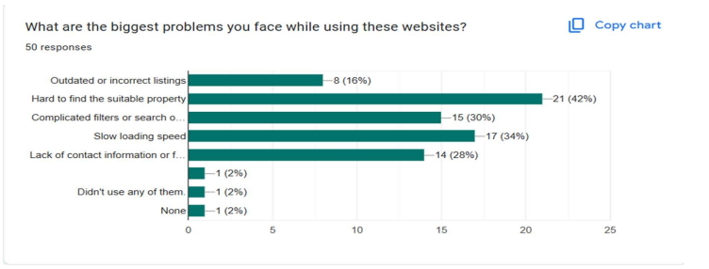
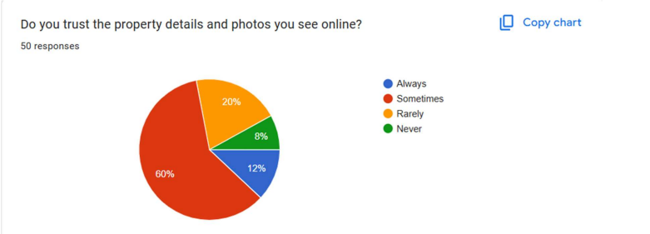

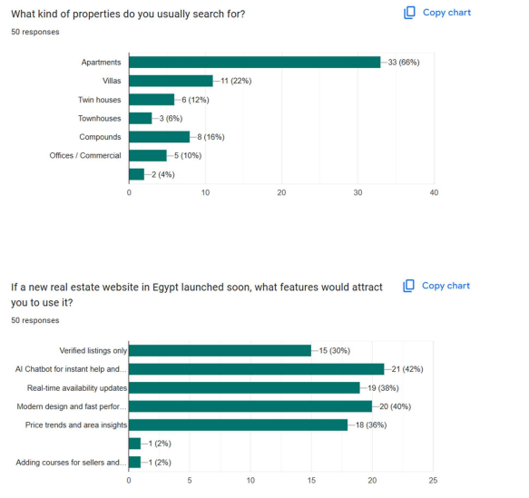
Based on the survey analysis, the proposed system “Estately” was designed to address the identified issues and provide a better user experience through a modern, scalable, and user-friendly platform.

c. Discussion of results:
This section provides an in-depth analysis of the quantitative data gathered from the user requirements survey (#N = 50). The primary objective of this survey was to evaluate user behavior, identify pain points within the current Egyptian real estate digital market, and discover feature gaps to inform the functional and non-functional specifications of the proposed platform.
1. User Engagement and Existing Market Footprint
The survey data indicates that while the real estate market attracts significant interest, user engagement is highly fragmented. Only 24% of respondents visit real estate platforms on a regular basis (14% Daily, 10% Weekly), whereas 40% access them Rarely, and 16% Never look at them. This highlights a clear retention problem in existing platforms; users do not find these sites engaging or useful enough for long-term or everyday interaction.
When analyzing the competitive landscape in Egypt, market share is heavily split among top players:
- The Official Real Estate Platform: 40% usage
- Bayut Egypt: 38% usage
- Nawy: 28% usage
- Property Finder: 24% usage
The overlapping percentages indicate that users routinely switch between multiple platforms rather than relying on a single, comprehensive solution. This fragmentation presents a substantial market opportunity for a new system that consolidates all core needs into a single, high-fidelity user experience.
2. User Intent and Property Preferences
Understanding target user goals is critical for structuring database queries and frontend indexing:
- Price Exploration Dominates: A striking 60% (30 responses) of users visit these websites "Just exploring prices." This means that the platform must cater heavily to casual browsers, research-oriented users, and investors by providing easy access to market trends.
- Transactional Intent: 30% of users are looking to buy, 20% to rent, and 14% to sell.
- Property Typology: In terms of specific searches, Apartments are the heavily dominant category at 66% (33 responses), followed by Villas (22%), Compounds (16%), and Twin Houses (12%). Commercial spaces represent only 10%.
Design Impact: The platform’s default view and search recommendations should prioritize residential apartment units and price tracking features, as these align with the vast majority of user traffic.
3. Current Market Pain Points and Trust Deficit
The survey reveals an overwhelming dissatisfaction with current software solutions in the Egyptian real estate sector. On a satisfaction scale from 1 (Lowest) to 5 (Highest), a massive 60% of users rated their experience as average or poor (34% rated a 3, 10% rated a 2, and 16% rated a 1). Only 18% expressed high satisfaction (score of 5).
This dissatisfaction stems from clear technical and structural failure points:
- Discoverability Issues (42%): Users find it "Hard to find the suitable property," highlighting poor matching or recommendation algorithms.
- Performance Bottlenecks (34%): "Slow loading speed" is a critical system bottleneck.
- Search Usability (30%): "Complicated filters or search options" alienate non-technical users.
- Data Quality and Missing Info (28%): A "Lack of contact information or full details" blocks users from completing transactions.
- Stale Data (16%): "Outdated or incorrect listings" ruin platform credibility.
Compounding these UX and performance problems is a severe trust deficit. A staggering 88% of respondents do not fully trust the property details and photos they see online (60% Sometimes, 20% Rarely, 8% Never). Only 12% "Always" trust the online descriptions.
4. Strategic System Opportunities (The Solution Space)
When asked what features would actively attract users to a newly launched real estate platform in Egypt, the responses clearly outlined the core architectural requirements for our system:
- AI Chatbot for Instant Help (42%): Emerging as the highest-demanded feature, users want an intelligent, conversational interface to bypass tedious, complicated search forms and get instant answers.
- Modern Design and Fast Performance (40%): Directly addressing the latency complaints, users demand a highly responsive UI with elite-tier performance.
- Real-Time Availability Updates (38%): Users want real-time event-driven data architecture to ensure they are not looking at sold or rented properties.
- Price Trends and Area Insights (36%): Reflecting the 60% of users who browse just to check prices, the system needs analytical dashboards showing property appreciation metrics.
- Verified Listings Only (30%): To combat the 88% trust deficit, a strict validation or verification badge system is necessary.
Conclusion & Transition to Requirements
The empirical data directly shapes the upcoming sections of this SRS document:
- To address the trust and data quality issues, the Functional Requirements (Part 2.d) must include an admin listing verification workflow, automated real-time availability sync hooks, analytical price-trend charts, and an interactive NLP-based AI Chatbot engine.
- To address the performance and filter friction, the Non-functional Requirements (Part 2.e) must mandate a strict Page Load Time threshold (e.g., $<2$ seconds), a mobile-first responsive design framework, and a highly intuitive, elastic search indexing mechanism.

d. Functional Requirements
The functional requirements describe the core functionalities and services provided by the system.
1. User Management
- Users shall be able to register and create accounts.
- Users shall be able to log in and log out securely.
- The system shall support role-based access for users and administrators.
2. Property Management
- Administrators shall be able to add, update, and delete property listings.
- The system shall allow storing detailed property information such as price, location, type, and images.
- Users shall be able to browse available properties.
3. Search and Filtering
- Users shall be able to search for properties using keywords.
- The system shall provide filtering options based on price, location, property type, and other attributes.
4. Property Details
- Users shall be able to view detailed information about a selected property.
- The system shall display property images and specifications clearly.
Administration Features
- Administrators shall be able to manage users and property listings.
- The system shall provide an admin dashboard for monitoring and management.
5. System Services
- The system shall validate user input before storing data.
- The system shall interact with the database to store and retrieve information efficiently.
6. Core AI Module
- The Agent module must understand user intent, extract details like budget and location, manage the conversation and manage appointments.
- The Recommender module must search real property data, rank properties, and filter them based on strict user rules.
- The Analyzer module must calculate fair price estimates, detect investment opportunities, and provide market snapshots.

e. Non-Functional Requirements
The non-functional requirements describe the quality attributes and constraints of the system.
1. Performance
- The system should provide fast response times for user requests.
- Property search results should be displayed efficiently.
- The AI system should load models once and reuse them to enhance speed.
- The system must cache repeated searches and run specific checks in parallel to minimize response times.
2. Scalability
- The system should support future expansion and additional features.
- The architecture should handle increasing numbers of users and properties.
3. Security
- User authentication and authorization should be implemented securely.
- Sensitive user data should be protected from unauthorized access.
4. Usability
- The system should provide a simple and user-friendly interface.
- Navigation between pages should be easy and intuitive.
- The system must seamlessly support both Arabic and English, allowing users to speak naturally in either language without requiring two separate backend versions.
- The AI assistant must retain conversation memory to contextually answer follow-up questions.
5. Maintainability
- The project should follow a layered architecture to simplify maintenance.
- The codebase should be modular and reusable.
- The AI architecture must be split into distinct modules (Agent, Recommender, Analyzer, Data) to ensure the system remains safe, clear, and easy to improve.

6. Reliability
- The system should operate consistently without major failures.
- Data should be stored accurately and reliably.
- The system must use a hybrid approach that combines AI language understanding with actual database facts, ensuring responses are trustworthy and not invented.
- An internal Auditor component must check the AI's answer before it reaches the user to guarantee it is strictly based on real system data.
7. Compatibility
- The web application should work on different browsers and devices.
8. Availability
- The system should be accessible to users whenever internet access is available.
9. Accuracy & Trustworthiness
- The AI shall not be used as the sole source of truth; its role is strictly limited to understanding user intent and explaining factual data retrieved from the database.

10. Localization
- Both the backend and the Graphical User Interface (GUI) must fully support Arabic text and right-to-left layouts to accommodate the natural communication of the Egyptian real estate market.

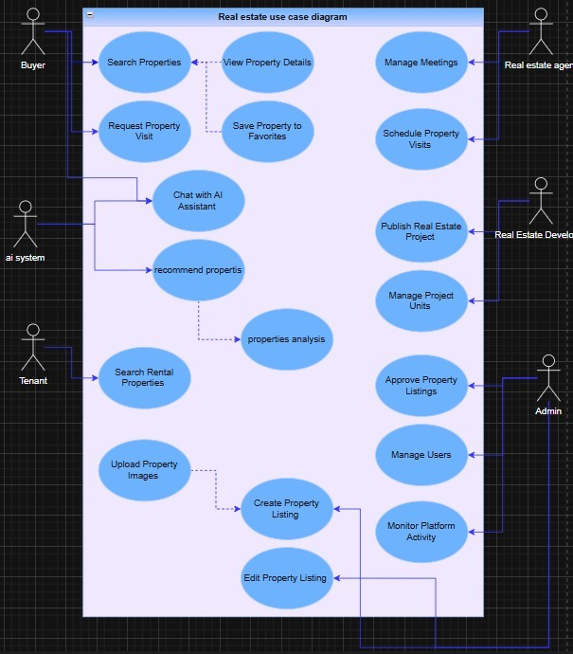
f. Use Case diagram

3. Design:
a. Sequence diagrams
components and the order in which operations are executed over time. It helps visualize the workflow of important business processes and the exchange of messages between system entities.
In Estately system, the sequence diagram demonstrates the interactions involved in major operations such as user creation, role assignment, employee management, property creation, feature linking, image uploading, and appointment booking. The diagram shows how different entities collaborate to complete these processes successfully.
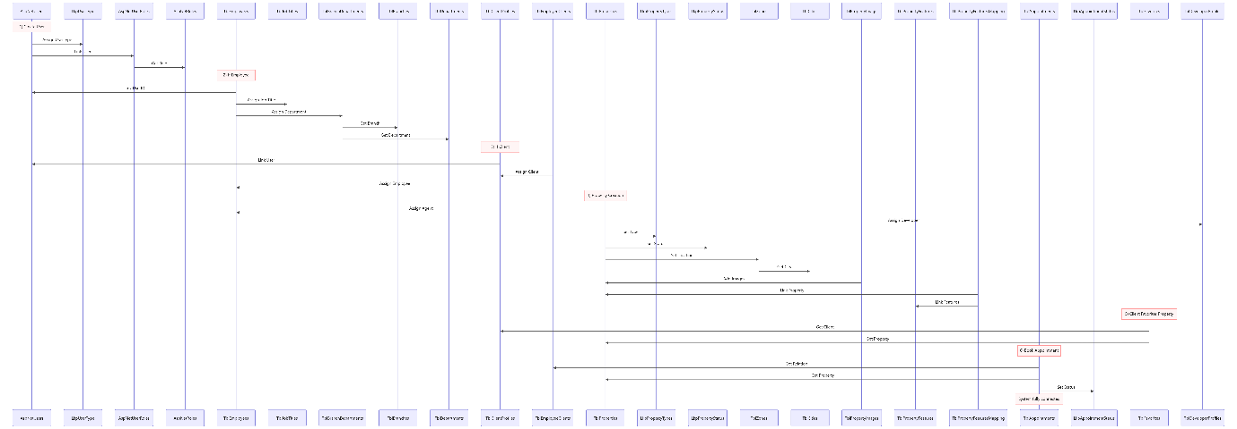

f. UML class diagrams
A UML Class Diagram is used to represent the static structure of a software system. It illustrates the system classes, their attributes, and the relationships between them. Class diagrams help developers understand the organization of the system and the interactions among different entities.
In Estately system, the UML Class Diagram represents the core entities such as users, properties, agents, appointments, cities, zones, images, and features. It also illustrates the associations between these entities, providing a clear view of the system's architecture and data organization.
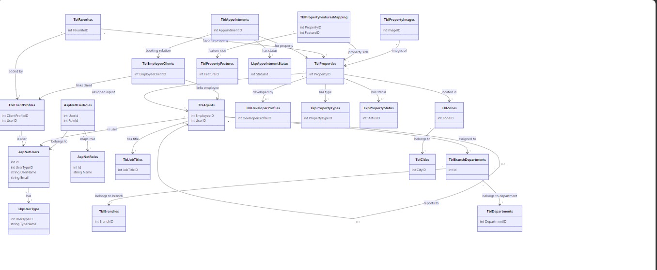
The sequence diagram illustrates the chronological flow of operations within the Estately system. It shows how users, employees, agents, properties, appointments, and related entities communicate with each other to perform system functions. The diagram highlights message exchanges, data retrieval operations, and object interactions required to complete business processes.

4. Implementation Aspects:
a. Overall System Architecture (Blocks diagram)
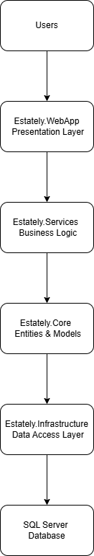

b. Tools, Technologies and/or Programming Languages
- Programming Languages
- C#
- SQL
- HTML
- CSS
- JavaScript
- Frameworks & Technologies
- ASP.NET Core
- Entity Framework Core
- ASP.NET Identity
- MVC Architecture
- Dependency Injection
- Database
- Microsoft SQL Server
- Development Tools
- Microsoft Visual Studio 2022
- SQL Server Management Studio (SSMS)
- Git & GitHub (if used)
- Architecture Pattern
- Layered Architecture (Onion Architecture)
- Repository Pattern
- Service Layer Pattern
- AI Technologies & Tools
- Python.
- Large Language Models (LLMs) .
- FAISS Index.
- XGBoost.
- LangGraph.
- FastAPI.
Description:
Estately system was developed using ASP.NET Core and C#. The application follows a layered architecture consisting of Presentation, Service, Core, and Infrastructure layers. Entity Framework Core is used for database communication, while SQL Server is used as the primary database management system.

c. Prototype:

