Database systems final project

**CAR RENTAL SYSTEM**

**Team members:**

|  |  |  |  |
| --- | --- | --- | --- |
| **Name:** | **ID:** | **Group** | **Section** |
| Adham Mostafa Abdulhamid | 6715 | 4 | 1 |
| Yahia Walid Mohamed | 7137 | 3 | 1 |
| Ahmed Ashraf Elsayed | 6742 | 2 | 2 |
| BahaaEldin Mohamed Gamal | 6726 | 4 | 1 |

**PHP pages:**

**I) user and admin authentication and authorization pages**

**1-login.php:**

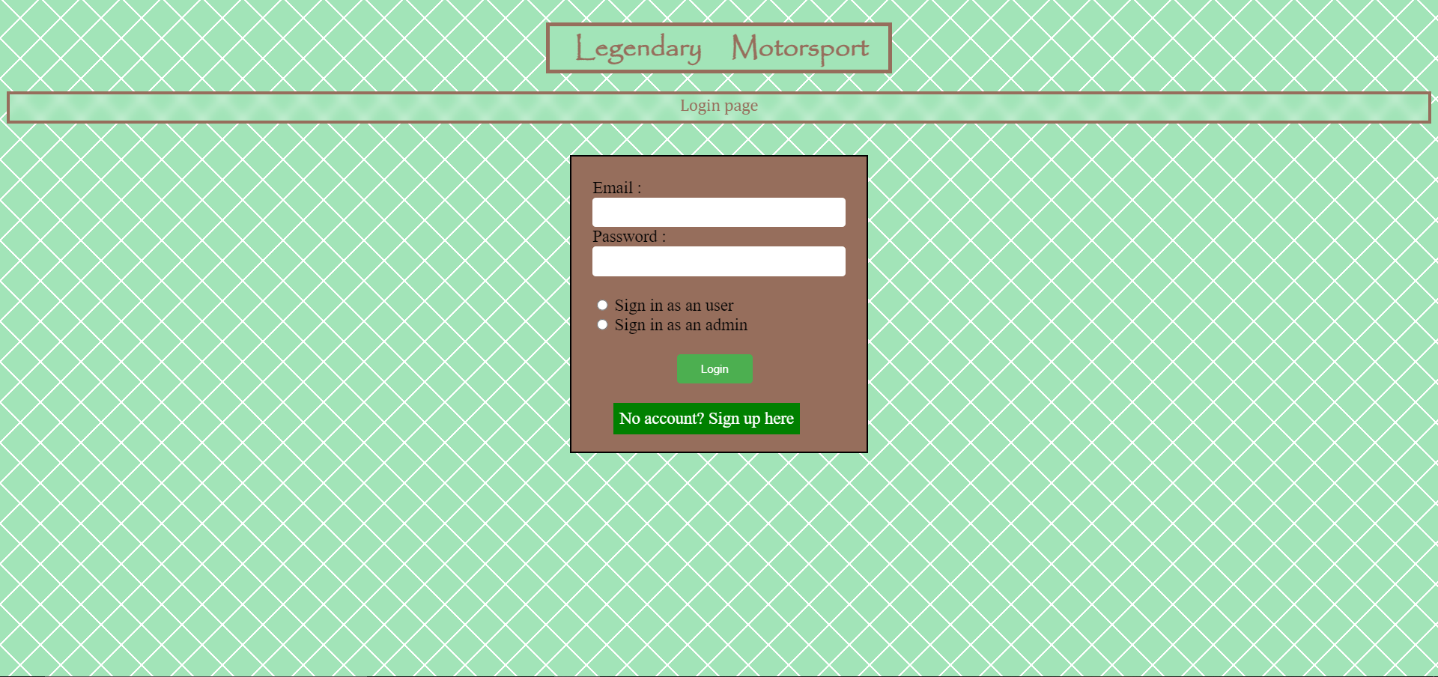

Used by both the user and admin to log in to the system.

Also can link to the signup.php page for new users.

**2-signup.php:**

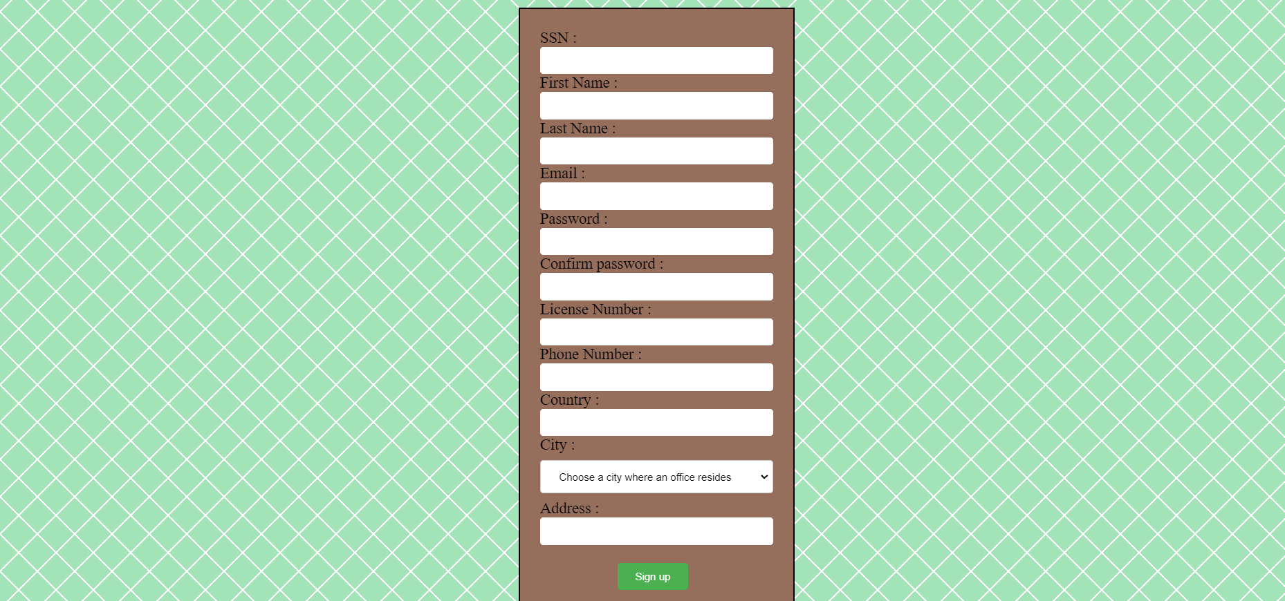

Used only by users.

Used to register new accounts

The select city option is limited only to cities where the company operates:

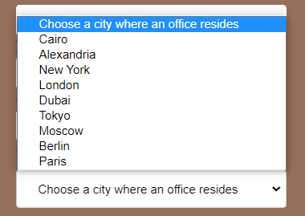

The list is dynamic as it retrieves the options from the database offices’ data.

It has the option to simply travel to the login page.

**II) User Pages:**

Most of user’s pages have this panel to allow for easier navigation:



Logout is used to destroy the session.

If a user tries to write a page in the URL bar with no session active the user will be automatically booted to sessionless.php to give the user the ability to go to login page to start a session.



**III) Profile Page:**

**1-userindex.php:**

The profile page shows no available rented cars if the user does not have any rented cars.

The following data is shown to users who have a rented car(s). The user can proceed to other pages from the above panel.

**IV) Browse Section:**

**1-browse.php**

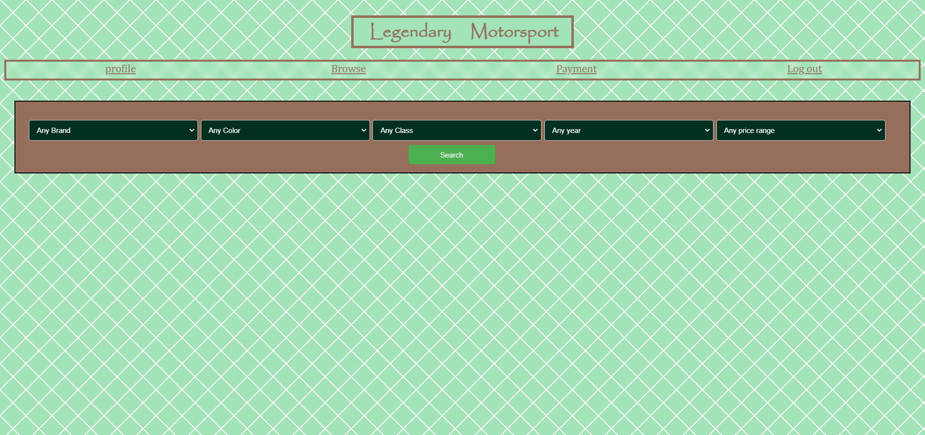

All select options are limited to the properties of the cars in the cars table assuming they aren’t even rented.

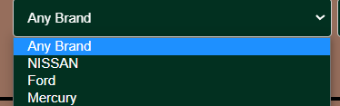

In case of no results:

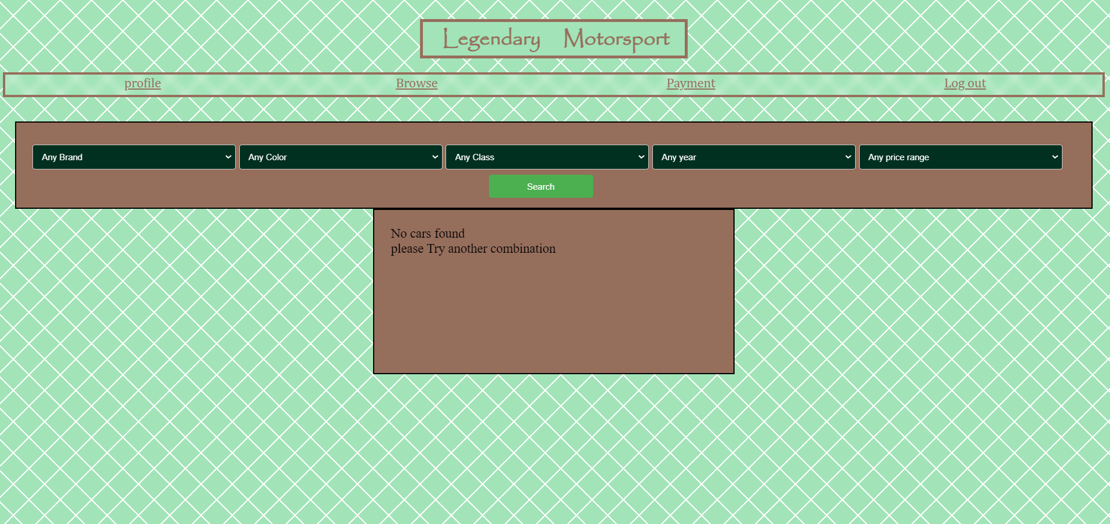

In case of results:

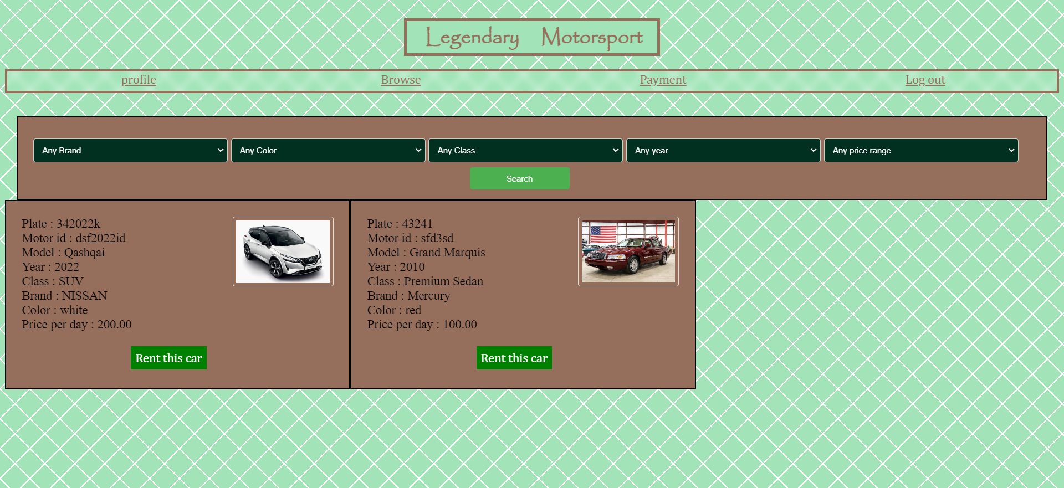

If a one is chosen then the user is redirected to the rent.php?plateid=”chosen car id”

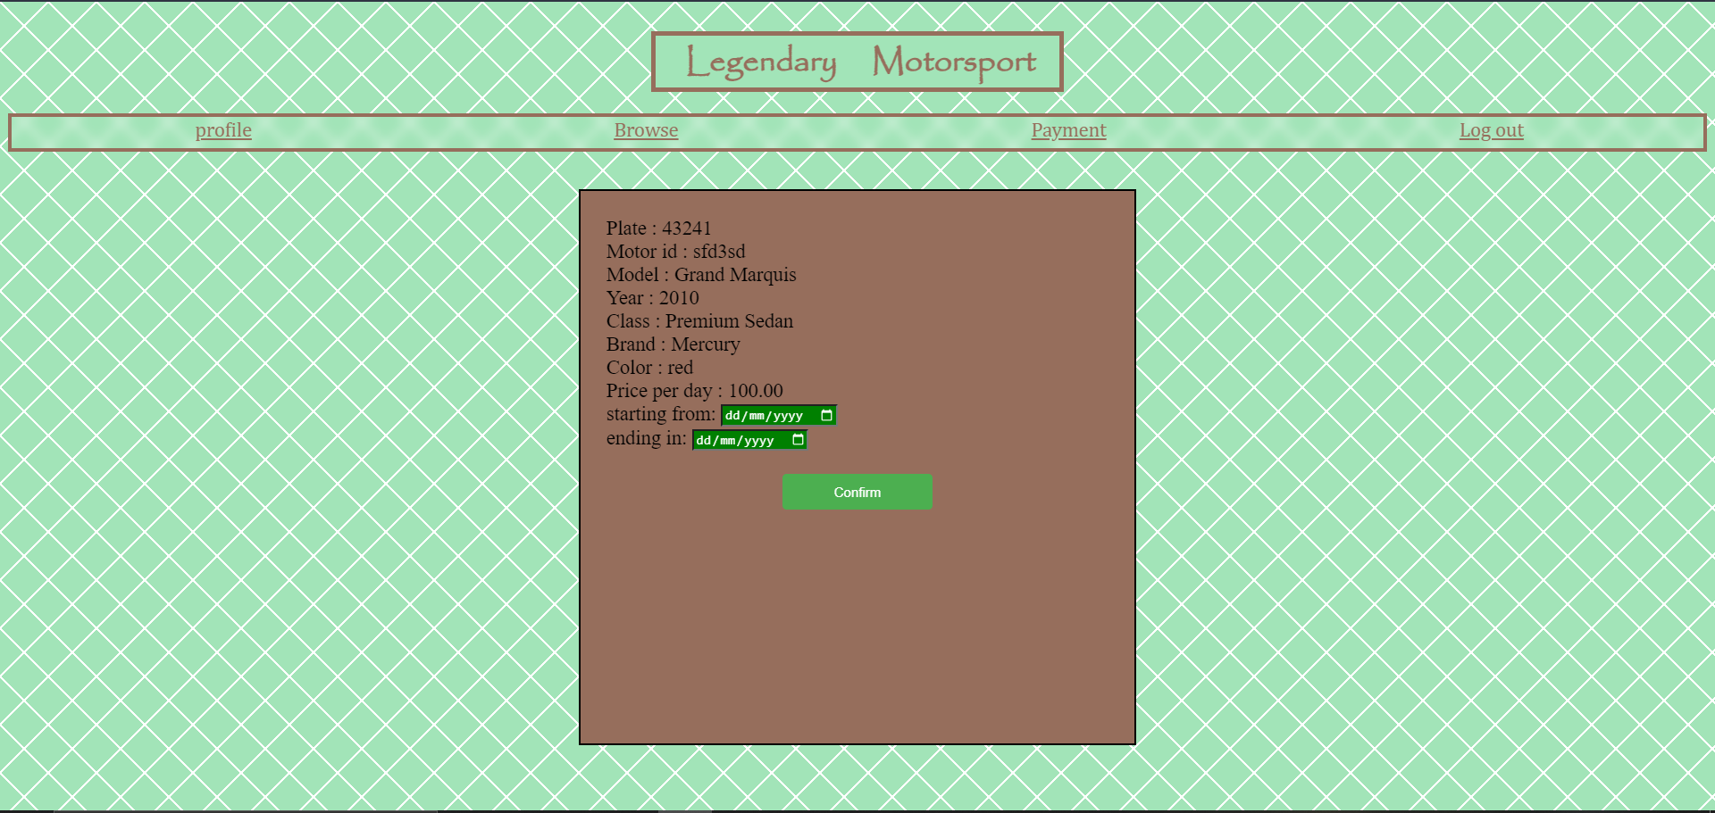

The user is alerted if the car was added to the rent table

**V) Payment Section:**

**1-Payment.php**

When the user has already reserved the car(s) they want, they can head to the payment section to check the details.

In case the user hasn’t chosen any cars, the page will look like the following:

And it will not accept any payment from the user if they choose to pay

In case the user has chosen any cars, the page will look like the following:

**2-postpayment.php**

After the user enters his payment information and confirms, the user will be redirected to the post payment page and will be given the transaction number for the payment.

**V) Admin page:**

After logging in as admin successfully, you will be redirected to “adminindex.php” page.  
You can select the service you wish to perform as admin from the select box shown in the image below.  
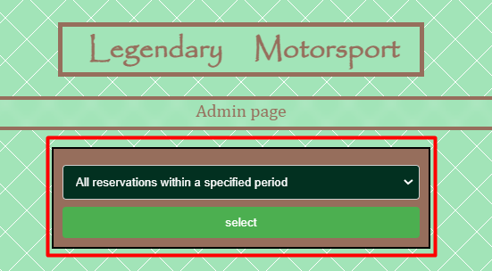

When you click on select you will be redirected to the page corresponding to the option you select.

## Selecting Option 1 (All reservation within a specific period):

You will be redirected to this page and asked to enter the starting date and ending date as shown in the image below:

After clicking on the search button, all reservation within the specified period will be displayed.  
None will be displayed if there are no matching reservations. Below is an example of reservations being displayed when the period matched.

## 2.Selecting Option 2 (All reservations of a car within specified period):

After Selecting the second option you will be asked to enter the start date and end date, in addition to the car plate which you can select from the select box at the top of the red box in the below image.

If the selected car is reserved with in the period selected, then it should be displayed as shown in the above image, otherwise nothing is displayed and you are prompted to select the car plate and period once again.

## 3.Selecting option 3 (displaying all cars information within a specific day):

After selecting this option, you will be prompted to enter the day you want to display the cars information at. The cars should then be displayed as shown above after clicking on the “Search” button.

## 4.Selecting option 4 (displaying rented cars based on costumer SSN):

After selecting this option, you will be asked to choose the SSN of the customer from a select box which displays all the available customers’ SSNs. When you click on “Search” button, if the customer made a reservation, The info will be displayed as shown in the above picture, otherwise nothing is displayed and admin is asked to select the customer SSN again.