Ain Shams University | ECE211: Electronics
Faculty of Engineering | 2nd Year Electrical Engineering
Electronics & Comm. Eng. Dept. | Fall 2024


Experiment (4) Report

Names | IDs | Department | Attendance slot | Group  No. | Group Code  Part A, B
Adham Alaa Abd Alraheem | 2200102 | CSE | From 11:00-13:30 First Rotation | Team 2 | B, 99

Part B:
1. The schematic of the circuit of Figure 19.
Adjust the resistance (R1) to 10 KΩ, the Resistance (RF) to x KΩ and supply voltage to ±15V. (1 Mark).

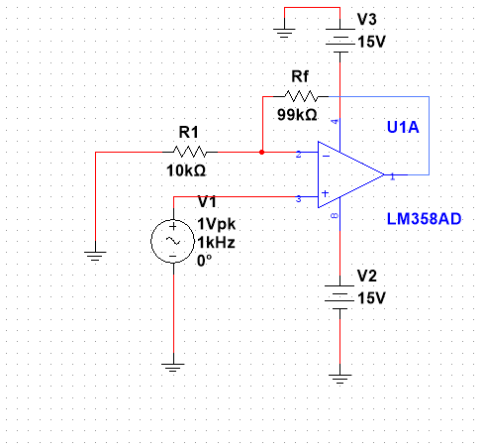

2. CRO snapshot displaying input and output waveforms.
(Vin is Sine wave with 1KHz frequency and 2 V-PP). (1 Mark).
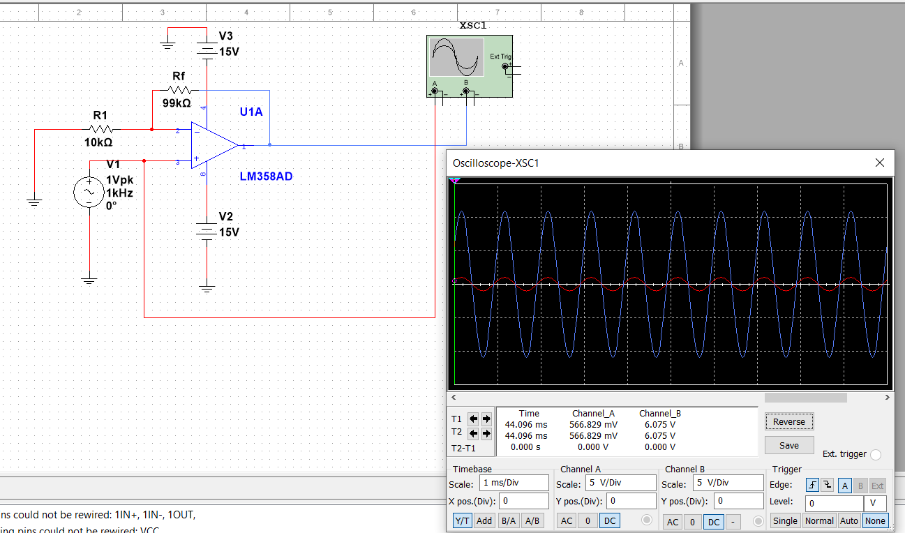

3. The voltage gain.
Vout = Vin (1+ Rf/R1) = 1(1 + 99/10) = 10.9 V
4. CRO snapshot displaying the voltage of the negative and positive terminals of the Op-Amp.
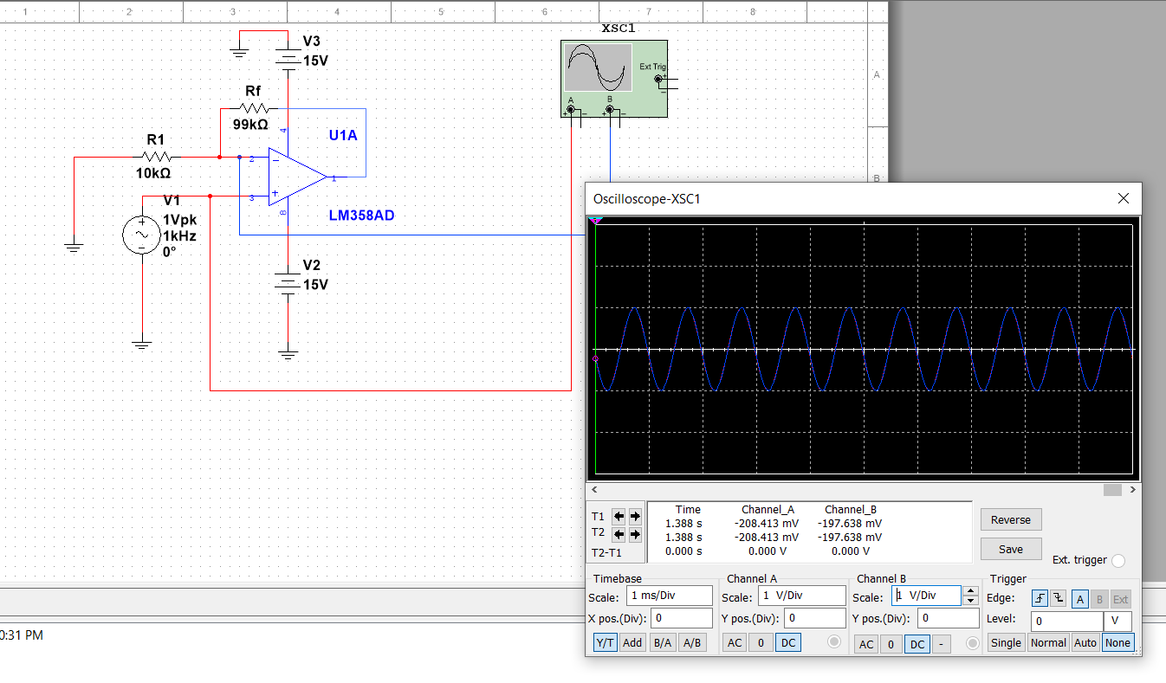
The voltage at both terminals is equal
5. CRO snapshot displaying current waveforms in the resistors R1 and RF and compare them to the expected values.
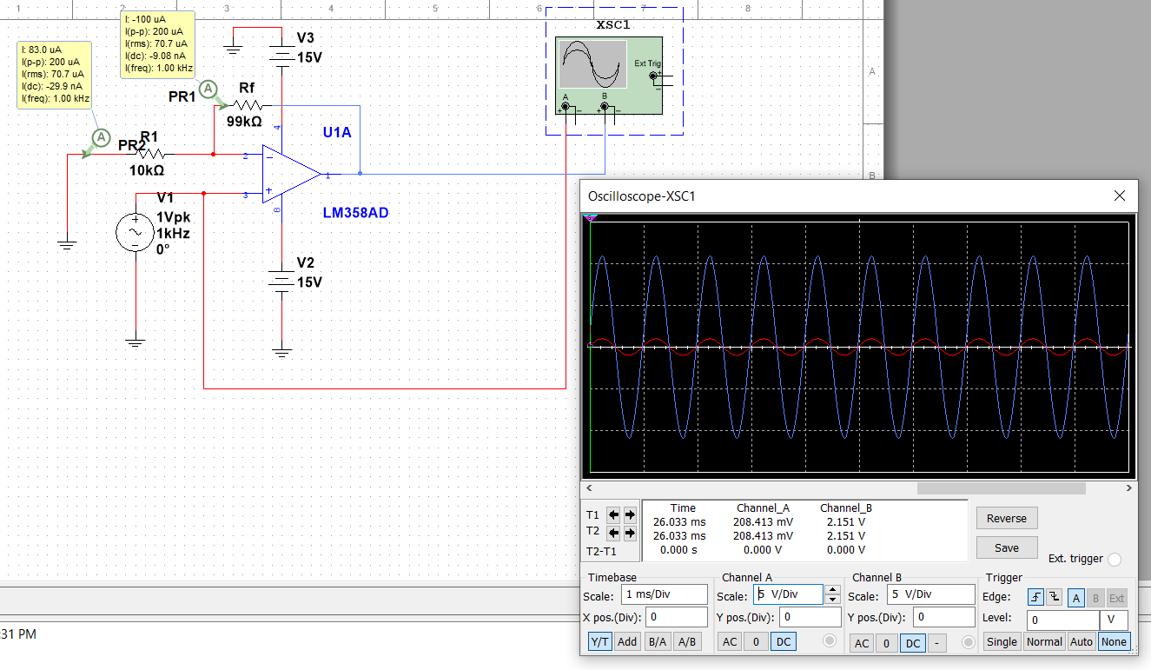
Expected :
I_{Rf} = (10.9/√2 - 1/√2)/99000 = 70.71 uA (rms)
I_{R1} = (1/√2)/10000 = 70.71 uA (rms)

