Ain Shams University | ECE211: Electronics
Faculty of Engineering | 2nd Year Electrical Engineering
Electronics & Comm. Eng. Dept. | Fall 2024


Experiment (2) Report

Names | IDs | Department | Attendance slot | Group  No. | Group Code  Part A, B
Adham Alaa Abd Alraheem | 2200102 | CSE | From 11:00-13:30 First Rotation | Team 2 | B, 1.3

Part B:
1-Construct a circuit that performs the above function:
2-Draw the circuit.
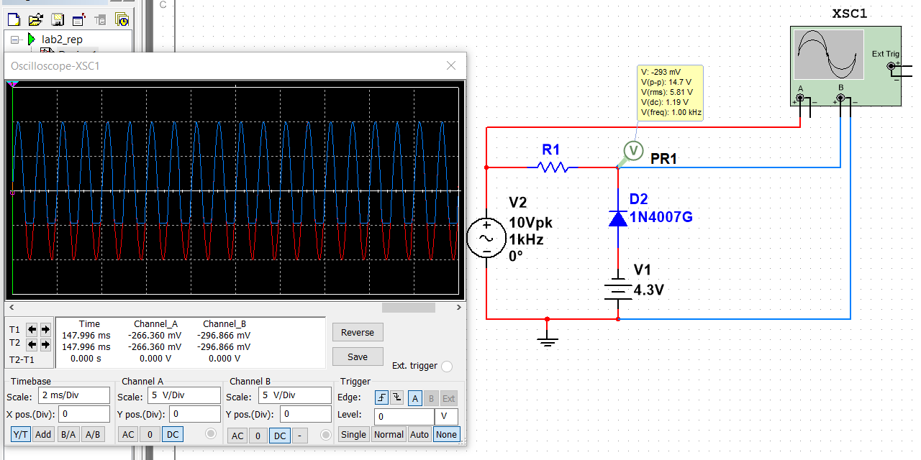
3-Apply Vin = 1.30 sin (2π (1000) t) and get a clear CRO snapshot for Vin and Vout waveforms.
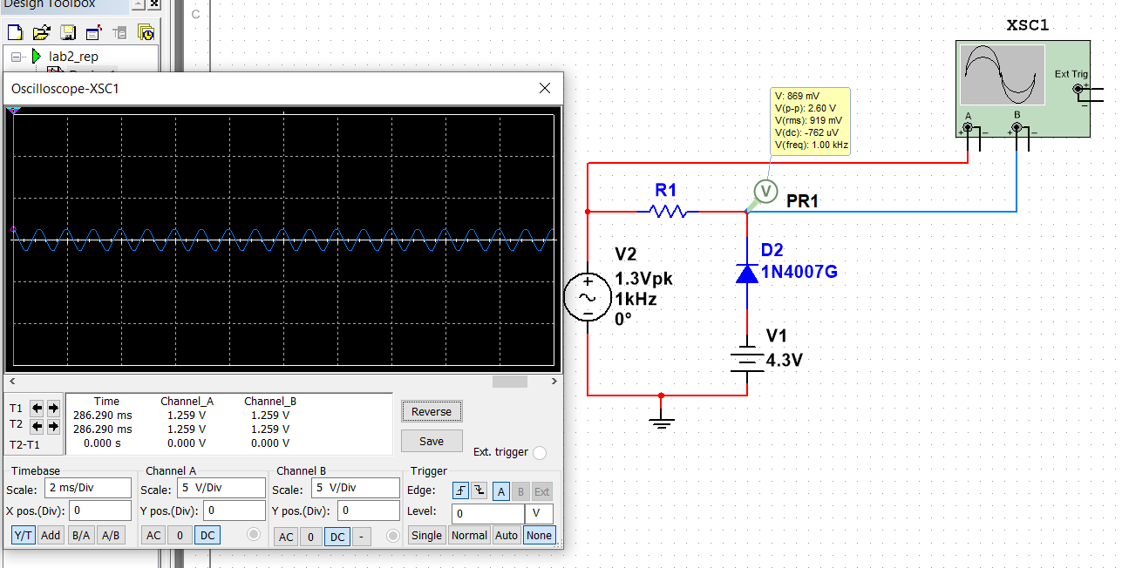

4-Display Vout Vs Vin (circuit transfer function).
