Queries:

Query 1:
MATCH (n)-[r1]->(m)
MATCH (m)-[r2]->(n)
RETURN n, r1, m, r2
LIMIT 300

Description:
To explicitly filter the graph to only show pairs of nodes that have a relationship pointing in both directions (ignoring any stray nodes that might only have a one-way relationship)

Output:
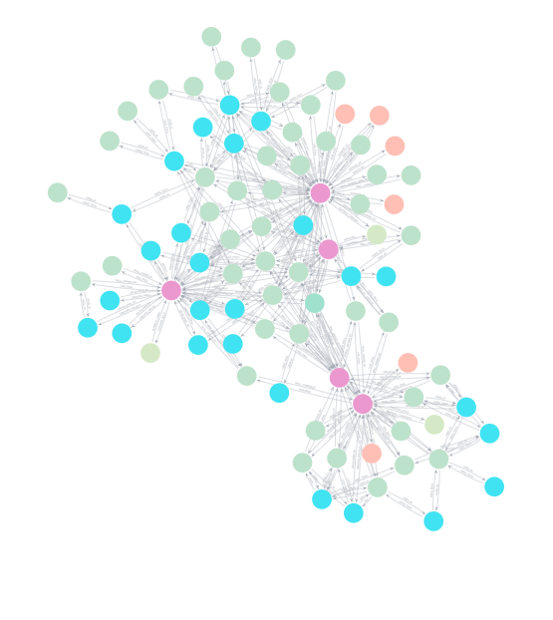
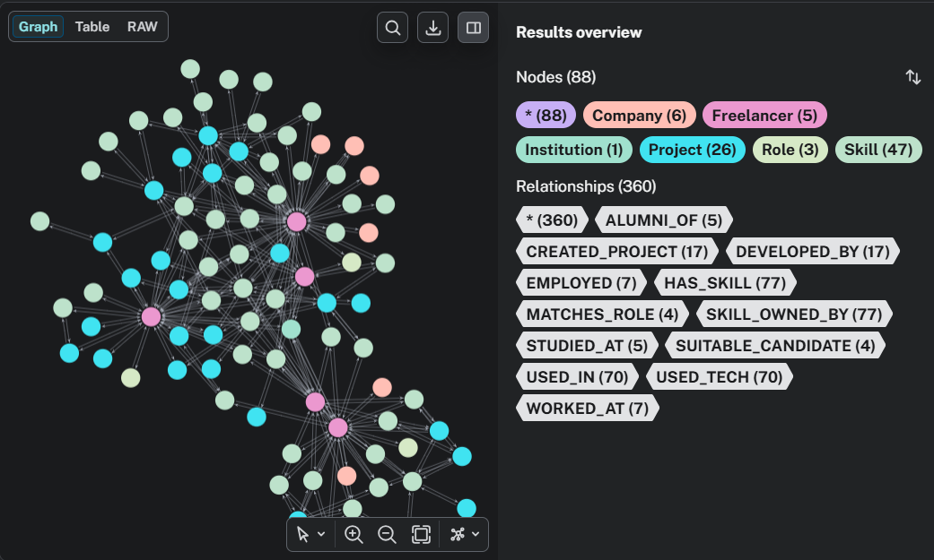

Query 2:
MATCH (target:Freelancer {name: 'Youssef Maaod'})-[]-(shared_node)-[]-(other:Freelancer)
WHERE target <> other
WITH other,
count(DISTINCT shared_node) AS similarity_score,
collect(DISTINCT shared_node.name) AS shared_entities
RETURN other.name AS Related_Freelancer,
similarity_score,
shared_entities
ORDER BY similarity_score DESC
LIMIT 5

Description:
To find the most "related" or similar freelancer to Youssef Maaod, can This query counts how many nodes they have in common. In the context of team formation, sharing the same skills, academic background, or project history is a great indicator of synergy.)

Output:

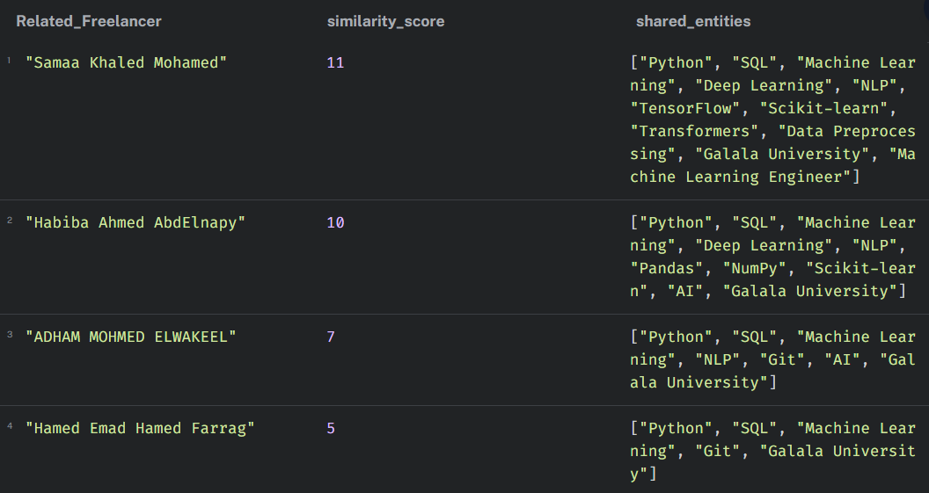

Query 3:
MATCH (target:Freelancer {name: 'Youssef Maaod'})-[:HAS_SKILL]->(s:Skill)<-[:HAS_SKILL]-(other:Freelancer)
WHERE target <> other
WITH other, count(s) AS shared_skill_count, collect(s.name) AS shared_skills
RETURN other.name AS Related_Freelancer, shared_skill_count, shared_skills
ORDER BY shared_skill_count DESC
LIMIT 5

Description:
To find the freelancers with overlapping technical skills (ignoring whether they went to the same university or worked at the same company), you can restrict the shared_node to only be a Skill
Output:
