NETFLIX
Data Cleaning & Dashboard Report
Python | Power Query | Power BI

Part 1: Python Data Cleaning (Jupyter Notebook)
The following steps were performed in Python using pandas to prepare the Netflix titles dataset for use in Power BI. Each step addresses a specific data quality issue found in the raw CSV.

Step 1 — Handle Missing Values
Several columns contained null/NaN entries. These were filled with meaningful placeholders so that Power BI can treat them as actual categories rather than displaying a blank or (Blank) label.

df['Director'] = df['Director'].fillna('Unknown')
df['Cast'] = df['Cast'].fillna('Unknown')
df['Country'] = df['Country'].fillna('Unknown')
df['Rating'] = df['Rating'].fillna('UR') # UR = Unrated
df['Release_Date'] = df['Release_Date'].fillna('Unknown')

Why this matters
Without filling nulls, Power BI groups all missing values as '(Blank)', making slicers and charts misleading.
Using 'Unknown' and 'UR' creates explicit filter options for unclassified content.

Step 2 — Date Standardization
The Release_Date column was stored as a plain string. It was converted to a proper datetime object using pd.to_datetime(). The errors='coerce' argument safely handles any malformed entries by converting them to NaT (Not a Time) instead of crashing.

df['Date_Added_Clean'] = pd.to_datetime(
df['Release_Date'].str.strip(),
errors='coerce'
)

Step 3 — Feature Engineering (Year & Month)
Two new columns were extracted from the cleaned date to enable time-based filtering in Power BI. Year_Added and Month_Added are essential for building time slicers and trend charts.

df['Year_Added'] = df['Date_Added_Clean'].dt.year
df['Month_Added'] = df['Date_Added_Clean'].dt.month_name()

New Column | Data Type | Purpose in Dashboard
Year_Added | Integer | Filter content by year added to Netflix
Month_Added | String | Analyze monthly addition trends

Step 4 — Duration Split
The Duration column contained mixed text such as '90 min' or '2 Seasons'. It was split into two separate columns so that numeric calculations (e.g., average movie length) can be performed in Power BI.

df['Duration_Value'] = df['Duration'].str.extract('(\d+)').astype(float)
df['Duration_Unit'] = df['Duration'].str.extract('([a-zA-Z]+)')

Step 5 — Drop Old Release_Date Column
The original Release_Date string column was removed after the clean datetime version (Date_Added_Clean) was created, avoiding duplicate and confusing columns in the dataset.

df_cleaned = df.drop(columns=['Release_Date'])

Step 6 — Normalize Column Names & Export
All column names were standardized to lowercase with underscores to ensure clean import into Power BI without case-sensitivity issues. The final DataFrame was exported to a new CSV file.

df.columns = df.columns.str.strip().str.lower().str.replace(' ', '_')
df['date_added_clean'] = pd.to_datetime(df['date_added_clean'], errors='coerce')
df.to_csv(r'D:\Work\Projects\Netflix\netflix_titles.csv', index=False)

Summary of All Cleaning Steps

# | Step | Action Taken
1 | Handle Missing Values | Fill nulls with 'Unknown' / 'UR'
2 | Date Standardization | Convert Release_Date to datetime
3 | Feature Engineering | Extract Year_Added & Month_Added
4 | Duration Split | Separate numeric value from unit
5 | Drop Old Column | Remove original Release_Date string
6 | Normalize & Export | Lowercase columns, save to CSV

Part 2: Power Query — Removing Errors
After loading the cleaned CSV into Power BI, use the Power Query Editor to identify and remove any remaining rows that contain errors. Follow the steps below.

How to Open Power Query
- Open your Power BI Desktop file (.pbix).
- In the Home ribbon, click Transform Data. Power Query Editor will open.
- In the left Queries panel, select the Netflix table.

Method A — Remove Rows with Errors (Entire Row)
Use this method to delete any row where at least one cell contains an error value.

- In the Home ribbon, click Remove Rows.
- Select Remove Errors from the dropdown menu.
- Power Query removes all rows containing errors across any column.

Quick Tip
This is the fastest option when you want a clean dataset with zero error cells.
Use it only if losing partial rows is acceptable for your analysis.

Method B — Replace Errors in Specific Columns
Use this method to keep the row but replace the error value with null or a default value.

- Right-click on the column header (e.g., duration_value).
- Choose Replace Errors...
- Enter the replacement value (e.g., null or 0) and click OK.

Method C — Filter Out Errors per Column
Use this method to inspect and filter errors column by column.

- Click the filter dropdown arrow on any column header.
- Uncheck Error from the filter list.
- Click OK. Rows with errors in that column are hidden/removed.

Recommended Columns to Check
Column | Likely Error Type | Recommended Action
date_added_clean | Unparseable date strings | Replace with null
duration_value | Non-numeric duration text | Replace with 0 or null
year_added | NaT from failed date parse | Replace with null
rating | Unlisted rating codes | Replace with 'UR'

Apply & Close
- Once all errors are handled, click Close & Apply in the Home ribbon.
- Power BI loads the cleaned data into the report canvas.
- Check the bottom status bar — it should show 0 errors.

Part 3: Building the Power BI Dashboard
With clean data loaded, follow the steps below to build a professional Netflix-themed dashboard in Power BI Desktop.

Step 1 — Set the Canvas Theme
- Go to View > Themes > Customize current theme.
- Set Background color to #1A1A2E (dark navy) or #141414 (Netflix black).
- Set font to Segoe UI or Arial throughout.

Step 2 — Add KPI Cards (Top Row)
Insert Card visuals across the top of the canvas to display headline numbers at a glance.

Card Title | Field / Measure
Total Titles | COUNT(show_id)
Total Movies | COUNTROWS filtered by type = Movie
Total TV Shows | COUNTROWS filtered by type = TV Show
Countries Covered | DISTINCTCOUNT(country)

Step 3 — Titles Added Over Time (Line Chart)
- Insert a Line Chart visual.
- X-Axis: year_added | Y-Axis: COUNT(show_id).
- Add a legend for type (Movie vs TV Show) to show two lines.
- Title: 'Content Added Per Year'.

Step 4 — Movies vs TV Shows Split (Donut Chart)
- Insert a Donut Chart visual.
- Legend: type | Values: COUNT(show_id).
- Set slice colors: red (#E50914) for Movies, dark navy for TV Shows.

Step 5 — Top Countries by Content (Map or Bar Chart)
- Option A (Bar Chart): X-Axis = COUNT(show_id), Y-Axis = country. Sort descending.
- Option B (Filled Map): Location = country, Values = COUNT(show_id).
- Limit to Top 15 using visual-level Top N filter.

Step 6 — Content Rating Distribution (Bar Chart)
- Insert a Clustered Bar Chart.
- Y-Axis: rating | X-Axis: COUNT(show_id).
- Sort by count descending. Title: 'Content by Maturity Rating'.

Step 7 — Average Movie Duration (Gauge or Card)
- Create a DAX measure: Avg Movie Duration = CALCULATE(AVERAGE(duration_value), type = "Movie")
- Insert a Gauge visual or a Card.
- Set min = 0, max = 180 (minutes). Target = 90 min as benchmark.

Step 8 — Add Slicers (Filters Panel)
Slicers allow the reader to filter all visuals simultaneously.

Slicer | Field | Style
Content Type | type | Dropdown or Toggle Buttons
Year Added | year_added | Between (range slider)
Month Added | month_added | Dropdown
Country | country | Search Dropdown
Rating | rating | List / Checkbox

Step 9 — Dashboard Layout Guide
Arrange visuals in a logical hierarchy for maximum readability:

Zone | Visuals
Top row (full width) | 4 KPI Cards side by side
Middle left (60%) | Line chart — Titles over time
Middle right (40%) | Donut chart — Movie vs TV
Bottom left (50%) | Bar chart — Top Countries
Bottom right (50%) | Bar chart — Rating distribution
Right sidebar | All slicers stacked vertically

Step 10 — Final Formatting Tips
- Set all card backgrounds to #E50914 (Netflix red) with white text for bold impact.
- Use consistent font size: 12pt for labels, 24-36pt for KPI numbers.
- Add a title banner at the top: 'Netflix Content Analytics Dashboard'.
- Enable Gridlines under View for alignment. Snap to grid when arranging visuals.
- Save and publish to Power BI Service if needed.

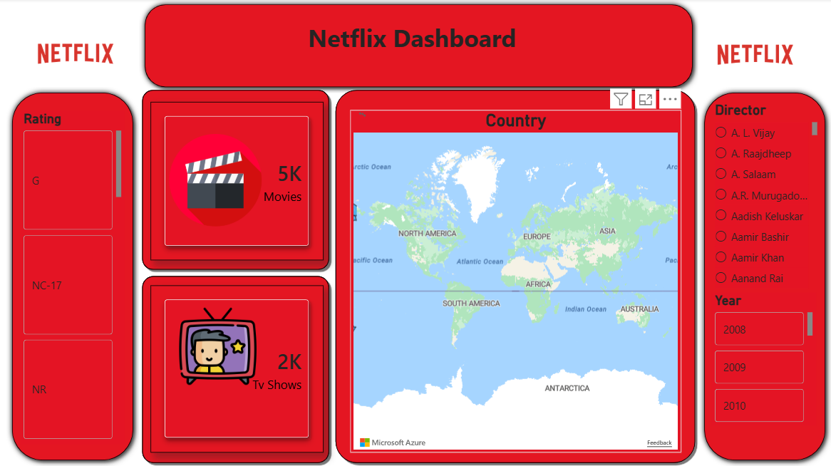

End of Report

