Romano

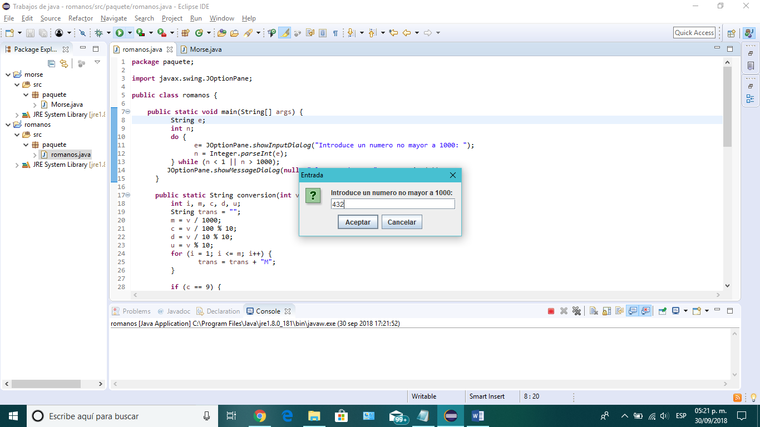

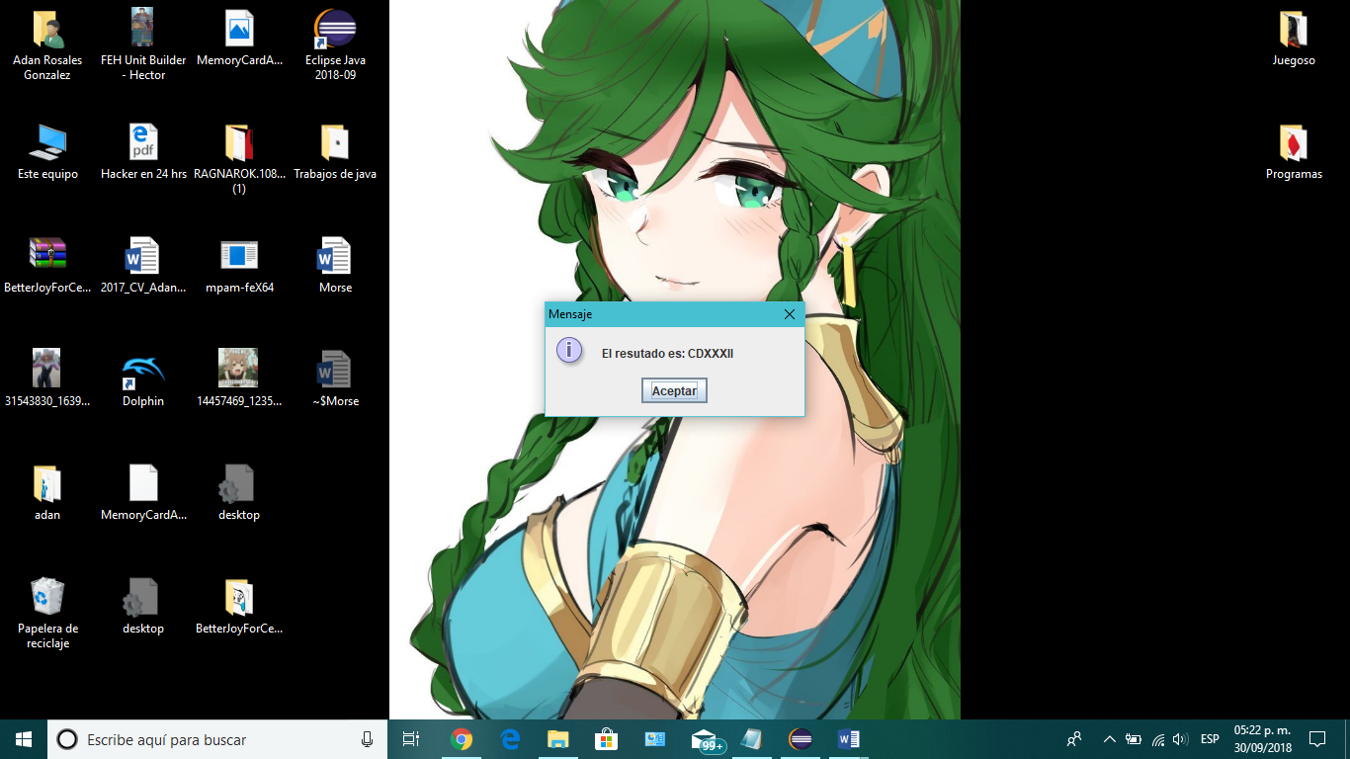

**package** paquete;

**import** javax.swing.JOptionPane;

**public** **class** romanos {

**public** **static** **void** main(String[] args) {

String e;

**int** n;

**do** {

e= JOptionPane.*showInputDialog*("Introduce un numero no mayor a 1000: ");

n = Integer.*parseInt*(e);

} **while** (n < 1 || n > 1000);

JOptionPane.*showMessageDialog*(**null**, "El resutado es: "+ *conversion*(n));

}

**public** **static** String conversion(**int** v) {

**int** i, m, c, d, u;

String trans = "";

m = v / 1000;

c = v / 100 % 10;

d = v / 10 % 10;

u = v % 10;

**for** (i = 1; i <= m; i++) {

trans = trans + "M";

}

**if** (c == 9) {

trans = trans + "CM";

} **else** **if** (c >= 5) {

trans = trans + "D";

**for** (i = 6; i <= c; i++) {

trans = trans + "C";

}

} **else** **if** (c == 4) {

trans = trans + "CD";

} **else** {

**for** (i = 1; i <= c; i++) {

trans = trans + "C";

}

}

**if** (d == 9) {

trans = trans + "XC";

} **else** **if** (d >= 5) {

trans = trans + "L";

**for** (i = 6; i <= d; i++) {

trans = trans + "X";

}

} **else** **if** (d == 4) {

trans = trans + "XL";

} **else** {

**for** (i = 1; i <= d; i++) {

trans = trans + "X";

}

}

**if** (u == 9) {

trans = trans + "IX";

} **else** **if** (u >= 5) {

trans = trans + "V";

**for** (i = 6; i <= u; i++) {

trans = trans + "I";

}

} **else** **if** (u == 4) {

trans = trans + "IV";

} **else** {

**for** (i = 1; i <= u; i++) {

trans = trans + "I";

}

}

**return** trans;

}

}