Pec.edu CMS_ Helpbook

*Version 1.0 April 2020*



Contents

Login 3

WEBMASTER features 4

Webmaster initialization 4

Adding Faculty 5

Adding a department HOD 6

Adding a 4C convener 7

Adding a Webhander 7

Adding a Memo 8

FACULTY features 10

(Regular Access) 10

Edit Profile 10

Adding memo 11

(Privileged Access) 12

Add Staff 12

WEB-HANDLER features 14

Add Articles 14

Add Gallery 16

4Cs Facilities 17[1]

4C Summary 17

# Login

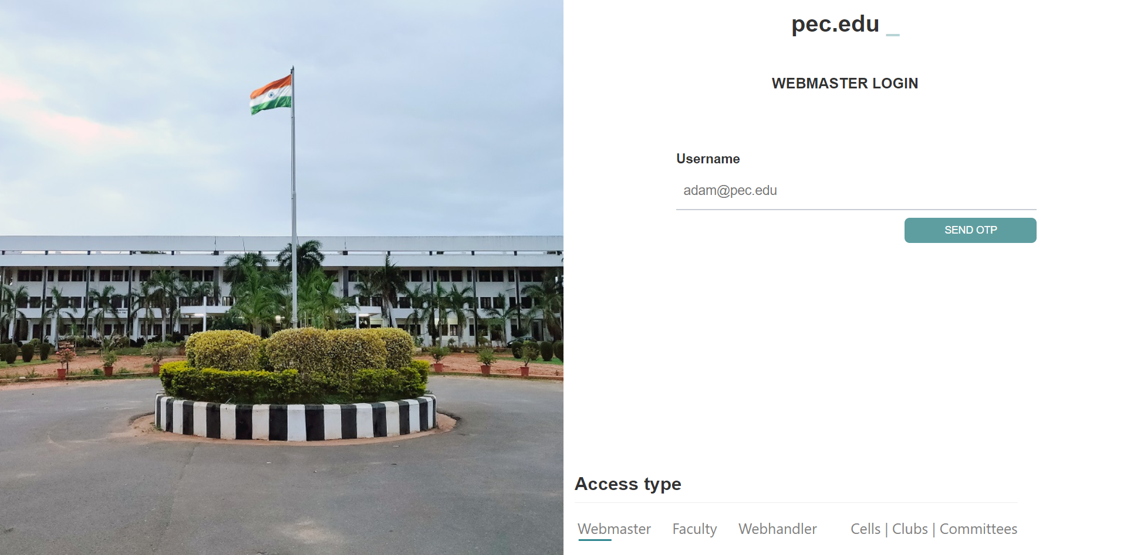

Figure 1: Login portal

Login for Webmaster, Faculty, Web-handler, 4C accounts-

1. Select the desired ‘Access Type’ from the options given at the bottom.
2. Enter Username i.e. your registered email and press Send OTP.  
   For 4C access select the respective title.
3. OTP will be sent if your mail id matches the registered mail id for the account.  
   The OTP will be sent from [noreply@pec.edu](mailto:noreply@pec.edu) and is an 8 digit PIN number.
4. Verify the CAPTCHA and enter the OTP.
5. 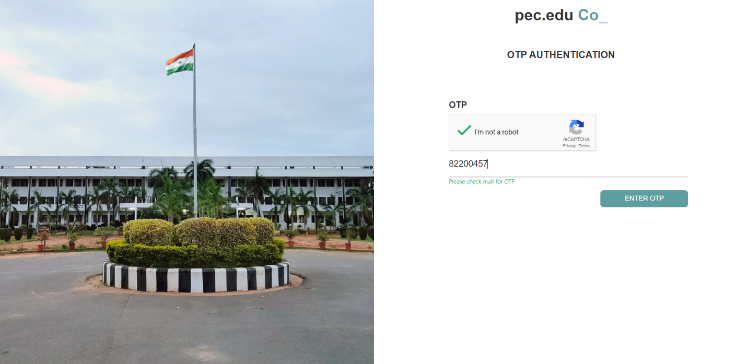You’re Logged in. Remember to sign-out when the work is done.

Figure 2: OTP page

# WEBMASTER features

## Webmaster initialization

Manual: To add a webmaster manually you have to first enter the fields in the login table (if you are entering manually, please enter the department as ‘other’ so that a global identity is maintained other than the department specific one) and then add the id and designation associated in the idref and desg columns of role table. This step is only recommended in the testing phase (before the webmaster is added as a faculty of a department). Only the master webmaster with server access can perform this.



Figure 3: Fields in login table



Figure 4: Fields in role table

From CMS: Go to ‘Add roles’ option from Webmaster window and fill the required fields.

You may delete a webmaster from the ‘View Roles’ option.

The Webmaster is recommended to lead the current maintenance team to scrutinize the whole website environment and discuss possible scope of improvement at the end/start of every academic semester to keep the website links updated and the features rolling.

## Adding a Faculty

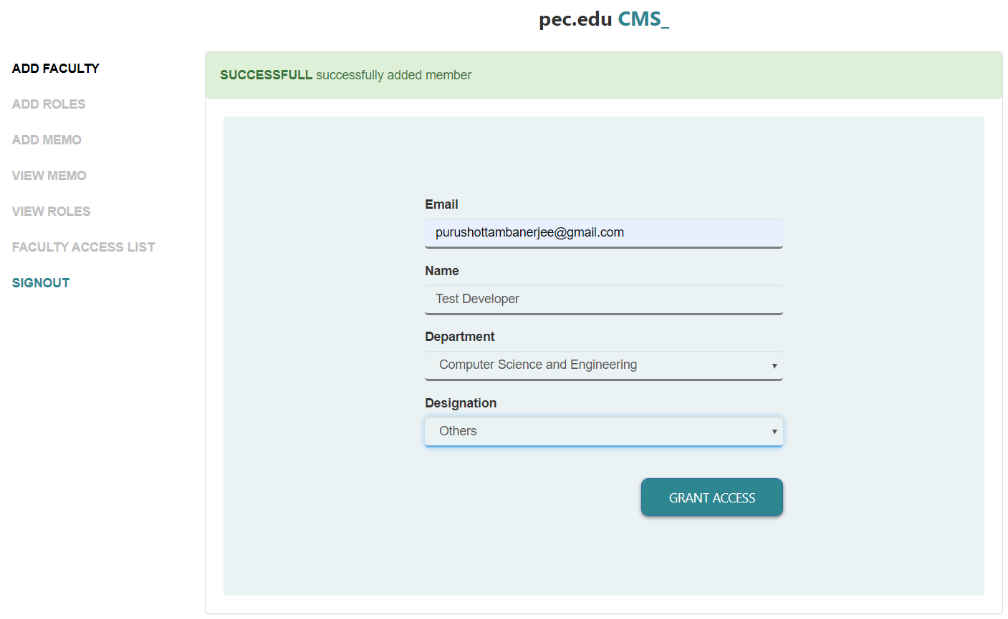

Figure 5: Adding a faculty

Provide the registered @pec.edu email, name of the Faculty (e.g. Ashok), department and designation (options: Professor, Assoc. Professor, Asst. Professor, Programmer, Others).

Note: This will add the faculty to the login table (for cms login) and basic_faculty_info (for department view) table. In case the faculty name is to be changed (e.g. Ashok -> Dr. Ashok) please visit the basic_faculty_info table and change the name there. You may delete faculty access for a particular faculty from ‘Faculty Access List’ option. It will delete the access rights only. The profile stays in the basic_faculty_info table.  
Warning: The faculty list is to be added seniority wise as the listing is done based on the automatically generated id.

On addition, the card will be automatically added to the department with empty data which the faculty can fill from Faculty login.

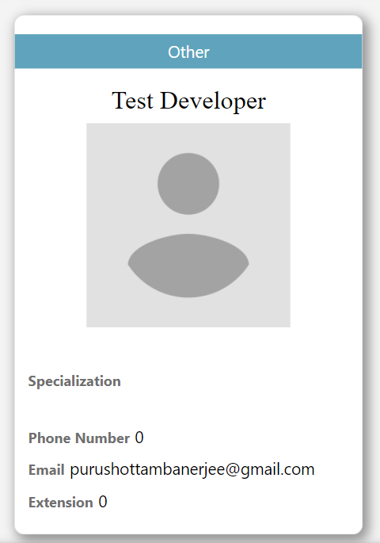

Figure 6: Faculty card by default on department view

## Adding a department HOD

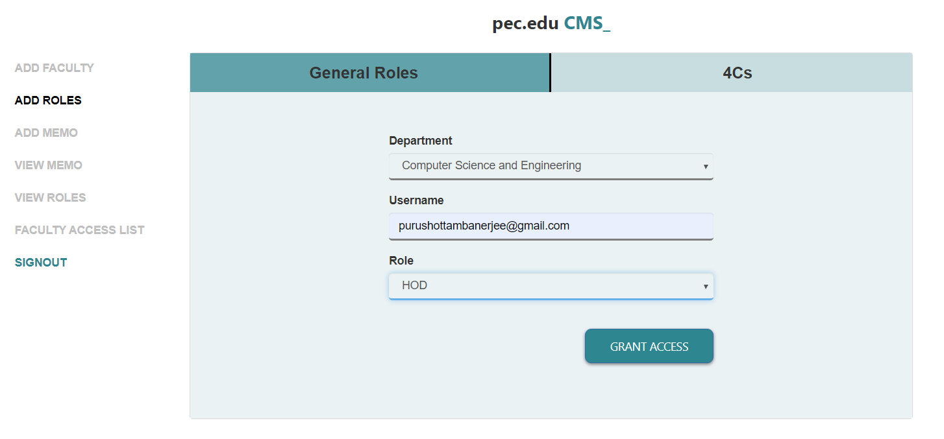

Figure 7: Adding HOD

Select the department, enter the associated mail id of the faculty and select the role as HOD.

Note: Only one HOD is associated with a department. It considers the newest entry. A department HOD has the additional option of adding staffs of the department from the Faculty login console. The tables associated are login and role directly and basic_faculty_info indirectly. You may delete a HOD from ‘View Roles’ option.

## Adding a 4C convener

Select the 4Cs tab in the ‘Add Roles’ option.

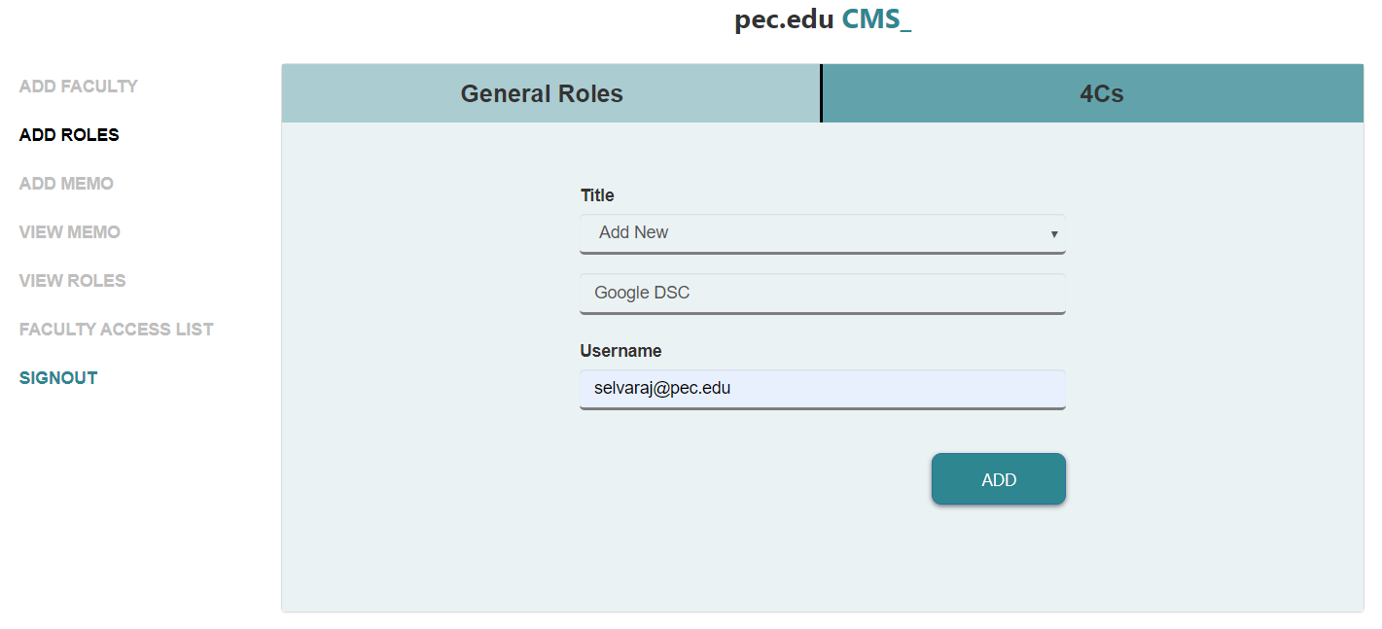

Figure 8: Add role panel

Select the title from the drop-down and give the associated convener mail id.

If the title is not given select ‘Add New’ from the dropdown, a field will prompt for the new title.

Note: Multiple titles may be associated with same convener mail id (e.g. [Ashok@pec.edu](mailto:Ashok@pec.edu) for clubs X and Y both). The table associated for web-handlers is the login table. You may delete a 4C convener from ‘View Roles’ option.

## Adding a Webhander

Done through General Roles tab of ‘Add Roles’ option. Follow regular process. Table associated are login and role.

Note: You may delete a web-handler from ‘View Roles’ option. The Web-handler have department specific features i.e. if the web-handler belongs to CSE he/she can uploads to CSE website. The associated table are login and roles. It is suggested to add one faculty per department as web-handler.

## Adding a Memo

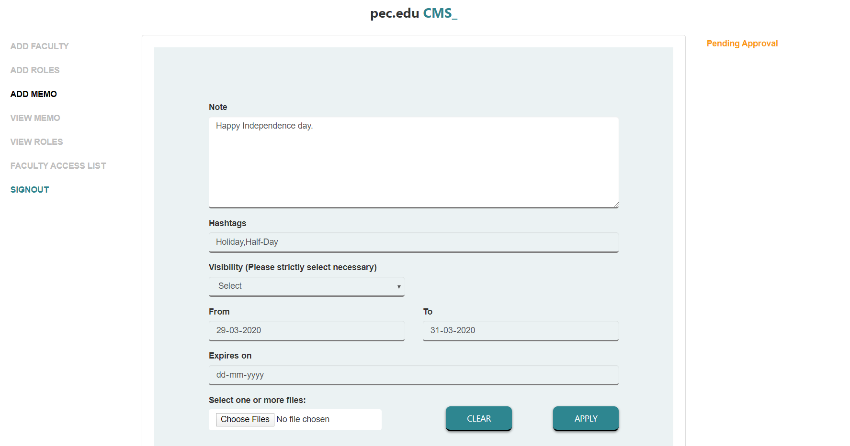

Figure 9: Add memo panel

Note: Enter your description. Please start with a brief summary as the card will display the first 15 words. Styling is not recommended inside the text field as the text file is automatically processed to generate a downloadable calendar file.

Hashtag: Enter one word descriptions separated by a comma (e.g. Holiday,Half-Day)

Visibility: 3 categories – all departments and main page (displays as departmental notice on home pages and all departs), main page (only home page) and department specific (only that department).

Expiry: The notice shall be hidden on the next day of given expiry date.

Webmasters can choose to upload one or more files with the memo (hold down shift/ctrl while selecting the files).

Webmasters has to approve any notice and update to be posted on the website and applications from faculty can be viewed on the right ‘Pending Approval’ section.

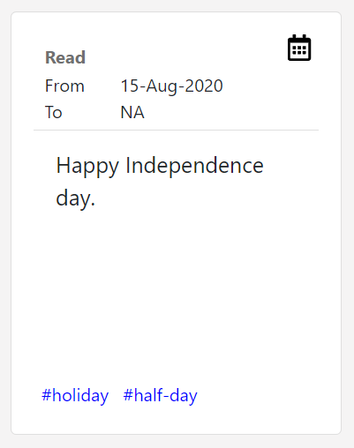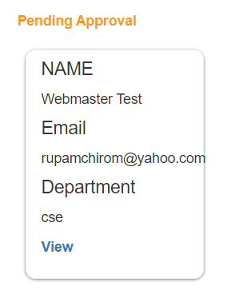

Figure : A memo upload request

Figure 11: A notice card with filled in information (the calendar icon on top-right downloads the information)

Note: If you encounter any error in adding it would mostly be due to character conflicting. These are additional measures taken considering website security. At such times HTML character codes are to be used. Some known conflicts:   
(Refer: <https://www.rapidtables.com/web/html/html-codes.html>)

|  |  |
| --- | --- |
| View | HTML code |
| ‘ | &#39; |

So, if you want to enter Student’s enter as Student &#39;s

Associated tables are news_update (for text), tags (for tags) and attachment (for storing attachments). You may delete a memo from the ‘View Memo’ option.

The folders where media is stored are:  
1. Cms/profilepics – Faculty images.  
2. Cms/articles – Articles headers.  
3. Cms/galleryimage – Gallery images.  
4. Cms/contentupload – News & Update attachments.

# FACULTY features

## (Regular Access)

## Edit Profile

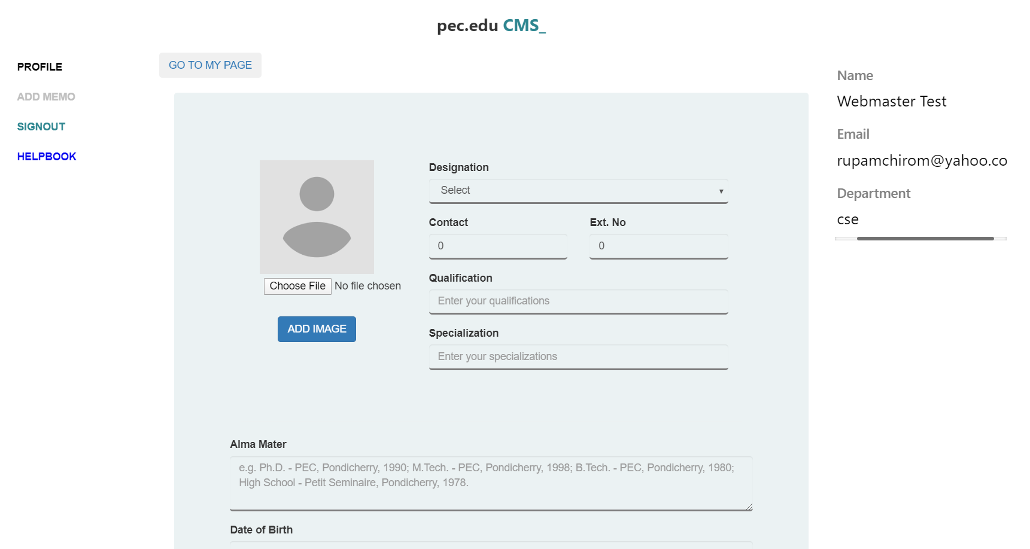

Figure : Faculty profile editor portal

Add your details according to the fields, add a profile image (passport size 2:3) by choosing a file and clicking on add image. You can use html styling elements like: text<br>text for next line, <b>**text**</b> for bold, <i>*text*</i> for italics in the text fields.

Your nameplate is displayed on the right. You may view your profile by clicking on ‘Go to my page’ on the top of the profile editor window.

Note: Involved tables in the database are (for login-login and role)- basic_faculty_info, academic, social_links, uploading and publications.

## Adding memo

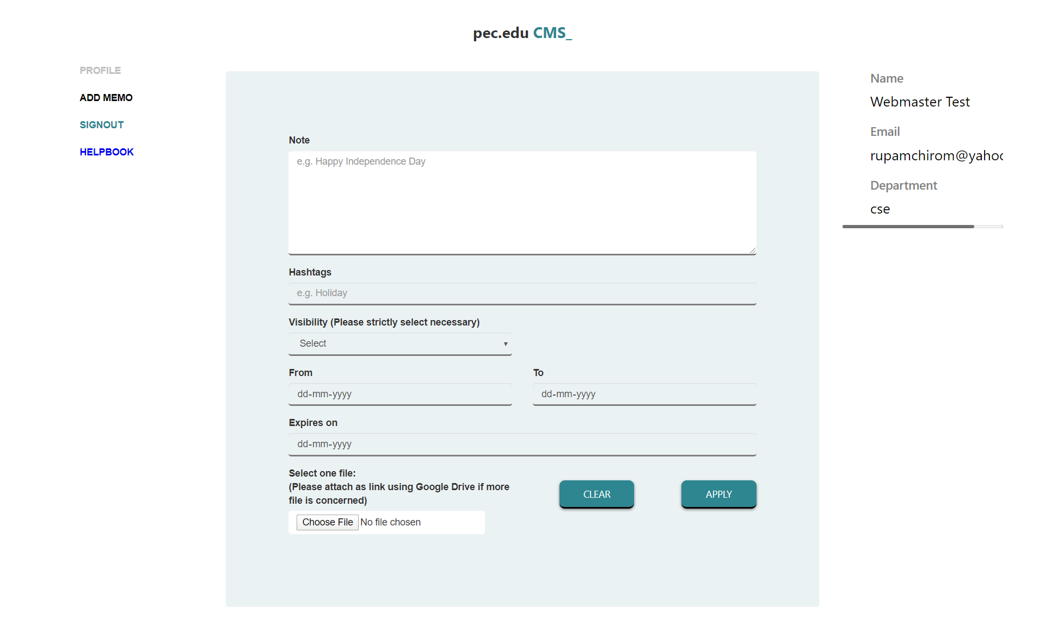

Figure : Memo application portal

Note: Enter your description. Please start with a brief summary as the card will display the first 15 words. Styling is not recommended inside the text field as the text file is automatically processed to generate a downloadable calendar file.

Hashtag: Enter one word descriptions separated by a comma (e.g. Holiday,Half-Day)

Visibility: 3 categories – all departments and main page (displays as departmental notice on home pages and all departs), main page (only home page) and department specific (only that department).

Expiry: The notice shall be hidden on the next day of given expiry date.

You may choose to upload one image or document file with the memo.

Webmasters has to approve any notice and update to be posted on the website.

Note: If you encounter any error in adding it would mostly be due to character conflicting. These are additional measures taken considering website security. At such times HTML character codes are to be used. Some known conflicts:   
(Refer: <https://www.rapidtables.com/web/html/html-codes.html>)

|  |  |
| --- | --- |
| View | HTML code |
| ‘ | &#39; |

So, if you want to enter Student’s enter as Student &#39;s

## (Privileged Access)

## Add Staff

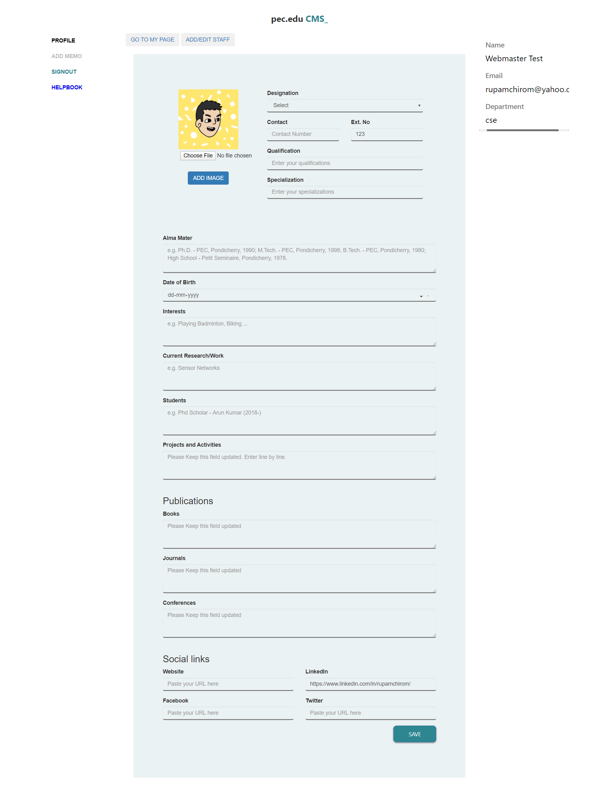

Figure : HOD privileged access

Click on the ‘Add/Edit Staff’ option above the profile editor. It will open the staff adder window.

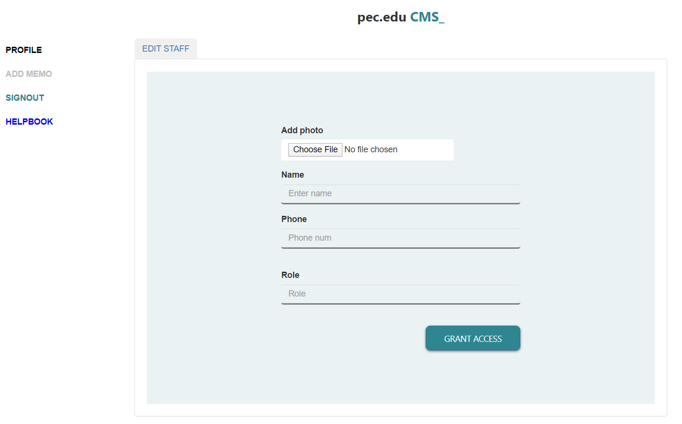

Figure : Add staff window

You can add the staffs one by one here and Edit the list with ‘Edit Staff’ option above this window.

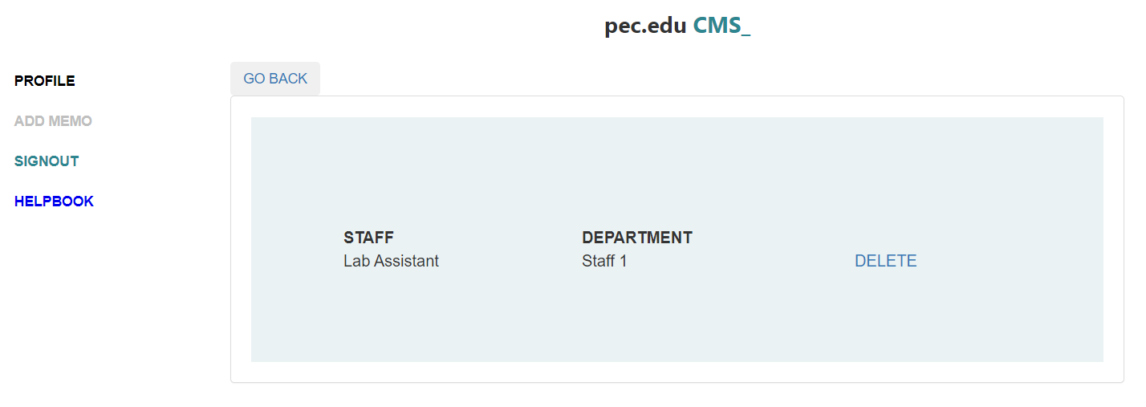

Figure : Edit staff window

Note: The staffs will show in the faculty page of departments after the list of faculties. The associated table in database is staff.

# WEB-HANDLER features

## Add Articles

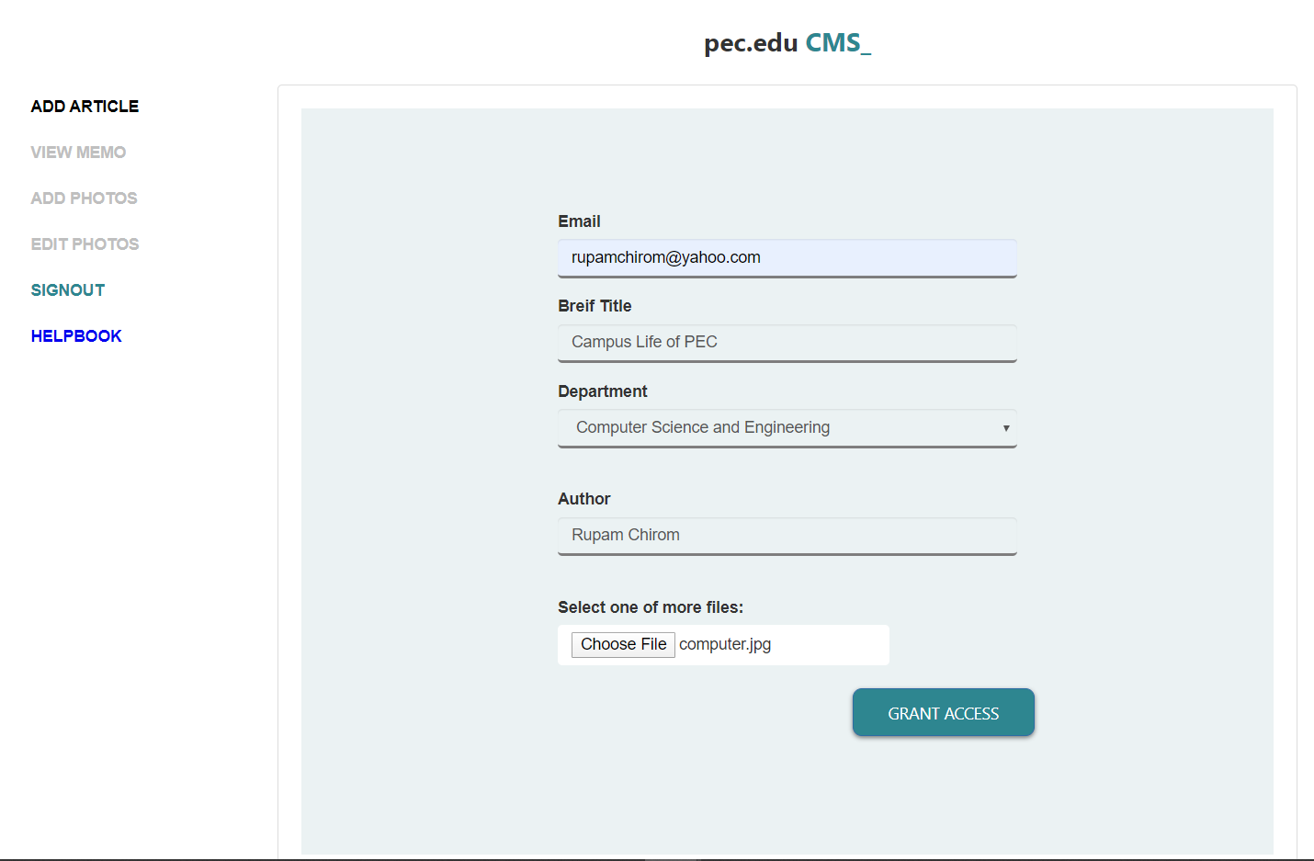

Figure 17: Add articles panel

Enter details for the articles in the ‘Add articles’ option.

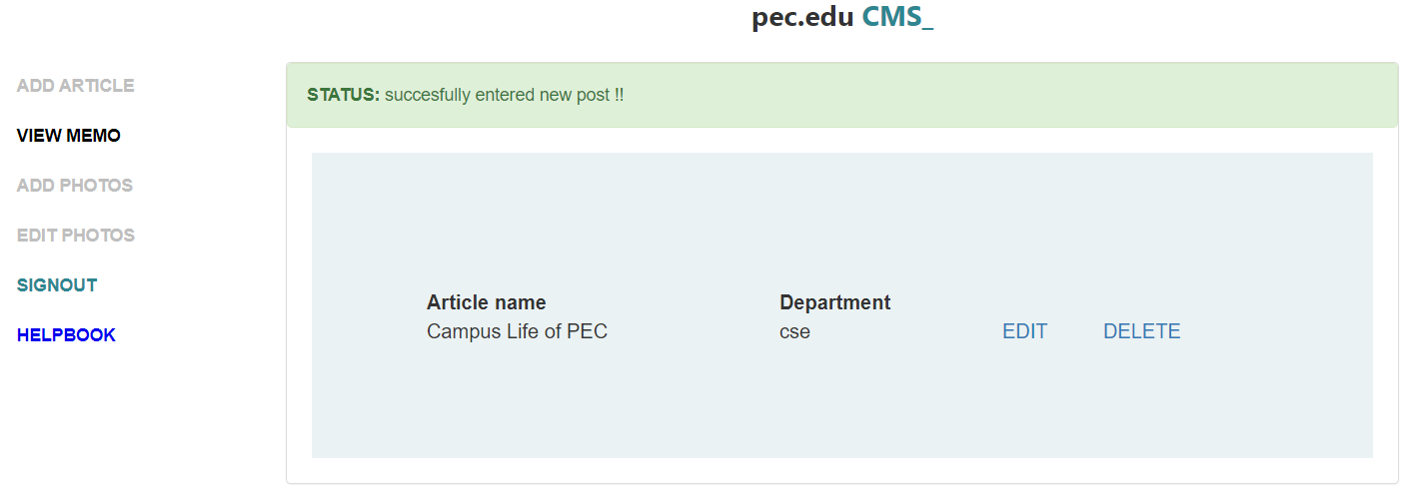

Figure 18: View memo panel

Add/Edit or Delete the article content from the ‘View memo’ option. You’ll find a Rich-Text-Editor panel here.

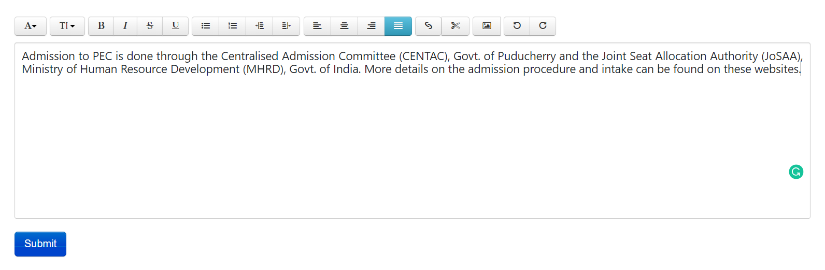

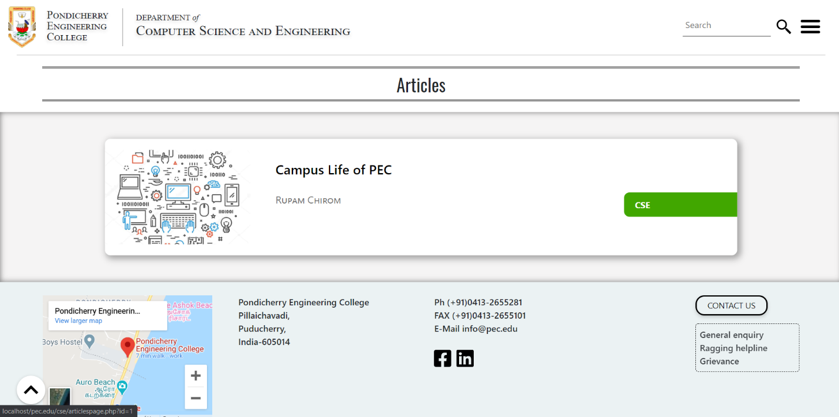Figure 19: Rich-Text-Editor for article

Figure 20: Article listing on front

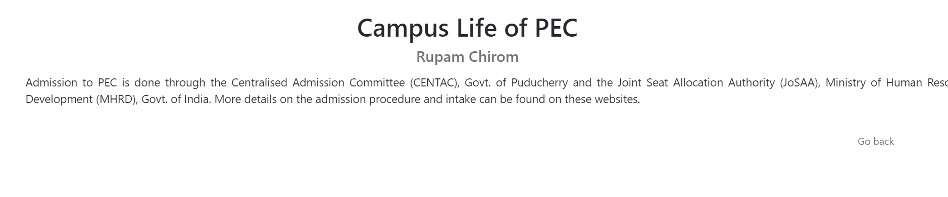

Figure 21: Article page

## Add Gallery

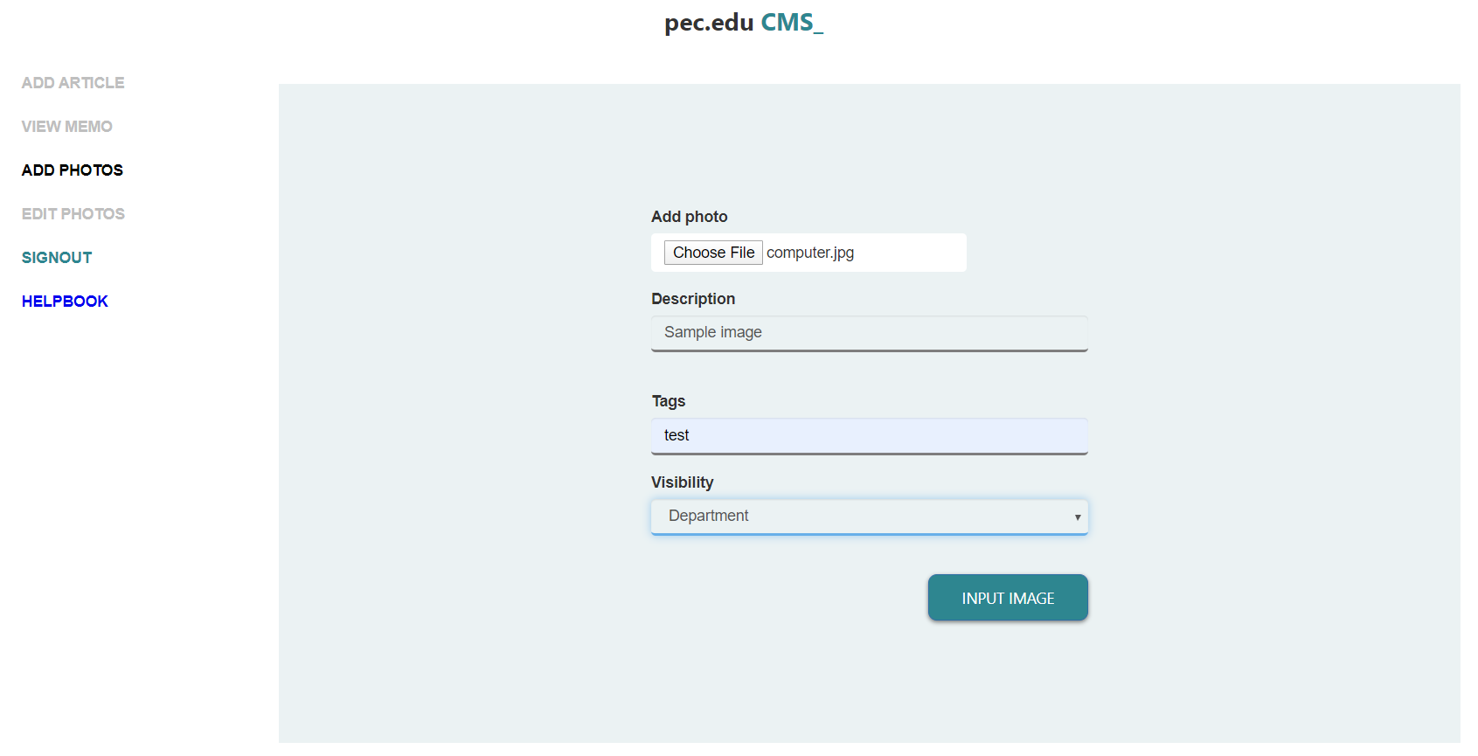

Add the image, description and title/tag related. Visibility can be set to Department, Campus or Others.

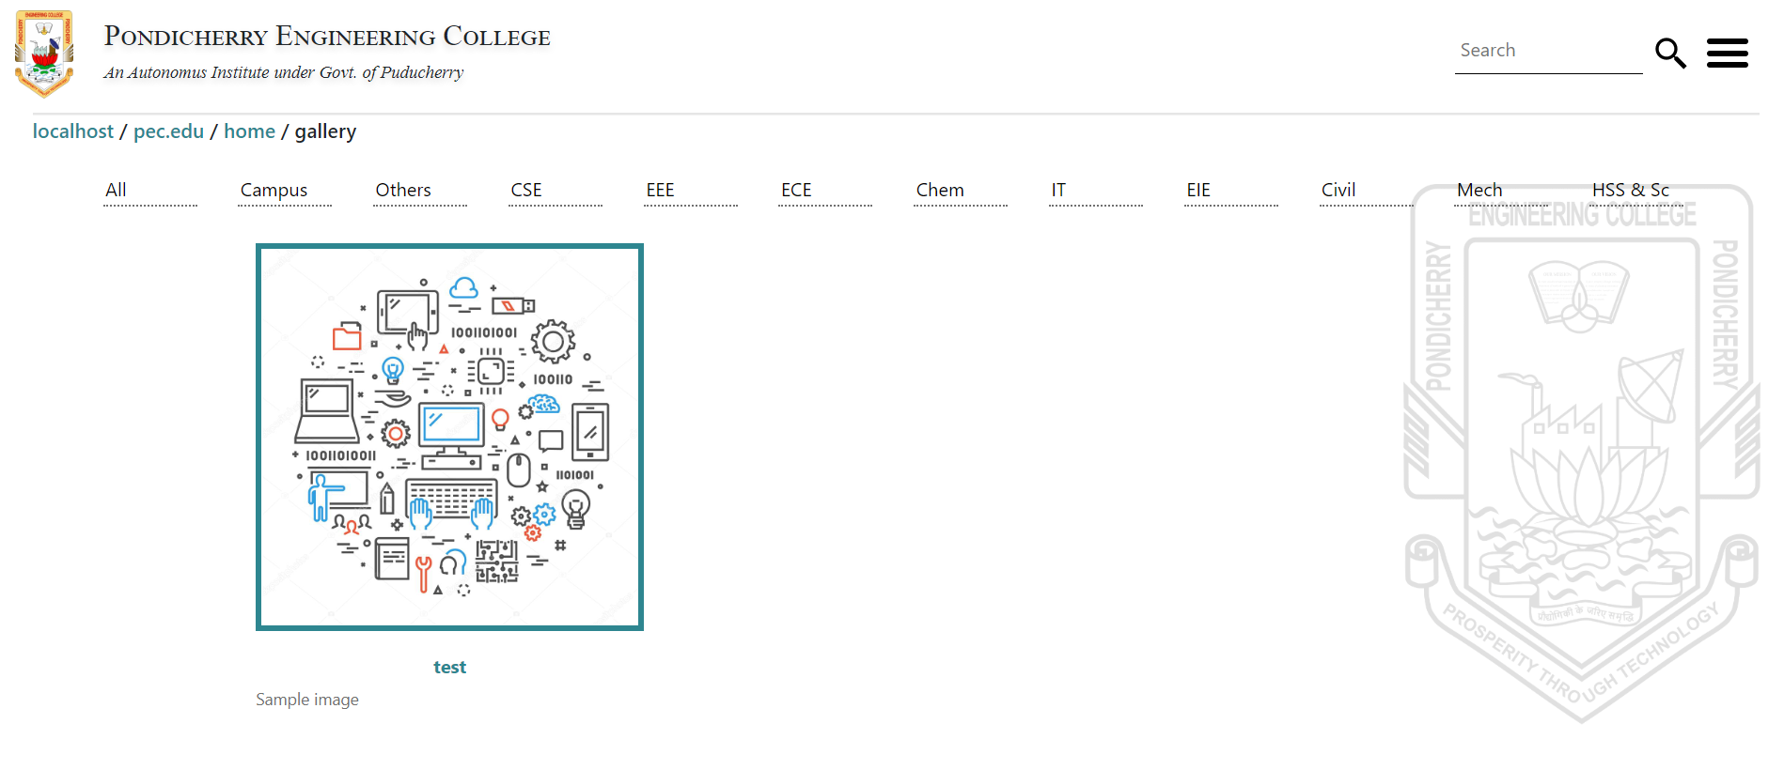

Figure 22: Gallery page

Note: You can delete the image from ‘Edit Photos’ option.

# 4Cs Facilities

## 4C Summary

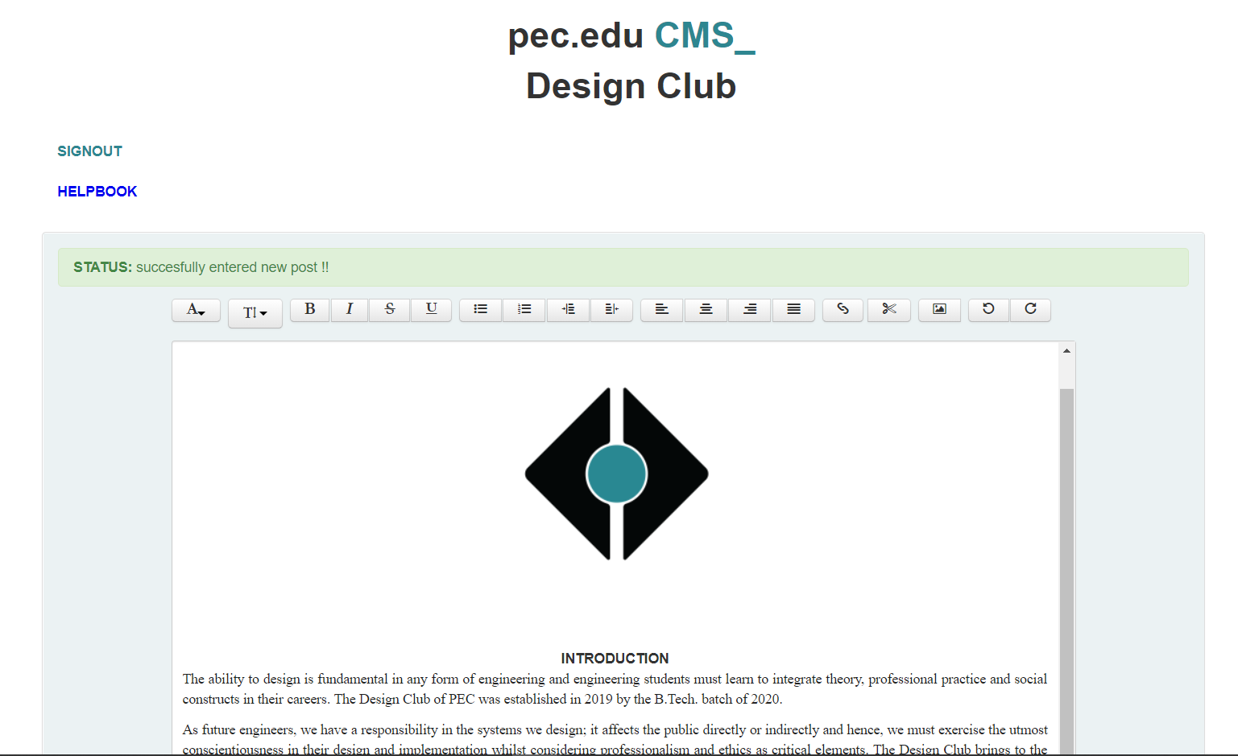

Figure 23: 4C window

Enter the details with the desired given formatting and press submit. You may update the same content by visiting here.

Note: You can view a 4C from the ‘On Campus’ section of the menu on the font-end. Associated table in database is article.

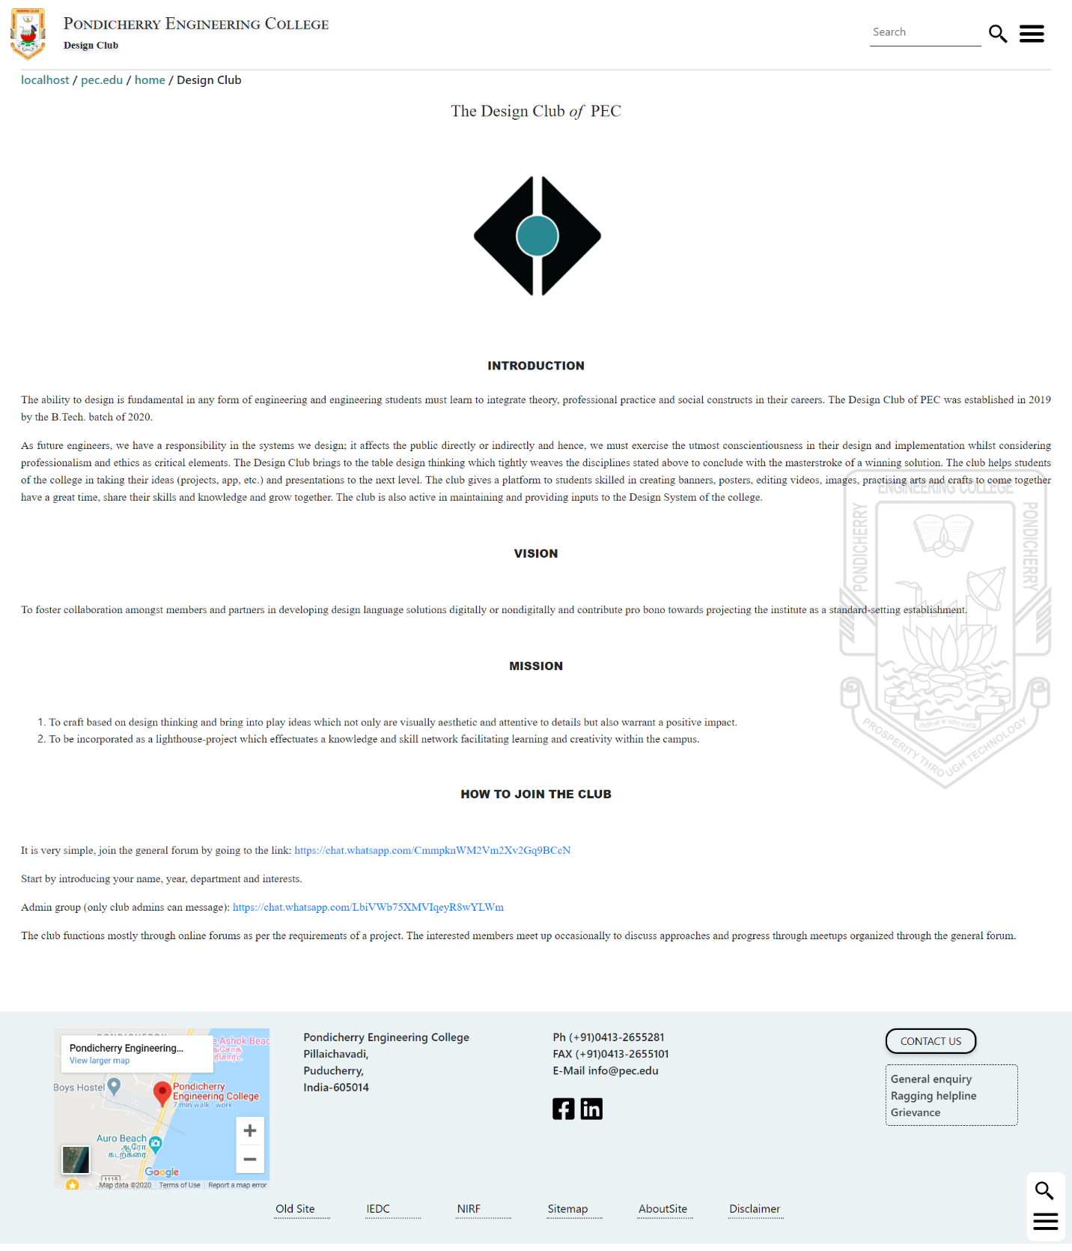

Figure 24: Design Club page created using CMS

THANK YOU.

The website was developed internally as an experiential initiative by the Design Club of PEC. The design closely follows the PEC Design System used extensively by the club in their design works to give an overall consistent look. The first version of the rework was launched on April 2020 after a yearlong research, development, testing and refining process and the project’s vision saw a website system that is congruent with the essence of the institute and having a clean non-distractive User Interface. The project consists of the ‘pec.edu CMS’ portal for staff’s use that silently powers the dynamic updates on the front-end; and the main ‘pec.edu’ portal open to everyone. The team aims for perfection; please feel free to drop any feedback or suggestion here (link:’../home/contact-us.html’).

Version 1.0.0.

Project Mentors

Dr. Ka. Selvaradjou, Department of Computer Science & Engineering

Dr. Shanthi Simon, Department of Humanities & Social Sciences

Dr. K. Sathiyamurthy, Department of Computer Science & Engineering

Special Thanks

Dr. S. Kothandaraman, Principal

Project Core Team

Batch of 2020

Rupam Chirom (CSE) – Scrum Master

Purushottam Banerjee (CSE) - Back-end Lead

Hari Kishore (CSE) – Front-end Lead

RamVignesh B. (CSE) – Club Organization’s Chair

Najmu Sehar Wani (Civil) – Club Operation’s Chair

RaviVarma (IT) – Media

Subisha Ramesh (CSE) – Content

Soundarya S. (CSE) - Content

Batch of 2021

Adharsh M (CSE) – Team Lead

Kadhirvel@Lokeshwaran K (CSE) – Team Lead

Roopan Chakravarthy Rodin (CSE) – Team Lead

Krishna Kumar Davuluri (CSE) – Team Lead

Ranjeet Mishra (CSE) – Team Lead

Raushan Kumar (EEE) – Team Lead

Supporting Team

Batch of 2020

Hemaachandar R (Civil) – Club Joint Secretary

Chinta Sri Vishnu Koushik (CSE) – Development Sprint

Vasandakumar S (CSE) – Development Sprint

Kumaran V (CSE) – Development Sprint

Batch of 2021

Moses M (CSE) - Team member

Gayathri A (CSE) - Team member

Seran R (CSE) - Team member

Deepika R (CSE) - Team member

Shifa K (CSE) - Team member

Shafreena S (CSE) - Team member

Swetha S (CSE) - Team member

Divyarupakala D (CSE) - Team member

Hema M (CSE) - Team member

Roshini T S (CSE) - Team member

1. 4Cs refers to Cells/Clubs/Committees/Chapters collectively.