TESTING

Home Page
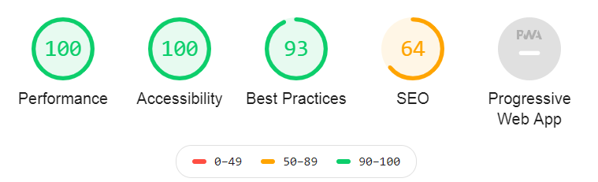

About Page

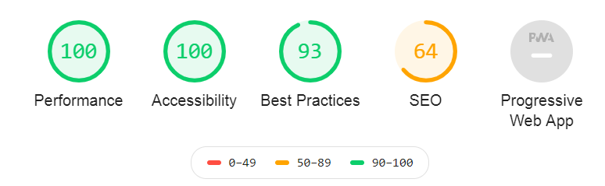

Academics Page

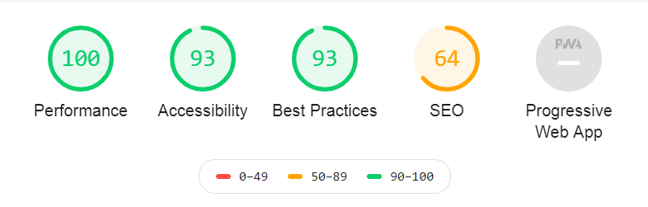

Achievement Page

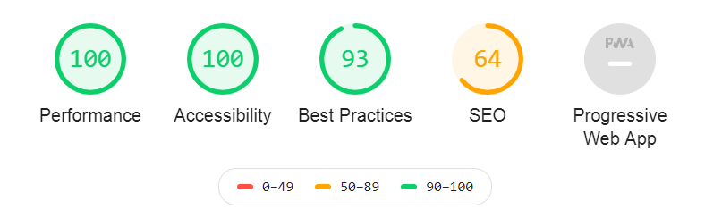
Utilities Page

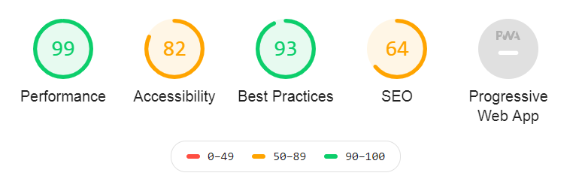

Contact Page

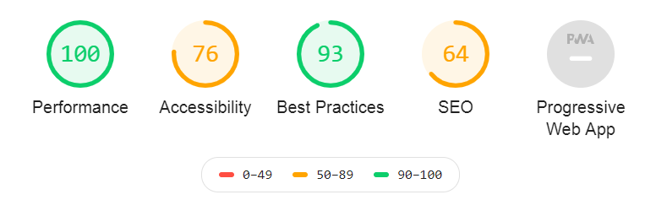

Logo Page

