**WEEK 5**

**Superset ID-6377161**

**Creating Microservices for account and loan**

**Directory**

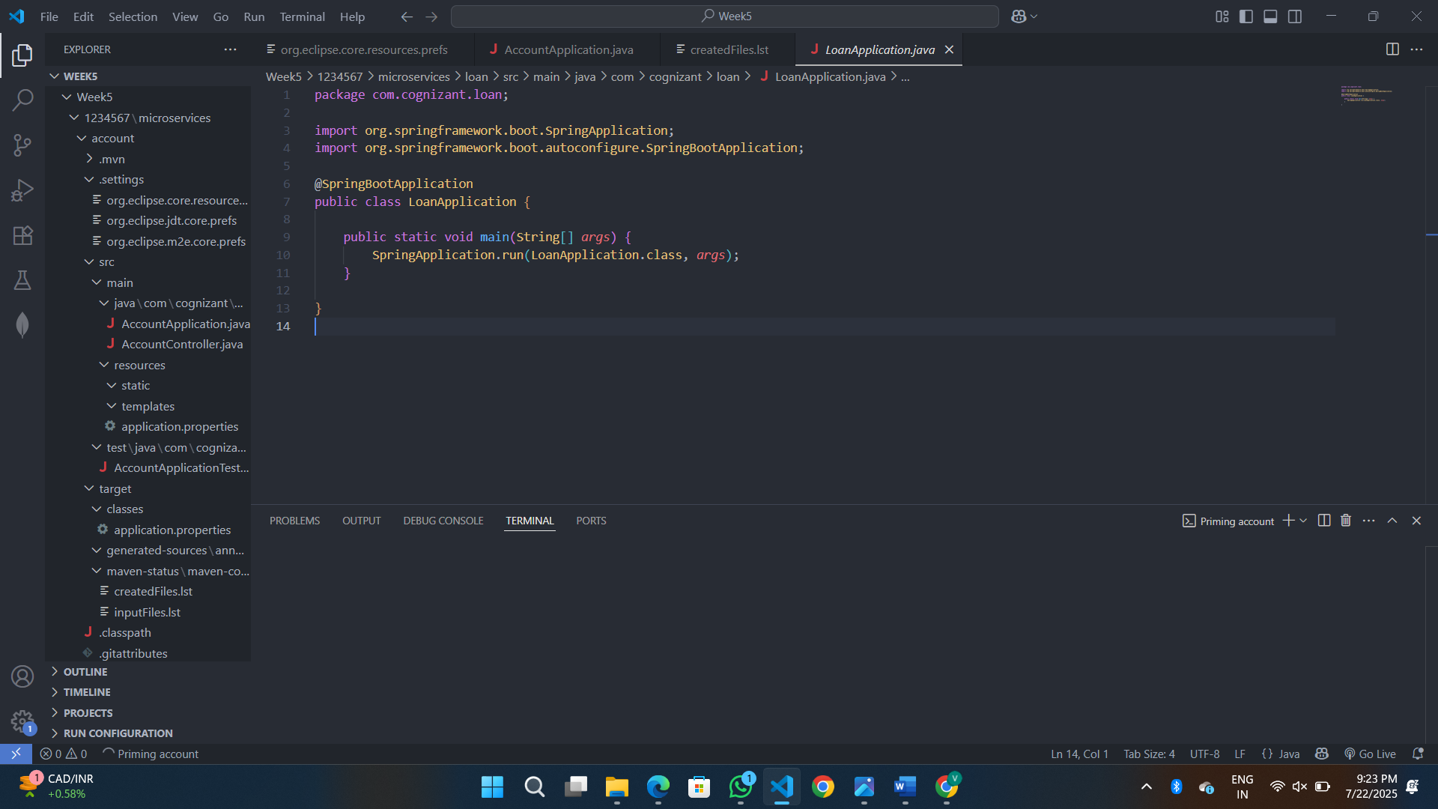

**ACCOUNT**

**AccountApplication.java**

package com.cognizant.account;

import org.springframework.boot.SpringApplication;

import org.springframework.boot.autoconfigure.SpringBootApplication;

@EnableDiscoveryClient

@SpringBootApplication

public class AccountApplication {

    public static void main(String[] *args*) {

        SpringApplication.run(AccountApplication.class, *args*);

    }

}

**AccountController.java**

package com.cognizant.account;

import org.springframework.web.bind.annotation.*;

@RestController

@RequestMapping("/accounts")

public class AccountController {

    @GetMapping("/{number}")

    public Account getAccountDetails(@PathVariable String *number*) {

        return new Account(*number*, "savings", 234343);

    }

}

class Account {

    private String number;

    private String type;

    private double balance;

    public Account(String *number*, String *type*, double *balance*) {

        this.number = *number*;

        this.type = *type*;

        this.balance = *balance*;

    }

    public String getNumber() { return number; }

    public String getType() { return type; }

    public double getBalance() { return balance; }

}

**Application.properties**

server.port=8080

spring.application.name=account-service

eureka.client.service-url.defaultZone=http://localhost:8761/eureka

**AccountApplicationTest.java**

package com.cognizant.account;

import org.junit.jupiter.api.Test;

import org.springframework.boot.test.context.SpringBootTest;

@SpringBootTest

class AccountApplicationTests {

    @Test

    void contextLoads() {

    }

}

**.classpath**

<?xml version="1.0" encoding="UTF-8"?>

<classpath>

    <classpathentry kind="src" output="target/classes" path="src/main/java">

        <attributes>

            <attribute name="optional" value="true"/>

            <attribute name="maven.pomderived" value="true"/>

        </attributes>

    </classpathentry>

    <classpathentry excluding="**" kind="src" output="target/classes" path="src/main/resources">

        <attributes>

            <attribute name="maven.pomderived" value="true"/>

        </attributes>

    </classpathentry>

    <classpathentry kind="src" output="target/test-classes" path="src/test/java">

        <attributes>

            <attribute name="optional" value="true"/>

            <attribute name="maven.pomderived" value="true"/>

            <attribute name="test" value="true"/>

        </attributes>

    </classpathentry>

    <classpathentry kind="con" path="org.eclipse.jdt.launching.JRE_CONTAINER/org.eclipse.jdt.internal.debug.ui.launcher.StandardVMType/JavaSE-17">

        <attributes>

            <attribute name="maven.pomderived" value="true"/>

        </attributes>

    </classpathentry>

    <classpathentry kind="con" path="org.eclipse.m2e.MAVEN2_CLASSPATH_CONTAINER">

        <attributes>

            <attribute name="maven.pomderived" value="true"/>

        </attributes>

    </classpathentry>

    <classpathentry kind="output" path="target/classes"/>

</classpath>

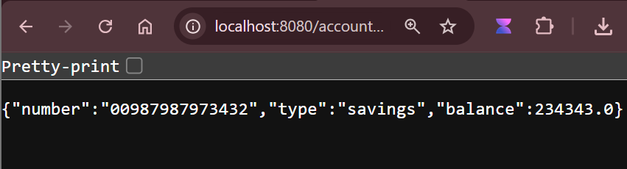

**LOAN**

**LoanApplication.java**

package com.cognizant.loan;

import org.springframework.boot.SpringApplication;

import org.springframework.boot.autoconfigure.SpringBootApplication;

@SpringBootApplication

public class LoanApplication {

    public static void main(String[] *args*) {

        SpringApplication.run(LoanApplication.class, *args*);

    }

}

**LoanController.java**

package com.cognizant.loan;

import org.springframework.web.bind.annotation.*;

@RestController

@RequestMapping("/loans")

public class LoanController {

    @GetMapping("/{number}")

    public Loan getLoanDetails(@PathVariable String *number*) {

        return new Loan(*number*, "car", 400000, 3258, 18);

    }

}

class Loan {

    private String number;

    private String type;

    private double loan;

    private int emi;

    private int tenure;

    public Loan(String *number*, String *type*, double *loan*, int *emi*, int *tenure*) {

        this.number = *number*;

        this.type = *type*;

        this.loan = *loan*;

        this.emi = *emi*;

        this.tenure = *tenure*;

    }

    public String getNumber() { return number; }

    public String getType() { return type; }

    public double getLoan() { return loan; }

    public int getEmi() { return emi; }

    public int getTenure() { return tenure; }

}

**LoanApplicationTest.java**

package com.cognizant.loan;

import org.junit.jupiter.api.Test;

import org.springframework.boot.test.context.SpringBootTest;

@SpringBootTest

class LoanApplicationTests {

    @Test

    void contextLoads() {

    }

}

