Online Assessment Tool

Installation Instructions

Author: Ranjeet Kumar

Owner: IBM

Status: Draft

Document History

Revision History

|  |  |  |  |
| --- | --- | --- | --- |
| Revision Number | Revision Date | Summary of Changes | Changes marked |
| 0.1 | 04/03/2020 | Initial |  |
|  |  |  |  |
|  |  |  |  |
|  |  |  |  |
|  |  |  |  |
|  |  |  |  |

Contents

1. Introduction 4

1.1 Purpose 4

1.2 Scope 4

1.3 Software Version 4

2. Install Node.JS on windows 5

2.1 Steps to install Node.JS 5

2.2 Verify Node.JS Installation 10

2.3 Verify NPM 11

3. Install Angular 12

3.1 Steps to install angular 12

3.2 Angular command – Create & Run the program 13

4. Install MongoDB on windows 15

4.1 Installation of MongoDB 15

4.2 Configuration of MongoDB 16

5. Install Eclipse ID 17

6. Import Online Assessment Tool project to Eclipse 18

# 1. Introduction

## Purpose

The purpose of this document is to provide the instruction to install the required MEAN (MongoDB, Express, Angular and NodeJS) stack software to work on the POC project to create Technical Assessment Tool

## Scope

Once this pilot project is successful then it should be flexible to accommodate the assessment packs of DWP, DevOps & QA-Automation also.

## Software Version

Below is the software version required to install for Online Assessment Tool project.

Node JS -> v12.15.0

Angular -> 9.0.5

Npm version -> 6.14.0

MongoDB -> v4.2.3

# 2. Install Node.JS on windows

The first steps in using Node.js is the installation of the Node.js libraries on the client system. To perform the installation of Node.js, perform the below steps.

## 2.1 Steps to install Node.JS

**Step 1)** Go to the site <https://nodejs.org/en/download/> and download the 64-bit setup files for Node.js.

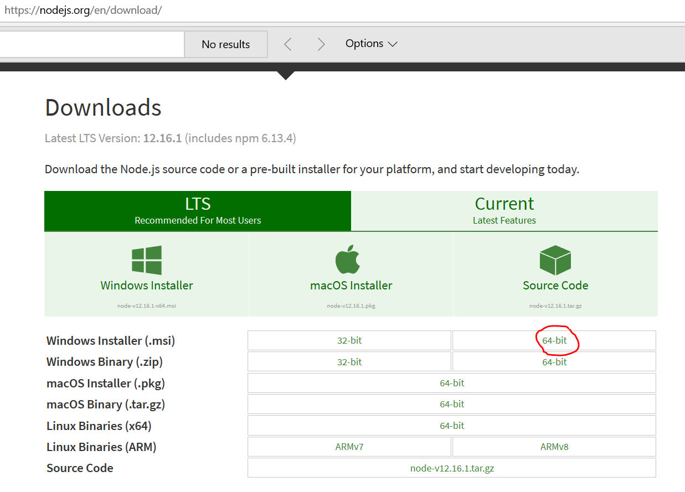

**Step 2)** Double click on the downloaded .msi file to start the installation. Click the Run button on the first screen to begin the installation.

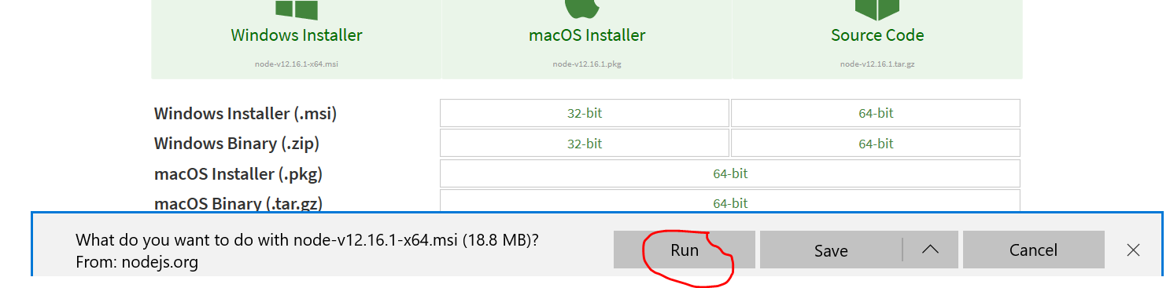

**Step 3)** In the next screen, click the "Next" button to continue with the installation

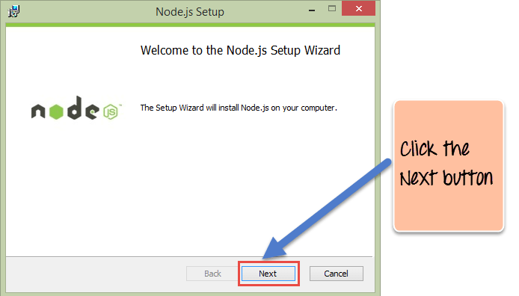

**Step 4)** In the next screen, Accept the license agreement and click on the Next button.

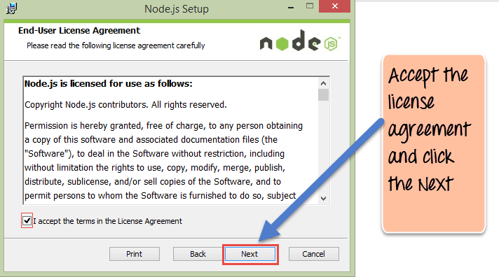

**Step 5)** In the next screen, choose the location where Node.js needs to be installed and then click on the Next button.

1. First, enter the file location for the installation of Node.js. This is where the files for Node.js will be stored after the installation.

2. Click on the Next button to proceed ahead with the installation.

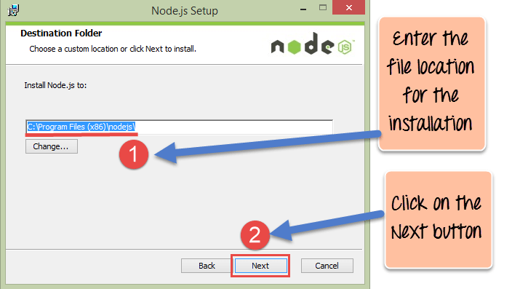

**Step 6)** Accept the default components and click on the Next button.

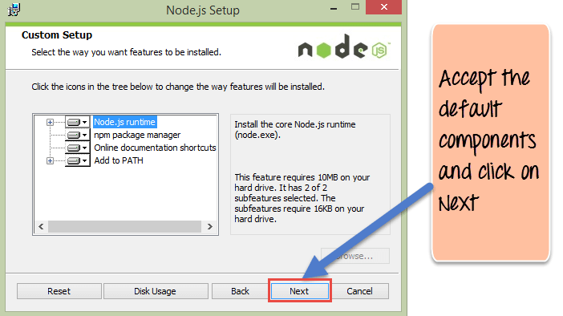

**Step 7)** In the next screen, click the Install button to start the installation.

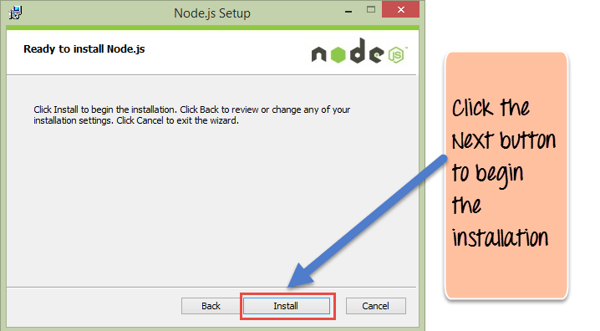

**Step 8)** Click the Finish button to complete the installation.

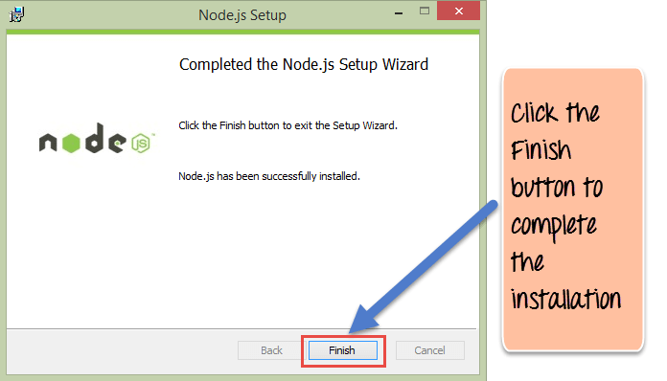

## 2.2 Verify Node.JS Installation

**Step 1)** Opens the command prompt window

**Step 2)** Enter the ‘node -v’ version command and press enter.It will display output as “v Number” where Number is the version number of Node,js.

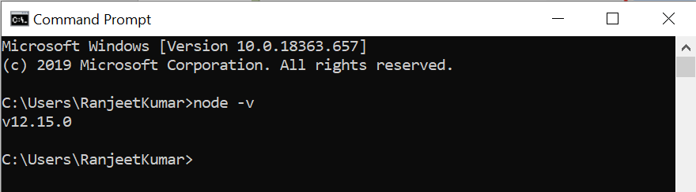

## 2.3 Verify NPM

NPM is the abbreviation of node package manager, it is installed during Node.js installation. Run below command in a dos terminal to check its installation status. If output the correct version number means it is installed correctly.

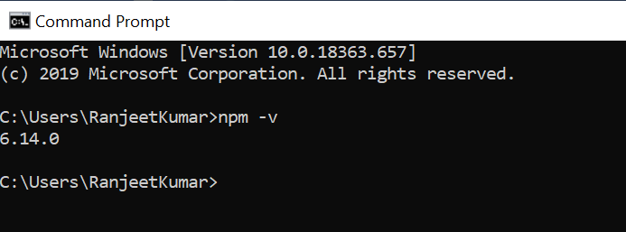

# Install Angular

The favorite way of installing Angular JS is via the command line. To install the AngularJS app on server via command line, the easiest way to accomplish this is via Angular’s CLI (the CLI stands for Command Line Interface). Angular CLI helps us to create projects, generate application and library code.

## Steps to install angular

Angular JS can simply be installed using NPM as mentioned in below steps.

**Step 1)** Open Command Prompt and install the Angular CLI with the below command.

npm install -g @angular/cli

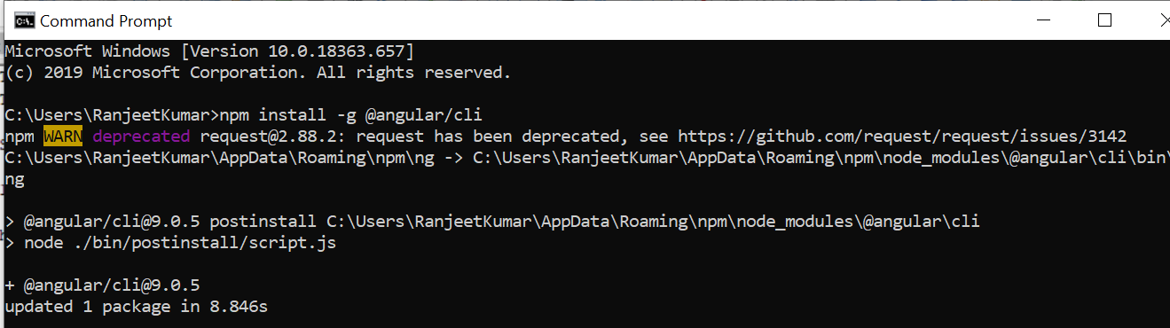

**Step 2)** Once the command is run, a question appears asking if we would like to share anonymous usage data with the Angular Team at Google . You can type Y or N as it’s not crucial to the installation.

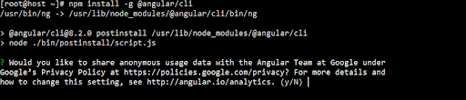

**Step 3)** If everything goes well, the below command will give the output pictured below.

ng --version

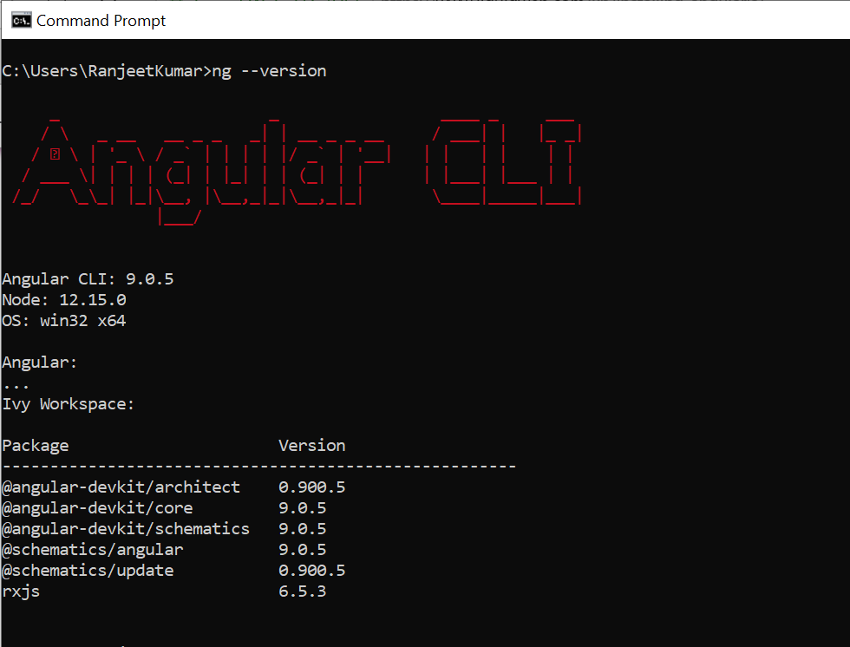

## 3.2 Angular command – Create & Run the program

### *3.2.1 Command to create new project*

The following command will create new project and install the angular libraries.

> ng new <project-name>

Example: ng new OAT

**Note:**

(1) After we issue the command, the first question to be asked is:  
“Would you like to add Angular routing? (y/N)”  
Just type “Y” on this one and proceed to the next question.

(2) Then, the follow up question is asked: Which stylesheet format would you like to use?

let’s choose CSS; just press Enter on your keyboard and wait for the install to finish.

### *Command to start Angular server*

To start the Angular server which will serve the application we need to issue the following command.

>ng serve

### *Command to add new component to angular project*

Run below command to add any new component to angular JS project.

>ng generate component <Component_Name>

Example : ng generate component login

### *Command to add new service to angular project*

Run below command to add any new service to angular JS project.

>ng service <service_Name>

Example : ng service login

# 4. Install MongoDB on windows

## 4.1 Installation of MongoDB

**Step 1)** Go to MongoDB download Page and click download as shown in the screenshot.

URL: <https://www.mongodb.com/download-center/community>

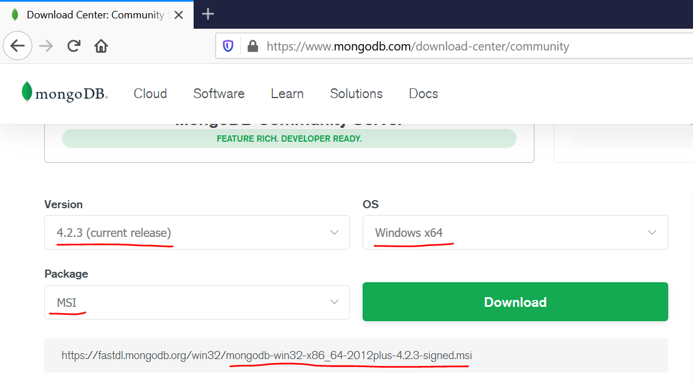

**Step 2)** Double click on the downloaded .msi file (mongodb-win32-x86_64-2012plus-4.2.3-signed.msi) to start the installation

**Step 3)** Click Next when the MongoDB installation windows pops up and accept the MongoDB user Agreement

**Step4)** When the setup asks you to choose the Setup type, choose Complete.

**Step5)** Click Install to begin the installation.

**Step6)** Click Finish once the MongoDB installation is complete.

## 4.2 Configuration of MongoDB

**Step 1)** Locate the folder where we have installed MongoDB. We can find the folder at below location:

C:\Program Files\MongoDB\Server\4.2

1. Create two folders here, name them data and log.  
2. Create another folder inside data and name it as db, that’s where all the data will be stored.

**Step 2)** Open command prompt and navigate to the bin folder of MongoDB

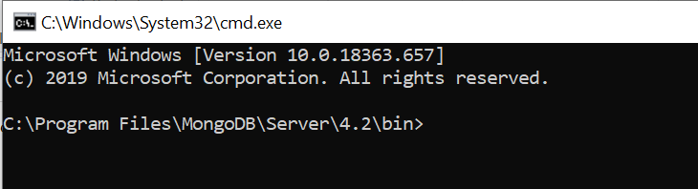

**Step 3)** Configure the data & log folder and set MongoDB as service by typing this command.

mongod --dbpath "C:\Program Files\MongoDB\Server\4.2\data\db"

**Step 4)** Start MongoDB as a service by typing this command.

>mongod

# 5. Install Eclipse ID

**Step 1)** Download "eclipse-jee-neon-3-win32.zip" using below url

<https://www.eclipse.org/downloads/download.php?file=/technology/epp/downloads/release/neon/3/eclipse-jee-neon-3-win32.zip>

**Step 2)** Follow steps provided in below url for Node JS patch installation.

<https://www.dev2qa.com/node-js-hello-world-example-with-eclipse/>

# Import Online Assessment Tool project to Eclipse

Download the project from below provided box url and import to the eclipse.

Box URL:

<https://ibm.ent.box.com/folder/103876627152?utm_source=trans&utm_medium=email&utm_campaign=collab%2Bauto%20accept%20user>

