DSA
Exercise 2:
E-commerce Platform Search Function
File:01Product.java
public class Product {
int productId;
String productName;
String category;

public Product(int productId, String productName, String category) {
this.productId = productId;
this.productName = productName;
this.category = category;
}

public void displayProduct() {
System.out.println("Product ID: " + productId);
System.out.println("Product Name: " + productName);
System.out.println("Category: " + category);
}
}
public class SearchDemo {

public static Product linearSearch(Product[] products, int searchId) {
for (int i = 0; i < products.length; i++) {
if (products[i].productId == searchId) {
return products[i];
}
}
return null;
}

public static Product binarySearch(Product[] products, int searchId) {
int left = 0;
int right = products.length - 1;

while (left <= right) {
int mid = (left + right) / 2;

if (products[mid].productId == searchId) {
return products[mid];
} else if (products[mid].productId < searchId) {
left = mid + 1;
} else {
right = mid - 1;
}
}

return null;
}
File 2: SearchDemo.java
public static void main(String[] args) {

Product[] products = {
new Product(101, "Laptop", "Electronics"),
new Product(102, "Shoes", "Fashion"),
new Product(103, "Mobile", "Electronics"),
new Product(104, "Watch", "Accessories"),
new Product(105, "Book", "Education")
};

int searchId = 104;

System.out.println("Linear Search Result:");
Product linearResult = linearSearch(products, searchId);

if (linearResult != null) {
linearResult.displayProduct();
} else {
System.out.println("Product not found");
}

System.out.println();

System.out.println("Binary Search Result:");
Product binaryResult = binarySearch(products, searchId);

if (binaryResult != null) {
binaryResult.displayProduct();
} else {
System.out.println("Product not found");
}

System.out.println();

System.out.println("Time Complexity Analysis:");
System.out.println("Linear Search: O(n)");
System.out.println("Binary Search: O(log n)");
System.out.println("Binary Search is better for large sorted product lists.");
}
}
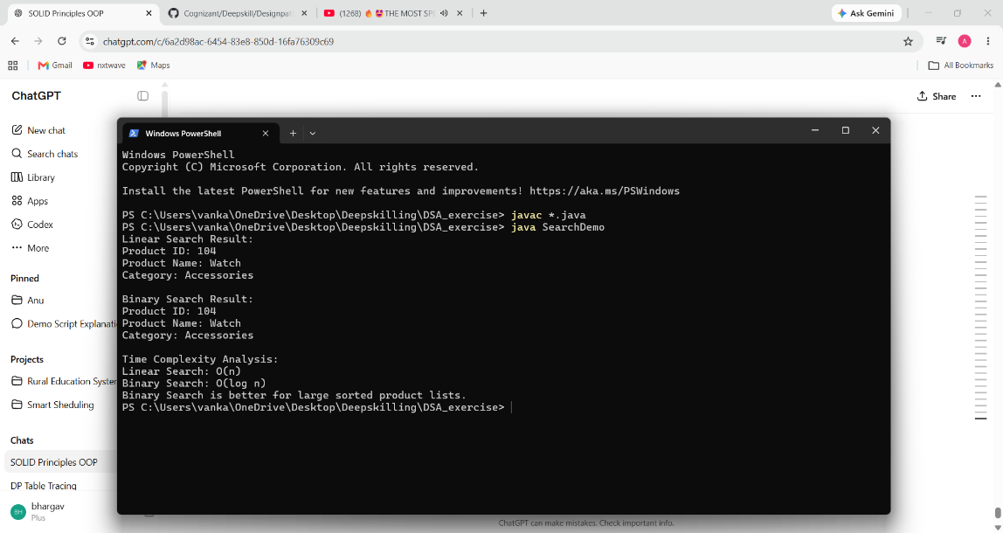

7.FinancialForecast
public class FinancialForecast {

public static double calculateFutureValue(double currentValue, double growthRate, int years) {

if (years == 0) {
return currentValue;
}

return calculateFutureValue(currentValue * (1 + growthRate), growthRate, years - 1);
}

public static void main(String[] args) {

double currentValue = 10000;
double growthRate = 0.10;
int years = 5;

double futureValue = calculateFutureValue(currentValue, growthRate, years);

System.out.println("Current Value: " + currentValue);
System.out.println("Growth Rate: " + (growthRate * 100) + "%");
System.out.println("Years: " + years);
System.out.println("Future Value: " + futureValue);
}
}
