Design Patterns:Module-01
Logger file:
public class Logger {

private static Logger instance;

private Logger() {
}

public static Logger getInstance() {
if (instance == null) {
instance = new Logger();
}
return instance;
}

public void log(String message) {
System.out.println("LOG: " + message);
}
}

Testlogger file:
public class TestLogger {

public static void main(String[] args) {

Logger logger1 = Logger.getInstance();
Logger logger2 = Logger.getInstance();

logger1.log("Application Started");
logger2.log("Logging Information");

if (logger1 == logger2) {
System.out.println("Only one instance of Logger is created.");
} else {
System.out.println("Multiple instances are created.");
}
}
}
Output:

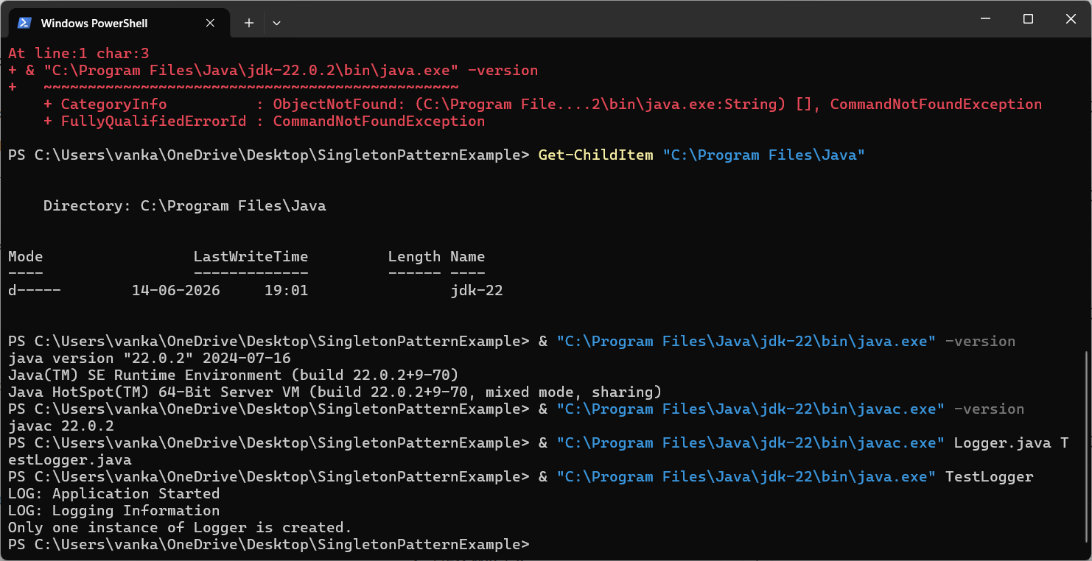

Exercise 2: Implementing the Factory Method Pattern
File 1: Document.java
public interface Document {
void open();
}
File 2: WordDocument.java
public class WordDocument implements Document {
public void open() {
System.out.println("Opening Word Document");
}
}
File 3: PdfDocument.java
public class PdfDocument implements Document {
public void open() {
System.out.println("Opening PDF Document");
}
}
File 4: ExcelDocument.java
public class ExcelDocument implements Document {
public void open() {
System.out.println("Opening Excel Document");
}
}
File 5: DocumentFactory.java
public abstract class DocumentFactory {
public abstract Document createDocument();
}
File 6: WordDocumentFactory.java
public class WordDocumentFactory extends DocumentFactory {
public Document createDocument() {
return new WordDocument();
}
}
File 7: PdfDocumentFactory.java
public class PdfDocumentFactory extends DocumentFactory {
public Document createDocument() {
return new PdfDocument();
}
}
File 8: ExcelDocumentFactory.java
public class ExcelDocumentFactory extends DocumentFactory {
public Document createDocument() {
return new ExcelDocument();
}
}
File 9: TestFactoryMethod.java
public class TestFactoryMethod {
public static void main(String[] args) {
DocumentFactory wordFactory = new WordDocumentFactory();
Document word = wordFactory.createDocument();
word.open();
DocumentFactory pdfFactory = new PdfDocumentFactory();
Document pdf = pdfFactory.createDocument();
pdf.open();
DocumentFactory excelFactory = new ExcelDocumentFactory();
Document excel = excelFactory.createDocument();
excel.open();
}
}

