|  |
| --- |
| **Department of Computer Science and Engineering**    **DATABASE SYSTEM LAB – CSE 2262**  ***A mini project report on***    **Database Management System Of CINEMA**  **Group members:**  **Name: Munagala Sai Sandeep**  **Register no: 210962074**  **Section: A**  **Roll no: 17**  **Name: K S Adharsh Reddy**  **Register no: 210962014**  **Section: A**  **Roll no: 05**  **Department of Computer Science and Engineering**  **Manipal Institute of Technology, Manipal.**  **April 2023** |
|  |



DEPARTMENT OF COMPUTER SCIENCE & ENGINEERING

Manipal

07/05/2023

CERTIFICATE

This is to certify that the project titled Database Management System Of CINEMA is a record of the bonafide work done by Student(s) (Reg. No. 210962074 & 210962082) submitted in partial fulfilment of the requirements for the award of the Degree of Bachelor of Technology (B.Tech.) in COMPUTER SCIENCE & ENGINEERING of Manipal Institute of Technology, Manipal, Karnataka, (A Constituent Institute of Manipal Academy of Higher Education), during the academic year 2022-2023.

Name and Signature of Examiners:

1. Dr Roopalakshmi R, Associate Professor, CSE Dept.
2. Prof. Tanuja Shailesh, Assistant Professor, CSE Dept.

**Content:**

1. Abstract
2. Problem Statement
3. ER Diagram
4. Relational Tables
5. DDL Commands
6. List of SQL Queries
7. PL/SQL Procedures/Functions/Triggers
8. UI DESIGN
9. References

**Introduction:**

A film industry database is a collection of information about the film industry, including films, actors, directors, producers, studios, OTT, and other industry professionals. The database may also contain information about individual actors, directors, producers, and other professionals, such as their biographical details, filmography, awards, and other career achievements.

Film industry databases are commonly used by film studios, production companies, distributors, and other industry professionals to track trends, analyse performance, and make informed decisions about their projects. They may also be used by journalists, researchers, and film enthusiasts to explore the history and evolution of the film industry and discover new and interesting films, actors, and directors.

**Attributes:**

Type 1: Movies – Movie_ID, Title, Release_year, Movie_language, Director_ID, Genre.

Type 2: Director – Director_ID, First name, Last name, Gender.

Type 3: Movie Cast – Movie_ID, Actor_ID, Charater_Name.

Type 4: Actor – Actor_ID, First name, Last name, Gender.

Type 5: Rating – Movie_ID, Rating.

Type 6: Genre – Movie_ID, Genre_Name.

Type 7: Awards – Name, Year_awarded, Category, Movie_ID.

**Required software:**

* NOTEPAD
* EXCEL
* MYSQL
* NETBEANS

**Problem statement:**

A database management system (DBMS) is required to manage a movie database. The database will store information about movies, actors, directors, production companies, genres, and ratings.

**Data requirements:**

1. Movie data: The database should store information about each movie, including the title, release year.
2. Actor data: The database should store information about each actor, including their name, birth date, and a list of movies they have appeared in.
3. Director data: The database should store information about each director, including their name, birth date, and a list of movies they have directed.
4. Award data: The database should store information about each award, including the name of the movie, category of the award, year of the award.
5. Genre data: The database should store information about each genre, including the name and a list of movies in that genre.
6. Rating data: The database should store information about each movie rating, including the name of the movie, the rating source, and the rating value.

**Functional requirements:**

1. Searching: The database allows users to search for movies based on various criteria, such as title, genre, actor, or director.
2. Updating: The database allows users to update information about movies, actors, directors, awards, genres, and ratings.
3. Adding: The database allows users to add new movies, actors, directors, awards, genres, and ratings to the database.
4. Deleting: The database allows users to delete movies, actors, directors, awards, genres, and ratings from the database.
5. Reports: The database provides reports, such as the top-rated movies, and the most popular actors.
6. Security: The database should provide access control to ensure that only authorized users can access and modify the data.
7. Performance: The database should be optimized for fast queries and efficient storage to handle a large amount of data and a high number of concurrent users.

Overall, the database management system should provide a comprehensive and user-friendly solution for managing a movie database, with the ability to search, update, add, and delete data, as well as generate reports and ensure security and performance.

**ER Model :**

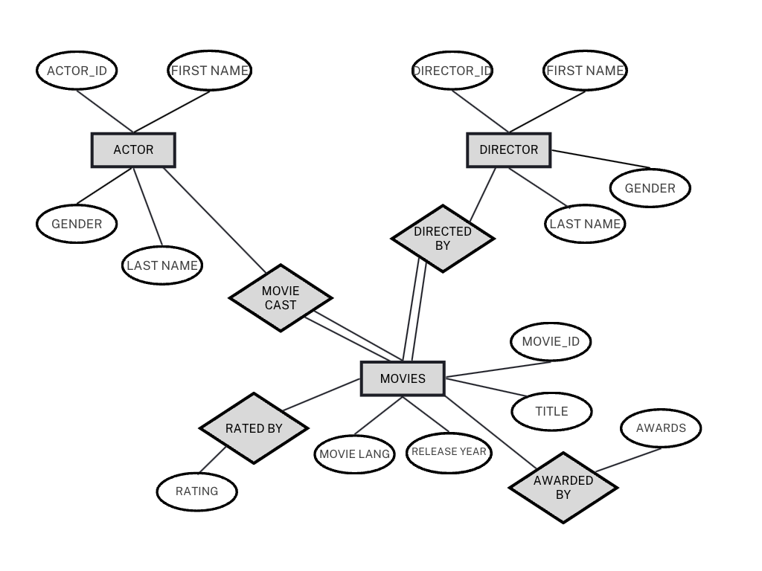

**Relational Tables and DDL Command:**

Use mini_project

**ACTOR TABLE:**

CREATE TABLE actors (

actor_id int PRIMARY KEY,

first_name VARCHAR(50) NOT NULL,

last_name VARCHAR(50) NOT NULL,

GENDER char(1)

);

|  |  |  |  |
| --- | --- | --- | --- |
| Actor_id | First_name | Last_name | Gender |
| 1 | Ram | Charan | M |
| 2 | Akshay | Kumar | M |
| 3 | Anushka | Shetty | F |
| 4 | Samantha | Ruth prabhu | F |
| 5 | Shahrukh | khan | M |

**DIRECTOR TABLE:**

CREATE TABLE directors (

director_id int PRIMARY KEY,

first_name VARCHAR(50) NOT NULL,

last_name VARCHAR(50) NOT NULL,

gender CHAR(1)

);

|  |  |  |  |
| --- | --- | --- | --- |
| Director_id | First_name | Last_name | Gender |
| 1 | SS | Rajamouli | M |
| 2 | Yash | Raj | M |
| 3 | B | Sukumar | M |
| 4 | Sidharth | Anand | M |

**MOVIE TABLE:**

CREATE TABLE movies (

movie_id INT PRIMARY KEY,

title VARCHAR(100) NOT NULL,

release_year int,

movie_language varchar(10),

director_id int,

genre VARCHAR(50),

FOREIGN KEY (director_id) REFERENCES directors(director_id) on delete cascade

);

|  |  |  |  |  |  |
| --- | --- | --- | --- | --- | --- |
| Movie_id | Title | Release_year | Movie_language | Director_id | Genre |
| 1 | RRR | 2023 | Telugu | 1 | Action |
| 2 | Mission mangal | 2019 | Hindi | 2 | Sci-fi |
| 3 | Bahubali | 2015 | Telugu | 1 | War |
| 4 | Rangasthalam | 2018 | Telugu | 3 | Drama |
| 5 | Paathan | 2023 | Hindi | 4 | Spy |

**MOVIE CAST TABLE:**

CREATE TABLE Movie_Cast (

movie_id INT,

actor_id INT,

character_name VARCHAR(255),

PRIMARY KEY (movie_id, actor_id),

FOREIGN KEY (movie_id) REFERENCES Movies(movie_id) on delete cascade,

FOREIGN KEY (actor_id) REFERENCES Actors(actor_id) on delete cascade

);

|  |  |  |
| --- | --- | --- |
| Movie_id | Actor_id | Charater_name |
| 1 | 1 | Sitarama Raju |
| 2 | 2 | Rakesh Dhawan |
| 3 | 3 | Devasena |
| 4 | 1 | Chitti babu |
| 4 | 4 | Ramalakshmi |
| 5 | 5 | Paathan |

**RATING TABLE:**

CREATE TABLE rating (

movie_id INT primary key,

RATING numeric(6,2),

FOREIGN KEY (movie_id) REFERENCES movies(movie_id) on delete cascade

);

|  |  |
| --- | --- |
| Movie_id | Rating |
| 1 | 9.30 |
| 2 | 8.80 |
| 3 | 8.30 |
| 4 | 9.30 |
| 5 | 8.90 |

**AWARD TABLE:**

CREATE TABLE awards (

name VARCHAR(255) NOT NULL,

year_awarded INT,

category VARCHAR(255),

movie_id INT,

FOREIGN KEY (movie_id) REFERENCES Movies(movie_id) on delete cascade

);

|  |  |  |  |
| --- | --- | --- | --- |
| Award_name | Year_awarded | Category | Movie_id |
| Oscar | 2023 | Best original song | 1 |
| Film fare | 2020 | Nominee for best director | 2 |
| Film fare | 2016 | Best film | 3 |
| Film fare | 2016 | Best director | 3 |

**GENRES TABLE:**

CREATE TABLE genres (

movie_id INT PRIMARY KEY,

genre_name VARCHAR(50) NOT NULL,

FOREIGN KEY (movie_id) REFERENCES movies(movie_id) on delete cascade );

|  |  |
| --- | --- |
| Movie_id | Genre |
| 1 | Action |
| 2 | Science friction |
| 3 | War |
| 4 | Drama |
| 5 | Spy |

**SQL Queries :**

--1. LIST THE CHARACTER OF THE ACTOR ACTED IN A MOVIE:

select * from actor natural join movie_cast where first_name = 'Ram';

-- 2. ONE OR MORE ACTORS ACTED IN TWO OR MORE MOVIES:

SELECT distinct title from movies natural join movie_cast where actor_id in (select actor_id from movie_cast group by actor_id having count(actor_id)>=2);

--3. LIST ALL ACTORS WHO ACTED BEFORE 2000 AND ALSO AFTER 2017 USING

select f_name,l_name,year from (select distinct a.first_name f_name, a.last_name l_name,m.release_year year from actors a, movie_cast mv, movies m where a.actor_id = mv.actor_id and m.movie_id =

mv.movie_id) where year <=2000 or year>=2017;

**PL/SQL Procedures:**

--1.RETRIVING DATA BY TAKING USER INPUT (MOVIE NAME):

DECLARE  
    v_movie_title varchar2(100);  
    v_movie_id number;  
    v_movie_release_year int;  
BEGIN  
    v_movie_title := '&movie_title';  
    select movie_id, release_year  
    into v_movie_id, v_movie_release_year  
    from movies  
    where title = v_movie_title;  
  
    DBMS_OUTPUT.PUT_LINE('Movie id: ' || v_movie_id);  
    DBMS_OUTPUT.PUT_LINE('Release year: ' || v_movie_release_year);  
END;  
/

--2.UPDATING MOVIE RATING

DECLARE

v_movie_id number;

v_new_rating number;

BEGIN

v_movie_id := '&movie_id';

v_new_rating := '&rating';

UPDATE rating

SET rating = v_new_rating

WHERE movie_id = v_movie_id;

DBMS_OUTPUT.PUT_LINE('Rating updated successfully.');

END;

/

--3.RETRIVE TOP RATED MOVIES

DECLARE  
    cursor c_top_movies is  
        select title,rating  
        from rating natural join movies  
        order by rating desc;  
BEGIN  
    for movie in c_top_movies LOOP  
        DBMS_OUTPUT.PUT_LINE('Title: ' || movie.title || ', Rating: ' || movie. rating);  
    END LOOP;  
END;  
/

**Function and Procedure:**

--4.FUNCTION TO RETRIEVE THE NUMBER OF MOVIES RELEASED IN A SPECIFIC YEAR:

create or replace function count_movies_in_year(r_year in number) return number is v_movie_count number;  
BEGIN  
    select count (*)  
    into v_movie_count  
    from movies  
    where release_year = r_year;  
  
    RETURN v_movie_count;  
END;  
/  
  
declare  
begin  
DBMS_OUTPUT.PUT_LINE ('NO OF MOVIES: ' || count_movies_in_year(2019));  
end;  
/  
  
--5.PROCEDURE TO UPDATE THE RATING OF A MOVIE:

create or replace procedure update_movie_rating(p_movie_id in number,p_new_rating in number) is  
BEGIN  
    update rating  
    set rating = p_new_rating  
    where movie_id = p_movie_id;  
  
    DBMS_OUTPUT.PUT_LINE('Rating updated successfully.');  
END;  
/  
  
declare  
begin  
update_movie_rating(2,9.5);  
end;  
/  
  
  
6. FUNCTION TO CALCULATE THE AVERAGE RATING FOR A MOVIE:

create or replace function calculate_average_rating return number is v_avg_rating number;  
BEGIN  
    select avg(rating)  
    into v_avg_rating  
    from rating;  
  
    RETURN v_avg_rating;  
END;  
/  
  
declare  
begin  
DBMS_OUTPUT.PUT_LINE ('average_rating: ' || calculate_average_rating());  
end;  
/

**TRIGGERS:**

7.TRIGGER TO CHECK MOVIE’s RATING MUST BE BETWEEN 0 AND 10:  
  
create or replace trigger check_rating_range  
before insert or update on rating  
for each row  
DECLARE  
    v_rating rating.rating%TYPE := :new.rating;  
BEGIN  
    IF v_rating < 0 OR v_rating > 10 THEN  
        RAISE_APPLICATION_ERROR(-20001, 'Rating must be between 0 and 10.');  
    END IF;  
END;  
/

**EXCEPTION:**

8. SEARCHING FOR A MOVIE WITH MOVIE ID :

DECLARE  
    movie_not_found EXCEPTION;  
    v_movie_id number;  
    v_movie_count number := 0;  
BEGIN  
    v_movie_id := '&movie_id';  
    select count(*)  
    into v_movie_count  
    from movies  
    where movie_id = v_movie_id;  
  
    IF v_movie_count = 0 THEN  
        raise movie_not_found;  
    ELSE  
        DBMS_OUTPUT.PUT_LINE('Movie Found.');  
    END IF;  
EXCEPTION  
    when movie_not_found then  
        DBMS_OUTPUT.PUT_LINE('Movie not found in the database.');  
END;  
/

**UI DESIGN:**

**Java Functional code:**

**

Updating Data:

Insertion of Data:

**Reference:**

1. JAVA The Complete Reference, Ninth Edition, Herbert Schildt, ORACLE PRESS
2. Silberschatz, Korth, Sudarshan, “ Database System Concepts”, McGraw-Hill, 6th Edition.
3. Iyan Bayross, “SQL, PL/SQL” 2nd/3rd Edition, BPB Publications.