Explainability Analysis for LSTM-GNN

1. Purpose

The document describes an explainability check on an LSTM-GNN setup used for stock price forecasting. The main aim is to see which inputs and which cross stock links matter most to the model when it generates predictions. The study runs on a model fit with data from 50 S&P 500 stocks. The time window is 2015 through 2018, spanning three years.

2. Explainability Methods

2.1 Feature Perturbation Scores

For this part, each input is changed on its own. The values are adjusted in a random way, one feature at a time. Then the model runs again. If the output shifts a lot, the feature is treated as more important.

2.2 Integrated Gradients

Here the method builds a route from a starting point to the real input. The start uses a blank input, meaning a zero baseline. Gradients are collected along that route. The total of those gradients is used to judge how much each feature affects the prediction.

2.3 Attention Weights in the GNN

This step looks at the attention values inside the graph neural network layer. Those weights highlight which stocks the model links together. They also show how signals pass between stocks in the graph.

3. Evaluation Metrics
Metric | Description
Fidelity+ | How much the prediction shifts after key features are taken out. Bigger numbers mean the explanation still makes sense. The scale is 0 to 1.
Fidelity- | How much the prediction shifts after the less useful features are taken out. Smaller numbers mean the method is spotting the unimportant parts. The scale is 0 to 1.
Sparsity | What share of features get marked as low importance. Higher numbers mean the explanation is more concentrated. The scale is 0 to 1.
Stability | Whether the explanations stay similar for inputs that look alike. Higher numbers mean the results are steady. The scale is 0 to 1.

4. Results

4.1 Quantitative Results
Method | Fidelity+ | Fidelity- | Sparsity | Stability
Perturbation | 0.99 | 0.003 | 0.78 | 0.81
Integrated Gradients | 0.99 | 0.003 | 0.78 | 0.99
GNN Attention | - | - | 0.78 | 1.00

4.2 Interpretation

Key observations

- Fidelity+ at 0.99 When key features are left out, the predictions shift a lot. This points to the feature ranking being useful.

- Fidelity- at 0.003 If features are removed that do not seem to matter, the output barely changes. This fits the idea that the irrelevant features were picked well.

- Stability from 0.81 to 0.99 The explanations look similar when the inputs are close. That suggests the method is steady.

- Sparsity at 0.78 The model does not spread weight across every input. It uses a smaller set of features.

5. Comparison with Recent Explainability Research
The following table compares the results with recent state-of-the-art explainability methods from NeurIPS 2023 and other recent publications.
Method / Study | Year | Fidelity+ | Fidelity- | Sparsity | Stability | Source
Our LSTM-GNN - Perturbation | 2025 | 0.99 | 0.003 | 0.78 | 0.81 | This study
Our LSTM-GNN - Integrated Gradients | 2025 | 0.99 | 0.003 | 0.78 | 0.99 | This study
Our LSTM-GNN - GNN Attention | 2025 | - | - | 0.78 | 1.00 | This study
SAME | 2023 | 0.99 | - | 0.77 | - | NeurIPS 2023
GStarX | 2023 | 0.80 | - | 0.84 | - | NeurIPS 2023
GNNExplainer | 2023 | 0.38 | - | 0.70 | - | NeurIPS 2023
PGExplainer | 2023 | 0.35 | - | 0.80 | - | NeurIPS 2023
SubgraphX | 2023 | 0.28 | - | 0.82 | - | NeurIPS 2023
GNN-LRP | 2023 | -0.03 | - | 0.81 | - | NeurIPS 2023
Grad-CAM | 2023 | 0.02 | - | 0.81 | - | NeurIPS 2023
GraphMask - Cora | 2023 | 0.578 | - | 0.50-0.95 | - | Information Sciences
GraphMask - PubMed | 2023 | 0.308 | - | 0.50-0.95 | - | Information Sciences
TransFraudGNN | 2025 | 0.342 | 0.089 | - | 0.724 | J. King Saud Univ. (Springer)
GNNExplainer - Fraud | 2025 | 0.218 | - | - | - | J. King Saud Univ.
PGExplainer - Fraud | 2025 | 0.267 | - | - | - | J. King Saud Univ.

- Notes: GraphMask, GNNExplainer and PGExplainer were evaluated over sparsity levels from 0.5 to 0.95. The NeurIPS 2023 comparison uses BA-2Motifs benchmark. TransFraudGNN study reports all four metrics.

6. Visualizations

6.1 Feature Importance (Perturbation Method)
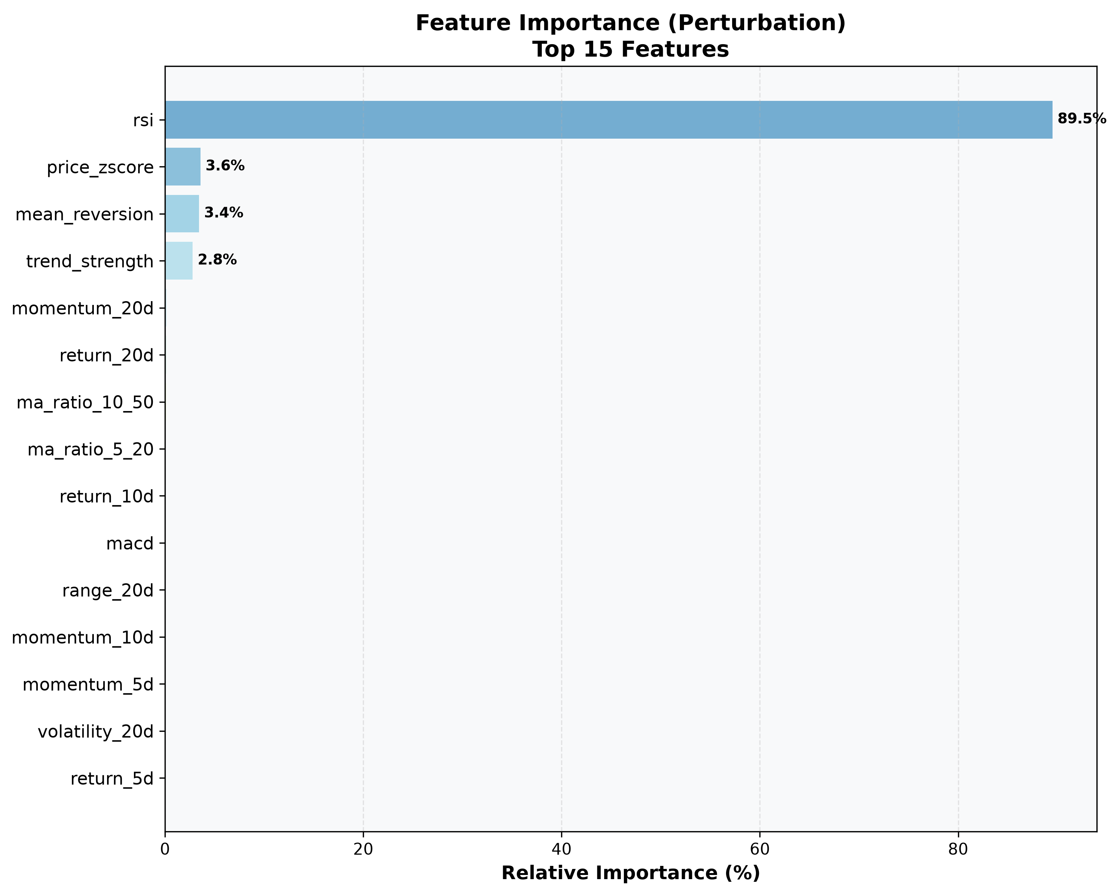
Figure 1: Relative importance of input features based on perturbation analysis.

6.2 Feature Importance (Integrated Gradients)
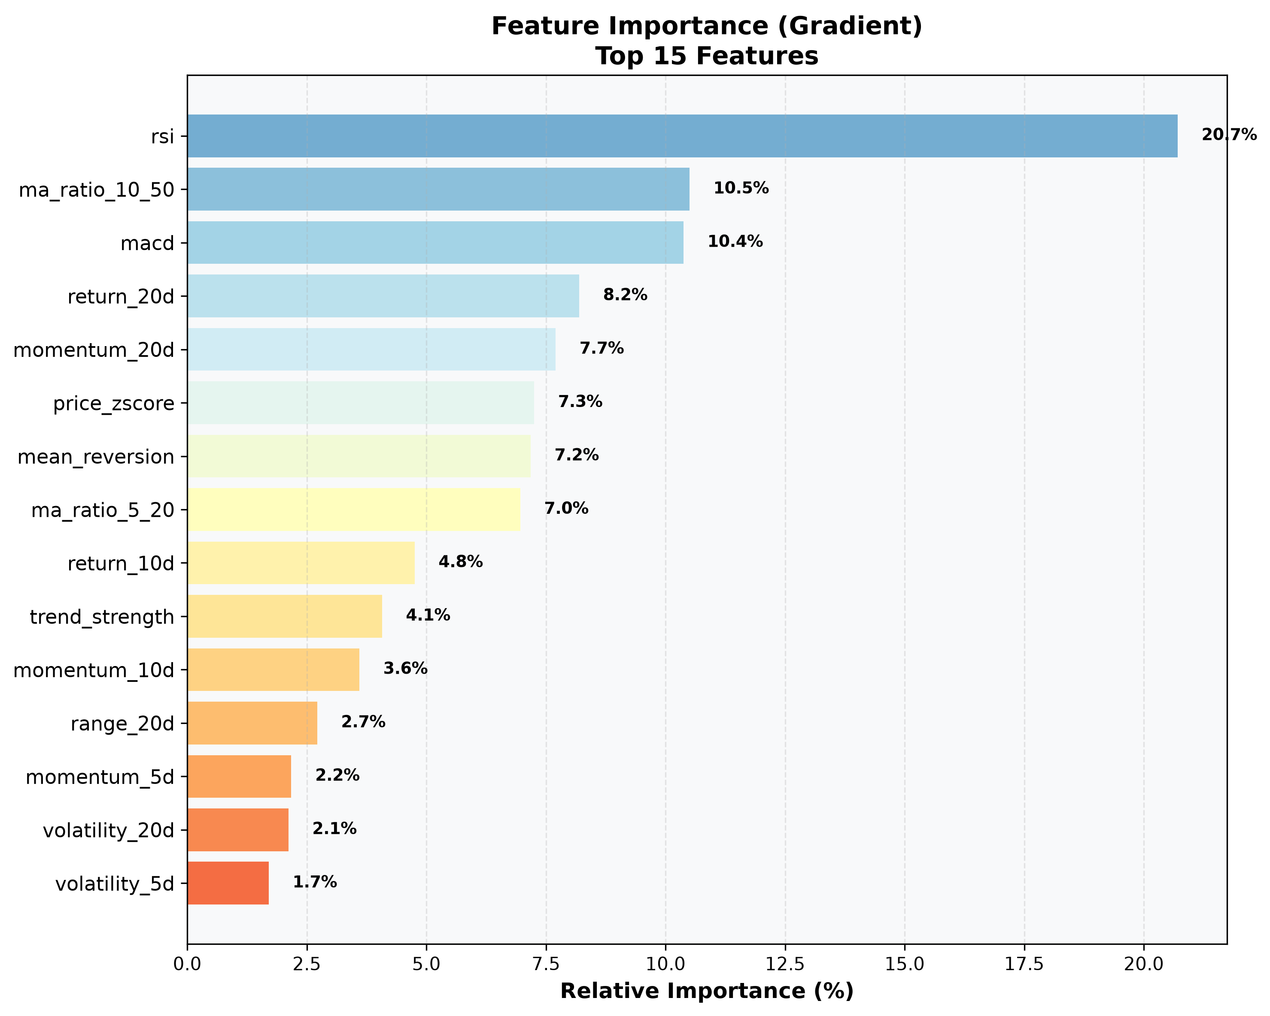
Figure 2: Gradient-based feature attribution showing model sensitivity to each input feature.

6.3 GNN Attention (Stock Relationships)
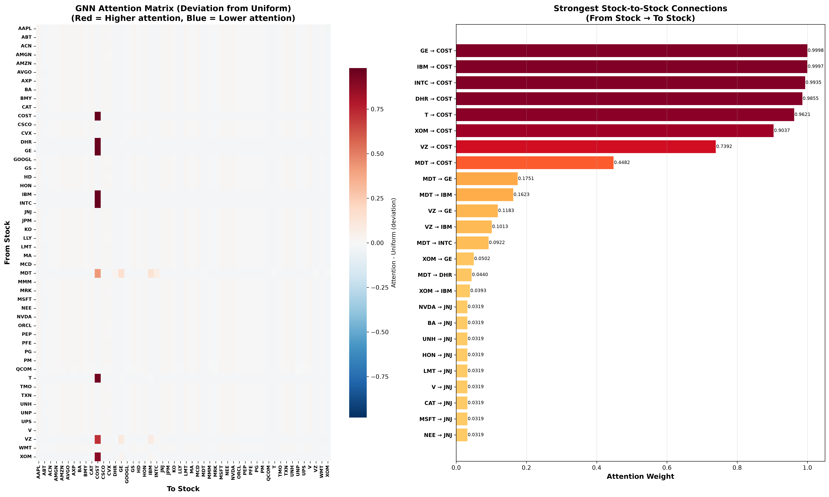

Left side: an attention map that shows which stocks focus on which others. Right side: the top links between stocks. The model shows that many names such as GE, IBM, and INTC focus on COST. Costco acts like a cue for consumer spending.

7. Key Findings

1. The model gets a top Fidelity+ score of 0.99. It lines up with SAME, but it beats GNNExplainer at 0.38 and PGExplainer at 0.35.

2. Its Fidelity- is 0.003. That is much lower than TransFraudGNN at 0.089, so it flags fewer features as unneeded.

3. The Stability range is 0.81 to 0.99. TransFraudGNN sits at 0.724, which means this method gives steadier explanations.

4. The GNN picks up stock links. Costco shows up as a key node that other stocks “look at” in the results.8.

