**OUTPUT SCREENSHOTS:**

**API 1:**

*A user should be able to request a booking for a cab from pickup location A to pickup location B*

**Request**:

mutation {

newBooking(

carType: "Sedan",

source: "Ambattur",

destination:"Vadapalani"

user: "Akaash") {

carType

source

destination

user{

name

}

}}

**Output:**

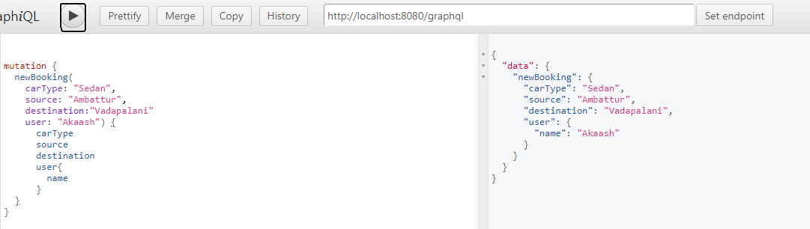

**API 2:**

*A user should be able to view his past bookings.*

**Request:**

query findBookings($name:String!){

findBookings(name:$name){

carType

destination

}}

**Query Variables:**

{"name": "Akaash"}

**Output:**

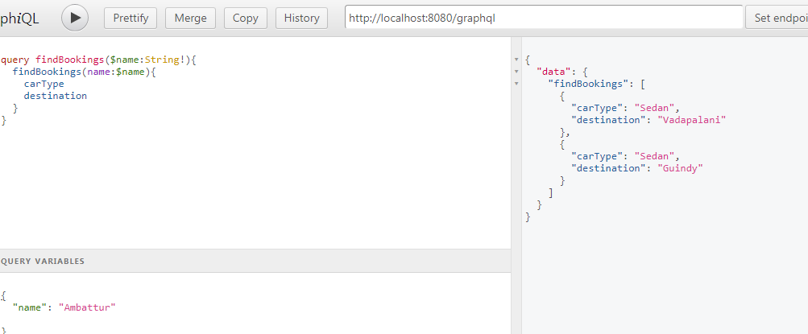

**API 3:**

*A User should be able to get cabs that are nearby*

**Request:**

query findCab($area:String!,$carType:String!){

findCab(area:$area,carType:$carType){

carType

cabId

distance

}}

**Query Variables:**

{"area": "Ambattur",

"carType": "SUV"

}

