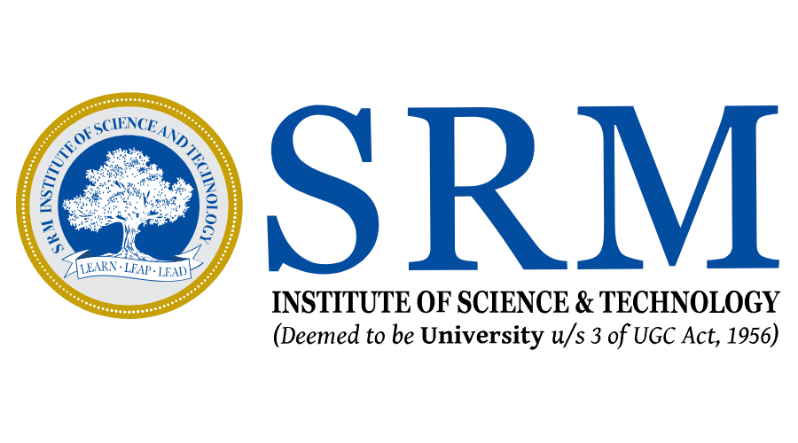
SRM Institute of Science and Technology

College of Engineering and Technology
School of Computing
Department of Computing Technologies

Work sheet No. 2.1
Introduction to Storage Networking Technologies

Name: Aaqib Salim Reg.No.: RA2411003010126 Date: 15-08-26

Instructions: Read each statement carefully and write True or False next to it.
- Storage networking helps organizations manage data growth efficiently.
True
- In Direct-Attached Storage (DAS), storage is shared among multiple servers.
False
- SAN provides centralized and consolidated storage management.
True
- NAS provides block-level access to storage data.
False
- Traditional storage is highly scalable and easily shared.
False
- SAN/NAS systems improve data availability and reliability.
True
- DAS environments are often referred to as stove-piped storage environments.
True

