SIMATS ENGINEERING
ASSESSMENT TOOL 3
COURSE NAME: CRYPTOGRAPHY AND NETWORK SECURITY COURSE CODE: CSA5115
COURSE OUTCOME COVERED
CO2: Analyze Public Key crypto system strategies using RSA and key Exchange for Encryption algorithm to strengthen information security. (BL4,BL5)
Debugging & Optimisation Task : 10%
QUESTIONS: Total Marks: 50 Annexure A
Code of Conduct:
I S.Adhikesavan - 192521172(Name / Reg No) certify that this submission is my original work and that I have adhered to the guidelines specified for this assessment. I understand that any violation of academic integrity rules will result in disciplinary action.
Signature of the student: Adhikesavan

Annexure A

Debugging & Optimisation Task
- Debugging & Optimization of Symmetric Encryption (DES / 3DES Implementation)

A Python program implementing DES and 3DES encryption produces inconsistent ciphertext for identical inputs across multiple runs.
- Identify and fix logical and implementation errors in key scheduling and permutation steps.

B. Optimize the code to reduce execution time for large input datasets (≥10 MB). C. Justify whether replacing DES/3DES with a modern cipher improves both security and performance.

2. Performance Analysis of Block Cipher Modes of Operation A Python script implements AES-like block cipher modes (ECB, CBC, CFB, OFB) but suffers from high latency and memory inefficiency.
A. Debug incorrect padding and IV handling causing decryption failures.
B. Refactor the code to minimize redundant computations and memory usage.
C. Compare and optimize the implementation to determine the most efficient mode for real-time secure communication.
Solution :
Question 1: Debugging & Optimization of DES / 3DES
Figure 1. Root Cause Analysis of Inconsistent Ciphertext

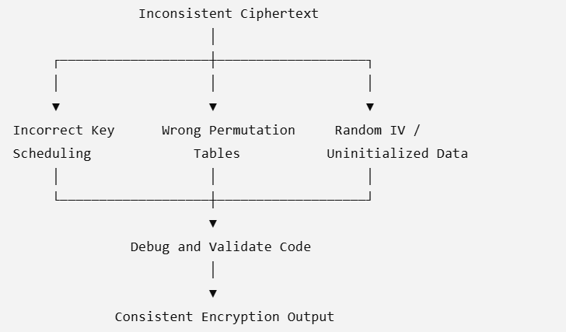

Figure 2. Performance Optimization Workflow
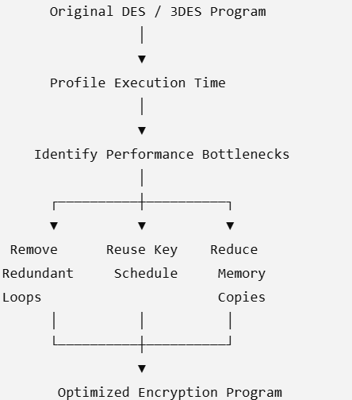

Figure 3. Security vs Performance Comparison
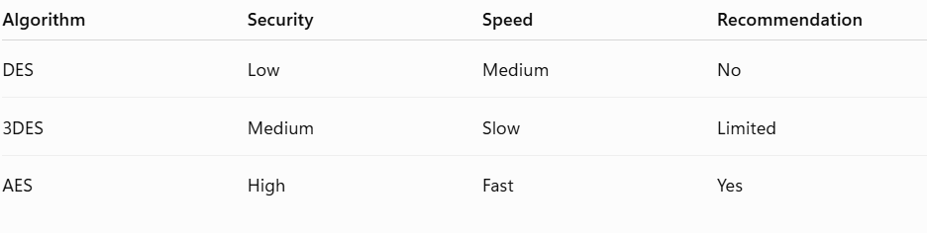
Question 2: Performance Analysis of Block Cipher Modes
Figure 4. Performance Comparison of Cipher Modes
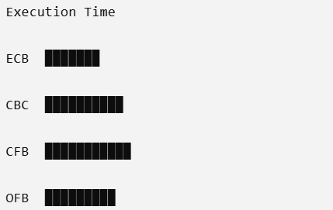

Figure 5. Decryption Failure Analysis
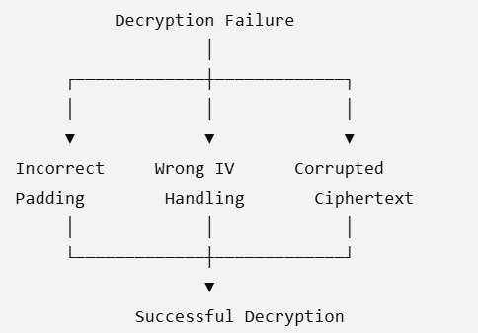
Figure 6. Cipher Mode Evaluation Matrix
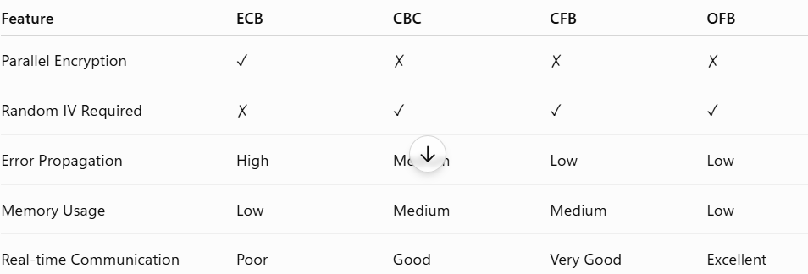

These diagrams are much better for analytical questions because they:
Analyze the causes of the problem rather than simply showing how encryption works.
Support debugging and optimization decisions.
Compare algorithms and cipher modes based on performance and security.
Help justify your recommendations with visual evidence.

RUBRICS FOR CALCULATION
Criteria | Weighta  ge | Level 4  (Exemplary) | Level 3  (Proficient) | Level 2  (Developing) | Level 1  (Beginning)
Problem  Identificati on | 20% | Accurately  identifies all errors and  root causes with clear  understandin g | Identifies  most errors with minor  gaps | Identifies  some errors  but misses  key issues | Unable to  identify  errors  correctly
Debugging | 25% | Applies  systematic  debugging  techniques  effectively to resolve  issues | Uses  appropriate debugging  methods with minor errors | Limited  debugging  approach;  requires  guidance | Unable to  debug or  resolve  issues
Optimizati on | 20% | Optimizes  code by  significantly improving  time  complexity  using  efficient  algorithms | Improves  time  complexity  with minor  gaps in  efficiency | Limited  improvement in time  complexity | No  improvemen t; inefficient approach  retained
Analysis | 20% | Demonstrate s strong  logical  reasoning  and clear  justification of solutions | Shows  reasonable  analysis with some  justification | Limited  analysis; weak reasoning | No  analytical  reasoning  demonstrate d
Code  Quality | 15% | Produces  clean, well  structured  code with  proper  comments  and  documentatio n | Code is  mostly clear with minor  documentatio n gaps | Code lacks  structure and proper  documentatio n | Poorly  written code with no  documentati on

