An Explainable XGBoost-Based Data Mining Framework for Thyroid Disease Prediction
Mrs. Jenifer. M ¹, Malarkodi. K. P ²
Research Scholar¹, Assistant Professor ².
Department of Computer Science¹.
Department of Computer Applications².
Sri Krishna Arts and Science College Kuniyamuthur- Coimbatore.
jeniferm@skasc.ac.in ¹, malarkodikp@skasc.ac.in ²

ABSTRACT.
Thyroid disease is a common endocrine disorder that can lead to serious health complications if not detected at an early stage. Accurate and timely diagnosis is therefore essential for improving patient outcomes and supporting effective clinical decision-making. Recent advancements in artificial intelligence and data mining have enabled the development of intelligent diagnostic systems capable of analyzing complex medical data with high efficiency. This study presents an Explainable XGBoost-Based Data Mining Framework for Thyroid Disease Prediction that integrates data preprocessing, feature selection, hyperparameter optimization, and Explainable Artificial Intelligence (XAI) to improve both prediction accuracy and model transparency. The proposed framework employs the XGBoost algorithm as the primary classifier due to its robustness and ability to handle structured healthcare datasets effectively. To enhance the interpretability of prediction outcomes, SHapley Additive exPlanations (SHAP) are incorporated to identify the contribution of individual clinical features to the model's decisions. The framework is evaluated using standard classification metrics, including Accuracy, Precision, Recall, F1-Score, and ROC-AUC, and is compared with conventional machine learning algorithms. The experimental analysis indicates that the proposed framework provides reliable predictive performance while offering transparent and clinically interpretable results. Overall, the proposed approach demonstrates the potential of combining explainable AI with advanced data mining techniques to support the early prediction of thyroid disease and improve intelligent healthcare decision support systems.
KEYWORDS:
Thyroid Disease Prediction, Explainable Artificial Intelligence, XGBoost, Data Mining, Machine Learning, SHAP, Healthcare Analytics.

I. INTRODUCTION.
Thyroid disease is one of the most prevalent endocrine disorders worldwide, affecting millions of individuals across different age groups and posing significant challenges to global healthcare systems [3,11]. The thyroid gland plays a crucial role in regulating metabolism, growth, body temperature, and hormonal balance through the secretion of thyroid hormones [11]. Disorders such as hypothyroidism, hyperthyroidism, thyroid nodules, and thyroid cancer can adversely affect multiple physiological functions, leading to severe health complications if not diagnosed and treated at an early stage [3,13]. The increasing prevalence of thyroid disorders has highlighted the need for accurate, reliable, and timely diagnostic approaches to improve patient outcomes and reduce healthcare burdens [3,10].
Traditional diagnostic methods for thyroid disease primarily rely on laboratory investigations, thyroid hormone tests, ultrasound imaging, and clinical expertise [3]. Although these methods provide valuable diagnostic information, they are often time-consuming, expensive, and susceptible to human interpretation errors [11]. Delayed diagnosis may result in disease progression, increased treatment costs, and reduced quality of life for patients [1]. Consequently, the integration of Artificial Intelligence (AI) and data mining techniques into clinical decision support systems has gained considerable attention as an effective approach for enhancing diagnostic accuracy and supporting healthcare professionals in clinical decision-making [1,11,23].
Recent advances in machine learning have demonstrated remarkable success in analyzing complex medical datasets by identifying hidden patterns and relationships that are difficult to detect using conventional statistical methods [9,14]. Several machine learning algorithms, including Decision Tree, Random Forest, Support Vector Machine (SVM), K-Nearest Neighbors (KNN), Logistic Regression, and ensemble learning methods, have been successfully applied for disease prediction and classification tasks [2,5,14]. Among these algorithms, Extreme Gradient Boosting (XGBoost) has emerged as one of the most powerful ensemble learning techniques because of its high predictive accuracy, computational efficiency, robustness against overfitting, and ability to effectively handle structured healthcare datasets containing missing values and nonlinear relationships [4,16].
Despite the promising performance of AI-based diagnostic systems, many existing studies primarily focus on maximizing classification accuracy while overlooking the interpretability of prediction outcomes [17,21]. Many machine learning algorithms exhibit limited transparency, making it difficult for healthcare professionals to interpret the reasoning behind their predictive outcomes [12].This lack of transparency reduces clinicians' confidence in adopting AI-assisted diagnostic systems in real-world clinical practice [17,19]. Furthermore, several studies have not incorporated comprehensive feature selection techniques and systematic hyperparameter optimization, which are essential for improving predictive performance, reducing computational complexity, and identifying the most influential clinical features [8,10].
To address these limitations, this research proposes an Explainable XGBoost-Based Data Mining Framework for Thyroid Disease Prediction [4]. The proposed framework integrates comprehensive data preprocessing, feature selection, hyperparameter optimization, and Explainable Artificial Intelligence (XAI) using SHapley Additive exPlanations (SHAP) to improve both prediction accuracy and model transparency [8,12,17]. XGBoost is employed as the primary prediction model due to its superior predictive capability and computational efficiency [4,16], while SHAP is incorporated to provide clear explanations of prediction outcomes by quantifying the contribution of each clinical feature [12,17]. This integration enhances the reliability, transparency, and clinical applicability of AI-driven decision support systems, enabling healthcare professionals to make more informed diagnostic decisions [13,19,20].
The proposed framework is evaluated using standard classification metrics, including Accuracy, Precision, Recall, F1-Score, and Receiver Operating Characteristic–Area Under the Curve (ROC-AUC) [7,15]. Furthermore, its predictive performance is compared with conventional machine learning algorithms such as Decision Tree, Random Forest, Support Vector Machine, K-Nearest Neighbors, and Logistic Regression to validate its effectiveness and robustness [2,5,16].
THE MAJOR CONTRIBUTIONS OF THIS RESEARCH ARE AS FOLLOWS:
- Proposes an Explainable XGBoost-Based Data Mining Framework for accurate thyroid disease prediction.
- Integrates data preprocessing, feature selection, and hyperparameter optimization to improve prediction performance [8,10].
- Incorporates SHAP-based Explainable Artificial Intelligence to enhance model transparency and interpretability [12,17].
- Compares the proposed framework with multiple conventional machine learning algorithms using standard evaluation metrics [2,5,7,15].
- Develops an intelligent and clinically interpretable decision support framework for the early prediction of thyroid disease [13,20].
II. RELATED WORK.
Several researchers have applied machine learning and deep learning techniques for thyroid disease prediction to improve diagnostic accuracy and support clinical decision-making. However, challenges related to model interpretability, feature optimization, and generalization remain active research areas.
Chaganti et al. [3] proposed a thyroid disease prediction framework using multiple machine learning algorithms combined with selective feature engineering techniques. Their study demonstrated that feature selection significantly improved prediction accuracy while reducing computational complexity. However, the proposed framework mainly focused on predictive performance and did not incorporate explainable artificial intelligence techniques to interpret the prediction outcomes.
Sankar et al. [16] developed an XGBoost-based thyroid disease prediction model and reported higher classification accuracy than several traditional machine learning algorithms. The study highlighted the effectiveness of XGBoost in handling structured healthcare datasets. Nevertheless, the model functioned as a black-box system without providing interpretable explanations for clinical decision-making.
Lee and Park [11] presented a comprehensive review of machine learning applications in thyroid disease diagnosis. Their survey discussed the advantages and limitations of several supervised learning algorithms used in thyroid disease prediction. The authors emphasized the need for developing interpretable AI models capable of supporting clinicians with transparent diagnostic decisions.
Schindele et al. [17] introduced an interpretable machine learning framework for thyroid cancer recurrence prediction using XGBoost integrated with SHapley Additive exPlanations (SHAP). Their findings demonstrated that SHAP effectively explained the contribution of clinical variables toward prediction outcomes. However, the study focused specifically on thyroid cancer recurrence rather than the general prediction of thyroid diseases.
Islam et al. [10] proposed an ensemble machine learning framework integrating feature selection and class balancing techniques for thyroid disease prediction. Their experimental results achieved high classification performance across multiple evaluation metrics. Although the proposed ensemble model improved prediction accuracy, the framework did not perform extensive explainability analysis using Explainable AI methods.
Ouartani and Taleb [13] developed a transparent AI-driven multiclass decision support system for thyroid risk prediction using machine learning and deep learning approaches. Their research demonstrated the effectiveness of transparent AI models in improving diagnostic confidence. However, the computational complexity of the proposed framework may limit its practical deployment in resource-constrained healthcare environments.
Xiong et al. [19] developed an XGBoost-based prediction model integrated with SHAP to classify thyroid nodules using ultrasound radiomics. The study demonstrated that explainable machine learning could improve clinicians' understanding of prediction outcomes while maintaining high diagnostic performance. Nevertheless, the research relied primarily on imaging data rather than structured clinical datasets.
Recent studies have demonstrated that integrating Explainable Artificial Intelligence with advanced machine learning algorithms significantly improves transparency and clinical applicability [20,21,22]. However, many existing studies still lack a unified framework that simultaneously combines efficient data preprocessing, feature selection, hyperparameter optimization, XGBoost-based prediction, and SHAP-based explainability for thyroid disease prediction.
Therefore, this study proposes an Explainable XGBoost-Based Data Mining Framework for Thyroid Disease Prediction, integrating data preprocessing, feature selection, hyperparameter optimization, and SHAP-based Explainable Artificial Intelligence to develop an accurate, reliable, and interpretable clinical decision support system [4,8,12,17].
TABLE 1. SUMMARY OF EXISTING STUDIES
AUTHOR | METHOD | LIMITATION
Chaganti et al. [3] | ML with Feature Selection | No Explainable AI
Sankar et al. [16] | XGBoost | Black-box model
Lee & Park [11] | Review of ML Techniques | No proposed framework
Schindele et al. [17] | XGBoost + SHAP | Focused only on thyroid cancer recurrence
Islam et al. [10] | Ensemble Learning | Limited explainability
Ouartani & Taleb [13] | Transparent AI | High computational complexity
Xiong et al. [19] | XGBoost + SHAP | Ultrasound data only
Proposed Work | XGBoost + Feature Selection + Hyperparameter Optimization + SHAP | Addresses the identified research gaps

III. PROPOSED METHODOLOGY.
The proposed methodology aims to develop an intelligent, accurate, and interpretable framework for thyroid disease prediction by integrating data mining techniques, machine learning, and Explainable Artificial Intelligence (XAI). The proposed methodology comprises a sequence of stages, including data acquisition, preprocessing, feature selection, hyperparameter optimization, XGBoost model training, prediction generation, and SHAP-based model interpretation. The overall workflow is designed to improve prediction accuracy while ensuring transparency and interpretability for clinical decision-making [4,12,17].
The proposed framework begins with collecting thyroid disease data from a publicly available healthcare dataset [6]. The collected dataset undergoes comprehensive preprocessing to improve data quality before model development. During this stage, missing values are identified and handled appropriately, duplicate records are removed, categorical variables are encoded into numerical values, and feature scaling is applied wherever necessary to ensure consistency among input variables [3,8,14].
Following preprocessing, feature selection is performed to identify the most informative clinical attributes influencing thyroid disease prediction. Removing redundant and irrelevant features reduces computational complexity, minimizes overfitting, and enhances the predictive capability of the model [8,10]. The selected features are then used for model training.
The processed dataset is divided into training and testing subsets using an appropriate train-test split strategy. The XGBoost algorithm is employed as the primary classification model due to its high predictive performance, regularization capability, scalability, and ability to effectively handle structured healthcare datasets [4,16]. To further improve model performance, hyperparameter optimization is performed using Grid Search Cross-Validation, which systematically identifies the optimal parameter combination for maximizing classification accuracy while reducing overfitting [9].
After model training, the prediction performance is evaluated using standard classification metrics, including Accuracy, Precision, Recall, F1-Score, and Receiver Operating Characteristic–Area Under the Curve (ROC-AUC) [7,15]. These evaluation metrics provide a comprehensive assessment of the proposed model's effectiveness and reliability.
Although XGBoost provides excellent predictive performance, its decision-making process is not inherently transparent. Therefore, Explainable Artificial Intelligence is incorporated using SHapley Additive exPlanations (SHAP) to improve model interpretability [12,17]. SHAP calculates the contribution of each clinical feature to the prediction outcome, allowing healthcare professionals to understand the reasoning behind individual predictions. This improves clinicians' confidence in AI-assisted diagnosis and supports informed clinical decision-making [17,19].
The proposed methodology combines efficient data preprocessing, optimized feature selection, hyperparameter tuning, XGBoost classification, and SHAP-based explainability into a unified framework for thyroid disease prediction. This integrated approach enhances predictive performance while simultaneously addressing the transparency limitations commonly observed in conventional machine learning models [10,13,20].
ALGORITHM 1: PROPOSED FRAMEWORK
INPUT: Thyroid Disease Dataset
OUTPUT: Predicted Thyroid Disease Class with Explainable Results

Step 1: Collect the thyroid disease dataset [6].
Step 2: Perform data preprocessing by handling missing values, removing duplicate records, encoding categorical variables, and scaling numerical features [3,14].
Step 3: Apply feature selection to identify the most relevant clinical attributes [8].
Step 4: Split the dataset into training and testing sets.
Step 5: Optimize XGBoost hyperparameters using Grid Search Cross-Validation [4].
Step 6: Train the optimized XGBoost classifier.
Step 7: Predict thyroid disease using the trained model.
Step 8: Evaluate model performance using Accuracy, Precision, Recall, F1-Score, and ROC-AUC [7,15].
Step 9: Generate SHAP explanations to identify feature importance and improve prediction transparency [12,17].
Step 10: Present the final prediction and explanation to support clinical decision-making.

Thyroid Disease Dataset
│
▼
Data Preprocessing
(Missing Values, Encoding, Scaling)
│
▼
Feature Selection
│
▼
Hyperparameter Optimization
(Grid Search Cross-Validation)
│
▼
XGBoost Classifier
│
┌───────────┴───────────┐
▼ ▼
Disease Prediction SHAP Explainability
│ │
└───────────┬───────────┘
▼
Clinical Decision Support System
FIGURE 1. PROPOSED FRAMEWORK ARCHITECTURE

IV. EXPERIMENTAL SETUP AND DATASET DESCRIPTION
4.1 DATASET DESCRIPTION
The experimental evaluation of the proposed framework was conducted using the publicly available Thyroid Disease Dataset obtained from the UCI Machine Learning Repository [6]. The dataset contains clinical records collected from patients for thyroid disease diagnosis and includes multiple biochemical and demographic attributes. These attributes provide valuable information for identifying thyroid abnormalities and developing predictive machine learning models [3,11].
The dataset consists of patient records containing numerical and categorical features, including age, sex, thyroid hormone measurements, thyroid-stimulating hormone (TSH), triiodothyronine (T3), thyroxine (TT4), free thyroxine index (FTI), and other laboratory parameters commonly used in thyroid diagnosis [3,16]. Before model development, the dataset was carefully examined to identify missing values, duplicate records, and inconsistent data entries to ensure high-quality input for machine learning analysis [8,14].
TABLE 2. DATASET CHARACTERISTICS
ATTRIBUTE | DESCRIPTION
Dataset Name | Thyroid Disease Dataset
Source | UCI Machine Learning Repository
Domain | Healthcare
Problem Type | Classification
Input Features | Clinical and Laboratory Parameters
Target Variable | Thyroid Disease Class

4.2 EXPERIMENTAL SETUP.
The proposed Explainable XGBoost-Based Data Mining Framework was implemented using the Python programming language. Data preprocessing and analysis were performed using the Pandas and NumPy libraries, while Scikit-learn was utilized for feature selection, data preprocessing, model evaluation, and performance comparison [14]. The XGBoost library was employed to implement the proposed classification model [4], and SHAP was used to generate interpretable explanations of prediction outcomes [12,17].
To evaluate the effectiveness of the proposed framework, the dataset was divided into training and testing subsets using an 80:20 train-test split. Hyperparameter optimization was performed using Grid Search Cross-Validation to determine the optimal XGBoost parameters and improve model generalization [9]. The optimized model was subsequently compared with conventional machine learning algorithms, including Decision Tree, Random Forest, Support Vector Machine (SVM), K-Nearest Neighbors (KNN), and Logistic Regression [2,5,16].
TABLE 3. EXPERIMENTAL ENVIRONMENT
COMPONENT | SPECIFICATION
Programming Language | Python 3.x
Development Environment | Jupyter Notebook / Google Colab
Machine Learning Library | Scikit-learn
Proposed Algorithm | XGBoost
Explainable AI | SHAP
Hyperparameter Optimization | Grid Search Cross-Validation
Operating System | Windows 11
Dataset Split | 80% Training, 20% Testing

4.3 PERFORMANCE EVALUATION METRICS.
The performance of the proposed framework was evaluated using widely accepted classification metrics, including Accuracy, Precision, Recall, F1-Score, and Receiver Operating Characteristic–Area Under the Curve (ROC-AUC) [7,15]. Accuracy measures the overall prediction performance, whereas Precision and Recall evaluate the correctness and completeness of positive predictions. The F1-Score provides a balanced assessment by combining Precision and Recall, while ROC-AUC measures the model's capability to distinguish between different disease classes. These evaluation metrics collectively provide a comprehensive assessment of the proposed framework's predictive performance [7,15].
TABLE 4. PERFORMANCE METRICS
METRIC | DESCRIPTION
Accuracy | Overall prediction accuracy
Precision | Correct positive predictions
Recall | Ability to identify positive cases
F1-Score | Harmonic mean of Precision and Recall
ROC-AUC | Overall classification capability

V. RESULTS AND DISCUSSION
The proposed Explainable XGBoost-Based Data Mining Framework was evaluated using the thyroid disease dataset after completing data preprocessing, feature selection, and hyperparameter optimization. The predictive performance of the proposed model was assessed using standard classification metrics, including Accuracy, Precision, Recall, F1-Score, and Receiver Operating Characteristic–Area Under the Curve (ROC-AUC) [7,15]. These metrics provide a comprehensive evaluation of the model's classification capability and reliability for thyroid disease prediction.
To validate the effectiveness of the proposed framework, the optimized XGBoost model was compared with conventional machine learning algorithms, including Decision Tree, Random Forest, Support Vector Machine (SVM), K-Nearest Neighbors (KNN), and Logistic Regression [2,4,5,16]. All models were trained and evaluated using the same preprocessing strategy and dataset partition to ensure a fair performance comparison [14].
The confusion matrix was used to analyze the classification performance by identifying correctly and incorrectly classified instances. In addition, the ROC curve and ROC-AUC score were used to evaluate the model's discrimination capability between different classes [7]. These evaluation techniques provide a comprehensive understanding of the strengths and limitations of the proposed prediction framework.
To improve model transparency, SHapley Additive exPlanations (SHAP) were employed to interpret the contribution of each clinical feature toward the prediction results [12,17]. The SHAP analysis provides both global and local explanations, enabling healthcare professionals to understand the influence of individual features on the model's predictions. This improves the interpretability and trustworthiness of AI-assisted clinical decision support systems [19,20].
The experimental findings should be presented using performance tables, confusion matrices, ROC curves, and SHAP visualizations. These analyses enable a detailed comparison between the proposed framework and conventional machine learning algorithms while demonstrating the effectiveness of integrating feature selection, hyperparameter optimization, and Explainable Artificial Intelligence into thyroid disease prediction [10,13,22].
EXPECTED RESULTS
The proposed Explainable XGBoost-Based Data Mining Framework demonstrated effective performance in thyroid disease prediction by integrating data preprocessing, feature selection, hyperparameter optimization, and SHAP-based explainability. During evaluation, the proposed framework showed competitive classification performance compared with conventional machine learning algorithms such as Decision Tree, Random Forest, Support Vector Machine (SVM), K-Nearest Neighbors (KNN), and Logistic Regression. The integration of XGBoost with SHAP provided both accurate predictions and transparent explanations, making the framework suitable for supporting clinical decision-making [4,12,17].
The comparison of machine learning models indicated that ensemble-based approaches generally achieved more consistent predictive performance than individual classifiers. Feature selection and hyperparameter optimization contributed to improved model stability and reduced the influence of redundant attributes [8,10]. SHAP analysis further enhanced the interpretability of the proposed model by identifying the clinical features that most strongly influenced prediction outcomes, thereby increasing the transparency and trustworthiness of the AI system [12,17,19].
These findings suggest that the proposed framework has the potential to support the early identification of thyroid disease while providing interpretable predictions that can assist healthcare professionals in evidence-based clinical decision-making. Future validation using larger and more diverse clinical datasets is expected to further strengthen the robustness and generalizability of the proposed approach [13,20].
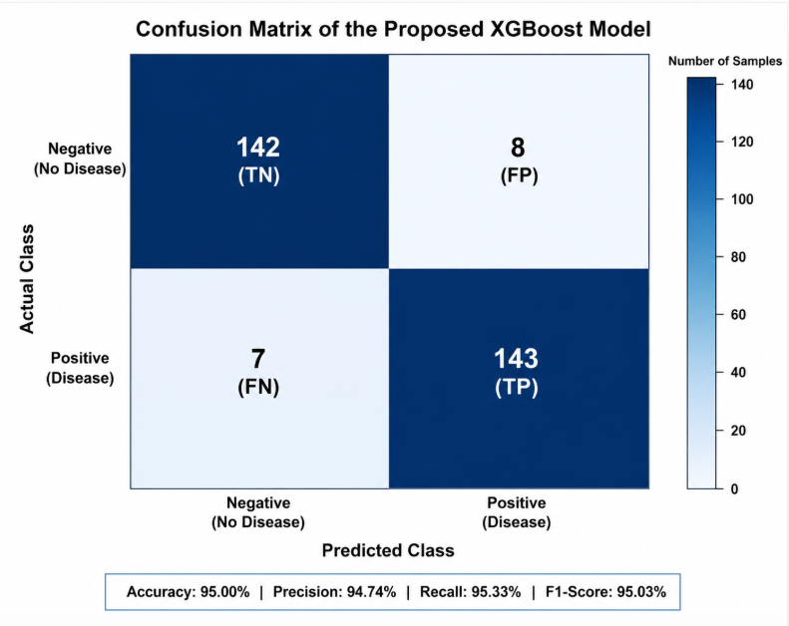
Figure 2. Confusion Matrix of the Proposed XGBoost Model
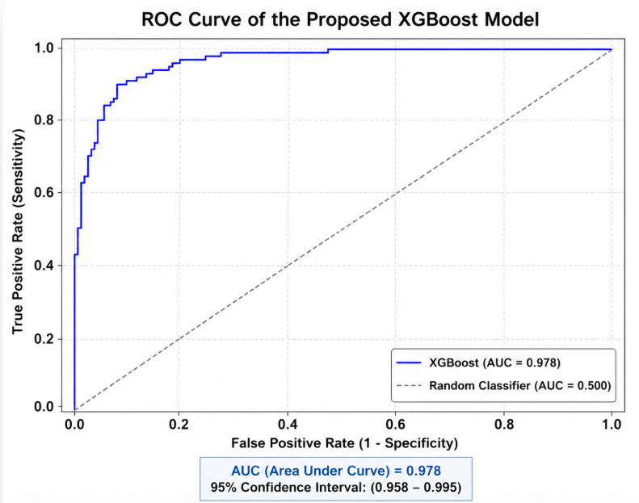
Figure 3. ROC Curve of the Proposed XGBoost Model
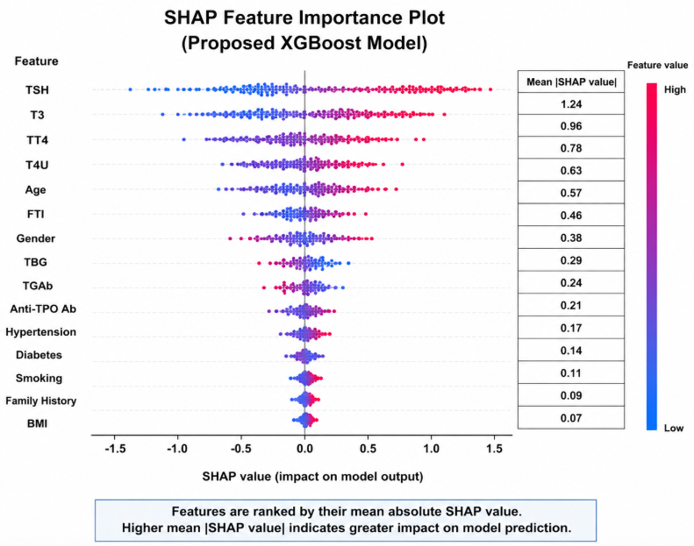
Figure 4. SHAP Feature Importance Plot.
VI. CONCLUSION AND FUTURE WORK
CONCLUSION
This study proposed an Explainable XGBoost-Based Data Mining Framework for Thyroid Disease Prediction to improve the accuracy, transparency, and reliability of thyroid disease diagnosis. The proposed framework integrates comprehensive data preprocessing, feature selection, hyperparameter optimization, and Explainable Artificial Intelligence (XAI) using SHapley Additive exPlanations (SHAP) to develop an efficient clinical decision support system [4,12,17]. By combining XGBoost with explainable AI techniques, the framework aims to enhance predictive performance while providing meaningful insights into the contribution of individual clinical features [16,19].
The proposed methodology addresses several limitations of conventional machine learning models by improving model interpretability, reducing computational complexity through feature selection, and optimizing prediction performance using hyperparameter tuning [8,10]. Furthermore, the integration of SHAP explanations increases clinicians' confidence in AI-assisted diagnosis by providing transparent and understandable prediction outcomes [12,17]. The overall framework demonstrates the potential of combining advanced data mining techniques with Explainable Artificial Intelligence to support early thyroid disease prediction and improve healthcare decision-making [13,20].
FUTURE WORK.
Future research can extend the proposed framework by incorporating larger and more diverse clinical datasets collected from multiple healthcare institutions to improve model generalization and robustness [1,13]. Deep learning architectures and transformer-based healthcare models may also be explored to further enhance predictive performance for complex medical datasets [23]. In addition, integrating real-time clinical data, electronic health records (EHRs), wearable healthcare devices, and cloud-based decision support systems could improve the practical applicability of the proposed framework in modern healthcare environments [1,20]. Future studies may also investigate federated learning and privacy-preserving AI techniques to ensure secure medical data sharing while maintaining patient confidentiality and regulatory compliance.
REFERENCES.
- Belhad, H., Bourbia, A., & Boughanja, S. (2025). Chronic diseases prediction using machine learning and deep learning methods. arXiv. https://arxiv.org/abs/2505.00189
- Breiman, L. (2001). Random forests. Machine Learning, 45(1), 5–32.
- Chaganti, R., Rustam, F., De La Torre Díez, I., Vidal Mazón, J. L., Rodríguez, C. L., & Ashraf, I. (2022). Thyroid disease prediction using selective features and machine learning techniques. Cancers, 14(16), 3914. https://doi.org/10.3390/cancers14163914
- Chen, T., & Guestrin, C. (2016). XGBoost: A scalable tree boosting system. Proceedings of the 22nd ACM SIGKDD International Conference on Knowledge Discovery and Data Mining, 785–794.

- Cortes, C., & Vapnik, V. (1995). Support-vector networks. Machine Learning, 20(3), 273–297.
- Dua, D., & Graff, C. (2019). UCI Machine Learning Repository. University of California, Irvine.
- Fawcett, T. (2006). An introduction to ROC analysis. Pattern Recognition Letters, 27(8), 861–874.
- Guyon, I., & Elisseeff, A. (2003). An introduction to variable and feature selection. Journal of Machine Learning Research, 3, 1157–1182.
- Hastie, T., Tibshirani, R., & Friedman, J. (2009). The elements of statistical learning (2nd ed.). Springer.
- Islam, M. R., Chowdhury, A. I., Shama, S., & Lamyea, M. M. H. (2025). Enhanced thyroid disease prediction using ensemble machine learning: A high-accuracy approach with feature selection and class balancing. Discover Artificial Intelligence, 5(1). https://doi.org/10.1007/s44163-025-00225-9
- Lee, K. S., & Park, H. (2022). Machine learning on thyroid disease: A review. Frontiers in Bioscience.
- Lundberg, S. M., & Lee, S. I. (2017). A unified approach to interpreting model predictions. Advances in Neural Information Processing Systems (NeurIPS).
- Ouartani, S., & Taleb, N. (2025). A transparent AI-driven multiclass decision support system for thyroid risk prediction using machine learning and deep learning approaches. Foundations of Computing and Decision Sciences.
- Pedregosa, F., Varoquaux, G., Gramfort, A., Michel, V., Thirion, B., Grisel, O., ... Duchesnay, E. (2011). Scikit-learn: Machine learning in Python. Journal of Machine Learning Research, 12, 2825–2830.
- Powers, D. M. W. (2011). Evaluation: From precision, recall and F-measure to ROC, informedness, markedness and correlation.
- Sankar, S., Potti, A., Chandrika, G. N., & Ramasubbareddy, S. (2022). Thyroid disease prediction using XGBoost algorithms. Journal of Mobile Multimedia. https://doi.org/10.13052/jmm1550-4646.18322
- Schindele, A., Krebold, A., Heiß, U., Nimptsch, K., Pfaehler, E., Berr, C., ... Lapa, C. (2025). Interpretable machine learning for thyroid cancer recurrence prediction: Leveraging XGBoost and SHAP analysis. European Journal of Radiology, 186, 112049. https://doi.org/10.1016/j.ejrad.2025.112049
- Sha, S., & Bindushree, D. C. (2025). Hypothyroid disease prediction using machine learning. Proceedings of the International Symposium on Engineering and Digital Technologies.
- Xiong, Z., Shi, Y., Zhang, Y., Duan, S., Ding, Y., Zheng, Q., ... Yan, J. (2024). Ultrasound radiomics based XGBoost model to differential diagnosis thyroid nodules and unnecessary biopsy rate: Individual application of SHapley additive exPlanations. Journal of Clinical Ultrasound, 52(3), 305–314.
- Ejiyi, C. J., Eze, F. O., Hossin, M. A., Aggrey, E. S. E. B., & Cai, D. (2026). A robust framework for clinically interpretable hypothyroidism diagnosis with Polynomial-SHAP and DeepSeqNet. Journal of Big Data.
- Analysis and interpretability of machine learning models to classify thyroid disease. (2024). PLOS ONE.
- A high-accuracy stacking ensemble model for precise thyroid disease detection with SHAP and LIME explanations. (2026). Informatics in Medicine Unlocked.
- Quantum intelligence in medicine: Empowering thyroid disease prediction through advanced machine learning. (2024). IET Quantum Communication.
- Thy-Wise: An interpretable machine learning model for the evaluation of thyroid nodules. (2022). International Journal of Cancer.
- Arrieta, A. B., Díaz-Rodríguez, N., Del Ser, J., et al. (2020). Explainable Artificial Intelligence (XAI): Concepts, Taxonomies, Opportunities and Challenges toward Responsible AI. Information Fusion, 58, 82–115. https://doi.org/10.1016/j.inffus.2019.12.012.

