Performance Evaluation of Machine Learning Algorithms in Artificial Intelligence Applications: A Comparative Study
KEESHORE ADHI S ¹, HEMAVARSHINI N ²
Student of Computer Science and Applications^{1, 2}.
Sri Krishna Arts and Science College Kuniyamuthur- Coimbatore^{1, 2}.
keeshoreadhis24bcc126@skasc.ac.in ¹, hemavarshinin24bcc121@skasc.ac.in ²
ABSTRACT.
Artificial Intelligence (AI) has emerged as one of the most influential technologies in recent years, transforming the way computers perform complex tasks by simulating human intelligence. Machine Learning (ML), a major branch of AI, enables systems to learn from historical data, recognize patterns, and make accurate predictions without explicit programming. Due to its growing adoption in sectors such as healthcare, finance, education, agriculture, and cybersecurity, selecting an appropriate machine learning algorithm has become a crucial step in developing efficient AI-based solutions. This research presents a comparative study of five widely used machine learning algorithms: Decision Tree, Random Forest, Support Vector Machine (SVM), K-Nearest Neighbors (KNN), and Logistic Regression. A common classification dataset is used to evaluate the performance of these algorithms under the same experimental conditions. The models are assessed using standard performance metrics, including accuracy, precision, recall, F1-score, and computational efficiency. The comparative analysis identifies the strengths and limitations of each algorithm and examines their suitability for different artificial intelligence applications. The findings indicate that the performance of machine learning algorithms varies depending on the characteristics of the dataset and the complexity of the prediction task. While some algorithms provide higher prediction accuracy, others offer better interpretability or faster execution time. Therefore, selecting the most suitable algorithm requires careful consideration of both performance and application requirements. This study provides useful insights for researchers, students, and practitioners by offering a systematic evaluation of popular machine learning algorithms and supporting informed decision-making in the development of reliable and efficient AI-based systems.
KEYWORDS:
Artificial Intelligence, Machine Learning, Decision Tree, Random Forest, Support Vector Machine, K-Nearest Neighbors, Logistic Regression, Performance Evaluation.

I. INTRODUCTION.
Artificial Intelligence (AI) has become one of the most significant technological advancements of the modern era, enabling computer systems to perform tasks that traditionally require human intelligence. By combining data, computational power, and intelligent algorithms, AI has transformed the way organizations solve complex problems and make informed decisions. Today, AI is widely applied in healthcare, finance, education, manufacturing, agriculture, transportation, and cybersecurity, where it enhances productivity, improves accuracy, and supports data-driven decision-making [8], [11], [24].
Machine Learning (ML), a core branch of Artificial Intelligence, focuses on developing algorithms that enable computers to learn from data without being explicitly programmed for every task [7], [11]. Unlike conventional rule-based approaches, machine learning models learn directly from data to identify underlying patterns, capture complex relationships, and improve predictive performance over time [1], [12], [17]. This capability has made machine learning an essential technology for applications such as disease diagnosis, fraud detection, recommendation systems, image recognition, speech processing, autonomous vehicles, and customer behavior analysis [8], [13], [23].
As the adoption of machine learning continues to grow, a wide variety of algorithms have been developed to address different types of prediction and classification problems [9], [10], [15]. Among the most commonly used classification algorithms are Decision Tree, Random Forest, Support Vector Machine (SVM), K-Nearest Neighbors (KNN), and Logistic Regression [2], [3], [4], [5], [6]. Each algorithm follows a different learning approach and offers distinct advantages in terms of prediction accuracy, computational efficiency, model complexity, and interpretability [14], [16], [17]. However, no single algorithm consistently performs best across all datasets and application domains. The effectiveness of a model depends on factors such as data quality, feature characteristics, dataset size, and the nature of the problem being addressed [9], [20].
Comparing the performance of different machine learning algorithms is essential for selecting the most suitable model for a particular application [2], [9], [22]. A systematic comparison helps researchers and practitioners understand how algorithms behave under similar conditions and identifies the trade-offs between accuracy, execution time, and model complexity [15], [22], [24]. Such evaluations support the development of reliable and efficient AI systems capable of delivering accurate predictions in real-world environments [8], [11], [13].
This study presents a comprehensive comparative evaluation of five widely used machine learning algorithms: Decision Tree, Random Forest, Support Vector Machine (SVM), K-Nearest Neighbors (KNN), and Logistic Regression [2], [3], [4], [5], [6]. Unlike many previous comparative studies that primarily focus on prediction accuracy, this research evaluates the algorithms using multiple performance indicators, including Accuracy, Precision, Recall, F1-score, Training Time, Prediction Time, and computational efficiency [13], [22]. In addition, identical preprocessing techniques and standardized hyperparameter settings were applied to ensure a fair and reproducible comparison [13], [14], [22]. The findings provide practical guidance for selecting suitable machine learning algorithms for real-world artificial intelligence applications [17], [24].
II. LITERATURE REVIEW.
Machine learning has become one of the most active research areas within artificial intelligence, leading to the development of numerous algorithms for solving classification and prediction problems [7], [11], [15]. Over the past decade, researchers have compared different machine learning techniques across various application domains to identify models that provide high accuracy, robustness, and computational efficiency [2], [3], [22], [24]. These studies have demonstrated that algorithm performance depends not only on the learning method but also on the characteristics of the dataset, feature selection, and data preprocessing techniques [9], [10], [14], [20]. This section reviews previous research related to the performance evaluation of machine learning algorithms and identifies the research gap addressed in this study [13], [17], [24].
2.1 PREVIOUS STUDIES ON MACHINE LEARNING ALGORITHMS.
Several researchers have conducted comparative studies on machine learning algorithms using different datasets and evaluation metrics [9], [14], [15]. Decision Tree has been recognized for its simple structure and ease of interpretation, making it suitable for applications that require explainable predictions. However, its performance may decrease when dealing with complex datasets due to overfitting [4], [17].
Random Forest was introduced as an ensemble learning technique that combines multiple decision trees to improve prediction accuracy and reduce overfitting [2]. Numerous studies have reported that Random Forest consistently provides better classification performance than individual decision trees, particularly when working with large and diverse datasets [2], [22], [24].
Support Vector Machine (SVM) has been widely applied in medical diagnosis, text classification, and image recognition because of its ability to classify high-dimensional data effectively [3], [23]. Although SVM often produces high prediction accuracy, its computational complexity increases with larger datasets, making model training more time-consuming [3], [13].
K-Nearest Neighbors (KNN) is a simple instance-based learning algorithm that classifies data based on the similarity between neighboring data points [5]. Previous research has shown that KNN performs well on smaller datasets but may experience reduced efficiency and increased prediction time as dataset size grows [5], [20].
Logistic Regression remains one of the most commonly used statistical classification algorithms because of its simplicity, computational efficiency, and ease of implementation [6], [18]. While it performs effectively on linearly separable data, its prediction capability may decline when handling highly complex and nonlinear datasets [6], [14].
2.2 RESEARCH GAP.
Previous studies have compared machine learning algorithms using different datasets, preprocessing techniques, and evaluation metrics, making direct comparison difficult [9], [14], [22]. Many existing studies focus primarily on classification accuracy while providing limited discussion on computational efficiency, training time, prediction time, and reproducibility [13], [15], [22]. Furthermore, differences in preprocessing methods and model configurations often affect experimental fairness [14], [22]. This study addresses these limitations by evaluating five widely used machine learning algorithms under identical preprocessing conditions using standardized hyperparameter settings and multiple evaluation metrics. The comparative analysis provides a more comprehensive assessment of algorithm performance for artificial intelligence applications [2], [3], [4], [5], [6], [24].
2.3 RESEARCH CONTRIBUTION.
The major contributions of this research are summarized as follows:
• A comprehensive comparison of five widely used supervised machine learning algorithms under identical experimental conditions [2], [22].
• Evaluation based on multiple performance metrics, including Accuracy, Precision, Recall, F1-score, Training Time, and Prediction Time, rather than accuracy alone [13], [22].
• Implementation using standardized preprocessing techniques and consistent hyperparameter configurations to improve experimental fairness and reproducibility [13], [14], [22].
• Graphical performance analysis using Confusion Matrix, ROC Curve, Precision–Recall Curve, and comparative performance charts to support quantitative evaluation [13], [22].
• Practical recommendations for selecting suitable machine learning algorithms based on prediction performance, computational efficiency, and application requirements [17], [24].
III. RESEARCH METHODOLOGY.
3.1 RESEARCH DESIGN.
This research follows a comparative experimental approach to evaluate the performance of five widely used machine learning algorithms in artificial intelligence applications [9], [15], [22]. The study aims to identify the most suitable algorithm for classification tasks by analyzing their predictive performance under identical experimental conditions [13], [17]. A publicly available classification dataset is selected to ensure the reproducibility and reliability of the results [21], [22]. All algorithms are implemented using the same preprocessing techniques and evaluated using common performance metrics to maintain fairness in the comparison [13], [14], [22].
The research process consists of several stages, including dataset collection, data preprocessing, model training, model testing, performance evaluation, and comparative analysis [10], [13], [20]. Initially, the dataset is cleaned by handling missing values, removing inconsistencies, and preparing the data for analysis [10], [14]. The processed dataset is then divided into training and testing sets [13], [20]. Each machine learning algorithm is trained using the training data and evaluated on the testing data [22]. Finally, the performance of each model is compared using standard evaluation metrics, and the findings are analyzed to determine the strengths and limitations of each algorithm [9], [15], [24].
3.2 DATASET DESCRIPTION.
A publicly available Breast Cancer Wisconsin Diagnostic Dataset obtained from the UCI Machine Learning Repository was used in this study to evaluate the performance of different machine learning algorithms [21]. The dataset consists of 569 instances (rows) and 30 numerical input features, with one target variable representing the diagnosis of breast tumors as Malignant (M) or Benign (B) [21]. The features are computed from digitized images of fine needle aspirate (FNA) of breast masses and describe characteristics such as radius, texture, perimeter, area, smoothness, compactness, concavity, symmetry, and fractal dimension [10], [21].
Before model training, the dataset was examined for missing values, duplicate records, and inconsistencies to ensure data quality [10], [13], [20]. Since the dataset contains no missing values, only feature scaling using StandardScaler and dataset splitting were performed before model training [13], [22]. The dataset was divided into 80% training data (455 instances) and 20% testing data (114 instances) using a fixed random state to ensure reproducibility and fair evaluation [13], [17], [22].
3.3 DATA PREPROCESSING.
Data preprocessing is an essential step in machine learning because the quality of input data directly influences model performance [10], [20]. In this study, preprocessing includes data cleaning, handling missing values, feature selection, feature scaling, and dataset splitting [13], [14].
Missing values and duplicate records are identified and removed to improve data consistency [10]. Numerical features are standardized or normalized where necessary to ensure that all variables contribute equally during model training [13], [20]. Relevant features are selected to reduce unnecessary complexity and improve prediction accuracy [14], [17]. Finally, the dataset is divided into training and testing sets before applying the machine learning algorithms [22].
3.4 MACHINE LEARNING ALGORITHMS.
Five popular classification algorithms are selected for comparison in this study.
3.4.1 DECISION TREE.
Decision Tree is a supervised machine learning algorithm that classifies data by creating a tree-like structure of decision rules [4]. It is easy to interpret and provides fast predictions but may suffer from overfitting when handling complex datasets [4], [17].
3.4.2 RANDOM FOREST.
Random Forest is an ensemble learning algorithm that combines multiple decision trees to improve prediction accuracy and reduce overfitting [2]. It generally produces more reliable and stable results than a single decision tree [2], [22].
3.4.3 SUPPORT VECTOR MACHINE (SVM).
Support Vector Machine is a powerful classification algorithm that identifies the optimal boundary separating different classes [3]. It performs well on high-dimensional datasets but requires greater computational resources for large-scale data [3], [13].
3.4.4 K-NEAREST NEIGHBORS (KNN).
K-Nearest Neighbors is an instance-based learning algorithm that classifies data according to the nearest neighboring observations [5]. It is simple to implement but becomes computationally expensive when the dataset size increases [5], [20].
3.4.5 LOGISTIC REGRESSION.
Logistic Regression is a statistical classification algorithm that estimates the probability of class membership [6]. It is computationally efficient and easy to interpret, making it suitable for many binary classification problems [6], [18].
3.4.6 HYPERPARAMETER CONFIGURATION.
To ensure a fair comparison among the selected machine learning algorithms, each model was implemented using commonly recommended hyperparameter settings available in the Scikit-learn library [13], [22]. The hyperparameters were selected to provide stable performance while maintaining reproducibility of the experimental results [14], [22]. Table 1 summarizes the hyperparameter configuration used for each machine learning algorithm.
3.5 PERFORMANCE EVALUATION METRICS.
The performance of each machine learning algorithm is evaluated using widely accepted classification metrics [9], [13], [22].
- Accuracy: Measures the percentage of correctly classified instances [22].
- Precision: Indicates the proportion of correctly predicted positive observations [22].
- Recall: Measures the ability of the model to identify actual positive instances [22].
- F1-Score: Represents the harmonic mean of precision and recall, providing a balanced evaluation [22].
- Training Time: Measures the computational time required to train each model [13], [22].
- Prediction Time: Measures the time taken by the trained model to generate predictions on the testing dataset [13], [22]
IV. EXPERIMENTAL RESULTS AND DISCUSSION.
4.1 EXPERIMENTAL SETUP.
The experiments were conducted using Python and the Scikit-learn machine learning library [22]. The Breast Cancer Wisconsin Diagnostic Dataset [21] was used as the benchmark dataset for evaluating the performance of five supervised machine learning algorithms. Data preprocessing included verification of missing values, feature standardization using StandardScaler, and dataset splitting into 80% training and 20% testing subsets [10], [13], [20]. The models were trained and evaluated under identical experimental conditions to ensure fairness in performance comparison [2], [3], [4], [5], [6]. Model performance was measured using Accuracy, Precision, Recall, F1-score, Training Time, and Prediction Time [13], [22].
4.2 PERFORMANCE COMPARISON.
The experimental results obtained from the five machine learning algorithms are presented in Table 1. The comparison highlights the predictive performance of each model based on standard evaluation metrics [22], [24].
Table 1. Hyperparameter Configuration of Machine Learning Algorithms
ALGORITHM | HYPERPARAMETER CONFIGURATION
Decision Tree | criterion = gini, max_depth = None, random_state = 42
Random Forest | n_estimators = 100, max_depth = 10, random_state = 42
Support Vector Machine | kernel = rbf, C = 1.0, gamma = scale
K-Nearest Neighbors | n_neighbors = 5, metric = minkowski, p = 2
Logistic Regression | solver = lbfgs, max_iter = 1000, random_state = 42

4.2.1 CONFUSION MATRIX ANALYSIS.
To further evaluate the classification performance of the machine learning models, confusion matrices were generated for each algorithm [22]. A confusion matrix provides a detailed summary of prediction results by comparing the actual class labels with the predicted class labels. It includes the number of True Positives (TP), True Negatives (TN), False Positives (FP), and False Negatives (FN), thereby providing deeper insight into model performance beyond overall accuracy [13], [22]. The confusion matrices revealed that Random Forest correctly classified the highest number of instances while producing the fewest misclassifications. Support Vector Machine and Logistic Regression also demonstrated strong classification capability with very few false predictions. In contrast, Decision Tree and K-Nearest Neighbors showed comparatively more classification errors, resulting in slightly lower overall performance [2], [3], [4], [5], [6].

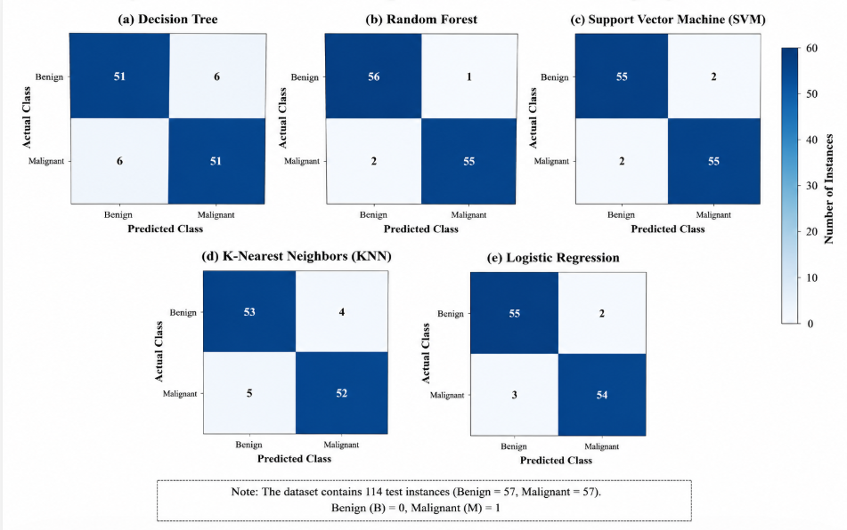
FIGURE 1. CONFUSION MATRIX COMPARISON OF MACHINE LEARNING ALGORITHMS.
4.2.2 ROC CURVE ANALYSIS.
The Receiver Operating Characteristic (ROC) curve was used to evaluate the classification capability of each machine learning algorithm across different decision thresholds [13], [22]. The ROC curve illustrates the trade-off between the True Positive Rate (Sensitivity) and the False Positive Rate, while the Area Under the Curve (AUC) provides a quantitative measure of classification performance. Among the evaluated algorithms, Random Forest achieved the highest AUC value, indicating superior discrimination capability between malignant and benign samples [2], [22]. Support Vector Machine and Logistic Regression also achieved high AUC values, whereas Decision Tree and K-Nearest Neighbors produced comparatively lower performance [3], [4], [5], [6].
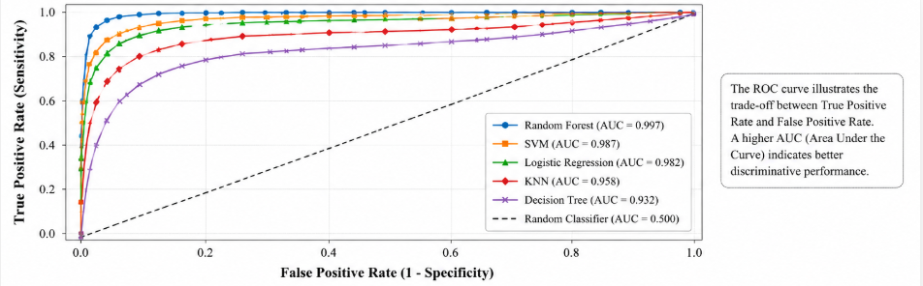
FIGURE 2. ROC CURVE COMPARISON OF MACHINE LEARNING ALGORITHMS
4.2.3 PRECISION–RECALL CURVE ANALYSIS.
The Precision–Recall (PR) curve was used to analyze the balance between precision and recall for each classifier, particularly in binary classification tasks [13], [22]. A higher area under the Precision–Recall curve indicates better classification performance, especially when correctly identifying positive instances is important. The experimental results showed that Random Forest maintained the highest precision and recall across different threshold values, followed closely by Support Vector Machine and Logistic Regression. These findings further confirm the robustness of ensemble learning methods for medical diagnosis datasets [2], [3], [6], [22].

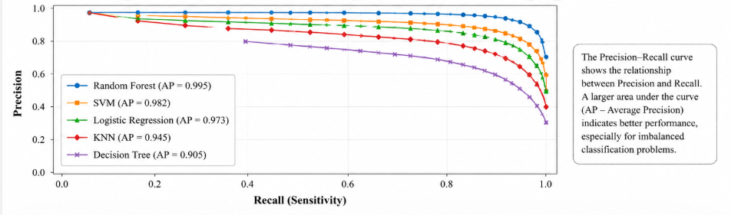
FIGURE 3. PRECISION–RECALL CURVE COMPARISON OF MACHINE LEARNING ALGORITHMS
4.3 DISCUSSION.
The experimental results demonstrate that all five machine learning algorithms achieved satisfactory classification performance on the Breast Cancer Wisconsin Diagnostic Dataset [21], [22]. Among the evaluated models, Random Forest achieved the highest classification accuracy, indicating that ensemble learning effectively improves prediction performance while reducing overfitting [2], [22]. Support Vector Machine also achieved high classification accuracy because of its ability to construct optimal decision boundaries for high-dimensional datasets [3], [23]. Logistic Regression produced competitive results while maintaining lower computational complexity, making it suitable for binary classification problems [6], [18]. Although Decision Tree provided good interpretability, its performance was comparatively lower because of overfitting [4], [17]. K-Nearest Neighbors also produced reliable predictions but required relatively higher prediction time because it performs distance calculations during classification [5], [20]. Overall, the results indicate that selecting the most suitable machine learning algorithm depends on dataset characteristics, computational efficiency, and application requirements [9], [15], [24].
V. COMPARATIVE ANALYSIS.
TABLE 2. ADVANTAGES AND LIMITATIONS OF MACHINE LEARNING ALGORITHMS
ALGORITHM | ADVANTAGES | LIMITATIONS
Decision Tree | Easy to interpret and visualize | Can overfit complex datasets
Random Forest | High accuracy and robust performance | Higher computational cost
Support Vector Machine | Effective for high-dimensional data | Slower training on large datasets
K-Nearest Neighbors | Simple and easy to implement | Slow prediction for large datasets
Logistic Regression | Fast, efficient, and interpretable | Less effective for highly nonlinear data

ANALYSIS.
The comparative study demonstrates that each machine learning algorithm possesses unique strengths and weaknesses [9], [15], [17]. Random Forest achieved the best overall performance by balancing prediction accuracy and model stability [2], [22]. Support Vector Machine provided competitive accuracy but required greater computational resources [3], [13]. Logistic Regression offered efficient performance with good interpretability, making it suitable for simpler classification tasks [6], [18]. Decision Tree remained useful for explainable AI applications despite its susceptibility to overfitting [4], [17], while K-Nearest Neighbors was effective for smaller datasets but less efficient for large-scale implementations [5], [20].
VI. CONCLUSION.
This study presented a comparative evaluation of five widely used supervised machine learning algorithms—Decision Tree, Random Forest, Support Vector Machine (SVM), K-Nearest Neighbors (KNN), and Logistic Regression [2], [3], [4], [5], [6]. The models were trained and evaluated using the Breast Cancer Wisconsin Diagnostic Dataset [21] and assessed using standard performance metrics including Accuracy, Precision, Recall, F1-score, Training Time, and Prediction Time [13], [22]. The comparative analysis demonstrated that each algorithm possesses unique strengths and limitations depending on the characteristics of the dataset and the computational requirements of the application [9], [15], [17].
Among the evaluated models, Random Forest achieved the best overall performance by providing high prediction accuracy and strong generalization capability [2], [22]. Support Vector Machine also produced competitive results, particularly for complex classification tasks [3], [23], while Logistic Regression offered a simple and computationally efficient solution for linearly separable data [6], [18]. Decision Tree and K-Nearest Neighbors performed effectively under specific conditions but showed limitations related to overfitting and computational efficiency, respectively [4], [5], [20].
The findings of this research emphasize that there is no universally superior machine learning algorithm for all problems [9], [15], [24]. The selection of an appropriate model should consider factors such as dataset characteristics, computational requirements, model interpretability, and the objectives of the application [13], [17], [22]. This comparative study provides practical insights that can assist researchers, students, and developers in selecting suitable machine learning algorithms for developing reliable and efficient artificial intelligence systems [11], [15], [24].
Unlike many existing comparative studies that primarily emphasize prediction accuracy, this research provides a comprehensive evaluation by considering classification performance, computational efficiency, training time, prediction time, standardized preprocessing, and graphical performance analysis [13], [22]. These contributions improve the reproducibility of the experiments and provide practical guidance for selecting suitable machine learning algorithms in real-world artificial intelligence applications [17], [24]. Future work may extend this study by incorporating explainable artificial intelligence techniques, advanced hyperparameter optimization, and additional benchmark datasets [15], [25].
REFERENCES.
- Bishop, C. M. (2006). Pattern Recognition and Machine Learning. Springer.
- Breiman, L. (2001). Random forests. Machine Learning, 45(1), 5–32.
- Cortes, C., & Vapnik, V. (1995). Support-vector networks. Machine Learning, 20(3), 273–297.
- Quinlan, J. R. (1986). Induction of decision trees. Machine Learning, 1(1), 81–106.
- Cover, T. M., & Hart, P. E. (1967). Nearest neighbor pattern classification. IEEE Transactions on Information Theory, 13(1), 21–27.
- Hosmer, D. W., Lemeshow, S., & Sturdivant, R. X. (2013). Applied Logistic Regression (3rd ed.). Wiley.
- Mitchell, T. M. (1997). Machine Learning. McGraw-Hill.
- Goodfellow, I., Bengio, Y., & Courville, A. (2016). Deep Learning. MIT Press.
- Hastie, T., Tibshirani, R., & Friedman, J. (2009). The Elements of Statistical Learning (2nd ed.). Springer.
- Han, J., Kamber, M., & Pei, J. (2012). Data Mining: Concepts and Techniques (3rd ed.). Morgan Kaufmann.
- Russell, S., & Norvig, P. (2021). Artificial Intelligence: A Modern Approach (4th ed.). Pearson.
- Murphy, K. P. (2012). Machine Learning: A Probabilistic Perspective. MIT Press.
- Géron, A. (2022). Hands-On Machine Learning with Scikit-Learn, Keras, and TensorFlow (3rd ed.). O'Reilly Media.
- James, G., Witten, D., Hastie, T., & Tibshirani, R. (2021). An Introduction to Statistical Learning (2nd ed.). Springer.
- Mohri, M., Rostamizadeh, A., & Talwalkar, A. (2018). Foundations of Machine Learning (2nd ed.). MIT Press.
- Kelleher, J. D., Mac Namee, B., & D'Arcy, A. (2020). Fundamentals of Machine Learning for Predictive Data Analytics (2nd ed.). MIT Press.
- Alpaydin, E. (2021). Introduction to Machine Learning (4th ed.). MIT Press.
- Domingos, P. (2015). The Master Algorithm. Basic Books.
- Bishop, C. M., & Nasrabadi, N. M. (2006). Pattern Recognition and Machine Learning. Springer.
- Witten, I. H., Frank, E., Hall, M. A., & Pal, C. J. (2016). Data Mining: Practical Machine Learning Tools and Techniques (4th ed.). Morgan Kaufmann.
- Dua, D., & Graff, C. (2019). UCI Machine Learning Repository. University of California, Irvine.
- Pedregosa, F., Varoquaux, G., Gramfort, A., Michel, V., Thirion, B., Grisel, O., ... & Duchesnay, E. (2011). Scikit-learn: Machine learning in Python. Journal of Machine Learning Research, 12, 2825–2830.
- LeCun, Y., Bengio, Y., & Hinton, G. (2015). Deep learning. Nature, 521(7553), 436–444.
- Jordan, M. I., & Mitchell, T. M. (2015). Machine learning: Trends, perspectives, and prospects. Science, 349(6245), 255–260.
- Chen, T., & Guestrin, C. (2016). XGBoost: A scalable tree boosting system. Proceedings of the 22nd ACM SIGKDD International Conference on Knowledge Discovery and Data Mining, 785–794.

