Timetable editor

Introduction
The timetable-function of Openrails offers a great option to define trains. The timetable is a simple csv-file (text-table), which defines the different trains. Since you have to take care of the correct data a macro for Microsoft Excel had been developed. Since not everyone has Excel, i have written this small editor.

Userinterface
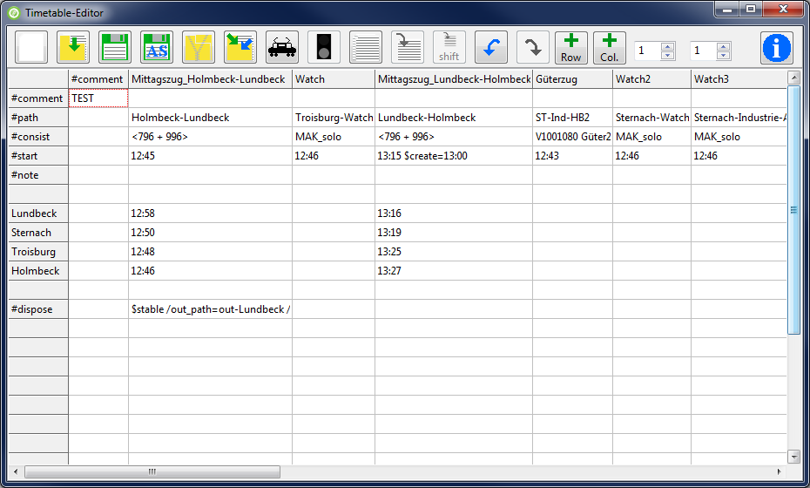
Symbols
 | Create new timetable |  | Open timetable
 | Save timetable |  | Save timetable as
 | Create a zip-file with the timetable, the paths and consists |  | Import another timetable into the current one
 | Define train |  | Dispose action definition
 | Manage sidings |  | Copy train (copy selected column)
 | Paste train (paste into selected column) |  shift | Paste train and shift times (paste into selected column)
 | Undo |  | Redo
  row | Add row above selected row |  col | Add column left of the selected column
 | Infobutton

The two spinedits are used to adjust the fixed rows (left spinedit) and fixed columns (right spinedit). Fixed lines are not editable.
The following is specific to Openrails timetables.
- In the corner of the first column-“#comment“ and the first row-“#comment“ Openrails expects the title of the timetable. The first column in the first row has to be empty. After the column-“#comment“ you define the different trains.
- #path: In this row the main paths for the train are entered.
- #consist: This row takes the consist of the train
- #start: Start time of the train.
- #note: Row for optinal commands
- #dispose: Row for the dispose-action. Defines what happens to the train, when it has arrived at the end of ist path.
Right clicking in one of the white cells of the table opens a menu, which lets you adjust the column width to the text in it and it lets you delete the current row or column.

Creating a timetable
After the editor has started, you choose if you want to create a new timetable or if you want to open an existing one. By clicking “new” a dialog is shown which lets you choose the route-database-file (*.tdb) of the route you want the timetable to be created for. Apart from the track work defined in this file, there are the station names saved in it, which the editor needs to know, to be able to create the timetable.
The editor extracts the station names out of the route database and shows them in a list. With buttons you are able to move the entries up or down the list. Since it is a normal listbox, you are able to insert new rows or delete an entry. The list has to be saved, before going on. Before saving, the editor tests if the folder “Openrails“ exists inside the folder „Activities“ of the route. If the folder doesn’t exist it offers to create it. You should do that, because the editor searches its files there and Openrails will look there for the timetable. The station files are saved with the ending „.stations“ with the save-dialog.
If there are station files available the editor offers to choose one, ore create a new one.
The stations are added to the table and you can start defining the trains.

Defining trains
To do this, click on the train-Icon, while you are in the column in which the train should be defined . Every train definition consists of four things. It has a name, a path, a consist and a start time. The name and start time have to be entered manually. The paths and consists are chosen from lists, so you don’t need to care to the correct spelling of the filename. The editor has loaded all available consists and paths which belong to installation of the chosen route. You are able to reload the files, for example if you created new paths or consists after having opened the editor.
To allow easier population of sidings, I would suggest the following way: Paths for sidings get a filename starting with “sid_”. This way they can be identified by the editor and you can choose if you want to see all paths, no sidings or just sidings. A similar way exists for consists. Here you can choose if you want to see all consists, only trains with engines or trains without engines.
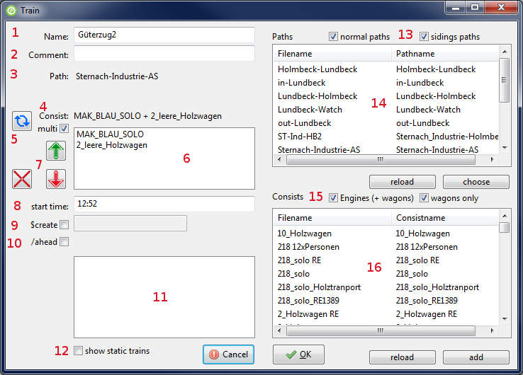
- Name for the train-definition or $static for a static train
- Comment to this train
- Path for the train
- Selected consist
- Reverses the consist, or in multi-consist-mode it reverses the selected part of the consist
- Only visible if the checkbox „multi” is selected. This way you can define a train which consists of two or more consist-files. The parts of this consists will be listed here
- Move a part of the multi-consist up or down the list, delete a part of the consist
- Start-time for the train
- Allows entering a time at which the consist will be created
- Allows defining, that this train will be placed ahead of another train, so that several trains can be placed on a siding in the right order
- Lists the already defined trains, so you can pick the one, which this train should be placed ahead to.
- Toggles if static trains ($static) should be visible in the list or not.
- You can choose which paths should be visible in the list. If you select both checkboxes, you will see all paths. If only the left one is selected you will see all paths, whose filename doesn’t start with “sid_”. If only the right on is selected you will see only paths with the beginning “sid_”.
- Path-List: Doubleclick or press choose to choose the selected path. Reload reloads the paths for this route
- You can choose which consists should be visible in the list. If you select both checkboxes, you will see all consists. If only the left one is selected, you will see all consists, which contain an engine. If only the right one is selected, you will see all consists, which haven’t got an engine.
- Consist-List: Doubleclick or press choose to choose the selected consist. Reload reloads the consists for this route.

Time
The times for stops of the passenger trains are added in the table. You are able to define actions like waiting for another train or something like that. You find these infos inside the manual of the timetable function.

Copying trains
You can copy a whole train (actually the whole column) and paste it into another column. There is a second paste-Button which allows to shift the times of the copied train, when pasting it. So it’s easy, to define trains which run the same path every hour, half an hour, or which interval is wanted.

Import timetable
It is possible to import another timetable into the current one. But you have to be careful. If the two timetables have a different row count (because of empty rows, comments or…), there will be mismatches between them.

Zip timetable
If you want to give your timetable to other persons, you can create a zip-file of the timetable. The zip-file will contain the timetable and all used paths and consists.

Undo / Redo
The program has a simple Undo-Redo-Function. There are maximum 10 steps you can go back and forth.

Dispose – or what happens to the train at the end of the path
The row with „#dispose“ defines what happens to the train if it has reached the end of its path. Normally the train simply disappears. But you can define other things like forming another train or send the current train to a siding. Adding these functions is not easy, but there is a helper which you can open by clicking on the icon with the signal.

Managing sidings
Sidings are at the moment not fully useable for train moves in timetable mode. However they can still be populated with static consists. To make it easier to do that, there is a tool in the timetable editor. The tool offers to create paths, so static consists can be placed. The paths are as long as the siding. The tool is started by clicking on the rails in the main window.
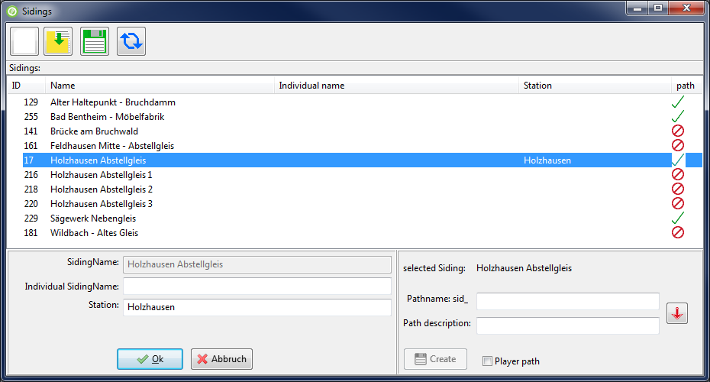
The list in the middle of the window will be empty at first. By clicking on the left Icon the trackdatabase is scanned for sidings, which will be listed here. The only information which can be obtained from the trackdatabase is the id(s) of the siding, the name and the position. Since there may be sidings with meaningless names (like unnamed siding) you have the possibility to enter a more meaningful name and a station. But these entries are only used in this list, to make it easier for you to identify the siding you want. You can save and load this list. After saving there will be a file named “sidings.siding” in the “Activites\OpenRails\”-folder of the route. To enter the data double click on the siding you want. A simple click on a siding selects it, so you can create the path. The pathname will begin with “sid_”, so the train window can filter the path. You can enter a path description. The description can be the same as the pathname. To do that leave the field empty or press the button with the red down arrow, to copy the text. You can choose if the path is only for AI trains or if the player can use it. The Timetable mode makes no difference to this, all paths are usable. But if a path is created as player path, it will be visible in the normal Activity mode, using the path description as start- and endpoint. I suggest leaving the checkbox unchecked, so the siding path is only for timetable mode. After Clicking on create the program will ask if the path should be created. In fact there will be two paths created. A siding has two endpoints and so the program creates a path from the first point to the second and another path using the opposite direction. The second path will have a “_rev” at the end of the filename and description, to show it’s the reversed version. The list marks sidings with existing paths with a green hook and the pathname is shown in the next column. Sidings without paths get a red crossed circle. To refresh the marked sidings in the list, press the button with the circular arrows. You can sort the list by clicking on the column heads. The column path can’t be sorted.
You can use the OpenRails Trackviewer to find out which siding is where. In the trackviewer go to File->search by index-> search trackitem and enter the id of the siding. The Trackviewer will jump to the siding. If you move the mouse over the siding, you will see the word siding and right of it the id of the siding. One end of the siding will have the id, you have searched.

Disclaimer
I can not guarantee that the programm runs without errors. So you use it at your own risk.
Lutz Döllermann, May 2015
Lutzs_de@yahoo.de

