Version Control System(vcs)
differnece bwtn git and git hub is that git is a software and git hub is a service provider
Repo(repository) or we can just call it as folder. a folder which contains a lot of software files is called repo in a world of git we call repo
1>git --version or git -v it check the version
2>git status
3>git init (one time per project)
4>.git a hidden folder to keep track history of all files and sub files

once if we move to .git we can see many hidden files like Head,Hook,refs,config,info,description,object
they will grove up onces we bring more files to it
we should not go to this folder amd make any changes manually
if we call on refs there will be two files that is head and tags
these are the actuall folder that kepps a track of this

COMMIT is like a checkpoints
workflow of git actually work
1st we have to make working directory after that we have to make a command git add . or git add filename its is not yet commited i.e checkpoint is not yet made where there is a staging area that it is ready to commit some files then we will go ahead and commit a file with a command that is git commit(ready to make a checkpoint)then a repo is on to a checking stage then we will use git push command.
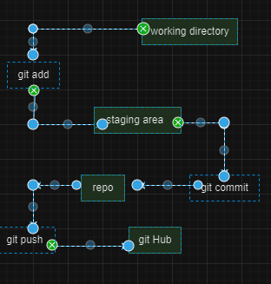
Staging area is an intermediate zone to make a commit it is almost like a prescreen before we saving a game
next we use git commit -m where (-m is a msg)
STAGE
git init => create a file or files
git add file1 file2 || gir add . (. means add every thing like what ever the fileas are there adding full to it)
git status=>if i press git status we can see ehat ever the file is in teracking and non tracking under it
COMMIT
git commit -m "any message"
git status
git log (log of commit with commit hash)
Git follows principle atomic commits i.e one commit do one task
keep commit centric to one feature one component or on fix .focused on one thing
git config --global core.editor "code --wait" (-- global means system wide if we make any change it will interract with global file)
git log --oneline
SETTING USERNAME IN GIT GLOWBALLY
git config --global user.name "m name"
git config -- global user.email "my email"
.GITIGNORE
dont want to track some files
nodes modules api key and secret key
get template online ,patterns ,tricky
BRANCHES
Like an alternative timeline
git branch
if we want to create a new branch example like git branch navbar
how to move to a different branch use git checkout navbar now it changes to nav-bar and pointer is pointing to it
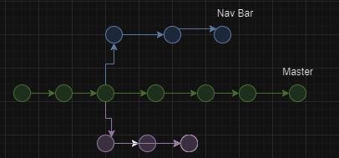
HEAD
Head points to where a branch is currently at
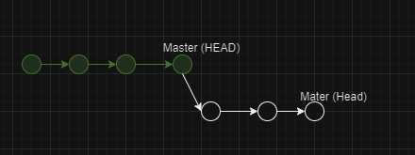
Head will be where the updated code base or intenstional code bases
git branch
git branch filename
git switch filename
git log
git switch master
git switch -c filename (create branch and move there)
git checkout -b filename
==>commit before switching to another branch
==>go to .git folder & checkout HEAD file
MERGING THE BRANCHES
2 types
1>fast forward merging
2>not fast forward merging
1>fast forward merging
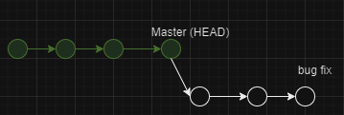
git switch master
git merge bugfix
2>not fast forward merging
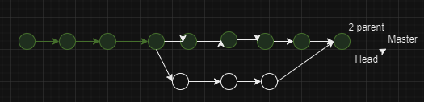
if we want to merge the branches this by giving a command git merge filename
then we can see in command git log
if we want to delete the branches we use git branch –d
-------------- GIT DIFF(informative command) --------------------------
git diff (compare working with staging)
it will not show the difference btwn the different file it shows the difference btwn same file that is file A
IT SHOW THE VERSION of x time and y time
->how to read diff
1> a-> file 1 & b->file 2 (same file over time)
2>--- file 1
3>++++ file2
4>change in line & little preview of it
GIT STASH
1> CREATE A repository , work & commit on main
2>switch to another main branch and work
3>conflicting changes do not allow you to switch branch without commit (if there is any change not even be changed worked on something in your branch, moved some file haven’t committed them and not even staged them this is exactly the stash comes to places )
git stash (you can switch branches)
git stash pop(bring back to those changes)
optionally
git stash apply(apply changes and keep them in the stash)
More Commands <hash> (detach Head):new branch
git switch main (re-attach head)
git checkout HEAD~2(look at 2 commit prior)
git reforce filename (get back to last commit version)
-------REBASE--------
alternative way to merging
clean up tools ( clean up commit)
important note:if you are in main branch or master branch new run the command form that side it can be run from side branch that is branch itself
------GIT HUB DISCUSSION-----------------------------------
GIT is a software and git hub is a service to host git online
.GIT HUB – is a collabration tools + backup + Open source
GIT LAB AND BITBUCKET
git clone <URL>
git config –global user.name “Your user name”
git config –global.user.email “your email”
set up ssh keys to continue to connect with github,github use ssh to allow you to push code. Password based code push is not allowed
ckeck instruction for your OS on github website, as the best & updated resource
Remote repository
git remote –v (this command allows you to see and figure out whether you have any remote repository being set up)
simply in terminal or bash anywhere you type git remote –v if it is empty that means not remote is added
git remote add origin URL where origin is a name and url
git remote rename oldname newname
git remote remove name
git push <remote> <branch>
git push origin main
git push <remote> localBranch:remote Branch
git push -u origin main
- u set up an upstream that allows you to run future command
is we don’t use –u and just we use git push origin main then if we want to again modify the code then will show the current branch main has no upstream branch to push the current branch and set the remote as upstream ,use
git push –set –upstream origin main
when we clone a repo you get just main branch connected rest of remote branch are not configured.
git switch branch_name
connect remote branch to local
git branch –r
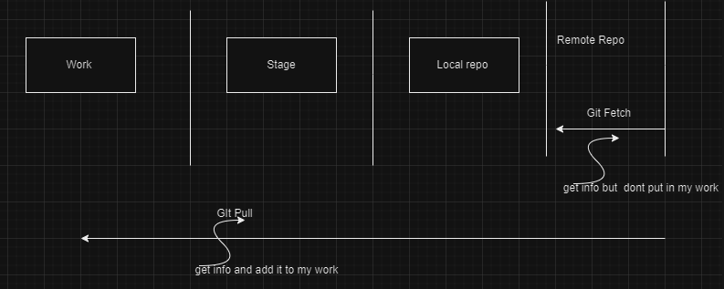
git pull is a combination command of git fetch + git merge
git pull origin main (changes will be merged to main)

