Fruits-360 CNN Experiment Report
Expanded 131-class activation and learning-rate study | Evidence-derived report

Executive summary
Twelve controlled CNN runs compared four hidden activations and three SGD learning rates. The validation-selected configuration was tanh at learning rate 0.1 (validation macro F1; accuracy tie-break; saved train-only checkpoint, no refit). Held-out test accuracy was 93.23%; macro F1 was 92.74%. Results are limited to the exact saved sampling scope.
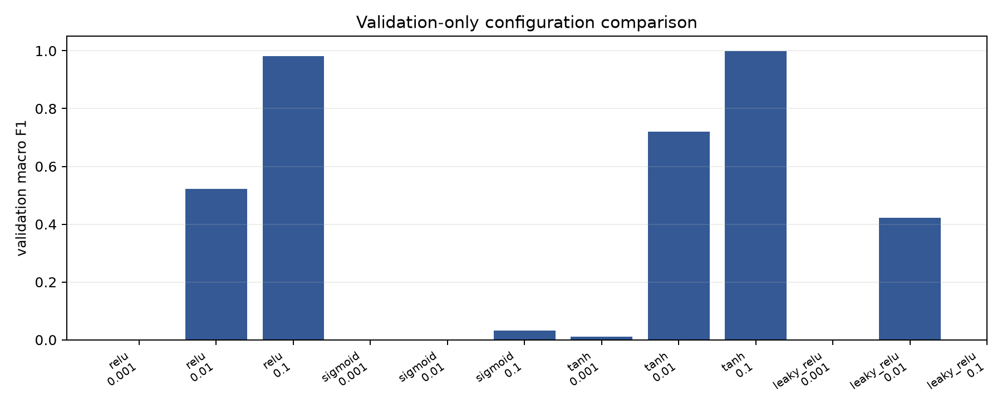

Provenance and scope
Dataset: Fruits-360 2020.05.18.0 / 131-class snapshot. Upstream source commit: ffda2d14eada57a0c5537700190b309cfea2e120. Dataset source: https://github.com/Horea94/Fruit-Images-Dataset. The supplied snapshot contains 67,692 Training and 22,688 Test images across 131 classes. This report does not claim a full-source run if the recorded sampled counts are smaller.
Split | Recorded images | Role
Training | 54,163 | parameter updates
Validation | 13,526 | configuration selection
Held-out test | 22,688 | one final evaluation
Sampling: All single-fruit Training and Test JPGs; exact duplicates excluded. Seed 20260919; batch size 128; epochs 8; image size 32; optimizer SGD, momentum=0. The selected train-only checkpoint is evaluated without a refit.

Methodology and architecture
The experiment keeps split, architecture, initialization controls, batch size and epoch budget fixed. Only activation and learning rate vary. Validation macro F1 selects the saved train-only checkpoint (accuracy breaks ties); it is then evaluated once on the saved held-out test evidence. No test metric is used for selection and no refit is performed.
Stage | Operation
Input | RGB image resized to 32
Feature extractor | Conv2D(8,3,same), activation, MaxPool2D, Conv2D(16,3,same), activation, MaxPool2D, Flatten, Dense(64), activation, Dense(131,softmax)
Classifier | Softmax over 131 classes
Objective | Sparse categorical cross-entropy; SGD
Softmax p(y=k|x)=exp(z_k)/Σ_j exp(z_j). Cross-entropy L=−Σ_i log p(y_i|x_i). SGD update θ←θ−η∇θL. Precision=TP/(TP+FP); recall=TP/(TP+FN); F1=2PR/(P+R). Macro metrics are unweighted class means.

All 12 validation comparisons
Activation | LR | Accuracy | Macro P | Macro R | Macro F1 | seconds
relu | 0.001 | 0.0109 | 0.0001 | 0.0076 | 0.0002 | 103.2
relu | 0.01 | 0.5302 | 0.6740 | 0.5164 | 0.5214 | 107.6
relu | 0.1 | 0.9847 | 0.9844 | 0.9828 | 0.9810 | 97.2
sigmoid | 0.001 | 0.0109 | 0.0001 | 0.0076 | 0.0002 | 104.3
sigmoid | 0.01 | 0.0146 | 0.0001 | 0.0076 | 0.0002 | 103.8
sigmoid | 0.1 | 0.1008 | 0.0328 | 0.0790 | 0.0320 | 102.5
tanh | 0.001 | 0.0470 | 0.0084 | 0.0337 | 0.0113 | 102.6
tanh | 0.01 | 0.7536 | 0.7777 | 0.7369 | 0.7193 | 102.3
tanh | 0.1 | 0.9979 | 0.9982 | 0.9978 | 0.9979 | 101.7
leaky_relu | 0.001 | 0.0113 | 0.0002 | 0.0081 | 0.0003 | 103.4
leaky_relu | 0.01 | 0.4483 | 0.6265 | 0.4448 | 0.4227 | 125.9
leaky_relu | 0.1 | N/A (diverged) | N/A (diverged) | N/A (diverged) | N/A (diverged) | 108.9
All values are validation metrics. Leaky ReLU at 0.1 diverged from epoch 6; its final metrics are unavailable and it is excluded from selection.

Training loss — all activation curves
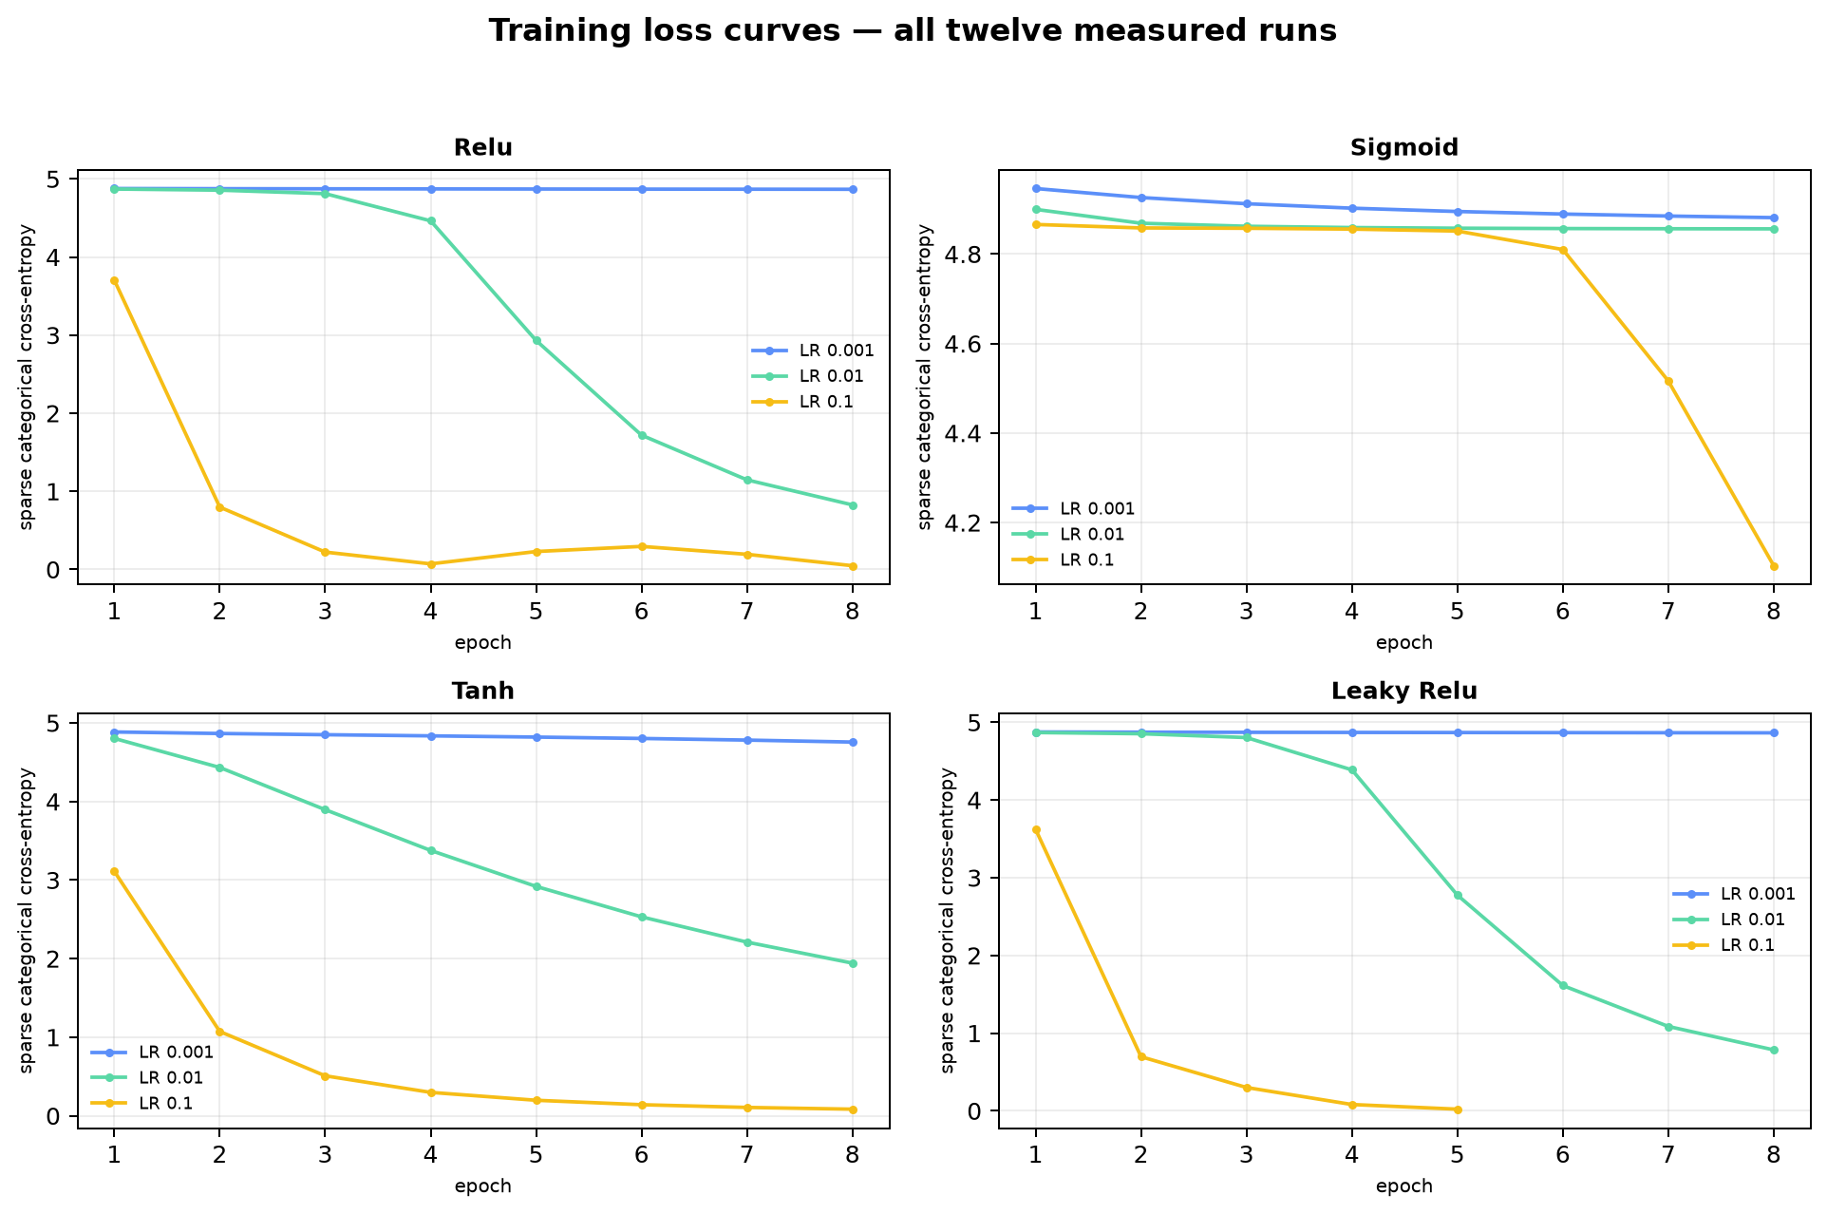
Each panel is one activation; colored lines are the three measured learning rates. Curves are generated directly from summary.json histories.

Training accuracy — all activation curves
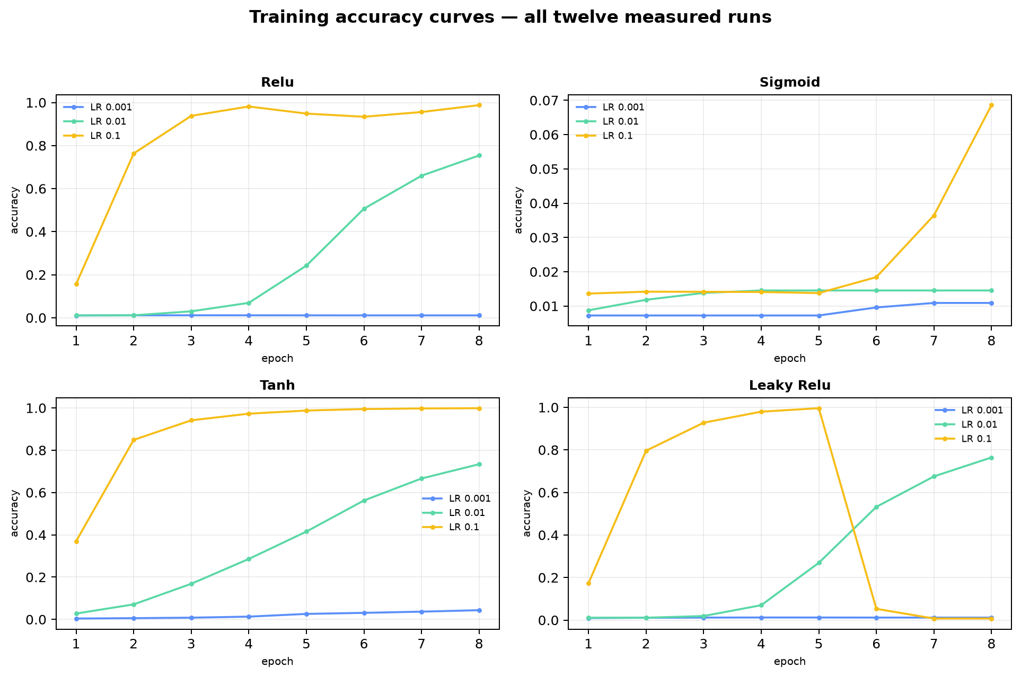
Each panel is one activation; colored lines are the three measured learning rates. Curves are generated directly from summary.json histories.

Validation loss — all activation curves
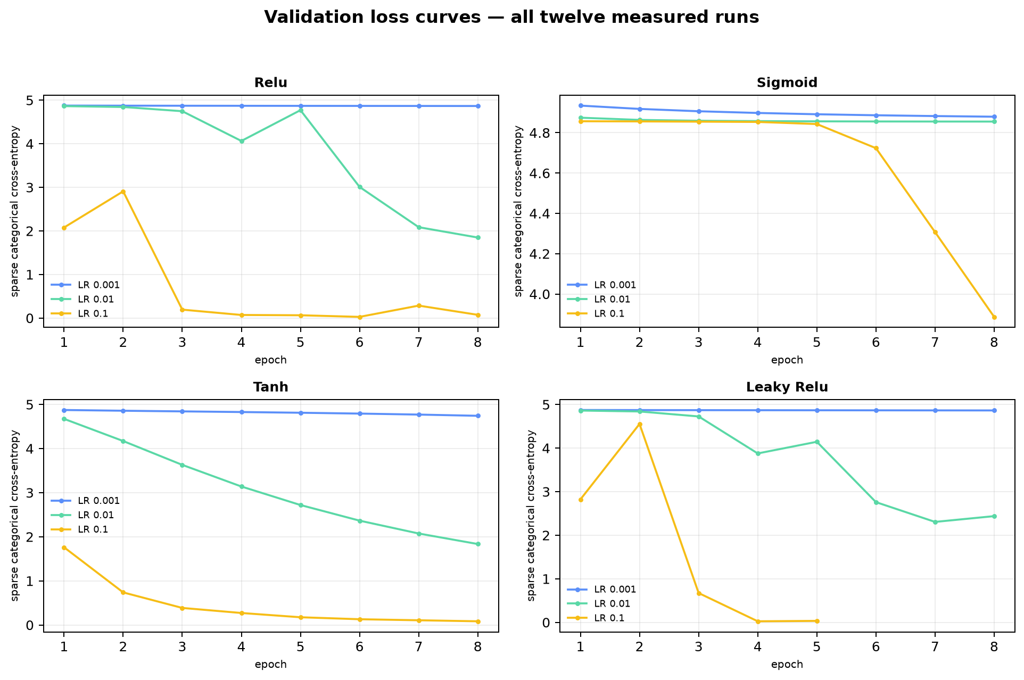
Each panel is one activation; colored lines are the three measured learning rates. Curves are generated directly from summary.json histories.

Validation accuracy — all activation curves
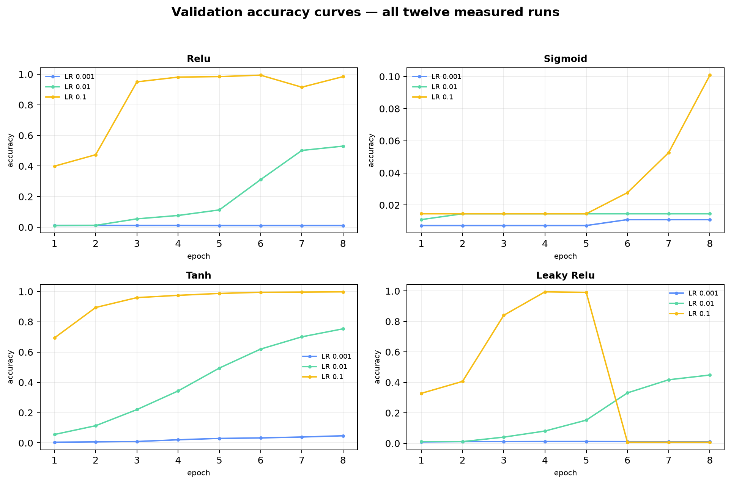
Each panel is one activation; colored lines are the three measured learning rates. Curves are generated directly from summary.json histories.

Held-out test evaluation
Metric | Measured value
accuracy | 0.9323
precision macro | 0.9406
recall macro | 0.9281
f1 macro | 0.9274
The full 131 × 131 confusion matrix is appended. The concise table below focuses on the classes with the lowest diagonal counts; ‘most common other prediction’ is only populated when errors occurred.
Class | correct | errors | most common other prediction
Corn | 54 | 96 | Physalis with Husk
Beetroot | 63 | 87 | Pear Stone
Pear Kaiser | 75 | 27 | Plum 3
Mangostan | 79 | 23 | Chestnut
Potato Sweet | 84 | 66 | Potato Red
Ginger Root | 91 | 8 | Pear Stone
Eggplant | 95 | 61 | Pepper Green
Apple Braeburn | 97 | 67 | Nectarine
Pear Monster | 103 | 63 | Physalis with Husk
Tomato not Ripened | 103 | 55 | Pepper Green
Pomegranate | 104 | 60 | Strawberry Wedge
Apple Crimson Snow | 109 | 39 | Apple Pink Lady
Cucumber Ripe | 113 | 17 | Apple Red Delicious
Peach | 113 | 51 | Grape Pink
Potato Red Washed | 114 | 37 | Onion Red
Pear | 115 | 49 | Apple Golden 3
Nectarine | 115 | 49 | Apple Braeburn
Pepino | 117 | 49 | Pear Williams

Limitations and interpretation
This is a controlled experiment, not a deployment claim. Its generalization is bounded by the recorded sampling, image preprocessing, fixed seed, training budget and source distribution. Repeated seeds, calibration, out-of-distribution testing and real-world photographs are outside the saved evidence.

Discussion and conclusion
Interpretation: Tanh at 0.1 reached validation macro F1 0.9979 and held-out test macro F1 0.9274. The validation-to-test gap shows that very high validation performance is not a guarantee of equivalent unseen-test accuracy. ReLU at 0.1 also learned strongly; Sigmoid remained weak within eight epochs. Increasing the learning rate helped several activations, but Leaky ReLU at 0.1 became numerically unstable. A larger step size is therefore not universally better. Three byte-identical Training images were removed before splitting. No image cap was applied; every remaining single-fruit image in the pinned snapshot was used. Eight epochs provide a time-bounded comparison, not proof of asymptotic convergence.

Reproduction and citations
Rebuild from saved evidence with scripts/build_expanded_submission.py. Rerun training through experiments/train_expanded.py --run, which recreates the evidence expected by this report.
[1] H. Muresan and M. Oltean, ‘Fruit recognition from images using deep learning,’ Acta Universitatis Sapientiae, Informatica, 10(1), 2018. https://arxiv.org/abs/1712.00580
[2] Fruits-360 dataset repository, Horea94/Fruit-Images-Dataset. https://github.com/Horea94/Fruit-Images-Dataset

Appendix A — Full held-out test confusion matrix
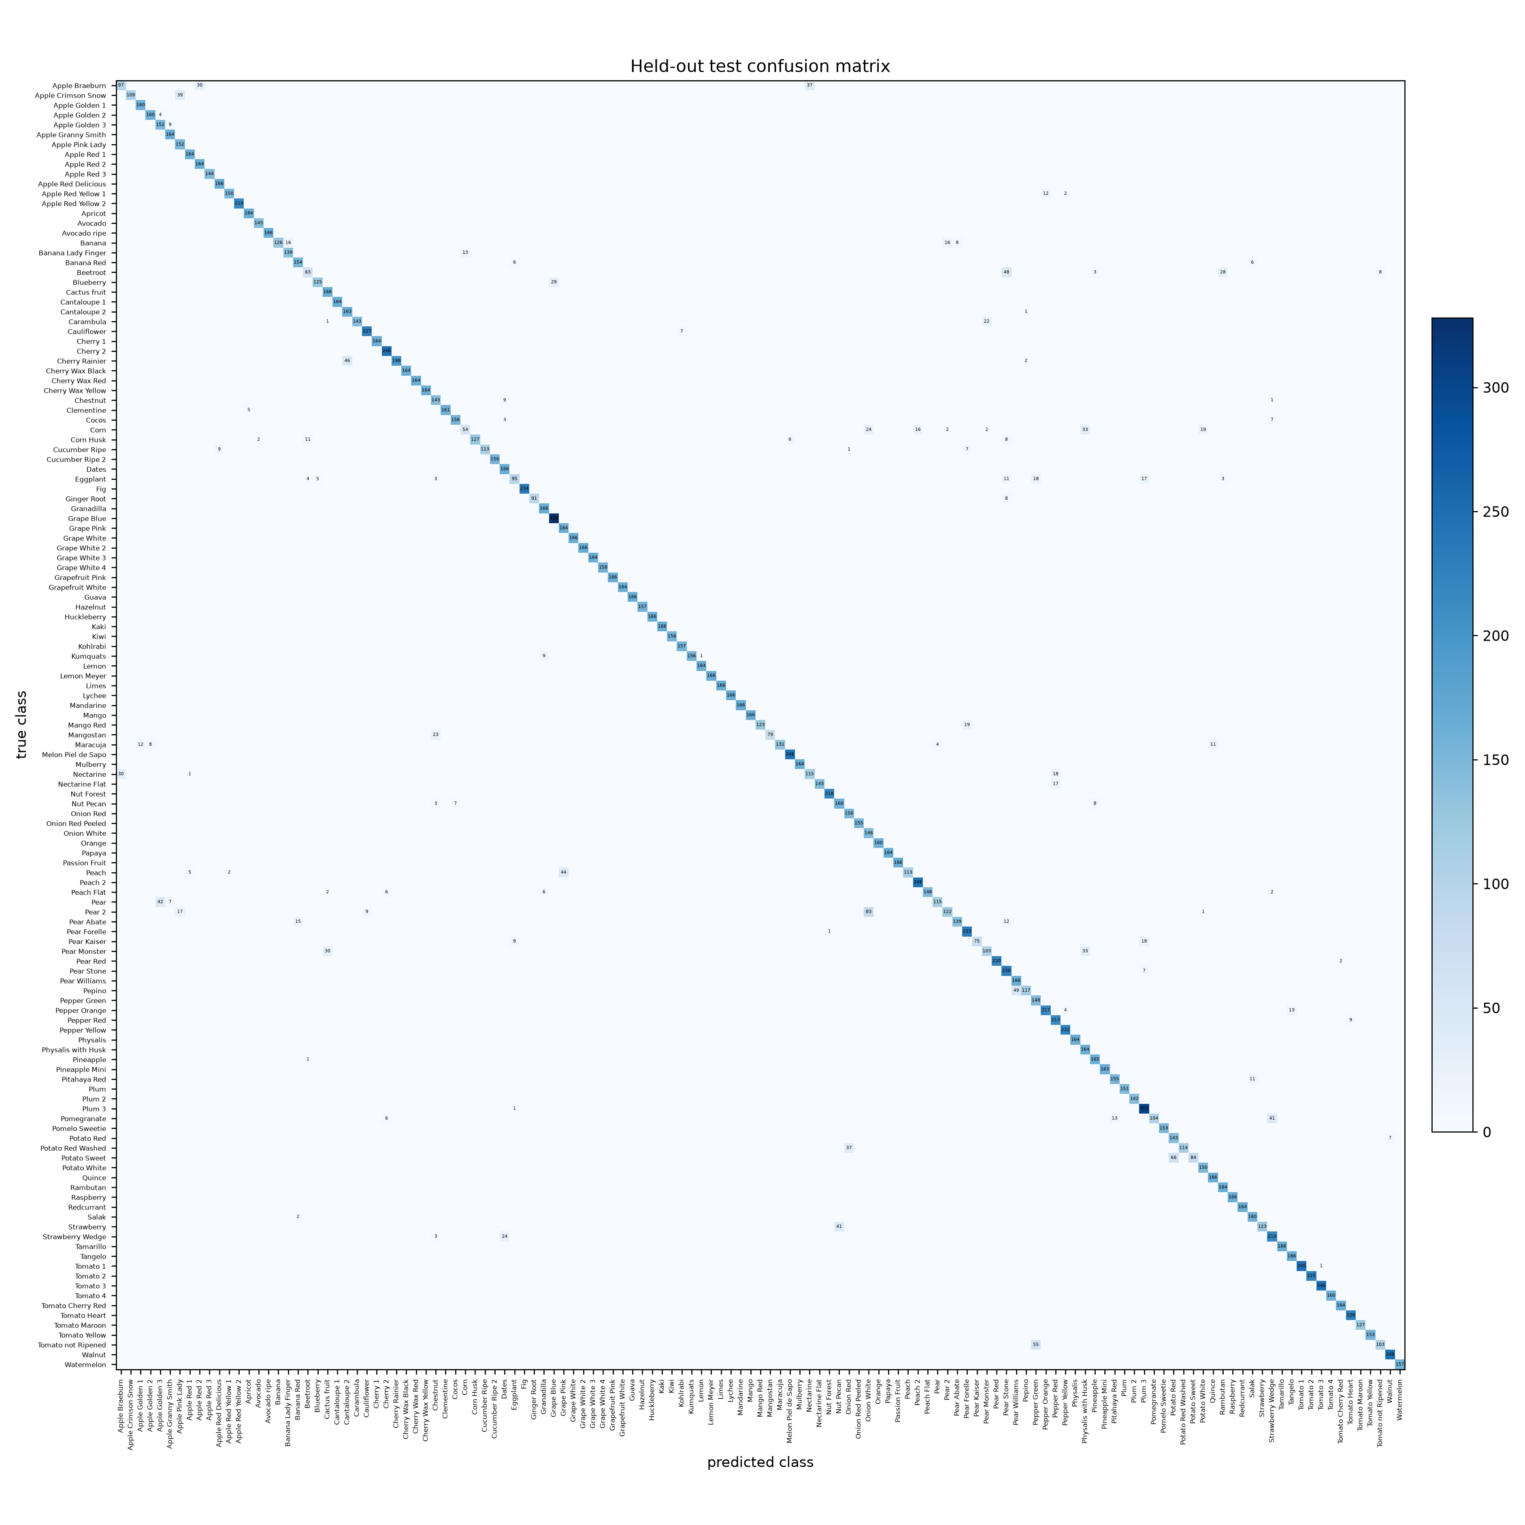
Rows are true classes and columns are predicted classes, in the exact scope.classes order in summary.json.

