Software Requirements Specification
for
Public Grievance Redressal System

Platform
Version 1.0 Approved
Prepared by Adhikesavan K
15-10-2026
Table of Contents
1. Introduction 3
1.1 Purpose 3
1.2 Document Conventions 3
1.3 Intended Audience and Reading Suggestions 3
1.4 Product Scope 3
1.5 References 4
2. Overall Description 4
2.1 Product Perspective 4
2.2 Product Functions 4
2.3 User Classes and Characteristics 5
2.4 Operating Environment 10
2.5 Design and Implementation Constraints 10
2.6 User Documentation 10
2.7 Assumptions and Dependencies 11
3. External Interface Requirements 11
3.1 User Interfaces 11
3.2 Hardware Interfaces 11
3.3 Software Interfaces 12
3.4 Communications Interfaces 12
4. System Features 12
4.1 User Authentication and Role-Based Access Control 12
4.2 Grievance Submission 13
4.3 Grievance Tracking 13
4.4 Officer Grievance Management 13
4.5 Administrative Management 14
4.6 Feedback and Rating System 14
5. Other Nonfunctional Requirements 15
5.1 Performance Requirements 15
5.2 Safety Requirements 15
5.3 Security Requirements 15
5.4 Software Quality Attributes 15
5.5 Business Rules 16
6. Other Requirements 16
6.1 Database Requirements 16
6.2 Internationalization Requirements 16
6.3 Legal and Regulatory Requirements 16
6.4 Accessibility Requirements 16
Appendix A: Glossary 16
Appendix B: Analysis Models 17
Appendix C: To Be Determined List 26
Revision History
Name | Date | Reason For Changes | Version

1. Introduction

1.1 Purpose
This Software Requirements Specification (SRS) defines the functional and non-functional requirements of the Public Grievance Redressal System (PGRS), Version 1.0. The PGRS is a standalone, web-based application that replaces existing manual grievance handling, which relies on paper forms, telephone calls, emails, and fragmented complaint records. The document covers the complete system scope, including grievance submission, tracking, officer assignment, resolution workflows, and administrative reporting, and serves as the primary reference for design, development, testing, and validation.

1.2 Document Conventions
This document follows the IEEE Std 830-1998 standard for Software Requirements Specifications. The following conventions apply:
- SHALL denotes mandatory requirements; SHOULD denotes recommended features.
- Functional requirements are identified as FR-XX and non-functional requirements as NFR-XX.
- Section headings follow a hierarchical decimal numbering system; bold text highlights critical terms and definitions.
- User roles (Citizen, Officer, Department Head, and Administrator) are identified explicitly throughout the document.
- Higher-level requirements propagate their priority levels to their child requirements unless stated otherwise.
- Dates, grievance records, and citizen information follow a standardized format to ensure consistency and ease of maintenance.

1.3 Intended Audience and Reading Suggestions
This SRS is intended for the following audiences:
- Software Developers and Engineers - design and implement the PGRS modules; read all sections.
- Project Managers - plan and track the project; focus on Sections 1, 2, and 5.
- System Testers and QA Engineers - verify that the system meets the specified requirements; focus on Sections 3 and 4.
- Government Officials and Stakeholders - policymakers and department heads who need to understand system capabilities; read Sections 1, 2, and 4.
- Database Administrators - responsible for schema design and management; focus on the data requirements in Section 4.
- Citizens - end users who submit grievances, check status, and view resolution history; focus on Section 4.
All readers should begin with Sections 1 and 2 before proceeding to the sections relevant to their role.

1.4 Product Scope
The PGRS is a full-featured, role-based web application that digitizes and streamlines grievance operations for government departments, municipalities, and public service organizations. It replaces manual, paper-based complaint processes with a centralized, secure, and efficient platform that enables fast grievance registration, transparent status tracking, and accountable resolution by government officers. Key objectives include:
- Providing a unified platform for citizens and government officers to manage grievances.
- Enabling real-time tracking of complaint status and resolution timelines.
- Automating grievance assignment, escalation, and reporting workflows.
- Generating insightful administrative reports for department heads and administrators.
- Supporting future integration with SMS gateways, government portals, and mobile applications.

1.5 References
- IEEE Std 830-1998, "IEEE Recommended Practice for Software Requirements Specifications," IEEE, 1998.
- Sommerville, I., "Software Engineering," 10th Edition, Pearson Education, 2015.
- Pressman, R. S., "Software Engineering: A Practitioner's Approach," 8th Edition, McGraw-Hill, 2014.
- PostgreSQL Documentation, PostgreSQL Global Development Group, https://www.postgresql.org/docs/; Supabase Documentation, https://supabase.com/docs.
- React.js Documentation, Meta Open Source, https://reactjs.org/docs/.
- Node.js Documentation, OpenJS Foundation, https://nodejs.org/en/docs/.
- Express.js API Reference, https://expressjs.com/en/api.html.

2. Overall Description

2.1 Product Perspective
The PGRS is a new, standalone web application that replaces the physical registers, disconnected email chains, and ad-hoc tracking spreadsheets currently used by government departments to manage citizen complaints. It integrates all grievance-related activities into a single platform accessible through modern web browsers.
The React.js frontend provides dedicated dashboards for citizens, officers, department heads, and administrators. It communicates with a Node.js/Express.js backend that exposes a RESTful API and persists data in a centralized Supabase PostgreSQL database. The architecture consists of a client layer (web browser), an application layer (React.js and Node.js/Express.js), and a data layer (Supabase PostgreSQL); see Appendix B.1. The system is standalone but can be extended in the future to integrate with SMS gateways, government portals, and mobile applications.

2.2 Product Functions
The PGRS shall provide the following major functions:
- User Authentication and Role-Based Access Control - secure login with role-specific permissions for Citizens, Officers, Department Heads, and Administrators.
- Grievance Submission - complaint registration with category selection, description, document attachments, and location details.
- Grievance Tracking - real-time status monitoring by citizens through a self-service portal.
- Officer Assignment and Workflow Management - assignment of grievances to appropriate officers by administrators and department heads, based on department and category.
- Resolution and Feedback - status updates, resolution notes, and closure by officers; feedback and ratings by citizens.
- Escalation Management - automatic escalation of unresolved grievances that exceed defined SLA timelines.
- Notification System - automated email and in-app notifications for submission, assignment, status updates, and resolution.
- Report Generation - daily, weekly, and monthly reports on grievance volumes, resolution rates, officer performance, and department-wise analytics.
- Audit Trail - a complete, immutable log of all actions performed on each grievance.

2.3 User Classes and Characteristics
The PGRS serves four distinct user classes: Administrator, Department Head, Government Officer, and Citizen. The use cases of each class are consolidated into a single use case description per user class, presented with the corresponding use case diagram.
1) ADMIN
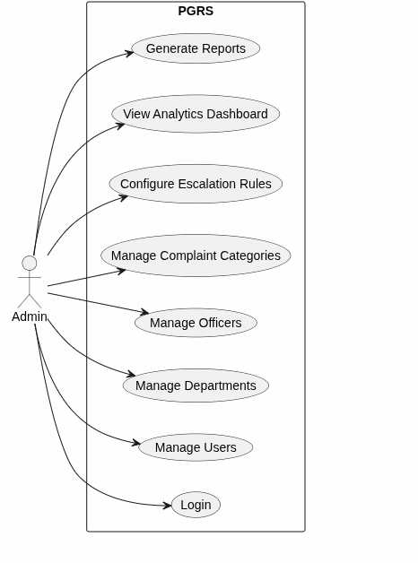
Figure 2.1: Use Case Diagram – Administrator
Use Case: Administrator Login and System Administration (UC-01 to UC-08)
Primary Actor: Administrator
Secondary Actor: System
Precondition:
- Administrator account is registered and active.
- Administrator is logged in with administrative and configuration privileges (for UC-02 to UC-08).
- Departments are available for officer management.
Postcondition:
- Administrator is authenticated and granted access to the administrative dashboard.
- User, department, officer, and complaint category/sub-category records are created, updated, activated, or deactivated.
- Escalation rules are configured and applied to grievance processing.
- Analytics are displayed and the requested report is generated.
Trigger:
- Administrator enters the login credentials and then selects an administrative option: Manage Users, Manage Departments, Manage Officers, Manage Complaint Categories, Configure Escalation Rules, Analytics Dashboard, or Generate Reports.
Main Access Scenario:
- Administrator opens the login page and enters username/email and password; System validates the credentials, role, and account status, creates a session, and opens the administrative dashboard.
- Manage Users: Administrator opens User Management, adds, updates, activates, or deactivates a user and enters the user information and role; System validates it, updates the record, and confirms.
- Manage Departments: Administrator adds or modifies department details; System checks for duplicates, saves, and updates the department list.
- Manage Officers: Administrator adds or modifies officer details and assigns the officer to a department; System verifies the account is unique and updates the officer's department and status.
- Manage Complaint Categories: Administrator adds or modifies categories and sub-categories and links them to a department if required; System checks for duplicates and updates the categories available for submission.
- Configure Escalation Rules: Administrator selects the department, category, priority, or stage, sets the escalation conditions (e.g., maximum response or resolution time) and the escalation level or authority, and clicks Save Rule; System validates, stores, and applies the rule.
- View Analytics Dashboard: System calculates total, resolved, pending, and escalated grievances and resolution rates and shows charts and statistics; Administrator applies filters (department, category, priority, status, date range).
- Generate Reports: Administrator selects the report type and filters and clicks Generate Report; System summarizes the data, displays the report, and Administrator downloads or prints it
- System records each administrative action and displays a confirmation message.
Exception Scenario:
- Incorrect username/email or password; account inactive or blocked; login fields missing.
- Required information missing or invalid; selected user or department does not exist.
- Duplicate email, mobile number, department, officer, or category.
- Department or category cannot be removed because it is linked to active grievances or officers.
- Invalid or negative time limits, or conflicting escalation rules.
- No data for the selected period or criteria; invalid date range or filter; dashboard retrieval or report generation fails.
- Database or server error occurs.
2) DEPARTMENT HEAD
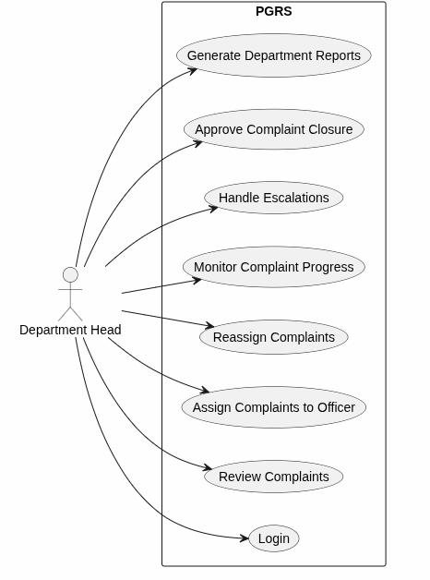
Figure 2.2: Use Case Diagram – Department Head
Use Case: Department Head Login and Complaint Management (UC-09 to UC-16)
Primary Actor: Department Head
Secondary Actor: System
Precondition:
- Department Head account is registered and active.
- Department Head is logged in and complaints exist for the department.
- Active officers are available for assignment or reassignment.
- For closure approval, the assigned officer has completed the resolution.
Postcondition:
- Department Head is authenticated and granted access to the department dashboard.
- Complaints are reviewed, assigned, or reassigned to an eligible officer.
- Complaint progress is displayed and escalated complaints receive corrective action.
- Closure is approved and the complaint status is updated to Closed.
- The requested department report is generated.
Trigger:
- Department Head enters the login credentials and then selects Review Complaints, Assign Complaint, Reassign Complaint, Monitor Complaint Progress, Escalations (or a complaint reaches an escalation condition), a complaint submitted for closure approval, or Generate Department Reports.
Main Access Scenario:
- Department Head opens the login page and enters username/email and password; System validates the credentials, role, and account status, creates a session, and opens the department dashboard.
- Review Complaints: Department Head opens the Complaints module and selects a complaint; System shows the description, category, priority, attachments, citizen details, and date; Department Head verifies it belongs to the department and decides the action.
- Assign Complaints: Department Head selects a pending complaint, chooses an active Government Officer, sets or confirms the priority, and clicks Assign; System updates the complaint, records it in the history, and notifies the officer.
- Reassign Complaints: Department Head selects an assigned complaint, chooses a new eligible officer with a reason, and clicks Reassign; System records the previous and new officer and notifies the new officer.
- Monitor Complaint Progress: Department Head views status, officer, priority, and due date, opens the status history, and filters pending, in-progress, resolved, and overdue complaints to identify delayed ones.
- Handle Escalations: System identifies complaints that exceeded the configured time; Department Head reviews the reason and previous actions, instructs the officer, reassigns, or forwards the complaint, and enters remarks; System updates the escalation status and notifies the concerned party.
- Approve Complaint Closure: Department Head reviews the resolution remarks and evidence and selects Approve Closure; System updates the status to Closed, records the approval, and notifies the citizen.
- Generate Department Reports: Department Head selects the report type and filters (date range, category, officer, status, priority) and clicks Generate Report; System displays the report for download or printing.
- System records each action in the complaint history.
Exception Scenario:
- Incorrect username/email or password; account inactive or blocked; login fields missing.
- No complaints available; complaint details or status history cannot be retrieved; complaint belongs to another department.
- No active or eligible officer; selected officer inactive; complaint already assigned or cannot be reassigned due to its status.
- No escalated complaints, or no suitable officer or authority for further action.
- Resolution information or evidence is incomplete, or the complaint is not eligible for closure; Department Head rejects the closure and returns it to the officer.
- No records for the criteria, or invalid date range or filter; report generation fails.
- Database or server error occurs.
3) GOVERNMENT OFFICER
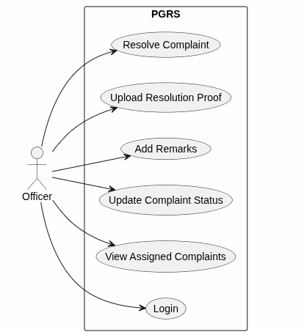
Figure 2.3: Use Case Diagram – Officer
Use Case: Officer Login and Complaint Resolution (UC-17 to UC-22)
Primary Actor: Officer
Secondary Actor: System
Precondition:
- Officer account is registered and active.
- Officer is logged in and the complaint is assigned to the Officer.
- Required resolution information is available for resolving a complaint.
Postcondition:
- Officer is authenticated and granted access to the officer dashboard.
- Assigned complaints are displayed with current details and status.
- Status updates, remarks, and resolution proof are stored and recorded in the complaint history.
- Complaint is marked Resolved and submitted to the Department Head for closure approval.
Trigger:
- Officer enters the login credentials and then selects View Assigned Complaints, Update Complaint Status, Add Remarks, Upload Resolution Proof, or Resolve Complaint.
Main Access Scenario:
- Officer opens the login page and enters username/email and password; System validates the credentials, role, and account status, creates a session, and opens the officer dashboard.
- View Assigned Complaints: Officer opens the Assigned Complaints module; System lists complaint ID, category, priority, status, and date; Officer opens a complaint and reviews the description, attachments, citizen information, and previous updates.
- Update Complaint Status: Officer selects Update Status, chooses the status and adds a note if required; System validates the transition, updates the status, records the previous and new status with the date and time, and notifies the citizen when applicable.
- Add Remarks: Officer enters investigation or action remarks and clicks Submit; System stores them with the complaint and records the date, time, and Officer information.
- Upload Resolution Proof: Officer selects a document, image, or other file; System validates the format and size, stores the file, links it to the complaint, and confirms the upload.
- Resolve Complaint: Officer performs the corrective action, adds resolution remarks and proof, and selects Resolve Complaint; System validates them, updates the status to Resolved or Closure Pending, records the resolution, forwards the complaint to the Department Head, and notifies the relevant users.
Exception Scenario:
- Incorrect username/email or password; account inactive or blocked; login fields missing.
- No complaints assigned; complaint does not belong to the Officer; complaint details cannot be retrieved.
- Invalid status transition; required status or resolution remarks missing.
- Remarks field empty, too long, or invalid; Officer lacks access or permission.
- Unsupported file format, file too large, or upload incomplete or corrupted.
- Resolution proof not uploaded when required, or complaint not eligible for resolution.
- Database, server, or storage error occurs.
4) CITIZEN
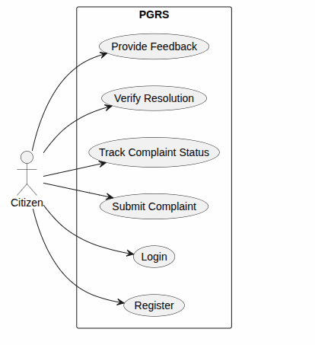
Figure 2.4: Use Case Diagram – Citizen
Use Case: Citizen Registration and Complaint Lifecycle (UC-23 to UC-28)
Primary Actor: Citizen
Secondary Actor: System
Precondition:
- Citizen does not have an existing account (for registration), or the account is registered, verified, and active.
- Citizen is logged in.
- For tracking, at least one complaint has been submitted.
- For verification and feedback, the complaint has been marked resolved by the Officer and is eligible.
Postcondition:
- Citizen account is created and the Citizen is authenticated to the citizen dashboard.
- Complaint is stored with a unique Complaint ID and its current status and progress are displayed.
- Verification decision and feedback rating are recorded with the complaint.
Trigger:
- Citizen selects Register, or enters the login credentials and then selects Submit Complaint, Track Complaint Status, Verify Resolution, or Provide Feedback.
Main Access Scenario:
- Register: Citizen enters personal information, a valid email or mobile number, and a password and clicks Register; System validates and checks for duplicates, creates the account, and redirects to login.
- Login: Citizen enters email/mobile number and password; System validates the credentials and account status, creates a session, and opens the citizen dashboard.
- Submit Complaint: Citizen enters the title, description, department, category, location or details, and optional attachments and clicks Submit; System validates, generates a unique Complaint ID, stores the complaint with its initial status, and confirms.
- Track Complaint Status: Citizen selects a complaint; System shows the status, progress, assigned department and officer, status history, and important dates.
- Verify Resolution: Citizen reviews the resolution details and proof of a resolved complaint and confirms it or indicates further action is required; System records the decision and forwards the complaint for closure or reopens it per the configured workflow.
- Provide Feedback: Citizen rates the resolution, adds optional comments, and clicks Submit Feedback; System stores them with the complaint and confirms.
Exception Scenario:
- Required information missing or invalid; invalid email or mobile number; email or mobile number already registered; password violates security rules.
- Incorrect email/mobile number or password; account inactive or blocked; login fields missing.
- Unsupported or oversized attachment; selected department or category unavailable.
- No complaints available; complaint does not belong to the Citizen or cannot be retrieved.
- Complaint not marked resolved, or Citizen not authorized; resolution proof unavailable.
- Verification or feedback already submitted; complaint not eligible for feedback; invalid rating or incomplete feedback.
- Database, server, or network error occurs.

2.4 Operating Environment
The PGRS shall operate in the following environment:
- Client Side: Google Chrome v100+, Mozilla Firefox v100+, Microsoft Edge v100+, or Safari v15+ on Windows 10/11, macOS 12+, or Ubuntu 20.04+. A minimum screen resolution of 1280x720 is recommended; the UI must also be responsive for tablet and mobile devices.
- Server Side: Node.js v18+ with Express.js on a Linux-based server (Ubuntu 22.04 LTS recommended). Minimum: 4-core CPU, 8 GB RAM, 100 GB SSD storage.
- Database: PostgreSQL hosted on Supabase (managed cloud database service).
- Frontend: React.js v18+ built with Vite, served via Nginx or Apache.
- Network: Stable internet connection with minimum 10 Mbps bandwidth; LAN deployment is also supported for intranet use.
- Security: HTTPS with TLS 1.2+ is mandatory for all client-server communication.

2.5 Design and Implementation Constraints
- Technology Stack: React.js (frontend), Node.js with Express.js (backend), and PostgreSQL hosted on Supabase (database), as used in the implemented system.
- Security Compliance: Passwords must be hashed using bcrypt; role-based access control (RBAC) must be enforced at the API level; JWT (JSON Web Tokens) shall be used for session management.
- Data Privacy: Citizen personal data must be handled in accordance with applicable government data protection regulations and privacy policies.
- Browser Compatibility: The UI must be fully functional and responsive on all modern browsers without relying on browser-specific APIs.
- Database Design: All tables must follow Third Normal Form (3NF) to eliminate data redundancy.
- API Design: Backend endpoints must follow RESTful conventions with standardized JSON responses.
- Performance: The system must support at least 200 concurrent users without performance degradation.
- Academic Context: The system is developed as a college academic project and must be fully demonstrable in a local development environment.

2.6 User Documentation
The following documentation shall be delivered with the PGRS software, in PDF format, and made accessible from the administrator dashboard:
- User Manual - guide covering all modules and workflows for each user role.
- Administrator Guide - system setup, user management, database backup, department configuration, and category management.
- Quick Reference Cards - single-page role-specific cheat sheets for Citizens, Officers, and Department Heads.
- Online Help System - context-sensitive help available through a Help button on each page.
- Installation Guide - step-by-step setup of development and production environments, including database initialization scripts.

2.7 Assumptions and Dependencies
Assumptions
- Government staff users have basic computer literacy and access to a web-enabled device.
- The government office has a stable internet or local area network (LAN) connection at all workstations.
- Citizen identity information submitted during registration is accurate and self-declared.
- The Supabase PostgreSQL database service is available 24/7 with appropriate backup mechanisms in place.
Dependencies
- Backend services depend on Node.js v18+ and the npm package ecosystem.
- The frontend depends on React.js v18+ and associated libraries, including React Router and Axios.
- Database operations depend on Supabase PostgreSQL and the Sequelize ORM.
- PDF generation for acknowledgment receipts and reports depends on the PDFKit or jsPDF library.
- Authentication depends on the jsonwebtoken (JWT) npm package.
- Email notifications depend on an SMTP service such as Nodemailer with Gmail or SendGrid.
- Future SMS notification integration will depend on a third-party SMS gateway API such as Twilio or MSG91.

3. External Interface Requirements

3.1 User Interfaces
- Citizen Portal: Accessible web interface for registration, login, grievance submission, status tracking, history, and feedback. Available in English and compliant with WCAG 2.1 accessibility guidelines.
- Officer Dashboard: Task-centric view of assigned grievances with priority indicators, action buttons for status updates and notes, and access to citizen-submitted documents.
- Department Head Dashboard: Management view of department-wide grievance statistics, officer workload, SLA compliance indicators, and escalation alerts.
- Administrator Console: Administrative interface for user management, department and category configuration, system-wide reports, and audit log viewing.
- Common UI Elements: Every screen includes a consistent navigation bar, role-based menu, notification bell, user profile icon, logout button, and Help link. Error messages are clear, user-friendly, and displayed inline near the relevant field.
- Responsive Design: The UI is responsive across desktop, tablet, and mobile screen sizes using a mobile-first CSS framework.

3.2 Hardware Interfaces
The PGRS does not interface directly with specialized hardware. Standard hardware interfaces include:
- Web-enabled client devices (desktops, laptops, tablets, smartphones) communicating with the server over HTTPS.
- Server hardware running Ubuntu 22.04 LTS with minimum 4-core CPU, 8 GB RAM, and 100 GB SSD storage.
- Network interface cards supporting standard TCP/IP communication.
- Optional: document scanners for digitizing physical complaint documents, accessed through browser-based file upload.

3.3 Software Interfaces
The PGRS shall interface with the following software components:
Software Component | Version | Interface Description
PostgreSQL Database (Supabase) | Managed service | Persistent storage for grievance records, user profiles, audit logs, and configuration data.
Node.js / Express.js | 18+ / 4.x | Backend application server providing RESTful API endpoints for all PGRS operations.
React.js | 18+ | Frontend SPA framework for all user-facing dashboards and portals.
Sequelize ORM | 6.x | Object-relational mapping layer for PostgreSQL database operations.
Nodemailer | Latest | SMTP-based email notification service for grievance updates.
JWT (jsonwebtoken) | Latest | Token-based authentication and session management.
PDFKit / jsPDF | Latest | PDF generation for acknowledgment receipts and reports.
Nginx / Apache | Latest stable | Web server for serving the React.js build and reverse-proxying API requests.

3.4 Communications Interfaces
- HTTPS Protocol: All client-server communication shall use HTTPS with TLS 1.2 or higher; HTTP requests shall be automatically redirected to HTTPS.
- RESTful API: The backend shall expose RESTful endpoints returning JSON responses with standard HTTP status codes (200 OK, 201 Created, 400 Bad Request, 401 Unauthorized, 403 Forbidden, 404 Not Found, 500 Internal Server Error).
- Email Notifications: Transactional emails shall be sent via SMTP (port 587 with STARTTLS) using Nodemailer, with templates for grievance acknowledgment, status updates, resolution notices, and escalation alerts.
- Future SMS Integration: The architecture shall support future integration with SMS gateway APIs (e.g., Twilio, MSG91) for acknowledgment and status update messages to registered mobile numbers.
- File Upload: The system shall support multipart/form-data uploads for grievance attachments (images, PDFs, documents), with a maximum of 5 MB per attachment and 3 attachments per grievance.

4. System Features

4.1 User Authentication and Role-Based Access Control

4.1.1 Description and Priority
This feature provides secure user authentication and enforces role-based access control across the PGRS. It is the foundation of the system's security architecture. Priority: High.

4.1.2 Stimulus/Response Sequences
- User enters credentials (email and password) on the login page. System validates them, generates a JWT token, and redirects the user to the role-specific dashboard.
- An unauthenticated user attempts to access a protected route. System intercepts the request, invalidates the session, and redirects to the login page with an appropriate message.
- Administrator creates a new officer account. System sends a welcome email with a temporary password and forces a password change on first login.
- User requests a password reset. System sends a time-limited reset link to the registered email address.

4.1.3 Functional Requirements
FR-01 | The system SHALL provide a secure login interface accepting registered email address and password.
FR-02 | The system SHALL hash all passwords using bcrypt with a minimum cost factor of 10 before storage.
FR-03 | The system SHALL issue a JWT access token upon successful authentication, valid for 8 hours.
FR-04 | The system SHALL enforce role-based access control (RBAC) at both the API and frontend route levels for the roles: Citizen, Officer, Department Head, and Administrator.
FR-05 | The system SHALL lock a user account for 15 minutes after 5 consecutive failed login attempts.
FR-06 | The system SHALL provide a password reset workflow via a time-limited (1-hour) email link.
FR-07 | The system SHALL log all authentication events (login, logout, failed attempts, password resets) in the audit trail.

4.2 Grievance Submission

4.2.1 Description and Priority
This feature allows registered citizens to submit grievances through the online portal, providing all information necessary for efficient processing and routing. Priority: High.

4.2.2 Stimulus/Response Sequences
- Citizen logs in and selects 'Submit Grievance'. System displays a structured complaint form with category selection.
- Citizen fills in the title, detailed description, category, sub-category, and location, and optionally uploads supporting documents. System validates the input and submits the grievance.
- System generates a unique Grievance Reference Number (GRN), stores the complaint, sends an acknowledgment email/notification, and displays the GRN to the citizen.

4.2.3 Functional Requirements
FR-08 | The system SHALL provide a multi-step grievance submission form with fields for: Title, Category, Sub-category, Department, Description (min 50 characters), Location/Address, and Supporting Documents.
FR-09 | The system SHALL auto-generate a unique Grievance Reference Number (GRN) in the format PGRS-YYYY-XXXXXX upon successful submission.
FR-10 | The system SHALL support document attachments (JPG, PNG, PDF) with a maximum size of 5 MB per file and a maximum of 3 files per grievance.
FR-11 | The system SHALL send an email acknowledgment to the citizen containing the GRN, submission timestamp, and expected resolution timeline upon grievance submission.
FR-12 | The system SHALL set the initial grievance status to 'Submitted' and record the submission timestamp.
FR-13 | The system SHALL allow a citizen to save a grievance as a draft before final submission.

4.3 Grievance Tracking

4.3.1 Description and Priority
This feature enables citizens to monitor the real-time status and progress of their submitted grievances through a transparent self-service portal. Priority: High.

4.3.2 Stimulus/Response Sequences
- Citizen navigates to 'My Grievances'. System displays all grievances submitted by the citizen with current status indicators.
- Citizen clicks a grievance. System displays the full detail view, including status timeline, officer notes, and resolution details if available.
- Citizen searches for a grievance by GRN or keyword. System filters and displays matching results.

4.3.3 Functional Requirements
FR-14 | The system SHALL provide a 'My Grievances' dashboard displaying all grievances submitted by the logged-in citizen with columns for GRN, Title, Category, Date, Status, and Actions.
FR-15 | The system SHALL display a real-time status timeline for each grievance showing: Submitted, Assigned, Under Investigation, Resolved, and Closed stages.
FR-16 | The system SHALL allow citizens to search and filter grievances by GRN, status, category, and date range.
FR-17 | The system SHALL allow citizens to download a PDF acknowledgment receipt for any submitted grievance.
FR-18 | The system SHALL allow citizens to add follow-up comments or additional information to an open grievance.

4.4 Officer Grievance Management

4.4.1 Description and Priority
This feature provides government officers with tools to view assigned grievances, investigate complaints, update resolution status, and communicate with citizens. Priority: High.

4.4.2 Stimulus/Response Sequences
- Officer logs in and views a dashboard of assigned grievances sorted by priority and due date.
- Officer opens a grievance, reviews citizen details and attachments, adds investigation notes, and updates the status to 'Under Investigation'.
- Officer resolves a grievance by updating the status to 'Resolved', adding a resolution note, and marking the case as closed. System notifies the citizen.
- Officer requests additional information from the citizen by adding a comment. System sends a notification to the citizen.

4.4.3 Functional Requirements
FR-19 | The system SHALL provide officers with a dashboard displaying all assigned grievances with priority flags, SLA countdown timers, and quick-action buttons.
FR-20 | The system SHALL allow officers to update the status of a grievance (Assigned, Under Investigation, Pending Information, Resolved, Closed).
FR-21 | The system SHALL allow officers to add internal notes (visible only to staff) and resolution notes (visible to citizen) for each grievance.
FR-22 | The system SHALL allow officers to request additional information from a citizen, placing the grievance in 'Pending Information' status.
FR-23 | The system SHALL notify the citizen via email and in-app notification upon any status change to their grievance.

4.5 Administrative Management

4.5.1 Description and Priority
This feature provides administrators and department heads with full control over grievance routing, user management, department configuration, and system-wide reporting. Priority: High.

4.5.2 Stimulus/Response Sequences
- Administrator creates a new officer account, assigns a department, and sets permissions. System sends a welcome email to the officer.
- Administrator or Department Head views newly submitted grievances and assigns them to available officers based on workload and expertise.
- Department Head views a grievance that has exceeded its SLA deadline. The system has already triggered an automatic escalation alert; the head manually re-assigns it to a senior officer.
- Administrator generates a monthly performance report and exports it as PDF.

4.5.3 Functional Requirements
FR-24 | The system SHALL allow administrators to create, edit, deactivate, and manage user accounts for all roles (Citizens, Officers, Department Heads).
FR-25 | The system SHALL allow administrators to configure departments, grievance categories, sub-categories, and SLA timelines.
FR-26 | The system SHALL allow administrators and department heads to assign or re-assign grievances to specific officers.
FR-27 | The system SHALL automatically escalate grievances that exceed their SLA deadline to the department head with an alert notification.
FR-28 | The system SHALL provide a report generation module supporting daily, weekly, and monthly reports on grievance volumes, resolution rates, SLA compliance, and officer performance, exportable as PDF or Excel.
FR-29 | The system SHALL maintain an immutable audit trail logging all user actions, status changes, and data modifications with timestamps and user identification.

4.6 Feedback and Rating System

4.6.1 Description and Priority
This feature allows citizens to provide feedback and rate the resolution of their grievances, enabling continuous improvement of government services. Priority: Medium.

4.6.2 Functional Requirements
FR-30 | The system SHALL allow citizens to rate resolved grievances on a 1-5 star scale and provide optional written feedback after a grievance is marked as 'Resolved'.
FR-31 | The system SHALL display aggregated satisfaction ratings for officers and departments on administrative dashboards.
FR-32 | The system SHALL allow citizens to reopen a resolved grievance within 7 days if they are not satisfied with the resolution.

5. Other Nonfunctional Requirements

5.1 Performance Requirements
NFR-01 | The system SHALL support a minimum of 200 concurrent users without performance degradation.
NFR-02 | All API responses SHALL be returned within 2 seconds under normal load conditions (less than 150 concurrent users).
NFR-03 | The system SHALL be capable of handling a minimum of 1,000 grievance submissions per day.
NFR-04 | Database query response times SHALL not exceed 500 milliseconds for standard read operations.
NFR-05 | The system SHALL achieve a minimum page load time of under 3 seconds on a standard 10 Mbps internet connection.

5.2 Safety Requirements
NFR-06 | The system SHALL perform automated daily database backups to a secure off-site or cloud storage location.
NFR-07 | The system SHALL provide data recovery capabilities allowing restoration to within the last 24 hours of data in the event of a system failure.
NFR-08 | The system SHALL display clear error messages to users without exposing internal system details, stack traces, or database information.

5.3 Security Requirements
NFR-09 | All communications between client and server SHALL use HTTPS with TLS 1.2 or higher.
NFR-10 | All passwords SHALL be stored as bcrypt hashes with a minimum cost factor of 10; plaintext passwords SHALL never be stored or logged.
NFR-11 | The system SHALL enforce role-based access control; users SHALL only access data and functions permitted by their role.
NFR-12 | The system SHALL implement input validation and sanitization on both the client and server side to prevent SQL injection, XSS, and CSRF attacks.
NFR-13 | JWT tokens SHALL have a maximum validity of 8 hours; refresh tokens SHALL be used for session extension with secure HTTP-only cookies.
NFR-14 | Personally Identifiable Information (PII) of citizens SHALL be encrypted at rest using AES-256.

5.4 Software Quality Attributes
Quality Attribute | Description
Availability | The system shall target 99.5% uptime during government working hours (8 AM - 8 PM). Planned maintenance shall be scheduled during off-peak hours.
Usability | The citizen portal shall be usable by individuals with basic computer literacy without requiring training. System workflows shall be completable within 3-5 clicks.
Maintainability | The codebase shall follow modular architecture principles. New departments and grievance categories shall be addable without code changes.
Scalability | The system architecture shall support horizontal scaling to accommodate increased load without significant refactoring.
Reliability | The system shall have a Mean Time Between Failures (MTBF) of at least 720 hours.
Portability | The application shall be deployable on any Linux-based server environment supporting Node.js v18+ and connectivity to a Supabase PostgreSQL database.
Testability | All API endpoints shall be testable via automated unit and integration test suites. Test coverage shall be a minimum of 70%.

5.5 Business Rules
- A citizen SHALL be required to register with a verified email address and mobile number before submitting a grievance.
- Each grievance SHALL be assigned to a single officer at any given time; re-assignment shall be logged in the audit trail.
- An officer SHALL not be able to close a grievance without entering a resolution note of at least 100 characters.
- Grievances SHALL be automatically escalated to the department head if not assigned within 2 business days of submission.
- Grievances SHALL be automatically escalated if not resolved within the configured SLA period (default: 15 working days).
- Citizens SHALL only have access to their own grievance records; cross-user data access is strictly prohibited.
- Deleted user accounts SHALL be anonymized; grievance records SHALL be retained for audit purposes per government data retention policies.

6. Other Requirements

6.1 Database Requirements
The PGRS database schema, implemented in PostgreSQL on Supabase, shall follow Third Normal Form (3NF) to eliminate data redundancy and shall represent the following key entities: Users, Grievances, GrievanceStatusHistory, Departments, Categories, SubCategories, Attachments, Notifications, AuditLogs, Feedback, and Comments. Foreign key constraints shall be enforced to maintain referential integrity, and all timestamps shall be stored in UTC.

6.2 Internationalization Requirements
PGRS Version 1.0 shall support an English-language interface. Unicode (UTF-8) encoding shall be used throughout to facilitate future multi-language support, and date and time formats shall be configurable per locale settings.

6.3 Legal and Regulatory Requirements
The PGRS shall comply with applicable government IT security policies and data protection regulations. Citizen data shall not be shared with third parties without explicit consent except as required by law. Grievance records shall be maintained for a minimum of 5 years in accordance with government record retention policies.

6.4 Accessibility Requirements
The citizen portal shall comply with WCAG 2.1 Level AA, including appropriate color contrast ratios, keyboard navigation support, and screen reader compatibility.

Appendix A: Glossary
Term / Acronym | Definition
PGRS | Public Grievance Redressal System - the web application described in this document.
GRN | Grievance Reference Number - unique identifier auto-generated for each submitted grievance (format: PGRS-YYYY-XXXXXX).
SLA | Service Level Agreement - the maximum time within which a grievance must be resolved, defined per category by administrators.
RBAC | Role-Based Access Control - a security model in which permissions are assigned to roles (Citizen, Officer, Department Head, Administrator) rather than individual users.
JWT | JSON Web Token - a compact, URL-safe token format used for authentication and session management.
RESTful API | Representational State Transfer Application Programming Interface - an architectural style for web services using standard HTTP methods.
ORM | Object-Relational Mapping - a technique for interacting with a relational database using object-oriented constructs (Sequelize is used in PGRS).
SRS | Software Requirements Specification - this document.
NFR | Non-Functional Requirement - a requirement specifying quality, performance, or operational criteria rather than specific behaviors.
FR | Functional Requirement - a requirement describing a specific behavior or function the system must perform.
PII | Personally Identifiable Information - data that can identify a specific individual, such as name, address, or mobile number.
WCAG | Web Content Accessibility Guidelines - international standards for making web content accessible to people with disabilities.
TLS | Transport Layer Security - cryptographic protocol ensuring secure network communication.
SMTP | Simple Mail Transfer Protocol - standard protocol for email transmission.

Appendix B: Analysis Models

B.1 System Architecture Overview
The PGRS follows a three-tier architecture:
- Presentation Layer: React.js web interface providing role-specific dashboards for Citizens, Government Officers, Department Heads, and Administrators.
- Application Layer: Node.js and Express.js REST API handling authentication, complaint processing, assignment, escalation, resolution, notifications, and report generation.
- Data Layer: Supabase PostgreSQL database managed through the Sequelize ORM, storing users, complaints, departments, categories, feedback, notifications, and related records.

B.2 Key Database Entities
Entity | Key Attributes
Users | user_id, name, email, password_hash, role, mobile, department_id, is_active, created_at
Departments | department_id, name, head_user_id, sla_days, is_active
Categories | category_id, name, department_id, is_active
Grievances | grievance_id, grn, title, description, category_id, department_id, citizen_id, officer_id, status, priority, created_at, resolved_at
GrievanceStatusHistory | history_id, grievance_id, changed_by, old_status, new_status, note, changed_at
Attachments | attachment_id, grievance_id, file_name, file_path, file_type, uploaded_by, uploaded_at
Feedback | feedback_id, grievance_id, citizen_id, rating, comment, submitted_at
Notifications | notification_id, user_id, message, date, is_read
Reports | report_id, report_type, generated_by, generated_at
AuditLogs | log_id, user_id, action, entity_type, entity_id, details, timestamp

B.3 Class Diagram
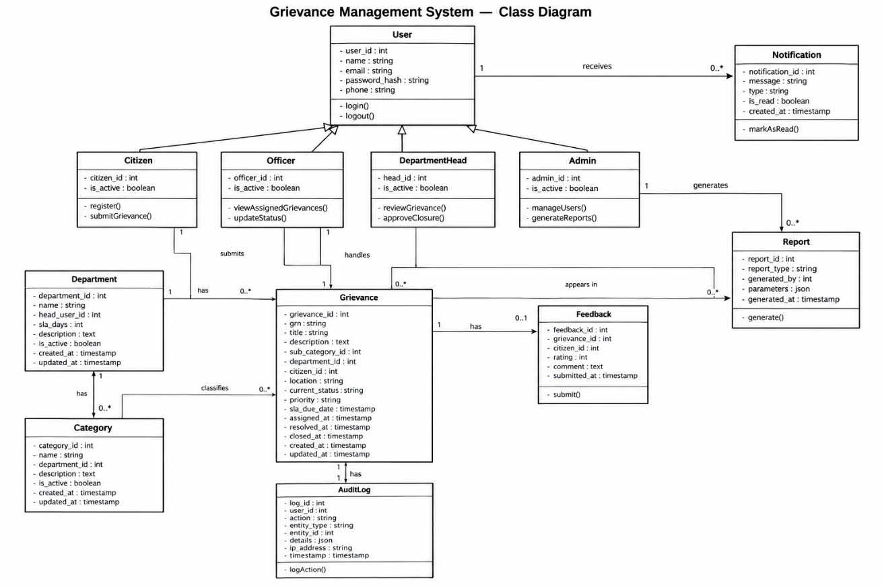
Figure B.3 Grievenace management system-class Diagram

B.3.1 Overview of Domain Model
The class diagram represents the structural model of the PGRS. A common User class supports authentication and role-based access, with specialized roles Citizen, Officer, Department Head, and Admin. The model also includes the Department, Category, Grievance, Feedback, Notification, Report, and AuditLog entities that support the complete grievance redressal workflow.

B.3.2 Class Dictionary and Data Definitions
Class Name | Responsibility | Key Attributes | Core Methods / Operations
User | Common authentication and user information for all roles. | userId, name, email, password, role | login(), logout()
Citizen | Submits complaints, tracks status, verifies resolutions, and provides feedback. | userId | submitComplaint(), trackComplaint(), verifyResolution(), provideFeedback()
Officer | Handles assigned complaints, updates status, adds remarks, and provides resolution proof. | userId, department | viewAssignedComplaints(), updateStatus(), addRemarks(), uploadResolutionProof(), resolveComplaint()
DepartmentHead | Reviews, assigns, reassigns, monitors, and handles escalated complaints within the department. | userId, department | reviewComplaints(), assignComplaint(), reassignComplaint(), monitorProgress(), handleEscalation(), approveClosure()
Admin | Manages users, departments, categories, escalation rules, analytics, and reports. | userId | manageUsers(), manageDepartments(), manageOfficers(), manageCategories(), configureEscalationRules(), viewAnalytics(), generateReports()
Department | Maintains department information and its associated complaints and officers. | departmentId, name, slaDays | manageDepartment()
Category | Classifies complaints under the appropriate department. | categoryId, name, departmentId | manageCategory()
Grievance | Stores complaint details and manages processing, assignment, and resolution status. | grievanceId, title, description, status, priority | submit(), assign(), updateStatus(), resolve()
GrievanceStatusHistory | Maintains the history of status changes made to a complaint. | historyId, oldStatus, newStatus, note, changedAt | recordStatusChange()
Attachment | Stores supporting documents and resolution proof associated with a complaint. | attachmentId, fileName, filePath, fileType | uploadAttachment()
Feedback | Stores citizen ratings and comments about the resolution. | feedbackId, rating, comment, submittedAt | submitFeedback()
Notification | Sends and records notifications related to complaint activities. | notificationId, message, date, isRead | sendNotification()
Report | Represents reports generated from complaint and departmental data. | reportId, reportType, generatedAt | generateReport()
AuditLog | Records important user and system actions for accountability and monitoring. | logId, action, entityType, entityId, timestamp | recordAction()

B.4 Activity Diagrams
The activity diagrams represent the main operational workflows of the PGRS, showing activity sequences, decision points, and interactions among Citizens, Government Officers, Department Heads, Administrators, and the PGRS web portal.

B.4.1 Citizen Complaint Submission and Resolution Workflow
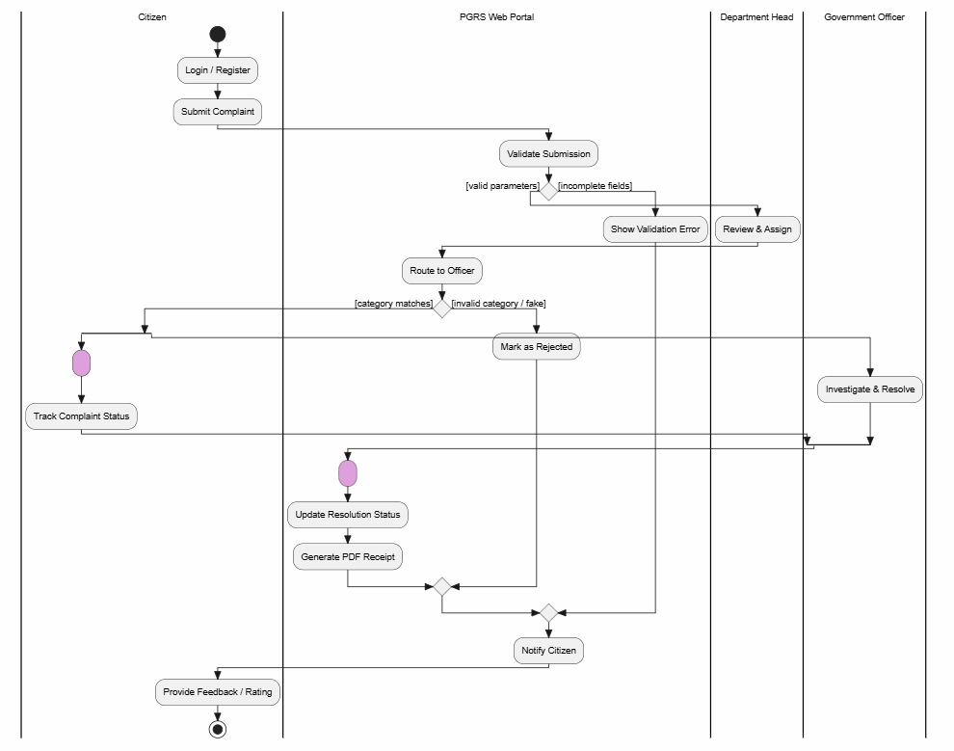

Figure B.4.1 Citizen Complaint Submission and Resolution Workflow

Behavioral Specifications
- Pre-conditions: The Citizen is registered and authenticated in the PGRS.
- Post-conditions: The complaint is recorded, processed by the concerned department, and its resolution status is updated.
Execution Sequence
- Citizen logs into the PGRS and submits a complaint with the required details.
- The system validates the complaint information and routes it to the appropriate department.
- The Department Head reviews and assigns the complaint to a Government Officer.
- The Government Officer investigates the complaint and updates its status.
- The officer uploads resolution proof after completing the required action.
- The system notifies the Citizen about the resolution.
- Citizen verifies the resolution and provides feedback or a rating.

B.4.2 Administrative Performance Reporting and SLA Escalation
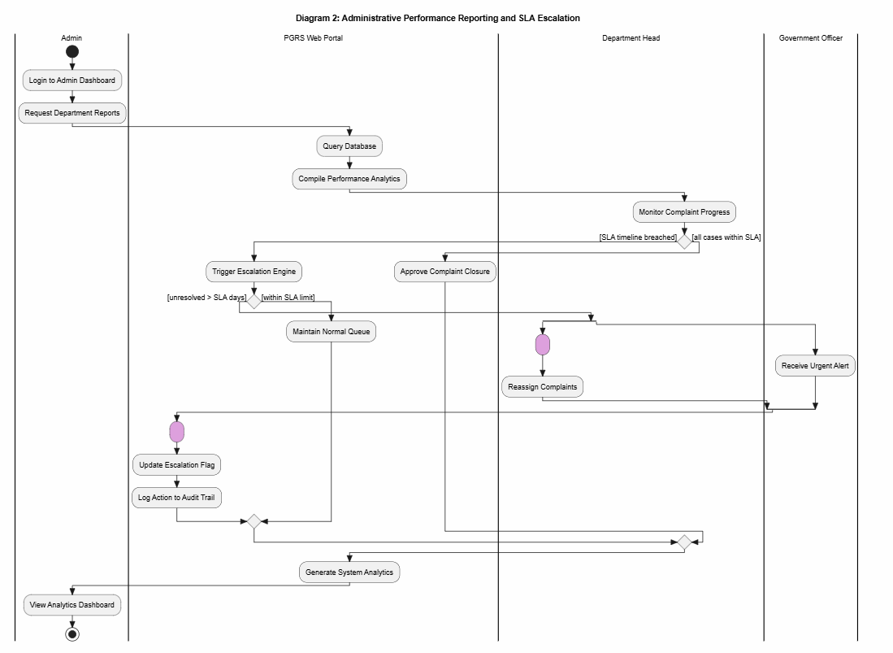

Figure B.4.2 Administrative Performance Reporting and SLA Escalation

Behavioral Specifications
- Pre-conditions: The Administrator is authenticated and complaint records are available.
- Post-conditions: Performance reports are generated and SLA-breached complaints are escalated.
Execution Sequence
- Administrator logs into the dashboard and requests department reports.
- The system retrieves complaint data and generates performance analytics.
- Department Head monitors the progress of complaints.
- The system checks whether complaints are within the defined SLA.
- If the SLA is exceeded, the system triggers escalation and updates the escalation status.
- The escalated complaint is reassigned or marked for urgent action.
- The system records the action in the audit trail and updates analytics.
- Administrator views the updated analytics dashboard.

B.4.3 Department Reassignment and Jurisdiction Dispute Resolution
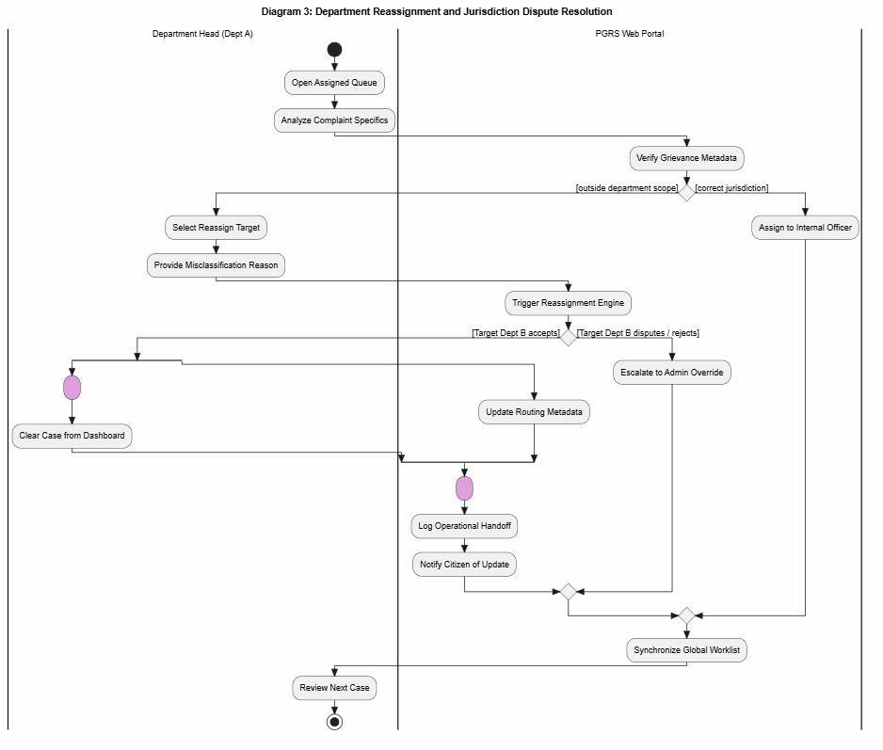

Figure B.4.3 Department Reassignment and Jurisdiction Dispute Resolution
Behavioral Specifications
- Pre-conditions: The Department Head is authenticated and has access to assigned complaints.
- Post-conditions: The complaint is assigned to the correct department or escalated for administrative resolution.
Execution Sequence
- Department Head opens the assigned complaint queue and reviews the complaint.
- The system verifies the complaint jurisdiction and metadata.
- If the complaint belongs to the current department, it is assigned to an internal officer.
- If it belongs to another department, the Department Head selects the reassignment target and provides a reason.
- The system triggers the reassignment process.
- If the target department accepts the complaint, the routing information is updated.
- If the target department rejects or disputes the reassignment, the complaint is escalated to the Administrator.
- The system records the handoff and notifies the Citizen about the update.

B.4.4 Citizen Verification and Grievance Evidence Auditing Workflow
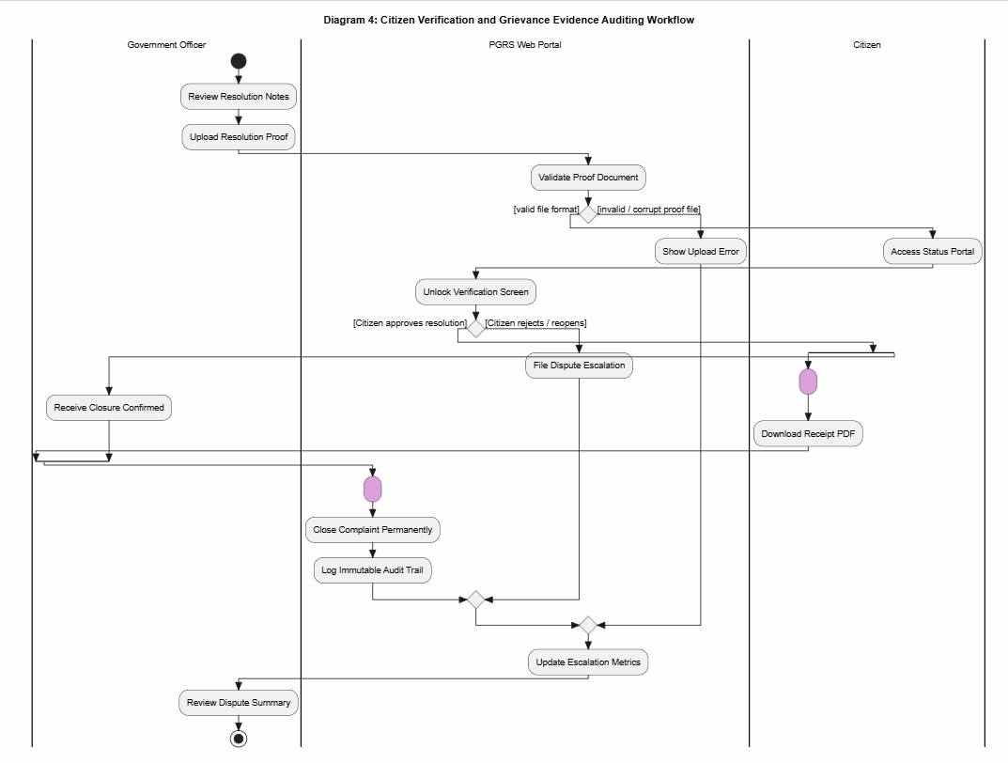
Figure B.4.4 Citizen Verification and Grievance Evidence Auditing Workflow

Behavioral Specifications
- Pre-conditions: The Government Officer has completed the complaint resolution and uploaded resolution proof.
- Post-conditions: The complaint is closed after successful verification or reopened for further action.
Execution Sequence
- Government Officer reviews the resolution details and uploads resolution proof.
- The system validates the uploaded proof document.
- If the document is invalid, the system displays an upload error.
- If the document is valid, the Citizen is allowed to review the resolution.
- Citizen verifies the resolution.
- If the Citizen accepts the resolution, the complaint is confirmed for closure.
- If the Citizen rejects the resolution, the complaint is reopened for further action.
- The system records the action in the audit trail and updates the relevant metrics.

B.5 Sequence Diagrams

B.5.1 Citizen Submitting a Grievance
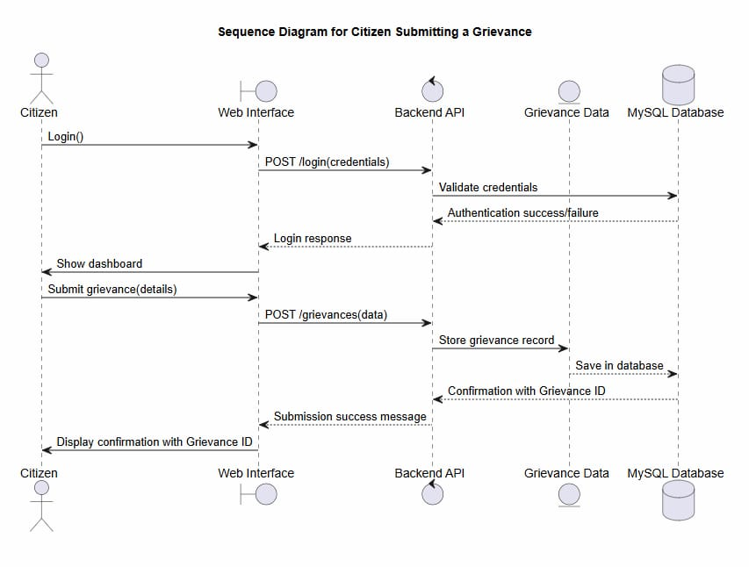

Figure B.5.1 Citizen Submitting a Grievance
Purpose: Illustrates the interaction when a Citizen submits a new grievance.
Participants: Citizen (initiating actor); Web Interface (login and submission); Backend API (authentication and submission requests); Grievance Data (the created grievance record); PostgreSQL Database (grievance and authentication data).
Execution Flow
- Trigger: The Citizen invokes login(credentials) through the Web Interface.
- Authentication: The Web Interface sends the credentials to the Backend API, which validates them using the PostgreSQL Database.
- Dashboard Response: After successful authentication, the system displays the Citizen dashboard.
- Grievance Submission: The Citizen invokes submitGrievance(details).
- Record Creation: The Backend API creates a new grievance record with the submitted details.
- Database Update: The grievance record is stored in the PostgreSQL Database.
- Confirmation: The database returns the generated Grievance ID to the Backend API.
- UI Response: The system displays a confirmation message with the Grievance ID.

B.5.2 Government Officer Resolving a Grievance
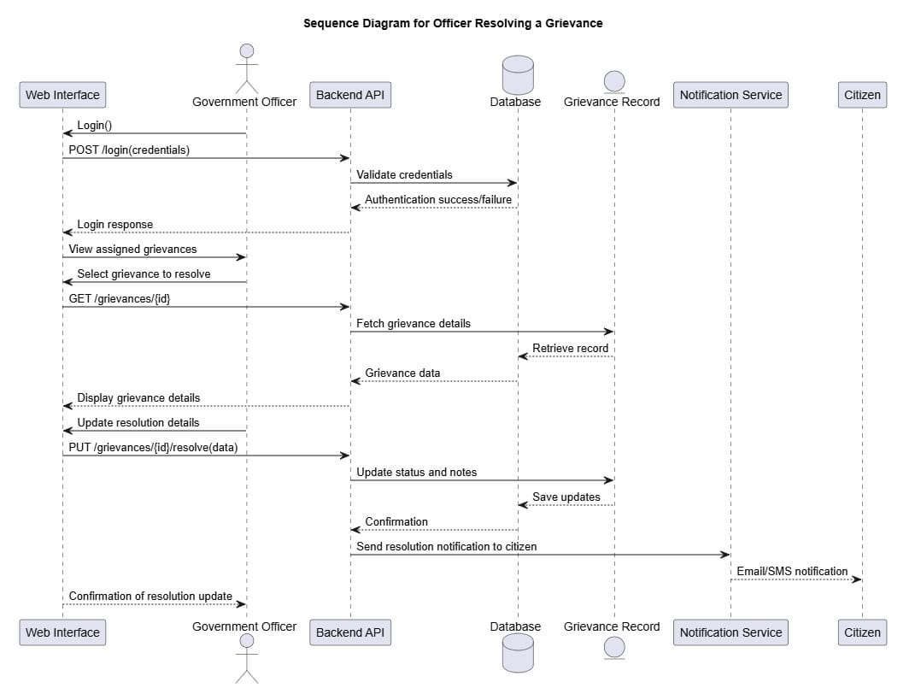

Figure B.5.2 Government Officer Resolving a Grievance
Purpose: Illustrates the interaction when a Government Officer reviews and resolves an assigned grievance.
Participants: Government Officer (processes the grievance); Web Interface; Backend API (retrieval and resolution requests); Database; Grievance Record; Notification Service (sends the resolution notification); Citizen (receives the notification).
Execution Flow
- Trigger: The Officer invokes login(credentials) through the Web Interface.
- Authentication: The Web Interface sends the credentials to the Backend API, which validates them using the Database.
- View Grievance: The Officer selects an assigned grievance to resolve.
- Data Retrieval: The Web Interface requests the grievance details from the Backend API.
- Record Fetch: The Backend API retrieves the grievance record from the Database.
- Display Details: The grievance information is displayed to the Officer.
- Resolution Update: The Officer invokes updateResolution(details) with the resolution information.
- Database Update: The Backend API updates the grievance status and resolution details in the Database.
- Confirmation: The system confirms that the resolution update was stored.
- Notification: The Backend API sends a resolution notification to the Citizen through the Notification Service.
- Final Response: The Web Interface displays confirmation of the resolution update to the Officer.

B.6 State Chart Diagram
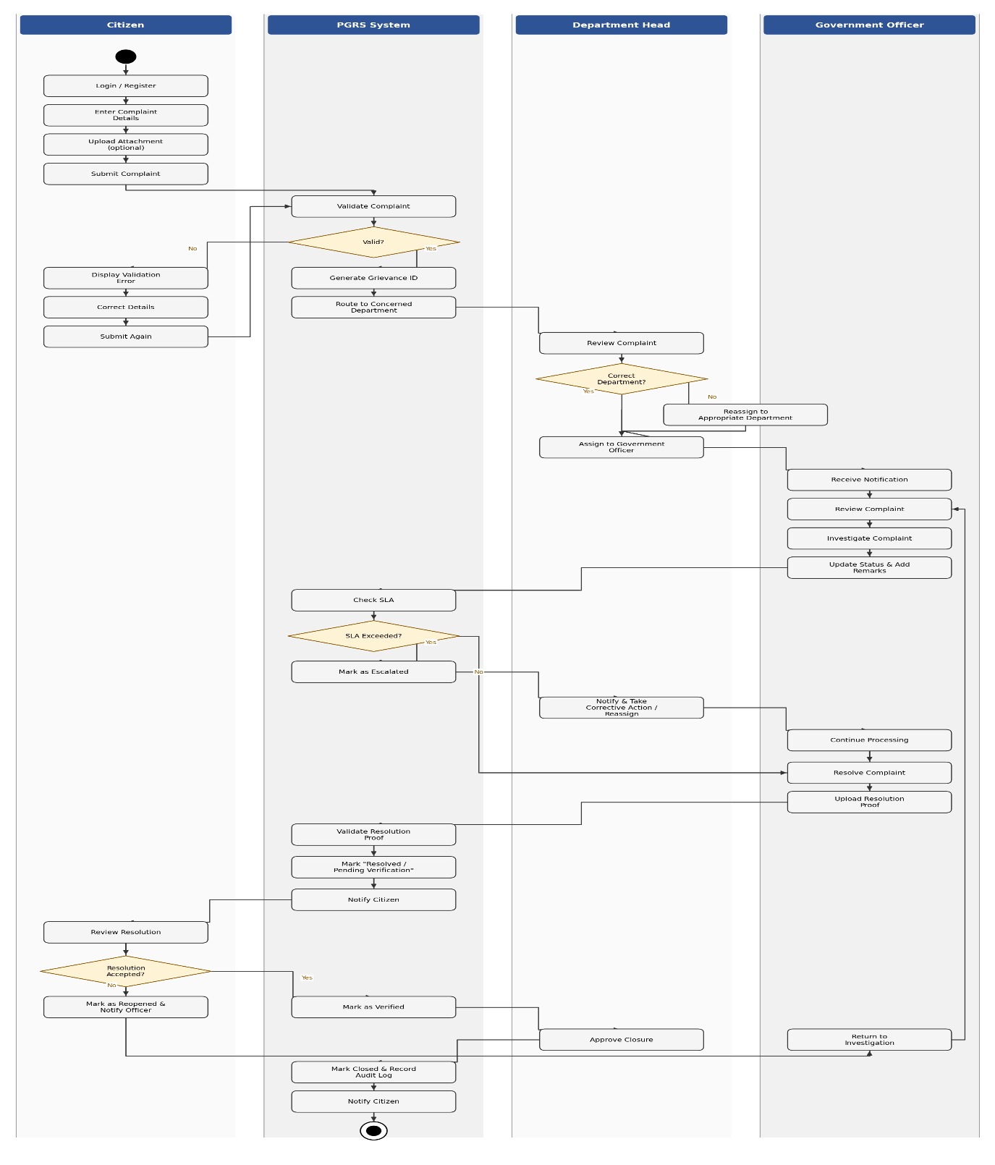
Figure B.6 State diagram
The state chart describes the major states and transitions of a grievance in the PGRS, from submission to final closure.
Primary States
Submitted | Citizen submits a grievance.
Under Review | Grievance is reviewed by the Department Head.
Assigned | Grievance is assigned to a Government Officer.
In Progress | Officer investigates and processes the grievance.
Escalated | Grievance is escalated when the SLA is exceeded.
Resolved | Officer completes the grievance and uploads resolution proof.
Pending Verification | Citizen reviews the resolution.
Reopened | Grievance is reopened if the citizen rejects the resolution.
Closed | Grievance is verified and approved for closure.
Behavioral Transition Logic
- Submission: The grievance moves from Submitted to Under Review to Assigned after validation and department assignment.
- Processing: The assigned officer investigates the grievance and moves it to In Progress.
- Escalation: If the SLA is exceeded, the grievance moves to Escalated and returns to processing after corrective action.
- Resolution: After investigation, the grievance moves to Resolved and then to Pending Verification.
- Verification and Closure: If the citizen accepts the resolution, the grievance moves to Closed. If rejected, it moves to Reopened and then back to In Progress for further action.

B.7 UML Component Diagram
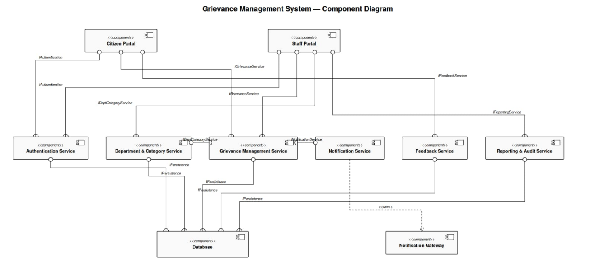
Figure B.7 Grievance Management System – component Diagram
The component diagram illustrates the high-level modular architecture of the PGRS and the interactions among its major software components, the database, and the notification gateway.

B.7.1 Components of the System
Component | Description
Citizen Portal | Grievance submission, tracking, verification, and feedback functions for citizens.
Staff Portal | Grievance review, assignment, processing, and monitoring functions for Government Officers and Department Heads.
Authentication Service | Handles user login, authentication, and role-based access.
Department & Category Service | Manages departments, complaint categories, and their associations.
Grievance Management Service | Handles grievance submission, assignment, status updates, resolution, and escalation.
Notification Service | Sends notifications to users about grievance updates and actions.
Feedback Service | Manages feedback submitted by citizens after grievance resolution.
Reporting & Audit Service | Generates reports and maintains audit records of system activities.
Database | Stores users, departments, categories, grievances, status history, attachments, feedback, notifications, reports, and audit logs.
Notification Gateway | External interface for delivering system notifications.

B.7.2 Actors and Component Interaction
The system supports four user roles: Citizen (submits grievances, tracks status, verifies resolutions, provides feedback); Government Officer (views assigned grievances, investigates, updates status, submits resolution proof); Department Head (reviews, assigns, reassigns, monitors, escalates, and approves closure); and Administrator (manages users, departments, categories, escalation rules, reports, and system records). The Citizen Portal is used mainly by citizens, while the Staff Portal is used by Government Officers and Department Heads; the Administrator accesses administrative functions through the staff-side application.

B.7.3 Interfaces and Connections
The component diagram uses the following interfaces and connectors:
- Authentication Interface - connects the portals with the Authentication Service.
- Grievance Service Interface - connects the portals with the Grievance Management Service.
- Department & Category Interface - provides department and category information.
- Notification Service Interface - connects the system with the Notification Service.
- Feedback Service Interface - handles citizen feedback.
- Reporting Service Interface - provides reporting and audit functions.
- Persistence Interface - connects system services with the Database.
- Notification Gateway Connection - allows the Notification Service to deliver notifications through the Notification Gateway.

B.8 UML Deployment Diagram
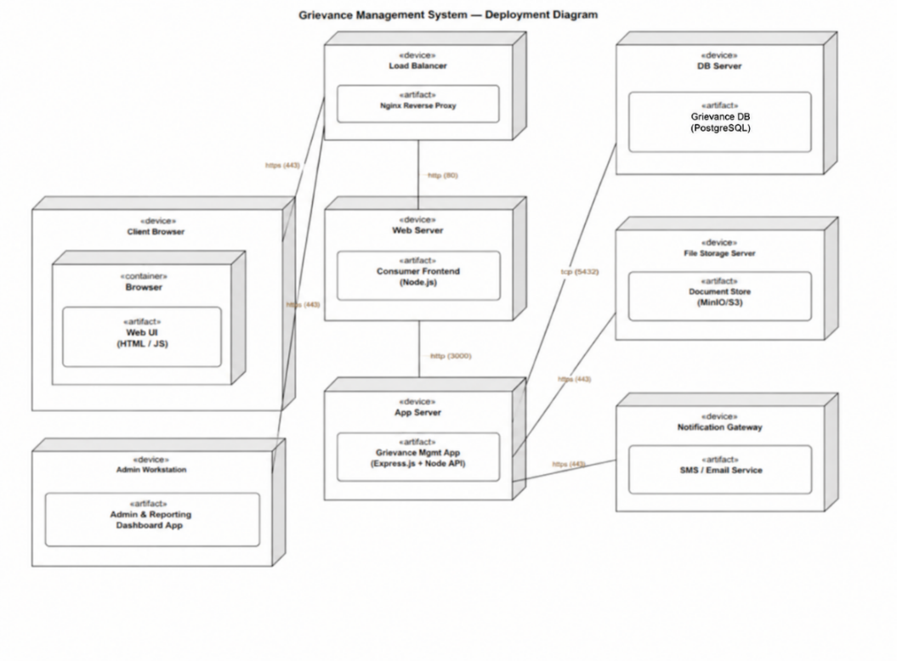
Figure B.8 Grievance Management System – Deployment Diagram
The deployment diagram shows the physical deployment of PGRS components across computational nodes. The multi-tier structure separates the user interface, application logic, database, file storage, and notification services, supporting maintainability, security, and efficient operation.

B.8.1 Deployment Nodes
Deployment Node | Description
Client Device | Device used by Citizens, Government Officers, Department Heads, and Administrators to access the PGRS through a web browser.
Web Server | Hosts the PGRS web interface and handles incoming client requests. Nginx is used as the web server.
Application Server | Runs the PGRS application: business logic, grievance processing, authentication, assignment, escalation, and other operations.
Database Server | Hosts the Supabase PostgreSQL database of users, departments, categories, grievances, feedback, notifications, and audit records.
File Storage Server | Stores grievance attachments and resolution proof uploaded by users and officers.
Notification Gateway | External services for sending email or SMS notifications to users.

B.8.2 Deployed Artifacts
- PGRS Web UI - deployed on the Web Server; provides the user interface.
- PGRS Application - deployed on the Application Server; implements the business logic.
- PGRS Database - deployed on the Database Server; provides persistent storage.
- Grievance Attachments and Resolution Proof Files - stored on the File Storage Server.
- Email/SMS Service - connected through the Notification Gateway.

B.8.3 Communication
Connection | Protocol
Client Device to Web Server | HTTPS
Web Server to Application Server | REST/JSON
Application Server to Database Server | PostgreSQL
Application Server to File Storage Server | File Storage Access
Application Server to Notification Gateway | SMTP/SMS API

B.9. source code:

B.7. Core Source Code

7.1 Authentication and Role-Based Access Control

'use strict';
const AuthService = require('../services/authService');
const { log } = require('../services/auditService');
exports.register = async (req, res, next) => {
try {
const user = await AuthService.registerCitizen(req.body);
await log(user.user_id, 'REGISTER_CITIZEN', 'user', user.user_id, null, req.ip);
res.status(201).json({ success: true, message: 'Registration successful' });
} catch (err) {
next(err);
}
};
exports.login = async (req, res, next) => {
try {
const { email, password } = req.body;
const { token, user } = await AuthService.login(email, password);
await log(user.user_id, 'LOGIN', 'user', user.user_id, null, req.ip);
res.json({ success: true, token, user });
} catch (err) {
next(err);
}
};
exports.logout = async (req, res) => {
const userId = req.user ? req.user.user_id : null;
if (userId) {
await log(userId, 'LOGOUT', 'user', userId, null, req.ip);
}
res.json({ success: true, message: 'Logged out successfully' });
};
const AuthService = require('../services/authService');
const { log } = require('../services/auditService');

exports.register = async (req, res, next) => {
try {
const user = await AuthService.registerCitizen(req.body);
await log(user.user_id, 'REGISTER_CITIZEN', 'user', user.user_id, null, req.ip);
res.status(201).json({ success: true, message: 'Registration successful' });
} catch (err) {
next(err);
}
};

exports.login = async (req, res, next) => {
try {
const { email, password } = req.body;
const { token, user } = await AuthService.login(email, password);
await log(user.user_id, 'LOGIN', 'user', user.user_id, null, req.ip);
res.json({ success: true, token, user });
} catch (err) {
next(err);
}
};

// Associated Service Implementation (backend/src/services/authService.js)
const bcrypt = require('bcryptjs');
const jwt = require('jsonwebtoken');
const { User } = require('../models');

class AuthService {
static async registerCitizen(data) {
const { name, email, password, mobile } = data;
const existing = await User.findOne({ where: { email } });
if (existing) {
throw Object.assign(new Error('Email already registered'), { status: 400 });
}
const password_hash = await bcrypt.hash(password, 12);
const user = await User.create({
name,
email,
password_hash,
role: 'citizen',
mobile,
is_active: true,
});
return user;
}

static async login(email, password) {
const user = await User.findOne({ where: { email } });
if (!user) {
throw Object.assign(new Error('Invalid credentials'), { status: 401 });
}
if (!user.is_active) {
throw Object.assign(new Error('Account inactive'), { status: 403 });
}
const isValid = await bcrypt.compare(password, user.password_hash);
if (!isValid) {
throw Object.assign(new Error('Invalid credentials'), { status: 401 });
}
const token = jwt.sign(
{ user_id: user.user_id, role: user.role, department_id: user.department_id },
process.env.JWT_SECRET,
{ expiresIn: process.env.JWT_EXPIRES_IN || '24h' }
);
return { token, user: { user_id: user.user_id, name: user.name, email: user.email, role: user.role } };
}
}
const jwt = require('jsonwebtoken');
const { User } = require('../models');

const verifyToken = async (req, res, next) => {
const authHeader = req.headers.authorization;
if (!authHeader || !authHeader.startsWith('Bearer ')) {
return res.status(401).json({ success: false, message: 'No token provided' });
}

const token = authHeader.split(' ')[1];
try {
const decoded = jwt.verify(token, process.env.JWT_SECRET);
const user = await User.findByPk(decoded.user_id, {
attributes: ['user_id', 'role', 'department_id', 'email', 'name', 'is_active'],
});
if (!user || !user.is_active) {
return res.status(401).json({ success: false, message: 'Account inactive or not found' });
}
req.user = user.toJSON();
return next();
} catch (err) {
if (err.name === 'TokenExpiredError') {
return res.status(401).json({ success: false, message: 'Token expired' });
}
return res.status(401).json({ success: false, message: 'Invalid token' });
}
};

const requireRole = (...roles) => (req, res, next) => {
if (!req.user) {
return res.status(401).json({ success: false, message: 'Unauthenticated' });
}
if (!roles.includes(req.user.role)) {
return res.status(403).json({ success: false, message: 'Forbidden: insufficient role' });
}
return next();
};

module.exports = { verifyToken, requireRole };

7.2 Grievance Submission
'use strict';

const GrievanceService = require('../services/grievanceService');
const { log } = require('../services/auditService');
exports.submit = async (req, res, next) => {
try {
const grievance = await GrievanceService.submitGrievance(
req.body,
req.user.user_id,
req.files || [],
);
await log(req.user.user_id, 'SUBMIT_GRIEVANCE', 'grievance', grievance.grievance_id, null, req.ip);
res.status(201).json({
success: true,
message: 'Grievance submitted successfully',
data: { grievance_id: grievance.grievance_id, grn: grievance.grn },
});
} catch (err) { next(err); }
};

const {
Grievance,
GrievanceStatusHistory,
SubCategory,
Category,
Department,
Attachment,
Notification,
} = require('../models');
const { generateGRN } = require('../utils/grnGenerator');

class GrievanceService {
/**
* Creates a new grievance.
* Accepts sub_category_id (required). department_id is auto-derived from
* SubCategory → Category → Department if not explicitly supplied.
*/
static async submitGrievance(data, citizenId, files) {
const {
title,
description,
sub_category_id,
location,
priority,
} = data;

// Resolve SubCategory → Category → Department
const subCat = await SubCategory.findByPk(sub_category_id, {
include: [{ model: Category, as: 'category' }],
});
if (!subCat || !subCat.is_active) {
throw Object.assign(new Error('Invalid or inactive sub-category'), { status: 400 });
}
if (!subCat.category || !subCat.category.is_active) {
throw Object.assign(new Error('Parent category is inactive'), { status: 400 });
}

const department_id = subCat.category.department_id;

const grn = generateGRN();

const g = await Grievance.create({
grn,
title,
description,
sub_category_id,
department_id,
citizen_id: citizenId,
location: location || null,
priority: priority || 'medium',
current_status: 'SUBMITTED',
});

// Attachments
if (files && files.length > 0) {
await Attachment.bulkCreate(files.map(file => ({
grievance_id: g.grievance_id,
file_name: file.originalname,
stored_name: file.filename,
file_path: file.path,
file_type: file.mimetype,
file_size: file.size,
attachment_type: 'citizen_document',
uploaded_by: citizenId,
})));
}

// Status history – initial entry
await GrievanceStatusHistory.create({
grievance_id: g.grievance_id,
changed_by: citizenId,
old_status: null,
new_status: 'SUBMITTED',
note: 'Grievance submitted by citizen',
});

// Notify department head
const dept = await Department.findByPk(department_id);
if (dept && dept.head_user_id) {
Notification.create({
user_id: dept.head_user_id,
message: `New grievance submitted: ${grn}`,
type: 'submission',
grievance_id: g.grievance_id,
}).catch(() => {});
}

return g;
}
}

module.exports = GrievanceService;

7.3 Grievance Assignment

const { Op } = require('sequelize');
const {
Grievance,
GrievanceAssignment,
GrievanceStatusHistory,
User,
Notification,
EscalationRule,
} = require('../models');

class GrievanceService {
/**
* Initial assignment of an officer to a grievance.
* Only allowed when there is NO active assignment and status is SUBMITTED or UNDER_REVIEW.
*/
static async assignOfficer(grievanceId, officerId, assignerUser) {
const g = await this.checkAccess(grievanceId, assignerUser);

const existing = await this._activeAssignment(grievanceId);
if (existing) {
throw Object.assign(
new Error('Grievance already has an active assignment. Use reassign instead.'),
{ status: 400 },
);
}

if (!['SUBMITTED', 'UNDER_REVIEW', 'REOPENED'].includes(g.current_status)) {
throw Object.assign(
new Error(`Cannot assign: grievance is in state ${g.current_status}`),
{ status: 400 },
);
}

// Validate officer belongs to the grievance's department
const officer = await User.findOne({
where: { user_id: officerId, role: 'officer', department_id: g.department_id, is_active: true },
});
if (!officer) {
throw Object.assign(
new Error('Officer not found, inactive, wrong role, or not in this department'),
{ status: 400 },
);
}

const assignedAt = new Date();

// SLA from EscalationRules
const categoryId = g.subCategory?.category?.category_id || null;

// Find matching rule (most specific first)
const rule = await EscalationRule.findOne({
where: {
[Op.or]: [
{ department_id: g.department_id, category_id: categoryId, priority: g.priority },
{ department_id: g.department_id, category_id: categoryId, priority: null },
{ department_id: g.department_id, category_id: null, priority: g.priority },
{ department_id: g.department_id, category_id: null, priority: null },
{ department_id: null, category_id: null, priority: null } // Global default fallback
],
is_active: true
},
order: [
['category_id', 'DESC'], // Prefer rules with category matched
['priority', 'DESC'], // Prefer rules with priority matched
['department_id', 'DESC']// Prefer rules with department matched
]
});

const slaDays = rule ? rule.sla_days : 7;
const slaDue = new Date(assignedAt.getTime() + slaDays * 24 * 60 * 60 * 1000);

// Create assignment record
await GrievanceAssignment.create({
grievance_id: g.grievance_id,
officer_id: officerId,
assigned_by: assignerUser.user_id,
assigned_at: assignedAt,
});

// Update grievance fast-access fields
const oldStatus = g.current_status;
await g.update({
current_status: 'ASSIGNED',
assigned_at: assignedAt,
sla_due_date: slaDue,
});

await GrievanceStatusHistory.create({
grievance_id: g.grievance_id,
changed_by: assignerUser.user_id,
old_status: oldStatus,
new_status: 'ASSIGNED',
note: `Assigned to officer ID ${officerId}`,
});

// Notifications (fire-and-forget)
Notification.bulkCreate([
{
user_id: officerId,
message: `You have been assigned grievance ${g.grn}.`,
type: 'assignment',
grievance_id: g.grievance_id,
},
{
user_id: g.citizen_id,
message: `Your grievance ${g.grn} has been assigned to an officer.`,
type: 'status_change',
grievance_id: g.grievance_id,
},
]).catch(() => {});

return g;
}
}

module.exports = GrievanceService;

7.4 Grievance Resolution
exports.resolve = async (req, res, next) => {
try {
const { grievance, resolution } = await GrievanceService.resolveGrievance(
req.params.id,
req.body,
req.files || [],
req.user,
);
await log(req.user.user_id, 'RESOLVE_GRIEVANCE', 'grievance', grievance.grievance_id,
{ resolution_id: resolution.resolution_id }, req.ip);
res.json({ success: true, message: 'Grievance resolved successfully', data: { resolution } });
} catch (err) { next(err); }
};
static async resolveGrievance(grievanceId, data, files, officerUser) {
const g = await this.checkAccess(grievanceId, officerUser);

if (g.current_status !== 'IN_PROGRESS') {
throw Object.assign(
new Error(`Cannot resolve: grievance is in state ${g.current_status}. Must be IN_PROGRESS.`),
{ status: 400 },
);
}
const { action_taken, resolution_description } = data;
if (!action_taken || !resolution_description) {
throw Object.assign(
new Error('action_taken and resolution_description are required'),
{ status: 400 },
);
}
const resolution = await Resolution.create({
grievance_id: g.grievance_id,
officer_id: officerUser.user_id,
action_taken,
resolution_description,
});

// Handle attachments (resolution proofs)
if (files && files.length > 0) {
await Attachment.bulkCreate(files.map(file => ({
grievance_id: g.grievance_id,
file_name: file.originalname,
stored_name: file.filename,
file_path: file.path,
file_type: file.mimetype,
file_size: file.size,
attachment_type: 'resolution_proof',
uploaded_by: officerUser.user_id,
})));
}
const oldStatus = g.current_status;
await g.update({ current_status: 'RESOLVED' });
await GrievanceStatusHistory.create({
grievance_id: g.grievance_id,
changed_by: officerUser.user_id,
old_status: oldStatus,
new_status: 'RESOLVED',
note: 'Grievance resolved by officer',
});

// Notify citizen
Notification.create({
user_id: g.citizen_id,
message: `Your grievance ${g.grn} has been marked as RESOLVED.`,
type: 'status_change',
grievance_id: g.grievance_id,
}).catch(() => {});

return { grievance: g, resolution };
}

7.5 File Upload and Resolution Proof Handling
'use strict';

const multer = require('multer');
const path = require('path');
const crypto = require('crypto');
const fs = require('fs');

const storageDir = process.env.UPLOAD_PATH || './uploads';

// Ensure base upload dir exists
if (!fs.existsSync(storageDir)) {
fs.mkdirSync(storageDir, { recursive: true });
}

const getGrievanceDir = (req) => {
const baseId = req.params.id || req.body.grievance_id || 'temp';
const dest = path.join(storageDir, 'grievances', String(baseId));
if (!fs.existsSync(dest)) {
fs.mkdirSync(dest, { recursive: true });
}
return dest;
};

const storage = multer.diskStorage({
destination: (req, _file, cb) => {
cb(null, getGrievanceDir(req));
},
filename: (_req, file, cb) => {
const uniqueSuffix = crypto.randomUUID() + path.extname(file.originalname);
cb(null, uniqueSuffix);
}
});

const fileFilter = (_req, file, cb) => {
const allowedMimeTypes = [
'image/jpeg', 'image/png', 'image/gif',
'application/pdf', 'application/msword',
'application/vnd.openxmlformats-officedocument.wordprocessingml.document'
];
if (allowedMimeTypes.includes(file.mimetype)) {
cb(null, true);
} else {
cb(Object.assign(new Error('Invalid file type'), { status: 400 }), false);
}
};

const upload = multer({
storage: storage,
limits: { fileSize: 5 * 1024 * 1024 }, // 5 MB limit
fileFilter: fileFilter
});

module.exports = upload;

7.6 Department Head Closure Approval and Rejection
static async approveClosure(grievanceId, decision, remarks, headUser) {
const g = await this.checkAccess(grievanceId, headUser);

if (g.current_status !== 'RESOLVED') {
throw Object.assign(
new Error(`Cannot review closure: grievance is in state ${g.current_status}. Must be RESOLVED.`),
{ status: 400 },
);
}
if (decision === 'rejected' && (!remarks || !remarks.trim())) {
throw Object.assign(
new Error('Remarks are required when rejecting a resolution during closure review.'),
{ status: 400 },
);
}

const oldStatus = g.current_status;
const newStatus = decision === 'approved' ? 'CLOSED' : 'IN_PROGRESS';
const now = new Date();

await g.update({
current_status: newStatus,
closed_at: decision === 'approved' ? now : null,
});
const note = decision === 'approved'
? (remarks || 'Resolution approved by Department Head. Grievance closed.')
: `Resolution rejected by Department Head. Returned to officer. Remarks: ${remarks}`;

await GrievanceStatusHistory.create({
grievance_id: g.grievance_id,
changed_by: headUser.user_id,
old_status: oldStatus,
new_status: newStatus,
note,
});
if (remarks) {
await Comment.create({
grievance_id: g.grievance_id,
user_id: headUser.user_id,
content: decision === 'approved' ? `Closure Approved: ${remarks}` : `Closure Review Rejected: ${remarks}`,
is_internal: true,
});
}
const activeAssignment = await this._activeAssignment(grievanceId);
if (activeAssignment) {
Notification.create({
user_id: activeAssignment.officer_id,
message: decision === 'approved'
? `Resolution for grievance ${g.grn} has been APPROVED by Department Head.`
: `Resolution for grievance ${g.grn} was REJECTED by Department Head: ${remarks}`,
type: 'status_change',
grievance_id: g.grievance_id,
}).catch(() => {});
}
Notification.create({
user_id: g.citizen_id,
message: decision === 'approved'
? `Your grievance ${g.grn} has been verified and CLOSED by the Department.`
: `Your grievance ${g.grn} is undergoing further action by the Department.`,
type: 'status_change',
grievance_id: g.grievance_id,
}).catch(() => {});

return g;
}
7.7 Automated SLA Escalation

'use strict';

const { Op } = require('sequelize');
const { Grievance, GrievanceStatusHistory, Escalation, Notification, Department } = require('../models');
const { log } = require('../services/auditService');
async function runSlaCheck() {
console.log('[SLA Monitor] Running SLA check for ASSIGNED/IN_PROGRESS grievances...');

const overdueGrievances = await Grievance.findAll({
where: {
current_status: { [Op.in]: ['ASSIGNED', 'IN_PROGRESS'] },
sla_due_date: { [Op.lt]: new Date() },
},
include: [
{ model: Department, as: 'department', attributes: ['head_user_id'] },
],
});
if (overdueGrievances.length === 0) {
console.log('[SLA Monitor] No overdue grievances found.');
return 0;
}
let escalated = 0;
for (const g of overdueGrievances) {
// Prevent duplicate escalation for the same grievance
const existingEscalation = await Escalation.findOne({
where: { grievance_id: g.grievance_id, escalated_by_system: true },
});
if (existingEscalation) {
continue;
}

const oldStatus = g.current_status;

await g.update({ current_status: 'ESCALATED' });

await Escalation.create({
grievance_id: g.grievance_id,
escalated_by_system: true,
escalated_at: new Date(),
department_head_id: g.department.head_user_id,
});

await GrievanceStatusHistory.create({
grievance_id: g.grievance_id,
changed_by: null,
old_status: oldStatus,
new_status: 'ESCALATED',
note: `System auto-escalation: SLA due date (${g.sla_due_date}) exceeded.`,
});

await Notification.create({
user_id: g.department.head_user_id,
message: `ESCALATION: Grievance ${g.grn} has exceeded its SLA. Requires immediate attention.`,
type: 'escalation',
grievance_id: g.grievance_id,
});

await log(null, 'AUTO_ESCALATE', 'grievance', g.grievance_id, null, '127.0.0.1');
escalated++;
}

console.log(`[SLA Monitor] Successfully escalated ${escalated} grievance(s).`);
return escalated;
}

module.exports = { runSlaCheck };

7.8 Admin and Department Report Generation
'use strict';

const { Op, fn, col, literal } = require('sequelize');
const sequelize = require('../config/database');
const {
Grievance,
Department,
Report,
} = require('../models');

class ReportService {
static _buildWhere(user, filters = {}) {
const where = {};

// Department scope
if (user.role === 'department_head') {
where.department_id = user.department_id;
} else if (filters.department_id) {
where.department_id = parseInt(filters.department_id, 10);
}

// Date range on created_at (submitted_at)
if (filters.from || filters.to) {
where.created_at = {};
if (filters.from) where.created_at[Op.gte] = new Date(filters.from);
if (filters.to) where.created_at[Op.lte] = new Date(filters.to);
}

return where;
}

static async generateSummary(user, filters = {}) {
const where = this._buildWhere(user, filters);

// 1. Total grievances
const total = await Grievance.count({ where });

// 2. Status-wise counts
const statusRows = await Grievance.findAll({
where,
attributes: ['current_status', [fn('COUNT', col('grievance_id')), 'count']],
group: ['current_status'],
raw: true,
});
const byStatus = {};
for (const row of statusRows) {
byStatus[row.current_status] = parseInt(row.count, 10);
}

// 3. Department-wise counts (admin only; dept head only sees their own)
let byDepartment = null;
if (user.role === 'administrator') {
const deptRows = await Grievance.findAll({
where,
attributes: [
'department_id',
[fn('COUNT', col('Grievance.grievance_id')), 'count'],
],
include: [{ model: Department, as: 'department', attributes: ['name'] }],
group: ['Grievance.department_id', 'department.department_id', 'department.name'],
raw: true,
nest: true,
});
byDepartment = deptRows.map(r => ({
department_id: r.department_id,
department_name: r.department ? r.department.name : null,
count: parseInt(r.count, 10),
}));
}
const priorityRows = await Grievance.findAll({
where,
attributes: ['priority', [fn('COUNT', col('grievance_id')), 'count']],
group: ['priority'],
raw: true,
});
const byPriority = {};
for (const row of priorityRows) {
byPriority[row.priority] = parseInt(row.count, 10);
}
const resolved = await Grievance.count({ where: { ...where, current_status: 'RESOLVED' } });
const closed = await Grievance.count({ where: { ...where, current_status: 'CLOSED' } });
const reopened = await Grievance.count({ where: { ...where, current_status: 'REOPENED' } });
const escalated = await Grievance.count({ where: { ...where, current_status: 'ESCALATED' } });
const dialect = sequelize.getDialect();
const diffExpression = dialect === 'postgres'
? 'EXTRACT(EPOCH FROM (closed_at - assigned_at)) / 3600'
: 'TIMESTAMPDIFF(HOUR, assigned_at, closed_at)';

const avgResolutionResult = await Grievance.findOne({
where: {
...where,
current_status: 'CLOSED',
assigned_at: { [Op.ne]: null },
closed_at: { [Op.ne]: null },
},
attributes: [
[
fn('AVG', literal(diffExpression)),
'avg_hours',
],
],
raw: true,
});
const avgResolutionHours = avgResolutionResult && avgResolutionResult.avg_hours != null
? parseFloat(parseFloat(avgResolutionResult.avg_hours).toFixed(2))
: null;
let officerStats = null;
const deptId = user.role === 'department_head' ? user.department_id : (filters.department_id ? parseInt(filters.department_id, 10) : null);
if (deptId) {
const { User, GrievanceAssignment } = require('../models');
const officers = await User.findAll({
where: { department_id: deptId, role: 'officer' },
attributes: ['user_id', 'name', 'email', 'is_active'],
});

officerStats = await Promise.all(officers.map(async (off) => {
const activeCount = await GrievanceAssignment.count({
where: { officer_id: off.user_id, unassigned_at: null }
});
const totalAssigned = await GrievanceAssignment.count({
where: { officer_id: off.user_id }
});
return {
user_id: off.user_id,
name: off.name,
email: off.email,
is_active: off.is_active,
active_workload: activeCount,
total_assigned: totalAssigned
};
}));
}

const reportParams = { filters, generated_at: new Date().toISOString() };
await Report.create({
report_type: 'status',
generated_by: user.user_id,
parameters: reportParams,
});

return {
total,
by_status: byStatus,
by_department: byDepartment,
by_priority: byPriority,
resolved,
closed,
reopened,
escalated,
avg_resolution_hours: avgResolutionHours,
officer_stats: officerStats,
applied_filters: filters,
};
}
}

module.exports = ReportService;

7.9 Citizen Feedback

'use strict';

const { Grievance, Feedback } = require('../models');

class FeedbackService {
static async submitFeedback(grievanceId, data, citizenUser) {
const { rating, comment } = data;
const r = parseInt(rating, 10);
if (!r || r < 1 || r > 5) {
throw Object.assign(new Error('Rating must be an integer between 1 and 5.'), { status: 400 });
}
const g = await Grievance.findByPk(grievanceId);
if (!g) {
throw Object.assign(new Error('Grievance not found.'), { status: 404 });
}

if (g.citizen_id !== citizenUser.user_id) {
throw Object.assign(new Error('Forbidden: not your grievance.'), { status: 403 });
}
if (g.current_status !== 'CLOSED') {
throw Object.assign(
new Error(`Feedback can only be submitted for CLOSED grievances. Current status: ${g.current_status}.`),
{ status: 400 },
);
}
const existing = await Feedback.findOne({ where: { grievance_id: grievanceId } });
if (existing) {
throw Object.assign(new Error('Feedback has already been submitted for this grievance.'), { status: 409 });
}

const feedback = await Feedback.create({
grievance_id: grievanceId,
citizen_id: citizenUser.user_id,
rating: r,
comment: comment || null,
});

return feedback;
}
}

module.exports = FeedbackService;

7.10 Frontend Role Guard and Dashboard Routing

import React, { useContext } from 'react';
import { Navigate } from 'react-router-dom';
import { AuthContext } from '../context/AuthContext';

export const getRoleHome = (role) => {
switch (role) {
case 'officer':
return '/officer/dashboard';
case 'department_head':
return '/head/dashboard';
case 'administrator':

return '/admin/dashboard';
case 'citizen':
default:
return '/dashboard';
}
};

const ProtectedRoute = ({ children, allowedRoles }) => {
const { user, loading } = useContext(AuthContext);

if (loading) {
return (
<div className="flex items-center justify-center min-h-screen">
<div className="spinner"></div>
</div> );
}

if (!user) {
return <Navigate to="/login" replace />;
}

if (allowedRoles && !allowedRoles.includes(user.role)) {
return <Navigate to={getRoleHome(user.role)} replace />;
}

return children;
};

export default ProtectedRoute;

DEMONSTRATION:

User Login Page

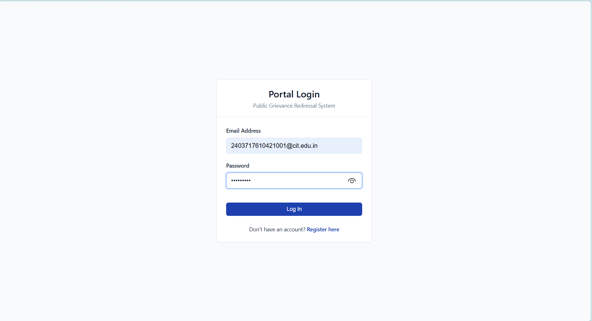
Figure 1 User Login Page

Role-Based Dashboard

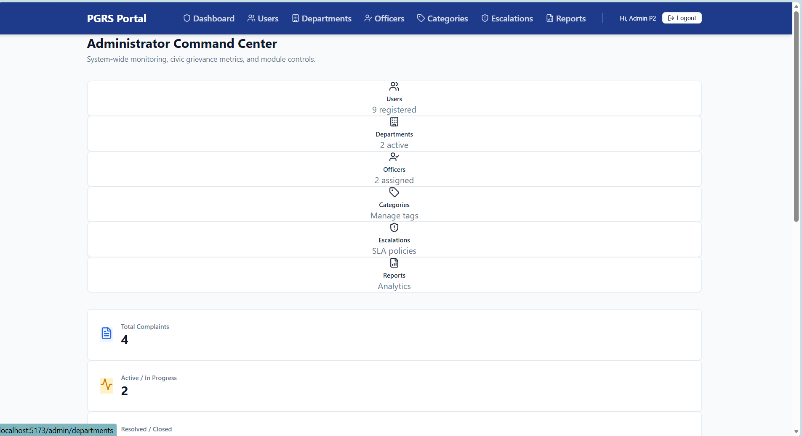

Figure 2 Role Based Dashboard

New Grievance Submission

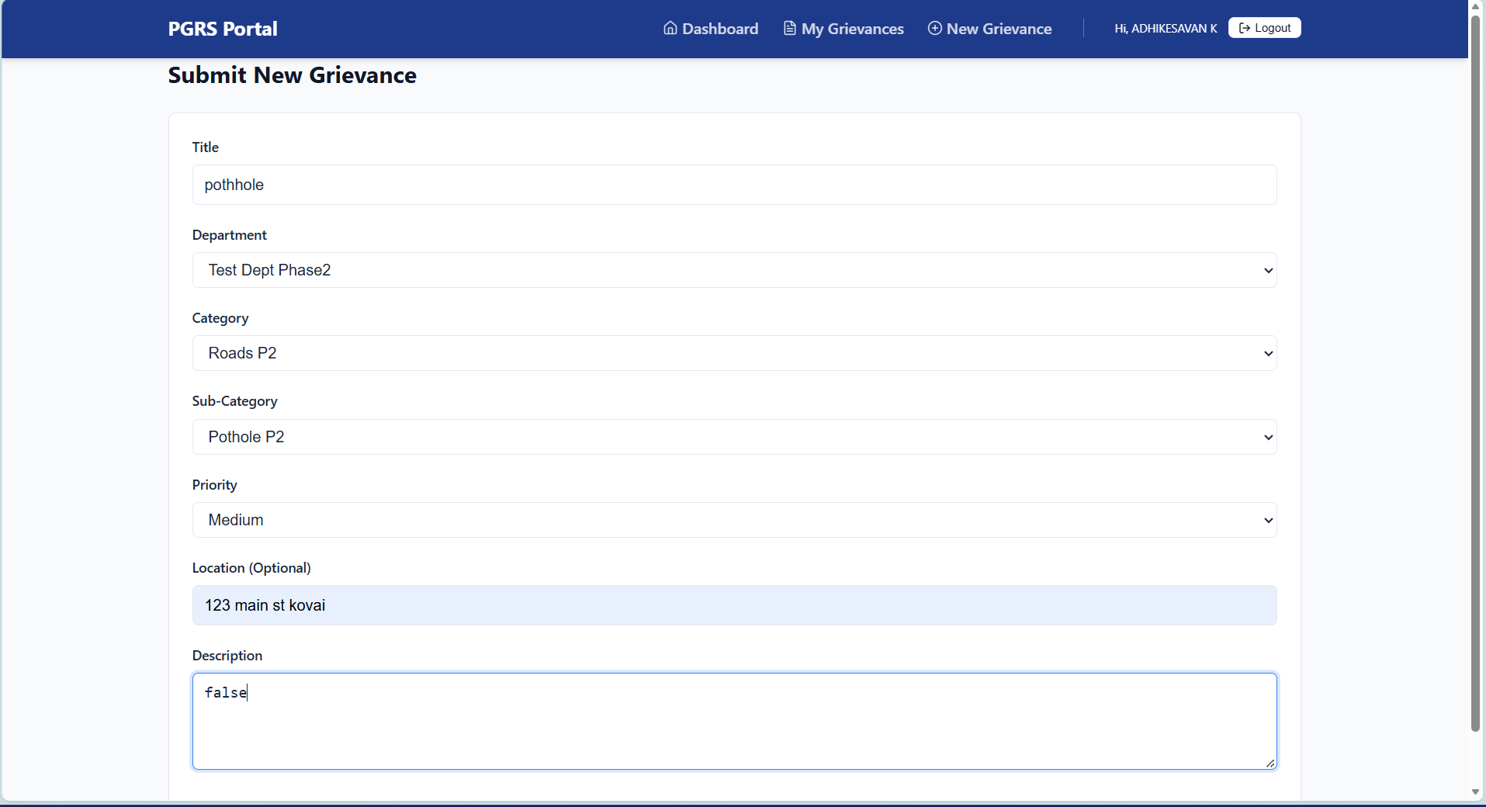
Figure 3 New Grievance Submission
Grievance Review
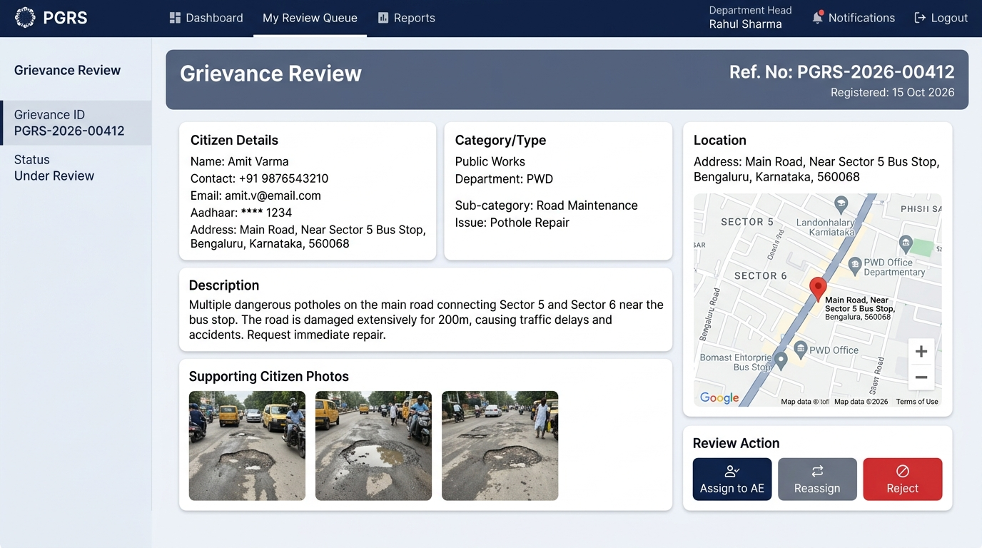
Figure 4 Grievance Review

Assign Grievance to Officer

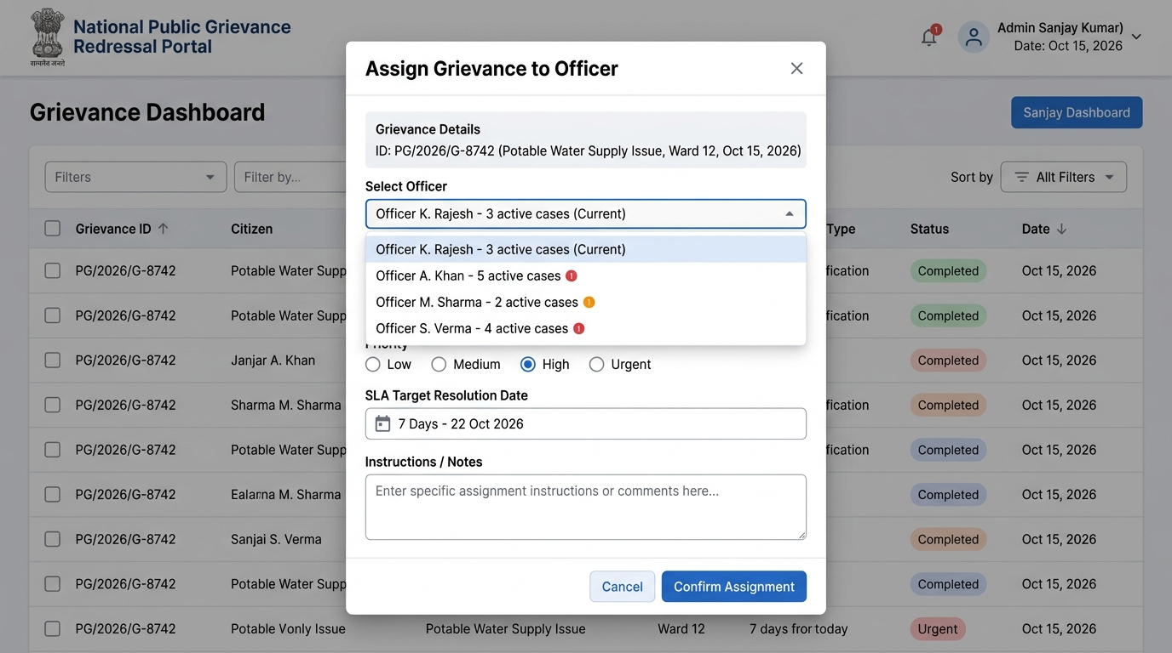
Figure 5 Assign Grievance to Officer

Assigned Grievances

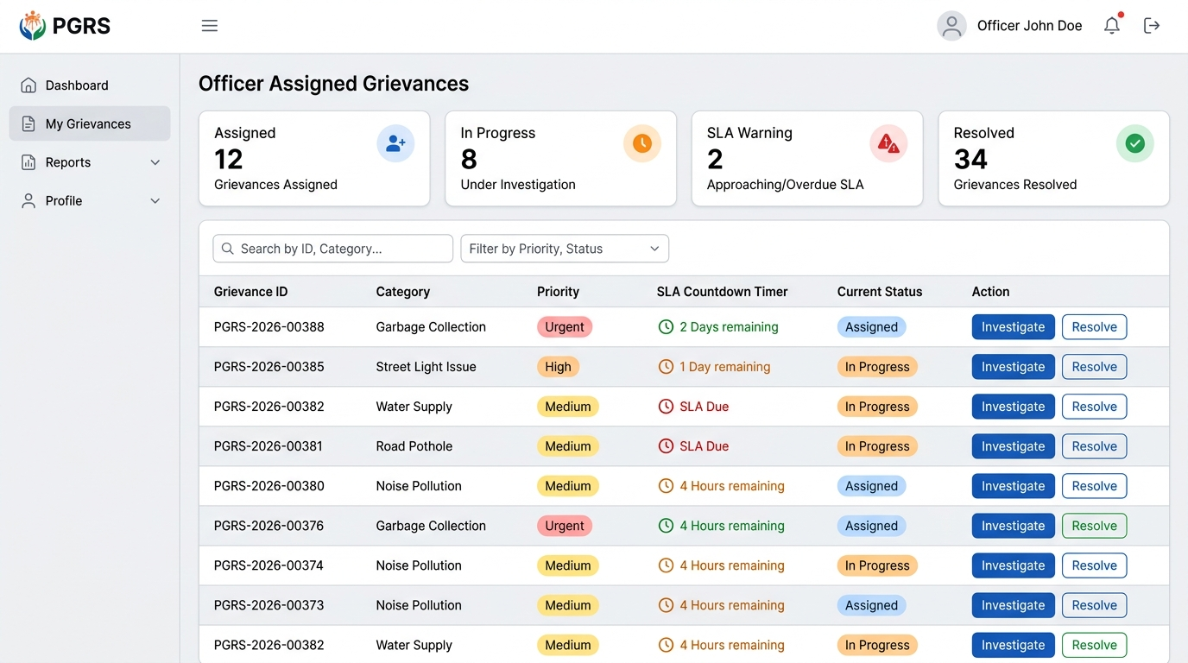
Figure 6 Assigned Grievances

Grievance Resolution

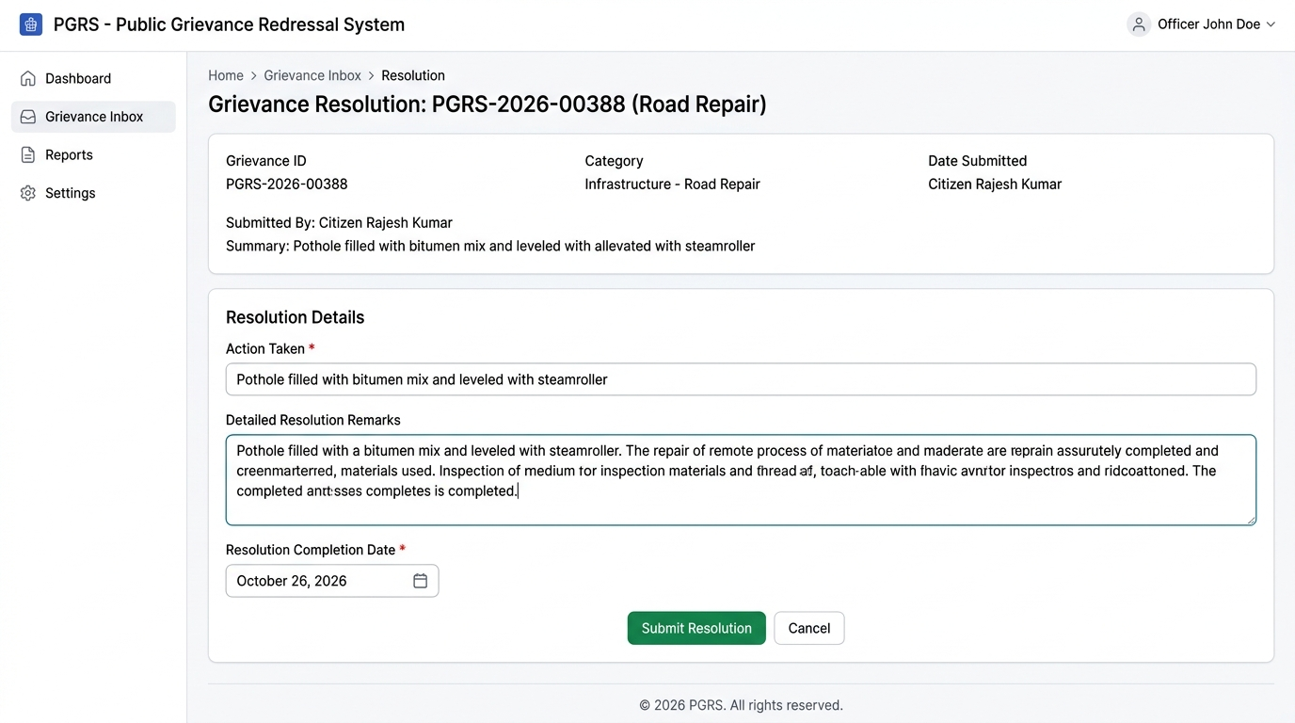
Figure 7 Grievance Resolution

Resolution Proof Upload

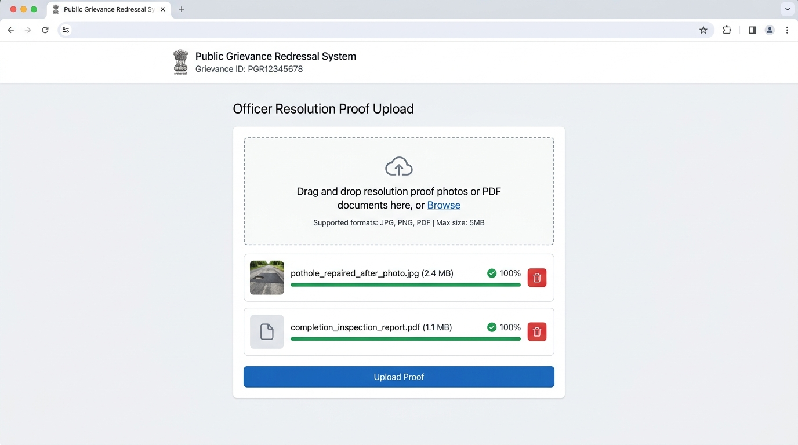
Figure 8 Resolution Proof Upload

Department Head Closure Approval

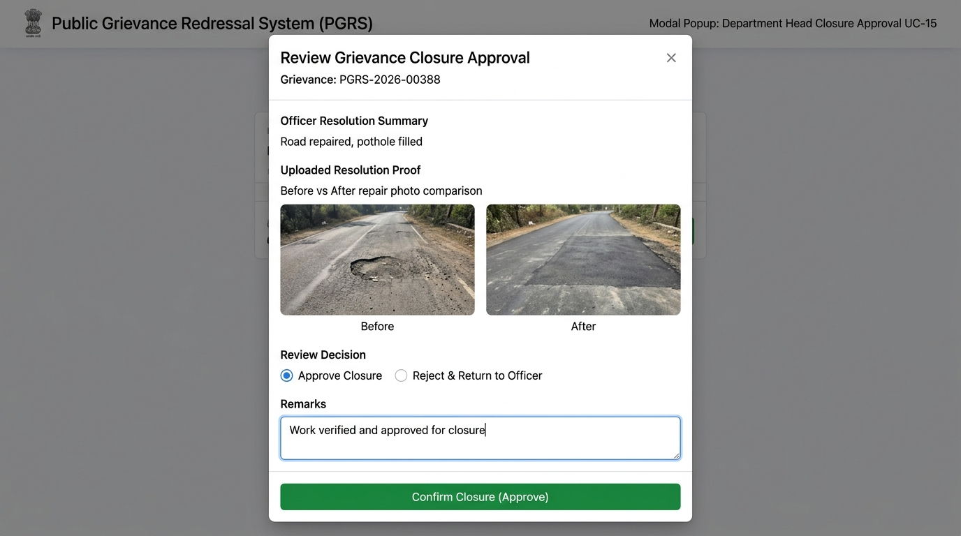
Figure 9 Department Head Closure Approval

SLA Escalation and Overdue Grievances

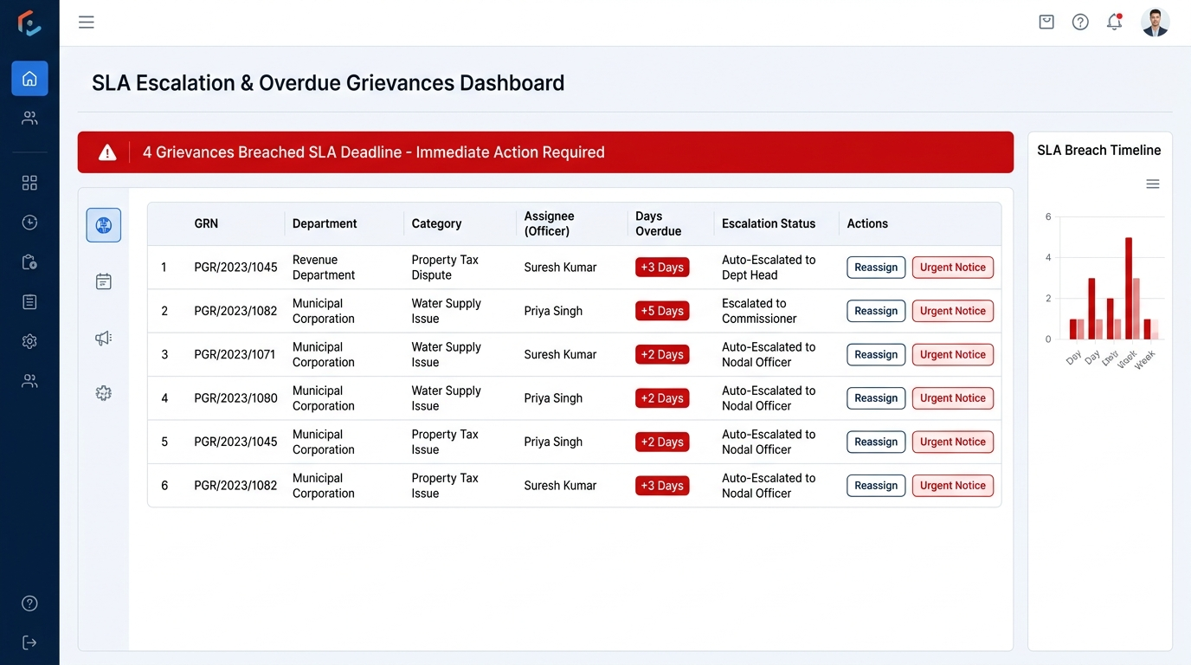
Figure 10 SLA Escalation and Overdue Grievances

Administrator Analytics Dashboard

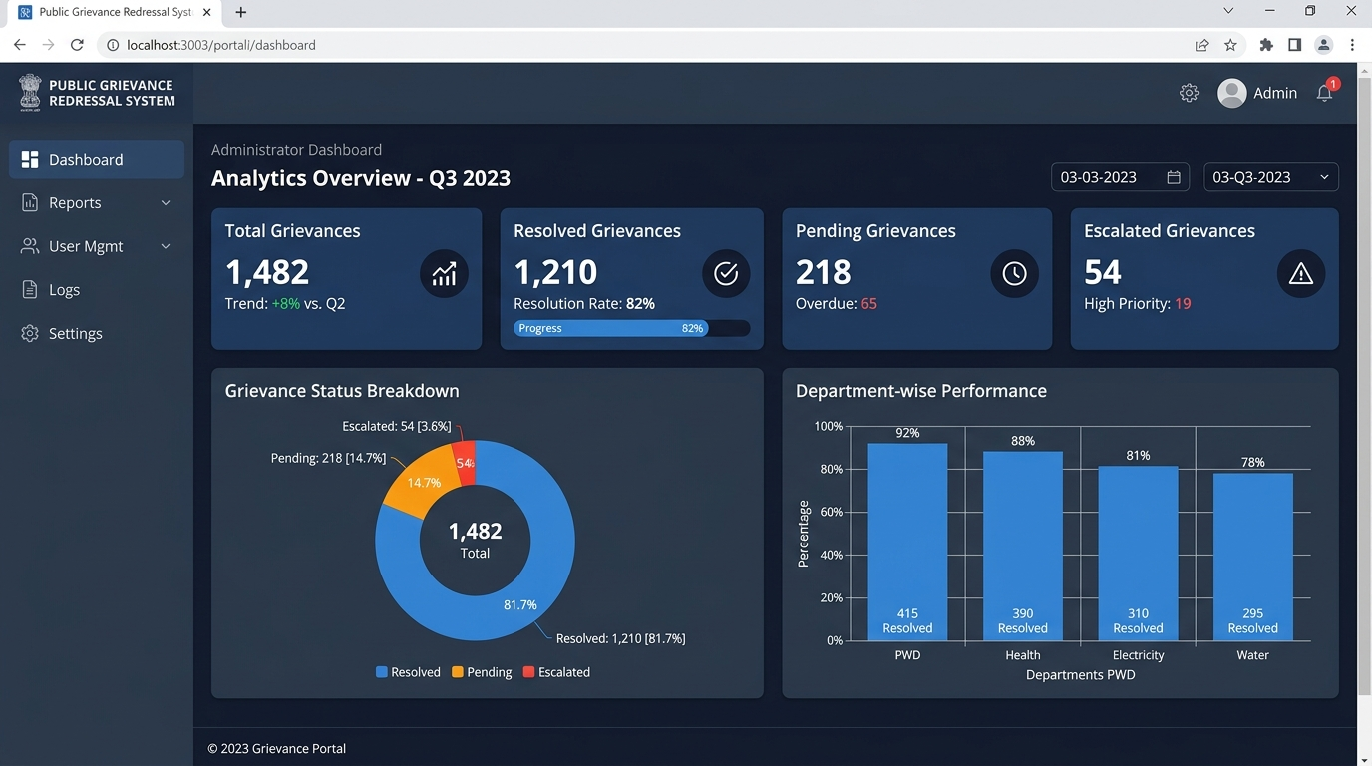
Figure 11 Administrator Analytics Dashboard

Report Generation

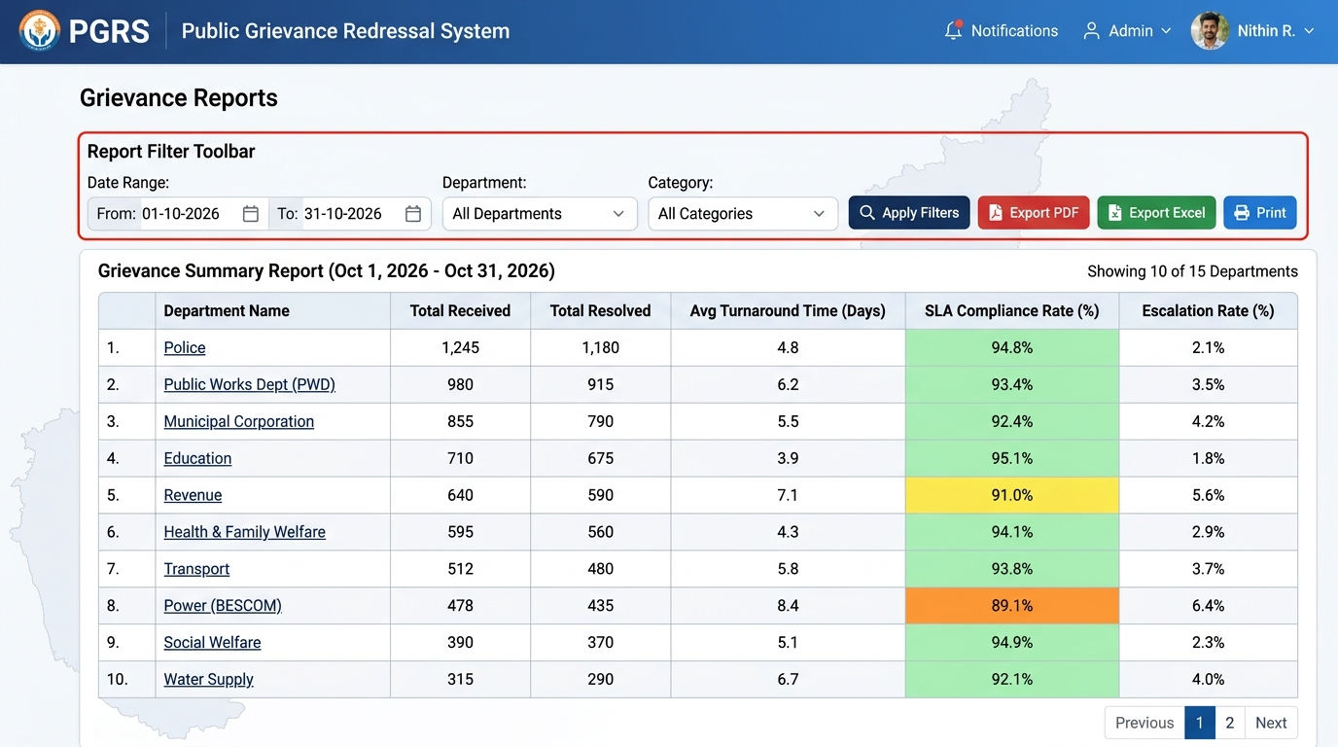 Figure 12 Report Generation

Grievance Status Tracking

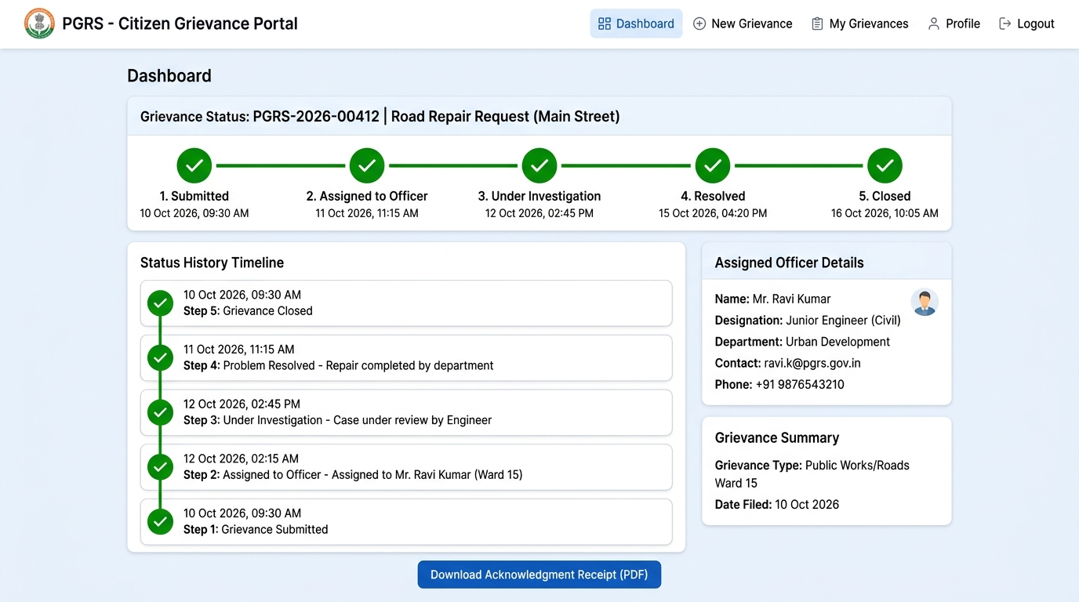
Figure 13 Grievance Status Tracking

Citizen Feedback Submission
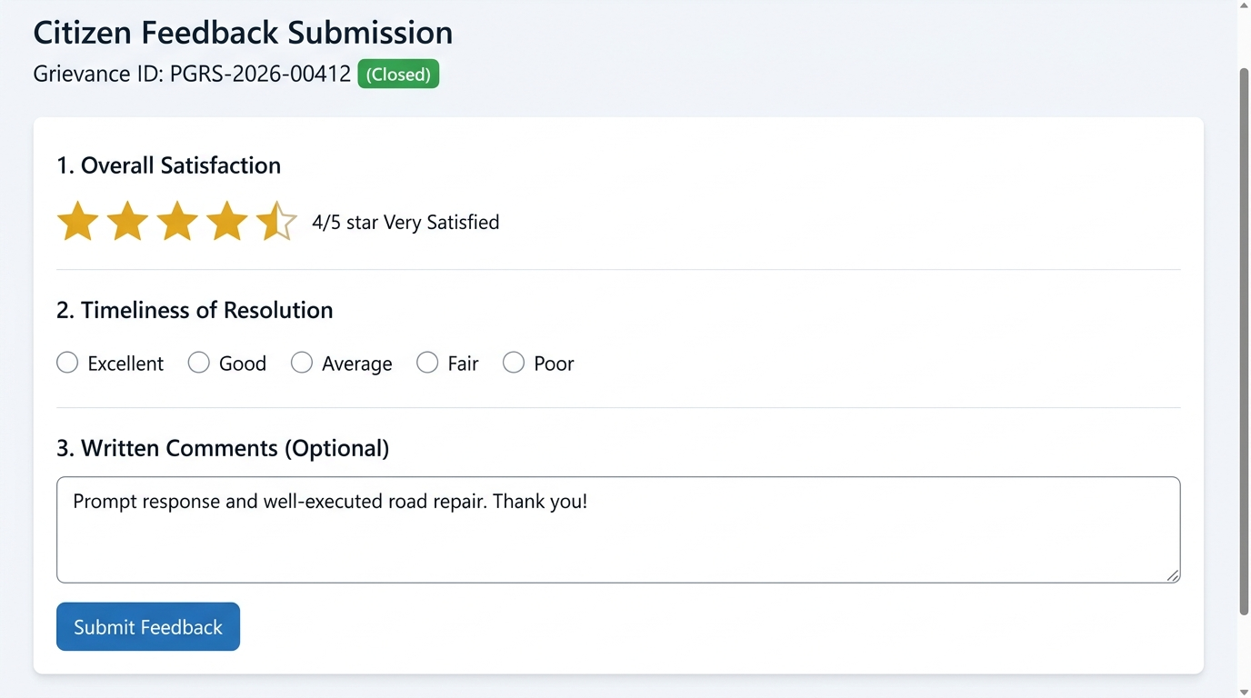
Figure 14 Citizen Feedback Submission

System Notifications

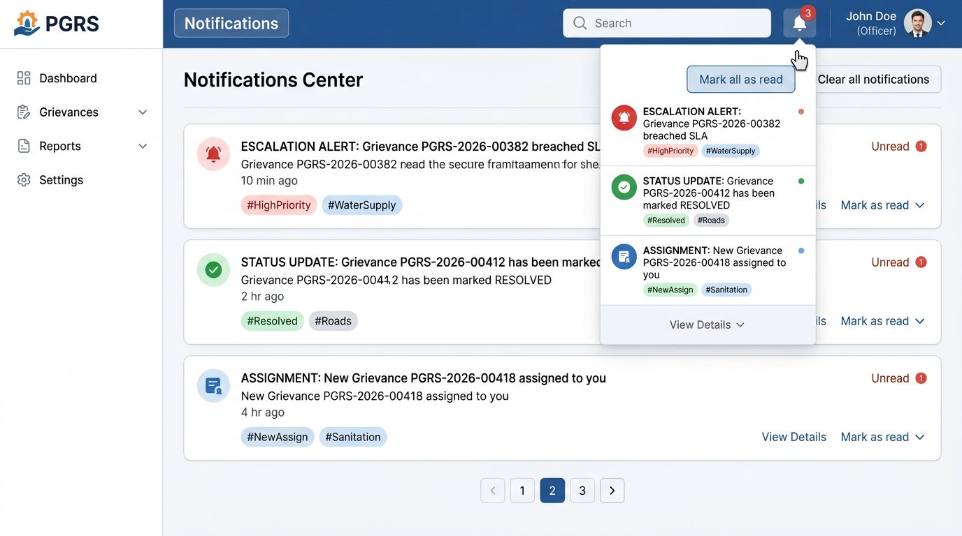

Figure 15 System Notifications

E- Resources

https://github.com/Adhi576/Public-Grievance-Redrassal-System.git

Appendix C: To Be Determined List
The following items require further clarification or decision before final implementation:
# | TBD Item | Responsible Party | Target Date
1 | Specific government data retention policy duration to confirm minimum record storage period. | Project Sponsor | TBD
2 | SMS gateway vendor selection (Twilio vs MSG91) and API integration specifications. | Technical Lead | TBD
3 | Exact SLA period (working days) for each grievance category to be defined by government stakeholders. | Government Stakeholder | TBD
4 | Confirmation of supported regional languages for future multilingual interface. | Project Manager | TBD
5 | Integration requirements with existing government portals (e.g., UID/Aadhaar verification for citizen registration). | Government IT Dept. | TBD
6 | Exact file format and layout specifications for report exports required by department heads. | Department Heads | TBD
This document will be updated as TBD items are resolved. All changes will be recorded in the Revision History table.

