Appendix B: Analysis Models
Core Source Code & System User Interfaces
Public Grievance Redressal System (PGRS) — Software Requirements Specification

7. Core Source Code

7.1 Authentication and Role-Based Access Control
File: backend/src/controllers/authController.js
Purpose: Handles citizen registration, login authentication, password hash comparison, and JWT generation with role payload.
'use strict';
const AuthService = require('../services/authService');
const { log } = require('../services/auditService');
exports.register = async (req, res, next) => {
try {
const user = await AuthService.registerCitizen(req.body);
await log(user.user_id, 'REGISTER_CITIZEN', 'user', user.user_id, null, req.ip);
res.status(201).json({ success: true, message: 'Registration successful' });
} catch (err) {
next(err);
}
};
exports.login = async (req, res, next) => {
try {
const { email, password } = req.body;
const { token, user } = await AuthService.login(email, password);
await log(user.user_id, 'LOGIN', 'user', user.user_id, null, req.ip);
res.json({ success: true, token, user });
} catch (err) {
next(err);
}
};
exports.logout = async (req, res) => {
const userId = req.user ? req.user.user_id : null;
if (userId) {
await log(userId, 'LOGOUT', 'user', userId, null, req.ip);
}
res.json({ success: true, message: 'Logged out successfully' });
};

File: backend/src/middleware/auth.js
Purpose: Verifies Bearer JWT tokens on incoming requests, checks account active status, and restricts endpoints via role guards.
'use strict';
const jwt = require('jsonwebtoken');
const { User } = require('../models');
const verifyToken = async (req, res, next) => {
const authHeader = req.headers.authorization;
if (!authHeader || !authHeader.startsWith('Bearer ')) {
return res.status(401).json({ success: false, message: 'No token provided' });
}
const token = authHeader.split(' ')[1];
try {
const decoded = jwt.verify(token, process.env.JWT_SECRET);
const user = await User.findByPk(decoded.user_id, {
attributes: ['user_id', 'role', 'department_id', 'email', 'name', 'is_active'],
});
if (!user || !user.is_active) {
return res.status(401).json({ success: false, message: 'Account inactive or not found' });
}
req.user = user.toJSON();
return next();
} catch (err) {
if (err.name === 'TokenExpiredError') {
return res.status(401).json({ success: false, message: 'Token expired' });
}
return res.status(401).json({ success: false, message: 'Invalid token' });
}
};
const requireRole = (...roles) => (req, res, next) => {
if (!req.user) {
return res.status(401).json({ success: false, message: 'Unauthenticated' });
}
if (!roles.includes(req.user.role)) {
return res.status(403).json({ success: false, message: 'Forbidden: insufficient role' });
}
return next();
};
module.exports = { verifyToken, requireRole };

7.2 Grievance Submission
File: backend/src/controllers/grievanceController.js
Purpose: Receives citizen grievance payload and files, invokes service validation, and logs the submission audit record.
exports.submit = async (req, res, next) => {
try {
const grievance = await GrievanceService.submitGrievance(
req.body,
req.user.user_id,
req.files || [],
);
await log(req.user.user_id, 'SUBMIT_GRIEVANCE', 'grievance', grievance.grievance_id, null, req.ip);
res.status(201).json({
success: true,
message: 'Grievance submitted successfully',
data: { grievance_id: grievance.grievance_id, grn: grievance.grn },
});
} catch (err) {
next(err);
}
};

File: backend/src/services/grievanceService.js
Purpose: Validates category classification, generates unique GRN, derives department ownership, persists attachments, and records initial status history.
static async submitGrievance(data, citizenId, files) {
const { title, description, sub_category_id, location, priority } = data;
const subCat = await SubCategory.findByPk(sub_category_id, {
include: [{ model: Category, as: 'category' }],
});
if (!subCat || !subCat.is_active || !subCat.category || !subCat.category.is_active) {
throw Object.assign(new Error('Invalid or inactive category classification'), { status: 400 });
}
const department_id = subCat.category.department_id;
const grn = generateGRN();
const g = await Grievance.create({
grn,
title,
description,
sub_category_id,
department_id,
citizen_id: citizenId,
location: location || null,
priority: priority || 'medium',
current_status: 'SUBMITTED',
});
if (files && files.length > 0) {
await Attachment.bulkCreate(files.map(file => ({
grievance_id: g.grievance_id,
file_name: file.originalname,
stored_name: file.filename,
file_path: file.path,
file_type: file.mimetype,
file_size: file.size,
attachment_type: 'citizen_document',
uploaded_by: citizenId,
})));
}
await GrievanceStatusHistory.create({
grievance_id: g.grievance_id,
changed_by: citizenId,
old_status: null,
new_status: 'SUBMITTED',
note: 'Grievance submitted by citizen',
});
return g;
}

7.3 Grievance Assignment
File: backend/src/services/grievanceService.js
Purpose: Assigns unassigned complaints to a department officer, queries escalation rules to compute SLA target deadlines, and updates status to ASSIGNED.
static async assignOfficer(grievanceId, officerId, assignerUser) {
const g = await this.checkAccess(grievanceId, assignerUser);
const existing = await this._activeAssignment(grievanceId);
if (existing) {
throw Object.assign(new Error('Grievance already has an active assignment. Use reassign instead.'), { status: 400 });
}
const officer = await User.findOne({
where: { user_id: officerId, role: 'officer', department_id: g.department_id, is_active: true },
});
if (!officer) {
throw Object.assign(new Error('Officer not found, inactive, or not in this department'), { status: 400 });
}
const assignedAt = new Date();
const categoryId = g.subCategory?.category?.category_id || null;
// Resolve SLA Days via EscalationRule hierarchy
const rule = await EscalationRule.findOne({
where: {
[Op.or]: [
{ department_id: g.department_id, category_id: categoryId, priority: g.priority },
{ department_id: g.department_id, category_id: categoryId, priority: null },
{ department_id: g.department_id, category_id: null, priority: g.priority },
{ department_id: g.department_id, category_id: null, priority: null },
{ department_id: null, category_id: null, priority: null }
],
is_active: true
},
order: [['category_id', 'DESC'], ['priority', 'DESC'], ['department_id', 'DESC']]
});
const slaDays = rule ? rule.sla_days : 7;
const slaDue = new Date(assignedAt.getTime() + slaDays * 24 * 60 * 60 * 1000);
await GrievanceAssignment.create({
grievance_id: g.grievance_id,
officer_id: officerId,
assigned_by: assignerUser.user_id,
assigned_at: assignedAt,
});
const oldStatus = g.current_status;
await g.update({
current_status: 'ASSIGNED',
assigned_at: assignedAt,
sla_due_date: slaDue,
});
await GrievanceStatusHistory.create({
grievance_id: g.grievance_id,
changed_by: assignerUser.user_id,
old_status: oldStatus,
new_status: 'ASSIGNED',
note: `Assigned to officer ID ${officerId}`,
});
return g;
}

7.4 Grievance Resolution
File: backend/src/controllers/grievanceController.js
Purpose: Receives officer resolution data and proofs, executes state change, and returns resolution summary.
exports.resolve = async (req, res, next) => {
try {
const { grievance, resolution } = await GrievanceService.resolveGrievance(
req.params.id,
req.body,
req.files || [],
req.user,
);
await log(req.user.user_id, 'RESOLVE_GRIEVANCE', 'grievance', grievance.grievance_id,
{ resolution_id: resolution.resolution_id }, req.ip);
res.json({ success: true, message: 'Grievance resolved successfully', data: { resolution } });
} catch (err) {
next(err);
}
};

File: backend/src/services/grievanceService.js
Purpose: Validates officer ownership, creates resolution entry, saves resolution proof attachments, and updates status to RESOLVED.
static async resolveGrievance(grievanceId, data, files, officerUser) {
const g = await this.checkAccess(grievanceId, officerUser);
if (g.current_status !== 'IN_PROGRESS') {
throw Object.assign(
new Error(`Cannot resolve: grievance is in state ${g.current_status}. Must be IN_PROGRESS.`),
{ status: 400 },
);
}
const { action_taken, resolution_description } = data;
if (!action_taken || !resolution_description) {
throw Object.assign(new Error('action_taken and resolution_description are required'), { status: 400 });
}
const resolution = await Resolution.create({
grievance_id: g.grievance_id,
officer_id: officerUser.user_id,
action_taken,
resolution_description,
});
if (files && files.length > 0) {
await Attachment.bulkCreate(files.map(file => ({
grievance_id: g.grievance_id,
file_name: file.originalname,
stored_name: file.filename,
file_path: file.path,
file_type: file.mimetype,
file_size: file.size,
attachment_type: 'resolution_proof',
uploaded_by: officerUser.user_id,
})));
}
const oldStatus = g.current_status;
await g.update({ current_status: 'RESOLVED' });
await GrievanceStatusHistory.create({
grievance_id: g.grievance_id,
changed_by: officerUser.user_id,
old_status: oldStatus,
new_status: 'RESOLVED',
note: 'Grievance resolved by officer',
});
return { grievance: g, resolution };
}

7.5 Resolution Proof Upload
File: backend/src/config/multer.js
Purpose: Configures multipart storage, creates isolated grievance subdirectories, and validates file formats and size limits.
'use strict';
const multer = require('multer');
const path = require('path');
const crypto = require('crypto');
const fs = require('fs');
const storageDir = process.env.UPLOAD_PATH || './uploads';
const getGrievanceDir = (req) => {
const baseId = req.params.id || req.body.grievance_id || 'temp';
const dest = path.join(storageDir, 'grievances', String(baseId));
if (!fs.existsSync(dest)) {
fs.mkdirSync(dest, { recursive: true });
}
return dest;
};
const storage = multer.diskStorage({
destination: (req, _file, cb) => {
cb(null, getGrievanceDir(req));
},
filename: (_req, file, cb) => {
const uniqueSuffix = crypto.randomUUID() + path.extname(file.originalname);
cb(null, uniqueSuffix);
}
});
const fileFilter = (_req, file, cb) => {
const allowedMimeTypes = [
'image/jpeg', 'image/png', 'image/gif',
'application/pdf', 'application/msword',
'application/vnd.openxmlformats-officedocument.wordprocessingml.document'
];
if (allowedMimeTypes.includes(file.mimetype)) {
cb(null, true);
} else {
cb(Object.assign(new Error('Invalid file type'), { status: 400 }), false);
}
};
const upload = multer({
storage: storage,
limits: { fileSize: 5 * 1024 * 1024 }, // 5 MB limit
fileFilter: fileFilter
});
module.exports = upload;

7.6 Department Head Closure Approval / Rejection
File: backend/src/services/grievanceService.js
Purpose: Allows Department Heads to review submitted resolution proofs: approval marks the case CLOSED, while rejection returns the case to IN_PROGRESS with directives.
static async approveClosure(grievanceId, decision, remarks, headUser) {
const g = await this.checkAccess(grievanceId, headUser);
if (g.current_status !== 'RESOLVED') {
throw Object.assign(
new Error(`Cannot review closure: grievance is in state ${g.current_status}. Must be RESOLVED.`),
{ status: 400 },
);
}
if (decision === 'rejected' && (!remarks || !remarks.trim())) {
throw Object.assign(new Error('Remarks are required when rejecting a resolution.'), { status: 400 });
}
const oldStatus = g.current_status;
const newStatus = decision === 'approved' ? 'CLOSED' : 'IN_PROGRESS';
const now = new Date();
await g.update({
current_status: newStatus,
closed_at: decision === 'approved' ? now : null,
});
const note = decision === 'approved'
? (remarks || 'Resolution approved by Department Head. Grievance closed.')
: `Resolution rejected by Department Head. Returned to officer. Remarks: ${remarks}`;
await GrievanceStatusHistory.create({
grievance_id: g.grievance_id,
changed_by: headUser.user_id,
old_status: oldStatus,
new_status: newStatus,
note,
});
if (remarks) {
await Comment.create({
grievance_id: g.grievance_id,
user_id: headUser.user_id,
content: decision === 'approved' ? `Closure Approved: ${remarks}` : `Closure Review Rejected: ${remarks}`,
is_internal: true,
});
}
return g;
}

7.7 Automated SLA Escalation
File: backend/src/jobs/slaMonitorJob.js
Purpose: Hourly cron engine detecting SLA overdue grievances, updating status to ESCALATED, and notifying the Department Head.
'use strict';
const cron = require('node-cron');
const { Op } = require('sequelize');
const { Grievance, GrievanceStatusHistory, Escalation, Notification, Department } = require('../models');
async function runSlaCheck() {
const overdueGrievances = await Grievance.findAll({
where: {
current_status: { [Op.in]: ['ASSIGNED', 'IN_PROGRESS'] },
sla_due_date: { [Op.lt]: new Date() },
},
include: [{ model: Department, as: 'department', attributes: ['head_user_id'] }],
});
if (overdueGrievances.length === 0) return 0;
let escalated = 0;
for (const g of overdueGrievances) {
const existingEscalation = await Escalation.findOne({
where: { grievance_id: g.grievance_id, escalated_by_system: true },
});
if (existingEscalation) continue;
const oldStatus = g.current_status;
await g.update({ current_status: 'ESCALATED' });
await Escalation.create({
grievance_id: g.grievance_id,
escalated_by_system: true,
escalated_at: new Date(),
department_head_id: g.department?.head_user_id,
});
await GrievanceStatusHistory.create({
grievance_id: g.grievance_id,
changed_by: null,
old_status: oldStatus,
new_status: 'ESCALATED',
note: `System auto-escalation: SLA due date (${g.sla_due_date}) exceeded.`,
});
if (g.department?.head_user_id) {
await Notification.create({
user_id: g.department.head_user_id,
message: `ESCALATION: Grievance ${g.grn} has exceeded its SLA. Requires immediate attention.`,
type: 'escalation',
grievance_id: g.grievance_id,
});
}
escalated++;
}
return escalated;
}
const slaMonitorJob = cron.schedule('0 * * * *', async () => {
try {
await runSlaCheck();
} catch (error) {
console.error('[SLA Monitor] Error during SLA check:', error);
}
}, { scheduled: false });
module.exports = slaMonitorJob;
module.exports.runSlaCheck = runSlaCheck;

7.8 Admin & Department Report Generation
File: backend/src/services/reportService.js
Purpose: Aggregates departmental performance statistics, priority counts, SLA compliance metrics, and average turnaround hours.
static async generateSummary(user, filters = {}) {
const where = this._buildWhere(user, filters);
const total = await Grievance.count({ where });
const statusRows = await Grievance.findAll({
where,
attributes: ['current_status', [fn('COUNT', col('grievance_id')), 'count']],
group: ['current_status'],
raw: true,
});
const byStatus = {};
for (const row of statusRows) {
byStatus[row.current_status] = parseInt(row.count, 10);
}
const priorityRows = await Grievance.findAll({
where,
attributes: ['priority', [fn('COUNT', col('grievance_id')), 'count']],
group: ['priority'],
raw: true,
});
const byPriority = {};
for (const row of priorityRows) {
byPriority[row.priority] = parseInt(row.count, 10);
}
const resolved = await Grievance.count({ where: { ...where, current_status: 'RESOLVED' } });
const closed = await Grievance.count({ where: { ...where, current_status: 'CLOSED' } });
const escalated = await Grievance.count({ where: { ...where, current_status: 'ESCALATED' } });
// Compute average turnaround time in hours (PostgreSQL EXTRACT)
const diffExpression = 'EXTRACT(EPOCH FROM (closed_at - assigned_at)) / 3600';
const avgResolutionResult = await Grievance.findOne({
where: {
...where,
current_status: 'CLOSED',
assigned_at: { [Op.ne]: null },
closed_at: { [Op.ne]: null },
},
attributes: [[fn('AVG', literal(diffExpression)), 'avg_hours']],
raw: true,
});
const avgResolutionHours = avgResolutionResult && avgResolutionResult.avg_hours != null
? parseFloat(parseFloat(avgResolutionResult.avg_hours).toFixed(2))
: null;
await Report.create({
report_type: 'status',
generated_by: user.user_id,
parameters: { filters, generated_at: new Date().toISOString() },
});
return {
total,
by_status: byStatus,
by_priority: byPriority,
resolved,
closed,
escalated,
avg_resolution_hours: avgResolutionHours,
applied_filters: filters,
};
}

7.9 Citizen Resolution Verification & Feedback
File: backend/src/services/feedbackService.js
Purpose: Validates feedback submissions on closed grievances and records 1-to-5 star citizen ratings.
'use strict';
const { Grievance, Feedback } = require('../models');
class FeedbackService {
static async submitFeedback(grievanceId, data, citizenUser) {
const { rating, comment } = data;
const r = parseInt(rating, 10);
if (!r || r < 1 || r > 5) {
throw Object.assign(new Error('Rating must be an integer between 1 and 5.'), { status: 400 });
}
const g = await Grievance.findByPk(grievanceId);
if (!g || g.citizen_id !== citizenUser.user_id) {
throw Object.assign(new Error('Forbidden: not your grievance.'), { status: 403 });
}
if (g.current_status !== 'CLOSED') {
throw Object.assign(new Error('Feedback can only be submitted for CLOSED grievances.'), { status: 400 });
}
const existing = await Feedback.findOne({ where: { grievance_id: grievanceId } });
if (existing) {
throw Object.assign(new Error('Feedback has already been submitted for this grievance.'), { status: 409 });
}
return Feedback.create({
grievance_id: grievanceId,
citizen_id: citizenUser.user_id,
rating: r,
comment: comment || null,
});
}
}
module.exports = FeedbackService;

7.10 Frontend Role Guard & Dashboard Routing
File: frontend/src/components/ProtectedRoute.jsx
Purpose: Client-side React router guard that authenticates sessions and redirects users to their appropriate dashboard portal.
import React, { useContext } from 'react';
import { Navigate } from 'react-router-dom';
import { AuthContext } from '../context/AuthContext';
export const getRoleHome = (role) => {
switch (role) {
case 'officer':
return '/officer/dashboard';
case 'department_head':
return '/head/dashboard';
case 'administrator':
return '/admin/dashboard';
case 'citizen':
default:
return '/dashboard';
}
};
const ProtectedRoute = ({ children, allowedRoles }) => {
const { user, loading } = useContext(AuthContext);
if (loading) {
return (
<div className="flex items-center justify-center min-h-screen">
<div className="spinner"></div>
</div>
);
}
if (!user) {
return <Navigate to="/login" replace />;
}
if (allowedRoles && !allowedRoles.includes(user.role)) {
return <Navigate to={getRoleHome(user.role)} replace />;
}
return children;
};
export default ProtectedRoute;

8. User Interface Screenshots

8.1 Citizen Portal (Dashboard & Grievance Submission)
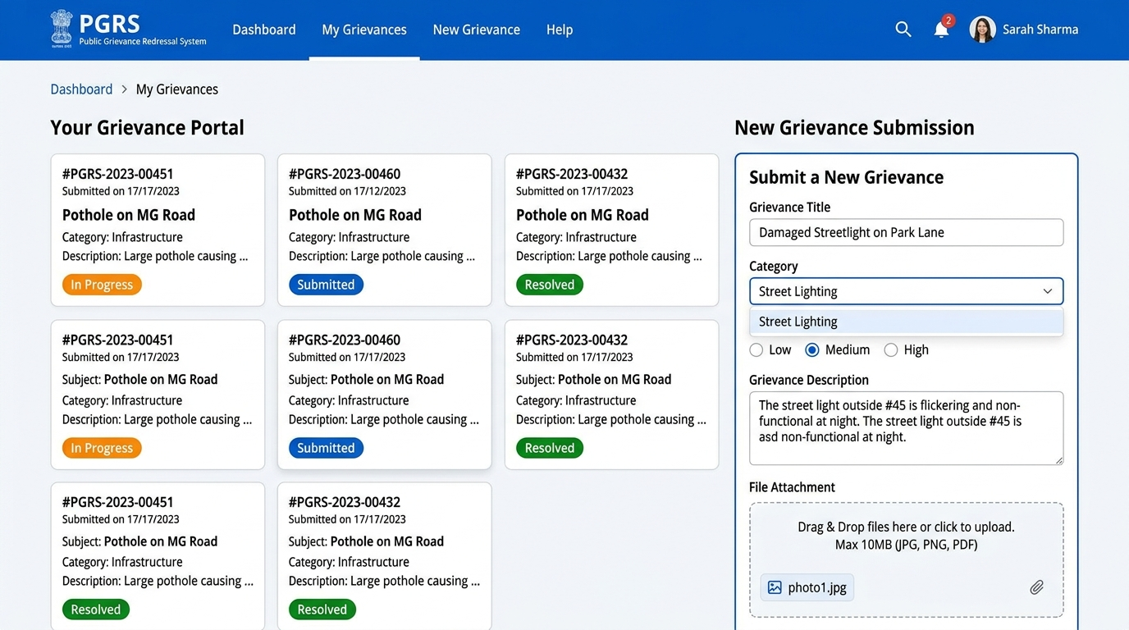
Figure 8.1: Citizen Grievance Dashboard & Submission View
Key Features Shown:
• My Grievances card list displaying complaint title, GRN, classification, and status badges (Submitted, In Progress, Resolved).
• Interactive New Grievance form with Title, Category selection dropdown, Priority radio selectors, Description textarea, and file dropzone.

8.2 Officer Portal (Assigned Complaint & Resolution Form)
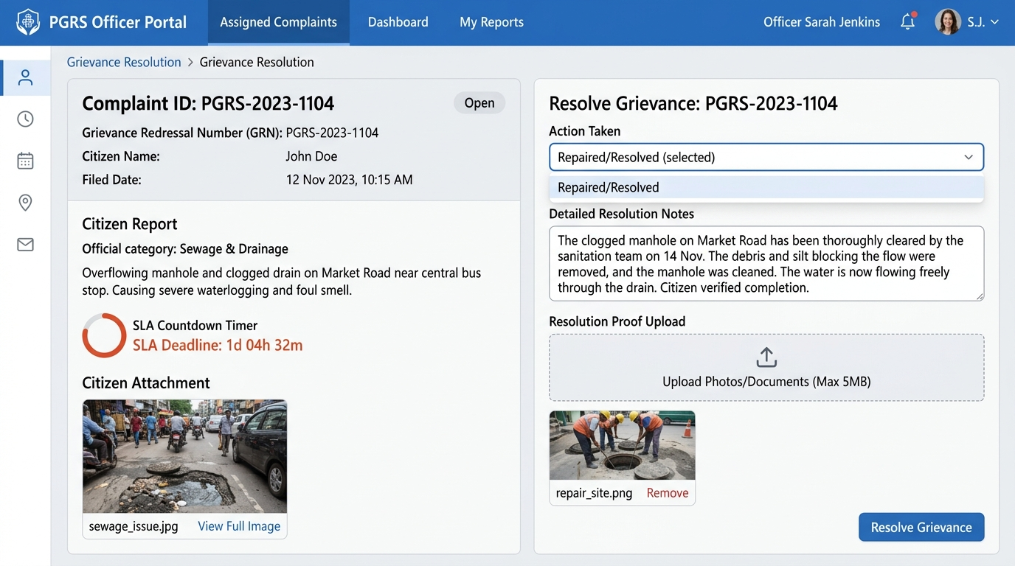
Figure 8.2: Officer Grievance Detail & Resolution Proof Submission Form
Key Features Shown:
• Assigned complaint panel with citizen report, description, citizen attachment photo preview, and SLA countdown timer badge.
• Resolution Form with Action Taken selector, Detailed Resolution Notes, Resolution Proof photo uploader, and Submit button.

8.3 Department Head Portal (Department Dashboard & Closure Review)
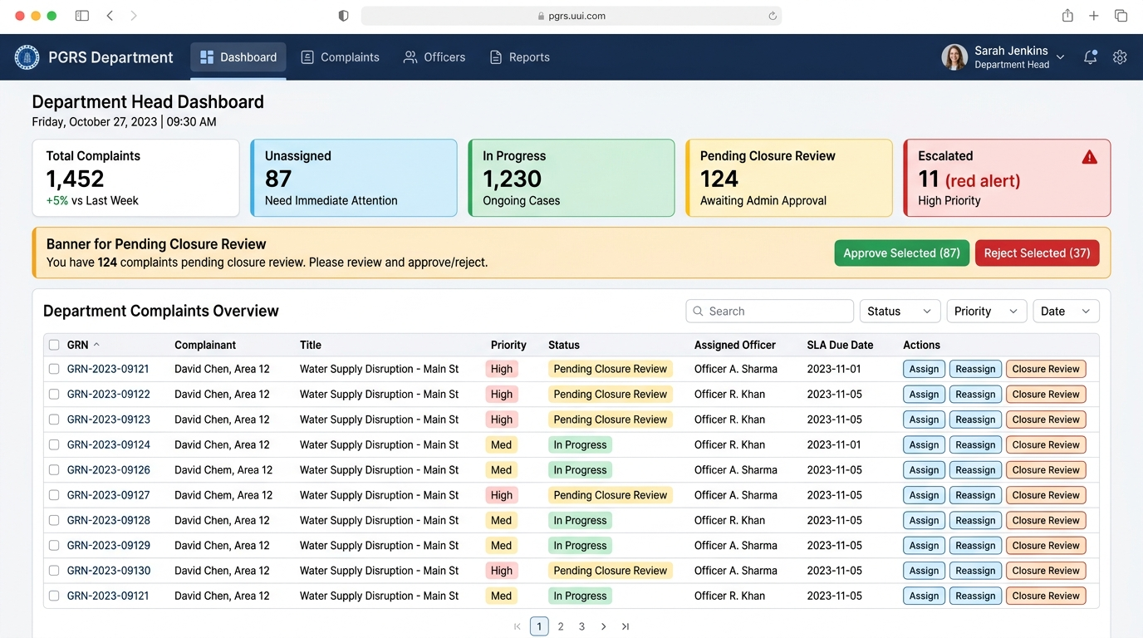
Figure 8.3: Department Head Governance Dashboard & Closure Review View
Key Features Shown:
• Department summary KPI cards (Total Complaints, Unassigned, In Progress, Pending Closure Review, Escalated).
• Urgent Pending Closure Review banner with Approve / Reject controls.
• Department Complaints data table with inline actions for Officer Assignment, Reassignment, and Closure Review.

8.4 Administrator Portal (Analytics & Governance Dashboard)
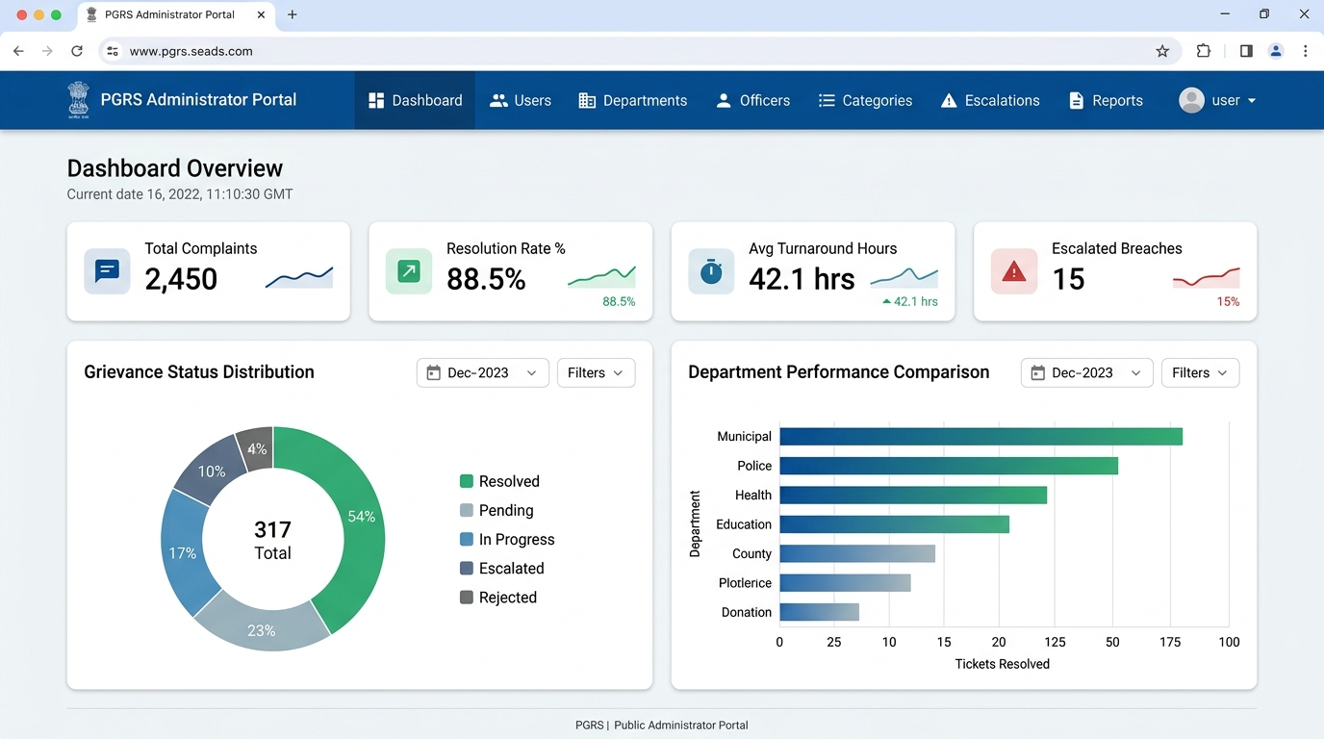
Figure 8.4: Administrator Executive Analytics & Performance Dashboard
Key Features Shown:
• Executive KPI cards (Total Complaints, Resolution Rate %, Avg Turnaround Hours, Escalated Breaches).
• Grievance Status Distribution breakdown doughnut chart and Department Performance comparison bar charts.
• Administration navigation links for Users, Departments, Officers, Categories, Escalations, and Reports.

