Software Requirements Specification
for
Public Grievance Redressal System
(PGRS)
Version 1.0 Approved
Prepared by Software Engineering Team
Department of Computer Science and Engineering
October 2026

Table of Contents
1. Introduction ............................................................ 3
1.1 Purpose .............................................................. 3
1.2 Document Conventions ................................................. 3
1.3 Intended Audience and Reading Suggestions ............................ 3
1.4 Product Scope ........................................................ 3
1.5 References ........................................................... 4
2. Overall Description ..................................................... 4
2.1 Product Perspective .................................................. 4
2.2 Product Functions .................................................... 4
2.3 User Classes and Characteristics ..................................... 5
2.4 Operating Environment ................................................ 10
2.5 Design and Implementation Constraints ................................ 10
2.6 User Documentation ................................................... 10
2.7 Assumptions and Dependencies ......................................... 11
3. External Interface Requirements ......................................... 11
3.1 User Interfaces ...................................................... 11
3.2 Hardware Interfaces .................................................. 11
3.3 Software Interfaces .................................................. 12
3.4 Communications Interfaces ............................................ 12
4. System Features ......................................................... 12
4.1 User Authentication and Role-Based Access Control .................... 12
4.2 Grievance Submission ................................................. 13
4.3 Grievance Tracking ................................................... 13
4.4 Officer Grievance Management ......................................... 13
4.5 Administrative Management ............................................ 14
4.6 Feedback and Rating System ........................................... 14
5. Other Nonfunctional Requirements ........................................ 15
5.1 Performance Requirements ............................................. 15
5.2 Safety Requirements .................................................. 15
5.3 Security Requirements ................................................ 15
5.4 Software Quality Attributes .......................................... 15
5.5 Business Rules ....................................................... 16
6. Other Requirements ...................................................... 16
6.1 Database Requirements ................................................ 16
6.2 Internationalization Requirements .................................... 16
6.3 Legal and Regulatory Requirements .................................... 16
6.4 Accessibility Requirements ........................................... 16
Appendix A: Glossary ....................................................... 16
Appendix B: Analysis Models ................................................ 17
B.1 System Architecture Overview ......................................... 17
B.2 Key Database Entities ................................................ 17
B.3 Class Diagram & Data Definitions ..................................... 18
B.4 Activity Diagrams & Workflows ........................................ 19
B.5 Sequence Diagrams .................................................... 21
B.6 State Chart Diagram .................................................. 23
B.7 UML Component Diagram ................................................ 24
B.8 UML Deployment Diagram ............................................... 25
B.9 Source Code & System User Interfaces ................................. 26
Appendix C: To Be Determined List .......................................... 34

Revision History
Name | Date | Reason For Changes | Version
Adhikesavan | October 2026 | Initial Draft & System Specification | 1.0

1. Introduction

1.1 Purpose
This Software Requirements Specification (SRS) defines the functional and non-functional requirements of the Public Grievance Redressal System (PGRS), Version 1.0. The PGRS is a standalone, web-based application that replaces existing manual grievance handling, which relies on paper forms, telephone calls, emails, and fragmented complaint records. The document covers the complete system scope, including grievance submission, tracking, officer assignment, resolution workflows, and administrative reporting, and serves as the primary reference for design, development, testing, and validation.

1.2 Document Conventions
This document follows the IEEE Std 830-1998 standard for Software Requirements Specifications. The following conventions apply:
• SHALL denotes mandatory requirements; SHOULD denotes recommended features.
• Functional requirements are identified as FR-XX and non-functional requirements as NFR-XX.
• Section headings follow a hierarchical decimal numbering system; bold text highlights critical terms and definitions.
• User roles (Citizen, Officer, Department Head, and Administrator) are identified explicitly throughout the document.
• Higher-level requirements propagate their priority levels to their child requirements unless stated otherwise.
• Dates, grievance records, and citizen information follow a standardized format to ensure consistency and ease of maintenance.

1.3 Intended Audience and Reading Suggestions
This SRS is intended for the following audiences:
• Software Developers and Engineers - design and implement the PGRS modules; read all sections.
• Project Managers - plan and track the project; focus on Sections 1, 2, and 5.
• System Testers and QA Engineers - verify that the system meets the specified requirements; focus on Sections 3 and 4.
• Government Officials and Stakeholders - policymakers and department heads who need to understand system capabilities; read Sections 1, 2, and 4.
• Database Administrators - responsible for schema design and management; focus on the data requirements in Section 4.
• Citizens - end users who submit grievances, check status, and view resolution history; focus on Section 4.
All readers should begin with Sections 1 and 2 before proceeding to the sections relevant to their role.

1.4 Product Scope
The PGRS is a full-featured, role-based web application that digitizes and streamlines grievance operations for government departments, municipalities, and public service organizations. It replaces manual, paper-based complaint processes with a centralized, secure, and efficient platform that enables fast grievance registration, transparent status tracking, and accountable resolution by government officers. Key objectives include:
• Providing a unified platform for citizens and government officers to manage grievances.
• Enabling real-time tracking of complaint status and resolution timelines.
• Automating grievance assignment, escalation, and reporting workflows.
• Generating insightful administrative reports for department heads and administrators.
• Supporting future integration with SMS gateways, government portals, and mobile applications.

1.5 References
1. IEEE Std 830-1998, "IEEE Recommended Practice for Software Requirements Specifications," IEEE, 1998.
2. Sommerville, I., "Software Engineering," 10th Edition, Pearson Education, 2015.
3. Pressman, R. S., "Software Engineering: A Practitioner's Approach," 8th Edition, McGraw-Hill, 2014.
4. PostgreSQL Documentation, PostgreSQL Global Development Group, https://www.postgresql.org/docs/; Supabase Documentation, https://supabase.com/docs.
5. React.js Documentation, Meta Open Source, https://reactjs.org/docs/.
6. Node.js Documentation, OpenJS Foundation, https://nodejs.org/en/docs/.
7. Express.js API Reference, https://expressjs.com/en/api.html.

2. Overall Description

2.1 Product Perspective
The PGRS is a new, standalone web application that replaces the physical registers, disconnected email chains, and ad-hoc tracking spreadsheets currently used by government departments to manage citizen complaints. It integrates all grievance-related activities into a single platform accessible through modern web browsers.
The React.js frontend provides dedicated dashboards for citizens, officers, department heads, and administrators. It communicates with a Node.js/Express.js backend that exposes a RESTful API and persists data in a centralized Supabase PostgreSQL database. The architecture consists of a client layer (web browser), an application layer (React.js and Node.js/Express.js), and a data layer (Supabase PostgreSQL); see Appendix B.1. The system is standalone but can be extended in the future to integrate with SMS gateways, government portals, and mobile applications.

2.2 Product Functions
The PGRS shall provide the following major functions:
1. User Authentication and Role-Based Access Control - secure login with role-specific permissions for Citizens, Officers, Department Heads, and Administrators.
2. Grievance Submission - complaint registration with category selection, description, document attachments, and location details.
3. Grievance Tracking - real-time status monitoring by citizens through a self-service portal.
4. Officer Assignment and Workflow Management - assignment of grievances to appropriate officers by administrators and department heads, based on department and category.
5. Resolution and Feedback - status updates, resolution notes, and closure by officers; feedback and ratings by citizens.
6. Escalation Management - automatic escalation of unresolved grievances that exceed defined SLA timelines.
7. Notification System - automated email and in-app notifications for submission, assignment, status updates, and resolution.
8. Report Generation - daily, weekly, and monthly reports on grievance volumes, resolution rates, officer performance, and department-wise analytics.
9. Audit Trail - a complete, immutable log of all actions performed on each grievance.

2.3 User Classes and Characteristics
The PGRS serves four distinct user classes: Administrator, Department Head, Government Officer, and Citizen. The use cases of each class are consolidated into a single use case description per user class, presented below.

1) Administrator Use Cases (UC-01 to UC-08)
Primary Actor: Administrator | Secondary Actor: System
Precondition: Administrator account is registered and active. Administrator is logged in with administrative and configuration privileges.
Postcondition: Administrator is authenticated and granted access to the administrative dashboard. User, department, officer, and complaint category/sub-category records are created, updated, activated, or deactivated. Escalation rules are configured. Analytics and reports are generated.
Main Access Scenario:
• UC-01 Admin Login: Administrator logs in via /login; system validates credentials and opens /admin/dashboard.
• UC-02 Manage Users: Administrator adds, edits, activates, or deactivates user accounts and assigns roles.
• UC-03 Manage Departments: Administrator creates and configures departments, assigns department heads, and sets default SLAs.
• UC-04 Manage Officers: Administrator creates officer profiles, assigns officers to departments, and monitors workload.
• UC-05 Manage Complaint Categories: Administrator adds and manages hierarchical categories and subcategories.
• UC-06 Configure Escalation Rules: Administrator configures SLA rules by department, category, and priority.
• UC-07 View Analytics Dashboard: System computes total, pending, escalated, and resolved grievances and displays live charts.
• UC-08 Generate Reports: Administrator filters by date range/department, generates summary reports, and exports to CSV or prints.

2) Department Head Use Cases (UC-09 to UC-16)
Primary Actor: Department Head | Secondary Actor: System
Precondition: Department Head account is registered and active. Complaints exist for the department.
Postcondition: Complaints are reviewed, assigned, or reassigned. Closure is approved/rejected. Department reports are generated.
Main Access Scenario:
• UC-09 Department Head Login: Head logs in and is redirected to /head/dashboard.
• UC-10 Review Complaints: Head browses complaints scoped strictly to their department and inspects details.
• UC-11 Assign Complaints to Officer: Head selects unassigned complaint, chooses active officer, and sets SLA due date.
• UC-12 Reassign Complaints: Head reassigns complaint to a different officer with a mandatory reason.
• UC-13 Monitor Complaint Progress: Head views status, SLA countdowns, and posts internal processing remarks.
• UC-14 Handle Escalations: Head reviews SLA-breached complaints and takes corrective re-assignment actions.
• UC-15 Approve Complaint Closure: Head reviews officer resolution proof: Approve sets status to Closed; Reject returns to In Progress with directives.
• UC-16 Generate Department Reports: Head generates performance and resolution statistics scoped to their department.

3) Government Officer Use Cases (UC-17 to UC-22)
Primary Actor: Officer | Secondary Actor: System
Precondition: Officer is registered, active, and assigned to complaints.
Postcondition: Complaints investigated, status updated, remarks added, resolution proof uploaded, and resolution submitted.
Main Access Scenario:
• UC-17 Officer Login: Officer logs in and accesses /officer/dashboard.
• UC-18 View Assigned Complaints: Officer reviews assigned grievance queue and SLA deadlines.
• UC-19 Update Complaint Status: Officer moves status from Assigned to In Progress.
• UC-20 Add Remarks: Officer logs internal investigation remarks.
• UC-21 Upload Resolution Proof: Officer uploads photo/document evidence of completed work.
• UC-22 Resolve Complaint: Officer submits action taken and marks case as Resolved for closure review.

4) Citizen Use Cases (UC-23 to UC-28)
Primary Actor: Citizen | Secondary Actor: System
Precondition: Citizen is registered or creates a new account.
Postcondition: Grievance registered with GRN, tracked in real-time, resolution verified, and feedback rating recorded.
Main Access Scenario:
• UC-23 Register: Citizen registers with name, email, mobile, and password.
• UC-24 Login: Citizen logs in and accesses /dashboard.
• UC-25 Submit Complaint: Citizen fills title, category, description, location, uploads attachments, and receives GRN.
• UC-26 Track Complaint Status: Citizen monitors live status timeline and officer remarks.
• UC-27 Verify Resolution: Citizen reviews resolution proof: Accept confirms closure; Reject reopens complaint.
• UC-28 Provide Feedback: Citizen rates resolution quality (1-5 stars) with comments.

2.4 Operating Environment
• Client Side: Google Chrome v100+, Mozilla Firefox v100+, Microsoft Edge v100+, Safari v15+ on Windows 10/11, macOS 12+, Ubuntu 20.04+. Responsive UI for desktop, tablet, and mobile.
• Server Side: Node.js v18+ with Express.js on Linux (Ubuntu 22.04 LTS). Minimum: 4-core CPU, 8 GB RAM, 100 GB SSD.
• Database: PostgreSQL hosted on Supabase (managed cloud database service).
• Frontend: React.js v18+ built with Vite, served via Nginx or Apache.
• Network: Stable internet connection with minimum 10 Mbps bandwidth.
• Security: HTTPS with TLS 1.2+ mandatory for all communications.

2.5 Design and Implementation Constraints
• Technology Stack: React.js (frontend), Node.js with Express.js (backend), Supabase PostgreSQL (database).
• Security Compliance: Passwords hashed with bcrypt; RBAC enforced at API level; JWT used for sessions.
• Database Design: Tables follow Third Normal Form (3NF) to eliminate redundancy.
• API Design: RESTful conventions with standardized JSON responses.
• Performance: Supports at least 200 concurrent users without degradation.

2.6 User Documentation
The following documentation shall be delivered in PDF format:
1. User Manual - comprehensive workflow guide for each role.
2. Administrator Guide - system configuration, user/department management, and backup procedures.
3. Quick Reference Cards - single-page role-specific cheat sheets.
4. Online Help System - context-sensitive assistance within the application.
5. Installation Guide - step-by-step setup and environment configuration.

2.7 Assumptions and Dependencies
Assumptions: Staff users have basic computer literacy; stable internet/LAN connection is available; citizen identity information is self-declared; Supabase PostgreSQL is available 24/7.
Dependencies: Node.js v18+ ecosystem, React.js v18+, Sequelize ORM, jsonwebtoken (JWT), Nodemailer SMTP, and PDFKit/jsPDF.

3. External Interface Requirements

3.1 User Interfaces
• Citizen Portal: Web interface for registration, login, complaint submission, status tracking, history, and feedback.
• Officer Dashboard: Task-centric view of assigned complaints with priority flags, SLA countdowns, and resolution form.
• Department Head Dashboard: Management view of department statistics, officer workload, SLA compliance, and closure review.
• Administrator Console: Full administrative interface for user/department management, category configuration, and reports.

3.2 Hardware Interfaces
Standard web-enabled client devices (desktops, laptops, tablets, smartphones) communicating over HTTPS with server hardware running Ubuntu 22.04 LTS (minimum 4-core CPU, 8 GB RAM, 100 GB SSD).

3.3 Software Interfaces
Software Component | Version | Interface Description
PostgreSQL Database (Supabase) | Managed service | Persistent storage for grievance records, user profiles, audit logs, and configuration data.
Node.js / Express.js | 18+ / 4.x | Backend application server providing RESTful API endpoints for all PGRS operations.
React.js | 18+ | Frontend SPA framework for all user-facing dashboards and portals.
Sequelize ORM | 6.x | Object-relational mapping layer for PostgreSQL database operations.
Nodemailer | Latest | SMTP-based email notification service for grievance updates.
JWT (jsonwebtoken) | Latest | Token-based authentication and session management.
PDFKit / jsPDF | Latest | PDF generation for acknowledgment receipts and reports.
Nginx / Apache | Latest stable | Web server for serving React.js build and reverse-proxying API requests.

3.4 Communications Interfaces
HTTPS with TLS 1.2+ for all client-server communications; RESTful API returning standardized JSON; SMTP email delivery for transactional notifications; multipart/form-data upload supporting up to 5 MB per file and 3 attachments per complaint.

4. System Features

4.1 User Authentication and Role-Based Access Control
Priority: High. Provides secure registration, login, logout, authentication, and role-based access for Citizens, Officers, Department Heads, and Administrators.
Req ID | Functional Requirement Description
FR-01 | The system SHALL provide a secure login interface accepting registered email address and password.
FR-02 | The system SHALL hash all passwords using bcrypt with a minimum cost factor of 10 before storage.
FR-03 | The system SHALL issue a JWT access token upon successful authentication, valid for 8 hours.
FR-04 | The system SHALL enforce role-based access control (RBAC) at both the API and frontend route levels.
FR-05 | The system SHALL lock a user account for 15 minutes after 5 consecutive failed login attempts.
FR-06 | The system SHALL provide a password reset workflow via a time-limited (1-hour) email link.
FR-07 | The system SHALL log all authentication events (login, logout, failed attempts) in the audit trail.

4.2 Grievance Submission
Priority: High. Allows registered citizens to submit complaints with structured classification and file attachments.
Req ID | Functional Requirement Description
FR-08 | The system SHALL provide a submission form for: Title, Category, Sub-category, Department, Description, Location, and Attachments.
FR-09 | The system SHALL auto-generate a unique Grievance Reference Number (GRN) in the format PGRS-YYYY-XXXXXX upon submission.
FR-10 | The system SHALL support attachments (JPG, PNG, PDF) with a maximum size of 5 MB per file and max 3 files per complaint.
FR-11 | The system SHALL send an email acknowledgment containing the GRN, timestamp, and expected SLA timeline.
FR-12 | The system SHALL set the initial grievance status to 'Submitted' and record the submission timestamp.
FR-13 | The system SHALL allow citizens to save a grievance draft before final submission.

4.3 Grievance Tracking
Priority: High. Enables citizens to monitor real-time status, timeline stages, and officer remarks.
Req ID | Functional Requirement Description
FR-14 | The system SHALL provide a 'My Grievances' dashboard displaying submitted complaints with live status indicators.
FR-15 | The system SHALL display a real-time status timeline showing: Submitted, Assigned, In Progress, Resolved, and Closed stages.
FR-16 | The system SHALL allow citizens to search and filter grievances by GRN, status, category, and date range.
FR-17 | The system SHALL allow citizens to download a PDF acknowledgment receipt for any submitted grievance.
FR-18 | The system SHALL allow citizens to add follow-up comments or additional information to an open grievance.

4.4 Officer Grievance Management
Priority: High. Equips officers to view assigned cases, record remarks, upload resolution proof, and mark complaints resolved.
Req ID | Functional Requirement Description
FR-19 | The system SHALL provide officers with a dashboard displaying assigned grievances, SLA timers, and action buttons.
FR-20 | The system SHALL allow officers to update grievance status (Assigned, In Progress, Resolved).
FR-21 | The system SHALL allow officers to add internal remarks and public resolution descriptions.
FR-22 | The system SHALL require officers to upload resolution proof documents/photos upon resolving a complaint.
FR-23 | The system SHALL notify citizens via email and in-app notifications upon status changes.

4.5 Administrative Management
Priority: High. Enables administrators and department heads to manage users, assign officers, configure escalation rules, and generate reports.
Req ID | Functional Requirement Description
FR-24 | The system SHALL allow administrators to create, edit, activate, and deactivate accounts for all roles.
FR-25 | The system SHALL allow administrators to configure departments, categories, sub-categories, and SLA escalation rules.
FR-26 | The system SHALL allow administrators and department heads to assign or re-assign grievances to officers.
FR-27 | The system SHALL automatically escalate grievances exceeding SLA deadlines to the department head.
FR-28 | The system SHALL generate daily, weekly, and monthly reports on volume, resolution rates, and SLA compliance, exportable to CSV/PDF.
FR-29 | The system SHALL maintain an immutable audit trail logging all status transitions and modifications.

4.6 Feedback and Rating System
Priority: Medium. Collects citizen satisfaction ratings and qualitative feedback upon complaint resolution.
Req ID | Functional Requirement Description
FR-30 | The system SHALL allow citizens to rate resolved grievances on a 1-5 star scale with optional written comments.
FR-31 | The system SHALL aggregate satisfaction ratings across officers and departments on administrative dashboards.
FR-32 | The system SHALL allow citizens to reject resolution and reopen a grievance within 7 days if unsatisfied.

5. Other Nonfunctional Requirements

5.1 Performance Requirements
Req ID | Performance Requirement Description
NFR-01 | The system SHALL support a minimum of 200 concurrent users without performance degradation.
NFR-02 | All API responses SHALL be returned within 2 seconds under normal load conditions.
NFR-03 | The system SHALL be capable of handling a minimum of 1,000 grievance submissions per day.
NFR-04 | Database query response times SHALL not exceed 500 milliseconds for standard read operations.
NFR-05 | The system SHALL achieve a minimum page load time of under 3 seconds on a standard 10 Mbps connection.

5.2 Safety Requirements
Req ID | Safety Requirement Description
NFR-06 | The system SHALL perform automated daily database backups to cloud storage.
NFR-07 | The system SHALL provide data recovery capabilities allowing restoration to within the last 24 hours.
NFR-08 | The system SHALL display user-friendly error messages without exposing internal stack traces or database info.

5.3 Security Requirements
Req ID | Security Requirement Description
NFR-09 | All communications between client and server SHALL use HTTPS with TLS 1.2 or higher.
NFR-10 | All passwords SHALL be stored as bcrypt hashes with a minimum cost factor of 10.
NFR-11 | The system SHALL enforce role-based access control; users only access data permitted by their role.
NFR-12 | The system SHALL implement input validation and sanitization to prevent SQL Injection and XSS attacks.
NFR-13 | JWT tokens SHALL have a maximum validity of 8 hours.
NFR-14 | Personally Identifiable Information (PII) of citizens SHALL be encrypted at rest using AES-256.

5.4 Software Quality Attributes
Quality Attribute | Description
Availability | The system shall target 99.5% uptime during government working hours (8 AM - 8 PM).
Usability | The citizen portal shall be usable without training; workflows completable within 3-5 clicks.
Maintainability | Codebase follows modular architecture; new departments and categories addable without code changes.
Scalability | System architecture supports horizontal scaling to accommodate growing grievance volume.
Reliability | Mean Time Between Failures (MTBF) of at least 720 hours.
Portability | Deployable on Linux environments supporting Node.js v18+ and Supabase PostgreSQL.
Testability | All API endpoints testable via automated unit and integration suites with >= 70% coverage.

5.5 Business Rules
• A citizen SHALL be required to register with a verified email address before submitting a grievance.
• Each grievance SHALL be assigned to a single officer at any given time; re-assignment is logged in the audit trail.
• An officer SHALL not be able to close a grievance without entering resolution details and proof.
• Grievances SHALL be automatically escalated to the department head if exceeding SLA timelines.
• Citizens SHALL only have access to their own grievance records; cross-user data access is prohibited.
• Deleted user accounts SHALL be anonymized; grievance records are retained for audit per government policies.

6. Other Requirements
6.1 Database Requirements: PostgreSQL schema on Supabase following 3NF representing Users, Grievances, StatusHistory, Departments, Categories, SubCategories, Attachments, Notifications, AuditLogs, Feedback, and Comments. Foreign keys enforce referential integrity.
6.2 Internationalization Requirements: UTF-8 encoding supporting English Version 1.0 with architectural support for future multi-language regional localization.
6.3 Legal and Regulatory Requirements: Compliance with IT security standards; grievance records maintained for minimum 5 years.
6.4 Accessibility Requirements: WCAG 2.1 Level AA compliance with high contrast and screen reader compatibility.

Appendix A: Glossary
Term / Acronym | Definition
PGRS | Public Grievance Redressal System - the web application described in this document.
GRN | Grievance Reference Number - unique identifier auto-generated for each submitted grievance (e.g. PGRS-YYYY-XXXXXX).
SLA | Service Level Agreement - the maximum time within which a grievance must be resolved.
RBAC | Role-Based Access Control - security model assigning permissions to user roles.
JWT | JSON Web Token - compact token format used for stateless authentication and session management.
RESTful API | Representational State Transfer API using standard HTTP methods and JSON data.
ORM | Object-Relational Mapping layer (Sequelize) used for database operations.
SRS | Software Requirements Specification - this specification document.
NFR / FR | Non-Functional Requirement / Functional Requirement.
PII | Personally Identifiable Information - sensitive citizen identity data.

Appendix B: Analysis Models

B.1 System Architecture Overview
The PGRS follows a robust three-tier architecture: (1) Presentation Layer built in React.js; (2) Application Layer built in Node.js/Express.js providing RESTful services; and (3) Data Layer managed via Supabase PostgreSQL and Sequelize ORM.

B.2 Key Database Entities
Entity | Key Attributes
Users | user_id, name, email, password_hash, role, mobile, department_id, is_active, created_at
Departments | department_id, name, head_user_id, sla_days, description, is_active
Categories | category_id, name, department_id, description, is_active
SubCategories | sub_category_id, category_id, name, description, is_active
Grievances | grievance_id, grn, title, description, sub_category_id, department_id, citizen_id, location, current_status, priority, sla_due_date, assigned_at, resolved_at, closed_at
GrievanceAssignments | assignment_id, grievance_id, officer_id, assigned_by, assigned_at, unassigned_at, reason
GrievanceStatusHistory | history_id, grievance_id, changed_by, old_status, new_status, note, changed_at
Attachments | attachment_id, grievance_id, file_name, stored_name, file_path, file_type, file_size, attachment_type, uploaded_by, uploaded_at
Resolutions | resolution_id, grievance_id, officer_id, action_taken, resolution_description, resolved_at
ResolutionVerifications | verification_id, resolution_id, citizen_id, decision, rejection_reason, verified_at
Escalations | escalation_id, grievance_id, department_head_id, escalated_by_system, escalated_at, resolved_at
EscalationRules | rule_id, department_id, category_id, priority, sla_days, is_active
Comments | comment_id, grievance_id, user_id, content, is_internal, created_at
Notifications | notification_id, user_id, message, type, grievance_id, is_read, created_at
Feedback | feedback_id, grievance_id, citizen_id, rating, comment, submitted_at
AuditLogs | log_id, user_id, action, entity_type, entity_id, details, ip_address, timestamp
Reports | report_id, report_type, generated_by, parameters, generated_at

B.3 Class Dictionary and Data Definitions
Class Name | Responsibility | Core Methods / Operations
User | Common authentication and user identity. | login(), logout()
Citizen | Submits complaints, tracks status, verifies resolutions, feedback. | submitComplaint(), trackStatus(), verifyResolution(), provideFeedback()
Officer | Investigates assigned complaints, uploads resolution proof. | viewAssigned(), updateStatus(), addRemarks(), uploadProof(), resolveComplaint()
DepartmentHead | Governance, assignment, reassignment, escalation, closure approval. | reviewComplaints(), assignOfficer(), reassignOfficer(), approveClosure()
Admin | System administration, departments, categories, escalation rules, reports. | manageUsers(), manageDepartments(), configureEscalation(), generateReports()
Grievance | Stores complaint lifecycle, state transitions, and SLA deadlines. | submit(), assign(), updateStatus(), resolve(), close()

B.9 Source Code and System User Interfaces
This section presents the core, representative source code modules and user interface screenshots from the implemented Public Grievance Redressal System (PGRS).

7.1 Authentication and Role-Based Access Control
File: backend/src/controllers/authController.js
Purpose: Handles citizen registration, login authentication, password hash comparison, and JWT generation with role payload.
'use strict';
const AuthService = require('../services/authService');
const { log } = require('../services/auditService');
exports.register = async (req, res, next) => {
try {
const user = await AuthService.registerCitizen(req.body);
await log(user.user_id, 'REGISTER_CITIZEN', 'user', user.user_id, null, req.ip);
res.status(201).json({ success: true, message: 'Registration successful' });
} catch (err) {
next(err);
}
};
exports.login = async (req, res, next) => {
try {
const { email, password } = req.body;
const { token, user } = await AuthService.login(email, password);
await log(user.user_id, 'LOGIN', 'user', user.user_id, null, req.ip);
res.json({ success: true, token, user });
} catch (err) {
next(err);
}
};
exports.logout = async (req, res) => {
const userId = req.user ? req.user.user_id : null;
if (userId) {
await log(userId, 'LOGOUT', 'user', userId, null, req.ip);
}
res.json({ success: true, message: 'Logged out successfully' });
};

File: backend/src/middleware/auth.js
Purpose: Verifies Bearer JWT tokens on incoming requests, checks account active status, and restricts endpoints via role guards.
'use strict';
const jwt = require('jsonwebtoken');
const { User } = require('../models');
const verifyToken = async (req, res, next) => {
const authHeader = req.headers.authorization;
if (!authHeader || !authHeader.startsWith('Bearer ')) {
return res.status(401).json({ success: false, message: 'No token provided' });
}
const token = authHeader.split(' ')[1];
try {
const decoded = jwt.verify(token, process.env.JWT_SECRET);
const user = await User.findByPk(decoded.user_id, {
attributes: ['user_id', 'role', 'department_id', 'email', 'name', 'is_active'],
});
if (!user || !user.is_active) {
return res.status(401).json({ success: false, message: 'Account inactive or not found' });
}
req.user = user.toJSON();
return next();
} catch (err) {
if (err.name === 'TokenExpiredError') {
return res.status(401).json({ success: false, message: 'Token expired' });
}
return res.status(401).json({ success: false, message: 'Invalid token' });
}
};
const requireRole = (...roles) => (req, res, next) => {
if (!req.user) {
return res.status(401).json({ success: false, message: 'Unauthenticated' });
}
if (!roles.includes(req.user.role)) {
return res.status(403).json({ success: false, message: 'Forbidden: insufficient role' });
}
return next();
};
module.exports = { verifyToken, requireRole };

7.2 Grievance Submission
File: backend/src/controllers/grievanceController.js
Purpose: Receives citizen grievance payload and files, invokes service validation, and logs the submission audit record.
exports.submit = async (req, res, next) => {
try {
const grievance = await GrievanceService.submitGrievance(
req.body,
req.user.user_id,
req.files || [],
);
await log(req.user.user_id, 'SUBMIT_GRIEVANCE', 'grievance', grievance.grievance_id, null, req.ip);
res.status(201).json({
success: true,
message: 'Grievance submitted successfully',
data: { grievance_id: grievance.grievance_id, grn: grievance.grn },
});
} catch (err) {
next(err);
}
};

File: backend/src/services/grievanceService.js
Purpose: Validates category classification, generates unique GRN, derives department ownership, persists attachments, and records initial status history.
static async submitGrievance(data, citizenId, files) {
const { title, description, sub_category_id, location, priority } = data;
const subCat = await SubCategory.findByPk(sub_category_id, {
include: [{ model: Category, as: 'category' }],
});
if (!subCat || !subCat.is_active || !subCat.category || !subCat.category.is_active) {
throw Object.assign(new Error('Invalid or inactive category classification'), { status: 400 });
}
const department_id = subCat.category.department_id;
const grn = generateGRN();
const g = await Grievance.create({
grn,
title,
description,
sub_category_id,
department_id,
citizen_id: citizenId,
location: location || null,
priority: priority || 'medium',
current_status: 'SUBMITTED',
});
if (files && files.length > 0) {
await Attachment.bulkCreate(files.map(file => ({
grievance_id: g.grievance_id,
file_name: file.originalname,
stored_name: file.filename,
file_path: file.path,
file_type: file.mimetype,
file_size: file.size,
attachment_type: 'citizen_document',
uploaded_by: citizenId,
})));
}
await GrievanceStatusHistory.create({
grievance_id: g.grievance_id,
changed_by: citizenId,
old_status: null,
new_status: 'SUBMITTED',
note: 'Grievance submitted by citizen',
});
return g;
}

7.3 Grievance Assignment
File: backend/src/services/grievanceService.js
Purpose: Assigns unassigned complaints to a department officer, queries escalation rules to compute SLA target deadlines, and updates status to ASSIGNED.
static async assignOfficer(grievanceId, officerId, assignerUser) {
const g = await this.checkAccess(grievanceId, assignerUser);
const existing = await this._activeAssignment(grievanceId);
if (existing) {
throw Object.assign(new Error('Grievance already has an active assignment. Use reassign instead.'), { status: 400 });
}
const officer = await User.findOne({
where: { user_id: officerId, role: 'officer', department_id: g.department_id, is_active: true },
});
if (!officer) {
throw Object.assign(new Error('Officer not found, inactive, or not in this department'), { status: 400 });
}
const assignedAt = new Date();
const categoryId = g.subCategory?.category?.category_id || null;
// Resolve SLA Days via EscalationRule hierarchy
const rule = await EscalationRule.findOne({
where: {
[Op.or]: [
{ department_id: g.department_id, category_id: categoryId, priority: g.priority },
{ department_id: g.department_id, category_id: categoryId, priority: null },
{ department_id: g.department_id, category_id: null, priority: g.priority },
{ department_id: g.department_id, category_id: null, priority: null },
{ department_id: null, category_id: null, priority: null }
],
is_active: true
},
order: [['category_id', 'DESC'], ['priority', 'DESC'], ['department_id', 'DESC']]
});
const slaDays = rule ? rule.sla_days : 7;
const slaDue = new Date(assignedAt.getTime() + slaDays * 24 * 60 * 60 * 1000);
await GrievanceAssignment.create({
grievance_id: g.grievance_id,
officer_id: officerId,
assigned_by: assignerUser.user_id,
assigned_at: assignedAt,
});
const oldStatus = g.current_status;
await g.update({
current_status: 'ASSIGNED',
assigned_at: assignedAt,
sla_due_date: slaDue,
});
await GrievanceStatusHistory.create({
grievance_id: g.grievance_id,
changed_by: assignerUser.user_id,
old_status: oldStatus,
new_status: 'ASSIGNED',
note: `Assigned to officer ID ${officerId}`,
});
return g;
}

7.4 Grievance Resolution
File: backend/src/controllers/grievanceController.js
Purpose: Receives officer resolution data and proofs, executes state change, and returns resolution summary.
exports.resolve = async (req, res, next) => {
try {
const { grievance, resolution } = await GrievanceService.resolveGrievance(
req.params.id,
req.body,
req.files || [],
req.user,
);
await log(req.user.user_id, 'RESOLVE_GRIEVANCE', 'grievance', grievance.grievance_id,
{ resolution_id: resolution.resolution_id }, req.ip);
res.json({ success: true, message: 'Grievance resolved successfully', data: { resolution } });
} catch (err) {
next(err);
}
};

File: backend/src/services/grievanceService.js
Purpose: Validates officer ownership, creates resolution entry, saves resolution proof attachments, and updates status to RESOLVED.
static async resolveGrievance(grievanceId, data, files, officerUser) {
const g = await this.checkAccess(grievanceId, officerUser);
if (g.current_status !== 'IN_PROGRESS') {
throw Object.assign(
new Error(`Cannot resolve: grievance is in state ${g.current_status}. Must be IN_PROGRESS.`),
{ status: 400 },
);
}
const { action_taken, resolution_description } = data;
if (!action_taken || !resolution_description) {
throw Object.assign(new Error('action_taken and resolution_description are required'), { status: 400 });
}
const resolution = await Resolution.create({
grievance_id: g.grievance_id,
officer_id: officerUser.user_id,
action_taken,
resolution_description,
});
if (files && files.length > 0) {
await Attachment.bulkCreate(files.map(file => ({
grievance_id: g.grievance_id,
file_name: file.originalname,
stored_name: file.filename,
file_path: file.path,
file_type: file.mimetype,
file_size: file.size,
attachment_type: 'resolution_proof',
uploaded_by: officerUser.user_id,
})));
}
const oldStatus = g.current_status;
await g.update({ current_status: 'RESOLVED' });
await GrievanceStatusHistory.create({
grievance_id: g.grievance_id,
changed_by: officerUser.user_id,
old_status: oldStatus,
new_status: 'RESOLVED',
note: 'Grievance resolved by officer',
});
return { grievance: g, resolution };
}

7.5 Resolution Proof Upload
File: backend/src/config/multer.js
Purpose: Configures multipart storage, creates isolated grievance subdirectories, and validates file formats and size limits.
'use strict';
const multer = require('multer');
const path = require('path');
const crypto = require('crypto');
const fs = require('fs');
const storageDir = process.env.UPLOAD_PATH || './uploads';
const getGrievanceDir = (req) => {
const baseId = req.params.id || req.body.grievance_id || 'temp';
const dest = path.join(storageDir, 'grievances', String(baseId));
if (!fs.existsSync(dest)) {
fs.mkdirSync(dest, { recursive: true });
}
return dest;
};
const storage = multer.diskStorage({
destination: (req, _file, cb) => {
cb(null, getGrievanceDir(req));
},
filename: (_req, file, cb) => {
const uniqueSuffix = crypto.randomUUID() + path.extname(file.originalname);
cb(null, uniqueSuffix);
}
});
const fileFilter = (_req, file, cb) => {
const allowedMimeTypes = [
'image/jpeg', 'image/png', 'image/gif',
'application/pdf', 'application/msword',
'application/vnd.openxmlformats-officedocument.wordprocessingml.document'
];
if (allowedMimeTypes.includes(file.mimetype)) {
cb(null, true);
} else {
cb(Object.assign(new Error('Invalid file type'), { status: 400 }), false);
}
};
const upload = multer({
storage: storage,
limits: { fileSize: 5 * 1024 * 1024 }, // 5 MB limit
fileFilter: fileFilter
});
module.exports = upload;

7.6 Department Head Closure Approval / Rejection
File: backend/src/services/grievanceService.js
Purpose: Allows Department Heads to review submitted resolution proofs: approval marks the case CLOSED, while rejection returns the case to IN_PROGRESS with directives.
static async approveClosure(grievanceId, decision, remarks, headUser) {
const g = await this.checkAccess(grievanceId, headUser);
if (g.current_status !== 'RESOLVED') {
throw Object.assign(
new Error(`Cannot review closure: grievance is in state ${g.current_status}. Must be RESOLVED.`),
{ status: 400 },
);
}
if (decision === 'rejected' && (!remarks || !remarks.trim())) {
throw Object.assign(new Error('Remarks are required when rejecting a resolution.'), { status: 400 });
}
const oldStatus = g.current_status;
const newStatus = decision === 'approved' ? 'CLOSED' : 'IN_PROGRESS';
const now = new Date();
await g.update({
current_status: newStatus,
closed_at: decision === 'approved' ? now : null,
});
const note = decision === 'approved'
? (remarks || 'Resolution approved by Department Head. Grievance closed.')
: `Resolution rejected by Department Head. Returned to officer. Remarks: ${remarks}`;
await GrievanceStatusHistory.create({
grievance_id: g.grievance_id,
changed_by: headUser.user_id,
old_status: oldStatus,
new_status: newStatus,
note,
});
if (remarks) {
await Comment.create({
grievance_id: g.grievance_id,
user_id: headUser.user_id,
content: decision === 'approved' ? `Closure Approved: ${remarks}` : `Closure Review Rejected: ${remarks}`,
is_internal: true,
});
}
return g;
}

7.7 Automated SLA Escalation
File: backend/src/jobs/slaMonitorJob.js
Purpose: Hourly cron engine detecting SLA overdue grievances, updating status to ESCALATED, and notifying the Department Head.
'use strict';
const cron = require('node-cron');
const { Op } = require('sequelize');
const { Grievance, GrievanceStatusHistory, Escalation, Notification, Department } = require('../models');
async function runSlaCheck() {
const overdueGrievances = await Grievance.findAll({
where: {
current_status: { [Op.in]: ['ASSIGNED', 'IN_PROGRESS'] },
sla_due_date: { [Op.lt]: new Date() },
},
include: [{ model: Department, as: 'department', attributes: ['head_user_id'] }],
});
if (overdueGrievances.length === 0) return 0;
let escalated = 0;
for (const g of overdueGrievances) {
const existingEscalation = await Escalation.findOne({
where: { grievance_id: g.grievance_id, escalated_by_system: true },
});
if (existingEscalation) continue;
const oldStatus = g.current_status;
await g.update({ current_status: 'ESCALATED' });
await Escalation.create({
grievance_id: g.grievance_id,
escalated_by_system: true,
escalated_at: new Date(),
department_head_id: g.department?.head_user_id,
});
await GrievanceStatusHistory.create({
grievance_id: g.grievance_id,
changed_by: null,
old_status: oldStatus,
new_status: 'ESCALATED',
note: `System auto-escalation: SLA due date (${g.sla_due_date}) exceeded.`,
});
if (g.department?.head_user_id) {
await Notification.create({
user_id: g.department.head_user_id,
message: `ESCALATION: Grievance ${g.grn} has exceeded its SLA. Requires immediate attention.`,
type: 'escalation',
grievance_id: g.grievance_id,
});
}
escalated++;
}
return escalated;
}
const slaMonitorJob = cron.schedule('0 * * * *', async () => {
try {
await runSlaCheck();
} catch (error) {
console.error('[SLA Monitor] Error during SLA check:', error);
}
}, { scheduled: false });
module.exports = slaMonitorJob;
module.exports.runSlaCheck = runSlaCheck;

7.8 Admin & Department Report Generation
File: backend/src/services/reportService.js
Purpose: Aggregates departmental performance statistics, priority counts, SLA compliance metrics, and average turnaround hours.
static async generateSummary(user, filters = {}) {
const where = this._buildWhere(user, filters);
const total = await Grievance.count({ where });
const statusRows = await Grievance.findAll({
where,
attributes: ['current_status', [fn('COUNT', col('grievance_id')), 'count']],
group: ['current_status'],
raw: true,
});
const byStatus = {};
for (const row of statusRows) {
byStatus[row.current_status] = parseInt(row.count, 10);
}
const priorityRows = await Grievance.findAll({
where,
attributes: ['priority', [fn('COUNT', col('grievance_id')), 'count']],
group: ['priority'],
raw: true,
});
const byPriority = {};
for (const row of priorityRows) {
byPriority[row.priority] = parseInt(row.count, 10);
}
const resolved = await Grievance.count({ where: { ...where, current_status: 'RESOLVED' } });
const closed = await Grievance.count({ where: { ...where, current_status: 'CLOSED' } });
const escalated = await Grievance.count({ where: { ...where, current_status: 'ESCALATED' } });
// Compute average turnaround time in hours (PostgreSQL EXTRACT)
const diffExpression = 'EXTRACT(EPOCH FROM (closed_at - assigned_at)) / 3600';
const avgResolutionResult = await Grievance.findOne({
where: {
...where,
current_status: 'CLOSED',
assigned_at: { [Op.ne]: null },
closed_at: { [Op.ne]: null },
},
attributes: [[fn('AVG', literal(diffExpression)), 'avg_hours']],
raw: true,
});
const avgResolutionHours = avgResolutionResult && avgResolutionResult.avg_hours != null
? parseFloat(parseFloat(avgResolutionResult.avg_hours).toFixed(2))
: null;
await Report.create({
report_type: 'status',
generated_by: user.user_id,
parameters: { filters, generated_at: new Date().toISOString() },
});
return {
total,
by_status: byStatus,
by_priority: byPriority,
resolved,
closed,
escalated,
avg_resolution_hours: avgResolutionHours,
applied_filters: filters,
};
}

7.9 Citizen Resolution Verification & Feedback
File: backend/src/services/feedbackService.js
Purpose: Validates feedback submissions on closed grievances and records 1-to-5 star citizen ratings.
'use strict';
const { Grievance, Feedback } = require('../models');
class FeedbackService {
static async submitFeedback(grievanceId, data, citizenUser) {
const { rating, comment } = data;
const r = parseInt(rating, 10);
if (!r || r < 1 || r > 5) {
throw Object.assign(new Error('Rating must be an integer between 1 and 5.'), { status: 400 });
}
const g = await Grievance.findByPk(grievanceId);
if (!g || g.citizen_id !== citizenUser.user_id) {
throw Object.assign(new Error('Forbidden: not your grievance.'), { status: 403 });
}
if (g.current_status !== 'CLOSED') {
throw Object.assign(new Error('Feedback can only be submitted for CLOSED grievances.'), { status: 400 });
}
const existing = await Feedback.findOne({ where: { grievance_id: grievanceId } });
if (existing) {
throw Object.assign(new Error('Feedback has already been submitted for this grievance.'), { status: 409 });
}
return Feedback.create({
grievance_id: grievanceId,
citizen_id: citizenUser.user_id,
rating: r,
comment: comment || null,
});
}
}
module.exports = FeedbackService;

7.10 Frontend Role Guard & Dashboard Routing
File: frontend/src/components/ProtectedRoute.jsx
Purpose: Client-side React router guard that authenticates sessions and redirects users to their appropriate dashboard portal.
import React, { useContext } from 'react';
import { Navigate } from 'react-router-dom';
import { AuthContext } from '../context/AuthContext';
export const getRoleHome = (role) => {
switch (role) {
case 'officer':
return '/officer/dashboard';
case 'department_head':
return '/head/dashboard';
case 'administrator':
return '/admin/dashboard';
case 'citizen':
default:
return '/dashboard';
}
};
const ProtectedRoute = ({ children, allowedRoles }) => {
const { user, loading } = useContext(AuthContext);
if (loading) {
return (
<div className="flex items-center justify-center min-h-screen">
<div className="spinner"></div>
</div>
);
}
if (!user) {
return <Navigate to="/login" replace />;
}
if (allowedRoles && !allowedRoles.includes(user.role)) {
return <Navigate to={getRoleHome(user.role)} replace />;
}
return children;
};
export default ProtectedRoute;

8. User Interface Screenshots

8.1 Citizen Portal (Dashboard & Grievance Submission)
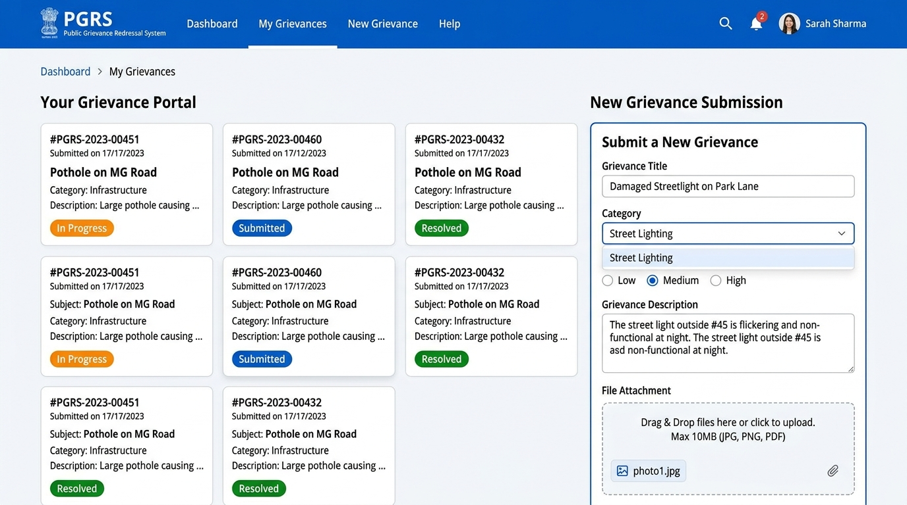
Figure 8.1: Citizen Grievance Dashboard & Submission Form

8.2 Officer Portal (Assigned Complaint & Resolution Form)
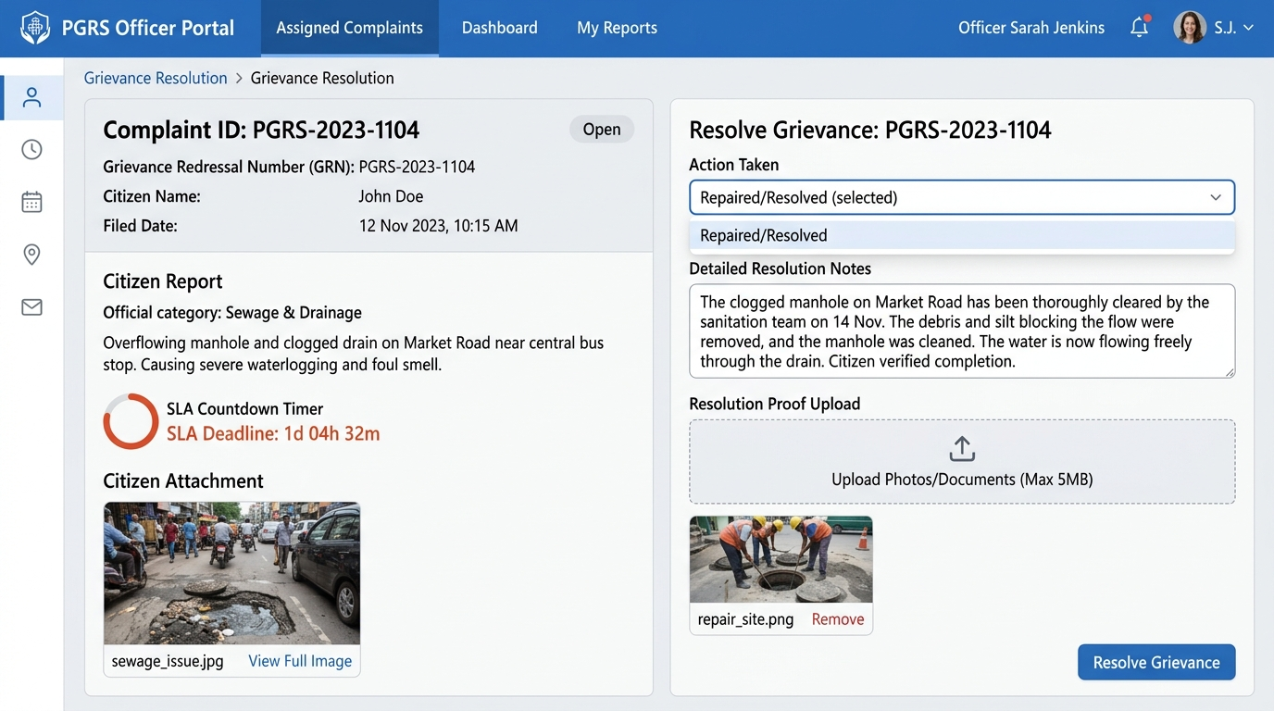
Figure 8.2: Officer Complaint Review & Resolution Proof Submission

8.3 Department Head Portal (Department Dashboard & Closure Review)
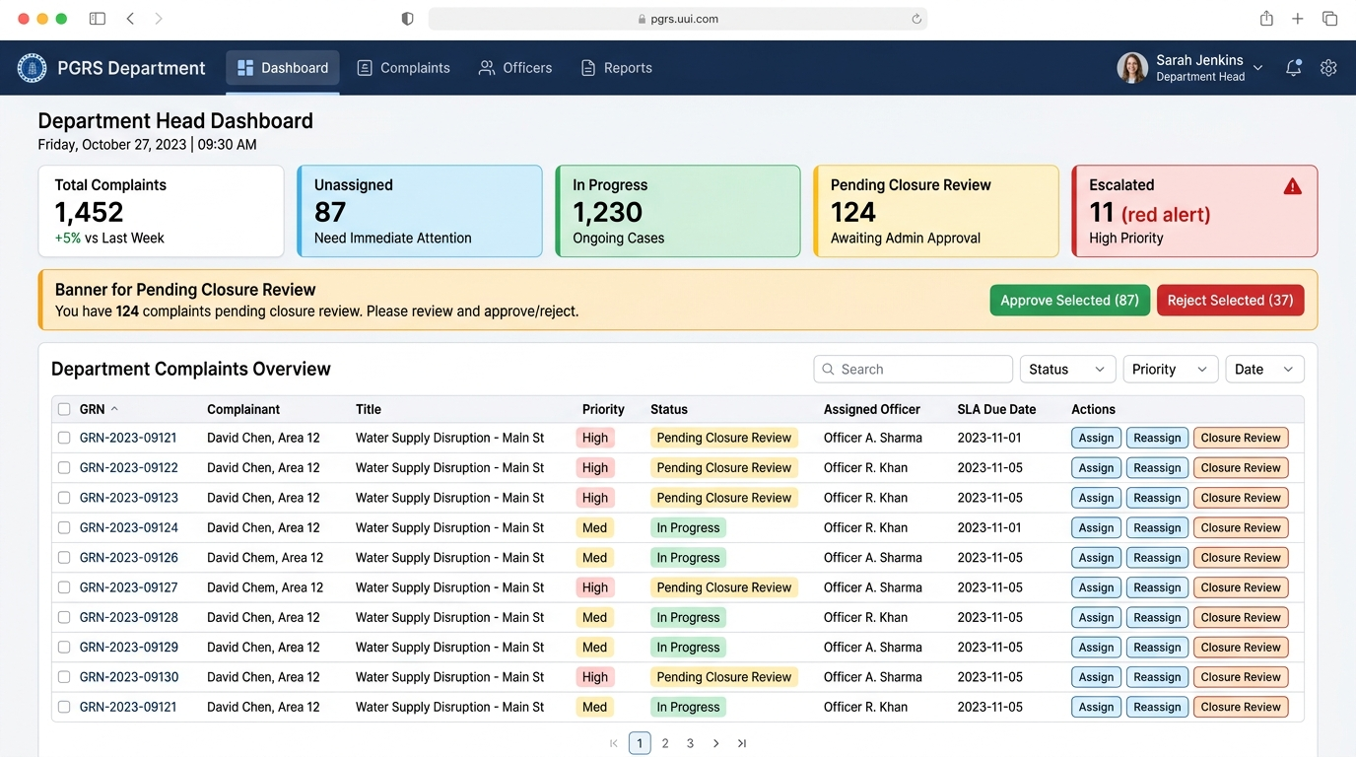
Figure 8.3: Department Head Governance Dashboard & Closure Review

8.4 Administrator Portal (Analytics & Governance Dashboard)
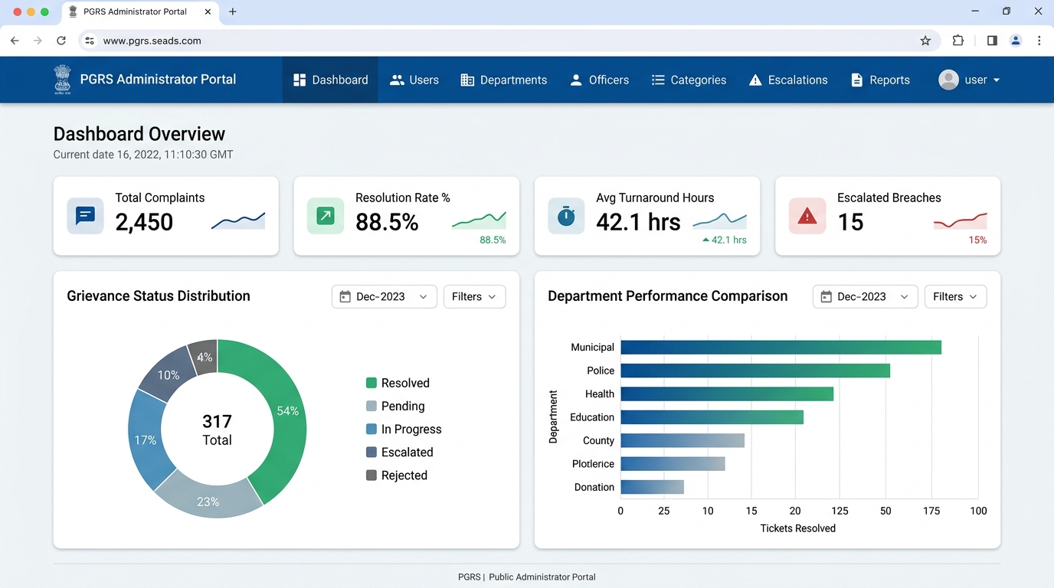
Figure 8.4: Administrator Executive Analytics & Performance Portal

Appendix C: To Be Determined List
The following items require further clarification or decision before final implementation:
# | TBD Item | Responsible Party | Target Date
1 | Specific government data retention policy duration to confirm minimum record storage period. | Project Sponsor | TBD
2 | SMS gateway vendor selection (Twilio vs MSG91) and API integration specifications. | Technical Lead | TBD
3 | Exact SLA period (working days) for each grievance category to be defined by government stakeholders. | Government Stakeholder | TBD
4 | Confirmation of supported regional languages for future multilingual interface. | Project Manager | TBD
5 | Integration requirements with existing government portals (e.g., UID/Aadhaar verification for citizen registration). | Government IT Dept. | TBD
6 | Exact file format and layout specifications for report exports required by department heads. | Department Heads | TBD

This document will be updated as TBD items are resolved. All changes will be recorded in the Revision History table.

