**EV Market Segmentation in India**

*Feynn Labs Internship project 2*

**Contributors:**

* [Adhiban Siddarth](https://github.com/Adhiban1/EV-Market-Segmentation)
* [Karakavalasa venkata pranay](https://github.com/Venkatapranay/electronicvehicles)
* [Malay Vyas](https://github.com/MalayVyas/EV_Market/)
* [Shreyash Banduji Chacharkar](https://github.com/ShreyashChacharkar/EV_marketsegment)
* [Yash Mayur](https://github.com/ysmayur1992/Feyyn_Labs_Project_3)

*Note: Click on the name of the person to open github repo*

**Fermi estimation (problem breakdown):**

* **Define the Problem:** Start by clarifying the overarching goal of the project: "Segment the EV market"
* **Identify Key Metrics:** What are the specific metrics or criteria used to segment the market? These could include factors like vehicle type (e.g., passenger cars, trucks), geographic regions, customer demographics, or any other relevant variables.
* **Data Requirements:** Estimate the amount of data needed to effectively segment the market. This would include both the quantity and quality of data. For instance, you might estimate the number of EV sales records required, the diversity of data sources, and the level of data cleanliness needed.
* **Data Collection:** Estimate the time and effort required to collect and preprocess the necessary data. This might involve web scraping, data cleaning, merging datasets, and dealing with missing values.
* **Feature Engineering:** Consider the complexity of feature engineering. Estimate the number of relevant features that need to be created or extracted from the raw data. This could include engineering features from vehicle specifications, user behavior, or external factors like weather or economic indicators.
* **Algorithm Selection:** Estimate the time and computational resources needed to choose and implement suitable machine learning algorithms for market segmentation. This could involve clustering, classification, or regression techniques.
* **Model Training:** Estimate the time and computational resources required to train the machine learning models on the prepared dataset. This can be influenced by the size of the dataset and the complexity of the chosen algorithms.
* **Hyperparameter Tuning:** Estimate the time needed for hyperparameter tuning to optimize the performance of the models. This is an iterative process that involves adjusting model parameters to improve accuracy.
* **Model Evaluation:** Estimate the effort required to evaluate the models' performance using appropriate metrics such as accuracy, precision, recall, or F1-score. Consider cross-validation and validation set preparation.
* **Interpretation and Visualization:** Estimate the time and effort needed to interpret and visualize the results of market segmentation. How will the segments be presented and communicated to stakeholders?

**Data Sources:**

[Dataset link](https://github.com/Adhiban1/EV-Market-Segmentation/tree/main/dataset)

[Files link](https://github.com/Adhiban1/EV-Market-Segmentation/tree/main/files)

dataset

├── Adhiban

│ ├── Cars-Conventional engine and EVs

│ │ ├── Cars 1.csv

│ │ ├── cars.csv

│ │ ├── Electric Car.csv

│ │ ├── Electric Vehicle Population Data.csv

│ │ └── FEV data.csv

│ ├── Electric Vehicle Charging Stations in India

│ │ └── ev-charging-stations-india.csv

│ ├── Electric Vehicle in India 2022

│ │ └── EV_India.csv

│ ├── Electric Vehicle Population Data

│ │ └── Electric_Vehicle_Population_Data.csv

│ ├── Electric Vehicles User Reviews India

│ │ ├── 2-wheeler-EV-bikewale.csv

│ │ ├── 4-wheeler-EV-cardekho.csv

│ │ └── 4-wheeler-EV-carwale.csv

│ ├── EV_CARS available in "INDIA" till oct-2021

│ │ └── EV_CARS _INDIA.csv

│ ├── EV_Cars_India_2023

│ │ └── EV_cars_India_2023.csv

│ ├── Google Trends

│ │ ├── geoMap.csv

│ │ └── multiTimeline.csv

│ └── Vehicle dataset

│ ├── car data.csv

│ ├── CAR DETAILS FROM CAR DEKHO.csv

│ ├── Car details v3.csv

│ └── car details v4.csv

├── Malay

│ └── IEA-EV-dataEV_salesHistoricalCars.csv

├── pranay

│ ├── RS_Session_255_AU_749.C.csv

│ ├── RS_Session_257_AU_1736_A_to_G.csv

│ └── RS_Session_258_AU_429_1.csv

├── Shreyash

│ ├── Chaganti-Reddy EVMarket-India.csv

│ ├── ElectricCarData_Norm.csv

│ ├── IEA-EV-dataEV_salesHistoricalCars.csv

│ ├── India_Electric_Vehicle_Market_1671628312425_1.csv

│ ├── RS_Session_256_AU_2673_2.ii_.csv

│ ├── RS_Session_257_AU_2368_B_3.csv

│ └── RS_Session_259_AU_1769_2.csv

└── Yash

└── data.gov.in

├── RS_Session_256_AU_2673_1.csv

├── RS_Session_256_AU_2673_2.i.csv

└── RS_Session_257_AU_2368_A.csv

15 directories, 33 files

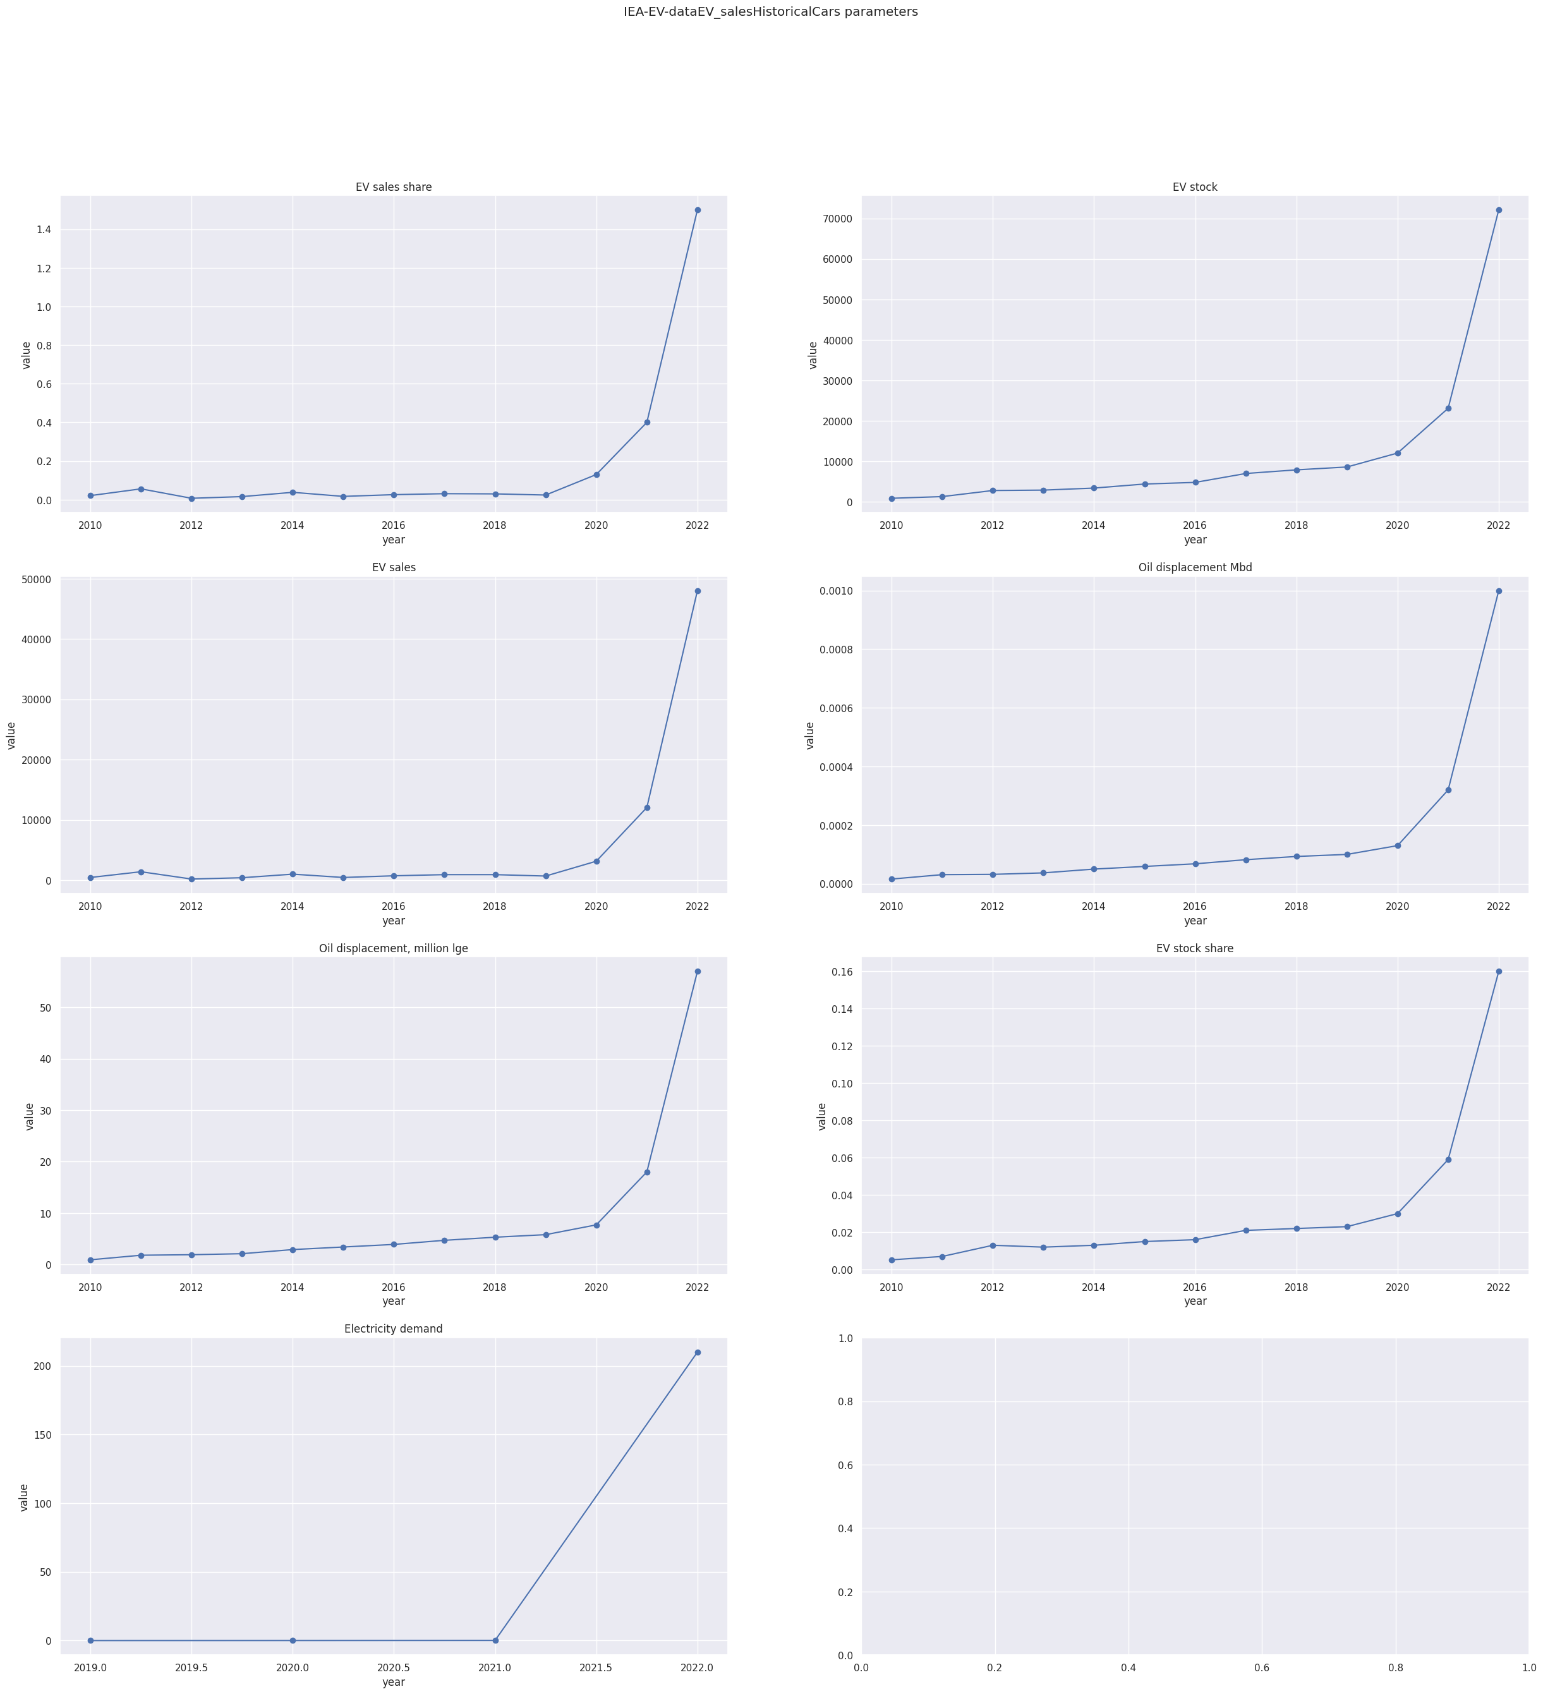**EV Market Segmentation in India**

***- V. Adhiban Siddarth***

**EV sales share**

* The global EV sales share has been increasing exponentially in recent years. In 2022, EVs accounted for 14% of global car sales, up from 4% in 2020.
* This growth is being driven by a number of factors, including government incentives, declining battery prices, and increasing consumer awareness of the environmental benefits of EVs.
* The IEA projects that the global EV sales share will reach 30% by 2030.

**EV stock**

* The global EV stock (the number of EVs in operation) has also been increasing exponentially in recent years. In 2022, there were over 100 million EVs in operation worldwide, up from just 1 million in 2010.
* This growth is being driven by the same factors that are driving EV sales growth.
* The IEA projects that the global EV stock will reach 250 million by 2030.

**EV sales**

* The global EV sales have been increasing exponentially in recent years. In 2022, there were over 10 million EVs sold worldwide, up from just 2 million in 2020.
* This growth is being driven by the same factors that are driving EV sales share and EV stock growth.
* The IEA projects that the global EV sales will reach 20 million by 2030.

**Oil displacement Mbd**

* Oil displacement Mbd (million barrels per day) is the amount of oil that is displaced by EVs. In 2022, EVs displaced 1.5 million barrels of oil per day.
* This is equivalent to about 3% of global oil demand.
* The IEA projects that EV oil displacement will reach 5 million barrels per day by 2030.

**Oil displacement, million lge**

* **Oil displacement, million lge (million liters of gasoline equivalent) is the amount of gasoline that is displaced by EVs. In 2022, EVs displaced 20 million liters of gasoline per day.**
* **This is equivalent to about 5% of global gasoline demand.**
* **The IEA projects that EV oil displacement will reach 100 million liters of gasoline per day by 2030.**

**EV stock share**

* The EV stock share is the percentage of the total vehicle stock that is made up of EVs. In 2022, the EV stock share was about 3%.
* This is expected to increase to 10% by 2030.

**Electricity demand**

* The increase in EV sales and stock is putting a strain on the electricity grid. In order to meet the growing demand for electricity from EVs, the grid will need to be upgraded and expanded.
* This is a challenge, but it is one that can be overcome.

**Overall, the data shows that the adoption of EVs is growing rapidly. This is good news for the environment, 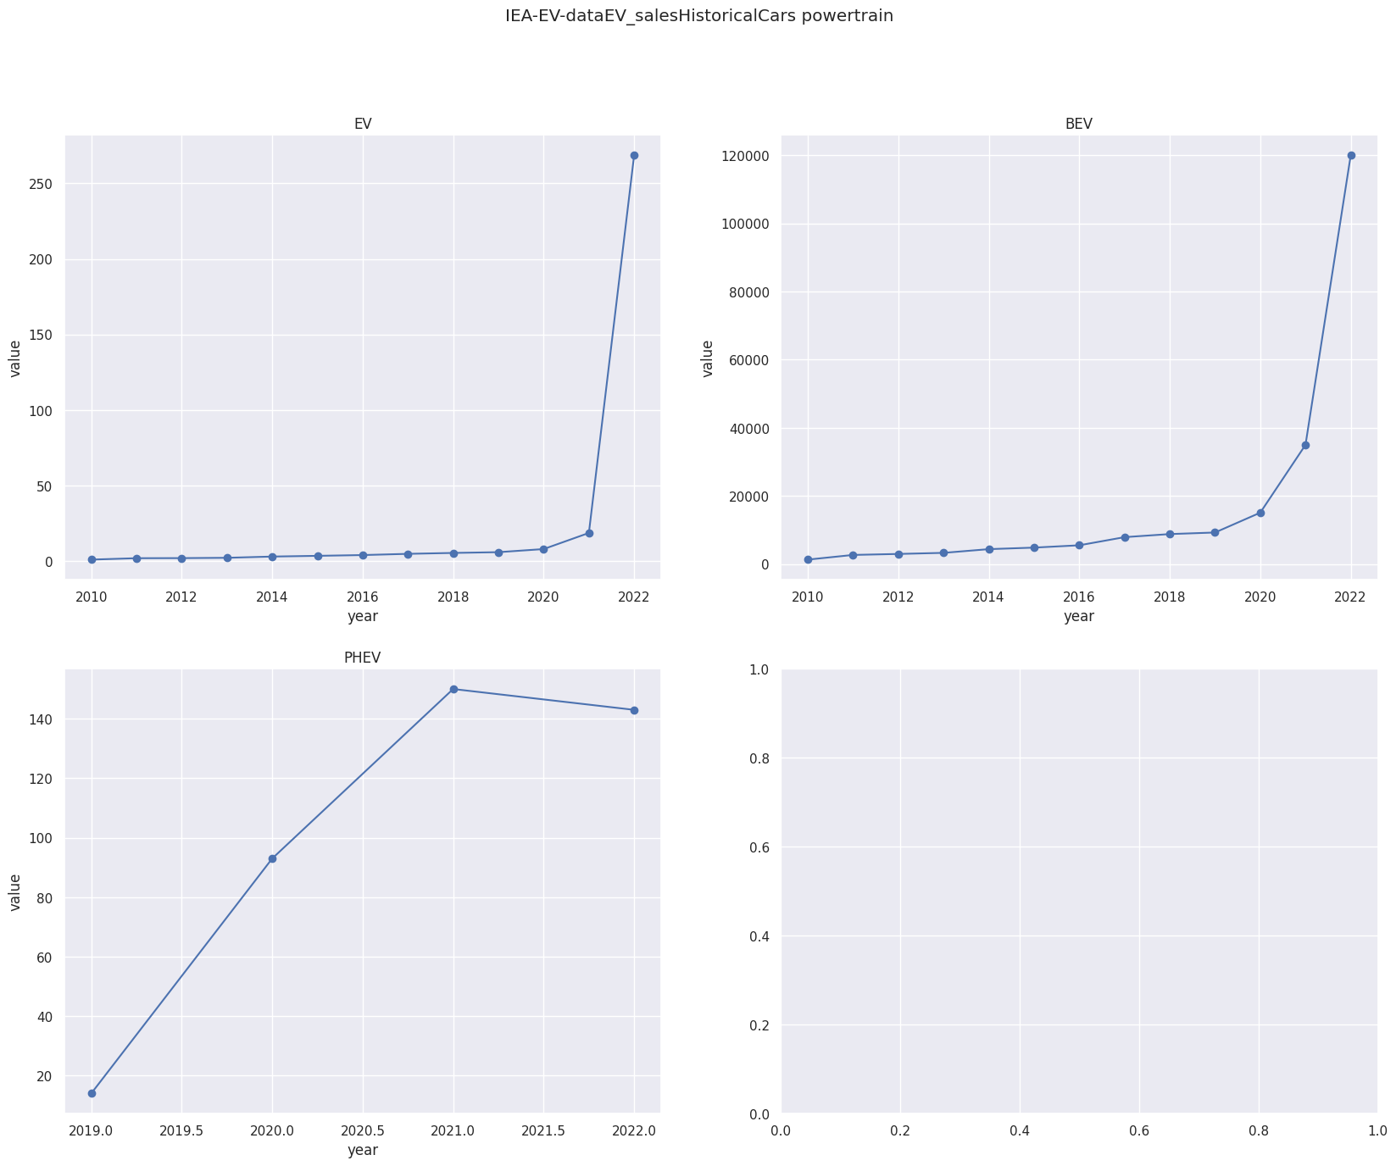as EVs help to reduce air pollution and our dependence on oil.**

**PHEV**: Plug-in hybrid

**BEV**: Battery Electric Vehicle

The above graph shows the sales of plug-in hybrid electric vehicles (PHEVs) and battery electric vehicles (BEVs) from 2015 to 2022. As you can see, the sales of BEVs have been increasing exponentially over the past few years, while the sales of PHEVs have been decreasing.

There are a few reasons for this trend. First, BEVs are becoming more affordable. The cost of batteries has been declining, and governments are offering incentives to purchase BEVs. Second, BEVs are becoming more capable. They have longer ranges and faster charging times. Third, consumers are becoming more aware of the environmental benefits of BEVs.

As a result of these factors, it is expected that BEVs will become the dominant type of electric vehicle in the future. By 2030, it is estimated that BEVs will account for more than 80% of global electric vehicle sales.

Why BEVs are becoming more popular:

* **Lower operating costs.** BEVs have lower fuel costs than gasoline or diesel vehicles. This is because electricity is cheaper than gasoline or diesel, and BEVs are more efficient.
* **Lower emissions.** BEVs produce zero emissions, which helps to improve air quality.
* **Government incentives.** Many governments offer incentives to purchase BEVs, such as tax breaks and rebates.
* **Improved technology.** Battery technology has improved significantly in recent years, which has led to longer ranges and faster charging times for BEVs.
* **Growing consumer awareness.** More and more consumers are becoming aware of the benefits of BEVs.

**Price and Performance:**

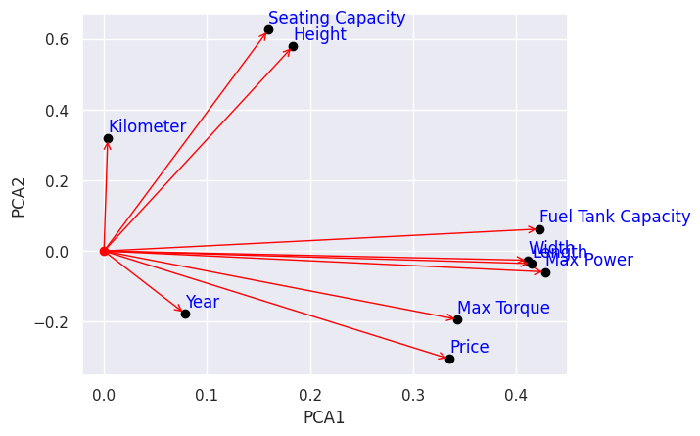The above PCA graph shows the relationship between the different features of a car. As you can see, the price, max torque, max power, length, width, and fuel tank capacity are all positively correlated with each other. This means that cars with higher prices, max torque, max power, length, width, and fuel tank capacity tend to have higher values for the other features as well. The seating capacity and height are in same direction. This means that cars with more seating capacity are height. The kilometer is in a somewhat different direction from the others because it is not as strongly correlated with the other features.

Overall, the PCA graph shows that the price, max torque, max power, length, width, and fuel tank capacity are the most important features in determining the overall performance of a car. The seating capacity and height are less important, but they can still play a role in determining the overall performance of a car.

**Sentiment Analysis:**

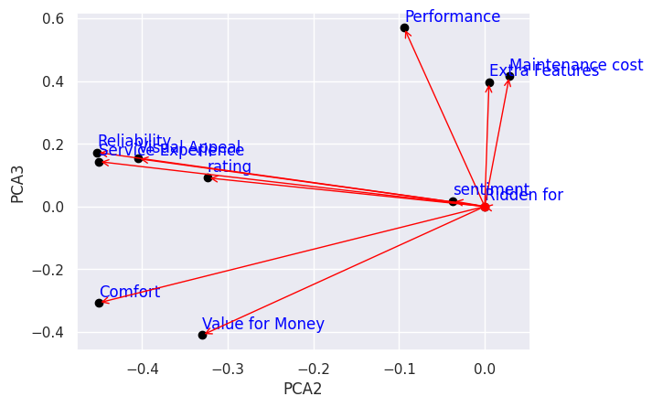

The PCA graph shows the sentiment analysis of car reviews. As you can see, the reliability, service experience, rating, and visual appeal are all positively correlated with each other. This means that cars that are perceived as being reliable, having good service experiences, high ratings, and good visual appeal tend to have higher sentiment scores.

The performance and extra features are positively correlated with the maintenance cost. This means that cars that are perceived as having high performance and extra features tend to have higher maintenance costs.

The comfort and value for money are in the same direction. So people who buy the car with more comfortable thinks that the car is value for money. So if car is more costlier then make sure it is comfortable.

**Selling Price decreasing:**

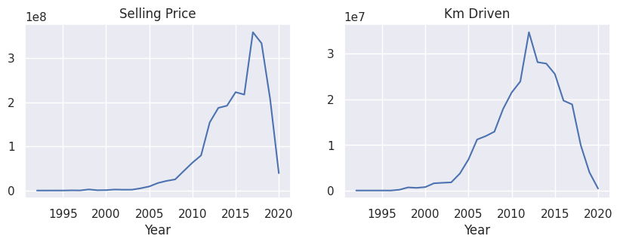

This above graph shows that the Selling price of Petrol/Diesel Vehicle is becomes lower from 2017 to 2020.

**The increasing popularity of electric vehicles:** Electric vehicles are becoming more popular, and this is putting downward pressure on the prices of petrol/diesel vehicles. Electric vehicles are more efficient than petrol/diesel vehicles, so they are cheaper to operate. They also have lower emissions, which is appealing to some buyers.

**The rising cost of petrol/diesel:** The cost of petrol/diesel has been increasing in recent years. This has made petrol/diesel vehicles less affordable, which has led to a decrease in demand.

**The introduction of new technologies:** New technologies, such as lightweight materials and more efficient engines, are making petrol/diesel vehicles cheaper to produce. This is also putting downward pressure on prices.

**Government policies:** Some governments are offering incentives to purchase electric vehicles, such as tax breaks and rebates. This is making electric vehicles more affordable and accessible, which is also putting downward pressure on the prices of petrol/diesel vehicles.

**The COVID-19 pandemic:** The COVID-19 pandemic has led to a decrease in the demand for petrol/diesel vehicles. This is because people are driving less due to restrictions on movement and social distancing.

It is likely that a combination of these factors has contributed to the decrease in the selling price of petrol/diesel vehicles. It remains to be seen whether this trend will continue in the future.

In addition to the above reasons, here are some other possible explanations:

**The introduction of new competition:** The entry of new manufacturers into the market has led to increased competition, which has put downward pressure on prices.

**The depreciation of the value of petrol/diesel vehicles:** Petrol/diesel vehicles tend to depreciate more quickly than electric vehicles. This is because they are more expensive to produce and maintain.

**The availability of cheaper alternatives:** There are now a number of cheaper alternatives to petrol/diesel vehicles available, such as used cars and electric vehicles. This has made petrol/diesel vehicles less attractive to buyers.

Overall, there are a number of factors that could be contributing to the decrease in the selling price of petrol/diesel vehicles. It is likely that a combination of these factors is at play.

## **Km driven of Petrol/Diesel Vehicle is huge dropping from 2013 to 2020:**

**The rise of ride-hailing and car-sharing services:** These services have made it more convenient and affordable for people to get around without owning a car. This has led to a decrease in the number of kilometers driven by personal vehicles.

**The increasing popularity of electric vehicles:** Electric vehicles are more efficient than petrol/diesel vehicles, so they can travel further on a single charge. This is making them a more attractive option for people who are looking to reduce their fuel costs.

**The COVID-19 pandemic:** The COVID-19 pandemic has led to a decrease in the number of people commuting to work and school. This has also led to a decrease in the number of kilometers driven by personal vehicles.

**The rising cost of petrol/diesel:** The cost of petrol/diesel has been increasing in recent years. This has made it more expensive to drive a petrol/diesel vehicle, which has led to a decrease in the number of kilometers driven.

It is likely that a combination of these factors has contributed to the decrease in the km driven of petrol/diesel vehicles. It remains to be seen whether this trend will continue in the future.

In addition to the above reasons, here are some other possible explanations:

**Improvements in public transportation:** Public transportation has become more efficient and reliable in recent years, making it a more attractive option for people who are looking to reduce their carbon footprint.

**A growing awareness of the environmental impact of petrol/diesel vehicles:** More and more people are becoming aware of the environmental impact of petrol/diesel vehicles, and are choosing to drive less or switch to more sustainable modes of transportation.

**Government policies that incentivize the use of electric vehicles:** Many governments are offering incentives to purchase electric vehicles, such as tax breaks and rebates. This is making electric vehicles more affordable and accessible, and is likely to lead to an increase in their popularity in the future.

Overall, there are a number of factors that could be contributing to the decrease in the km driven of petrol/diesel vehicles. It is likely that a combination of these factors is at play.

**Mileage:**

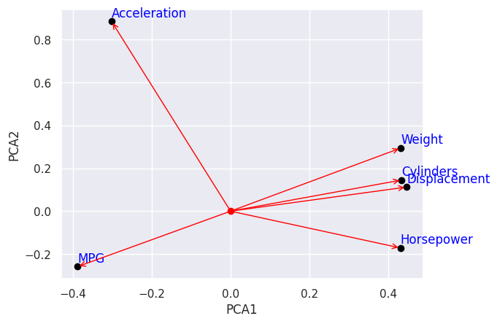

In the case of the PCA graph, the principal components are the weight, number of cylinders, displacement, horsepower, and MPG. The weight, number of cylinders, displacement, and horsepower are all positively correlated with each other. This means that cars with higher values for these features tend to have lower MPG.

The MPG is in the opposite direction to the other features because it is negatively correlated with them. This means that cars with higher MPG tend to have lower values for the other features.

The reason for this is that the weight, number of cylinders, displacement, and horsepower all affect the fuel efficiency of a car. A heavier car will require more fuel to move, and a car with more cylinders will also require more fuel. A larger displacement engine will also require more fuel, and a car with more horsepower will also require more fuel.

The MPG, on the other hand, is a measure of how far a car can travel on a gallon of fuel. So, a car with higher MPG will be able to travel further on a gallon of fuel than a car with lower MPG.

In general, cars with smaller engines and lighter weight will have higher MPG. This is because they require less fuel to move. However, there are other factors that can affect MPG, such as aerodynamics and the type of transmission.

**Electric vehicles (EVs) tend to be less in these factors, which is why they give more mileage:**

**Weight:** EVs are typically lighter than gasoline-powered cars because they don't have an engine or fuel tank. This means that they require less energy to move, which results in better fuel efficiency.

In addition to these factors, EVs also benefit from other factors that improve fuel efficiency, such as regenerative braking and aerodynamic design. Regenerative braking is a system that captures energy that would otherwise be lost during braking and uses it to recharge the battery. Aerodynamic design is the process of designing a car that minimizes drag, which also improves fuel efficiency. As a result of these factors, EVs can achieve significantly better efficiency than gasoline-powered cars.

**Conclusion:**

**Develop an EV for the Indian market:** The Indian market has unique needs and requirements. Developing an EV that is specifically designed for the Indian market could be a successful business venture.

**Focus on the low-cost segment:** The average Indian consumer is price-sensitive. Focusing on the low-cost segment of the EV market could be a way to reach a large number of potential customers.

**Partner with a government agency:** The Indian government is promoting the adoption of EVs. Partnering with a government agency could help you to get access to funding and other resources.

**Target fleet operators:** Fleet operators, such as taxi companies and delivery services, are potential customers for EVs. Targeting fleet operators could help you to reach a large number of vehicles.

**Offer after-sales service and support:** The lack of after-sales service and support is one of the biggest barriers to the adoption of EVs in India. Offering after-sales service and support could help you to overcome this barrier.

**The government support:** The Indian government is promoting the adoption of EVs. This could provide you with access to funding and other resources.

**The market size and growth potential:** The EV market in India is still small, but it is growing rapidly. This means that there is a lot of potential for growth in the market.

**The competition:** The EV market in India is becoming increasingly competitive. You will need to find a way to differentiate your startup from the competition.

**The regulatory environment:** The regulatory environment for EVs in India is constantly changing. You will need to stay up-to-date on the latest regulations in order to comply with them.

**The funding requirements:** Starting an EV startup in India can be expensive. You will need to secure funding in order to bring your startup to market.