**Market analysis:**

The predictive maintenance market in India is expected to reach $4 billion by 2026, growing at a compound annual growth rate (CAGR) of 25.2%. In 2021, the market generated nearly $900 million in revenue. The growth is due to increasing demand for reducing productivity loss and maintenance costs.

Predictive maintenance uses artificial intelligence (AI) to improve productivity and efficiency. AI can predict when a machine will break down, which allows for planning maintenance efforts where they are needed. This can reduce long-term repair costs.

The predictive maintenance market is expected to expand at a 24.2% CAGR from 2023 to 2033. The energy and utilities segment is expected to grow at a CAGR of around 32% over the forecast period. The large enterprises segment is projected to lead the market at a CAGR of 21.4% during the timeframe of 2022-2032.

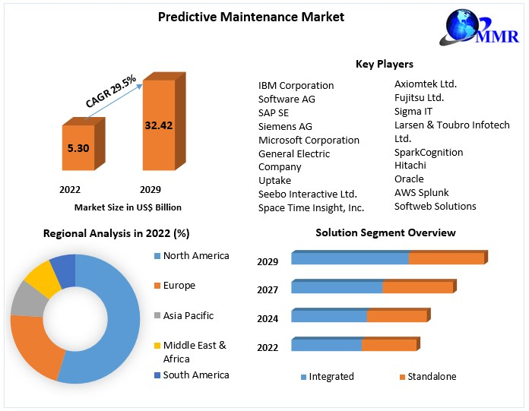The recorded data allows an engineer to estimate the eventual failure point of the observed asset, enabling it to be repaired or replaced shortly before it fails. Predictive maintenance reduces the occurrence of repair while still eliminating unexpected reactive maintenance and reducing equipment downtime and expenses associated with preventative maintenance. Predictive maintenance increases the lifespan of the equipment being observed. The report explores the Predictive Maintenance market's segments (Solution, Service, Deployment, Enterprise Size, End-Use, and Region). Data has been provided by market participants, and regions (North America, Asia Pacific, Europe, Middle East & Africa, and South America). It provides a thorough analysis of the rapid advances that are currently taking place across all industry sectors. Facts and figures, illustrations, and presentations are used to provide key data analysis for the historical period from 2018 to 2022. The report investigates the Predictive Maintenance market's drivers, limitations, prospects, and barriers. This MMR report includes investor recommendations based on a thorough examination of the Predictive Maintenance market's contemporary competitive scenario.

**Predictive Maintenance Market** size was valued at US$ 5.30 Bn.in 2022 and the total Predictive Maintenance revenue is expected to grow at 29.5% from 2023 to 2029, reaching nearly US$ 32.42 Bn.

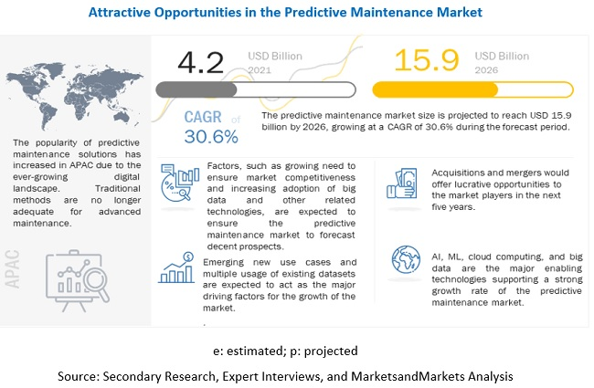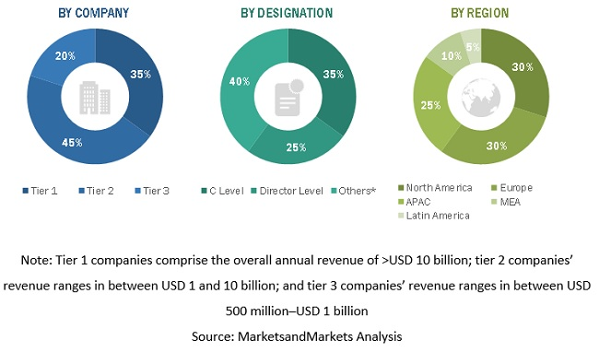

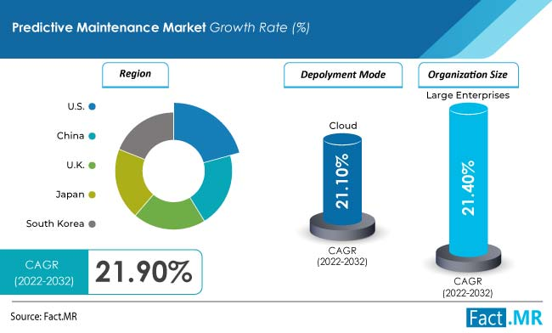

By deployment, the cloud-based segment is expected to dominate the market exhibiting a CAGR of 21.1% during the forecast period. Expansion of the segment can be attributed to benefits offered such as cost-efficiency, increased asset utilization, and better safety and compliance, among others.

Based on organization size, the large enterprises segment is projected to lead the market at a CAGR of 21.4% during the timeframe of 2022-2032. Predictive maintenance allows easy access to specific details on product and application habits. It also eases expenses and offers cost-cutting solutions that inhibit the expenses.

According to the analysis, the market in the US is expected to lead the global market. The country is estimated to secure a market value worth US$ 15.8 Million by 2032. The growth of the market can be attributed to the presence of established players in the region.

**Source:** [**https://www.marketsandmarkets.com/Market-Reports/operational-predictive-maintenance-market-8656856.html#:~:text=%5B294%20Pages%20Report%5D%20The%20Predictive,at%20a%20CAGR%20of%2030.6%25.**](https://www.marketsandmarkets.com/Market-Reports/operational-predictive-maintenance-market-8656856.html#:~:text=%5B294%20Pages%20Report%5D%20The%20Predictive,at%20a%20CAGR%20of%2030.6%25.)

**Business Model:**

1. **Offering of Subscription Based Services:**

Business model are back bones of any business model, spending time on defining a business model is good strategy rather than direct door sales. Subscription based business model can be effective in our scenario. There are many businesses use such strategy of some fixed cost and other requirement-based cost services.

|  |  |  |  |
| --- | --- | --- | --- |
|  | **Subscription plan 1** | **Subscription plan 2** | **Subscription plan 3** |
| Personalised web-based monitoring system | Checkmark | Checkmark | Checkmark |
| Personalised predictive system | Checkmark | Checkmark | Checkmark |
| Validity | **6 months** | **1 year** | **3 years** |
| IOT based services*(optional) | Checkmark | Checkmark | Checkmark |
| Services Charges**(fixed charges) | **20000** | **35000** | **50000** |

*\*\*modification charges & IOT based service didn’t included*

1. **Product & service description:**

**Real time Web Based monitoring and predictive maintenances app:**   
*prototype of real time web based predictive maintenance services*

***Include image here***

**How it works?**

Data collection through IOT based sensor

Step 1

Step 2

Step 3

Step 4

Step 5

Cloud storage

Data processing, Data checkup

Analytics, Prediction

Web based application

sample text. Enter your text here

. Enter your text here

1. **Go-to-market Strategy:**

**Step 1:  
Approaching Clients:**Approaching client via different marketing channels, direct sales through affiliation,

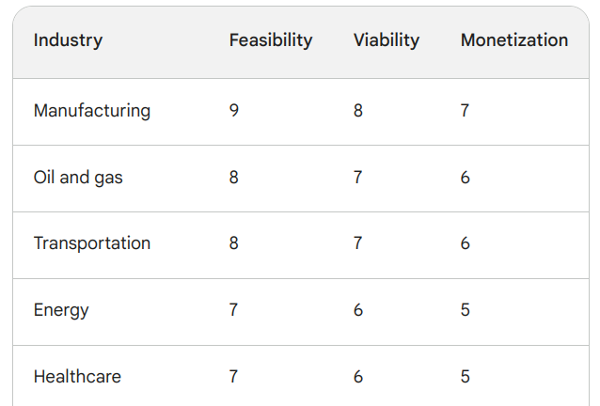

**Financial equation:**

One of best way to calculate way of profit would be by using following linear equation where each term has its sperate significance:

$$y=m*x\left(l\right)+c$$

$y=$ total profit

$m=$ cost of subscription services or (expected total sales/No. of customer)

$x(l)=$ market

$c=$ constant depends on other cost including primary and secondary cost

Therefore, this formula can also be written as

$Total profit =\frac{ Expected total sales}{No. of customer} * market + constant cost$

1. **Justifying Value of each variable:**

**1.1 Value of C:**

C is fixed cost associated with primary and supportive structure of business. It includes **supportive structure** human resource cost, technology cost, firm infrastructure, procurement and **primary structure** cost like cloud infrastructure, product development, distribution and reliability channel, marketing sales and services.

|  |  |  |
| --- | --- | --- |
| Supportive Activities | Cost | Justification |
| Human Resource | ₹ 12,00,000.00 | 4 employees |
| Technology development | ₹ 1,00,000.00 | software development/ security |
| Firm infrastructure | ₹ 3,00,000.00 | office furniture, rent, electricity |
| Procurement | ₹ 5,00,000.00 | 5000 per sensor |
| Primary Activities | **Cost** | **Justification** |
| Cloud Infrastructure | ₹ 1,00,000.00 | GCP, AWS storage bucket, compute engine |
| Product development | ₹ 50,000.00 | resources, data |
| Distribution and reliability | ₹ 2,00,000.00 | distribution channels, |
| Marketing and Sales | ₹ 1,00,000.00 | affiliate based, |
| Services | ₹ 1,00,000.00 | physical deployment of sensor, & maintenances, data quality checkup, personalised web based app |
| Total Cost | ₹26,50,000.00 |  |

Since we are in ideation stage, let us consider cost of supportive structure would be zero, but still primary structure of business will cost around 5 to 6 lakh rupees.

Therefore, **Let us consider value of C = 6 lakh.**

Value of C is doesn’t depend upon

**1.2 Value of x(l):**

This suggests that x(l) is a function that describes how market performance (x) is influenced by some variable or parameter (l).

The condition on which x(l) depends will vary depending on the factors that affect market performance in your predictive maintenance startup. These factors could include:

**Customer Demand:** If customer demand plays a significant role in profitability, l could represent variables related to customer behaviour, such as the number of customers, market segments, or demographics.

**Industry-Specific Metrics**: Industry growth and external factors, geopolitical scenario.

Since there is no direct formula for x(l), Let us consider following two scenario for determining value of x

Current market size for predictive maintenance services in India 1.5 billion $ (by mckensy), with currently 22% adoption rate for PDM in overall manufacturing units in India with 26.7 % CAGR growth rate. Let us consider that our aim to capture 2 % market in first year.