****Smart Industrial Predictive Solutions****

*Feynn Labs Internship project-3*

**Abstract**

**Smart Industrial Predictive Solutions** is a forward-looking project that harnesses data science and machine learning to revolutionize industrial maintenance. With a focus on predictive maintenance, this initiative empowers industries to proactively address equipment failures and optimize maintenance schedules. Through data-driven insights and advanced analytics, it promises to enhance efficiency, reduce downtime, and transform how industries manage machinery and equipment. This abstract provides an overview of the project's objectives, methodologies, and anticipated impacts on industrial operations.

**Contributors:**

* Adhiban Siddarth
* Karakavalasa venkata pranay
* Malay Vyas
* Shreyash Banduji Chacharkar
* Yash Mayur

**1. Problem Statement:**

In various industrial sectors, machinery and equipment serve as the backbone of operations. However, these assets are susceptible to breakdowns and failures, leading to unplanned downtime, safety risks, and increased maintenance costs. Traditional maintenance practices are often reactive, causing production disruptions and financial losses. The challenge is to develop a comprehensive predictive maintenance solution, "Smart Industrial Predictive Solutions" that leverages data science and machine learning to foresee equipment failures in advance, allowing industries to proactively schedule maintenance and optimize operations. This project seeks to address the critical need for efficient, cost-effective, and data-driven maintenance strategies in industrial settings, enhancing reliability, safety, and productivity while reducing operational disruptions and financial burdens.

**2. Market/Customer/Business Need Assessment:**

2.1. **Market Demand and Trends:** The industrial sector is facing increasing pressure to reduce downtime, enhance operational efficiency, and minimize maintenance costs. There is a growing demand for predictive maintenance solutions that can provide actionable insights and prevent unplanned equipment failures.

2.2. **Customer Pain Points:** Industrial customers face challenges related to equipment breakdowns, production interruptions, and high maintenance expenses. They seek solutions that can proactively identify maintenance needs, improve asset reliability, and optimize resource allocation.

2.3. **Competitive Landscape:** The competitive landscape includes a mix of traditional maintenance services and emerging predictive maintenance solutions. Existing offerings often lack the sophistication and data-driven approach of "Smart Industrial Predictive Solutions."

2.4. **Regulatory Compliance:** Regulatory bodies increasingly require industries to meet specific safety and reliability standards. Predictive maintenance solutions can aid in compliance by reducing safety risks and improving equipment reliability.

2.5. **Business Opportunities:** "Smart Industrial Predictive Solutions" presents an opportunity to cater to the growing demand for predictive maintenance services. It can tap into a market where industries are actively seeking cost-effective and efficient maintenance solutions.

2.6. **Financial Impact:** For businesses, reducing downtime and maintenance costs directly impacts the bottom line. Predictive maintenance solutions promise significant cost savings and improved profitability.

2.7. **Safety and Reputation:** Predictive maintenance also contributes to improved safety records and enhanced reputation for businesses, making it an attractive proposition for industries with strict safety requirements.

The market/customer/business need assessment highlights the strong demand for predictive maintenance solutions like "Smart Industrial Predictive Solutions." Industries are actively seeking ways to reduce downtime, enhance safety, and optimize maintenance practices, presenting a compelling opportunity for this innovative project to address critical pain points and fulfill market needs.

**3. Market analysis:**

The predictive maintenance market in India is expected to reach $4 billion by 2026, growing at a compound annual growth rate (CAGR) of 25.2%. In 2021, the market generated nearly $900 million in revenue. The growth is due to increasing demand for reducing productivity loss and maintenance costs.

Predictive maintenance uses artificial intelligence (AI) to improve productivity and efficiency. AI can predict when a machine will break down, which allows for planning maintenance efforts where they are needed. This can reduce long-term repair costs. The predictive maintenance market is expected to expand at a 24.2% CAGR from 2023 to 2033. The energy and utilities segment is expected to grow at a CAGR of around 32% over the forecast period. The large enterprises segment is projected to lead the market at a CAGR of 21.4% during the timeframe of 2022-2032.

The recorded data allows an engineer to estimate the eventual failure point of the observed asset, enabling it to be repaired or replaced shortly before it fails. Predictive maintenance reduces the occurrence of repair while still eliminating unexpected reactive maintenance and reducing equipment downtime and expenses associated with preventative maintenance. Predictive maintenance increases the lifespan of the equipment being observed. The report explores the Predictive Maintenance market's segments (Solution, Service, Deployment, Enterprise Size, End-Use, and Region).

Data has been provided by market participants, and regions (North America, Asia Pacific, Europe, Middle East & Africa, and South America). It provides a thorough analysis of the rapid advances that are currently taking place across all industry sectors. Facts and figures, illustrations, and presentations are used to provide key data analysis for the historical period from 2018 to 2022. The report investigates the Predictive Maintenance market's drivers, limitations, prospects, and barriers. This MMR report includes investor recommendations based on a thorough examination of the Predictive Maintenance market's contemporary competitive scenario.

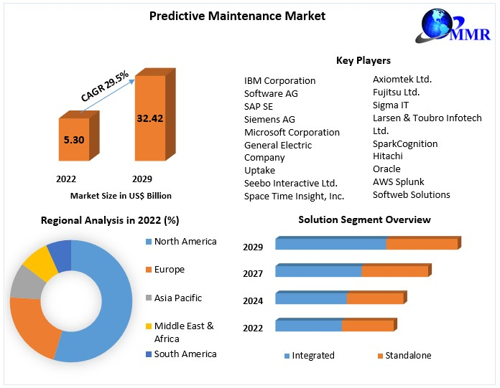

**Predictive Maintenance Market** size was valued at US$ 5.30 Bn.in 2022 and the total Predictive Maintenance revenue is expected to grow at 29.5% from 2023 to 2029, reaching nearly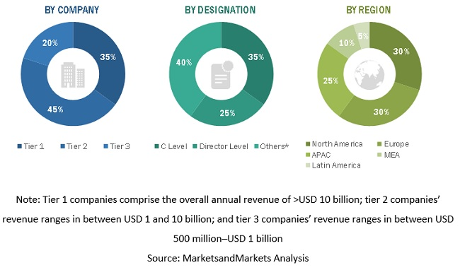 US$ 32.42 Bn.

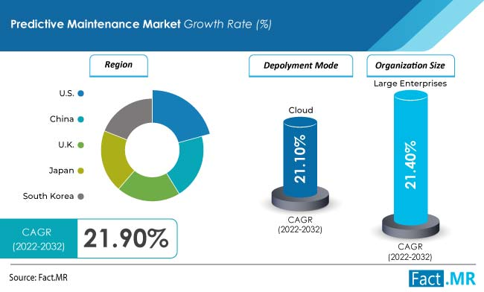

By deployment, the cloud-based segment is expected to dominate the market exhibiting a CAGR of 21.1% during the forecast period. Expansion of the segment can be attributed to benefits offered such as cost-efficiency, increased asset utilization, and better safety and compliance, among others. Based on organization size, the large enterprises segment is projected to lead the market at a CAGR of 21.4% during the timeframe of 2022-2032. Predictive maintenance allows easy access to specific details on product and application habits. It also eases expenses and offers cost-cutting solutions that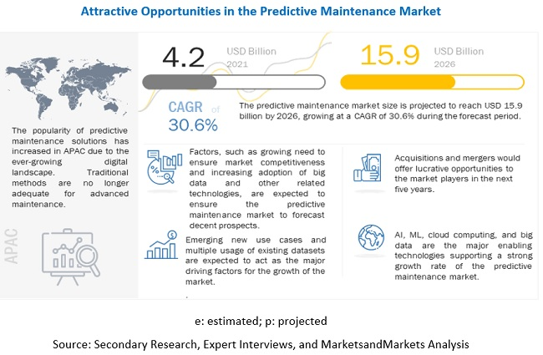 inhibit the expenses.

According to the analysis, the market in the US is expected to lead the global market. The country is estimated to secure a market value worth US$ 15.8 Million by 2032. The growth of the market can be attributed to the presence of established players in the region.

**Source: [https://www.marketsandmarkets.com/Market-Reports/operational-predictive-maintenance-market-8656856.html#:~:text=%5B294%20Pages%20Report%5D%20The%20Predictive,at%20a%20CAGR%20of%2030.6%25.](https://www.marketsandmarkets.com/Market-Reports/operational-predictive-maintenance-market-8656856.html" \l ":~:text=%5B294 Pages Report%5D The Predictive,at a CAGR of 30.6%25.)**

**4. Business Model:**

**4.1. Offering of Subscription Based Services:**

Business model are back bones of any business model, spending time on defining a business model is good strategy rather than direct door sales. Subscription based business model can be effective in our scenario. There are many businesses use such strategy of some fixed cost and other requirement-based cost services.

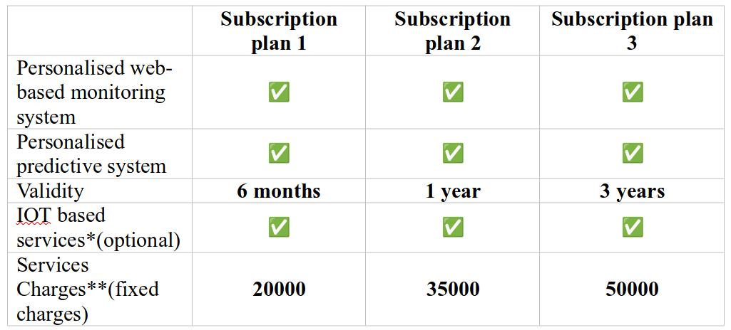

*\*\*modification charges & IOT based service didn’t included*

**4.2. Product & service description:**

Real time Web Based monitoring and predictive maintenances app:   
*prototype of real time web based predictive maintenance services*

**4.3. How it works?**

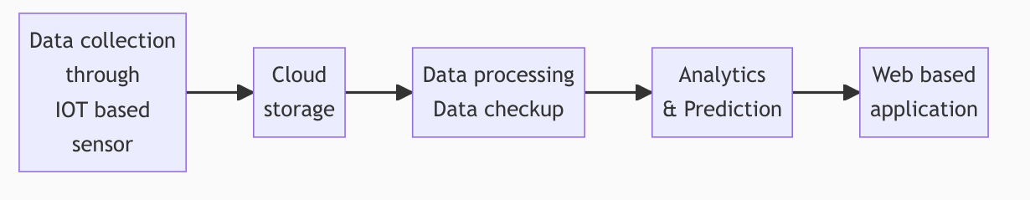

**4.4. Go-to-market Strategy**



**5. Financial equation:**

One of best way to calculate way of profit would be by using following linear equation where each term has its sperate significance:

Therefore, this formula can also be written as

**5.1. Justifying Value of each variable:**

**5.1.1 Value of C:**

C is fixed cost associated with primary and supportive structure of business. It includes **supportive structure** human resource cost, technology cost, firm infrastructure, procurement and **primary structure** cost like cloud infrastructure, product development, distribution and reliability channel, marketing sales and services.

|  |  |  |
| --- | --- | --- |
| **Supportive Activities** | **Cost** | **Justification** |
| **Human Resource** | ₹ 12,00,000.00 | 4 employees |
| **Technology development** | ₹ 1,00,000.00 | software development/ security |
| **Firm infrastructure** | ₹ 3,00,000.00 | office furniture, rent, electricity |
| **Procurement** | ₹ 5,00,000.00 | 5000 per sensor |
| **Primary Activities** | **Cost** | **Justification** |
| **Cloud Infrastructure** | ₹ 1,00,000.00 | GCP, AWS storage bucket, compute engine |
| **Product development** | ₹ 50,000.00 | resources, data |
| **Distribution and reliability** | ₹ 2,00,000.00 | distribution channels, |
| **Marketing and Sales** | ₹ 1,00,000.00 | affiliate based, |
| **Services** | ₹ 1,00,000.00 | physical deployment of sensor, & maintenances, data quality checkup, personalised web based app |
| **Total Cost** | ₹26,50,000.00 |  |

Since we are in ideation stage, let us consider cost of supportive structure would be zero, but still primary structure of business will cost around 5 to 6 lakh rupees.

Therefore, **Let us consider value of C = 6 lakhs.**

Value of C is doesn’t depend upon

**5.1.2 Value of x(t):** This suggests that x(t) is a function that describes how market performance (x) is influenced by some variable or parameter (t). The condition on which x(t) depends will vary depending on the factors that affect market performance in your predictive maintenance startup. These factors could include:

**5.1.3. Customer Demand:** If customer demand plays a significant role in profitability, l could represent variables related to customer behaviour, such as the number of customers, market segments, or demographics.

**5.1.4. Industry-Specific Metrics**: Industry growth and external factors, geopolitical scenario.

Since there is no direct formula for x(l), Let us consider following two scenario for determining value of x

Current market size for predictive maintenance services in India 1.5 billion $ (by mckensy), with currently 22% adoption rate for PDM in overall manufacturing units in India with 26.7 % CAGR growth rate. Let us consider that our aim to capture 2 % market in first year.

**6. Target Specifications and Characterization:**

1. **Equipment Compatibility:** "Smart Industrial Predictive Solutions" should be compatible with a wide range of industrial machinery and equipment, including but not limited to manufacturing machines, motors, pumps, conveyors, and processing equipment.

2. **Data Integration:** The system must seamlessly integrate with various data sources, such as sensors, IoT devices, and historical maintenance records. It should be able to collect, process, and analyze data from different formats and protocols.

3. **Real-time Monitoring:** The solution should provide real-time monitoring capabilities to continuously assess the health and performance of equipment, enabling immediate responses to emerging issues.

4. **Predictive Analytics:** "Smart Industrial Predictive Solutions" should employ advanced predictive analytics and machine learning algorithms to forecast equipment failures with a high degree of accuracy.

5. **User-Friendly Interface:** The user interface should be intuitive and user-friendly, catering to both technical and non-technical users within industrial settings.

6. **Customization:** The system should allow for customization to adapt to specific industrial processes and equipment types, accommodating diverse user requirements.

7. **Alerts and Notifications:** It should offer automated alerts and notifications to inform maintenance teams and operators about impending issues, facilitating proactive maintenance planning.

8. **Scalability:** The solution must be scalable to accommodate the needs of small to large-scale industrial operations, ensuring flexibility for businesses of varying sizes.

9. **Security:** Robust security measures should be in place to protect sensitive industrial data and ensure compliance with industry-specific regulations.

10. **Cost-Effectiveness:** "Smart Industrial Predictive Solutions" should demonstrate a strong return on investment (ROI) by reducing maintenance costs, minimizing downtime, and optimizing resource utilization.

11. **Reliability:** The system should be highly reliable, minimizing false alarms and ensuring accurate predictions to build trust among industrial users.

12. **Interoperability:** It should support interoperability with existing industrial control systems and software, promoting seamless integration into the existing operational framework.

13. **Maintenance Insights:** In addition to predictive alerts, the solution should provide insights into the root causes of equipment issues, aiding maintenance teams in making informed decisions.

14. **Compliance:** The system should assist industries in meeting regulatory compliance requirements related to safety and equipment reliability.

15. **Data Transparency:** Transparency in data collection, processing, and analysis should be a priority, allowing users to understand and trust the system's recommendations.

These specifications and characteristics define the essential features and capabilities that "Smart Industrial Predictive Solutions" should possess to effectively address the needs and challenges of industrial customers.

**7. Data Collection**

**8. Data Analysis & Machine Learning**

**9. Web app**

**10. Conclusion**