**Machine Predictive Maintenance for Industrial Machines**

**Abstract:**

This project focuses on developing a machine learning-based predictive maintenance system for industrial machines. By analyzing historical sensor data, including *Air temperature [K], Process temperature [K], Rotational speed [rpm], Torque [Nm], and Tool wear [min]*, the system predicts potential failures. The proposed solution aims to help businesses implement proactive maintenance strategies, reduce downtime, and optimize maintenance costs, ultimately leading to increased operational efficiency and potential revenue generation through a Flask app deployment.

**1. Problem Statement:**

The objective of this project is to develop a machine learning product that can predict potential failures in industrial machines based on various sensor readings such as *Air temperature [K], Process temperature [K], Rotational speed [rpm], Torque [Nm], and Tool wear [min]*. The product will help businesses in implementing predictive maintenance strategies, reducing downtime, and optimizing maintenance costs.

**2. Market/Customer/Business Need Assessment:**

The predictive maintenance market has seen significant growth in recent years due to its potential to enhance operational efficiency and reduce maintenance costs for businesses. Customers in various industries, such as manufacturing, energy, and transportation, face substantial losses due to unexpected machine failures. By proactively identifying potential failures, businesses can schedule maintenance activities more efficiently, leading to increased productivity and cost savings.

**3. Target Specifications and Characterization:**

The target customer characteristics include industrial companies with a fleet of machines that generate sensor data. The machine learning product should be scalable, accurate, and provide real-time predictions to support proactive maintenance decisions.

**4. External Search:**

Research various predictive maintenance approaches, machine learning algorithms, and industry best practices for handling similar datasets. Gather information from academic papers, industry reports, and online resources to understand existing solutions and identify areas of improvement.

**5. Benchmarking Alternate Products:**

Compare the developed predictive maintenance solution with existing products or services in the market. Assess its performance, ease of implementation, and cost-effectiveness to identify its competitive advantages.

**6. Applicable Patents:**

Conduct a patent search to ensure that the technology, software, and frameworks used in the project do not infringe on any existing patents.

**7. Applicable Regulations:**

Identify and comply with any government or environmental regulations that may affect the implementation or deployment of the predictive maintenance system.

**8. Applicable Constraints:**

Consider factors like space, budget, and expertise required to implement and maintain the predictive maintenance solution.

**9. Business Model:**

The monetization idea for the project involves offering the predictive maintenance service as a subscription-based model to industrial customers. The pricing could be based on the number of machines monitored and the frequency of predictions provided.

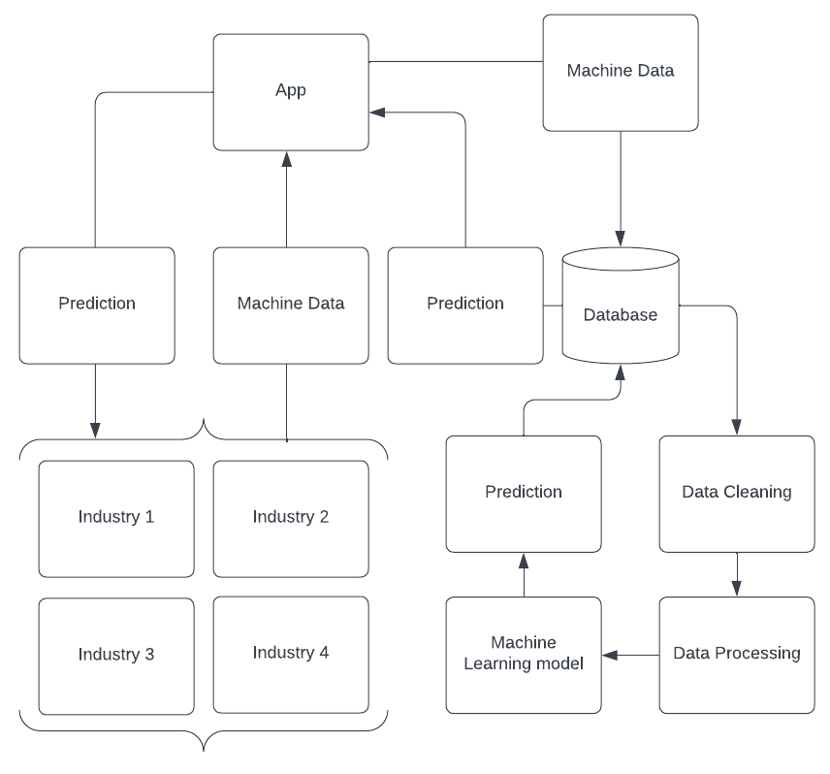

**10. Concept Generation:**

Develop the concept of using machine learning algorithms to predict machine failures based on historical sensor data. Explore different algorithms such as decision trees, random forests, and deep learning models.

**11. Concept Development:**

Provide a brief summary of the predictive maintenance system, explaining its architecture, data flow, and key components. Describe how it will assist businesses in optimizing their maintenance processes.

**12. Final Product Prototype:**

Present the abstract of the predictive maintenance system, along with a schematic diagram depicting its architecture and data flow.

**13. Product Details:**

Explain how the predictive maintenance system works, including data preprocessing, feature engineering, and model training.

Describe the data sources used, including the format of the input CSV file containing sensor readings.

List the algorithms, frameworks, and software employed in the system.

Define the team composition required for the development and maintenance of the system.

Provide an estimation of the implementation cost and potential return on investment for customers.

**14. Code Implementation/Validation on Small Scale (Optional - Bonus Grades):**

If applicable, include the code for implementing the predictive maintenance model on a small-scale dataset. This may involve data visualization, exploratory data analysis, and machine learning model training. Share a GitHub link to the code implementation for evaluation.

**15. Conclusion:**

Summarize the project's achievements, emphasizing the significance of predictive maintenance in optimizing industrial operations. Highlight the potential benefits for businesses in terms of cost savings, increased efficiency, and reduced downtime. Provide insights into future enhancements and expansions of the predictive maintenance system.

By following this comprehensive report structure, you can present a well-rounded and convincing project on "Machine Predictive Maintenance." It showcases the value of your flask app that enables businesses to predict machine failures and potentially earn revenue through subscription-based services.