Vitiligo Progress Report

# Patient Information

Name: Test Patient

Age: 28

Gender: Female

Duration Between Photos: 5.0 weeks

# Treatment Recommendation

Pharmacological: Calcineurin inhibitors; Physical: Narrow-band UVB; Depigmentation: Phenol-based creams

# Progress Summary

Change in Affected Area: -1.72%

## Before Treatment

Original Image:

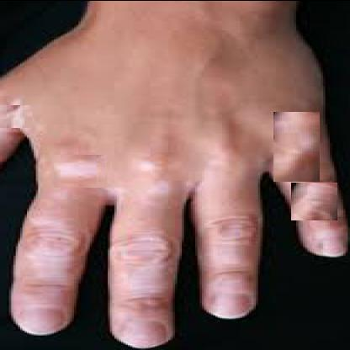

Segmented Image (affected areas in red):

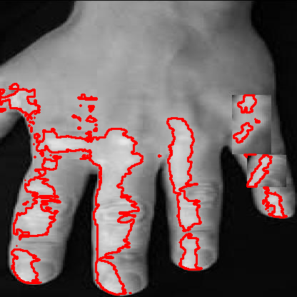

## After Treatment

Original Image:

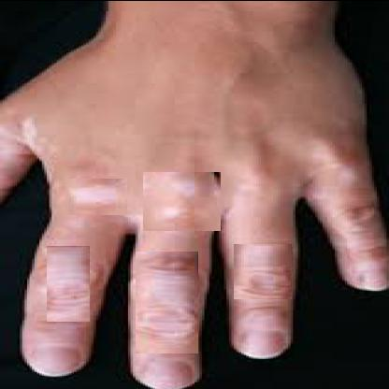

Segmented Image (affected areas in red):

