PROJECT 7
Stealth Scan vs Normal Scan Comparison
Category: Network Security & Recon | Difficulty: Intermediate
Target: Metasploitable 2 (192.168.80.133) | Status: Completed

Objective
To compare Nmap's stealth (SYN) scan against a full TCP connect scan on the same target, and understand the practical difference between them in speed and connection behavior.

Tools Used
- Kali Linux — attacker/scanning machine
- Nmap 7.99 — SYN scan and TCP connect scan

The Core Difference
A normal TCP connection takes 3 steps to open (SYN → SYN-ACK → ACK). A stealth scan sends the first step, reads the reply, then abandons the connection before the final step — so a full connection is never actually established. A connect scan completes all 3 steps, like a real application would.
- -sS Stealth / SYN scan — stops after step 2. This has actually been Nmap's default this whole time when run as root, which is why every earlier project's scan already used this method without it being typed explicitly.
- -sT Full TCP connect scan — completes all 3 steps, a real, loggable connection.

Step-by-Step Process
Command: nmap -sS 192.168.80.133
Stealth scan run first, against the default port list.
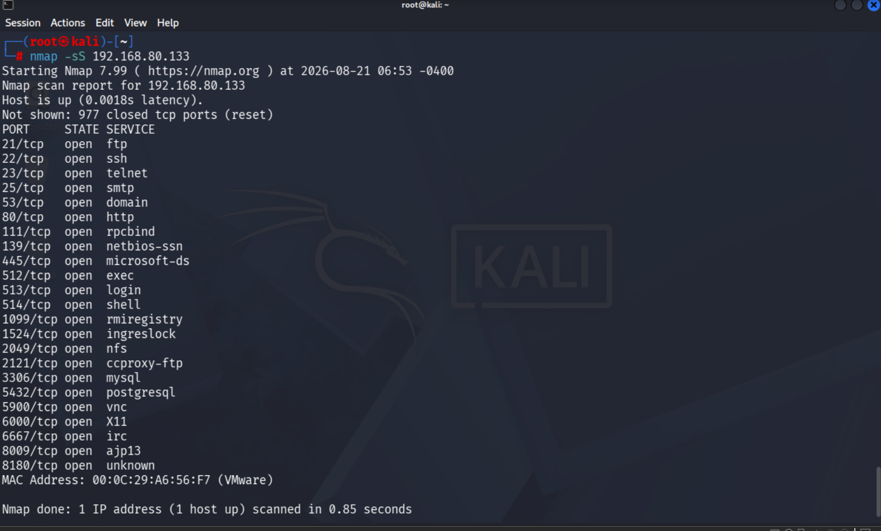
Figure 1 — Stealth (SYN) scan results
Command: nmap -sT 192.168.80.133
Full connect scan run second, against the same target and port list, for a direct comparison.
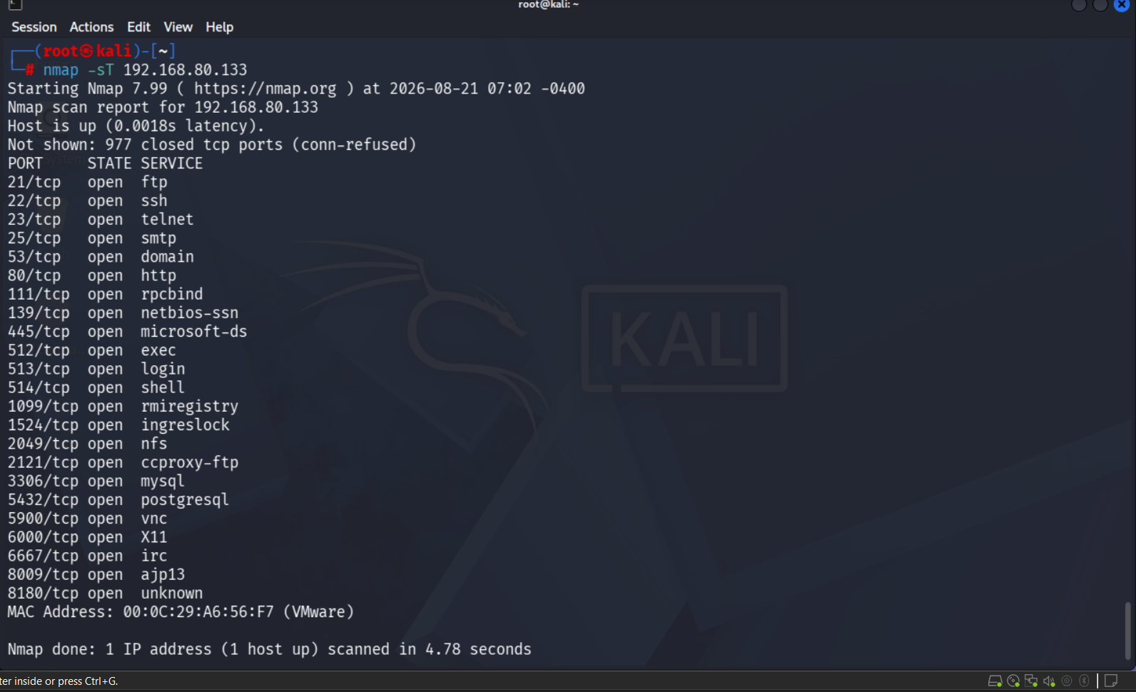
Figure 2 — Full TCP connect scan results

Findings
Metric | -sS (Stealth) | -sT (Connect)
Open ports found | 23 | 23
Closed ports label | reset | conn-refused
Scan duration | 0.85 seconds | 4.78 seconds
Connection completed? | No — abandoned after step 2 | Yes — full 3-step handshake
Both scans found the exact same 23 open ports, confirming the two methods are equally accurate. The main differences were speed and how each scan labels closed ports internally — the stealth scan reports closed ports as “reset,” while the connect scan reports them as “conn-refused,” reflecting the different mechanism each one uses to determine a port is closed.

Risk Analysis
- Connect scans are far more likely to be logged — Since -sT completes a real connection, the target service itself sees and can log a full, legitimate-looking connection. A stealth scan never finishes the handshake, so many services and basic logging never register it as a real connection attempt.
- Speed matters more at scale — The stealth scan's speed advantage seen here (0.85s vs 4.78s) becomes far more significant when scanning entire networks or the full 65,535-port range, where thousands of connection attempts add up quickly.
- “Stealth” is relative, not invisible — A SYN scan avoids basic connection logs, but modern firewalls and intrusion detection systems can still recognize the unusual SYN pattern itself. The name reflects older, simpler detection methods — not a guarantee of being undetected today.

Conclusion & Recommendation
Both scan types returned identical, reliable results, but the stealth scan completed roughly 5.6 times faster while avoiding fully established connections. For a real assessment, a stealth scan is the practical default choice; a full connect scan is mainly needed when raw socket privileges are unavailable (e.g. running as a non-root user) or when testing how a service behaves under a genuinely completed connection.

