PROJECT 2
Identify Live Hosts in a Subnet (Ping Sweep)
Category: Network Security & Recon | Difficulty: Intermediate
Target: Subnet 192.168.80.0/24 | Status: Completed

Objective
To identify all live hosts in the target subnet using two independent discovery methods — ICMP-based and ARP-based — and compare the results to confirm accuracy.

Tools Used
- Kali Linux — attacker/scanning machine
- Nmap 7.99 — ICMP-based host discovery
- Netdiscover — ARP-based host discovery
- arp-scan — ARP-based host discovery (cross-verification)

Step-by-Step Process
Step 1 — ICMP-Based Sweep (Ping Sweep)
Command: nmap -sn 192.168.80.0/24
Sends an ICMP echo request to every address in the range and lists which ones reply. 5 hosts responded, including the scanning machine's own subnet interface.
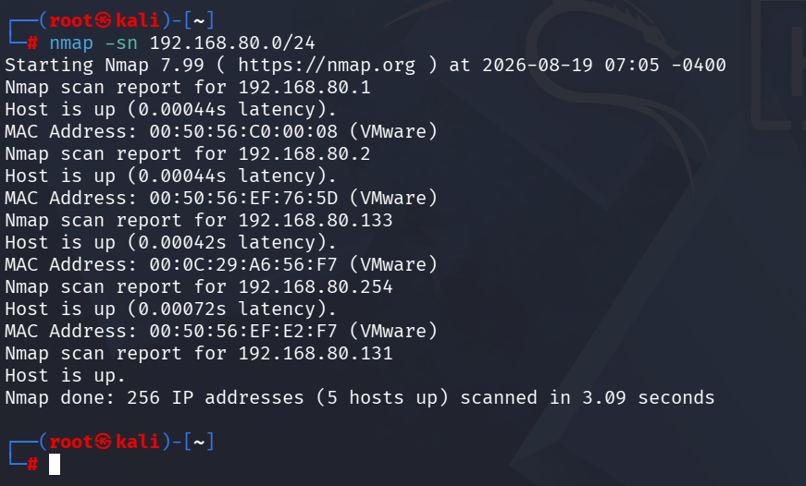
Figure 1 — ICMP-based host discovery (Nmap ping sweep)
Step 2 — ARP-Based Sweep (Netdiscover)
Command: netdiscover -r 192.168.80.0/24
Sends ARP requests instead of ICMP. ARP operates at a lower network layer and is required for basic local communication, so it is much harder to block than ping. 4 hosts responded, each showing its MAC address and hardware vendor.
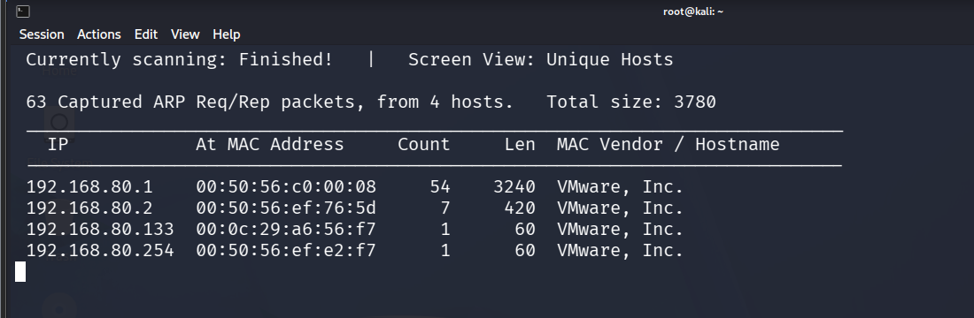
Figure 2 — ARP-based host discovery (Netdiscover)
Step 3 — ARP-Based Sweep (arp-scan) — Cross-Verification
Command: arp-scan 192.168.80.0/24
A second, independent ARP scanning tool was run to verify the netdiscover results were accurate and not tool-specific. The results matched exactly.
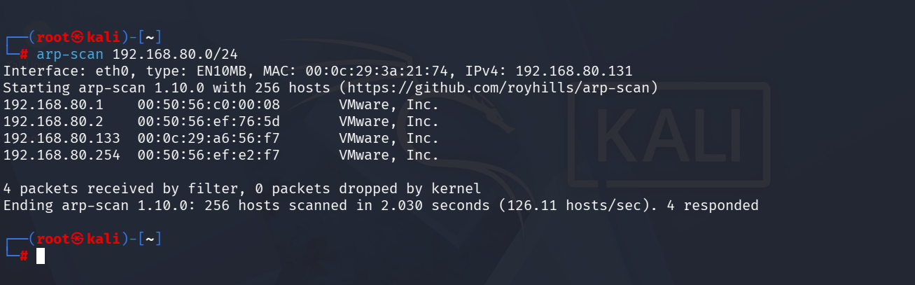
Figure 3 — ARP-based host discovery (arp-scan)

Findings
All three scans were compared against each other:
Host (IP) | Nmap (ICMP) | Netdiscover (ARP) | arp-scan (ARP)
192.168.80.1 (gateway) | Found | Found | Found
192.168.80.2 | Found | Found | Found
192.168.80.131 (Kali itself) | Found | Not shown | Not shown
192.168.80.133 (target) | Found | Found | Found
192.168.80.254 | Found | Found | Found
Both ARP-based tools (netdiscover and arp-scan) returned an identical set of 4 hosts, confirming the result was accurate and not a tool-specific error. The ICMP sweep found one additional address, 192.168.80.131 — this is the Kali scanning machine's own interface. A machine does not send an ARP request to itself, so ARP-based tools naturally exclude the scanner, while an ICMP sweep can still report it.

Risk Analysis
- Reliance on a single discovery method — ICMP (ping) can be disabled by a firewall, which would make a live host appear offline. If host discovery had only used ping, a filtered host could have been missed entirely.
- ARP cannot be blocked on a local segment — ARP is required for any device to communicate on the local network, so it cannot be filtered the way ICMP can. This means host discovery — the very first step of an attack — is very difficult to fully prevent from inside the same network.
- Host discovery is the foundation for every later step — Once an attacker knows which hosts are alive, every subsequent action (port scanning, service enumeration, exploitation) depends on that list. An attacker only needs one working discovery method to proceed, even if others are blocked.

Conclusion & Recommendation
Cross-verifying host discovery with both ICMP and ARP-based methods confirmed 4 active hosts on the subnet (excluding the scanning machine itself), with consistent results across three tools. On a real network, disabling ICMP responses alone would not be sufficient to hide hosts from a local attacker, since ARP-based discovery would still reveal them. Network monitoring should watch for ARP sweep patterns, not just ICMP traffic.

